CAPSTONE PROJECT – 1 ONLINE AGRICULTURE PRODUCTS STORE
PREP 1 ( PART-2 )
Documented by : B.Vaishnavi
Date : 05-May-2025

Mr. Henry, after being successful as a businessman and has become one of the wealthiest persons in the city. Now, Mr. Henry wants to help others to fulfil their dreams. One day, Mr.Henry went to meet his childhood friends Peter, Kevin and Ben. They live in a remote village and do farming. Mr. Henry asked his friends if they are facing any difficulties in their day-to-daywork. Peter told Mr. Henry that he is facing difficulties in procuring fertilizers which are very important for farm. Kevin said that he is also facing the same problem in-case of buying seeds for farming certain crops. Ben raised his concern on lack of pesticides which could help in greatly reducing pests in crops. After listening to all his friends’ problems, Mr. Henry thought that this is a crucial problem faced not only by his friends but also by so many other farmers. So, Mr. Henry decided to make an online agriculture product store to facilitate remote are a farmers to buy agriculture products. Through this Online Web / mobile Application, Farmers and Companies (Fertilizers, seeds and pesticides manufacturing Companies) can communicate directly with each other. The main purpose to build this online store is to facilitate farmers to buy seeds, pesticides, and fertilizers from anywhere through internet connectivity. Since new users are involved, Application should be user friendly. This new application should be able to accept the product (fertilizers, seeds, pesticides) details from the manufacturers and should be able to display them to the Farmers. Farmers will browse through these products and select the products what they need and request to buy them and deliver them to farmers location. Mr.Henry has given this project through his Company SOONY. In SOONY Company , Mr.Pandu is Financial Head and Mr Dooku is Project Coordinator. Mr.Henry , Mr Pandu , and Mr Dooku formed one Committee and gave this project to APT IT SOLUTIONS company for Budget 2Crores INR and 18 months Duration under CSR initiative. Peter, Kevin and Ben are helping the Committee and can be considered as Stakeholders share requirements for the Project . Mr Karthik is the Delivery Head in APT IT SOLUTIONS company and he reached out to Mr Henry through his connects and Bagged this project. APT IT SOLUTIONS company have Talent pool Available for this Project. Mr Vandanam is project Manager, Ms. Juhi is Senior Java Developer, Mr Teyson, Ms Lucie, Mr Tucker, Mr Bravo are Java Developers. Network Admin is Mr Mike and DB Admin is John. Mr Jason and Ms Alekya are the Tester. And you joined this team as a BA.

Question 1 – Audits - 5 Marks
4 Quarterly Audits are planned Q1 , Q2, Q3, Q4 for this Project What is your knowledge on how these Audits will happen for a BA ?
Answer 1 :
Audit is a quality check of the work.
Quarterly audit in order:
QUARTER 1

Stage | Requirement Gathering Phase
Status | Completed
Checklist | BRD template
 | Elicitation results report
 | Duplicate requirements report
 | Grouping of functionalities/features- Client signoff
QUARTER 2

Stage | Requirement Analysis Phase
Status | Completed
Checklist | UML Diagrams
 | Business to Functional Requirements mapping
 | Client Signoff
 | RTM Document version control
QUARTER 3

Stage | Design Phase
Status | Completed
Checklist | Utilization of Tools
 | Documented evidence on client communication.
 | Stakeholder MOM
QUARTER 4
Stage | Development Phase
Status | Completed
Checklist | Creating detailed checklist of requirement
 | Creating timeline and task with list of deliverables and deadlines
 | Meeting with Project development team.

Question 2 – BA Approach Strategy - 6 Marks
Before the Project is going to Kick Start, The Committee asked Mr Karthik to submit BA Approach Strategy Write BA Approach strategy (As a business analyst, what are the steps that you would need to follow to complete a project – What Elicitation Techniques to apply, how to do Stakeholder Analysis RACI/ILS, What Documents to Write, What process to follow to Sign off on the Documents, How to take Approvals from the Client, What Communication Channels to establish n implement, How to Handle Change Requests, How to update the progress of the project to the Stakeholders, How to take signoff on the UAT- Client Project Acceptance Form )
Your Team Project Manager - Mr Vandanam Senior Java Developer - Ms. Juhi Java Developers - Mr Teyson, Ms Lucie, Mr Tucker, Mr Bravo Network Admin - Mr Mike DB Admin - Mr John.
Testers - Mr Jason and Ms Alekya BA – You.
Technical Team have assembled to discuss on the Project approach and have finalised to follow 3-tier architecture for this project.
Answer 2 :
Elicitation Techniques: Conduct interviews with the stakeholders (Mr. Henry, Mr. Pandu, Mr. Dooku, Peter, Kevin, Ben) to gather the requirements. Organize focus group sessions to understand the needs of the remote area farmers. Review existing systems and documents to gather additional information. Conduct surveys and questionnaires to gather a wider perspective.

Stakeholder Analysis: Conduct RACI (Responsible, Accountable, Consulted, Informed) or ILS (Involved, Lead, Support) analysis to determine the roles and responsibilities of each stakeholder. Identify the key stakeholders and prioritize their requirements. Establish effective communication channels with the stakeholders to keep them informed about the progress of the project.
Documents: Write a Requirements Document (RD) to outline the functional and non-functional requirements of the project. Create a Business Requirements Document (BRD) to provide a detailed description of the project's objectives, scope, and deliverables. Prepare a Project Charter to define the project's goals, deliverables, timeline, and budget. Develop a Use Case Document to describe the processes and workflows involved in the project.
Sign Off: Obtain sign-off from the stakeholders on the Requirements Document, Business Requirements Document, Project Charter, and Use Case Document. Ensure that the stakeholders understand and agree with the requirements, scope, and objectives of the project.
Approvals: Obtain the client's approval on the project deliverables, budget, timeline, and approach. Ensure that the client's expectations are aligned with the project's goals and objectives. Communication Channels: Establish a regular communication schedule with the stakeholders to keep them informed about the project's progress. Create a communication plan to outline the channels and methods of communication. Schedule regular status meetings with the stakeholders to discuss the project's progress and address any issues or concerns.
Change Requests: Handle change requests in a structured and systematic manner. Evaluate the impact of each change request on the project's scope, timeline, and budget. Obtain approval from the stakeholders before implementing the change request.
Progress Updates: Keep the stakeholders informed about the project's progress through regular status reports and progress meetings. Highlight any risks or issues that need to be addressed. Provide regular progress updates to the stakeholders and seek their feedback.
Question 3 – 3-Tier Architecture - 5 Marks
Explain and illustrate 3-tier architecture?
Answer 3 :
Three-tier architecture, also known as multi-tier architecture, is a software design pattern that divides an application into three interconnected layers. In This architecture, there are 3 layers, it will organize applications into 3 logical and physical computing tiers - The presentation tier, User interface, The application tier, where data is processed. And the data tier, where the data associated with the application is stored and managed.

1. Application layer: It includes the agricultural mobile app screen. Login page functionality. 2. Business logic layer: Here, in this case, it's a payment method, products, company details, and specific rules.
3. Database layer: It can be company's details, product details data, farmers data

Screens , Pages, Validations on Page, Company Specific
logic, Functionality.
----Application Layer
All Re-usable components, Frequently changing components, Governing Body Rules & Regulations,
Compliances ...
Example : Printer, Payment gateways, Mail Servers RBI rules for Banks, IRDA rules for Insurance
----Business Logic Layer-----

Database components connecting to Databases
-----Data Layer-------

Database layer
Presentation Layer
Application layer

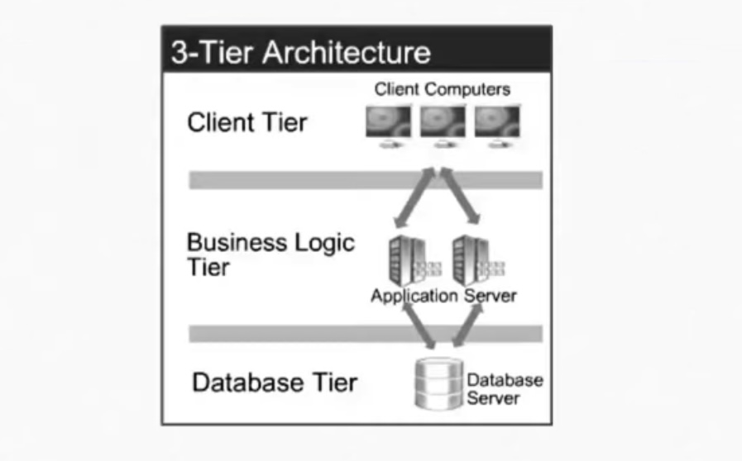

Question 4 – BA Approach Strategy for Framing Questions – 10 Marks
Business Analyst should keep What points in his/her mind before he frames a Question to ask to the Stakeholder
( 5W 1H – SMART – RACI – 3 Tier Architecture – Use Cases, Use case Specs, Activity
Diagrams ,Models, Page designs)
Answer 4 :
5W 1H
- Why - Why: Asking ‘Why’ entails clarifying why the issue, problem or situation at hand occurred. It aims to identify the triggers and rationalizes the occurrence of an issue or a problem. It explains in detail the reason and objectives behind the need for action or why there’s a need to do the 5W1H method in the first place. This last W is also often asked five times to discover the root cause of the situation and to prevent it from recurring.

- What - What element should clearly describe the situation, the specific problem, or basically explain the purpose of the method usage. If possible, it should also state the overall goal for implementing the solution that would be identified.
- Who - Who refers to the specific people or group relevant to the issue or the situation. It should include the person who discovered the problem, who can possibly solve it, and who will be responsible for implementing the possible solution.
- Where - Where element should contain the exact location or position of the recognized issue. It can be a place, facility, or even a certain process where the solution is to be implemented.
- When - When should include all the components of the situation pertaining to anything related to dates. It should state the timeline, deadline, duration, or any other details that could help in the resolution of the problem.
- How - How, as the last element of the method, specifies the steps on how the identified plan/s should be carried out. It should also include all the resources, tools, methods, means, and even the expenditure needed for the endeavours to be effective.

SMART - Specific, Measurable, Attainable, Relevant, and Time-Bound
- Specific - A Strategy to Set a Specific goal.
- Measurable - Measuring the process or procedure of attaining a goal at each phase.
- Attainable or Achievable - Concept of deciding whether a goal is achievable or not.
- Relative - Relevant to the other same business goals.
- Time-bound - To set a specific period to achieve the target goal

R, A, C, I stand for:
Responsible - Responsible designates the task as assigned directly to this person (or group of people). The responsible person is the one who does the work to complete the task or create the deliverable. Every task should have at least one responsible person and could have several.
Responsible parties are typically on the project team and are usually developers or other creators. Here PM is the responsible
Accountable - The accountable person delegates and reviews the work involved in a project. Their job is to make sure the responsible person or team knows the expectations of the project and completes work on time. Every task should have only one accountable person and no more.
Accountable parties are typically on the project team, usually in a leadership or management role.
Consulted - Consulted people provide input and feedback on the work being done in a project. They have a stake in the outcomes of a project because it could affect their current or future work. Project managers and teams should consult these stakeholders ahead of starting a task to get input on their needs, and again throughout the work and at the completion of a task to get feedback on the outcome.
Informed - Informed folks need to be looped into the progress of a project but not consulted or overwhelmed with the details of every task. They need to know what’s going on because it could affect their work, but they’re not decision makers in the process. Informed parties are usually outside of the project team and often in different departments. They might include heads or directors of affected teams and senior leadership in a company.
Unified Modeling Language (UML):
The industry-standard language for specifying, visualizing, constructing, and documenting software systems. It simplifies software design, and communication about the design

Use Case Specs
- Use case in this BA needs to approach through primary actor to the line-up design for the working structured
- Who is the primary user?
- What type of product need for the project?
- Placing order
- Order confirmation needs to be require
- Delivery channel & tracking updates

- The activity diagram is in the UML for modelling the dynamic aspects of the system for various aspects we need to mark certain questions with stakeholders.
- What activity is going to perform
- Functional relational between the part
- Business functionally and business objectives.
- Modelling& page design - It’s a very important part of the question for requirement getting where BA needs to ask a stakeholder about.
- In what way do you want functioning to look like?
- The web page function looks like?
- Functional activity
- Payment gateway
- Complain and function update.
Question 5 – Elicitation Techniques - 6 Marks
As a Business Analyst, What Elicitation Techniques you are aware of? ( BDRFOWJIPQU)
Answer 5 :
Brainstorming: Brainstorming is a popular technique used in requirements elicitation, where it helps to generate a large number of ideas in a short amount of time. Brainstorming is a group elicitation technique where a problem or topic is presented to the group, and participants are asked to produce as many ideas to solve/address the topic as possible. As ideas are presented, a scribe documents the ideas and ensures the participants can see what is being captured.
Document Analysis: Document analysis is a qualitative research technique used by researchers to interpret and categorize primary sources or original accounts from people who had personal experiences with the topic. The process involves evaluating electronic and physical documents to gain an understanding of their meaning and develop upon the information they provide. Researchers use three main types of documents in their research: public records, personal documents, and physical evidence.

Reverse engineering: is an elicitation technique that can extract implemented requirements from the software code This technique is usually utilized in migration projects when an existing system has little or outdated documentation and it is necessary to study what the system actually does. Reverse engineering refers to looking at the solution to figure out how it works. Basically, you work your business analysis backward from the solution to understand the data, processes, and business.
Focus group elicitation: It is a technique used to gather qualitative information from participants in a group environment. It is a form of requirements elicitation that involves gathering feedback from relevant stakeholders to refine processes, ideas, or solutions that emerged as an outcome of earlier elicitation activities, such as brainstorming and document analysis. The feedback and comments are recorded for use in later phases of requirements elicitation.
Observation: A technique where the business analyst watches how the stakeholders perform their tasks, either in their natural environment or in a simulated setting. Observation can be passive, where the business analyst does not interfere with the stakeholders' work, or active, where the business analyst participates in the work or asks questions. Observation is useful for understanding the current processes, workflows, pain points, and opportunities for improvement.

Interviews: A one-on-one or group conversation between the business analyst and the stakeholders, where the business analyst asks open-ended or closed-ended questions to elicit information. Interviews can be structured, semi-structured, or unstructured, depending on the level of flexibility and formality. Interviews are useful for exploring complex or sensitive topics, clarifying requirements, and building rapport with stakeholders.
Workshop: It is a set of methods used by business analysts to gather information from stakeholders in a workshop setting. These techniques are designed to encourage participation, collaboration, and creativity among the stakeholders, and to generate insights that can be used to refine processes, ideas, or solutions that emerged as an outcome of earlier elicitation activities.
Questionnaires are a popular tool used to gather data from respondents about their attitudes, experiences, or opinions. They can be used to collect quantitative and/or qualitative information. Questionnaires can be self-administered or researcher-administered. Self-administered questionnaires can be delivered online or in paper-and-pen formats, in person or through mail. All questions are standardized so that all respondents receive the same questions with identical wording.

JAD (Joint application development) : JAD is a methodology used in software development to gather and define software requirements rapidly. It involves bringing together the stakeholders developers and users in joint sessions. The JAD methodology involves four phases: Preparation, Session, Documentation, and Implementation. During the Session phase, experts participate in interactive discussions and decision-making activities.The outcome of the JAD session is documented, including detailed notes, sketches, and other materials generated during the session. The documentation is used to create a final specification for the software application.
Prototyping is an experimental process where design teams implement ideas into tangible forms from paper to digital. Teams build prototypes of varying degrees of fidelity to capture design concepts and test them on users. Its a process where business analysts use prototypes to elicit and validate the stakeholders' requirements through an iterative process that creates a model or design of those requirements.
Prototype tools are : Basmiq., axure etc. Using mentioned tools, one can prepare UML diagrams effectively.
Use case Specs - early designs, mock-ups, prototypes with real users. User testing helps you to find out if the potential design will be usable.

Question 6 – This project Elicitation Techniques - 5 Marks
Which Elicitation Techniques can be used in this Project and Justify your selection of Elicitation Techniques?
Prototyping
Use case Specs
Document Analysis
Brainstorming
Fertilizers, seeds, pesticides details from the manufacturers and should be able to display them to the
Farmers.
To gather the business requirements from the client, you went to SOONY and met Mr. Henry. When Mr.Henry was asked about the project and what are they expecting from the project, Mr. Henry stated that he is expecting to have a login for all its users (fertilizers, seeds, pesticides manufacturers and Farmers) , a product catalog of fertilizers, seeds, pesticides, a search option to search for products, payment process, and delivery tracking.

After doing the stakeholder analysis, you have found out that Peter, Kevin, Ben are the key stakeholders and you have scheduled an appointment to meet them. After meeting with them and trying to gather the stakeholder requirements, Kevin said that, a Farmer should be able to browse through the products catalog once they visit the website and need to have a search option so that they can search for any product they need. Peter said that, if a farmer wants to buy any product or add them to buy-later list, they need to login first using their email id and password. If it is a new user, then they can create a new account by submitting their email ID and creating a secure password. Ben added saying that, Farmers needs to have an easy-to-use payment gateway which should include cash-on-delivery (COD), Credit/Debit card and UPI options so that the user’s experience should be better. Kevin mentioned that, a user gets an email confirmation regarding their order status. A delivery tracker to track the whereabouts of their order.
Identify Business Requirements (which includes Stakeholder Requirements)
BR001 – Farmers should be able to search for available products in fertilizers, seeds, pesticides.
BR002 – Manufacturers should be able to upload and display their products in the application.
Answer 6 :
I would be using Workshop and will invite all stakeholder and will set up agenda, discussion, requirement gathering, client expectation.
I would be using use case specs as it helps for early designs, mock-ups, prototypes with real users. User testing helps us to find out if the potential design will be usable.
BR001 – Farmers should be able to search for available products in fertilizers, seeds, pesticides. BR002 – Manufacturers should be able to upload and display their products in the application.
BR003- Farmers need to login first using their email id and password to make any purchase or add to buy list.
BR004- New users need to create a new account by submitting their email ID and creating a secure password.
BR005- Farmers needs to have an easy-to-use payment gateway which should include cash-on- delivery (COD), Card and Net banking options.
BR006- Users must get an email confirmation regarding their order status and a delivery tracker to track the whereabouts of their order.

Question 7 – 10 Business Requirements- 10 Marks
Make suitable Assumptions and identify at least 10 Business Requirements.
Answer 7 :
BR001- Search- Users should be able to search for available products in different categories.
BR002- Upload & Display- Dealers should be able to upload and display their products in the application.
BR003- Browse- Users should be able to browse through the Product Catalogue.
BR004- Chat- Dealers should be able to communicate with users.
BR005- Login- Login option should be available for all Users.
BR006- Track Delivery- Users should be able to track deliveries.
BR007- Add to cart- Users should be able to add items to add to cart.
BR008- Registration- New user can create a new a/c by using email and mobile no verification.
BR009- Payment Processing- Users should be able to do payment from payment gateway which should include COD, Card and Net banking options.
BR010- Order Confirmation- Users should get order confirmation once order is successfully placed.
Question 8 –Assumptions- 5 Marks
List your assumptions
Assumption 1: Users can login using Facebook, Google Yahoo account.
Assumption 2: Users should have basic technical knowledge to browse websites or make purchase. Assumption 3: Due to boom in online shopping trend, customers will prefer online shopping.
Assumption 3: The dealers/traders need to display good quality product in the application to increase their sales.
Assumption 4: Users should have knowledge on agricultural products, its usage and longevity.
Assumption 5: Customers should have online accounts for secured payment processing.

Question 9 – This project Requirements Priority - 8 Marks
Give Priority 1 to 10 numbers ( 1 being low priority – 10 being high priority) to these Requirements after discussions with the stakeholders.

Req ID | Req Name | Req Description | Priorit  y
BR001 | Farmer Search for Products | Farmers should be able to search for available  products in fertilizers, seeds, pesticides | 8
BR002 | Manufacturers upload their Products | Manufacturers should be able to upload and display their products in the application | 8
Once the requirements are finalized, as a business analyst, one of the major roles is to act as a liaison between the client and the project team. To gather the requirements correctly from the client side and then to deliver those requirements to the project team in a way they understand.
To make the project team understand the requirements, you need to convert those requirements into UML diagrams and screen mock-ups.
Answer 9 :
S.No | Requirement ID | Requirement Category | Description | Priority
1 | BR001 | Search | Customers should be able to search for available products in different categories | 3
2 | BR002 | Upload & Display | Dealers should be able to upload and display their products in the application. | 4
3 | BR003 | Browse | Customers should be able to browse through the Product Catalogue | 7
4 | BR004 | Chat | Dealers should be able to communicate with customers | 1
5 | BR005 | Login | Login option should be available for all Users. | 1
6 | BR006 | Track Delivery | Customers should be able to track deliveries | 9
7 | BR007 | Add to cart | Customers should be able to add items to add to cart | 2
8 | BR008 | Registration | New user can create a new a/c by using email and mobile no verification. | 2
9 | BR009 | Payment Processing | Customers should be able to do payment from payment gateway which should include COD, Card and Net banking options. | 2
10 | BR010 | Order Confirmation | Customers should get order confirmation once order is successfully placed | 8

Question 10 – Use Case Diagram - 10 Marks
Draw use case diagram
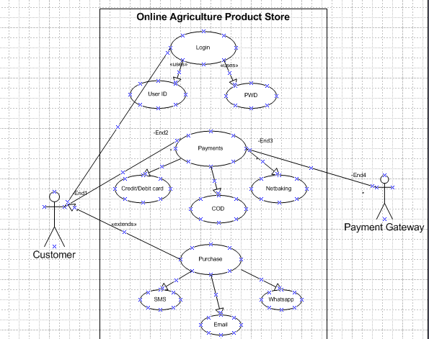

Question 11 – (minimum 5) Use Case Specs - 15 Marks
Prepare use case specs for all use cases
Use case spec 1 – User Buying fertilizer from online agriculture product store
BRIEF DESCRIPTION | This Use case explains how a Farmer uses the Online Agriculture Product Store to buy Fertilizers.
ACTORS | 1. Farmers  2. Database/Admin
Pre-Conditions | • There should be an active Internet connection.  • Farmer should have Laptop/Mobile.
Basic Flow | • Use case Begins with User logs in.  • User validation is performed.  • Customer begins to search for the Agriculture Product.  • Application displays multiple products for the Searched product.  • User selects the product and add it to cart.  • User selects the Delivery location for product delivery.  • User selects the Payment mode to pay.  • Order placed and user receives an SMS for Order confirmation.  • Use case Ends successfully.
Alternate Flow | • Invalid User – This happens when the user validation fails.  App display message: User validation not completed Successfully. Use case ends with failure condition.  • Product Out of Stock – If the user selects the product which is out of stock. App display message: Product out of stock. Select from similar product available.  • Product Out of Stock for selected location: If the product is not available for the Selected location.  App display message: Product out of stock for selected location. Please try after few days when the product is available / Try selecting from similar products.  • No response from Payment server: While making payment, if the server disconnects or there is no response from the server.  • Use Case Ends
Post Conditions | • Successful Completion – User bought the fertilizer successfully.  • Failure Condition – User couldn’t purchase the product due to some Technical/Financial reason
SUPPLEMENTAL REQUIREMENTS | • The price of all the agriculture product should be as per the Govt. policy.  • The application shall keep a usage detail of all complete and incomplete transactions.

Use case spec 2 – User registering in the application.
BRIEF DESCRIPTION | This Use case describes, how a user registers himself in an Online Agriculture Store
ACTORS | 1. Farmers  2. Database/Admin
Pre-Conditions | • There should be an active Internet connection.  • Farmer should have Laptop/Mobile.  • The user should have active Email address.  • The user should have active mobile number.
Basic Flow | Use case Begins – When a new user starts registering himself with the user details.  1. User enters user details: Name, Address, Mobile number, and Email ID.  2. Application displays option to send OTP to mobile for mobile verification.  3. User sends OTP to the mobile number.  4. User enters OTP received.  5. Application displays OTP verified.  6. User validation performed.  7. Application displays User created successfully.  Use case Ends.
Alternate Flow | 1. Invalid OTP: If the user enters the incorrect OTP. Display Message: Please enter the correct OTP.  2. Mobile number already used: In this case, if the user enters the mobile number which is already in use, which means that the user is already a registered user.  Display Message: Mobile number is already in use. Please enter the correct mobile number.  3. Email address is already used: If the user enters the email address which is already used to register, which means that the user has already a registered user.  Display Message: Email address is already in use. Please enter the correct Email address.  4. User ID not available: If the user enters the User ID which is already used, then the application gives the below message.  Display Message: User ID already used. Please enter another user id.  5. Server issue: If the user not able to create the user id, when the server breakdown. Display Message: Server busy. Please try again later.
Post Conditions | • Successful completion: The user id has been successfully created.  • The details updated in the log accordingly.
SUPPLEMENTAL REQUIREMENTS | • The application shall keep a log, Including date and time, of all complete and incomplete transactions.

Use case spec 3– User making payment for the order placed.
BRIEF DESCRIPTION | This use case describes, how the user goes through a Payment process after the product selection
ACTORS | • Farmer  • Admin  • Bank
Pre-Conditions | • There should be an active Internet connection.  • Farmer should have Laptop/Mobile.  • User should have an active Bank account.  • User should have active mobile number to receive the Bank OTP.
Basic Flow | Use case Begins – when the user initiates the payment after the selection of the product.  1. User validation performed.  2. Application displays multiple options to Pay by Credit card, Debit card, Net Banking, and UPI.  3. User has option to pay by Credit card, Debit card, Net Banking, UPI  4. User selects the Payment mode and fill the details.  5. Application displays Payment completed.  6. User receives email and SMS with the Order completion.  Use case Ends
Alternate Flow | 1. Incorrect Card details: If the user enters incorrect Card details. User receives SMS from Bank about Payment failure due to incorrect card details entered.  Display Message: Payment not completed.  2. Incorrect OTP: If the user enters incorrect OTP. Display Message: Payment declined. Incorrect OTP entered.  3. Insufficient Funds: Payment got declined due to insufficient funds.  Display Message: Payment declined. User receives SMS from Bank confirming the Payment declined due to insufficient funds.  4. Server Busy: Payment didn’t complete due to Server busy. Display Message: Payment not completed. Server Busy. Please try again
Post Conditions | • Successful Completion: Payment is completed, and the Order is placed successfully
SUPPLEMENTAL REQUIREMENTS | • The application shall keep a log, Including date and time, of all complete and incomplete transactions

Use case spec 4 – Seller adding and updating the products in the portal.
BRIEF DESCRIPTION | • This Use case describes how a Seller/Manufacturer adds this product on the portal.
ACTORS | • Seller / Manufacturer  • Database/Admin
Pre-Conditions | • There should be an active Internet connection.  • Seller should have Laptop/Mobile
Basic Flow | Use case Begins – When the Seller wants to Add/update any New Agricultural product at Agricultural Product store.  1. Seller selects the Sale option before Login.  2. User validation performed.  3. Application displays different Product selling alternatives. In this case the Seller selects Agricultural product option.  4. Seller chooses product categories.  5. The Seller enters product details i.e., Product Name, Type of the product, Price and Offers on product and Approximate Delivery date.  6. Application displays the new Product detail updated successfully.  7. Seller also receives a receipt by SMS or email.  Use case Ends.
Alternate Flow | • Region wise product price display to customer: Seller tries to update the Price as per the region; however the application throws an error.  Display Message: Price not matching as per the region. Please enter the correct price.  • Incorrect product categories: Seller selects the wrong product category. Display Message: Incorrect Product category. Please select the correct category
Post Conditions | • Successful completion - The product has been successfully updated
SUPPLEMENTAL REQUIREMENTS | • The application shall keep a log, Including date and time, of all complete and incomplete transactions with the admin

Use case spec 5 – User cancelling the product.
BRIEF DESCRIPTION | • This use case describes how user cancel/return the product at online agricultural product store
ACTORS | • Farmer  • Database/Admin  • Seller
Pre-Conditions | • There should be an active Internet connection.  • Seller should have Laptop/Mobile.
Basic Flow | Use case Begins – When the User wants to cancel/return agriculture product at agricultural product store.  1. User validation performed.  2. Application displays multiple order, which has already been placed.  3. User selects the Order/Product for cancellation/return.  4. Application displays Reason for cancellation/return.  5. User provides reason for cancellation/return.  6. Application displays Product cancellation/return requested. Product will be picked up at certain time and date.  7. Seller receives message or product cancellation/return.  8. Seller arranges the product pick up.  9. Admin issues Refund to User.  10. User receives the Refund.  Use case Ends.
Alternate Flow | • Cancel Period over: Application displays this message when the user tried to cancel after the cancellation/return period is over.  Display Message: Product cannot be returned.
Post Conditions | • Successful cancellation/Return: The product has been successfully cancelled and the internal logs have been updated.  • Refund Initiated: Refund has been initiated.
SUPPLEMENTAL REQUIREMENTS | • The application shall keep a log, Including date and time, of all complete and incomplete transactions with the admin

Question 12 – (minimum 5) Activity Diagrams - 15 Marks
Activity diagrams
Add to cart
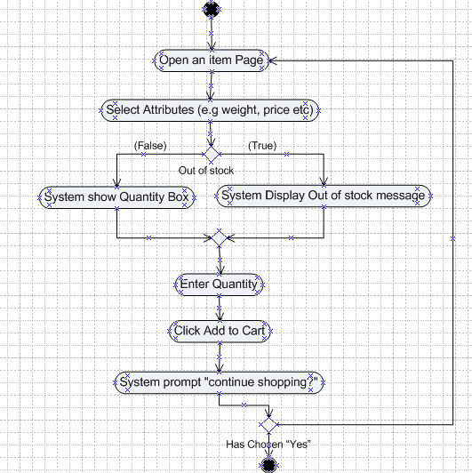

Payment
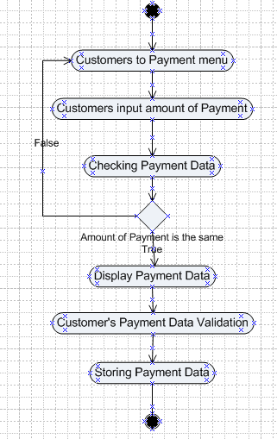

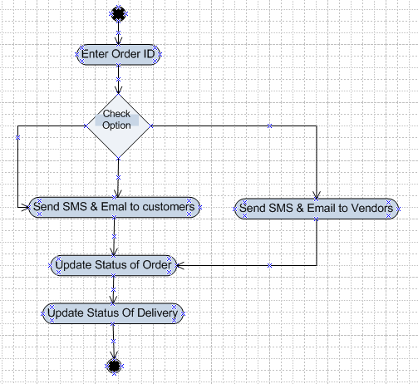
Delivery boy :

Register and customer login:
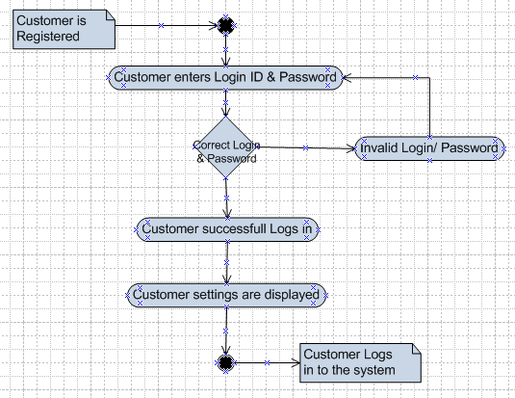

Product Return
