**Question 1 – 4 Quarterly Audits are planned Q1 , Q2, Q3, Q4 for this Project What is your knowledge on how these Audits will happen for a BA ? - 5 Marks**

**Answer:**

In the context of Business Analysis (BA), audits during a project are critical for ensuring that the project is on track and meets its objectives. Audits are typically conducted at specific intervals, such as quarterly audits (Q1, Q2, Q3, Q4) to assess the project's progress. For a BA, audits serve as a review mechanism to ensure that:

Quarter 1: We will have Audit report on Requirement Gathering Phase.

It can be done from week 1 to week 10. On which area and on what basis on audit will happen. Therefore as a BA we need to prepare the checklist.

BRD Template

Elicitation technique report.

Client signoff documents

Email communication To CC BCC.

Quarter2 Requirement Analysis Phase.

UML diagram

Business to functional requirements mapping

Client signoff documents

RTM document version control

Email communication To, CC, BCC.

Quarter3 Desing phase

Utilization of tools

Document evidence on client communication

Stakeholder MOM

Email communication To, CC, BCC

Quarter4 Development phase

JAD session report

End user manual preparation document

BA and developer MOM

Email communication To, CC, BCC

Quarter 5 Testing

Test case summary

Training report to end users

Lessons learnt document

Email communication To, CC, BCC

Question 2 – BA Approach Strategy - 6 Marks

**Answer:**

As a Business Analyst (BA) working on this project, the approach strategy involves several key steps to ensure successful project completion:

1. **Elicitation Techniques**:
2. 6.1.2 Requirement Elicitation Techniques
3. Brainstorming
4. Document Analysis
5. Reverse Engineering
6. Focus Groups
7. Observation
8. Workshop
9. JAD (Joint Application Development) -Requirements Workshop 62
10. Interview

**A RACI matrix is a tool used to clarify roles and responsibilities in a project. It helps show who is responsible for what tasks. The letters in "RACI" stand for:**

* R = Responsible: The person who does the work.
* A = Accountable: The person who is ultimately answerable for the task.
* C = Consulted: People who give advice or information.
* I = Informed: People who need to be kept updated about progress

| **Activity** | **Mr. Henry** | **Mr. Pandu** | **Mr. Dooku** | **Peter, Kevin, Ben** | **Mr. Karthik** | **Mr. Vandanam** | **Ms. Juhi** | **Java Devs** | **Mr. Mike** | **Mr. John** | **Mr. Jason & Ms. Alekya** |
| --- | --- | --- | --- | --- | --- | --- | --- | --- | --- | --- | --- |
| **Requirements Gathering (Functional/Non-Functional)** | R | C | A | C | C | I | I | I | I | I | I |
| **Feasibility Study (Technology, Resources)** | C | A | C | I | R | C | I | I | I | I | I |
| **Design System Architecture** | I | C | I | I | A | R | C | R | I | C | I |
| **System Development (Java)** | I | I | I | I | I | C | R | R | I | I | I |
| **User Interface Design** | C | I | I | R | C | A | R | C | I | I | I |
| **Database Design** | I | I | I | I | C | C | I | I | R | A | I |
| **Testing** | I | I | I | I | C | I | I | I | I | I | A |
| **Deployment** | I | I | C | I | A | R | I | I | I | I | I |

**What Documents to Write-**

**Business Requirements Document (BRD)**: Captures the business needs, requirements, and objectives.

**Functional Requirements Document (FRD)**: Details the system functionality and features.

**Test Case Document**: Defines interactions between users and the system.

**How to take Approvals from the Client**

Share documentation with stakeholders for approval.

Gather feedback and revise the document.

Obtain final approval from the client or project sponsor

**What Communication Channels to establish and implement**

Regular meetings, Weekly status meeting, bi-weekly sprint reviews, and monthly stakeholder updates.

**How to Handle Change Request:** Change Request Form, Do Impact Analysis, Approval Process, Documentation.

**How to update the progress of the project to the Stakeholders:** Weekly Status Report, Monthly Review Meetings.

**How to take signoff on the UAT- Client project Acceptance Form:**  UAT preparation, Conduct UAT, Fix Issue, Acceptance Form, Final Review Meeting, Obtain Sign-Off.

**Question 3 – 3-Tier Architecture**

**Application Layer-** Topmost layer of the architecture- also know as “Presentation Layer.

It handles user interface(UT) components such as screen, pages.

**Business Logic Layer-** middle layer of the architecture- acts as an intermediary between the presentation layer and the data storage layer- layer contains the core logic of the application. Eg: Printer payment gateways.

**Database Layer-** Bottom layer of the architecture, responsible for storing and retrieving date.

Eg: MySQL, Oracle datebase.

**Question 4 – BA Approach Strategy for Framing Questions –**

1. **5W1H Framework**:
   * **Who**: Who are the stakeholders? Who will use the system?
   * **What**: What are the goals, features, and functionalities?
   * **When**: When do the requirements need to be implemented?
   * **Where**: Where will the application be used (e.g., geographical locations)?
   * **Why**: Why are these requirements important for the business?
   * **How**: How should the system function, and how will the user interact with it?
2. **SMART**:
   * Ensure that the questions are **Specific, Measurable, Achievable, Relevant**, and **Time-bound** to avoid ambiguity.
3. **RACI**:
   * Frame questions to clarify roles and responsibilities. Ask questions that define who is **Responsible**, **Accountable**, **Consulted**, and **Informed** for each requirement or task.

**UML, Unified Modelling Language,** it is a standardise way of diagramming and modelling software system to aid in design, development and communication between team members.

**Question 5 – Elicitation Techniques - 6 Marks**

**Answer:**

Some common elicitation techniques for gathering business requirements include:

**Brainstorming**: A group activity where stakeholders generate ideas or solutions on a given topic or problem.

**Document Analysis**

**.0003:** Reviewing existing documentation (like reports, user manuals, policies) to gather relevant information.

**Review of existing systems:** Analyzing current systems, processes, and workflows to identify opportunities for improvement.

**Focus Groups:** Bringing together a small group of stakeholders to discuss specific issues or topics in a guided manner.

**Open-ended Interviews:** Conducting one-on-one or group interviews where questions allow for detailed, in-depth responses.

**Workshops:** Structured, facilitated group discussions with stakeholders to explore requirements, solve problems, or define system behaviors.

**Joint Application Development (JAD):** A collaborative approach involving key stakeholders to define requirements for new applications.

**Interviews (Structured or Unstructured):** Direct interactions with stakeholders to gather specific or open-ended information.

**Prototyping**: Creating early models or mock-ups of the system for stakeholders to interact with, offering a tangible form to clarify needs.

**Questionnaires/Surveys:** Using written forms to gather data from a larger group of stakeholders, often focusing on quantitative data.

**User Stories:** Describing requirements or features from the perspective of the user, typically used in agile methodologies.

**Question 6 – This Project Elicitation Techniques - 5 Marks**

**Answer:**

For this project, the following elicitation techniques are most suitable:

1. **Interviews**:
   * Interviews with stakeholders (Mr. Henry, Peter, Kevin, and Ben) will help gather detailed business requirements, such as specific needs for search options, product displays, and payment gateways.
2. **Document Analysis**:
   * Review any existing documentation or market research data that can provide context on current processes and any regulatory requirements.
3. **Prototyping**:
   * A prototype of the product catalog or payment interface can be shown to stakeholders (e.g., farmers) to get their feedback on user experience.
4. **Brainstorming**:
   * Brainstorming sessions with stakeholders can generate new ideas or improve existing features for the application, especially in terms of user interface and usability.

**Question 7 – 10 Business Requirements**

1. **BR001**: Farmers should be able to search for available products (fertilizers, seeds, pesticides).
2. **BR002**: Manufacturers should be able to upload and display their products on the platform.
3. **BR003**: Users (Farmers and Manufacturers) should be able to register using email and password.
4. **BR004**: If the user Forget password, there should be provision to retrieve the password.
5. **BR005**: Farmers should be able to view detailed product descriptions and prices.
6. **BR006**: The system should support a secure payment gateway with options like COD, Credit/Debit cards, and UPI.
7. **BR007**: Farmers should receive email notifications confirming their orders.
8. **BR008**: The system should allow farmers to track the delivery status of their orders.
9. **BR009**: The platform should provide a "Buy Later" option for farmers to save products for future purchases.
10. **BR010**: The system should allow manufacturers to update their product catalog periodically.

**Question 8 –Assumptions**

**Answer:**

1. The project will have internet connectivity for both farmers and manufacturers.
2. The platform will support multiple languages for accessibility to a diverse user base.
3. The platform will provide security features like SSL certificates and encryption for secure transactions.
4. Payment gateways will be integrated for COD, Credit/Debit card, and UPI options.
5. Manufacturers will regularly update product availability and pricing.

**Question 9 – This project Requirements Priority**

|  |  |  |  |
| --- | --- | --- | --- |
| **Req ID** | **Req Name** | **Req Description** | **Priority** |
| BR001 | Farmer Search for Products | Farmers should be able to search for available products in fertilizers, seeds, pesticides | 8 |
| BR002 | Manufacturers upload their Products | Manufacturers should be able to upload and display their products | 8 |
| BR003 | User Registration | Users should be able to register with email and password | 9 |
| BR004 | Forgot Password | If the user Forget password, there should be provision to retrieve the password. | 9 |
| BR005 | Product Details | Farmers should be able to view detailed product descriptions | 7 |
| BR006 | Payment Gateway | The system should support various payment methods (COD, card, UPI) | 10 |
| BR007 | Email Notification | Farmers should receive order confirmations via email | 6 |
| BR008 | Delivery Tracking | The system should allow farmers to track the delivery status | 9 |
| BR009 | Buy Later Option | Farmers should be able to save products for future purchases | 5 |
| BR010 | Product Updates | Manufacturers should be able to update product details | 6 |

**Q10) Question 10 – Use Case Diagram - 10 Marks**

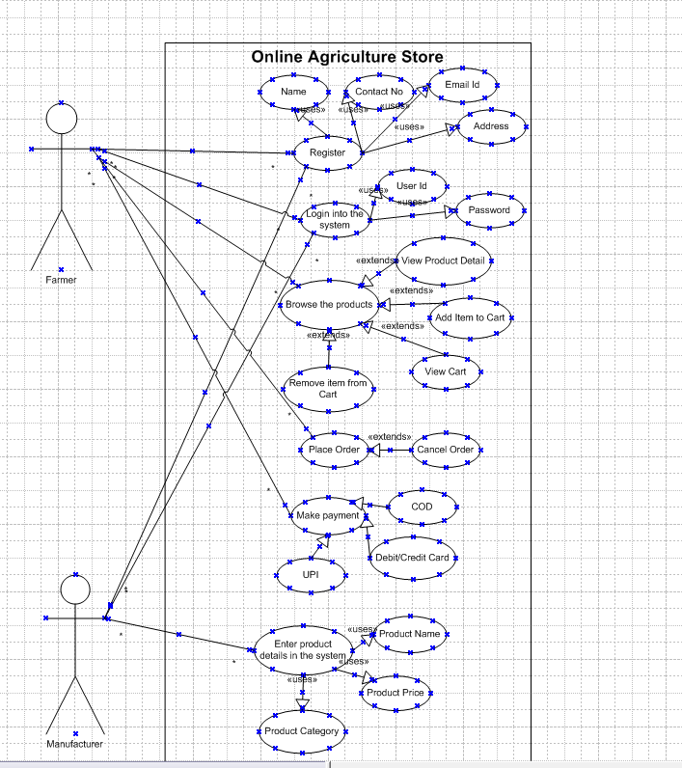

**Question 11 – (minimum 5) Use Case Specs - 15 Marks**

|  |  |
| --- | --- |
| **Use Case ID** | **UC001** |
| Use Case Name | Online User Registeration |
| Created By | Shahzad Ahmed Mahagami |
| Date Created | 05-02-2025 |
| Last Updated By | Shahzad Ahmed Mahagami |
| Last Updated On | 05-02-2025 |
| Actor | Farmer, Manufacturer |
| Description | This use case describes how the user can register in the system |
| Pre condition | The user’s device connected to the Internet when user register a new account. |
| Post condition | User account is created successfully |
| Basic Flow | Step 1: The user clicks on the “Sign up” button.  Step 2. System asks the user to fill the Registration form consisting of name, email id, mobile no, password, password confirmation. Step 3. The user enters the form details an clicks on “Sign Up” button.  Step 4. System asks the user for verification code sent by SMS to the mobile number and sent to email. id Step 5. The user enters verification code.  Step 6. System verifies the verification code. It is ok.  Step 7. User account is created successfully. |
| Alternative Flow | If user enters invalid mobile no, system will prompt message If user enters invalid email id, system will prompt message If the password and confirm password don’t match, system will prompt message If user enters wrong OTP, error message is displayed to enter correct OTP |
| Frequency of Use | High |

|  |  |
| --- | --- |
| **Use Case ID** | **UC002** |
| **Use Case Name** | **Browse the products** |
| Created By | Shahzad Ahmed Mahagami |
| Date Created | 05-02-2025 |
| Last Updated By | Shahzad Ahmed Mahagami |
| Last Updated On | 05-02-2025 |
| Actor | Farmer |
| Description | This use case describes how the user can browse the products in the system |
| Pre condition | User should have been registered into the application |
| Post condition | User is successfully able to browse the product list |
| Basic Flow | Step 1: User selects the filters such as product category, price, name etc  Step 2: User can sort the product list based on price, quuantity Step 3: Filtered list of products is dispalyed. Step 4: User then clicks on the product to view the product detail Step 5: User can 'Add to cart' the product in order to buy the product. |
| Alternative Flow | If user is not able to get the right information, he can call customer care |
| Exceptions | If internet connectivity is lost while doing this use case,system displays "Check your internet connectivity" |
| Frequency of Use | High |
| Assumption | It is assumed user is registered  It is assumed user has computer knowledge |

|  |  |
| --- | --- |
| **Use Case ID** | **UC003** |
| **Use Case Name** | **Enter the product details in to the system** |
| Created By | Shahzad Ahmed Mahagami |
| Date Created | 05-02-2025 |
| Last Updated By | Shahzad Ahmed Mahagami |
| Last Updated On | 05-02-2025 |
| Actor | Manufacturer |
| Description | This use case describes how the user can enter the products details in the system |
| Pre condition | User should have been registered into the application |
| Post condition | User is successfully able to enter the product details into the system |
| Basic Flow | Step 1: User navigates to the page to add new product in the system Step 2: User enters the product details such as name, category, price, features, specifications etc and saves the form. Step 3: System validates the form. Step 4: On successful validation, the product is successfully created in the system. |
| Alternative Flow | 1) If the form fails validation, then user has to resolve the validation errors in order to submit the form 2) User can update the product details for existing Product. User can navigate to the page to update the product, update the product details, and save the form |
| Exceptions | If internet connectivity is lost while doing this use case, system displays "Check your internet connectivity" |
| Frequency of Use | High |
| Assumption | It is assumed user is registered  It is assumed user has computer knowledge |

|  |  |
| --- | --- |
| **Use Case ID** | **UC004** |
| **Use Case Name** | **Place order** |
| Created By | Shahzad Ahmed Mahagami |
| Date Created | 05-02-2025 |
| Last Updated By | Shahzad Ahmed Mahagami |
| Last Updated On | 05-02-2025 |
| Actor | Farmer |
| Description | This use case describes how the user can place order |
| Pre condition | User should have been registered into the application |
| Post condition | User is successfully able to place order for the products in the system |
| Basic Flow | Step 1: User navigates to the product details page of the product Step 2: User 'Add to cart' the product Step 3: After adding all the products to the cart, user navigates to the cart Step 4: User clicks on Place order button Step 5: User selects the shipping address Step 6: User selects the payment option Step 7: After making successful payment Step 8: Order is placed successfully , message is sent via SMS and Email |
| Alternative Flow | 1) If the payment fails then order is not placed 2) User can remove items from the cart 3) User can update the shipping address in the system |
| Exceptions | If internet connectivity is lost while doing this use case,system displays "Check your internet connectivity" |
| Frequency of Use | High |
| Assumption | It is assumed user is registered  It is assumed user has computer knowledge |

|  |  |
| --- | --- |
| **Use Case ID** | **UC005** |
| Use Case Name | Make Payment |
| Created By | Shahzad Ahmed Mahagami |
| Date Created | 05-02-2025 |
| Last Updated By | Shahzad Ahmed Mahagami |
| Last Updated On | 05-02-2025 |
| Actor | Farmer |
| Description | This use case describes how the user can make payment in the system |
| Pre condition | User should have been registered into the application |
| Post condition | User is successfully able to make payment |
| Basic Flow | Step 1: User selects the Payment option, COD, Debit or Credit Card, UPI Step 2: User enters payment details Step 3: If the details are correct, the payment is processed Step 4: On successful payment, confimation is send on mobile and via email |
| Alternative Flow | If payment details are incorrect, then system will prompt message If payment fails, the system will prompt message |
| Exceptions | If internet connectivity is lost while doing this use case,system displays "Check your internet connectivity" |
| Frequency of Use | High |
| Assumption | It is assumed user is registered  It is assumed user has computer knowledge |

**Question 12 – (minimum 5) Activity Diagrams - 15 Marks**

**User Registration**

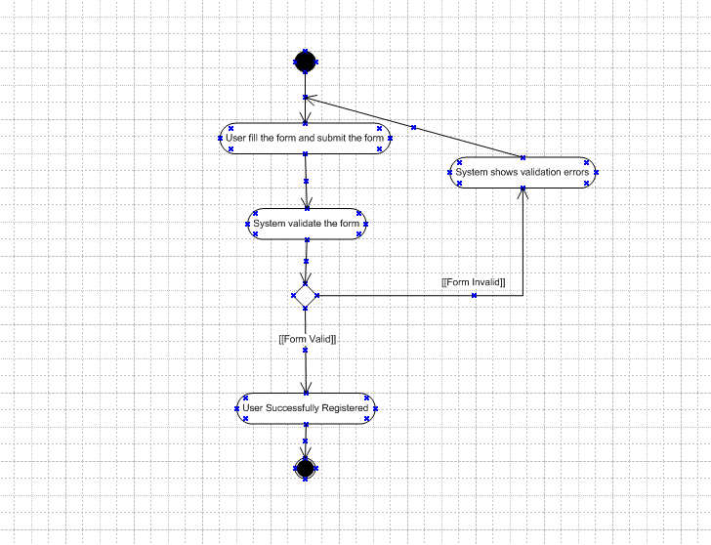

**User Login**

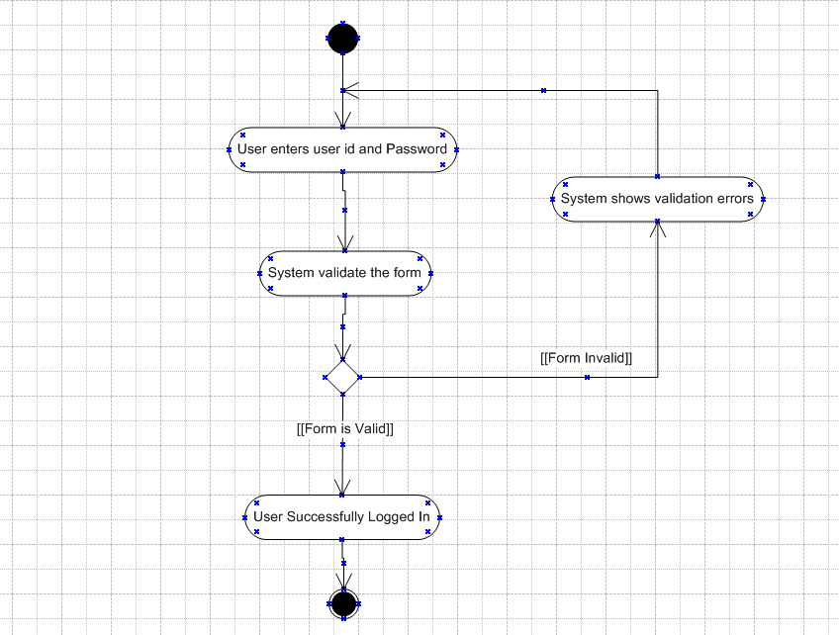

**Browse the product**

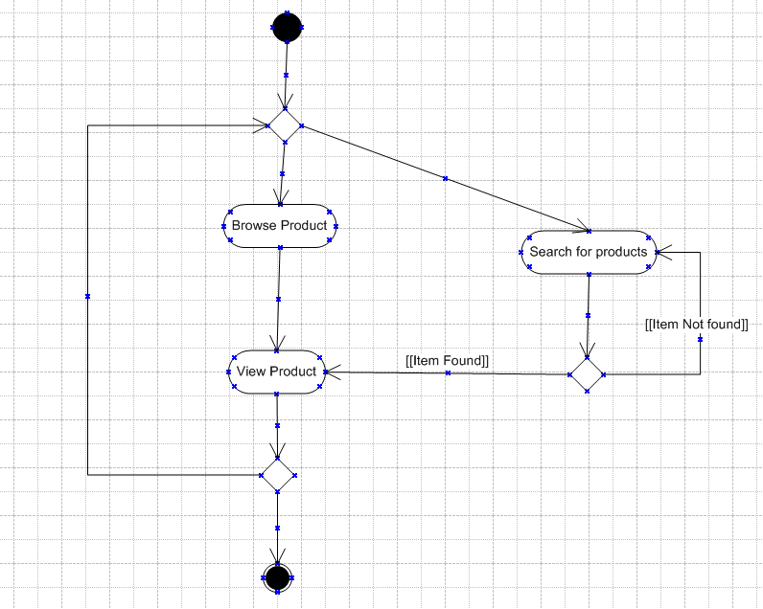

**Place Order**

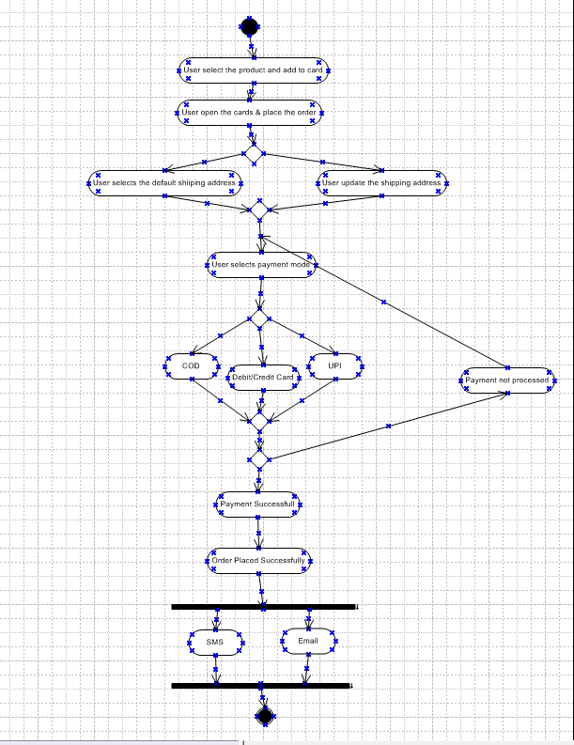

**Make payment**

