**Waterfall Project2 – Part -2/2**

**Question 1 Document 6**

Please prepare a use case diagram, activity diagram and a use case specification document.

**Answer**

*Use case diagram*

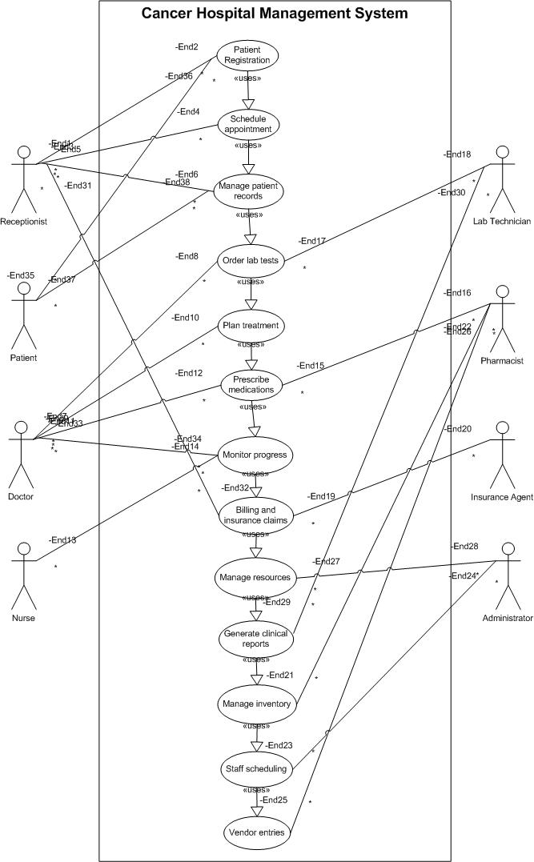

*Activity Diagram*

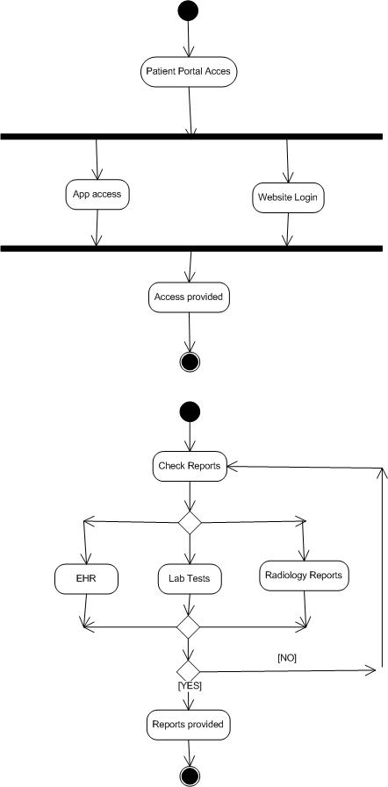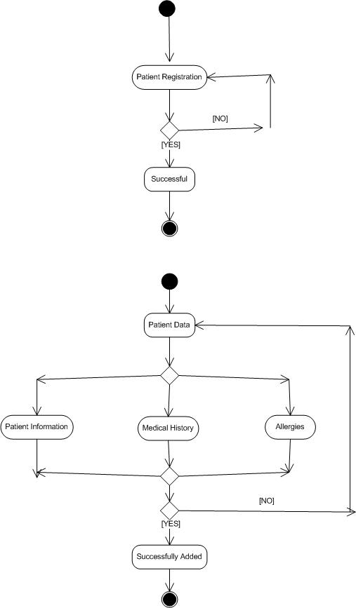

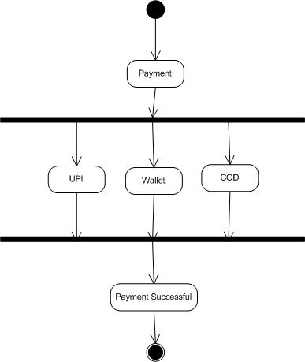

*Use Case Specification: Patient Registration*

1. Use Case Name

Patient Registration

2. Use Case Description

This use case describes the process of registering a new patient in the Cancer Hospital Management System. It includes capturing patient demographics, medical history, insurance information, assigning a unique patient ID, and scheduling the initial consultation with an oncologist.

3. Actors

*Primary Actors:*

- Registration Staff

- Patient

*Secondary Actors:*

- Insurance Verification System

- Electronic Medical Records (EMR) System

- Appointment Scheduling System

- Oncologist

4. Basic Flow

1. Patient arrives at the registration desk with required documentation

2. Registration staff initiates a new patient registration in the system

3. Registration staff enters patient demographic information (name, DOB, gender, contact details, address)

4. Registration staff enters patient's medical history including:

- Family history of cancer

- Previous cancer diagnoses and treatments

- Current medications

- Allergies

- Comorbidities

5. Registration staff captures insurance information

6. System validates insurance eligibility through integration with insurance verification system

7. System generates a unique patient ID

8. Registration staff collects required consent forms and uploads scanned copies to the system

9. Registration staff schedules initial consultation with appropriate oncologist based on cancer type/symptoms

10. System generates a patient information packet with hospital information, appointment details, and patient portal access instructions

11. System sends confirmation email/SMS to patient with appointment details

12. Registration staff provides the patient with physical copies of appointment details and patient information packet

5. Alternate Flows

*5.1 Patient is a Referral*

- At step 1, if patient is referred from another healthcare facility:

1. Registration staff enters referring physician information

2. System requests medical records from referring facility (if electronic sharing is available)

3. Resume at step 2 of basic flow

*5.2 Incomplete Documentation*

- At step 1, if patient has incomplete documentation:

1. Registration staff records available information

2. System flags the patient record as incomplete

3. Registration staff provides patient with list of required documentation

4. Patient is given provisional registration status

5. Resume at step 3 of basic flow

*5.3 Insurance Verification Failure*

- At step 6, if insurance verification fails:

1. System notifies registration staff of verification failure

2. Registration staff informs patient of verification failure

3. Registration staff provides patient with self-pay options or financial assistance programs

4. If patient agrees to proceed, resume at step 7 of basic flow

5. If patient cannot proceed, registration is saved as incomplete and process ends

6. Exceptional Flows

*6.1 System Failure During Registration*

1. If system crashes during registration:

1. System automatically saves data entered up to the point of failure

2. Registration staff informs IT support

3. Registration staff completes registration using paper forms

4. When system is restored, registration staff enters remaining information

5. Resume at appropriate step based on completion status

*6.2 Emergency Registration*

1. If patient requires immediate medical attention:

1. Registration staff initiates expedited registration process

2. System generates temporary patient ID

3. Only critical information is captured (name, DOB, emergency contact)

4. Patient is immediately directed to emergency oncology department

5. Complete registration is performed after patient is stabilized

7. Pre-Conditions

1. Registration staff has valid system credentials and appropriate access rights

2. System integration with insurance verification system is operational

3. Appointment scheduling system has up-to-date oncologist availability

4. Registration terminals are operational and connected to the hospital network

5. Patient has appropriate identification documents

8. Post-Conditions

1. Patient is successfully registered in the system with a unique patient ID

2. Patient has an initial consultation appointment scheduled

3. Patient record is accessible to authorized healthcare providers

4. Patient is registered in the patient portal system

5. Initial appointment is visible in the oncologist's schedule

9. Assumptions

1. Registration staff is trained in using the Cancer Hospital Management System

2. Patients can provide accurate personal and medical history information

3. Hospital has established protocols for different types of cancer cases

4. System has predefined templates for different cancer types

5. Hospital has sufficient oncologists to accommodate new patient appointments within a reasonable timeframe

10. Constraints

1. System must comply with HIPAA regulations for patient data privacy and security

2. Registration process should be completed within 30 minutes for standard cases

3. System must maintain 99.9% uptime during hospital operating hours

4. Patient data must be encrypted both in transit and at rest

5. System must support concurrent registration processes during peak hours

11. Dependencies

1. Integration with insurance verification system

2. Integration with electronic medical records system

3. Integration with appointment scheduling system

4. Integration with patient portal system

5. Integration with hospital billing system

6. Availability of scanning equipment for document digitization

12. Inputs and Outputs

*Inputs:*

1. Patient demographic information

2. Patient medical history

3. Insurance information

4. Referring physician information (if applicable)

5. Scanned identification documents

6. Scanned insurance cards

7. Signed consent forms

*Outputs:*

1. Unique patient ID

2. Patient information packet

3. Appointment confirmation

4. Patient portal access credentials

5. Registration confirmation in EMR system

13. Business Rules

1. All cancer patients must be assigned to an oncologist specializing in their specific cancer type

2. New patients must be scheduled for initial consultation within 5 business days

3. Patients with suspected aggressive cancers must be flagged for expedited appointments

4. All patients must sign informed consent for treatment and privacy forms

5. Insurance verification must be completed before finalizing registration

6. Patient IDs must follow the established format: YYYY-NNNNN-CC (Year-Sequential Number-Check Digits)

7. Complete medical history must be captured before initial consultation

8. Patients without insurance must be informed of financial assistance programs

14. Miscellaneous Information

1. This use case is part of the Patient Management module of the Cancer Hospital Management System

2. Future system enhancements will include integration with national cancer registries

3. The registration process will be reviewed quarterly for efficiency improvements

4. Patient satisfaction surveys regarding the registration process will be conducted monthly

5. Registration process metrics (time to complete, accuracy, patient satisfaction) will be tracked and reported

**Question 2 Document 7**

Screens and pages

**Answer**

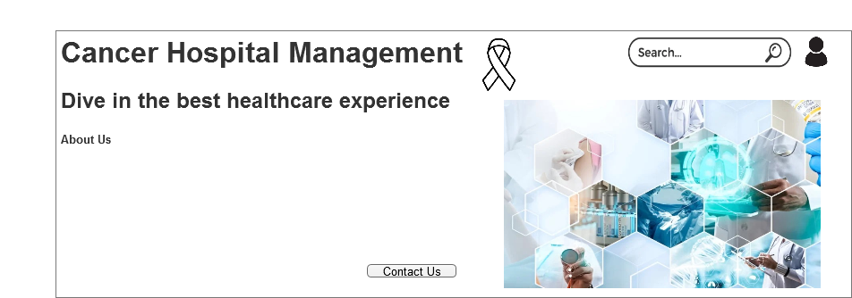

Home Page

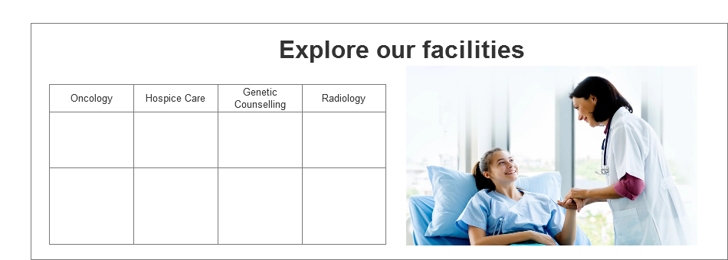Services

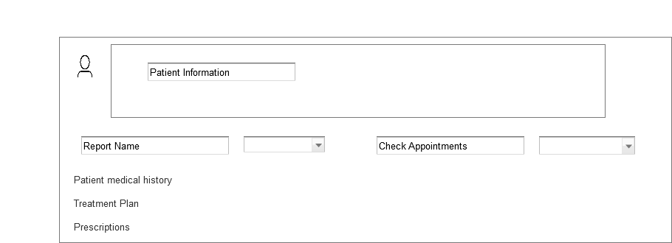Patient Portal

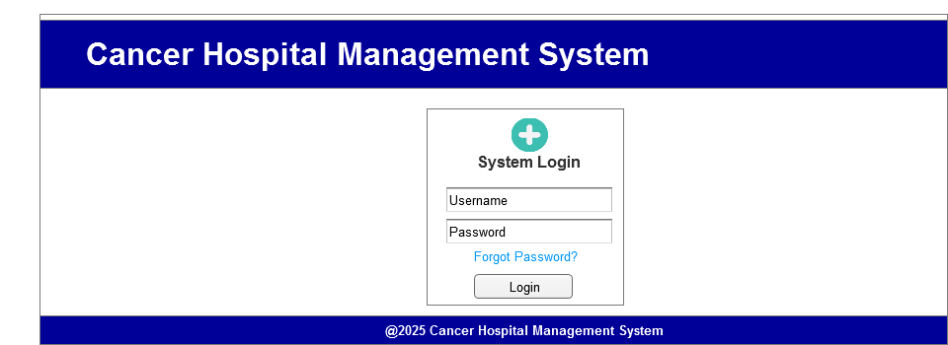Login Page

**Question 3 Document 8**

Tools Visio and Axure

**Answer**

In my experience working on the cancer hospital management system project using the waterfall model, both Visio and Axure proved to be invaluable tools with distinct strengths. Visio excelled at creating detailed use case diagrams, and activity diagrams during the requirements and design phases, providing clear visual documentation that stakeholders could easily understand and approve before development began. The tool's precision in creating standardized UML diagrams was particularly helpful when mapping out the complex relationships between various hospital departments and patient care workflows.

Meanwhile, Axure transformed our static wireframes into interactive prototypes that simulated the actual user experience, allowing me to test complex interactions for critical processes like patient registration, treatment plan management, and payment processing. The ability to create master components in Axure significantly streamlined my work when designing consistent UI elements across multiple screens.

The combination of both tools enables thorough document requirements and validate user interfaces before coding began, adhering to the waterfall methodology's emphasis on complete documentation and sequential development. This approach minimized costly changes during later development stages and ensured that the final system accurately reflected the detailed specifications we had meticulously documented.

**Question 4 Document 9**

BA Experience

**Answer**

My experience as a Business Analyst for the cancer hospital management system was both challenging and rewarding.

-During requirement gathering, I applied the MoSCoW technique to prioritize features and used FURPS for validation, though client unavailability periodically forced me to work with alternative stakeholders to maintain momentum.

-In the analysis phase, creating UML and activity diagrams proved invaluable for visualizing complex workflows specific to cancer care. When team members disagreed with certain aspects, I facilitated focused discussions to incorporate their insights, ultimately strengthening the solution architecture.

-The design phase involved translating requirements into detailed test cases and working extensively with clinical experts to create realistic test scenarios that accurately reflected oncology care complexities. Developing negative test cases proved particularly valuable for safety-critical features like medication management.

-During development, I found my role as translator between technical and clinical stakeholders to be crucial. JAD sessions helped resolve implementation challenges, though managing resistant team members required diplomatic one-on-one conversations to address underlying concerns.

-Testing demanded meticulous attention to healthcare-specific validation requirements, and I worked closely with oncology staff to obtain appropriate test data while continuously updating the RTM to ensure complete coverage.

-Throughout deployment, coordinating end-user training while accommodating hospital staff's demanding schedules was particularly challenging. Creating role-specific documentation and organizing multiple training sessions helped ensure successful adoption.

The waterfall methodology's structured approach proved appropriate for this healthcare project, where patient safety and regulatory compliance necessitated thorough documentation and systematic validation at each stage.