**Waterfall Model Documents**

**Document 6: Please prepare a use case diagram, activity diagram and a use case specification document.**

**USE CASE DIDGRAM**

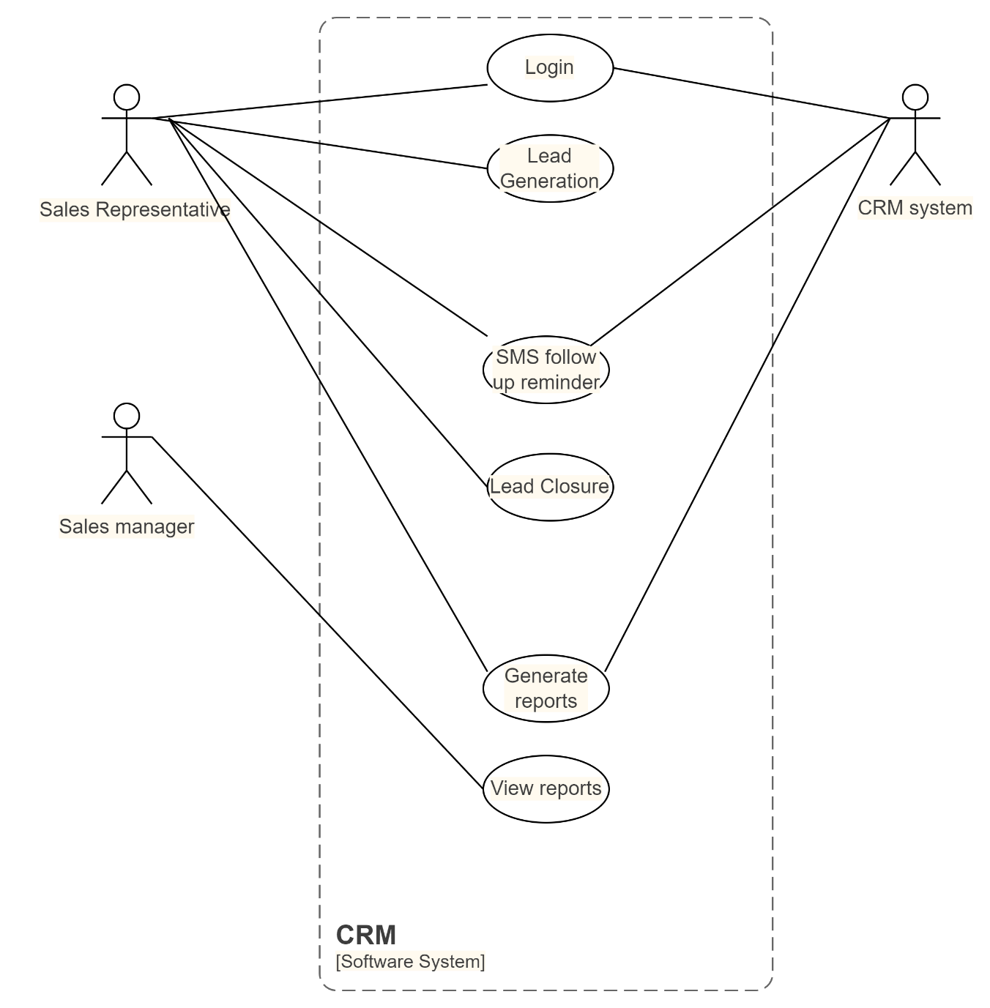

**ACTIVITY DIAGRAM**

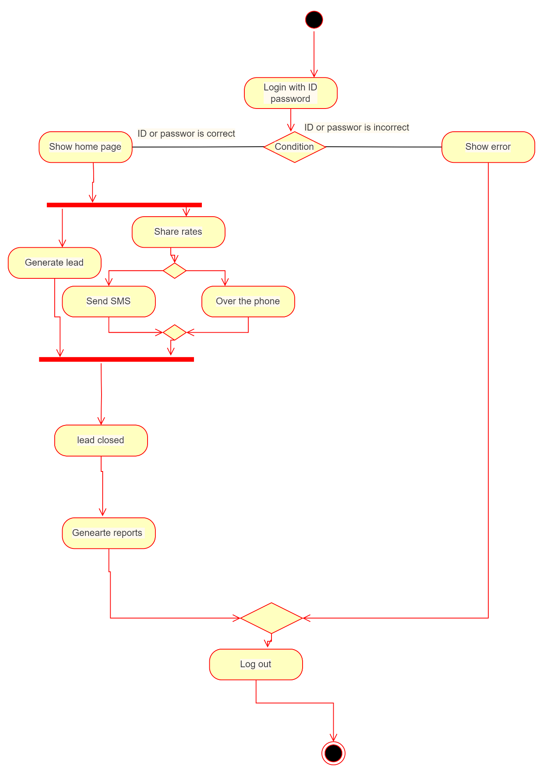

**Use case specification document.**

|  |  |
| --- | --- |
| **1. Use case Name** | **Login** |
| **2. Use case Description** | **User name and password** |
| **3. Actors Primary Actor** | **Sales Person** |
| **4. Secondary actors** | **CRM system** |
| **5. Basic Flow** | **User name and password are correct** |
| **6. ALTERNATE FLOW** | **User name or password is incorrect** |
| **7. Exceptional flows** | **Server is down** |
| **8. Pre- Conditions** | **Active internet** |
| **9. post-conditions** | **Home page is displayed after logging in** |
| **10. Assumptions** | **We assume that the user has the software knowledge** |
| **11. Constraints** | **User name cannot be numbers** |
| **12. Dependencies** | **Registration process** |
| **13. Inputs** | **User name and password** |
| **14. Outputs** | **Status flag** |
| **15. Business Rules** | **Username – valid and unique name (special characters allowed)**  **Password – 1 capital, 1 small, 1 special character, 1 number, last 5 passwords cannot be repeated, 8 to 16 characters** |
| **16.Miscellaneous Information** | **Browser compatibility** |

|  |  |
| --- | --- |
| **1. Use case Name** | **Lead Generation** |
| **2. Use case Description** | **Lead generation** |
| **3. Actors Primary Actor** | **Sales Person** |
| **4. Secondary actors** |  |
| **5. Basic Flow** | **Lead is generated** |
| **6. ALTERNATE FLOW** | **Incorrect lead is generated** |
| **7. Exceptional flows** | **Server is down** |
| **8. Pre- Conditions** | **Active internet** |
| **9. post-conditions** | **Details of the customer are displayed** |
| **10. Assumptions** | **We assume that the user has the software knowledge** |
| **11. Constraints** | **Wrong details entered by the customer** |
| **12. Dependencies** | **Registration process** |
| **13. Inputs** | **Lead request** |
| **14. Outputs** | **Status flag** |
| **15. Business Rules** | **Lead must have name and number of the customer** |
| **16.Miscellaneous Information** | **Browser compatibility** |
| **1. Use case Name** | **SMS Reminder** |
| **2. Use case Description** | **SMS** |
| **3. Actors Primary Actor** | **Sales Person** |
| **4. Secondary actors** | **CRM system** |
| **5. Basic Flow** | **SMS is sent to the customer** |
| **6. ALTERNATE FLOW** | **SMS is not sent to the customer** |
| **7. Exceptional flows** | **Server is down** |
| **8. Pre- Conditions** | **Active internet** |
| **9. post-conditions** | **Customer receives the SMS** |
| **10. Assumptions** | **We assume that the user has the software knowledge** |
| **11. Constraints** | **Incorrect customer number** |
| **12. Dependencies** | **Registration process** |
| **13. Inputs** | **SMS request** |
| **14. Outputs** | **Status flag** |
| **15. Business Rules** | **SMS must be 900 characters long only** |
| **16.Miscellaneous Information** | **Browser compatibility** |

|  |  |
| --- | --- |
| **1. Use case Name** | **Lead Closure** |
| **2. Use case Description** | **Lead is closed** |
| **3. Actors Primary Actor** | **Sales Person** |
| **4. Secondary actors** |  |
| **5. Basic Flow** | **Lead is closed after customer purchase the product** |
| **6. ALTERNATE FLOW** | **Lead is not closed because customer did not purchase the product** |
| **7. Exceptional flows** | **Server is down** |
| **8. Pre- Conditions** | **Active internet** |
| **9. post-conditions** | **Customer purchases the product, lead closed** |
| **10. Assumptions** | **We assume that the user has the software knowledge** |
| **11. Constraints** | **Customer have doubts** |
| **12. Dependencies** | **Registration process** |
| **13. Inputs** | **Lead status request** |
| **14. Outputs** | **Status flag** |
| **15. Business Rules** | **Lead closure** |
| **16.Miscellaneous Information** | **Browser compatibility** |

|  |  |
| --- | --- |
| **1. Use case Name** | **Generate Reports** |
| **2. Use case Description** | **Report to and from** |
| **3. Actors Primary Actor** | **Sales Person** |
| **4. Secondary actors** | **CRM system** |
| **5. Basic Flow** | **Reports are generated** |
| **6. ALTERNATE FLOW** | **Reports are not generated** |
| **7. Exceptional flows** | **Server is down** |
| **8. Pre- Conditions** | **Active internet** |
| **9. post-conditions** | **Reports are displayed** |
| **10. Assumptions** | **We assume that the user has the software knowledge** |
| **11. Constraints** | **Complex reports are not generated** |
| **12. Dependencies** | **Registration process** |
| **13. Inputs** | **Report request** |
| **14. Outputs** | **Status flag** |
| **15. Business Rules** | **Report must be in excel format and PDF** |
| **16.Miscellaneous Information** | **Browser compatibility** |

|  |  |
| --- | --- |
| **1. Use case Name** | **View Reports** |
| **2. Use case Description** | **Report to and from** |
| **3. Actors Primary Actor** | **Sales manager** |
| **4. Secondary actors** | **CRM system** |
| **5. Basic Flow** | **Reports are generated** |
| **6. ALTERNATE FLOW** | **Reports are not generated** |
| **7. Exceptional flows** | **Server is down** |
| **8. Pre- Conditions** | **Active internet** |
| **9. post-conditions** | **Reports are displayed** |
| **10. Assumptions** | **We assume that the user has the software knowledge** |
| **11. Constraints** | **Complex reports are not generated** |
| **12. Dependencies** | **Registration process** |
| **13. Inputs** | **Report request** |
| **14. Outputs** | **Status flag** |
| **15. Business Rules** | **Report must be in excel format and PDF** |
| **16.Miscellaneous Information** | **Browser compatibility** |

**Document 7- Screens and pages**

**Login Page**

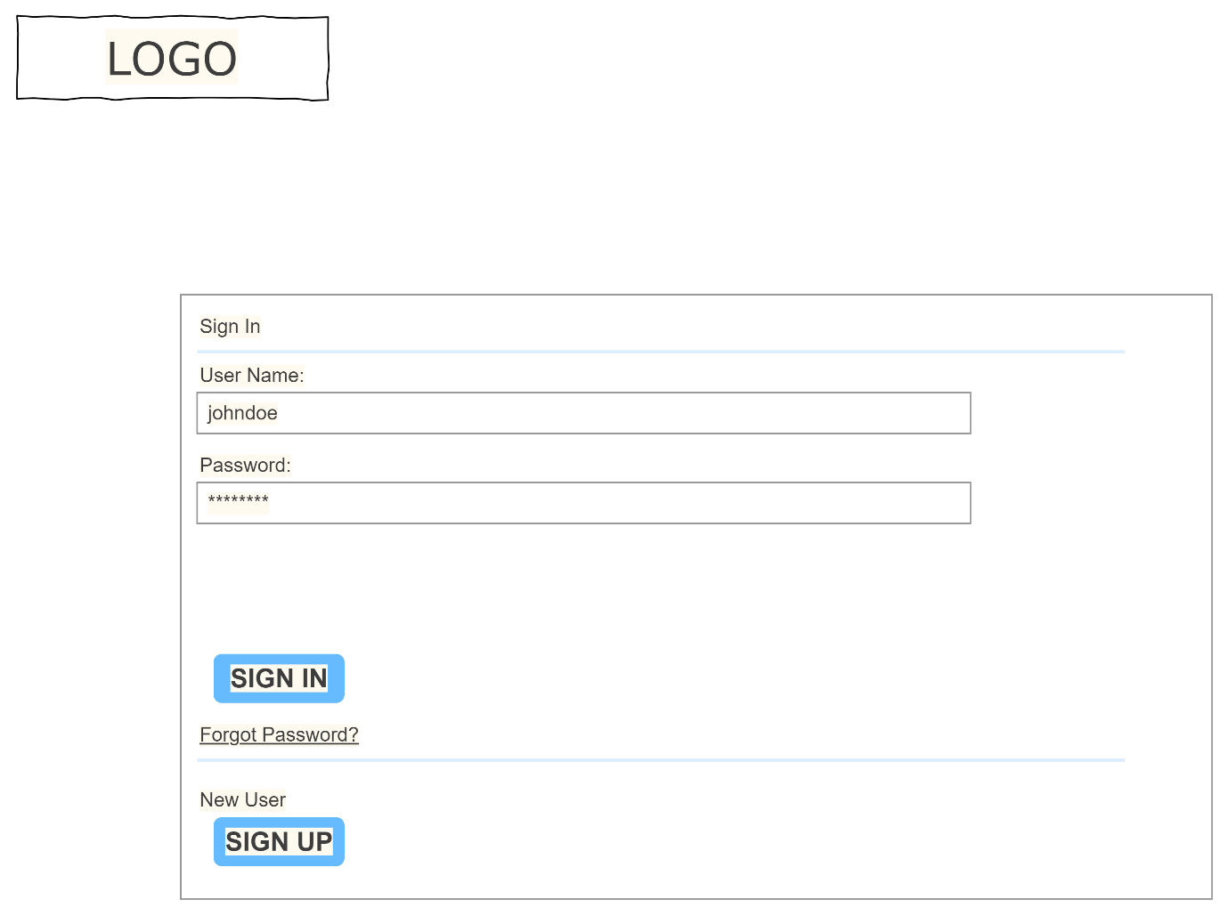

**Home page**

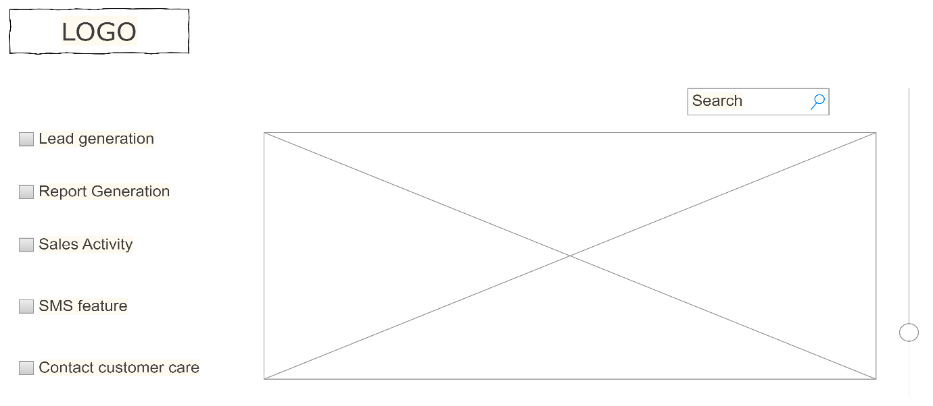

**Reports page**

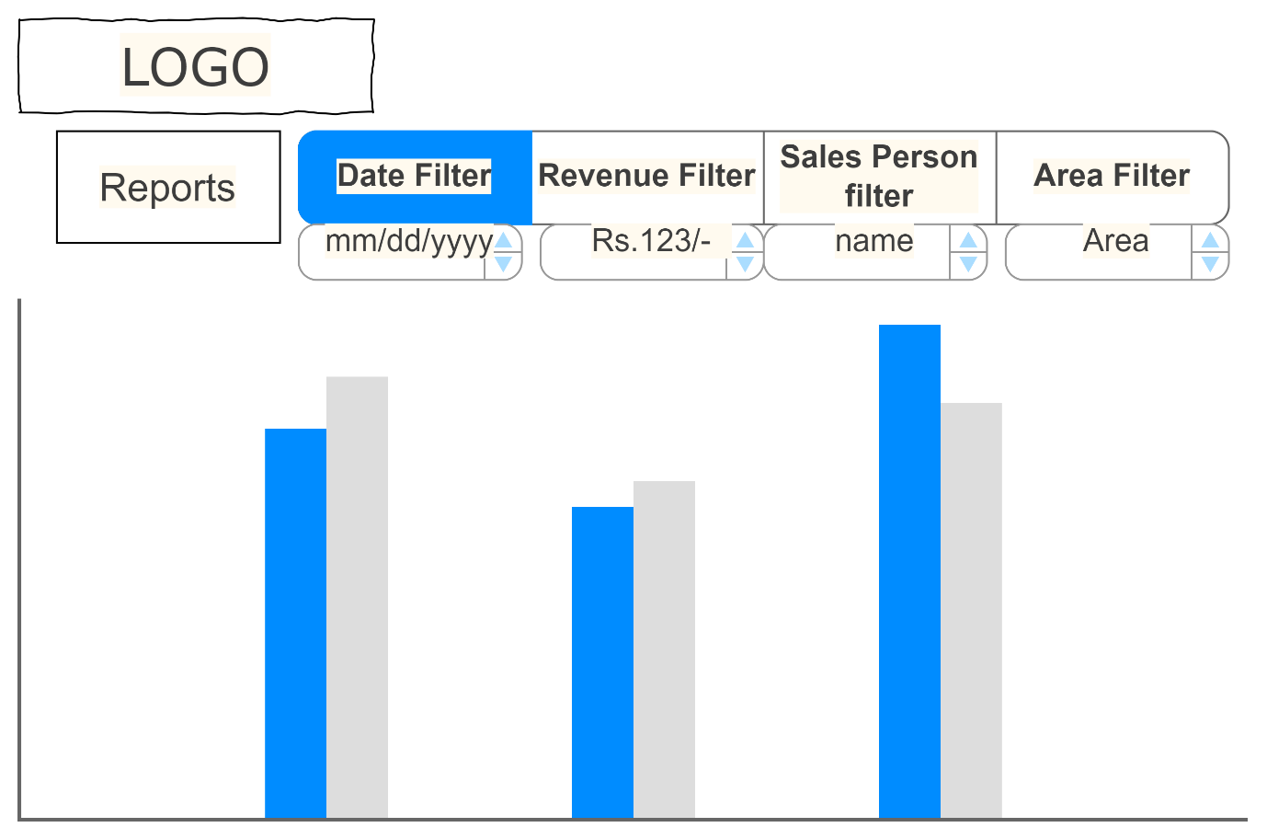

**Document 8- Tools-Visio and Axure**

My experience with both the tools Visio and Axure was good. Visio helped me to create detailed, multi-level diagrams and flowcharts. MS Visio helped me in creating the activity diagrams and the use case diagrams and present the stakeholders the visual representation of the process flow and user interaction.  It worked as a powerful tool for capturing and presenting ideas in a way that’s accessible and impactful. The drag and drop interface made my job much easier.

I used Axure primarily to create interactive prototypes of software applications, which helps them visually communicate design ideas, gather feedback from stakeholders early on in the development process, and validate requirements by simulating user interactions before any actual coding begins. This helped me to identify and address potential issues in the design phase, minimizing rework later in the project.

**Document 9- BA experience**

**1. Requirement gathering:**

● To gather requirements, we used brainstorming and interview technique.

● Client is not available for some period of time during this phase. So as a BA I

need to source out point of contacts from his side and get the information

ASAP.

● For validation of the requirement I used the FURPS technique which means the requirements attribute of functionality, usability, reliability, performance and supportability

● I used prototyping for stakeholders to get more clear idea of the requirements

**2. Requirement Analysis:**

● In analysis phase I drew various UML diagrams like use case diagram, activity diagram for the stakeholders to get a better idea about the requirements.

● After the preparation of the UML diagrams they were presented to the team and further discussion regarding the changes were made until the diagrams were finalised.

● Prepare BRS and SRS

**3. Design:**

● Test cases were prepared referring to the use case diagrams

● Communicate with client on design and solution documents

● Both negative and positive test cases were involved in the document.

● care had to be taken to not miss even a single test case as it would have huge impact on the future of the software

● I would further update the test case reference in the RTM software so that I can clearly know if the requirements validated were all met.

**4. Development:**

● Organized JAD sessions

● Technical team had issues understanding the requirements for which I acted as a intermediary and helped them for their next step of coding.

● I tried to maintain healthy environment amongst the team members as during the JAD sessions there were a lot of indifferences in the opinions of many.

● Referred diagrams to code the Unit

● communication between the technical team and the client was also necessary as the client had to understand the running of the software for which I conducted the meeting with both of them. Sometimes client was not available then I would record the meeting and then again discuss over the point with the client.

**5. Testing:**

● Prepare test cases from use cases was a very important task to be completed

● with the help of testing team we Performed high level testing

● Test data is requested by BA from client and updated RTM side by side

● further after all the above I had to Take signoff from client

● this was further followed by Preparation of client for UAT

**6. Deployment:**

● Further I Forwarded RTM to client which should be attached to project closure

Document after matching all the requirements from my side in the RTM.

● then I Coordinated with the technical team to complete and share end user manuals with the client as it was required by him to use the software.

● Once the product was deployed at the client’s place, I worked on Planning and organizing training sessions for the client to understand the product better

● Last meeting was very important meeting for which I made sure that all the attendees were present for the meeting.

***END***