# Business Requirements Document (BRD)

**Project Title**: Inventory and Delivery Management System for Dairy Products  
**Client**: Hatsun Agro Product Ltd  
**Prepared By**: Kumaran Dharmalingam  
**Date**: 03-04-2025

**1. Executive Summary**

The client, a dairy product manufacturing company with multiple plants and warehouses across the country, seeks to develop a centralized software solution to:

* Efficiently manage inventory of milk and ice-cream products
* Ensure the quickest delivery routes and fulfilment for customer orders

**2. Business Objectives**

* **Inventory Optimization**: Maintain optimal stock levels across all plants and warehouses.
* **Real-Time Tracking**: Enable visibility of product levels, expiry dates, and movement.
* **Delivery Efficiency**: Automate and optimize delivery scheduling to minimize time and cost.
* **Customer Satisfaction**: Ensure timely delivery with accurate order fulfilment.

**3. Scope of Work**

**In Scope**

* Centralized inventory management
* Order processing and fulfilment tracking
* Delivery route optimization (based on location, traffic, and availability)
* Integration with existing ERP or standalone functioning
* Mobile application for delivery staff
* Alerts for low stock, near expiry, delayed orders

**Out of Scope**

* Manufacturing process automation
* Accounting and HR modules (unless explicitly required)

**4. Key Features**

**Inventory Management**

* Stock management per warehouse and plant
* FIFO (First in First Out) handling for perishable products
* Barcode scanning for product tracking
* Expiry and batch management
* Inventory transfer between locations

**Order Management**

* Customer order capture (portal & mobile)
* Auto-allocation to nearest warehouse
* Order tracking & status updates

**Delivery Module**

* Route optimization using maps & real-time traffic
* Delivery personnel tracking
* Proof of delivery capture (digital signature/photo)
* Customer notification (SMS/Email)

**Reports & Dashboards**

* Daily inventory reports
* Delivery performance metrics
* Order fulfilment SLA adherence
* Stock ageing and expiry analysis

**5. Stakeholders**

| **Role** | **Responsibility** |
| --- | --- |
| Client Project Sponsor | Final decision-making, approvals |
| Operations Manager | Defines logistics requirements |
| IT Manager | Coordinates software integration |
| Development Team | Builds the solution |
| QA Team | Ensures quality of the product |

**6. Assumptions**

* Internet connectivity is available at all warehouses/plants.
* Delivery agents will use smartphones for app access.
* Data from existing systems will be available for migration if required.

**7. Constraints**

* Seasonal demand variations (Summer peak for ice-cream)
* Perishability of products requires fast delivery and accurate tracking
* Limited technical expertise in some warehouses

**8. Development Plan**

**Phase 1 – Requirement Gathering & Design (2 Weeks)**

* Stakeholder workshops
* Finalize system architecture and tech stack

**Phase 2 – Development (8 Weeks)**

* Inventory Management Module (3 Weeks)
* Order & Delivery Module (3 Weeks)
* Reporting & Notification System (2 Weeks)

**Phase 3 – Integration & Testing (3 Weeks)**

* ERP/Data migration if needed
* UAT with client teams

**Phase 4 – Deployment & Training (2 Weeks)**

* Production deployment
* Staff training and onboarding

**Phase 5 – Support & Maintenance (Ongoing)**

* 3 months post-deployment support

**9. Resource Plan**

| **Role** | **Count** | **Duration** | **Responsibility** |
| --- | --- | --- | --- |
| Project Manager | 1 | Full Project | Coordination, Reporting |
| Business Analyst | 1 | Phase 1–4 | Requirement gathering, client communication |
| Backend Developer | 2 | Phase 2–3 | API & database development |
| Frontend Developer | 2 | Phase 2–3 | UI for web and mobile |
| QA Engineer | 1 | Phase 3 | Testing and bug tracking |
| DevOps Engineer | 1 | Phase 3–4 | Deployment, CI/CD |
| Trainer | 1 | Phase 4 | Conducts user training |

**10. Estimated Budget**

A detailed cost estimate will be prepared based on technology choices and scope finalization. Initial ballpark:

* Development Cost: $45,000 – $60,000
* Infrastructure/Cloud: $500/month (approx.)
* Maintenance (Post Go-live): $1,000/month

**11. Success Criteria**

* Inventory discrepancy < 5%
* Delivery SLA adherence > 95%
* Uptime of system > 99.5%
* Positive feedback from delivery and warehouse users

Process Flow Diagram

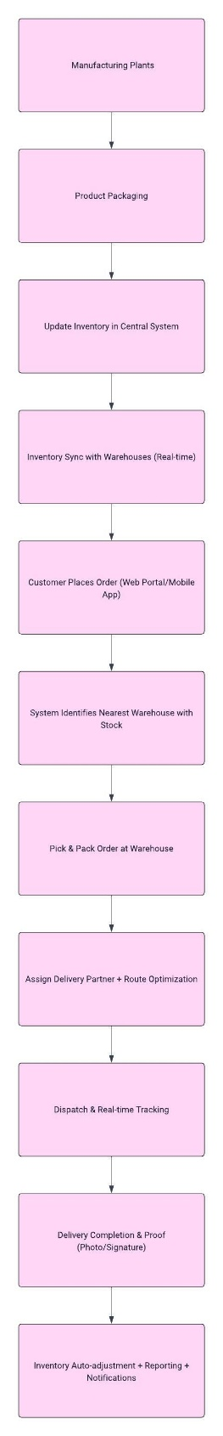

**Introduction Letter to a client to Understand the Business Process**

**Subject:** Introduction – Business Analyst Assigned to Your Project

Dear Arun(poc person),

I hope this message finds you well.

My name is Kumaran Dharmalingam, and I’m excited to introduce myself as the Business Analyst assigned to work with you and your team on the **Inventory and Delivery Management System** project. It’s a pleasure to be part of this engagement, and I’m looking forward to a productive collaboration.

As we begin this journey, my primary responsibility is to lead the **business understanding phase** — ensuring we gain a clear, in-depth view of your current operations around inventory management and delivery workflows. I’ll be working closely with your key stakeholders to gather requirements, identify operational pain points, and align our software solution with your long-term goals for efficiency, visibility, and customer satisfaction.

To kick things off, I’d like to propose a brief meeting where we can introduce teams, align on objectives, and map out the discovery process. This will also be a great opportunity for me to understand your priorities, expectations, and any existing systems or data you’d like us to consider.

Please feel free to suggest a convenient time for this discussion, or share any materials that would help us prepare ahead of time. I’m here to ensure this project runs smoothly and delivers real value to your operations.

Looking forward to working with you and your team.

Warm regards,  
Kumaran Dharmalingam  
Business Analyst  
Sagar Global systems  
+91-9281398375  
kumarandharmalingam@gmail.com

**Brief Business Requirements Document (BRD)** for **Online Store / eCommerce Platform**

**Business Requirements Document (BRD)**

**Project Title**: Online Store / eCommerce Platform  
**Prepared By**: Kumaran Dharmalingam  
**Date**: 04-04-2025

1. Executive Summary

This project aims to design and develop a scalable and user-friendly online store that allows customers to browse products, place orders, and make secure payments. The platform will support both desktop and mobile access, offering a seamless shopping experience. Vendors/admins will be able to manage product listings, inventory, and track sales from a centralized dashboard.

2. Business Objectives

* Enable customers to purchase products online with ease
* Offer a secure and reliable order and payment process
* Allow admin to manage product catalogue, orders, inventory, and promotions
* Provide sales insights and customer behaviour analytics for business growth
* Scale the platform to support new product categories and vendors

3. Key Stakeholders

| Role | Responsibility |
| --- | --- |
| Customers | Browse, purchase, track orders |
| Admin | Manage products, orders, inventory, and users |
| Vendors (optional) | Manage their own product listings and orders |
| Delivery Partners | Fulfil and deliver orders |

4. High-Level Requirements

* User registration, login, and profile management
* Product catalogue with categories, filters, and search
* Shopping cart and checkout process
* Secure payment gateway integration (e.g., Stripe, Razorpay)
* Order tracking and status updates
* Inventory and stock management
* Promotions and discount coupon engine
* Admin dashboard for product and order management
* Email/SMS notifications for order and delivery updates
* Optional: Multi-vendor support (Marketplace model)

5. Assumptions & Constraints

* Platform will support both web and mobile views
* Delivery logistics may be handled internally or via third-party APIs
* Product images and descriptions will be provided by the business team
* Payments must be PCI-DSS compliant

6. Success Criteria

* 95% of orders processed without support intervention
* Load time of less than 3 seconds per page
* 99.5% platform uptime
* Positive customer feedback and repeat orders within 3 months
* Increase in daily active users and monthly sales volume

**Software Requirements Specification (SRS)**

**Project Title**: Online Store / eCommerce Platform  
**Prepared By**: [Your Name]  
**Date**: [Insert Date]

**1. Introduction**

**1.1 Purpose**

This document outlines the functional and non-functional requirements for the development of a web-based **Online Store** that allows users to browse, purchase, and track products online while enabling admins to manage the backend operations efficiently.

**1.2 Scope**

The system will allow users to register, browse products, add items to their cart, make payments securely, and track orders. Admins can manage product listings, orders, inventory, and promotions. The system should be accessible via web browsers and optimized for mobile.

**1.3 Definitions**

* **SKU**: Stock Keeping Unit
* **Checkout**: Process of confirming and paying for products
* **Admin Panel**: Backend dashboard to manage the store

**2. Functional Requirements**

**2.1 User Module**

* Register and login using email, phone, or social logins
* View and edit user profile, address, and preferences
* Browse product categories and search by keyword or filter
* Add/remove items from the cart
* Apply coupon codes during checkout
* Make secure payments via integrated gateway
* View order history and track order status
* Rate and review purchased products

**2.2 Product & Catalogue Management (Admin)**

* Add, edit, delete product listings (name, image, price, stock)
* Assign products to categories and tags
* Manage SKUs and stock levels in real time
* Add promotional banners and homepage highlights

**2.3 Order Management**

* View all orders with status (Pending, Shipped, Delivered, Cancelled)
* Update order status and trigger notifications
* View customer invoices and delivery details

**2.4 Promotions & Coupons**

* Create and manage coupon codes (flat discount, percentage-based)
* Set expiry dates and usage limits

**2.5 Notifications**

* Email and SMS alerts for order placement, status updates, delivery
* Admin alerts for low stock and new orders

**2.6 Reports & Analytics**

* Sales reports by date/product/category
* Customer behaviour analytics
* Stock and inventory turnover reports

**3. Non-Functional Requirements**

| **Requirement** | **Description** |
| --- | --- |
| **Performance** | Page load time under 3 seconds |
| **Scalability** | System must support up to 10,000 concurrent users |
| **Availability** | 99.5% uptime expected |
| **Security** | Must comply with PCI-DSS for payment handling, use HTTPS, encrypted passwords |
| **Responsiveness** | Optimized for desktop, tablet, and mobile views |
| **Localization (optional)** | Multilingual and multi-currency support if needed in future |

**4. External Interfaces**

**4.1 Payment Gateway Integration**

* Integration with APIs like Phonepe,Gpay, Razorpay, or PayPal
* Handle transaction success/failure and update order status accordingly

**4.2 Delivery Partner Integration (Optional)**

* API to send shipment data and receive tracking info
* Auto-update order status from shipping API

**5. Assumptions & Constraints**

* Internet connection is required to use the platform
* Admin users must be assigned roles for controlled access
* Product content (images, descriptions) will be provided by the business team
* Initial deployment will be in a single region/language

**6. Future Enhancements *(Optional Section)***

* Wishlist and Save for Later functionality
* Chatbot for customer support
* Loyalty points and reward system
* Multi-vendor marketplace support

**ERD of Diagram for a support ticket/Ticketing life cycle**

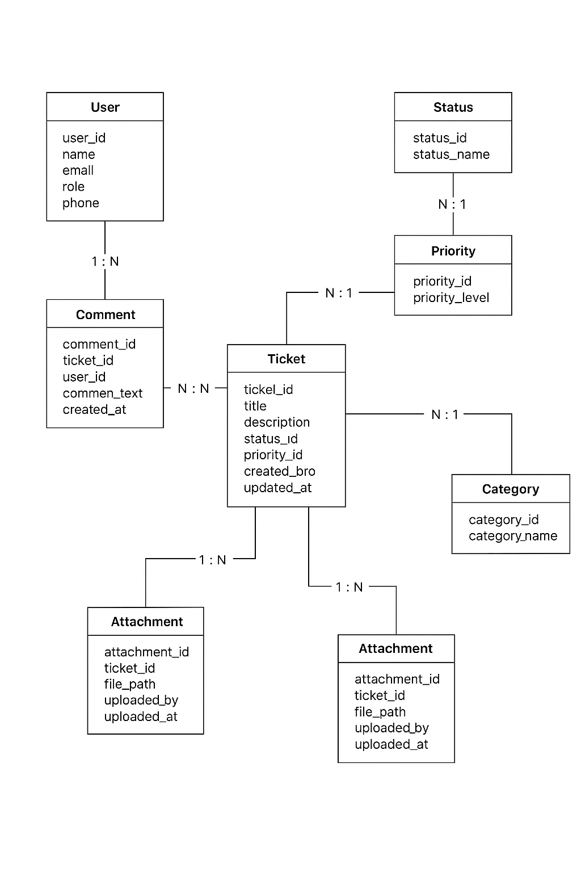

**1. User Registration & Login**

**As a** visitor,  
**I want to** register or log in to the eCommerce platform,  
**So that** I can access my profile, track orders, and shop securely.

*Acceptance Criteria*:

* User can register via email/phone/social login.
* User can log in and log out securely.
* Password reset functionality is available.

**2. Product Browsing & Search**

**As a** shopper,  
**I want to** browse or search for products by category, filters, or keywords,  
**So that** I can easily find what I’m looking for.

*Acceptance Criteria*:

* Categories and subcategories are clearly listed.
* Filter and sort options (e.g., price, brand, rating).
* Search bar supports autosuggestions.

**3. View Product Details**

**As a** shopper,  
**I want to** view detailed information about a product,  
**So that** I can decide whether to purchase it.

*Acceptance Criteria*:

* Product images, description, price, availability shown.
* Size/colour options (if applicable).
* Customer ratings and reviews displayed.

**4. Add to Cart**

**As a** shopper,  
**I want to** add products to my shopping cart,  
**So that** I can continue browsing and purchase multiple items together.

*Acceptance Criteria*:

* Product added to cart with correct quantity and variation.
* Cart icon updates in real-time.
* Cart is persistent across sessions.

**5. View and Modify Cart**

**As a** shopper,  
**I want to** view, update, or remove items from my cart,  
**So that** I can manage my purchase list before checkout.

*Acceptance Criteria*:

* User can increase/decrease quantity or remove items.
* Total amount reflects all changes.
* Option to apply coupons or promo codes.

**6. Checkout & Delivery Address**

**As a** shopper,  
**I want to** enter or select a delivery address during checkout,  
**So that** my order is shipped to the correct location.

*Acceptance Criteria*:

* Existing addresses shown.
* User can add/edit/delete addresses.
* Address validation is in place.

**7. Payment**

**As a** shopper,  
**I want to** pay for my order using secure and flexible payment options,  
**So that** I can complete the purchase securely.

*Acceptance Criteria*:

* Multiple options available (Card, UPI, Net Banking, COD).
* Payment gateway integration is secure.
* Payment success/failure is handled gracefully.

**8. Order Confirmation & Notification**

**As a** shopper,  
**I want to** receive an order confirmation,  
**So that** I know my order has been successfully placed.

*Acceptance Criteria*:

* Order summary displayed.
* Email/SMS confirmation sent.
* Order number generated.

**9. Order Tracking**

**As a** shopper,  
**I want to** track my order status,  
**So that** I know when to expect delivery.

*Acceptance Criteria*:

* Real-time status updates (Processing, Shipped, Out for Delivery, Delivered).
* Tracking number and courier link provided.

**10. Product Delivery**

**As a** shopper,  
**I want to** receive my product at my delivery address,  
**So that** I can start using it.

*Acceptance Criteria*:

* Delivery confirmation and signature (if required).
* Delivery status updated in user profile.