**Requesting For Tools Installation**

I Pratik Jadhav enrolled for Business Analyst Training with COEPD, hereby voluntarily declare that, I completed BA Workshop sessions. I request COEPD to support me in installing the tools in my system. I understood that,

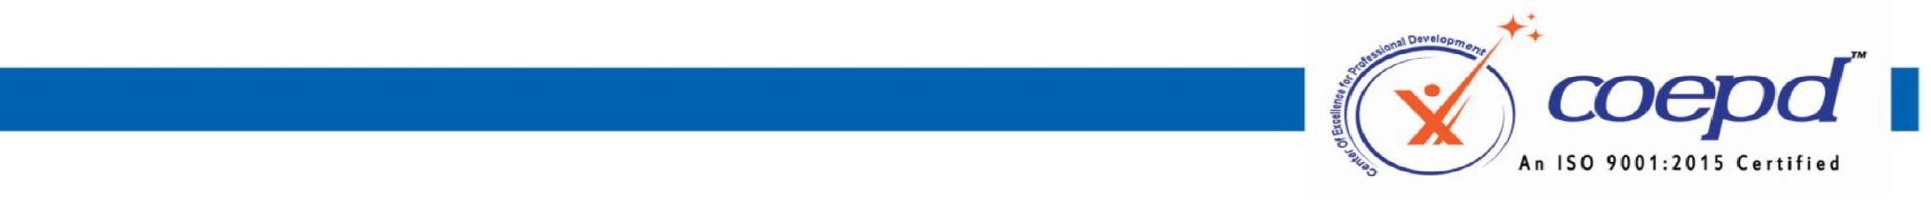MAC, Linux etc.,



1.

Tools

Installation

will

done

only

one

time

through

Coepd

portal.

In

case

of

losing

application

from

system,

Coepd

is

not

responsible

for

re-installation.

2.

Tools

installation

support

is

complementary

to

the

training

3.

COEPD

is

not

liable

for

any

damages

caused

during

the

installation

process

4.

These

Tools

are

Trail

Versions

and

works

during

the

trial

period

only.

5.

COEPD

will

install

the

tools

only

in

the

OS

supported

by

Microsoft,

and

will

not

be

responsible

for

the

other

OS

’

s

like

6.

Aspirant

should

buy

the

actual

license

after

the

expiry

of

trail

period.

Signature of the student:



Name of the Student: Pratik Jadhav

Batch Start date:08/02/2025 Request Date: 03/03/2025



3rd Floor, Sahiti Arcade, Beside S.R. Nagar Police Station, S.R. Nagar, Hyderabad - 500038

www.coepd.cominfo@coepd.com