E Vishnu

 +91-8197944543

 [chachovishnu007@gmail.com](mailto:chachovishnu007@gmail.com)

 #37, 8th main, 11th cross, Hoyasala nagar, Bengaluru- 560016

# SUMMARY

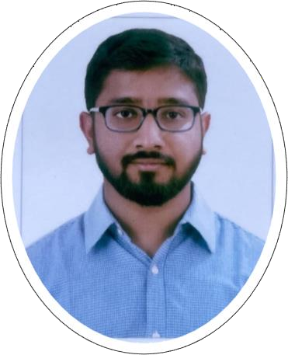

A seasoned banking professional with 7+ years of experience in the field of export LC advising and trade finance department.

Offering strong abilities in handling multiple tasks simultaneously and delivering them on time.

# SKILLS

* Risk management
* Microsoft Excel, Word, and Power Point
* Trade execution.
* Trading concepts.
* Relationship development

# ACCOMPLISHMENTS

* Rewards & Recognition for sustainable employee at Deutsch Bank 2023

# CERTIFICATIONS

* Trade Finance Certification Course at Deutsch Bank, 2023

# LANGUAGES

* English and Hindi: Full Professional Proficiency
* Telugu, Tamil, Kannada: Speaking proficiency.

# PERSONAL

* DoB: 09-March-1995
* Marital status: Unmarried

# EXPERIENCE

March 2022 – Current

**Senior Analyst, Deutsch Bank** | Pune, India

* Worked in trade finance and lending department handling collections product (import & export) for a year.
* Upgraded to handling **Export LC advising** product.
* Managing and training team of new graduates.

June 2020 – Feb 2022

## Assistant Manager, Axis Bank | Bengaluru, India

* Trade financing in branch banking under Exports team for corporate clients or Credit clients
* I support Inward remittance for exports, LC bill collection/ Negotiation, Export bill Discounting (Pre to Post shipment), EDPMS clearance.

September 2016 – June 2020

## Assistant Manager, IndusInd Bank Ltd | Bengaluru, India

* Started as contract staff working in Cash Management Services (CMS), processing RTGS & NEFT for corporate clients.
* In 2017, became full time employee and worked at Cheque clearing house (GBO) handling outward cheque whole of the IBL Bengaluru branches.
* Since 2019 worked in Trade financing department as operational service executive for the emerging corporate clients. Import collection bills, Export bills, Processing Bill of Entry and Shipping bill for outwards and inwards made giving the clients the best service in handling and coordinating with central processing team for the transactions to take place in extremely fast, easy, and seamless manner.

# EDUCATION

2016

Sri Shakthi Institute of Engineering and Technology | Coimbatore, Tamil Nadu

## Bachelor of Engineering: Mechanical Engineering

CGPA: 7.82 /10

2012

Vision PU College | Bengaluru, Karnataka **HSC (Higher Secondary Certificate)** Percentage: 82 /100