Online Agriculture Products Store

Mr. Henry, after being successful as a businessman and has become one of the wealthiest persons in the city. Now, Mr. Henry wants to help others to fulfil their dreams. One day, Mr. Henry went to meet his childhood friends Peter, Kevin and Ben. They live in a remote village and do farming. Mr. Henry asked his friends if they are facing any difficulties in their day-to-day work. Peter told Mr. Henry that he is facing difficulties in procuring fertilizers which are very important for farm. Kevin said that he is also facing the same problem in-case of buying seeds for farming certain crops. Ben raised his concern on lack of pesticides which could help in greatly reducing pests in crops.

After listening to all his friends’ problems, Mr. Henry thought that this is a crucial problem faced not only by his friends but also by so many other farmers. So, Mr. Henry decided to make an online agriculture product store to facilitate remote area farmers to buy agriculture products. Through this Online Web / mobile Application, Farmers and Companies (Fertilizers, seeds and pesticides manufacturing Companies) can communicate directly with each other.

The main purpose to build this online store is to facilitate farmers to buy seeds, pesticides, and fertilizers from anywhere through internet connectivity. Since new users are involved, Application should be user friendly.

This new application should be able to accept the product (fertilizers, seeds, pesticides) details from the manufacturers and should be able to display them to the Farmers. Farmers will browse through these products and select the products what they need and request to buy them and deliver them to farmers location.

Mr. Henry has given this project through his Company SOONY. In SOONY Company, Mr Pandu is Financial Head and Mr Dooku is Project Coordinator. Mr. Henry , Mr Pandu , and Mr Dooku formed one Committee and gave this project to APT IT SOLUTIONS company for Budget 2 Crores INR and 18 months Duration under CSR initiative. Peter, Kevin and Ben are helping the Committee and can be considered as Stakeholders share requirements for the Project.

Mr Karthik is the Delivery Head in APT IT SOLUTIONS company and he reached out to Mr Henry through his connects and Bagged this project. APT IT SOLUTIONS company have Talent pool Available for this Project. Mr Vandanam is project Manager, Ms. Juhi is Senior Java Developer, Mr Teyson, Ms Lucie, Mr Tucker, Mr Bravo are Java Developers. Network Admin is Mr Mike and DB Admin is John. Mr Jason and Ms Alekya are the Tester. And you joined this team as a BA.

# Question 1 – Functional Requirements:

Functional requirement defined the specific functionality of the system.

Business requirements are high level requirements whereas functional requirements talk about specific functionality. Business requirements are gathered from Users, Business owners, Project sponsors etc. Functional requirements are discussed with IT team.

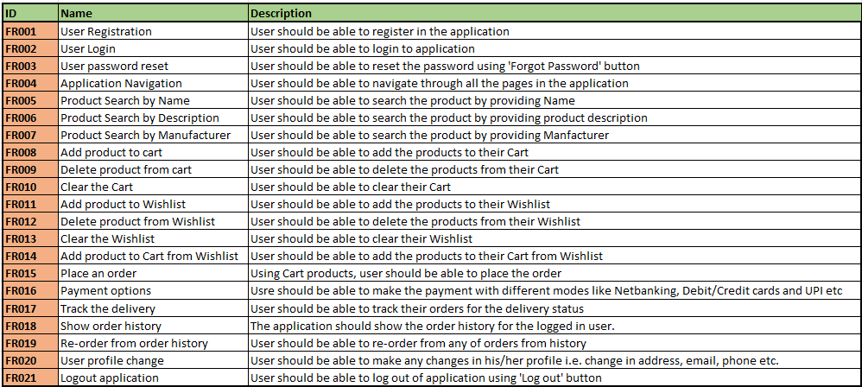

Non-Functional Requirements – These requirements describe the qualities and attributes of the system …and not the functionality.

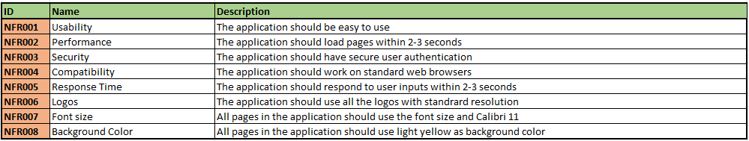

# Question 2 –: Prepare 5 wireframes

User Registration:

User Login:

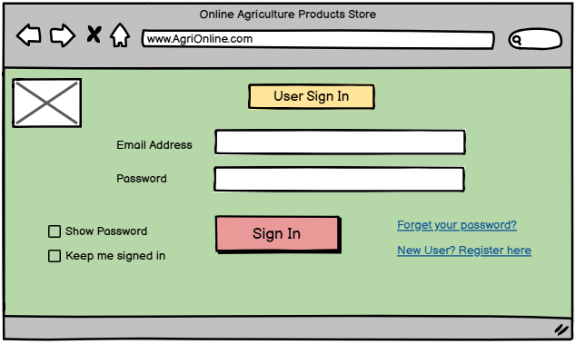

Product Search:

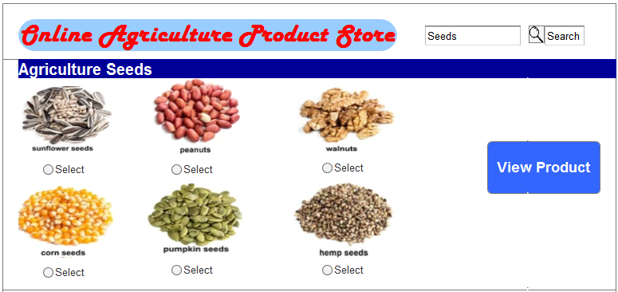

Add product to Cart:

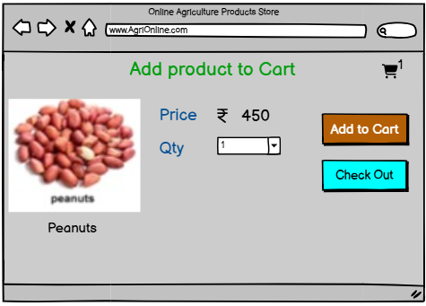

Make Order Payment:

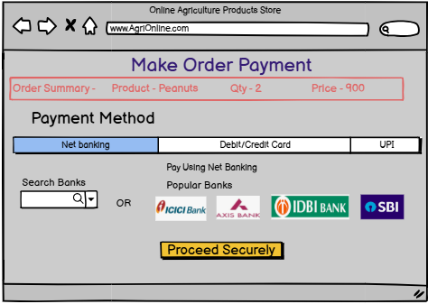

# Question 3 – Tools (Visio, Balsamiq)

**Microsoft Visio –** It is a diagramming application used to create flowcharts, use case and activity diagrams. It provides various shapes like Rectangle, Circle, Arrows etc. It also provides basic flowchart shapes. It has got UML section to get the shapes needed for use case and activity diagrams like Use Case, Actor, Relations (Use, Extend).

**Balsamiq** – It is a wireframing tool used to create mock-ups and prototypes for user interfaces. This tool helps BA in modelling the requirements i.e. changing the requirement into visual representation. It is a drag and drop tool. It has various widgets to represent the different symbols like Web page, Title, Images etc. It also provides facility to create links among different pages.

**Axure** - It is a more advanced prototyping tool used to create interactive wireframes for user interfaces. It is mainly used in design phase of SDLC to model the requirements. In Widgets section there are various shapes (like Image, Heading, Text etc) to design the page. It has also got the Master section to copy the design of one wireframe to multiple pages. We can add links to other pages in the wireframe and also give URLs to images.

Difference between Wireframes, Mock ups and Prototypes –

Wireframe is basic skeleton outline of design. It focusses on layout and functionality…. Not visual details.

Mocks ups are more detail visual re-presentation of design with elements like Colour etc. It gives the realistic impression of product.

Prototypes is more interactive of design. It allows user to know the interfaces.

# Question 4 – Requirement Traceability Matrix (RTM)

RTM is a document to track the requirements throughout the project. It also ensures that all requirements are complete, and no requirement is missed/skipped. At any point of time, it gives the summary about status of all the requirements to be informed to all stakeholders.

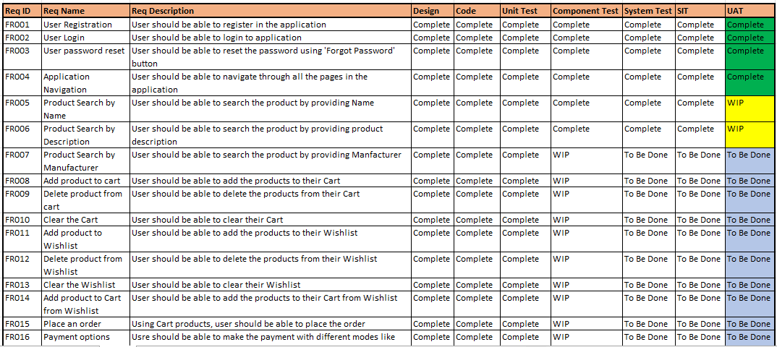

# Question 5 – Test Case Documents

Test case document contains various scenarios those will be tested by testers to test the particular functionality and ensure that it is working as expected. It is detail description of test that is performed on software application. It acts as guidebook for testers.

Any violation from expected result is treated as bug.

1) Test Case document for User Registration:

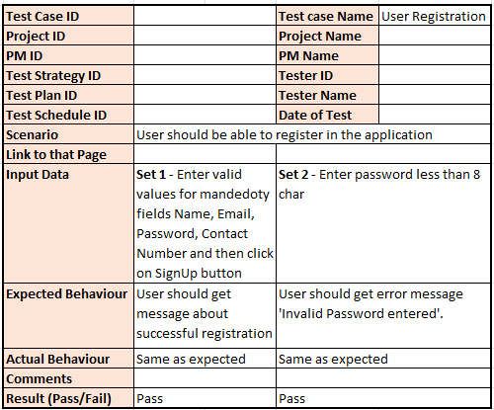

2) Test Case document for User Login:

3) Test Case document for User password reset:

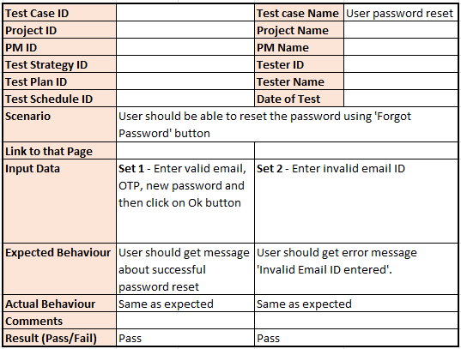

4) Test Case document for Product Search by Name:

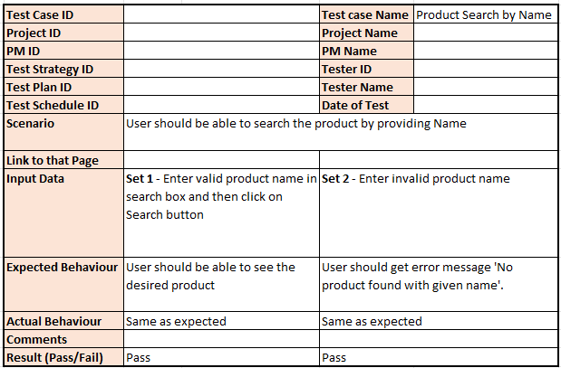

5) Test Case document for Product Search by Description:

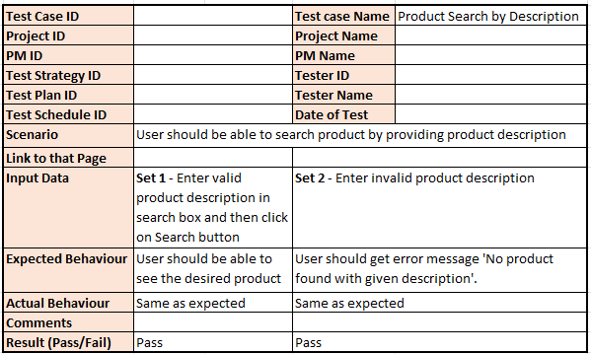

6) Test Case document for Product Search by Manufacturer:

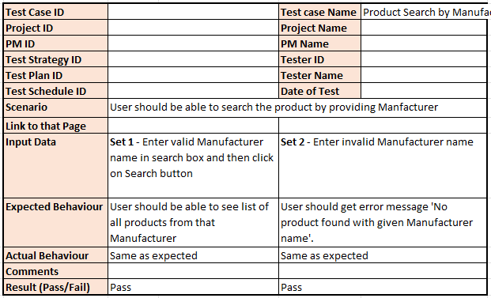

7) Test Case document for Add product to cart:

8) Test Case document for Clear the Cart:

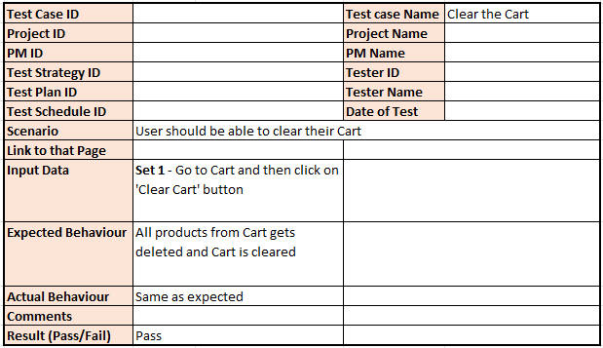

9) Test Case document for Place an order:

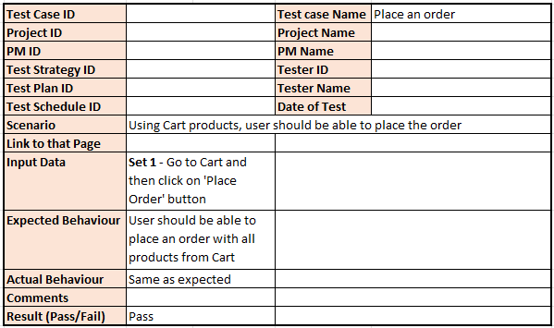

10) Test Case document for Payment option Net Banking:

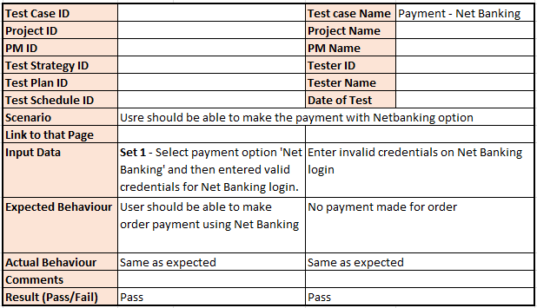

# Question 6 – DB Design

**DB schema** is blueprint of structure of database that includes tables, fields, relationships etc.

**Entity-Relationship diagram** is visual representation of relationship between the entities in database. It shows the entities (like tables), attributes (like fields) and relation between them.

Primary and Foreign keys.

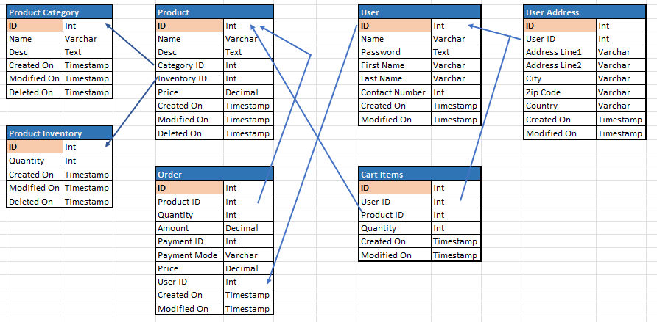

# Question 7 – Data Flow Diagram

Data Flow Diagram (DFD) is a graphical representation of flow of data within a system. It shows how data moves between the processes and where it is stored. It helps Analysts/Designers to understand the flow of data.

1.0 Registration – In this process data flows between user and user master database. On screen, when user enter values for all the fields and click on ‘Submit’ button, the data flows from user to user-master database. Once registration is done, the registration ID comes back from database and shown to user.

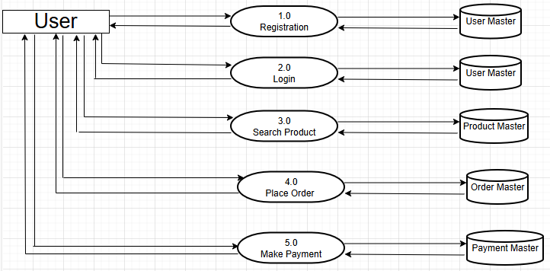

# Question 8 – Change Request

Change Request is a formal proposal to make changes in the earlier gathered requirements of the product/application.

As BA, I would take following steps to handle the change request:

* Understand the scope of change request and document it.
* Determine the impact of this change request on things like Schedule, Budget, Resources, Risks etc.
* Prioritize change request based on its urgency, importance, impact on business etc.
* Seek the approval for change request from the concern stake holders like Project Sponsor.
* Communicate the change request and its impact to all relevant stake holders.
* Handover the change request to project team for implementation.

# Question 9 – Change Request Vs an Enhancement

Difference between Change Request and Enhancement:

* Enhacement is adding new functionality/requirement in the product. Change request is modification to existing requirement.
* The size of enhancement is mostly larger than size of typical change request

In given problem statement, since client wants to add new functionality/feature of selling their crop yields through this application ….**this is new requirement and hence needs to be treated as Enhancement**.

As a BA, before giving any response to client on this enhancement, I would do follosing:

* Work with design/development team to determine the feasibility and impact of new requirement.
* Determine potential Cost to complete the enhancement and what benefit Client/User will have with this enhancement.

# Question 10 – Estimations

The estimations are typically done in Manhours. Manhours are the required effort of resources to complete a project.

There are 3 types of projects:

* Small – Up to 500 hours
* Medium - Up to 1000 hours
* Large – More than 1000 hours

Below is the calculation of manhours for the given case study.

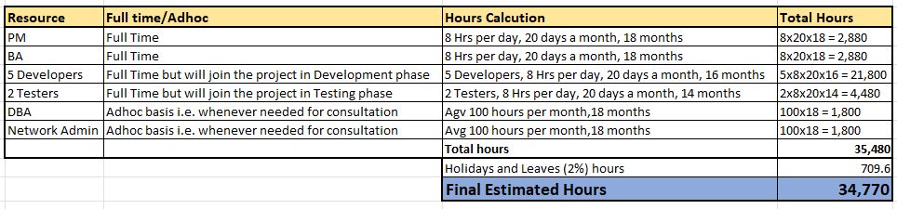

# Question 11 – UAT Acceptance process

User Acceptance Testing is done with below steps:

* **Planning** – In this step planning to conduct UAT is done. The blueprint for each feature to be tested is made available. Also the acceptance criteria for each feature is determined.
* **Designing** – Test cases are designed to test each feature in all possible ways. All positive and negative scenarios are considered.
* **UAT Testers** – These are the end users testing the application/product. They should know how to run the test cases and also need to understand the functionality of the application.
* **Bug Fixing** – If there are any bug reported during the UAT, the development team should fix all those bugs and make the application error free.
* **Signoff** – After removing all the bugs reported earlier, the testing team confirms that the UAT is complete, and application/product is accepted. Then all the stakeholders come to conclusion that application is ready to Go Live and sign it off for production deployment.

# Question 12 – Project Closure Document

Project closure document is a formal document that is prepared while closing the project. It summarizes things like Achievements, lesson learnt, challenges, technical stack used etc. This document serves as comprehensive record of project details that can be referred by future projects.

Below points are normally included in project closure document:

* Project Requirement Overview
* Achievements
* Lesson learnt
* Technical Stack used
* Challenges faced
* Quality Assurance process
* Resource Utilization
* Risks Management

Sample report:

