**Nurturing Process - Capstone Project 1 – Part 3/3**

Online Agriculture Product Store

**Question 1 Functional Requirements**

Identify minimum 20 functional requirements

**Answer**

Functional requirements define the specific behaviours, functions, or operations of a system. They describe what the system should do, outlining the necessary tasks, actions, or activities it must perform to achieve its objectives.

|  |  |  |
| --- | --- | --- |
| **Req ID** | **Requirement Name** | **Requirement Description** |
| FR001 | Farmer Registration | Farmers should be able to register with basic details and location information |
| FR002 | Farmer Search for Products | Farmers should be able to search for available  products in fertilizers, seeds, pesticides |
| FR003 | Add New Product | Manufacturers must be able to add new product listings with details, pricing, and availability |
| FR004 | Product Details | Farmers should be able to view detailed product specifications and usage instructions |
| FR005 | Add to cart | Farmers must be able to add products to shopping cart |
| FR006 | Unique Order ID | System must generate unique order ID for each transaction |
| FR007 | Delivery Specifications | System should allow farmers to specify delivery location and preferred delivery date |
| FR008 | Track Order | Farmers should be able to track order status in real-time |
| FR009 | Payment Invoice | System should generate payment confirmation and invoice |
| FR010 | Payment Options | System must support multiple payment methods including online and cash on delivery |
| FR011 | Order Confirmation | System should send order confirmation and updates via SMS/email |
| FR012 | Feedback | Farmers should be able to rate products and provide feedback after purchase |
| FR013 | Notifications | System should send delivery notifications to farmers |
| FR014 | Delivery Charges | System must calculate delivery charges based on location and order weight |
| FR015 | Add Filters | System must provide filtering options based on price range and product type |
| FR016 | Inventory Tracking | System should maintain real-time inventory tracking for all products |
| FR017 | Page Loading Time | Each Page should load within 2 seconds time |
| FR018 | Update Product Information | Manufacturers should be able to update/modify existing product information |
| FR019 | Manufacturer Registration | Manufacturers should be able to register as verified sellers on the platform |
| FR020 | Mobile device compatibility | System should be compatible with all types of mobile devices |

**Question 2 Minimum 5-page designs**

Make wireframe and prototypes

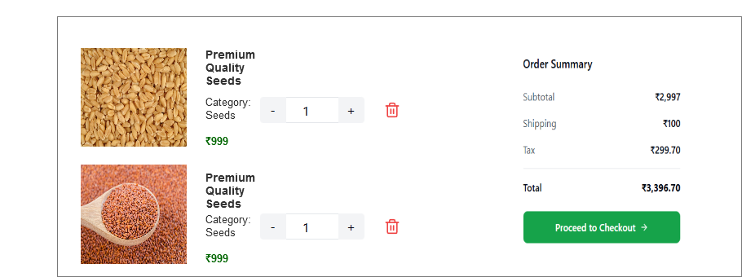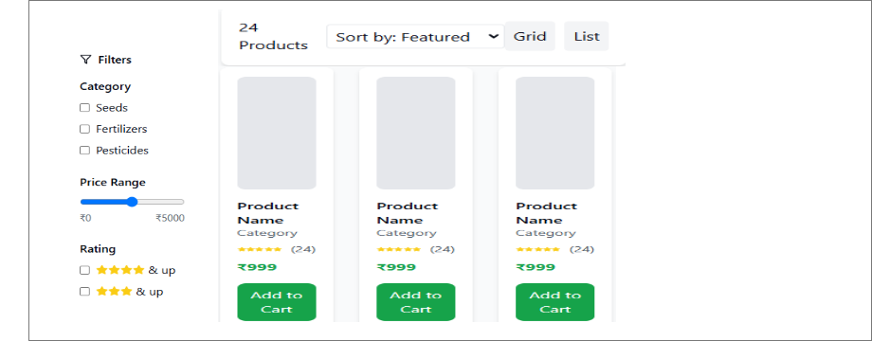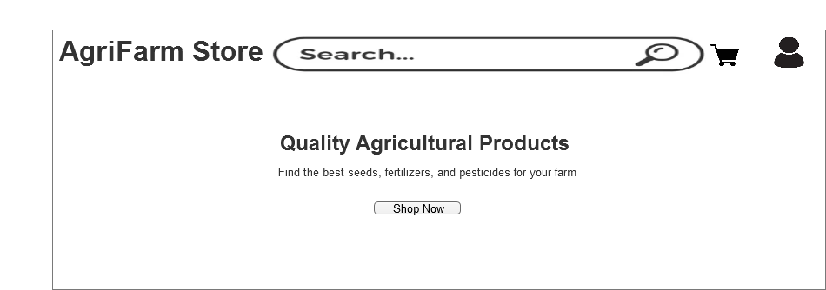**Answer**

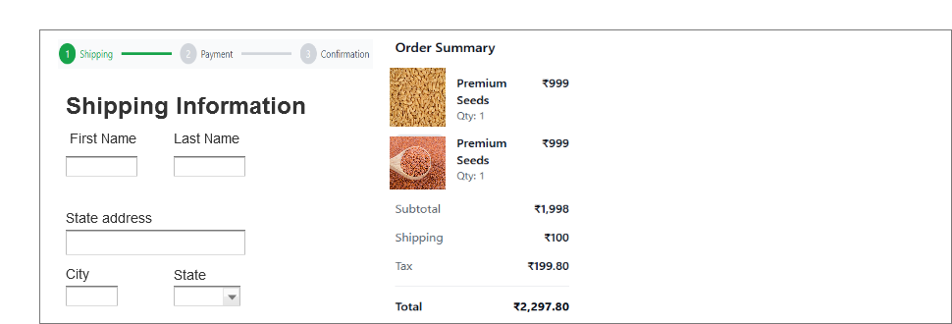

**Question 3 Tools (Visio, Balsamiq)**

Make a note of the Tools, which you are using for above concepts

**Answer**

Microsoft Visio is a diagramming and vector graphics application that helps create flowcharts, org charts, network diagrams, floor plans, and business process models. It offers pre-built shapes, templates, and real-time collaboration features. Visio integrates with Microsoft Office and supports data-driven visualizations, making it popular for technical and business documentation.

Balsamiq is a rapid wireframing tool that allows designers to create low-fidelity mock-ups of user interfaces. It uses a sketch-like, hand-drawn style to keep stakeholders focused on layout and functionality rather than visual design details. The tool includes pre-built UI components and supports both desktop and cloud-based versions.

Axure is a prototyping tool for creating interactive wireframes and design specifications. It allows rapid creation of clickable prototypes without coding, features dynamic content, conditional logic, and animations. Key capabilities include responsive design, team collaboration, and direct developer handoffs through generated documentation.

**Question 4 RTM**

Prepare RTM

**Answer**

|  |  |  |  |  |  |  |  |  |  |
| --- | --- | --- | --- | --- | --- | --- | --- | --- | --- |
| **Req ID** | **Requirement Name** | **Requirement Description** | **Design** | **Code** | **UT (Unit Testing)** | **CT (Component Testing** | **ST (System Testing)** | **SIT** | **UAT** |
| FR001 | Farmer Registration | Farmers should be able to register | Complete | Complete | Complete | Complete | Complete | Complete | Incomplete |
| FR002 | Farmer Search for Products | Farmers should be able to search products | Complete | Complete | Complete | Complete | Incomplete | Incomplete | Incomplete |
| FR003 | Add New Product | Manufacturers must be able to add new product | Complete | Complete | Complete | Complete | Incomplete | Incomplete | Incomplete |
| FR004 | Product Details | Farmers should be able to view product details | Complete | Complete | Complete | Complete | Incomplete | Incomplete | Incomplete |
| FR005 | Add to cart | Farmers must be able to add products to cart | Complete | Complete | Complete | Complete | Incomplete | Incomplete | Complete |
| FR006 | Unique Order ID | System must generate unique order ID | Complete | Complete | Complete | Complete | Incomplete | Incomplete | Incomplete |
| FR007 | Delivery Specifications | System should allow farmers to specify delivery location | Complete | Complete | Complete | Complete | Incomplete | Incomplete | Incomplete |
| FR008 | Track Order | Farmers should be able to track order status | Complete | Complete | Complete | Complete | Incomplete | Incomplete | Incomplete |
| FR009 | Payment Invoice | System should generate payment confirmation and invoice | Complete | Complete | Complete | Complete | Incomplete | Incomplete | Incomplete |
| FR010 | Payment Options | System must support multiple payment methods | Complete | Complete | Complete | Complete | Incomplete | Incomplete | Incomplete |
| FR011 | Order Confirmation | System should send order confirmation | Complete | Complete | Complete | Complete | Incomplete | Incomplete | Incomplete |
| FR012 | Feedback | Farmers should be able to rate products | Complete | Complete | Complete | Complete | Incomplete | Incomplete | Incomplete |
| FR013 | Notifications | System should send delivery notification | Complete | Complete | Complete | Complete | Incomplete | Incomplete | Incomplete |
| FR014 | Delivery Charges | System must calculate delivery charges | Complete | Complete | Complete | Complete | Incomplete | Incomplete | Incomplete |
| FR015 | Add Filters | System must provide filtering options | Complete | Complete | Complete | Complete | Incomplete | Incomplete | Incomplete |
| FR016 | Inventory Tracking | System should maintain real-time inventory | Complete | Complete | Complete | Complete | Incomplete | Incomplete | Incomplete |
| FR017 | Page Loading Time | Each Page should load within 2 seconds time | Complete | Complete | Complete | Complete | Incomplete | Incomplete | Incomplete |
| FR018 | Update Product Information | Manufacturers should be able to update product information | Complete | Complete | Complete | Complete | Incomplete | Incomplete | Incomplete |
| FR019 | Manufacturer Registration | Manufacturers should be able to register | Complete | Complete | Complete | Complete | Incomplete | Incomplete | Incomplete |
| FR020 | Mobile device compatibility | System should be compatible | Complete | Complete | Complete | Complete | Incomplete | Incomplete | Incomplete |

**Question 5- 10 Test Case Documents**

Prepare 10 Test Case Documents

**Answer**

|  |  |  |  |
| --- | --- | --- | --- |
| Test case ID | 001 | Test case Name | Search Query |
| Project ID | PID001 | Project Name | Online Agriculture Store |
| PM ID | 5679 | PM Name | Mr. Vandanam |
| Test strategy ID | PID78TS001 | Tester ID |  |
| Test plan ID | PID78TP001 | Tester Name |  |
| Test schedule ID | PID78TS001 | Date of Test |  |

|  |  |
| --- | --- |
| Scenario | Farmer Registration |

|  |
| --- |
| Link to the page: |

|  |  |  |  |  |  |
| --- | --- | --- | --- | --- | --- |
|  | Set 1 | Set 2 | Set 3 | Set 4 | Set 5 |
| Input Data | -Full Name  -Mobile  -Number  -Email Address  -Location  -Farm Size  -Password |  |  |  |  |
| Expected behaviour | Account Created |  |  |  |  |
| Actual behaviour |  |  |  |  |  |
| Comments |  |  |  |  |  |
| Result (Pass/Fail) |  |  |  |  |  |

|  |  |  |  |
| --- | --- | --- | --- |
| Test case ID | 002 | Test case Name | Search Query |
| Project ID | PID002 | Project Name | Online Agriculture Store |
| PM ID | 5679 | PM Name | Mr. Vandanam |
| Test strategy ID | PID78TS002 | Tester ID |  |
| Test plan ID | PID78TP002 | Tester Name |  |
| Test schedule ID | PID78TS002 | Date of Test |  |

|  |  |
| --- | --- |
| Scenario | Manufacturer Product Upload |
| Link to the page: | | |

|  |  |  |  |  |  |
| --- | --- | --- | --- | --- | --- |
|  | Set 1 | Set 2 | Set 3 | Set 4 | Set 5 |
| Input Data | -Navigate to product management section  -Click "Add New Product"  -Enter product details  -Upload product images  -Click Submit |  |  |  |  |
| Expected behaviour | Product should be successfully added to catalogue |  |  |  |  |
| Actual behaviour |  |  |  |  |  |
| Comments |  |  |  |  |  |
| Result (Pass/Fail) |  |  |  |  |  |

|  |  |  |  |
| --- | --- | --- | --- |
| Test case ID | 003 | Test case Name | Search Query |
| Project ID | PID003 | Project Name | Online Agriculture Store |
| PM ID | 5679 | PM Name | Mr. Vandanam |
| Test strategy ID | PID78TS003 | Tester ID |  |
| Test plan ID | PID78TP003 | Tester Name |  |
| Test schedule ID | PID78TS003 | Date of Test |  |

|  |  |
| --- | --- |
| Scenario | Product Search |

|  |
| --- |
| Link to the page |

|  |  |  |  |  |  |
| --- | --- | --- | --- | --- | --- |
|  | Set 1 | Set 2 | Set 3 | Set 4 | Set 5 |
| Input Data | -Enter search term in search bar  -Apply filters  -Click Search |  |  |  |  |
| Expected behaviour | Relevant products should be displayed |  |  |  |  |
| Actual behaviour |  |  |  |  |  |
| Comments |  |  |  |  |  |
| Result (Pass/Fail) |  |  |  |  |  |

|  |  |  |  |
| --- | --- | --- | --- |
| Test case ID | 004 | Test case Name | Search Query |
| Project ID | PID004 | Project Name | Online Agriculture Store |
| PM ID | 5679 | PM Name | Mr. Vandanam |
| Test strategy ID | PID78TS004 | Tester ID |  |
| Test plan ID | PID78TP004 | Tester Name |  |
| Test schedule ID | PID78TS004 | Date of Test |  |

|  |  |
| --- | --- |
| Scenario | Shopping Cart |

|  |
| --- |
| Link to the page |

|  |  |  |  |  |  |
| --- | --- | --- | --- | --- | --- |
|  | Set 1 | Set 2 | Set 3 | Set 4 | Set 5 |
| Input Data | -Select product quantity  -Click "Add to Cart"  -View cart  -Update quantity  -Remove item |  |  |  |  |
| Expected behaviour | Products should be added to cart |  |  |  |  |
| Actual behaviour |  |  |  |  |  |
| Comments |  |  |  |  |  |
| Result (Pass/Fail) |  |  |  |  |  |

|  |  |  |  |
| --- | --- | --- | --- |
| Test case ID | 005 | Test case Name | Search Query |
| Project ID | PID005 | Project Name | Online Agriculture Store |
| PM ID | 5679 | PM Name | Mr. Vandanam |
| Test strategy ID | PID78TS005 | Tester ID |  |
| Test plan ID | PID78TP005 | Tester Name |  |
| Test schedule ID | PID78TS005 | Date of Test |  |

|  |  |
| --- | --- |
| Scenario | Checkout Process |

|  |
| --- |
| Link to the page |

|  |  |  |  |  |  |
| --- | --- | --- | --- | --- | --- |
|  | Set 1 | Set 2 | Set 3 | Set 4 | Set 5 |
| Input Data | -Click "Proceed to Checkout"  -Confirm delivery address  -Select payment method  -Review order summary  -Confirm order |  |  |  |  |
| Expected behaviour | Order should be placed |  |  |  |  |
| Actual behaviour |  |  |  |  |  |
| Comments |  |  |  |  |  |
| Result (Pass/Fail) |  |  |  |  |  |

|  |  |  |  |
| --- | --- | --- | --- |
| Test case ID | 006 | Test case Name | Search Query |
| Project ID | PID006 | Project Name | Online Agriculture Store |
| PM ID | 5679 | PM Name | Mr. Vandanam |
| Test strategy ID | PID78TS006 | Tester ID |  |
| Test plan ID | PID78TP006 | Tester Name |  |
| Test schedule ID | PID78TS006 | Date of Test |  |

|  |  |
| --- | --- |
| Scenario | Delivery Address Validation |

|  |
| --- |
| Link to the page |

|  |  |  |  |  |  |
| --- | --- | --- | --- | --- | --- |
|  | Set 1 | Set 2 | Set 3 | Set 4 | Set 5 |
| Input Data | -Enter delivery address details  -Submit address |  |  |  |  |
| Expected behaviour | Address should be validated |  |  |  |  |
| Actual behaviour |  |  |  |  |  |
| Comments |  |  |  |  |  |
| Result (Pass/Fail) |  |  |  |  |  |

|  |  |  |  |
| --- | --- | --- | --- |
| Test case ID | 007 | Test case Name | Search Query |
| Project ID | PID007 | Project Name | Online Agriculture Store |
| PM ID | 5679 | PM Name | Mr. Vandanam |
| Test strategy ID | PID78TS007 | Tester ID |  |
| Test plan ID | PID78TP007 | Tester Name |  |
| Test schedule ID | PID78TS007 | Date of Test |  |

|  |  |
| --- | --- |
| Scenario | Order Tracking |

|  |
| --- |
| Link to the page |

|  |  |  |  |  |  |
| --- | --- | --- | --- | --- | --- |
|  | Set 1 | Set 2 | Set 3 | Set 4 | Set 5 |
| Input Data | -Login to account  -Navigate to "My Orders"  -Select specific order  -View tracking details |  |  |  |  |
| Expected behaviour | Current order status should be displayed |  |  |  |  |
| Actual behaviour |  |  |  |  |  |
| Comments |  |  |  |  |  |
| Result (Pass/Fail) |  |  |  |  |  |

|  |  |  |  |
| --- | --- | --- | --- |
| Test case ID | 008 | Test case Name | Search Query |
| Project ID | PID008 | Project Name | Online Agriculture Store |
| PM ID | 5679 | PM Name | Mr. Vandanam |
| Test strategy ID | PID78TS008 | Tester ID |  |
| Test plan ID | PID78TP008 | Tester Name |  |
| Test schedule ID | PID78TS008 | Date of Test |  |

|  |  |
| --- | --- |
| Scenario | Product Review |

|  |
| --- |
| Link to the page |

|  |  |  |  |  |  |
| --- | --- | --- | --- | --- | --- |
|  | Set 1 | Set 2 | Set 3 | Set 4 | Set 5 |
| Input Data | -Navigate to purchased product  -Click "Write Review"  -Enter rating (1-5 stars)  -Write review text  -Submit review |  |  |  |  |
| Expected behaviour | Review should be posted |  |  |  |  |
| Actual behaviour |  |  |  |  |  |
| Comments |  |  |  |  |  |
| Result (Pass/Fail) |  |  |  |  |  |

|  |  |  |  |
| --- | --- | --- | --- |
| Test case ID | 009 | Test case Name | Search Query |
| Project ID | PID009 | Project Name | Online Agriculture Store |
| PM ID | 5679 | PM Name | Mr. Vandanam |
| Test strategy ID | PID78TS009 | Tester ID |  |
| Test plan ID | PID78TP009 | Tester Name |  |
| Test schedule ID | PID78TS009 | Date of Test |  |

|  |  |
| --- | --- |
| Scenario | Language Selection |

|  |
| --- |
| Link to the page |

|  |  |  |  |  |  |
| --- | --- | --- | --- | --- | --- |
|  | Set 1 | Set 2 | Set 3 | Set 4 | Set 5 |
| Input Data | -Click language selector  -Choose different language  -Confirm selection |  |  |  |  |
| Expected behaviour | Change to selected language |  |  |  |  |
| Actual behaviour |  |  |  |  |  |
| Comments |  |  |  |  |  |
| Result (Pass/Fail) |  |  |  |  |  |

|  |  |  |  |
| --- | --- | --- | --- |
| **Test case ID** | 010 | **Test case Name** | **Search Query** |
| **Project ID** | PID010 | **Project Name** | Online Agriculture Store |
| **PM ID** | 5679 | **PM Name** | Mr. Vandanam |
| **Test strategy ID** | PID78TS010 | **Tester ID** |  |
| **Test plan ID** | PID78TP010 | **Tester Name** |  |
| **Test schedule ID** | PID78TS010 | **Date of Test** |  |

|  |  |
| --- | --- |
| **Scenario** | Payment Processing |

|  |
| --- |
| **Link to the page:** |

|  |  |  |  |  |  |
| --- | --- | --- | --- | --- | --- |
|  | **Set 1** | **Set 2** | **Set 3** | **Set 4** | **Set 5** |
| **Input Data** | -Select payment method  -Enter payment details  -Confirm payment  -Wait for processing |  |  |  |  |
| **Expected behaviour** | Payment Processed |  |  |  |  |
| **Actual behaviour** |  |  |  |  |  |
| **Comments** |  |  |  |  |  |
| **Result (Pass/Fail)** |  |  |  |  |  |

**Question 6 DB Design**

Draw DB schema and ER diagram

**Answer**

DB schema is a blueprint that outlines the structure of a database, including its tables, fields, relationships, constraints, and other characteristics.

An Entity-Relationship Diagram (ERD) is a visual representation of the relationships between entities in a database. It depicts the entities (such as tables), attributes (properties or fields), and relationships between them.

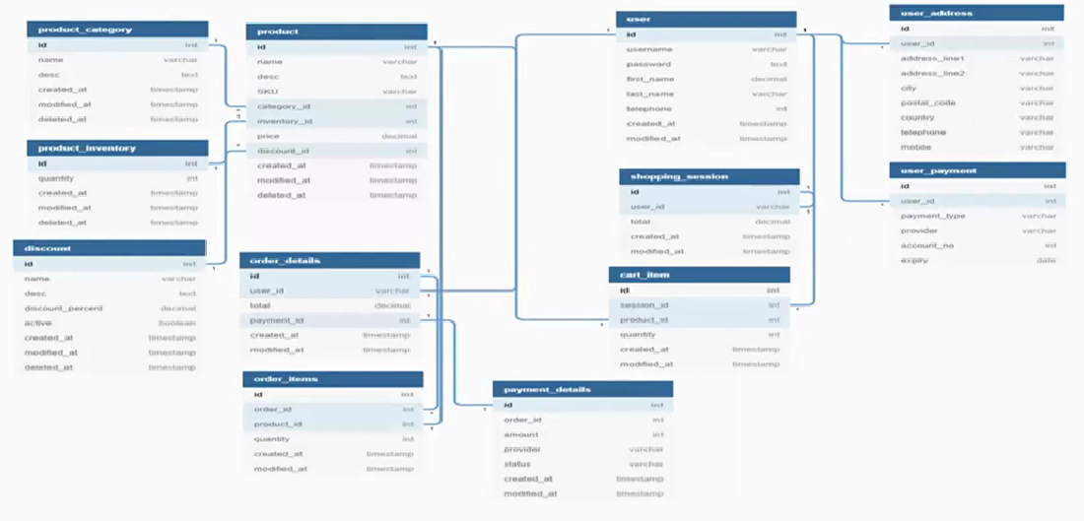

**Question 7 Data Flow Diagram**

What a dataflow diagram? Draw a data flow diagram to represent the in-flow and out-flow of data when a Farmer is placing an order for the product.

**Answer**

A Data Flow Diagram (DFD) is a graphical representation of the flow of data within a system. It visually shows how data moves from one process to another, how its stored, and where it ends up.

It helps analysts and designers understand the flow of data within a system, identify potential bottlenecks or inefficiencies, and communicate system requirements to stakeholders.

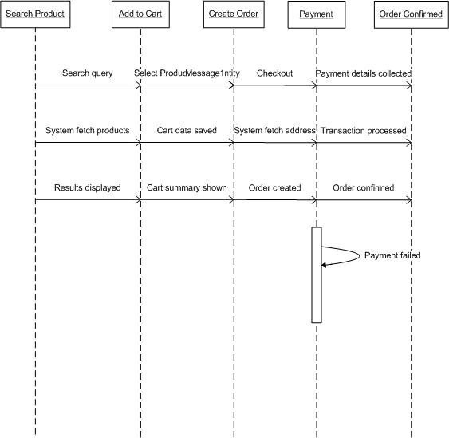

**Question 8 Change Request**

How do you handle change requests in a project?

**Answer**

A change request is a formal proposal to alter a system, product, or project.

1. Understand the scope of change request and document the change request

2. Do the impact analysis- project scope, schedule, budget, resources, and risks.

3. Prioritize change requests based on its urgency, importance, impact on project.

4. Seek approval from the project sponsor for the change request.

5. Communicate the change request and its potential impacts to all relevant stakeholders, including the project team.

**Question 9 Change Request Vs an Enhancement**

As the project is in process, Ben and Kevin have contacted you. The reason is to inform you that they want the Farmers to sell their crop yields through this application i.e. Farmers should be able to add their crop yields or products and display to general public and should be able to sell them. They also want to introduce Auction system for their Crop yields. As a BA, what will be your response?

Is this a change request or an enhancement?

**Answer**

In this scenario, introducing auction system for the farmer’s crop yields would be considered as a change request as it fundamentally changes the business model and system architecture.

As a BA, I should document the change request formally and analyse impact on current project scope, timeline, and budget. Present the document to the committee (Mr. Henry, Mr. Pandu, Mr. Dooku) for approval and then if approved, create new requirements documentation and update project plans. I would also consider implementing a separate phase to avoid disrupting current development.

**Question 10 Estimations**

Come up with estimations- How many manhours required?

**Answer**

Man hours are the required effort of the resources to complete a project. There are 3 types of projects:

-Small: Up to 500 hours

-Medium: Up to 1000 hours

-Large: Up to 1500 hours

Analysis

As per the case study, the duration of the project is 18 months and the current team size is around 12. This will come under medium project. As the trained resources are available, trainers are not required. As the structure of the project is available, new and enhanced infrastructure is not required.

**Question 11 UAT**

Explain UAT acceptance process

**Answer**

Planning: In this step, Blue Prints are made to implement UAT testing for every feature that needs to test and minimum standards for accepting the test

Designing: Here the Test cases are designed to hide all the possibilities of software packages in a real-world environment.

UAT Testers: A Testing team consists of an end user that meet the criteria for implementing testing. They should know the test cases to run and understand the functionalities.

Bug Fixing: Whatever Bugs are found in the UAT Testing, the development team should work on them and make it software error free.

Sign Off: After removing all the bugs, the testing team indicate acceptance of the completion of the bugs. In this phase all the stakeholders conclude that the software is ready to GO LIVE and sign it off.

**Question 12 Project Closure Document**

Explain project closure document

**Answer**

A project closure document, also known as a project closure report- is a formal document that summarizes the key outcomes, lessons learned, and final details of a completed project. It serves as a comprehensive record of the project’s accomplishments, challenges, and overall performance providing valuable insights for stakeholders and future projects.

Points to be included in a project closure document are:

* Project Overview
* Achievements
* Lessons Learned
* Quality Assurance
* Resource Utilization
* Risk Management
* Challenges