Document 6 : Document 6- Please prepare a use case diagram, activity diagram and a use case specification document.

**Answer**:

**Use case Daigram**

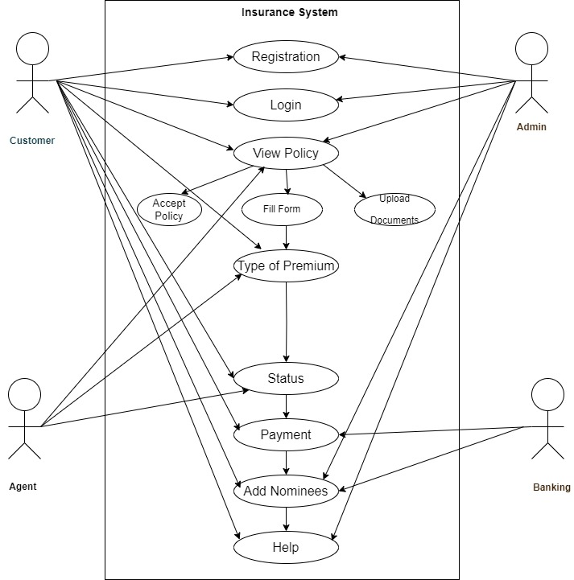

**Activity Diagram:**

1. Login Page

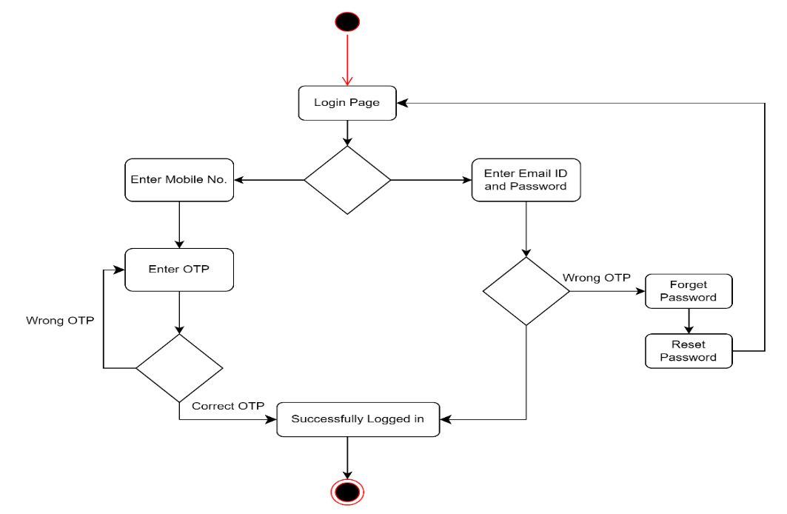

1. Sign Up Page

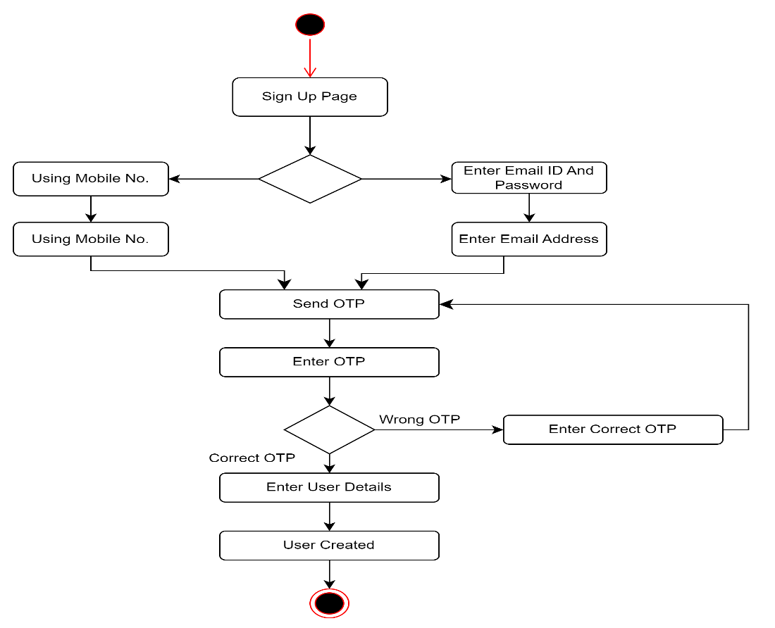

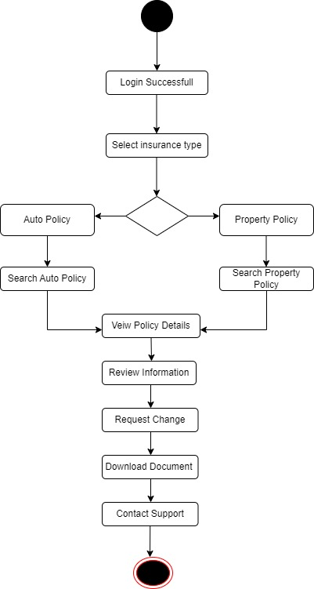3.) Policy Search

4.) Premium Page

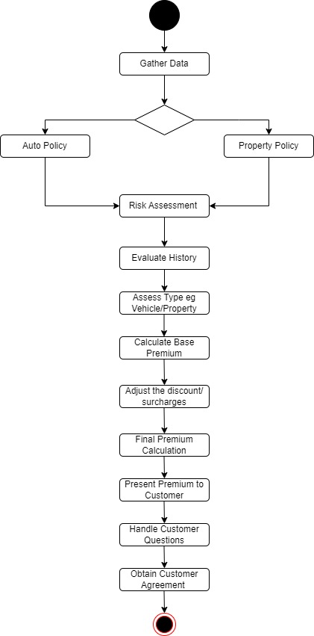

5.) Status page

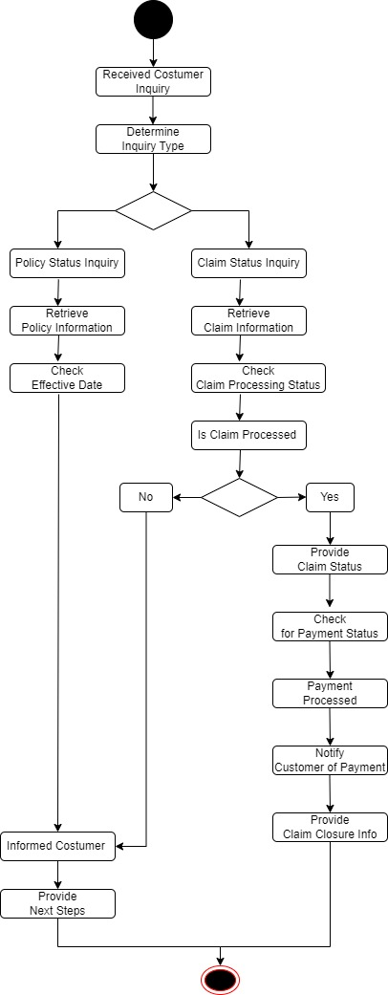

**Prepare use case specification for all use cases**

|  |  |
| --- | --- |
| Use Case Specification | Details |
| Use Case ID | 1 |
| Use Case Name | User Login for PNC Analysis |
| Brief Description | This Use Case explains how users (customers, agents, or admins) log into the system to access Property and Casualty insurance analysis features. |
| Actors | 1. Customer 2. Agent 3. Admin 4. Banking |
| Pre-Conditions | * There should be an active Internet connection. * User must have valid login credentials (username and password). * The system must be operational and accessible. |
| Basic Flow | 1. User navigates to the login page. 2. User enters their username and password. 3. System performs user validation. 4. If validation is successful, the user is redirected to their dashboard. 5. User accesses features for PNC analysis. 6. Use case ends successfully. |
| Alternate Flow | Invalid Credentials:  If user validation fails (due to incorrect username or password), the app displays an error message: "Invalid username or password. Please try again." Flow returns to Step 2.  Account Locked:  If the user exceeds the maximum number of failed login attempts, the app displays: "Your account has been locked due to multiple failed login attempts. Please contact support." Flow ends with failure condition.  Forgot Password:  If the user clicks on "Forgot Password", the system provides steps to reset the password via email. Flow ends.  User Not Registered:  If the user attempts to log in with an unregistered email, the app displays: "No account found with this email. Please register." Flow ends. |
| Post Condition | Successful Completion: User successfully logged in and accesses the dashboard for PNC analysis.  Failure Condition: User fails to log in due to invalid credentials or account issues. |
| Supplemental Requirements | The application should enforce strong password policies.  The system should log all login attempts (successful and unsuccessful).  The application must comply with data protection regulations for handling user credentials. |

|  |  |
| --- | --- |
| Use Case Specification | Details |
| Use Case ID | 2 |
| Use Case Name | User Sign Up for PNC Analysis |
| Brief Description | This Use Case explains how a new user (customer, agent, or admin) registers for an account to access the Property and Casualty insurance analysis features. |
| Actors | 1. Customer 2. Agent 3. Admin 4. Banking |
| Pre-Conditions | * Active Internet connection. * The agent must have received an invitation or special instructions to sign up for access. |
| Basic Flow | 1. Agent navigates to the Agent Sign-Up page. 2. Agent enters registration information (e.g., name, agency name, email, password). 3. The agent accepts the terms and conditions. 4. The agent submits the registration form. 5. The system checks for validation (unique emails, password policies). 6. If everything is valid, the new agent account is created. 7. The agent receives a confirmation email for account verification. 8. Use case ends successfully, redirecting the agent to the login page. |
| Alternate Flow | Email Already Registered:  If the agent tries to use an existing email, the system displays: "This email is already associated with an agent account." Flow ends.  Input Validation Error:  If any provided data fails validation, appropriate error messages are shown. Flow returns to Step 2.  Terms and Conditions Not Accepted:  If the agent does not accept the terms, a message prompts acceptance before proceeding. Flow returns to Step 3.  Missing Verification Code:  If the agent does not provide a required verification code, the system prompts for it, displaying an error for invalid entries. Flow ends until verification is complete. |
| Post Condition | Successful Completion: Agent's account is successfully created with an email confirmation sent.  Failure Condition: Agent unable to sign up due to validation issues or existing accounts. |
| Supplemental Requirements | Password should meet strong security requirements (e.g., minimum length, combination of letters, numbers, and special characters).  The application must ensure that user data is stored securely and comply with data protection regulations.  The system should maintain logs of sign-up attempts for auditing and troubleshooting purposes. |

|  |  |
| --- | --- |
| Use Case Specification | Details |
| Use Case ID | 3 |
| Use Case Name | Policy Search for PNC Analysis |
| Brief Description | This Use Case describes how customers, agents, and admins can search for existing insurance policies (auto and property) within the Property and Casualty analysis system. |
| Actors | 1. Customer 2. Agent 3. Admin |
| Pre-Conditions | * Active Internet connection. * User must be logged into the system with a valid account (Customer, Agent, Admin). * User must have permission to access the policy search feature. |
| Basic Flow | User navigates to the "Policy Search" page.  User enters search criteria (e.g., policy number, customer name, date range, type of policy).  User submits the search request.  The system processes the search request:  Retrieves relevant policy data from the database based on the entered criteria.  The system displays the search results, including a list of matching policies with details (e.g., policy number, customer name, policy type, status).  User selects a specific policy from the list to view detailed information.  The system displays detailed policy information, including coverage details, premium amounts, and any claims associated with the policy.  Use case ends successfully. |
| Alternate Flow | No Matching Policies Found:  If no policies match the search criteria, the system displays a message: "No policies found matching your criteria. Please refine your search." Flow ends.  Invalid Search Criteria:  If the search criteria have invalid formats (e.g., incorrect date format, invalid characters), the system shows an error message: "Invalid search inputs. Please check your entries." Flow returns to Step 2.  Session Timeout:  If the user session has timed out, the system displays: "Session expired. Please log in again to continue." Flow ends, redirecting to login page.  Insufficient Permissions:  If the user lacks permissions to perform a policy search, the system displays: "You do not have permission to access this feature." Flow ends. |
| Post Condition | Successful Completion: User successfully retrieves and views the desired policy information.  Failure Condition: User unable to perform the search due to errors, permissions issues, or session expiration. |
| Supplemental Requirements | Search functionality should allow filtering based on various parameters for efficient retrieval.  Ensure user data and search results are displayed in compliance with data privacy regulations.  Maintain logs of all search queries for auditing and monitoring purposes.  Implement performance measures to ensure the search process returns results in a timely manner |

|  |  |
| --- | --- |
| Use Case Specification | Details |
| Use Case ID | 4 |
| Use Case Name | View Premium Details for PNC Analysis |
| Brief Description | This Use Case describes how a customer, agent, or admin can view premium details for a specific insurance policy (auto or property) within the PNC analysis system. |
| Actors | 1. Customer 2. Agent 3. Admin |
| Pre-Conditions | * Active Internet connection. * User must be logged into the system with a valid account. * User must have the necessary permissions to view premium details. |
| Basic Flow | User navigates to the "Premium Page."  User selects a specific policy from which to view premium details.  The system retrieves and displays premium information, including:  Current premium amounts  Previous premiums  Payment history  Coverage details related to the premium  Use case ends successfully. |
| Alternate Flow | Policy Not Found:  If the selected policy is not found, the system displays a message: "The selected policy could not be found." Flow ends.  Insufficient Permissions:  If the user lacks the required permissions to view premium details, the system displays: "You do not have permission to view this information." Flow ends. |
| Post Condition | Successful Completion: The user successfully views the premium details of the selected policy.  Failure Condition: The user is unable to view the premium details due to policy-related issues or permissions. |
| Supplemental Requirements | Ensure that premium details are displayed securely and comply with data privacy regulations.  Include responsive design elements for optimal viewing across devices. |

|  |  |
| --- | --- |
| Use Case Specification | Details |
| Use Case ID | 5 |
| Use Case Name | Check Policy Status for PNC Analysis |
| Brief Description | This Use Case describes how a customer, agent, or admin can check the status of a specific insurance policy (auto or property) on the Status Page. |
| Actors | 1. Customer 2. Agent 3. Admin |
| Pre-Conditions | * Active Internet connection. * User must be logged into the system with a valid account. * User must have the necessary permissions to view policy status. |
| Basic Flow | User navigates to the "Status Page."  User selects "Check Policy Status."  User enters the policy number or selects the policy from a list.  The system retrieves the current status of the policy, including:  Coverage status  Payment status  Renewal dates  Any pending documents  The system displays the policy status details to the user.  Use case ends successfully |
| Alternate Flow | Policy Not Found:  If the entered policy number is invalid, the system displays a message: "The policy number entered does not exist." Flow ends.  Insufficient Permissions:  If the user lacks the required permissions to view policy status, the system displays: "You do not have permission to view this information." Flow ends. |
| Post Condition | Successful Completion: The user successfully views the current status of the selected policy.  Failure Condition: The user is unable to check the policy status due to invalid information or permissions issues. |
| Supplemental Requirements | Ensure that policy status information is displayed securely and complies with data privacy regulations.  Provide a clear and user-friendly interface to navigate the status checks. |

**Document 7- Screens and pages**

**Answer:**

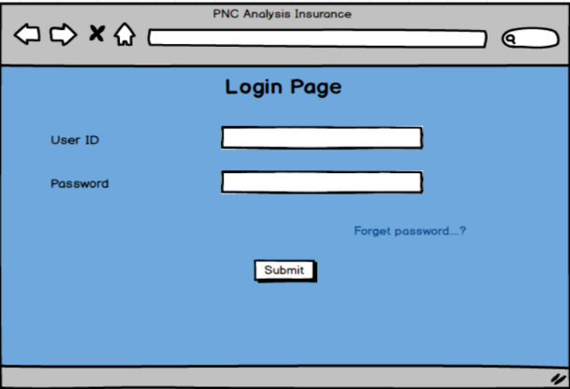 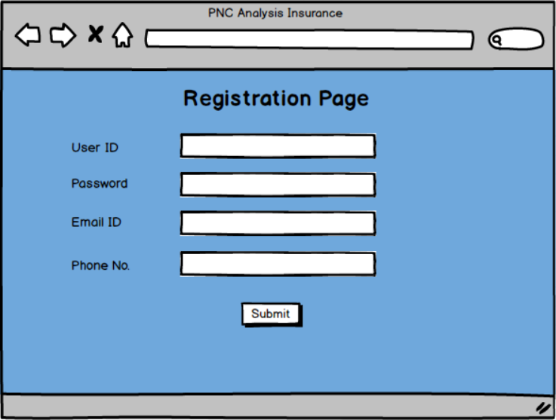

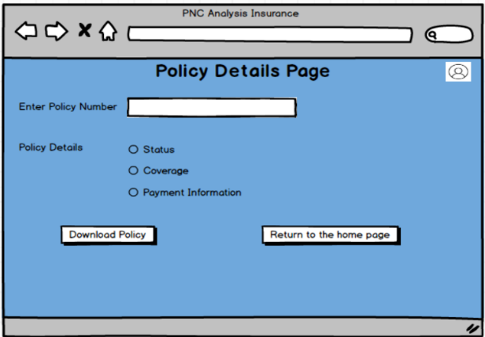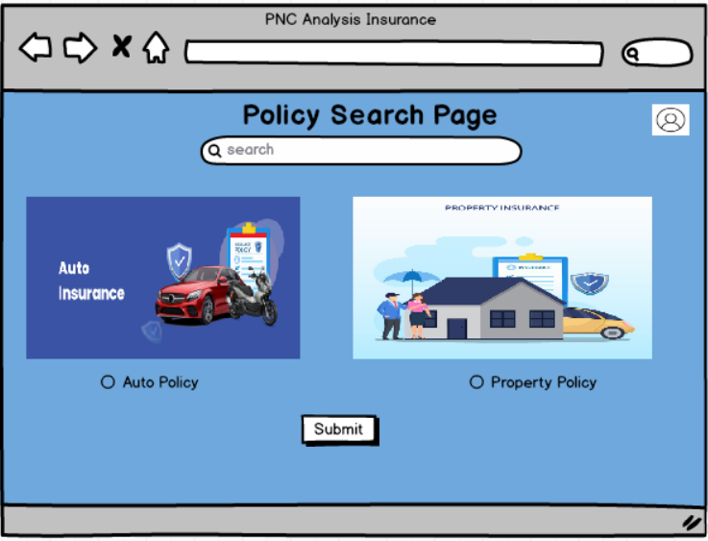

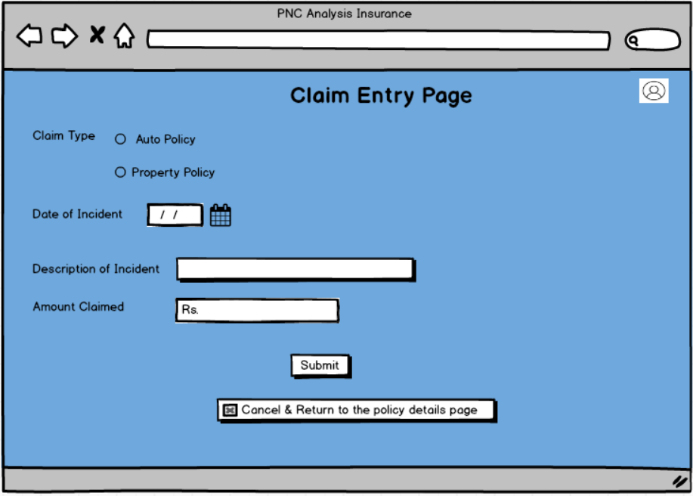

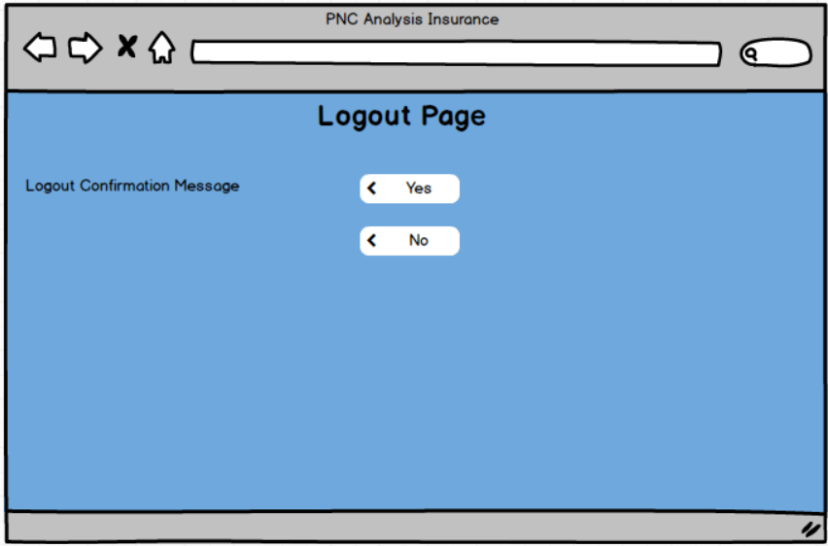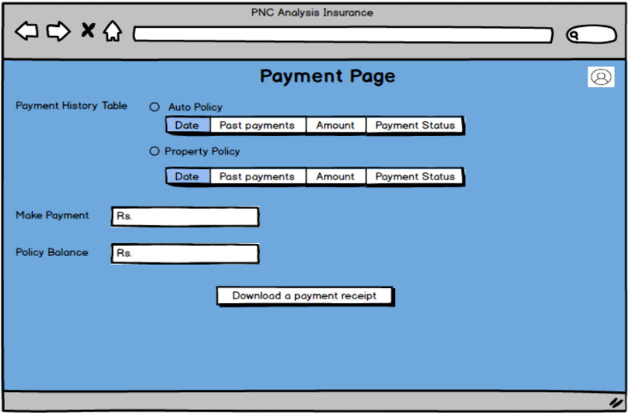

**Document 8- Tools-Visio and Axure**

**Answer**: In this project, I used **draw.io** and **Balsamiq** to create wireframes and diagrams for the PNC analysis system. **draw.io** was particularly useful for creating flowcharts, data flow diagrams, and system architecture diagrams. Its user-friendly interface and cloud-based collaboration capabilities made it easy to visualize the overall structure and processes of the system, as well as create clear, detailed representations of workflows. The drag-and-drop functionality in draw.io allowed for quick adjustments, and the tool’s integration with cloud storage services made sharing and collaborating on diagrams efficient.

On the other hand, **Balsamiq** was an excellent tool for low-fidelity wireframing. It helped me quickly sketch out user interface designs with a focus on layout and functionality rather than visual details. Balsamiq’s simple, hand-drawn style helped communicate the flow of the user experience without getting caught up in fine design elements. The tool’s intuitive drag-and-drop components made it easy to assemble screens, while its straightforward approach kept the focus on usability and user interaction. Overall, **draw.io** was ideal for high-level diagrams and process mapping, while **Balsamiq** was the perfect choice for rapidly prototyping user interfaces and getting early feedback on the design concepts

**Document 9- BA experience My experience as BA in following phases:**

**Answer:** My Experience as a Business Analyst in PNC Analysis for Auto and Property

1. **Requirement Gathering:** During the Requirement Gathering phase, I employed the MOSCOW technique (Must Have, Should Have, Could Have, Won't Have) to prioritize and structure the client’s requirements. As the client was unavailable for some time, I took the initiative to identify alternative point-of-contacts within their team, ensuring that we received the necessary information promptly. To validate the requirements, I used the FURPS technique (Functionality, Usability, Reliability, Performance, Supportability), ensuring all requirements met the project’s standards. While gathering requirements, I discovered several instances of duplicated or repeated requirements, which I promptly removed to streamline the process. Prototyping was used to clarify the requirements and provide more specific details, allowing stakeholders to have a clearer understanding of the final product.
2. **Requirement Analysis:** During the Requirement Analysis phase, I created UML diagrams to visually represent the functional and non-functional requirements, ensuring clear communication between stakeholders and the development team. I also used Activity Diagrams to illustrate the process flow, making the requirements more tangible and understandable. Throughout this phase, there were instances where team members disagreed with the diagrams or suggested modifications. As a BA, I had to carefully evaluate these suggestions, make necessary adjustments, and maintain alignment with the client’s needs. Additionally, I prepared the Business Requirement Specification (BRS) and System Requirement Specification (SRS) documents, capturing all the detailed requirements for the project.
3. **Design:** During the Design phase, I prepared test cases based on the use case diagrams, ensuring comprehensive coverage of both positive and negative test cases. I actively communicated with the client on design and solution documents to ensure we were aligned. Writing negative test cases was crucial, as it ensured that all possible error conditions were accounted for, preventing later-stage issues. I also prepared test data for the team to use during testing and updated the Requirements Traceability Matrix (RTM) to ensure that all requirements were mapped to the corresponding design elements.
4. **Development:** In the Development phase, I organized Joint Application Development (JAD) sessions to bridge the gap between business and technical teams, allowing for better collaboration and resolving any concerns. I handled any discrepancies or conflicts that arose during these sessions by conducting one-on-one discussions, emphasizing the importance of team cooperation for the success of the project. During the coding phase, I referred to diagrams to guide the development of the Unit. Regular meetings were conducted with the technical team and client, which sometimes proved challenging when team members were unavailable. I managed this by recording the sessions and following up with the missing members individually to ensure no crucial information was missed.
5. **Testing:** In the Testing phase, I prepared test cases derived from the use cases and ensured high-level testing was performed to validate the system’s functionality. I worked closely with the client to request the necessary test data and updated the RTM to reflect the testing progress. After the testing phase, I obtained client signoff and prepared them for User Acceptance Testing (UAT), ensuring they were ready for the final validation of the system before deployment.
6. **Deployment:** In the Deployment phase, I forwarded the RTM to the client as part of the project closure document. I coordinated with the team to complete and share end-user manuals and training materials. Planning and organizing training sessions was crucial to ensure that all relevant stakeholders understood how to use the system. I made sure that all candidates attended the training sessions to guarantee the smooth adoption of the new system.

Throughout these phases, I learned the importance of clear communication, collaboration, and attention to detail. As a BA, it was essential to ensure that every step was aligned with the client's needs while also managing the expectations of the technical team and ensuring smooth delivery of the project.