**Waterfall Model Documents**

**Part 1/2 Evaluation**

**Document 1- Business case document template.**

Why is this project initiated?

>> Manual HR management practices prevalent for over 3 years. Increasing workforce complexity due to company growth over the years. Project helps to Streamline operations aligns with company’s growth strategy. Project supports compliance and improves organizational efficiency.

What are the current problems?  
>> Current problem are as follows -

* We are unable to track the daily shift timing of every employee.
* We are unable to track the productivity hours of every employee.
* We are unable to feed the employee Data in Server.
* Lack of centralized data for employee records.
* Manual processes causing delays and errors.
* We are manually updating every employee’s data in every profile.
* We are unable to set the Hierarchy for every department.
* We are unable to calculate salary on time due to less accurate data and manual updates.
* We are facing issues to upload documents on server.
* We are unable to update the system with labor laws.
* Employees are unsatisfied by current HR management system and having bad user experience.

With this project how many problems could be solved?

>> By completing this project, we can –

* Automate daily, weekly and monthly HR processes.
* Enhance employee engagement.
* Ensure compliance with every labor laws.
* Provide actionable insights through analytics.
* Reduce payroll processing time by 50% within 3 months.
* Achieve 90% employee satisfaction with the new system within 1 year.

What are the resources required?>> For completing this project, we required below mentioned resources –

Timeline we required of 6 Months.

People:

Project Manager, Business Analyst, HR Team (SME), Developer Team, external consultants.

Licensed Software, Implementation and training, Tools and Technology such as Cloud-based solutions (e.g., AWS), Website and Applications, Server Systems and Computers, Collaboration tools for training and communication (Video tutorials, PPTs, Recorded training sessions).

How much organizational change is required to adopt this technology?>> For the current project we do not require any organizational changes for non-technical aspects. Only need to provide the necessary Training to operate the new Management System.

Time frame to recover ROI?

>> Current project is about the implementation of new HR management system in organization which we will require trained HR so that they can know how to use the system and trained existing employee also. Which will require minimum 3 months to complete.

How to identify Stakeholders?  
>> In the current project everyone act as the Stakeholder as everyone is facing some problem and can contribute smaller segments to build the Management system.

**Document 2: BA Strategy**

Business Analyst Approach Strategy

1. Project Initiation

Understand Project Objectives: Gather high-level details of the project from stakeholders or project sponsors to understand the business goals.

Stakeholder Identification and Analysis:

Identify Stakeholders: Create a stakeholder list (internal and external) to understand their roles, interests, and influence.

Analyze Stakeholders: Will use tools like a Stakeholder Map or Matrix to categorize stakeholders by influence and impact.

RACI/ILS:

RACI: Identify who is Responsible, Accountable, Consulted, and Informed for each project task.

ILS: Outline Interest, Level of Influence, and Support required from stakeholders.

2. Requirements Elicitation -

For the current we will use following Elicitation Techniques:

Interviews: Schedule one-on-one or group interviews with subject matter experts (SMEs).

Surveys/Questionnaires: Collect inputs from a broader audience when required.

Prototyping: Create mock-ups to validate requirements visually.

3. Documentation -

Following Key Documents to Prepare for current project:

* Business Requirements Document (BRD): Captures high-level business needs.
* Functional Requirements Document (FRD): Details system functionalities required to meet business needs.
* Requirements Traceability Matrix (RTM): Tracks requirements throughout the project lifecycle.
* Process Flow Diagrams: Visual representation of workflows.

4. Stakeholder Communication -

Establish Communication Channels:

Regular Meetings with SMEs (Kick-offs, Status Updates, etc.),

Email Updates,

Project Management Tools (e.g., Jira which is currently used in my organization),

Identify the audience for each communication type such as HR(SMEs) and Employees.

5. Review and Sign-off Process -

Document Review:

Share drafts of documents with stakeholders for feedback.

Conduct review sessions to address concerns.

Sign-off Process:

We will use tools like e-signature platforms or formal approval emails.

Ensure stakeholders confirm that all requirements are clear and meet expectations.

6. Change Request Management -

Change Request Process:

Log all change requests using a Change Request Form or tool.

Assess the impact on scope, timeline, and budget.

Conduct a review meeting with stakeholders.

Obtain approval from authorized stakeholders before implementation.

Update Documents:

Modify affected documents (e.g., BRD, FRD) and trace changes in the RTM.

7. Progress Updates -

Reporting Mechanisms:

* Weekly status reports.
* Dashboards for real-time updates.
* Milestone-based progress tracking.

Stakeholder Meetings:

Conduct periodic reviews to present progress and address concerns.

8. User Acceptance Testing (UAT) -

Preparation:

* Need to Develop UAT Test Plan with clear objectives and criteria.
* Need to Prepare Test Cases based on requirements.

Execution:

* Facilitate UAT sessions with HRs and Employee.
* Log defects and feedback for resolution.

Sign-off:

* Prepare a Client Project Acceptance Form.
* Ensure the client validates all requirements and formally approves the final deliverable.

9. Project Closure -

Final Deliverables:

Ensure all documentation, deliverables, and lessons learned are shared.

Retrospective:

Conduct a post-project review to identify successes and areas for improvement.

Handover:

Transfer fully functional system to HR Management.

**Document 3- Functional Specifications**

|  |  |
| --- | --- |
| Project Name | Spine HrOne |
| Customer Name | HR Management |
| Project Version | V1.0 |
| Project Sponsor | GuruImpact |
| Project Manager | Latika Rai |
| Project Initiation Date | 01/01/2025 |

Functional Requirement specifications:

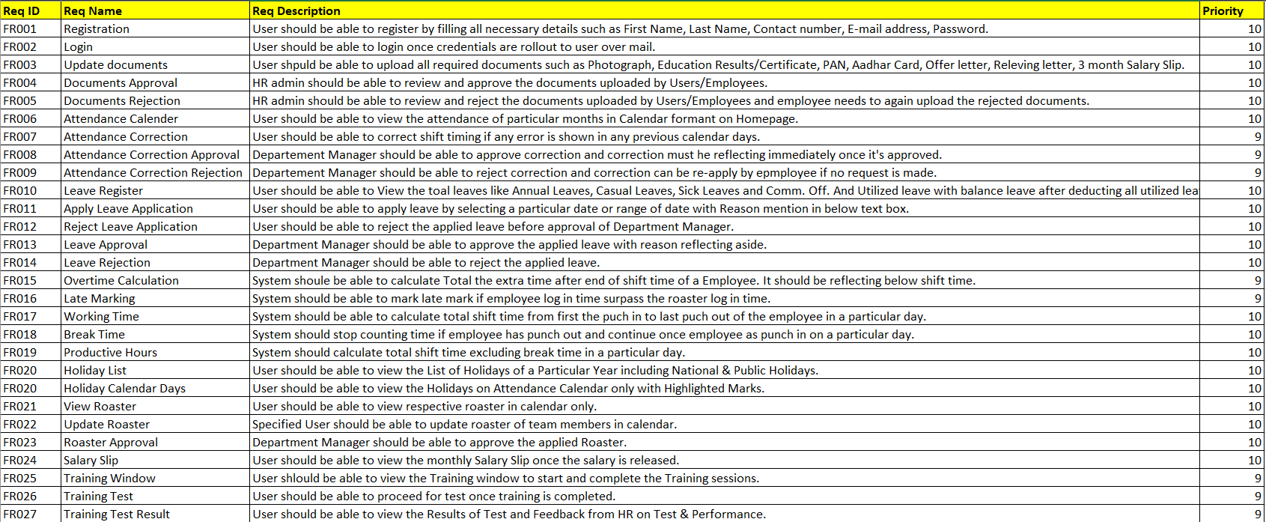

**Document 4- Requirement Traceability Matrix**  
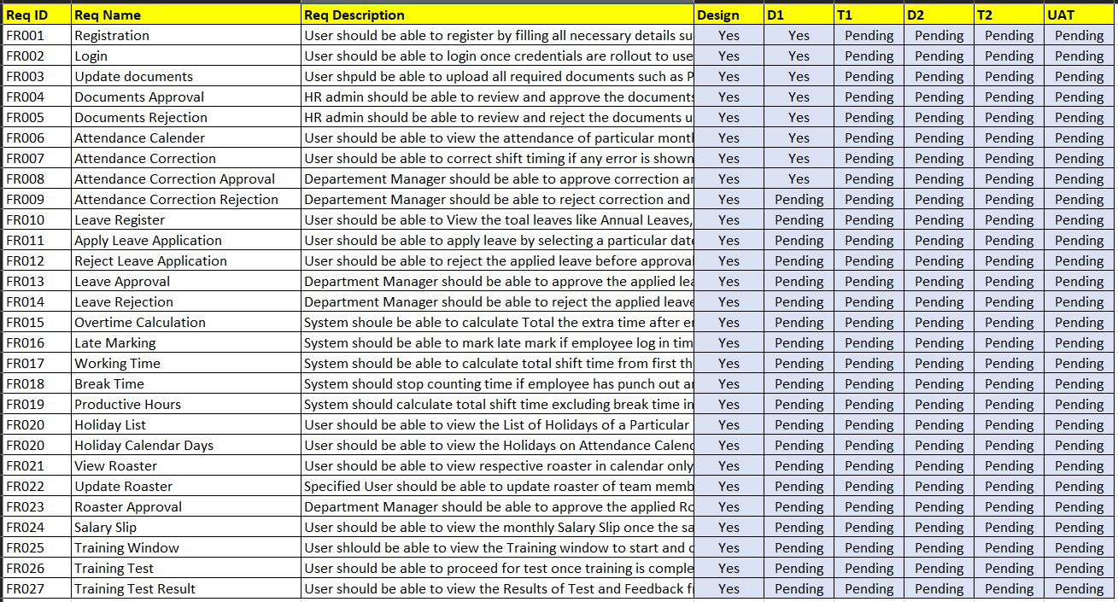

**Document 5- BRD Template**

**HrOne**

**PRO01BRD001-19012025**

**Version 0.02**

**BA Tejas Yadav**

**1.Document Revisions**

|  |  |  |
| --- | --- | --- |
| **Date** | **Version Number** | **Document Changes** |
| 12/12/2024 | 0.01 | Initial Draft |
| 10/01/2025 | 0.02 | Updated BRD |
|  |  |  |
|  |  |  |

**2. Approvals**

|  |  |  |  |  |
| --- | --- | --- | --- | --- |
| Role | Name | Title | Signature | Date |
| Project Sponsor | GuruImpact | Organization | GI. | 05/12/2024 |
| Business Owner | Rahul Jain | CEO | Rahul J. | 08/12/2024 |
| Project Manager | Parshotam D. | Product Manager | P.D. | 12/12/2024 |
| System Architect | Abhishek S. | Lead DA | Abhi S. | 03/01/2025 |
| Development Lead | Omakar K. | Sr. Developer | Omkar K. | 03/01/2025 |
| User Experience Lead | Priya M. | Senior Executive | Priya M. | 03/01/2025 |
| Quality Lead | Poornima K. | Senior Executive | Poornima K. | 03/01/2025 |
| Content Lead | Clementina K. | Team Lead | Clementina K. | 05/01/2025 |

**3. RACI Chart for This Document**

The RACI chart identifies the persons who need to be contacted whenever changes are

made to this document. RACI stands for responsible, accountable, consulted, and informed.

These are the main codes that appear in a RACI chart, used here to describe the roles played

by team members and stakeholders in the production of the BRD. They are adapted from

charts used to assign roles and responsibilities during a project.( RACI Can be made for IT side[Project stakeholder] as mentioned above, apart from that Can also Be made for Client side[Business Stakeholder]).

The following describes the full list of codes used in the table:

* Authorize has ultimate signing authority for any changes to the document.

R = Responsible for creating this document.

A = Accountable for accuracy of this document (for example, the project manager)

S = Supports Provides supporting services in the production of this document

C = Consulted Provides input (such as an interviewee).

I = Informed Must be informed of any changes.

|  |  |  |  |  |  |  |  |
| --- | --- | --- | --- | --- | --- | --- | --- |
| Name | Position | * | R | A | S | C | I |
| Parshotam D. | Project Manager | Yes |  |  |  |  | Yes |
| Tejas Yadav | BA | Yes | Yes | Yes |  |  | Yes |
| Abhishek S. | System Arch. |  |  | Yes | Yes |  |  |
| Omkar K. | Developer |  |  | Yes | Yes |  |  |
| Priya M. | SME |  |  |  |  | Yes |  |

4. Introduction

4.1. Business Goals

* Automate daily, weekly and monthly HR processes.
* Enhance employee engagement.
* Ensure compliance with every labor laws.
* Provide actionable insights through analytics.
* Reduce payroll processing time by 50% within 3 months.
* Achieve 90% employee satisfaction with the new system within 1 year.

4.2. Business Objectives

* User friendly design and easy to understand.
* Increase HR’s operational productivity.
* Track attendance and daily productivity of employees.
* Automate daily, weekly and monthly insight analysis.
* Enhance employee engagement.
* Streamline recruitment workflows.
* Centralized employee data on server.
* Tracking of leaves and performance of every employee.
* Automate payroll process.
* A manual how to operate software and a feedback from to improve any bugs or error.

4.3. Business Rules

* The software must feature an intuitive and easy-to-navigate interface.
* Clear instructions and tooltips should be available to guide users.
* Automate repetitive HR tasks such as attendance tracking, payroll processing, and leave management.
* Generate actionable insights and analytics dashboards with minimal user input.
* The system must record daily attendance via integrated tools (e.g., biometric systems or online check-ins).
* Allow HR and managers to monitor productivity metrics, including task completion rates.
* Generate daily, weekly, and monthly reports on employee performance, attendance trends, and overall department productivity.
* Deliver automated alerts for anomalies, such as absenteeism spikes or performance dips.
* rovide a portal for employees to view attendance, leave balances, and performance feedback.
* Include features like feedback submission, surveys, and recognition tools to boost morale.
* Implement an applicant tracking system (ATS) to manage job postings, applications, and interview schedules.
* Ensure seamless communication with candidates through email notifications and updates.
* Store all employee data (personal details, performance records, payroll information, etc.) on a secure, centralized server.
* Ensure compliance with data protection regulations (e.g., GDPR, CCPA).
* Allow employees to request and track leave applications through the system.
* Track and store performance evaluations, goal completions, and review cycles.
* Integrate attendance data to calculate salaries, deductions, and bonuses automatically.
* Generate payslips and tax documents in compliance with relevant laws.
* Provide a comprehensive user manual, both as an in-app guide and a downloadable document.
* Incorporate a feedback form within the software for reporting bugs or suggesting improvements.
* Ensure role-based access controls (e.g., admin, HR, employee levels).
* Implement encryption for sensitive data, including employee personal and financial information.
* The system must support scalability to accommodate growing employee numbers.
* Allow HR to customize workflows, forms, and reporting parameters.

4.4. Background

* Manual HR management practices prevalent for over 3 years.
* Increasing workforce complexity due to company growth over the years.
* Project helps to Streamline operations aligns with company’s growth strategy.
* Project supports compliance and improves organizational efficiency.

4.5. Project Objective

* User friendly design and easy to understand.
* Increase HR’s operational productivity.
* Track attendance and daily productivity of employees.
* Automate daily, weekly and monthly insight analysis.
* Enhance employee engagement.
* Streamline recruitment workflows.
* Centralized employee data on server.
* Tracking of leaves and performance of every employee.
* Automate payroll process.
* A manual how to operate software and a feedback from to improve any bugs or error.

4.6. Project Scope

Purpose of the Project

To design and implement a user-friendly, feature-rich HR software that automates and streamlines HR operations, enhances employee engagement, and provides actionable insights to improve productivity and decision-making.

4.6.1. In Scope Functionality

* Create a visually appealing and intuitive interface for HR staff, employees, and management.
* Ensure compatibility with multiple platforms (desktop, web, and mobile).
* Develop a system to track employee attendance using biometric integration, manual input, or online check-ins.
* Monitor daily task completion and overall employee productivity metrics.
* Centralize employee information, including personal details, performance records, leave balances, and payroll details.
* Provide role-based access to sensitive information.
* Implement a recruitment management module, including job posting, application tracking, and candidate communication.
* Enable employees to apply for and track leave balances.
* Develop tools for performance tracking, goal management, and feedback sessions.
* Generate daily, weekly, and monthly reports for attendance, performance, and payroll.
* Deliver visual dashboards for quick insights.
* Integrate attendance and performance data to calculate salaries automatically.
* Generate payslips, tax documents, and compliance reports.
* Add features such as feedback forms, surveys, recognition systems, and announcements.
* Include a feedback form for reporting bugs or suggesting improvements.
* Provide a detailed user manual and in-app help system.
* Implement robust security measures, including encryption, role-based access controls, and audit trails.
* Ensure compliance with legal requirements, such as GDPR and local labor laws.
* Conduct thorough testing to ensure functionality, reliability, and user-friendliness.
* Include end-user feedback during the testing phase.
* Deploy the system on a centralized server or cloud platform.
* Provide ongoing support, updates, and bug fixes.

4.6.2. Out Scope Functionality

The following activities are excluded from the project scope:

* Development of hardware or biometric devices.
* Management of third-party integrations outside the core software requirements.
* Customization of workflows for individual users without organizational approval.

5. Assumptions

* The organization has or will provide the necessary technical infrastructure (e.g., servers, cloud storage, biometric devices) to support the HR software.
* HR staff and employees will have basic technical skills to use the software.
* Adequate training sessions will be provided for all users.
* The defined scope of the project will remain stable throughout the development lifecycle, with minimal changes.
* Existing employee data (attendance records, payroll information, etc.) is accurate, complete, and accessible for migration to the new system.
* APIs for third-party tools (e.g., payroll processors, attendance devices) will be available and functional.
* The organization will provide guidelines for data security and compliance requirements.
* Stakeholders will provide timely approvals and feedback to keep the project on schedule.
* Sufficient budget will be available for software development, testing, deployment, and maintenance.
* Subject matter experts and key stakeholders will be available to clarify requirements and review deliverables.

6. Constraints

* The project must adhere to the allocated budget without exceeding it.
* The development, testing, and deployment must be completed within the defined project timeline.
* The availability of skilled developers, testers, and project managers may limit the pace of development.
* The software must function within the technical limitations of the chosen platform (e.g., Windows, macOS, cloud infrastructure).
* Excessive customization requests outside the approved project scope will not be accommodated without a formal change request.
* The system must comply with relevant data protection and labor laws, such as GDPR, CCPA, or local employment laws.
* Migrating historical data from existing systems to the new platform may encounter compatibility issues or inaccuracies.
* The initial release must be scalable but within the bounds of current employee numbers and anticipated growth.
* Delays in feedback or approvals from stakeholders could impact the project timeline.
* The software's success depends on the willingness and adaptability of end-users to adopt the system.

7. Risks

* 1. Resistance to Change :
     + HR team may not accept the developed system.
     + Continuously asking for changes.
     + Risk can be transfer to SME.
  2. Budget overruns :
     + Regular budget reviews and stakeholder updates.
     + Do nothing about the risk. Accept the consequences
  3. Data security breaches :
     + Robust encryption and access controls.
     + Risk can be transfer to Security Developers.
  4. Third party server :
     + Dependencies on third party server.
     + Risk can be transferred to Third Party.

Technological Risks

* Legacy System Integration: Difficulty integrating with existing systems or devices, such as biometric devices or payroll systems.
* Data Security Breaches: Potential for unauthorized access or data loss due to insufficient security measures.
* Scalability Issues: The software may struggle to handle increased user loads or data as the organization grows.
* Technology Obsolescence: Risk of using outdated or unsupported technologies, leading to maintenance challenges.
* System Downtime: Unexpected outages during deployment or usage, affecting business continuity.

Skills Risks

* Lack of Expertise: Insufficient skilled personnel for software development, testing, or maintenance.
* Inadequate Training: Users and HR personnel may lack the skills to operate or troubleshoot the system effectively.
* Dependence on Key Personnel: Over-reliance on specific individuals with critical skills, creating bottlenecks if they are unavailable.
* Knowledge Gaps: Developers may misunderstand HR processes, leading to feature misalignment with business needs.

Political Risks

* Internal Resistance: Resistance from employees or HR staff due to fear of change or job displacement.
* Management Disagreement: Conflicting priorities or lack of alignment among key stakeholders.
* Policy Conflicts: Changes in organizational policies or leadership affecting project priorities.
* Regulatory Changes: Alterations in labor laws or data protection regulations impacting software compliance.

Business Risks

* Budget Overruns: Costs exceeding initial estimates due to scope changes or unexpected challenges.
* Unrealized ROI: The software may fail to deliver expected productivity gains or cost savings.
* Adoption Challenges: Employees may not fully utilize the system, reducing its effectiveness.
* Vendor Dependency: If third-party vendors fail to deliver integrated tools or services on time.
* Competition: Delays in software deployment may give competitors an edge.

Requirements Risks

* Ambiguous Requirements: Misunderstandings or incomplete requirements leading to incorrect functionality.
* Scope Creep: Frequent changes or additions to the project scope causing delays or cost overruns.
* Unrealistic Expectations: Stakeholders may expect features or performance beyond technical feasibility.
* Misalignment: Features developed may not align with actual HR needs due to inadequate stakeholder input.

Other Risks

* Cultural Resistance: Employees from different regions or departments may resist adopting standardized processes.
* Geopolitical Factors: Political instability or trade restrictions impacting access to tools or vendors.
* Environmental Risks: Disruptions due to natural disasters or pandemics affecting project timelines.
* Data Migration Risks: Loss or corruption of historical data during migration to the new system.
* Legal Liabilities: Non-compliance with data privacy or labor regulations leading to fines or lawsuits.

**8. Business Process Overview** :

**1. Requirements Analysis Phase**

* **Objective:** Gather and document all functional and non-functional requirements.
* **Activities:**
  + Conduct meetings with HR teams, employees, and stakeholders to understand their needs.
  + Identify system objectives, features, and business rules.
  + Develop detailed requirement documents, including use cases and workflows.
* **Deliverable:**
  + Requirement Specification Document (RSD).
  + High-level process diagrams and user stories.

**2. System Design Phase**

* **Objective:** Translate the requirements into a detailed system design.
* **Activities:**
  + Define system architecture and data flow diagrams.
  + Design the user interface (UI) and user experience (UX) workflows.
  + Specify database schemas and data storage methods.
  + Outline integration points with third-party tools (e.g., payroll systems, biometrics).
* **Deliverable:**
  + System Design Document (SDD), wireframes, and mockups.

**3. Implementation (Development) Phase**

* **Objective:** Build the software system based on the approved design.
* **Activities:**
  + Develop core functionalities, including attendance tracking, payroll automation, and recruitment workflows.
  + Write and test backend logic for data processing and reporting.
  + Integrate third-party tools and services for features like email notifications or biometric attendance.
  + Implement security measures, such as encryption and role-based access controls.
* **Deliverable:**
  + Fully functional HR software system (initial version).

**4. Testing Phase**

* **Objective:** Ensure the system meets requirements, is free of bugs, and is ready for deployment.
* **Activities:**
  + Perform unit, integration, system, and user acceptance testing (UAT).
  + Simulate real-world scenarios, such as employee logins, attendance checks, and payroll calculations.
  + Collect feedback from test users and refine functionalities as needed.
* **Deliverable:**
  + Test Reports, Issue Logs, and Bug Fix Documentation.

**5. Deployment Phase**

* **Objective:** Launch the software for real-world use.
* **Activities:**
  + Migrate historical data (e.g., attendance records, payroll data) to the new system.
  + Configure the system for live operations, including server setup and domain configuration.
  + Train HR staff and employees on software usage.
  + Conduct a final review and obtain approval from stakeholders.
* **Deliverable:**
  + Deployed HR software system and training materials.

**6. Maintenance Phase**

* **Objective:** Provide ongoing support, updates, and enhancements.
* **Activities:**
  + Monitor system performance and resolve any issues or bugs.
  + Roll out periodic updates for new features or compliance changes.
  + Collect feedback for future improvements and address user concerns.
* **Deliverable:**
  + Updated versions of the software and support documentation.

Requirements Analysis → 2. System Design → 3. Implementation → 4. Testing → 5. Deployment → 6. Maintenance.

8.1. Legacy System (AS-IS)

* Registration & Login: Currently, user registration and login processes are manual or semi-automated, requiring HR intervention, which leads to delays in user onboarding.
* Document Management: Employees upload or submit documents manually, and the review process by HR is inefficient, often requiring multiple follow-ups for corrections and approvals.
* Attendance & Leave Management: Attendance corrections, leave applications, and approvals are processed manually, making it difficult for employees to track real-time updates or view their attendance records accurately.
* Time Tracking: The calculation of working hours, overtime, break time, and productive hours is either entirely manual or dependent on basic tools, leading to errors and inconsistencies.
* Holiday & Roaster Management: Employees rely on manually communicated holiday lists or work rosters without access to a centralized system for real-time updates.
* Salary Slip Access: Employees often receive their salary slips through email or manual distribution, which can result in delays and increased dependency on HR.
* Training & Feedback: The training process lacks structure, and employees do not have a centralized platform to access training sessions, take tests, or receive feedback from HR.

8.2. Proposed Recommendations (TO-BE)

* Registration & Login: User registration and login will be fully automated with a secure, self-service interface, enabling faster onboarding and seamless account management.
* Document Management: Employees will be able to upload documents via a centralized portal where HR can review, approve, or reject them quickly, with automated notifications for any required corrections.
* Attendance & Leave Management: Attendance correction and leave application workflows will be automated, allowing employees to view attendance calendars, leave balances, and approval statuses in real time.
* Time Tracking: An automated system will calculate working hours, overtime, break time, and productive hours with real-time updates displayed on employee dashboards.
* Holiday & Roaster Management: A centralized calendar will display national holidays and employee-specific work rosters, with functionality for managers to update schedules dynamically.
* Salary Slip Access: Salary slips will be made available digitally through a user portal, ensuring employees receive timely and secure access with notification alerts.
* Training & Feedback: Training sessions, tests, and feedback will be managed through a dedicated module that streamlines the entire process, offering structured learning and performance assessment.

**9. Business Requirements:**

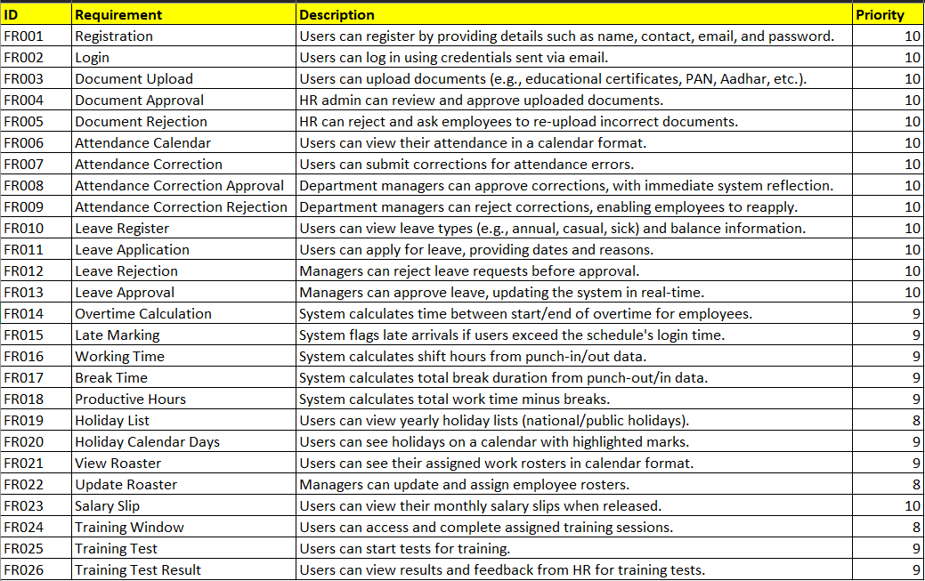

**10.Appendices**

1. List of Acronyms

* HR - Human Resources
* PAN - Permanent Account Number
* FR - Functional Requirement
* ID – Identifier

2.Glossary of Terms

* Registration: The process of creating a new account by providing personal information.
* Login: Accessing the system using pre-approved credentials.
* Document Upload: Submitting required documents, such as certificates, for verification.
* Document Approval: Verification and confirmation of uploaded documents.
* Document Rejection: Rejecting uploaded documents that do not meet the requirements.
* Attendance Calendar: A calendar showing attendance logs for a user.
* Attendance Correction: A user-requested correction for inaccuracies in attendance logs.
* Leave Register: A module to track and manage different types of leaves (e.g., annual, sick).
* Roaster: A schedule or assignment of work shifts for employees.
* Training Test: A module where users complete evaluations for a training session.

Related Documents

* System Requirement Specification (SRS): Defines technical specifications for implementing the business requirements.
* User Manual: A guide for end-users to navigate the system functionalities.
* HR Policies Document: Includes details on leave policies, attendance, holidays, and training rules.