1. **Audit:**

A "BA audit" for a Business Analyst typically involves reviewing their work processes, documentation, and project deliverables to assess their effectiveness in gathering requirements, analyzing data, communicating with stakeholders, and delivering solutions, often through a combination of document reviews, interviews with stakeholders, and evaluating project outcomes against defined criteria

It is divided into five parts

1. **Documentation part**
2. **Mailing part**
3. **Timesheet**
4. **Analysis part**
5. **Client interaction**

* In the first part audit examines the document for the product what are the requirements of the clients. What the client actually requires and what are the suggestions conferred by the business analyst
* In the second part the auditor keeps mail interaction with client and communication inside the team PM to team and PM to BA and other internal communication
* In the 3rd part the auditor examines the timesheet. The time frame which is given to the stakeholders and the time taken for completion of the project both should meet
* The 4th part is mainly dependent on analysis part. How much of funds is released till now and the remaining funds will be released based on the amount of work that has done
* The 5th part is the product handover to the client, delivering a product based on the clients expectation

1. **BA Approach Strategy**

BA approach strategy is a plan that describes how a business analyst will perform activities for a project. Approach basically includes how to do stakeholder analysis, What are the elicitation techniques, What all documents to be written, How to get the sign of the written documents from clients side, How change request has to be handled, How the project progress has to be updated to clients, How to give UAT signoff

**BA approach steps**

* Identifying the primary business objectives
* Defining the project scope
* Detailing project requirements
* Overseeing technical application
* Assisting in implementing the solutions
* Assessing the value generated by the project

**BA techniques**

* Process mapping, which involves creating visual representations of current processes
* Flowcharts, which depict the steps of a process

1. **3-tier architecture**

It basically has 3 layers

* Presentation tier – which is basically the user interface – its includes the login page, functionality and web and mobile app screens
* Application tier – where data is processed - Payment methods, rules included
* Data tier – where the data associated with application is stored and managed – company product and farmers data

1. **BA Approach Strategy for Framing Questions**

**5 W and 1H which BA needs to ask stakeholder:**

* What is the project about
* Why the project is initiated
* Who will be benefitted
* When it should be completed
* Whom should I connect with for the requirements
* How we can complete the project

**3-tier architecture**

It basically has 3 layers

* Presentation tier – which is basically the user interface – its includes the login page, functionality and web and mobile app screens
* Application tier – where data is processed - Payment methods, rules included
* Data tier – where the data associated with application is stored and managed – company product and farmers data

**Usecases:**

* Who is the primary user of the product
* What type of product will be sold online
* Placing and order confirmation
* Delivery and Tracking

**Activity Diagram:**

* Business functionality
* Business objective

**Modelling and page designs:**

* How will the webpage look
* Payment gateway
* Functionality working

1. **Elicitation Techniques:**

Elicitation techniques include brain storming, Document analysis, Stakeholder analysis, Prototyping, interview and survey

**Prototyping:** the practice of creating a simplified, interactive version of a proposed software system to gather feedback from users and stakeholders, helping to identify and refine key requirements early in the development process by providing a tangible representation of the system's functionality and design before full development begins.

**Stakeholder Analysis:** A stakeholder analysis is the process of identifying, prioritizing, and understanding the needs and expectations of all individuals or groups who are affected by or can influence a project, allowing the BA to plan and execute the project in a way that meets their interests and ensures their support**.**

**Interview:** This is the most common used elicitation technique. Here the interviewer asks questions to the stakeholders directly about the requirements**.** One to one interview is the commonly used technique. It can be both structured and unstructured format. Where the interviewer can ask set of predefined question or go empty without any preparations and ask on the sport questions

1. **Prototyping:** the practice of creating a simplified, interactive version of a proposed software system to gather feedback from users and stakeholders, helping to identify and refine key requirements early in the development process by providing a tangible representation of the system's functionality and design before full development begins.

**Document analysis:** This technique is used to gather business requirement by reviewing the existing business material. This process is used to identify the gaps in the process basically the AS-IS process and T0-BE business process. This is useful when the plan is to update an existing feature.

**Survey:** A set of questionaire is given to the stakeholder to know their thoughts. After collecting the responses the data is analysed to identify the area of interest. The questions should be direct and once the questions are ready ask the stakeholders to participate.

**Brainstorming**: This technique is used to identify new idea and find a solution for a issue. Usually SMEs or domain experts participate and they give number of ideas for the issues. Its is conducted in round table. It is basically conducted to answer questions like

* What are the expectations of the system
* What are the risk factors
* What are the organization rules to be followed
* How this type of issue can be prevented in future

1. **10 Business requirements**

* Login through mobile or email ID
* User should get product details when selected
* COD and all payment options should be available
* The application should have a login page and user should be able to create his own profile
* Once booking is done customer should get confirmation in email or mobile number
* Exchange option should be available
* Delay in delivery should be updated to customers
* Proper customer services should be available
* User should have an option to cancel the order and get the money back
* Post delivery feedback option should be available

1. **Assumptions:**

* The application should have login page
* It should allow the users to login through web application
* The user should be able to see the list of products once login is done
* The user should get the product details once the product is selected
* The user should have COD options
* He should be able to make the payments through netbanking/card or through UPI
* The user should get an option to return/exchange the product is there is any discrepancies
* The user should be able to provide feedback for the product received
* The user should have an option to cancel the order
* The user should be able to contact the customer services when he need any help regarding the product purchased

1. **Product requirement priority**

|  |  |  |  |
| --- | --- | --- | --- |
| **Req ID** | **Req Name** | **Req Description** | Priority |
| BR001 | Farmers search for products | Farmers should be able to search for available products, seeds, fertilizers | 8 |
| BR002 | Manufactures upload their products | Manufactures uploads their product along with description and pics in the website | 8 |
| BR003 | Login option | Farmers should be able to login to the application once they have created an account in the website | 10 |
| BR004 | Product information | Users should be able to see the product details once the product is selected | 5 |
| BR005 | Payment option | User should have an option to make payments through netbanking/card or UPI | 8 |
| BR006 | Return/exchange | user should get an option to return/exchange the product is there is any discrepancies | 5 |
| BR007 | provide feedback | user should be able to provide feedback for the product received | 4 |
| BR008 | cancel order | user should have an option to cancel the order | 7 |
| BR009 | contact customer services | user should be able to contact the customer services when he need any help regarding the product purchased/product | 5 |
| BR0010 | No limitation | Users should not have any limitation to book the product | 3 |

1. **Use case diagram**

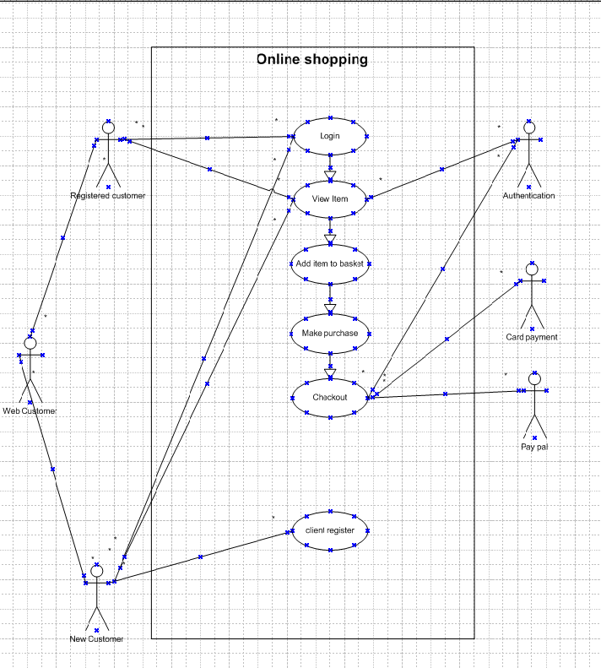

1. **Use case specs:**

|  |  |  |
| --- | --- | --- |
| **UC Name** | Login |  |
| **UC #** | 1.00 |  |
| **Primary Actor** | Registered Online User |  |
| **Use Case Story** | This use case enables the user to login and access the accounts online |  |
| **Trigger** | User enters User ID |  |
| **Pre-Condition** | 1. User needs to be a registered online user 2. User account must be active (not locked) |  |
| **Post-Condition** | User is able to view account summary page |  |
| **Primary Flow (PF)** | **Title:** User is able to login without any errors | |
| **Actor Action** | **System Response** |
| 1) User enters User ID |  |
| 2) User clicks 'Continue' button | 3) System validates User ID.  If valid, go to next step  If invalid, go to Alternate Flow 1 (AF1) |
|  | 4) System displays password page |
| 5) User enters Password |  |
| 6) User clicks 'Login' button | 7) System validates Password. If valid, go to next step If invalid, go to AF2 |
|  | 8) System displays Account Summary page |
|  |  |  |
| **Alternate Flow 1(AF1)** | **Title:** Invalid User Id | |
| **Actor Action** | **System Response** |
|  | 1) System displays the following error message: Invalid User ID. Please Re-try |
| 2) Go to Step 1 of PF |  |
|  |  |  |
| **Alternate Flow 2 (AF2)** | **Title:** Invalid Password | |
| **Actor Action** | **System Response** |
|  | 1) System calculates the password failure count. If password failure count is < 3, go to next step  else,  go to Exception Flow 1 (EF1) |
|  | 2) System displays the following error message: Invalid Password. Please Re-Try |
| 3) Go to step 5 of PF |  |
|  |  |  |
| **Exception Flow 1 (EF1)** | **Title:** Password failure count=3 | |
| **Actor Action** | **System Response** |
|  | 1) System locks the account the displays the following error message: Your account is locked. Please contact 1-800-XXX-XXXX to unlock the account. |

|  |  |  |
| --- | --- | --- |
| **UC Name** | **Adding item to shopping cart** |  |
| **UC #** | 2.00 |  |
| **Primary Actor** | Registered Online User |  |
| **Use Case Story** | This use case enables the user to add item into the shopping cart |  |
| **Trigger** | User searches product and adds into shopping cart |  |
| **Pre-Condition** | 1. User needs to be a registered online user 2. User account must be active (not locked) |  |
| **Post-Condition** | User is able to view the items added into the cart |  |
| **Primary Flow (PF)** | **Title:** User is able to login without any errors | |
| **Actor Action** | **System Response** |
| 1) User enters username |  |
| 2) User enters password |  |
| 3) User clicks 'Login' button | 4)The user is redirected to the home page of the application |
| 5) user clicks on search field and searches for the product |  |
| 6) User types the product name | 7)If the product is present it will be listed in the search page  else,  If product does not exist go to **AF1** |
| 8) User clicks on the product searched | 9) User will be taken to the information page of the product |
| 10) The user selects the quantity |  |
| 11) User clicks on add to cart button | 12) The items gets added to the shopping cart |
|  |  |  |
| **Alternate Flow 1(AF1)** | **Title: Searched item is not present** | |
| **Actor Action** | **System Response** |
|  | 1) System displays the following error message: Item doesnot exist |

|  |  |  |
| --- | --- | --- |
| **UC Name** | **Updating shopping cart** |  |
| **UC #** | 3.00 |  |
| **Primary Actor** | Registered Online User |  |
| **Use Case Story** | This use case enables the user to update items in the shopping cart |  |
| **Trigger** | User updates product in cart |  |
| **Pre-Condition** | 1. User needs to be a registered online user 2. User account must be active (not locked) |  |
| **Post-Condition** | User is able to update the items added to cart |  |
| **Primary Flow (PF)** | **Title:** User is able to login without any errors | |
| **Actor Action** | **System Response** |
| 1) User enters username |  |
| 2) User enters password |  |
| 3) User clicks 'Login' button | 4)The user is redirected to the home page of the application |
| 5) User clicks on search field and searches for the product |  |
| 6) User types the product name | 7)If the product is present it will be listed in the search page  else,  If product does not exist go to **AF1** |
| 8) User clicks on the product searched | 9) User will be taken to the information page of the product |
| 10) The user selects the quantity |  |
| 11) User clicks on add to cart button | 12) The item gets added to the shopping cart |
| 13)The user clicks on search field again |  |
| 14) User types in the search field and searches for another product | 15) If the product is present it will be listed in the search page  else,  If product does not exist go to **AF1** |
| 16) User clicks on the product searched | 17) User will be taken to the information page of the product |
| 18) The user selects the quantity |  |
| 19) User clicks on add to cart button | 20) The items gets added to the shopping cart |
|  |  |  |
| **Alternate Flow 1(AF1)** | **Title: Searched item is not present** | |
| **Actor Action** | **System Response** |
|  | 1) System displays the following error message: Item doesnot exist |
| 2) go to step 14 |  |

|  |  |  |
| --- | --- | --- |
| **UC Name** | **Making payment for the item added in the cart** |  |
| **UC #** | 4.00 |  |
| **Primary Actor** | Registered Online User |  |
| **Use Case Story** | This use case enables the user to add item into the shopping cart |  |
| **Trigger** | User makes payment |  |
| **Pre-Condition** | 1. User needs to be a registered online user 2. User account must be active (not locked) |  |
| **Post-Condition** | User is able to make payment to the items added to the cart |  |
| **Primary Flow (PF)** | **Title:** User is able to login without any errors | |
| **Actor Action** | **System Response** |
| 1) User enters username |  |
| 2) User enters password |  |
| 3) User clicks 'Login' button | 4)The user is redirected to the home page of the application |
| 5) User clicks on search field and searches for the product |  |
| 6) User types the product name | 7)If the product is present it will be listed in the search page  else,  If product does not exist go to **AF1** |
| 8) User clicks on the product searched | 9) User will be taken to the information page of the product |
| 10) The user selects the quantity |  |
| 11) User clicks on add to cart button | 12) The items gets added to the shopping cart |
| 13) The user clicks on the cart | 14) The cart opens with the list of items on it |
| 15) User clicks on proceed to payment button | 16) User will be redirected to the payment page with the list of all payment methods |
| 17)User selects the radio button for the respective payment method |  |
| 18) User clicks on use this payment method button | 19) User will be redirected to the payment gateway |
| 20) User enters the card details |  |
| 22) User clicks on make payment button |  |
| 23)user enter OTP | 24) If the payment is successful redirect to the order confirmation page  Else,  If the payment fails go to **AF2** |
|  |  |  |
| **Alternate Flow 1(AF1)** | | **Title: Searched item is not present** | |
| **Actor Action** | **System Response** |
|  | 1) System displays the following error message: Item doesnot exist |
|  | 2) go to step 6 |  |
| **Alternate Flow 1(AF2)** | **Title: Payment failure** | |
| **Actor Action** | **System Response** |
|  | 1) System calculates the OTP count. If failure count is < 3, go to next step  else,  go to Exception Flow 1 (EF1) System displays the following error message: “Payment failed” |
| 2) Go to step 17 |  |
|  |  |  |
| **Exceptional Flow 1(AF1)** | **Title:** OTP failure count=3 | |
| **Actor Action** | **System Response** |
|  | 1) System takes the user to the payment gateway page. Please retry after 24 hrs |

|  |  |  |
| --- | --- | --- |
| **UC Name** | Cancelling order |  |
| **UC #** | 5.00 |  |
| **Primary Actor** | Registered Online User |  |
| **Use Case Story** | This use case enables the user to cancel the order placed |  |
| **Trigger** | User cancels order |  |
| **Pre-Condition** | 1. User needs to be a registered online user 2. User account must be active (not locked) |  |
| **Primary Flow (PF)** | | **Title:** User is able to login without any errors | |
| **Actor Action** | **System Response** |
| 1) User enters username |  |
| 2) User enters password |  |
| 3) User clicks 'Login' button | 4)The user is redirected to the home page of the application |
| 5) User clicks on search field and searches for the product |  |
| 6) User types the product name | 7)If the product is present it will be listed in the search page  else,  If product does not exist go to **AF1** |
| 8) User clicks on the product searched | 9) User will be taken to the information page of the product |
| 10) The user selects the quantity |  |
| 11) User clicks on add to cart button | 12) The items gets added to the shopping cart |
| 13) The user clicks on the cart | 14) The cart opens with the list of items on it |
| 15) User clicks on proceed to payment button | 16) User will be redirected to the payment page with the list of all payment methods |
| 17)User selects the radio button for the respective payment method |  |
| 18) User clicks on use this payment method button | 19) User will be redirected to the payment gateway |
| 20) User enters the card details |  |
| 22) User clicks on make payment button |  |
| 23)user enter OTP | 24) If the payment is successful redirect to the order confirmation page  Else,  If the payment fails go to **AF2** |
| 25)go to user account |  |
| 26) Click on order history | 27) list of orders placed will be displayed |
| 27)Select the checkbox of the order that has to be cancelled |  |
| 28) Click on cancel order | 29) A pop up will be shown asking whether you want to cancel the order |
| 30)Click on yes | 31) A message “order cancelled” will be shown next to the order |
|  | |  |  |
| **Alternate Flow 1(AF1)** | | **Title: Searched item is not present** | |
| **Actor Action** | **System Response** |
|  | 1) System displays the following error message: Item doesnot exist |
| 2) go to step 6 |  |
| **Alternate Flow 1(AF2)** | | **Title: Payment failure** | |
| **Actor Action** | **System Response** |
|  | 1) System calculates the OTP count. If failure count is < 3, go to next step  else,  go to Exception Flow 1 (EF1) System displays the following error message: “Payment failed” |
| 2) Go to step 17 |  |
|  | |  |  |
| **Exceptional Flow 1(AF1)** | | **Title:** OTP failure count=3 | |
| **Actor Action** | **System Response** |
|  | 1) System takes the user to the payment gateway page. Please retry after 24 hrs |

1. **Activity diagram**

**Login :**

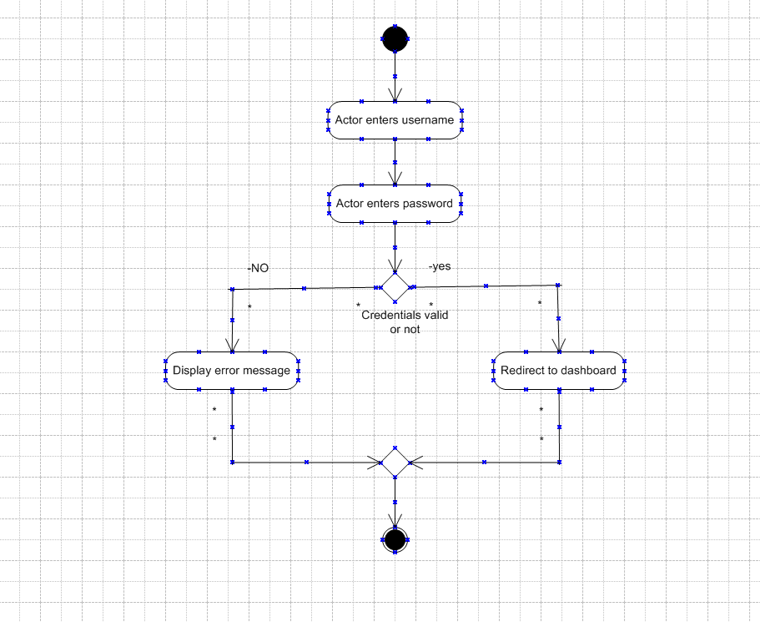

**Adding items to shopping cart:**

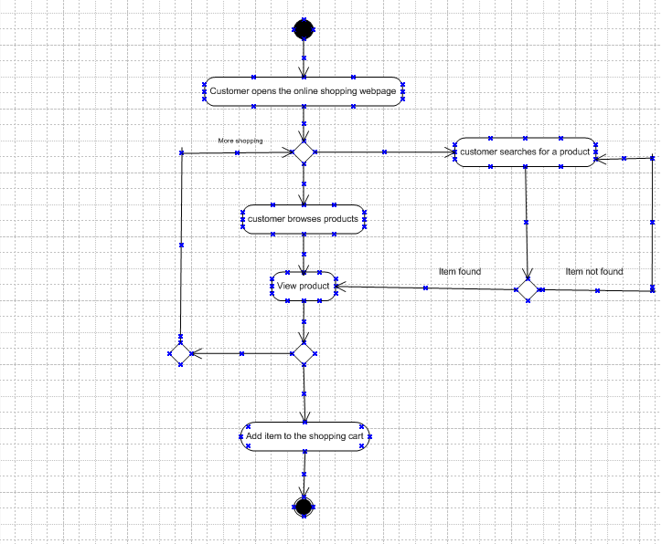

**Viewing the shopping cart:**

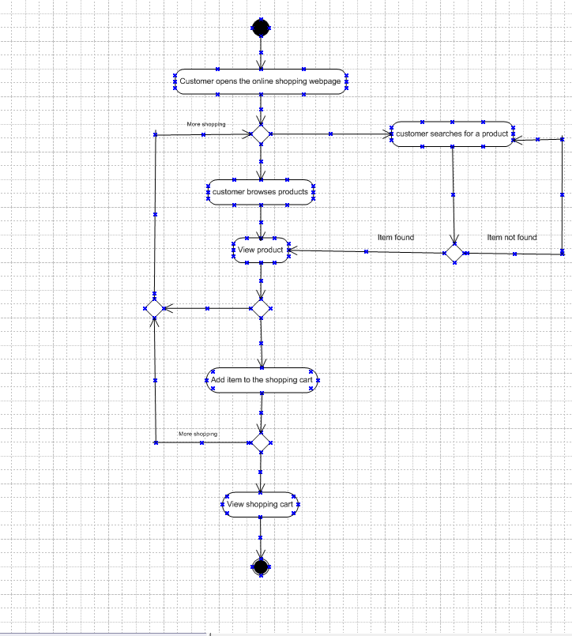

**Viewing and updating items in the shopping cart**

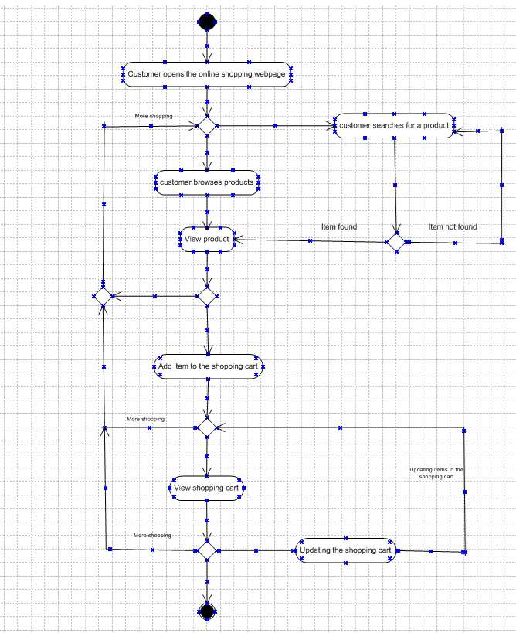

Making payment and checkout

