Project Prep 1 Case Part 2
Online Agriculture Products Store
1 Question
4 Quarterly Audits are planned Q1 , Q2, Q3, Q4 for this Project What is your knowledge on how these Audits will happen for a BA ?
Answer
Q1 – Requirement & Planning Audit Checklist
- Business requirements documented and signed off by stakeholders.
- Functional and non-functional requirements are clearly defined.
- Scope is well-defined with no ambiguities.
- Feasibility analysis and impact assessment completed.
- Stakeholder expectations and communication plan established.
- Project timeline and milestones validated.

Q2 – Development & Compliance Audit Checklist
- Requirements traceability maintained in project documentation.
- Development progress mapped against the planned timeline.
- Compliance with project methodology (Agile, Waterfall, etc.).
- Any scope creep, changes, or deviations documented and approved.
- Business rules and data validation are incorporated in development.

Q3 – Testing & UAT Audit Checklist
- Test cases mapped to business requirements and executed.
- Functional, system, integration, and performance testing completed.
- User Acceptance Testing (UAT) feedback documented and analyzed.
- Critical defects identified, reported, and fixed.
- Training and user documentation prepared.
- Compliance with security and data privacy regulations verified.

Q4 – Deployment & Post-Implementation Audit Checklist
- System deployed with all functionalities as per requirements.
- Farmer and manufacturer feedback collected and analyzed.
- Post-implementation issues logged and resolved.
- Performance and stability of the system assessed.
- Training sessions conducted for end-users.
- Lessons learned documented for future improvements.

2 Question
Before the Project is going to Kick Start, The Committee asked Mr Karthik to submit BA Approach
Answer
- What Elicitation Techniques to apply
Interviews: Conducting one-on-one interviews with stakeholders to gather detailed information about their requirements and expectations.
Surveys: surveys to collect feedback and preferences from a broader set of stakeholders.
Workshops: Organizing workshops to bring together different stakeholder groups for collaborative discussions.
- how to do Stakeholder Analysis RACI/ILS
Initially by listing all the individuals, groups, or organizations that have an interest or influence on the online agricultural product store project. They may include:
Farmers and suppliers, Customers, Management and executives, Business partners.
Creating a RACI (Responsible, Accountable, Consulted, Informed) or ILS (Informed, Listened to, Supported) matrix to define roles and responsibilities for each stakeholder in the project.
- What Documents to Write
Project Charter: This document which includes the project's objectives, scope, stakeholders, and high-level deliverables.
Business Case: The business case includes the project by outlining its benefits, costs, risks, and potential return on investment (ROI).
Business Requirements Document (BRD): The BRD describes the high-level business objectives, functional requirements, and constraints of the online agricultural product store.
Functional Requirements Document (FRD): The FRD provides more detailed descriptions of the specific features and functions of the website, including user stories, use cases, and workflows.
Non-Functional Requirements Document (NFRD): This document covers non-functional aspects such as performance, security, scalability, and user experience requirements.
- What process to follow to Sign off on the Documents
This process should involve stakeholders reviewing and approving the documents, ensuring their alignment with business needs and project objectives.
- How to take Approvals from the Client
To take approvals from the client establishing a formal process to obtain approvals from the client at stages of the project this may include conducting review meetings, walkthroughs, and obtaining written acceptance on deliverables.
- What Communication Channels to establish and implement
Establishing effective communication channels with stakeholders, including regular meetings, email, Video Conferencing, project management software, and collaboration platforms to facilitate efficient communication and information sharing.
- How to Handle Change Requests
To handle a change request this includes documenting change requests, assessing their impact on project scope, timeline, and budget, and obtaining appropriate approvals before implementing changes.
- How to update the progress of the project to the Stakeholders
To update the progress of the project to the Stakeholders this can be done through status reports, dashboards, and meetings to ensure transparency and keep stakeholders informed.
- How to take signoff on the UAT- Client Project Acceptance Form
To take signoff on the UAT- Client Project Acceptance Form Create a UAT plan, conduct test sessions, and obtain sign-off on the UAT results and the Client Project Acceptance Form to ensure the project meets the client's expectations.
3 Question
Explain and illustrate 3-tier architecture?
Answer
3-tier architecture, also known as multi-tier architecture, is a software design pattern that divides an application into three interconnected layers such as presentation layer, business logic layer, and data storage layer.
- Presentation Layer: The first tier, or the presentation layer, is the user interface that interacts directly with the end-users. This layer is responsible for presenting information to users and receiving their input. It typically includes the user interface components, such as web pages, mobile app screens, or desktop interfaces. The primary goal of this layer is to provide an intuitive and user-friendly experience.

- Application Layer: The second tier, often referred to as the application or business logic layer, acts as an intermediary between the presentation layer and the data storage layer. It contains the application's core logic, processing rules, and business functions. This layer handles user requests, processes data, and communicates with the data layer to retrieve or update information. It encapsulates the application's functionality and business rules, making it easier to modify or extend without affecting the user interface.

- Data Layer: The third tier, known as the data layer or data access layer, is responsible for managing and storing data. It interacts with databases, file systems, or external data sources. The data layer handles tasks like data retrieval, storage, and manipulation. Separating data-related operations into this tier ensures data integrity and allows for more efficient data management.

Illustration of 3 tier architecture

Presentation Layer (User Interface)
(Web browser or mobile app)

Application Layer (Business Logic)
(e-commerce)

Data Layer (Data Storage)
(Product, Customer, Order Data)
In this illustration, the Presentation Layer is the top tier and is responsible for the user interface and interaction with the end-users. It also includes the visual components, such as web pages, forms, buttons, and navigation menus, that users interact with.
The Application Layer, also known as the Business Logic Layer, serves as the intermediary between the presentation and data layers. It manages user authentication, order processing, and inventory management. This layer ensures that the business processes are executed correctly and efficiently.
The Data Layer is the lowest tier and is responsible for managing data storage and retrieval. This layer interacts with the database management system to execute queries and transactions.

4 Question

BA Approach Strategy for Framing Questions

Answer
5W 1H - Use the 5W 1H framework (Who, What, When, Where, Why, and How) to structure the questions. This framework ensures comprehensive coverage of the information needed. Start with broader questions and then delver into more specific details as necessary.
SMART - Framing the questions that are Specific, Measurable, Achievable, Relevant, and Time-bound. SMART questions will help to clarify requirements, gather specific information, and ensure that the responses are actionable and measurable. These criteria help ensure that goals are well-defined and have a higher likelihood of success.
RACI - Consider the RACI (Responsible, Accountable, Consulted, and Informed) matrix to identify the roles and responsibilities of stakeholders. This will help you determine who should be involved in decision-making, who should provide input, and who needs to be informed about certain aspects.
Tier Architecture - Understand the three-tier architecture of the system and its components. This will help to ask questions related to the system's presentation layer, business logic layer, and data storage layer. Seek clarity on how information flows between these layers and how they interact with each other.
UML – It provides a visual representation of an aspects of a system, it is a standardized way of diagramming and modeling software system to aid design, development and communication between members.
Page design – It is useful for creating an effective and visually appealing online presence that can attract and retain visitors.

5 Question
As a Business Analyst, What Elicitation Techniques you are aware of? ( BDRFOWJIPQU)
Answer
Brainstorming - Brainstorming is a creative and collaborative technique used to generate a wide range of ideas and solutions for a specific problem or topic. It involves a group of individuals coming together to freely share their thoughts, ideas, and suggestions, often in a spontaneous and non-judgmental manner.
Document Analysis - This involves the systematic review and examination of documents to gather information, insights, or requirements for a specific project or inquiry. This technique is particularly useful when you need to extract knowledge, details, or data from existing documents, such as reports, manuals, contracts, research papers, or any textual information.
Requirements Workshops - Conducting facilitated sessions with stakeholders to gather requirements, clarify doubts, resolve conflicts, and ensuring collaboration among participants.
Interviews - One-on-one or group discussions with stakeholders to gather detailed information, understanding their perspectives, and uncover specific requirements.
Focus Groups -In a focus group, a skilled facilitator guides a structured discussion where participants share their thoughts, ideas, and experiences related to the subject. The interaction within the group can lead to a deeper understanding of the topic, uncovering both shared and diverse viewpoints.
Observation – This involves directly watching and taking notes on people's actions, behaviors, and interactions in a natural or controlled setting. It is a valuable method for gathering information and understanding various aspects of a subject without relying only on what people say. It focuses on what people do.
Prototyping – This involves creating simplified, visual representations of a product, system, or concept to gather feedback, refine ideas, and clarify requirements
Questionnaires and Surveys -This involve the systematic collection of information and opinions from a group of individuals. These techniques typically use a structured set of questions to gather data on a particular topic, and they are commonly employed in research, market analysis, and requirements gathering.
User Stories - User stories helps to capture the requirements, needs, and expectations of end-users and stakeholders in a format that is easy to understand and prioritize.
Use Cases - Describing interactions between actors (users) and the system to illustrate how the system should behave and what actions it should support. These elicitation techniques provide various approaches to engage stakeholders, gather their insights, and understand their requirements effectively.

6 Question

Which Elicitation Techniques can be used in this Project and Justify your selection of Elicitation Techniques?

Answer
Answer
Prototyping: Prototyping can be utilized to gather feedback and validate the requirements for the online agriculture product store. As the application needs to be user-friendly, creating a prototype can help visualize the user interface and functionalities. It allows stakeholders, including Mr. Henry's friends and other potential users, to provide feedback on the proposed solution and make necessary refinements before development. Prototyping enables visualization, feedback, and refinement of the user interface and functionalities, ensuring a user-friendly application.

Use Case Specs: Use case specifications can be employed to capture the interactions and sequences of actions between the various actors (farmers, manufacturers, and the online store) and the system being developed. By documenting use cases, the project team can identify the specific functionalities and requirements needed to facilitate the communication and transactions between farmers and manufacturers. Use case specs provide a structured approach to elicit, validate, and prioritize the requirements for the online store. Use case specifications help in capturing the specific interactions and functionalities required for the online store, facilitating effective communication and transactions between farmers and manufacturers.

Document Analysis: Document analysis can be useful to understand the existing challenges faced by farmers and the requirements expressed by Mr. Henry's friends. Analyzing any available documentation, such as reports on agricultural issues, farming practices, or market research, can provide insights into the specific problems related to procuring fertilizers, seeds, and pesticides. It helps in identifying the key main points and requirements that the online store needs to address. Document analysis assists in understanding the existing challenges faced by farmers and extracting requirements from the given scenario and any available documentation related to agriculture and farming practices.

Brainstorming: Brainstorming sessions can be conducted with the stakeholders, including Mr. Henry, Peter, Kevin, and Ben, to gather their perspectives and insights. The session can focus on discussing the challenges faced by farmers, potential features and functionalities of the online store, and any additional requirements that may arise during the discussion. Brainstorming encourages collaboration and creativity, allowing for the exploration of innovative solutions and capturing comprehensive requirements. Brainstorming encourages active participation from stakeholders and facilitates the generation of diverse ideas and requirements, ensuring comprehensive coverage of the stakeholders' needs.

7 Question
10 Business Requirements

Answer
BR001 – The online product store should be able to use in mobile devices which will be convenient for the farmers

BR002 – Farmers should able to create user accounts using their E-mail ID to buy the products

BR003 – They should able to login through their registered E-mail ID

BR004 – The online store should have product catalog of fertilizers, seeds, pesticides, and the information about the products, price, availability about the product

BR005 – Farmers should be able to browse the product through search option to search for any product

BR006 – Farmers should be able to add the product to the wishlist and add to card so that they can buy later

BR007 – The platform should provide various payment methods such as cash-on-delivery, credit / debit card, UPI options

BR008 – Customers should able to receive the E-mail once they get confiriming their order details

BR009 – customers should able to track the order

BR010 – The information provided by the farmers should be secured which includes payment details and personal information

BR011 – Farmers should able to rate the products, give feedback, reviews which helps to know about their experience
8 Question
Assumptions

Answer
- Having reliable internet access to use the online platform
- A user can login using face book or google account
- User may have online accounts for secured payment processing
- providing adequate customer support to address inquiries and issues promptly
- platform should meet a certain level of quality and safety standards
- To provide accurate product information and handle their personal data and financial transactions
- Users will engage with the online store, browse products, and make purchases
- Safe delivery and logistics services are available to fulfill orders and deliver products to customers
- Farmers should willing and interested in listing their products on the platform
9 Question
use case diagram
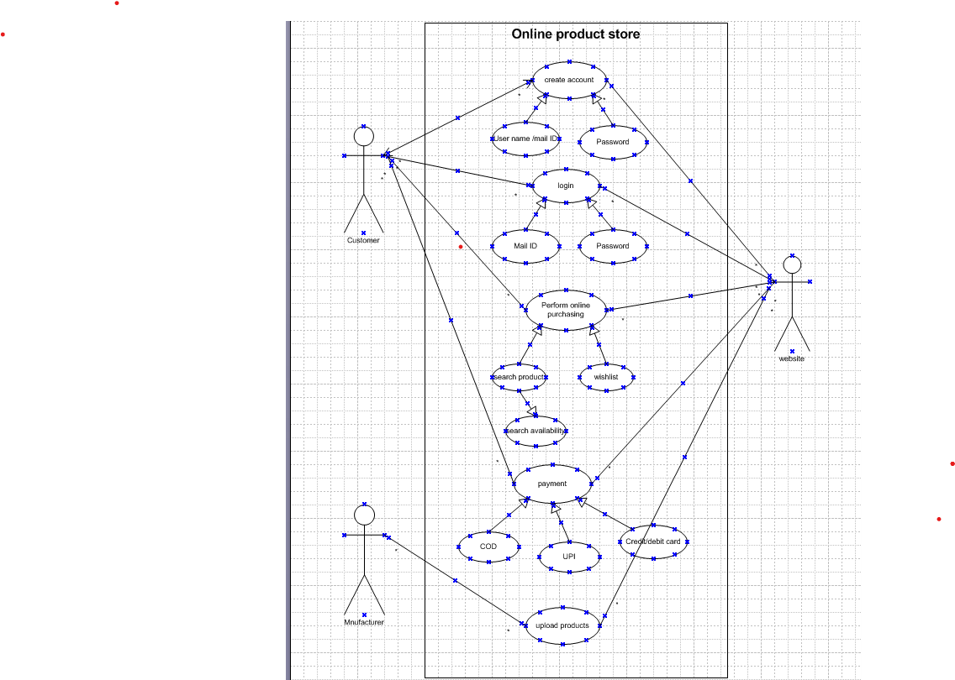
10 Question
(minimum 5) Use Case Specs

Use case ID | UC001
Usecase Name | User registration
Actor | Farmer/customer
Description | A customer can create a new account
Pre- condition | The customer has a valid E-mail address
Post- condition | The customer account is created and registered in the system.
Basic flow | The system presents a registration form which includes Name, E-mail, password, phone number
Alternative flow | The e-mail address entered by the customer already registered
Exceptional | Incomplete details and password
Assumptions | Customers are willing to provide accurate information

Use case ID | UC002
Usecase Name | User login
Actor | Farmer/ customer
Description | Customer can login into their own accounts
Pre- condition | Valid E-mail and password
Post- condition | Successfully logged into the account
Basic flow | Username & password are correct
Alternative flow | - Password is wrong  - Username is wrong  - Username & password are wrong
Exceptional | - Forgot password  - Forgot username
Assumptions | Customers have registered account with valid E-mail address and password

Use case ID | UC003
Usecase Name | Product catalog
Actor | Farmer/customer
Description | The customer can search for specific products within the catalog
Pre- condition | The customer is logged into the system
Post- condition | The customer can view the product catalog
Basic flow | The customer can search for specific products
Alternative flow | The customer selects a product catalog
Exceptional | The customer does not find the product
Assumptions | The product catalog is kept with relevant product information

Use case ID | UC004
Usecase Name | Purchase & wish list
Actor | Customer/ Farmer
Description | The customer can buy and can add products to wish list for future purchase
Pre- condition | The customer is logged into their account
Post- condition | The customer is successfully added to their wish list
Basic flow | The customer selects a product they wish to add to their wish list
Alternative flow | If the product is already in the customers wish list, the system informs the customer and provide the option like remove the product from the wish list
Exceptional | Customers can access their wish list from their account profile
Assumptions | Customer can view their wish list from their account profile

Use case ID | UC005
Usecase Name | Payment gateway
Actor | Customer/Farmer
Description | The customer can choose and complete the payment for the purchase
Pre- condition | The customer has selected the payment method
Post- condition | The store receives an order confirmation
Basic flow | The online store updates the order status based on the payment outcome
Alternative flow | If the payment is declined, the customer will informed about the declined payment
Exceptional | The customer can retry the payment or choose alternative methods
Assumptions | The payment gateway supports multiple payment methods, including credit/debit card, cash on delivery and UPI

11 Question
(minimum 5) Activity Diagrams
Answer
Activity diagram – registration process
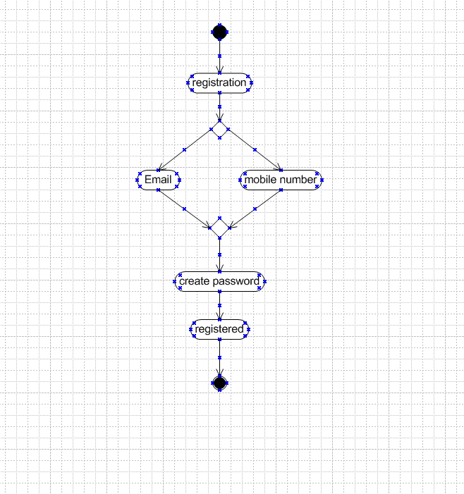

Activity diagram – user login page
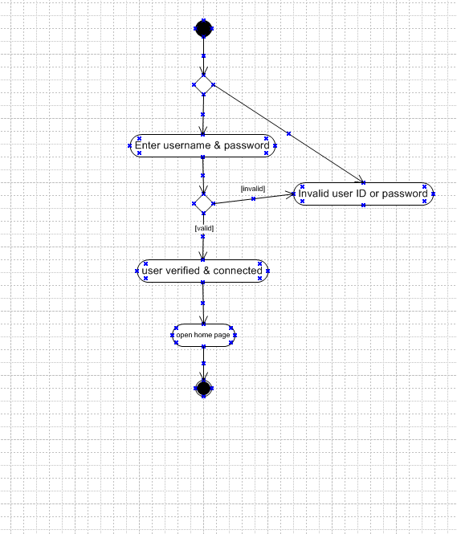
Activity diagram – Product catalog
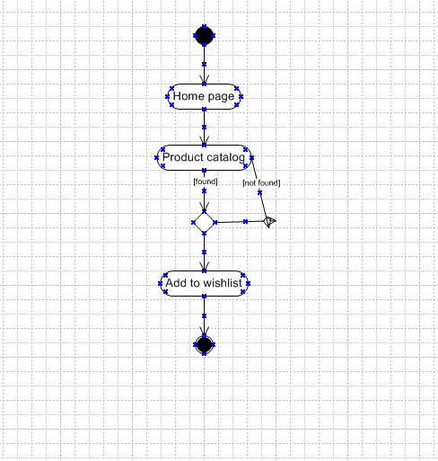
Activity diagram – Purchase or wishlist
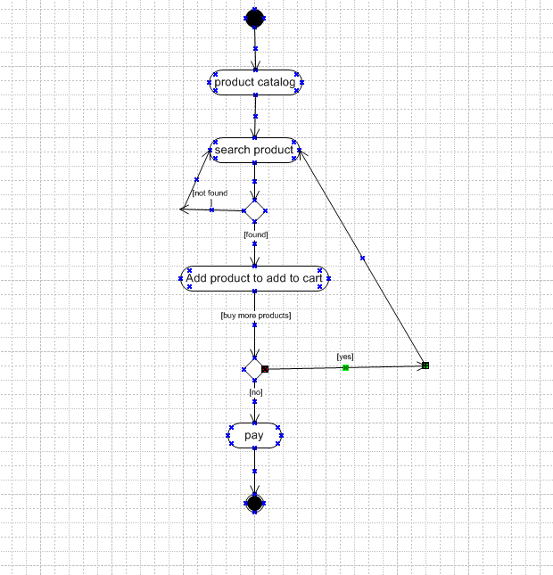
Activity diagram – payment gateway

