**Q1. 4 Quarterly Audits are planned Q1 , Q2, Q3, Q4 for this Project. What is your knowledge on how these Audits will happen for a BA ?**

As a business analyst, I understand that quarterly audits are crucial to reviewing the work and understanding how well a company sustains operational efficiency and controls accounting processes while complying with its standard rules and regulations. Conducting audit from time to time, ensure the firms are aligned with the project goals and that the company's financial reporting is accurate.

*Q1:- Planning and Requirement Phase:*

|  |  |  |
| --- | --- | --- |
| Week | Activity | BA Responsibility |
| 1 - 2 | Project kickoff | Participating in the kickoff meeting with Mr. Henry and other business stakeholder (Mr. Peter, Mr. Kevin and Mr. Ben) to finalize the initial requirements and understanding the documentations. |
| 3 - 4 | Stakeholder Elicitation | Conducting initial interview session with Mr. Peter, Mr. Kevin and Mr. Ben and drafting Business Requirement Document(BRD) |
| 5 - 6 | Requirement Analysis | Analyzing gathered requirement for clarity, completeness and consistency. Share BRD draft with Mr. Vandanam (PM) and Mr. Kartik (Delivery Head) for feedback. |
| 7 - 8 | BRD and FRS Preparation | Focusing on the initial scope (seeds, fertilizers, pesticides, basic listing, and display). Updating BRD and start traceability matrix linking requirements to goals. |
| 9 | Stakeholder Validation and Sign-off | Presenting the initial BRD to Mr. Peter, Mr. Kevin, and Mr. Ben for feedback and validation. Incorporating feedback and updating the BRD. Sharing documents with stakeholders for feedback and sign-off |
| 10 - 11 | Technical Feasibility and Requirement Traceability Matrix | Collaborating with Ms. Juhi (Senior Java Dev) to validate technical feasibility ensuring requirements are clear and well-documented. Refining the Requirements Traceability Matrix (RTM) to link requirements to FSD components. Preparing for the Q1 Audit. |
| 11 -12 | Audit Preparation | Gathering initial documents for Q1 audit (BRD, FRS, RTM, stakeholder meeting records) |
| 13 | Q1 Audit | Participating in Q1 audit meeting, present BRD, stakeholder engagement summary, RTM to audit committee |

*Q2:- Design, Frist Development and Testing iteration:*

|  |  |  |
| --- | --- | --- |
| Week | Activity | BA Responsibility |
| 14 | Post-Audit Follow-up and Sprint Planning | Reviewing Q1 audit findings and addressing any action items from the Q1 audit. Collaborating with Ms. Juhi aligns to ensure developers align with requirements and break them into stories. |
| 15 | Test Plan Review | Draft test scenarios for key features with Mr. Jason and Alekya. |
| 16 - 20 | Design Phase and Development Support | Working with Ms. Juhi and dev team to translate requirements into UI/UX mock-ups design for the mobile application interfaces and website design, focusing on key user flows for both manufacturers and farmers, Detailing the specific requirements for the mobile applications (Android and iOS) and website building answer questions, provide clarifications on requirements, and participating in sprint review meetings to Support team with any challenges in coding development. |
| 21-23 | Component Design and System Testing | Actively participating and reviewing the system test plan and test cases to ensure comprehensive coverage of all functional and non-functional requirements for the developed components. Preparing business scenarios and test data for system testing. Validating that the system behaves as expected from a user perspective. |
| 24 | RTM and SRS Updates | Updating RTM based on changes & progress. Update SRS with design details and share with Mr. John (DB Admin) for schema input. |
| 25 | Internal Review and Audit Preparation | Assess progress by conducting internal reviews with the project team. Prepare design documents, updated RTM, updated SRS, updated FRS, progress report and change request log |
| 26 | Q2 Audit | Participate in Q2 audit meeting, present design progress, RTM progress, justify changes, requirement implementation, any challenges and note action items. |

*Q3: Second Development and Testing iteration and UAT Planning:*

|  |  |  |
| --- | --- | --- |
| Week | Activity | BA Responsibility |
| 27 - 29 | Post-Audit Follow-up and Requirements Elaboration | Review Q2 audit findings and addressing any action items from the Q2 audit. Based on the feedback from the first iteration and any new insights, further elaborating on the remaining requirements and refining user stories for the next set of features to be developed. |
| 30 - 34 | Mid-project status review | Continuing to manage change requests, update documentation, and provide clarifications to the development and testing teams for the second iteration. |
| 35 - 36 | System Testing 2 | Participating in system testing of the complete integrated system, focusing on the new features and ensuring that the previously developed functionalities are still working as expected. |
| 37 | UAT Planning | Collaboration with stakeholders in planning for User Acceptance Testing (UAT). Defining UAT scenarios and test data based on key business processes. Verification that the UAT plan aligns with the project goals and stakeholder expectations. |
| 38 | Audit Planning | Compile dev progress, test results, and system test plans. Identifying delays or budget issues with Mr. Kartik. Practice presentation and address gaps. |
| 39 | Q3 Audit | Present development, testing results, readiness for UAT and highlight CSR impact |

*Q4: UAT testing, Finalize and Deployment:*

|  |  |  |
| --- | --- | --- |
| Week | Activity | BA Responsibility |
| 40 - 41 | Final Requirements Review and Documentation | Conducting a final review of all requirements documentation to ensure completeness and accuracy. Finalizing user manuals and training materials in collaboration with the technical writing team. |
| 42 - 45 | Final Development Review | Ensure development aligns with BRD (e.g., multilingual support). All modules should aligned to business requirements. |
| 46 - 48 | System Testing 3 | Participating in final system testing and regression testing to ensure the stability and readiness of the application for deployment. Verifying that all critical defects have been resolved. |
| 49 | UAT Execution | Record UAT feedback, will log change requests if requires. Finalize acceptance test scripts |
| 50-51 | Audit Planning | Ensure critical defects are fixed, gather test reports, user guides, and plans. Practice full presentation with Mr. Vandanam and Assisting him to prepare for knowledge transfer. Finalize RTM, BRD, FRS, CR logs for records and create manuals for farmers and manufacturers. |
| 39 | Q4 Audit | Attending final reviews with delivery head and sponsor and secure approval from Mr. Henry and team. |

**Q2. Before the Project is going to Kick Start, The Committee asked Mr Karthik to submit BA Approach Strategy**

**Write BA Approach strategy (As a business analyst, what are the steps that you would need to follow to complete a project – What Elicitation Techniques to apply, how to do Stakeholder Analysis RACI/ILS, What Documents to Write, What process to follow to Sign off on the Documents, How to take Approvals from the Client, What Communication Channels to establish n implement, How to Handle Change Requests, How to update the progress of the project to the Stakeholders, How to take signoff on the UAT- Client Project Acceptance Form )**

As a Business Analyst, my sole objective is to act as a bridge between stakeholders and the development team to ensure the successful delivery of a solution that meets business needs. My strategy aims to provide a clear understanding of the requirements and ensure successful project delivery within the 18-month timeline and INR 2 crore budget under the CSR initiative.

At the outset, I will review the high-level project charter, understand the business goals, and engage with key stakeholders to comprehend the current state, pain points, and desired outcomes.

1. Elicitation Technique: To gather comprehensive requirements from stakeholders (Mr. Henry, committee members, and potentially manufacturers), I will apply the following elicitation techniques:

* Interviews: One-on-one sessions with Mr. Henry and his friends (Peter, Kevin, Ben) to understand business needs such as required products and services expected.
* Brainstorming: We will plan a brainstorming session where the problem will be presented in front of the participants and participants can provide their input without any criticism. The goal is to gather as many ideas as possible. A scribe will document the ideas so that all participants can see what ideas are listed so that there is no overlap.
* Workshops: Will enable collaborative sessions to define features, and prioritize requirements. This will encourage shared understanding and high-level business needs.
* Questionnaires/Surveys: Useful for capturing input from wider stakeholder groups, distributed survey forms in different languages to potential farmers and manufacturers (if accessible) to gather input on usability and product details.
* Observation: Understand the actual flow of current operations. While direct observation of farmers and manufacturers might not be feasible, we can gather insights from farmers' existing practices and challenges through stakeholder interviews. If possible, visit agricultural settings to observe farmer needs first hand.
* Document Analysis: Will review any possible existing documents, market research, or competitor analysis on agricultural e-commerce platforms or CSR guidelines for best practices to understand current processes.

1. *Stakeholder Analysis:* Will create a comprehensive list of stakeholders including internal (e.g., business heads, SMEs, developers, QA) and external (e.g., clients, vendors) stakeholders. Group them based on their roles such as Decision-makers, Influencers, Users, Contributors, and Approvers. A RACI (Responsible (R), Accountable (A), Consulted (C), Informed (I)) matrix.

RACI Matrix:

|  |  |  |  |  |  |  |  |  |  |  |
| --- | --- | --- | --- | --- | --- | --- | --- | --- | --- | --- |
|  | Me (BA) | Mr. Henry (Owner/Sponsor) | Mr. Peter,  Mr. Kevin, Mr. Ben (Stakeholders) | Mr. Karthik (Delivery Head) | Mr. Vandanam (PM) | Ms. Juhi (Senior Java Dev) | Mr. Teyson,  Ms. Lucie, Mr. Tucker, Mr. Bravo  (Java Devs) | Mr.  Mike (Network Admin) | Mr. John (DB Admin) | Mr. Jason, Ms. Alekya  (Testers) |
| Requirement Gathering | R | A | C | I | C | I | -- | -- | -- | -- |
| Analysis | R | A | C | C | C | I | I | -- | -- | -- |
| Design & Planning | C | A | C | C | R | C | C | C | C | I |
| Feasibility Study | C | I | I | A | R | C | C | C | C | I |
| Development | I | -- | -- | I | C | A | R | C | C | I |
| Database Management | I | -- | -- | I | C | C | C | -- | R | I |
| Infrastructure Setup | I | -- | -- | I | C | C | C | R | -- | I |
| Testing | I | I | -- | I | C | C | C | -- | -- | R |
| UAT | R | A | C | I | C | C | C | I | I | R |
| Deployment | I | I | -- | I | A | C | C | R | R | I |
| Project Monitoring | C | I | I | A | R | I | I | I | I | I |
| Go-Live & Support | I | A | C | C | R | C | C | C | C | C |

1. *Documents to Write and Review:* Drafted based on elicitation and validated against business needs in a clear, concise, and structured manner for shared understanding and traceability.

* Business Requirement Document (BRD): Captures high-level business needs, goals, and objectives. It will outline the features, expected benefits, scope, stakeholders, and overall vision.
* Software Requirement Specification (SRS): Detailed technical requirements for the development team. It covers non-functional requirements, system interactions, and data flows.
* RTM (Requirement Traceability Matrix): Links requirements to design, development, testing artifacts, and deliverables.
* Use Case Document: Describes user interactions with different users (farmers and manufacturers)
* Test Scenarios (Collaboration with Testers): Defines acceptance and system test cases, and how the requirements will be tested.
* User Manual: Guides for farmers and manufacturers post-deployment.

1. *Process to Sign Off on Documents:* To formally acknowledge and agree upon the documented requirements with the key stakeholders.

* Document Preparation: Prepare documents with input from stakeholders and the team based on elicitation in clear and well-organized requirements documents (BRD, User Stories, Use Cases, etc.) and validate against business needs.
* Review Meetings: Share drafts with Mr. Vandanam, Mr. Kartik, and the committee for feedback via email or workshops.
* Review Meeting: Schedule review meetings with relevant stakeholders (primarily Mr. Henry, Mr. Peter, Mr. Kevin, and Mr. Ben) to present the documented requirements and take their feedback.
* Final Sign-off: Obtain formal sign-off on the finalized requirements documents through digital signature or email confirmation.

1. *Approvals from the Client:* To ensure that the client (Mr. Henry) is informed and provides necessary approvals throughout the project lifecycle.

* Initial Alignment: Present the BRD/SRS during the kickoff meeting for preliminary approval. Afterward, each document version will be sent with a change log through clear and consistent communication channels like official email channels .
* Milestone Approval: Seek approvals at key stages (e.g., design completion, prototype demo) via review meetings or email confirmations.
* Follow-Up: Conduct follow-up calls or meetings if feedback is pending.

1. *Communication & Collaboration Strategy:* To establish and implement effective communication channels to ensure timely and transparent information flow among all stakeholders.

* MS Teams: Daily syncs, quick discussions, and file sharing with Mr. Henry, Peter, Kevin, and Ben.
* Email Communication: For formal updates, weekly status reports, document sharing, quick clarifications, and approvals.
* Jira and Confluence Tracker: Use a tool like Jira or Confluence Tracker for task tracking and team coordination.
* Monthly Review Meetings: Share progress, risks, and changes. Showcase the developed application to stakeholders for feedback and alignment.

1. *Change Request Handling:* To establish a structured process for managing changes to the agreed-upon requirements.

* Change Request Submission: All change requests must be formally submitted with a clear description of the proposed change via email or a change request form, detailing impact.
* Impact Assessment: A detailed analysis will be conducted to understand the impact of the change on requirements, design, development, testing, and documentation.
* Evaluation: Assess and review the impact on scope, budget (INR 2 crore), and timeline (18 months) with Mr. Vandanam and Ms. Juhi.
* Approval Workflow: Present to Mr. Henry and the committee for approval document in the Change Request Log will be required for significant changes.
* Implementation: If approved, the requirements documents, design, and project plan will be updated accordingly. Update BRD/SRS and traceability matrix; notify the team of changes.
* Communication: Notify stakeholders through email and all change requests will be tracked in a change request log, including their status, impact, and resolution.

1. *Project Progress Reporting:* To keep all stakeholders informed about the project's progress, milestones achieved, and any potential risks or issues.

* Status Reports: Email concise reports with milestones achieved, risks, and next steps during the weekly/bi-weekly internal team meetings and the periodic stakeholder update meetings.
* Dashboards: Utilize Gantt charts, burndown charts, or other visual tools like Power BI or Excel to illustrate the project timeline and progress against milestones.
* Real-time: Showcasing working functionalities provides tangible evidence of progress through Jira dashboards and Confluence pages to identify issues and their status to the relevant stakeholders.

1. *User Acceptance Testing (UAT) and Client Project Acceptance:* To ensure that the developed application meets the client's expectations and is ready for deployment.

* UAT Preparation: Define clear UAT test scenarios based on the agreed-upon business requirements and use cases, involving Mr. Peter, Mr. Kevin, and Mr. Ben.
* UAT Execution: Schedule a UAT session with Mr. Henry and the committee to validate the application. Facilitate and support the stakeholders during the UAT execution phase. Ensure they have the necessary test environment and guidance.
* Defect Management: All issues are logged in Jira with timelines for fixes. Establish a clear process for logging, tracking, and resolving any defects identified during UAT.
* Sign-Off: Once the stakeholders are satisfied that the application meets the agreed-upon requirements all critical defects are closed, and no open issues remain. Request signatures from Mr. Henry; retain a copy for records.

**Q3. Explain and illustrate 3-tier architecture?**

The 3-Tier Architecture, also known as the three-layer architecture, is a client-server software architecture that separates an application into three distinct layers, or tiers. The purpose of this architecture is to improve modularity, maintainability, scalability, reliability and flexibility of the software system.

**Application Layer**

* Screen
* Page
* Validation on Page
* Company specific logic
* Functionality
* All Reusable components
* Frequently changing components
* Governing body rules & regulations
* Compliances e.g., UPI

**Business Layer**

**Data Layer**

* Database components connection to database
* *Application Layer:* This tier represents the user interface of the application and is responsible for presenting data to the user and receiving user input. It includes the graphical user interface (GUI) components, such as web pages, forms, and widgets.
* *Business Layer:* This tier contains the business logic of the application and performs the core processing of the data. It is responsible for processing user requests, retrieving and manipulating data, and performing complex operations. It acts as a middle layer between the client and the database server which are used to exchange partially processed data.
* *Data Layer:* This tier is responsible for managing the data storage and retrieval in the system. It includes the database or file system where data is stored, as well as the data access layer (DAL) that interacts with the database to read and write data.

**Q4. Business Analyst should keep What points in his/her mind before he frames a Question to ask to**

**the Stakeholder**

**( 5W 1H – SMART – RACI – 3 Tier Architecture – Use Cases, Use case Specs, Activity**

**Diagrams, Models, Page designs)**

As a Business Analyst, using the **5W1H** framework to ensure covering all essential dimensions of a requirement, process, or issue. It helps us to gather essential information from the stakeholders. This tool is used to extract the following requirements from the clients:

* Who: Who are the actors involved? Who benefits? Who is affected? This helps to identify the relevant stakeholders (e.g., Farmers, Manufacturers, Admin, Mr. Henry, and committee members for insights).
* What: What is the system supposed to do? What are the data elements involved? What are the business rules? Clearly define the subject of the question to gather specific requirements or clarifications (e.g., features, constraints).
* When: When does this process occur? When are certain actions triggered? Consider the project timeline to prioritize urgent needs or phase-specific inputs (e.g., 18-month schedule).
* Where: Where does this process take place? Where is the data stored or accessed? Determine the context or platform to focus questions on appropriate stories (e.g., web portal, mobile app)
* Why: Why is this requirement important? Understand the purpose or business value to align questions with stakeholder objectives (e.g., improve user experience).
* How: How does this process currently work? How should it work in the future? How will the system support this? How will it be implemented or work? Explore the method or process to ensure feasibility within budget and resources (e.g., authentication, flow).

The **SMART** technique is used to formulate requirements queries. A properly constructed requirement should comply with **SMART**:

* Specific: Frame questions to avoid ambiguity, focusing on a single aspect. e.g., What attributes should be shown in product detail? Or can you specify the types of seeds to be included in the product list?
* Measurable: Include criteria to quantify responses, e.g. How many farmers do you expect to use the app in the first year?
* Attainable: Ensure questions target realistic outcomes within the given budget and given timeline. e.g. Is it achievable to limit payment methods to two within the budget?
* Relevant: Align questions with project goals and stakeholder priorities. e.g. Is multilingual assistance suitable to enhance farmer accessibility? Or how does this help farmers or increase sales?
* Time-bound: Connect questions to certain results. e.g. By when should the registration feature be ready for testing?

When examining the processes and responsibilities, the **RACI Matrix** is used to frame questions to clarify roles.

* Responsible: Identify who will perform the task related to the task at hand. e.g. Who is responsible for implementing the search feature?
* Accountable: Determine the decision-maker to direct approval-related questions. They are in charge of making sure the work is relevant and accurate. e.g. Who is accountable for approving the BRD?
* Consulted: Engage subject matter experts for technical insights. They give criticism or suggestions regarding the work being done on a project. e.g. Who needs to be consulted before a decision is made?
* Informed: Ensure questions explain who is required to be informed about a project's development. These people are not involved in making decisions but must be aware of developments and maintain transparency since they may have an impact on their work. e.g. Who needs to be informed about the progress?

Request answers to learn how the requirement affects each layer in **3 tier architecture** if the solution needs:

* Application Layer: Focus on UI and user interaction. Ask about UI/UX, page design, and accessibility. e.g. How should this data be presented to the user?
* Business Layer: Address business logic and processes. Ask about processing, rules, and validations. e.g. What business rules need to be applied to this data?
* Data Layer: Explore data storage and management. Ask about data inputs, outputs, storage, and integrity. e.g. Where will this data be stored and how will it be accessed?

**Use Cases and Use Case Specs** Ask inquiries about the connections between actors and the system. Ensure questions elicit details for all relevant use cases. Frame questions to gather specifics for use case elements. Inquire about alternative flows or unusual circumstances to

improve the requirements.

**Activity Diagrams** are Illustrations of a sequence of events or control flow in a system that resembles data flow diagrams. Design questions to map out activity sequences. Identify decision criteria for branches in the flow. Clarify transitions between activities. e.g. Are there any decision points or parallel activities that are missed?

**Model** use pre-existing or draft as guidance when you ask questions. There are 3 types of models:

* Data Models: Ask about data entities and relationships. e.g. Are these the correct entities and attributes?
* Process Models: Explore business processes. e.g. Who is involved in each activity?
* Conceptual Models: Seek clarity on high-level concepts. e.g. How should the system model farmer empowerment metrics?

Visual aids are used by **Page Designs** to gather feedback. Frame questions about layout and navigation. Ensure questions cover interactive elements. Address usability for diverse users. e.g. Is the layout intuitive? Or What should the product listing page include?

**Q5. As a Business Analyst, What Elicitation Techniques you are aware of?**

**(BDRFOWJIPQU)**

As a Business Analyst, I am aware of a wide range of elicitation techniques to gather accurate, relevant, and complete information from stakeholders. The acronym BDRFOWJIPQU helps remember a comprehensive set of elicitation techniques:

|  |  |  |
| --- | --- | --- |
| Letter | Technique | Explanation |
| B | Brainstorming | A collaborative technique to generate ideas related to a specific topic or problem by encouraging free-flowing input from stakeholders. Captures diverse perspectives quickly, ideal for the initial scope definition. |
| D | Document Analysis | Review existing documents such as business plans, process flows, reports, policies, procedures, system specifications, etc. to understand the current state, identify existing requirements, and uncover potential gaps. Provides a baseline for requirements, reducing dependence on stakeholder memory. |
| R | Reverse Engineering | Analysing an existing system or process to understand its components, functionalities, and underlying principles, especially in inheritance systems. Identifies unspoken requirements and gaps, useful for leveraging existing solutions within budget constraints. |
| F | Focus Group | Gathering insights and opinions from a small targeted group to collect feedback, perceptions, and expectations on suggested features. |
| O | Observation | Watching stakeholders perform tasks to understand their work, processes, interactions, and challenges in first hand. Uncovers unnoticed requirements by using real-world instances. |
| W | Workshop | Facilitated sessions with stakeholders to define, prioritize, and finalize requirements. Highly interactive. |
| J | Joint Application Development | A structured workshop involving key stakeholders, developers, and BA to collaboratively define and agree on requirements. Accelerating requirements gathering and design, enabling collaboration between business and IT, and resolving complex issues quickly. |
| I | Interview | One-on-one conversations with stakeholders to gather detailed information about their needs, expectations, and perspectives. It can be structured, semi-structured, or unstructured. Allows for personalized, in-depth exploration of stakeholder needs. |
| P | Prototype | Creating a working model or mockup of the proposed solution to visualize requirements and elicit feedback from stakeholders. Prototypes can range from low-fidelity sketches to high-fidelity interactive models. Validates UI/UX requirements early, reducing rework. |
| Q | Questionnaire/ Survey | Distributing a set of written questions to a large number of stakeholders to collect quantitative and qualitative data. Efficiently gathers input from a wide audience, supporting sustainability. |
| U | Use Case Specs | Capturing requirements from the user’s perspective on how users will interact with the system to achieve specific goals. Focuses on user needs, aligning with Activity Diagrams and Use Cases. |

**Q6. Which Elicitation Techniques can be used in this Project and Justify your selection of Elicitation Techniques?**

**Prototyping**

**Use case Specs**

**Document Analysis**

**Brainstorming**

For the implementation of this Online Agriculture Store, I would prefer to use the following elicitation technique:

* Prototyping:  prototyping—particularly sketches and mockups of key screens (like Registration, Product Search, and Order Tracking)—will be crucial to visualizing the user experience for both farmers and manufacturers. This will help us to elicit feedback in the early stage not only to understand the layout, navigation, and key elements of the application required but also the technical knowledge of the users that will help to prepare future user manuals and avoid costly changes later.
* Use Case Spec: This will assist us in outlining the system's and actors' functional interactions. Vital for specifying the sequence of operations for functions such as order placement, search, and log-in. This technique will help us in building appropriate test cases and UAT scenarios.
* Document Analysis: If there are any existing manual processes, brochures, local market practices documentation, or even competitor analysis reports related to agricultural product sales, analyzing these documents can provide us with valuable context and initial requirements. Examining any relevant agricultural regulations, trade practices, or business rules by the Government can help us identify restrictions and obligatory requirements for the platform
* Brainstorming: It will help us to generate a wide range of ideas for features, functionalities, and potential challenges. It can help us to uncover specific needs or preferences of the different agricultural communities that might not be immediately noticeable such as if any stakeholder other than the business stakeholders is from an agricultural background from a different area then his/her inputs will be crucial.

**Q7. Make suitable Assumptions and identify at least 10 Business Requirements.**

|  |  |  |
| --- | --- | --- |
| Req Id | Req Name | Req Description |
| BR001 | Farmers search for products | Farmers should be able to search for available products such as fertilizers, seeds, pesticides |
| BR002 | Manufacturer upload their product | Manufacturers should be able to upload and display their products in the application |
| BR003 | Farmer Registration and Login | Farmers should be able to register for an account and securely log in to the application to access personalized features (e.g., saved items, order history - future). |
| BR004 | Manufacturer Registration and Login | Manufacturers should be able to register their business and create secure login credentials to manage their product listings. |
| BR005 | Multilingual Language Support | The system should support multiple regional languages to enhance farmer accessibility. |
| BR006 | Category-wise Product Display | Products should be listed by category (Seeds, Fertilizers, Pesticides) and by crop types. |
| BR007 | Product Detail Display | Farmers should view detailed product information in their own language (e.g., usage instructions, expiry date). |
| BR008 | Contact Manufacturer Option | Farmers should have a way to contact the respective manufacturers for inquiries or support related to specific products (e.g., through a contact form or displayed contact information). |
| BR009 | Payment Gateway Integration | The application should integrate a payment gateway to process transactions (e.g., UPI, cards) for product purchases by farmers. |
| BR010 | Order Placement and Tracking | Farmers should be able to place orders and track their order and delivery status in real-time. |

**Q8. List your assumptions**

Some of my Assumptions are:

1. The platform is targeted at Indian farmers and agricultural manufacturers.
2. The payment gateway will support multiple payment methods (e.g., UPI, credit/debit cards) to cater to diverse farmer preferences in India.
3. There will be a need for user account management for farmers and manufacturers.
4. User data privacy and compliance with the IT laws of India will be ensured by the development team.
5. Manufacturers are assumed to have a verified license or registration number to be eligible to onboard.
6. Mr. Henry and his friends (Peter, Kevin, and Ben) will be available throughout the project lifecycle to clarify requirements.
7. The system should provide some level of customer support.
8. The application will be developed for both Android mobile platforms and web browsers.
9. The farmers and manufacturers will have basic digital literacy or receive training under CSR.
10. The project will utilize a 3-tier architecture (Application, Business and Data tiers) to support scalability and maintainability within the budget and timeline.

**Q9. Give Priority 1 to 10 numbers ( 1 being low priority – 10 being high priority) to these Requirements after discussions with the stakeholders**

|  |  |  |  |
| --- | --- | --- | --- |
| Req Id | Req Name | Req Description | Priority |
| BR001 | Farmers search for products | Farmers should be able to search for available products such as fertilizers, seeds, pesticides | 10 |
| BR002 | Manufacturer upload their product | Manufacturers should be able to upload and display their products in the application | 9 |
| BR003 | Farmer Registration and Login | Farmers should be able to register for an account and securely log in to the application to access personalized features (e.g., saved items, order history - future). | 9 |
| BR004 | Manufacturer Registration and Login | Manufacturers should be able to register their business and create secure login credentials to manage their product listings. | 8 |
| BR005 | Multilingual Language Support | The system should support multiple regional languages to enhance farmer accessibility. | 8 |
| BR006 | Category-wise Product Display | Products should be listed by category (Seeds, Fertilizers, Pesticides) and by crop types. | 6 |
| BR007 | Product Detail Display | Farmers should view detailed product information in their own language (e.g., usage instructions, expiry date). | 7 |
| BR008 | Contact Manufacturer Option | Farmers should have a way to contact the respective manufacturers for inquiries or support related to specific products (e.g., through a contact form or displayed contact information). | 6 |
| BR009 | Payment Gateway Integration | The application should integrate a payment gateway to process transactions (e.g., UPI, cards) for product purchases by farmers. | 5 |
| BR010 | Order Placement and Tracking | Farmers should be able to place orders and track their order and delivery status in real-time. | 4 |

**Q10. Draw use case diagram**

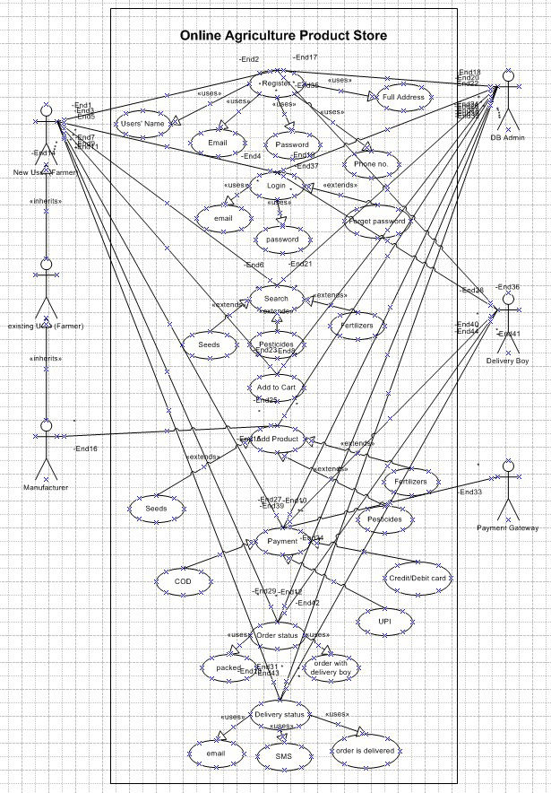

**Q11. Prepare use case specs for all use cases**

|  |  |
| --- | --- |
| Use Case Specs - Registration | |
| Description | Enables a farmer or manufacturer to register for an account with the application. |
| Actor | Farmer, Manufacturer |
| Pre-Condition | The user has a valid email or mobile number. |
| Post-Condition | The user has a verified account and can log in. |
| Basic Flow | * The user navigates to the registration page. * The user enters details (users’ name, email, password, phone no.   and address)   * The user submits the registration form. * The system validates the entered information. * If validation is successful, the system will create a new account. |
| Alternative Flow | If the email/mobile is already registered, the system prompts the user to log in or reset the password. |
| Exceptional Flow | * If the user exceeds the maximum number of failed login attempts, the system may lock the account and provide instructions for recovery (e.g., via email). * If there is an error accessing the user account information in the database, the system displays a generic error message. * If there is a network issue during submission, the system displays a connection error message. |
| Assumption | The user remembers their registered email and password. |
| Constraints | Password attempts may be limited. Account lockout policy may be in place. |
| Dependencies | Database connectivity, email verification service |
| Input-Output | * Input: User details * Output: Registration success message |
| Business Rules | Users must provide a unique email/mobile to register. |
| Misc. Info | CAPTCHA may be required to prevent bots |

|  |  |
| --- | --- |
| Use Case Specs - Login | |
| Description | Allows a registered farmer or manufacturer to log in to the application using their credentials. |
| Actor | Farmer, Manufacturer |
| Pre-Condition | The user has a verified account with valid credentials. |
| Post-Condition | The user is successfully logged in and accesses the dashboard. |
| Basic Flow | * The user navigates to the login page. * The user enters email and password. * The system validates the credentials. * The system grants access to the user dashboard. * The use case ends successfully. |
| Alternative Flow | If credentials are incorrect, the system allows three retry attempts before locking the account. |
| Exceptional Flow | If the account is locked, the user must use the "Forgot Password" option. |
| Assumption | Passwords are encrypted and stored securely in the Data Tier. |
| Constraints | Login must support high concurrency for rural users. |
| Dependencies | Depends on UC002 (Registration) and the Application Tier for authentication. |
| Input-Output | * **Input**: Email, password. * **Output**: Dashboard access or error message. |
| Business Rules | Accounts lock after three failed login attempts. |
| Misc. Info | To be reviewed during Q2 audit; traceability to BR003/BR004. |

|  |  |
| --- | --- |
| Use Case Specs - Product Search and Category-wise Browsing | |
| Description | Enables farmers to search products and view them by category |
| Actor | Farmer |
| Pre-Condition | Farmer is logged in |
| Post-Condition | Matching products are displayed |
| Basic Flow | * The Farmer enters a keyword (e.g., "seeds", "fertilizer name") into the search bar or selects a product category (Seeds, Pesticides, Fertilizers). * The system receives the search query or category selection. * The system searches the product catalogue based on the entered keywords or selected category. * The system retrieves a list of matching products, potentially including name, brief description, and price. * The system displays the search results to the Farmer. |
| Alternative Flow | * No results → display “No products found” * The system updates the displayed list accordingly. |
| Exceptional Flow | If there is an error in the search engine, the system displays an error message and prompts the Farmer to try again later. |
| Assumption | The product catalogue is up-to-date and accurately indexed for searching. |
| Constraints | Category filters must be mutually exclusive |
| Dependencies | Product listing database |
| Input-Output | * **Input:** Search keywords or selected category from the Farmer. * **Output:** List of matching products displayed to the Farmer. |
| Business Rules | Only available products are shown |
| Misc. Info | Frequency of use: High (a core function for farmers). |

|  |  |
| --- | --- |
| Use Case Specs - Manufacturer Product Upload | |
| Description | Allows a logged-in manufacturer to add a new product listing to the online store. |
| Actor | Manufacturer |
| Pre-Condition | Manufacturer is logged in |
| Post-Condition | Product is visible in store |
| Basic Flow | * The Manufacturer navigates to the "Add Product" page. * The system displays a form with fields for product details. * The Manufacturer enters the product details and uploads product images. * The Manufacturer submits the product form. * The system validates the entered information. * If validation is successful, the system saves the product information and images to the database. * The system displays a confirmation message to the Manufacturer. |
| Alternative Flow | * If the Manufacturer enters invalid data in any field or misses required fields, the system displays error messages. * If there is an issue uploading images, the system displays an error. |
| Exceptional Flow | * If there is an error saving the product information, the system displays an error message. * If there is an error storing the uploaded images, the system displays an error. |
| Assumption | Manufacturer is verified |
| Constraints | Only authenticated manufacturers can upload |
| Dependencies | Manufacturer Logs In must have been successfully executed. |
| Input-Output | * **Input:** Product info * **Output:** Upload confirmation |
| Business Rules | Product details must adhere to defined formats and validation rules. |
| Misc. Info | SKU auto-generated |

|  |  |
| --- | --- |
| Use Case Specs - Order Placement, Payment and Tracking | |
| Description | Farmers place orders and pay using Net Banking, COD, or UPI. They can also track their orders in real time. |
| Actor | Farmer |
| Pre-Condition | * The farmer is logged in and has chosen a product. * A purchase has been made. |
| Post-Condition | The order is confirmed, the payment is completed, and the order status is shown. |
| Basic Flow | * The farmer selects a product and proceeds to payment. * The farmer chooses a payment method (e.g., UPI, card). * The system redirects to the payment gateway. * The farmer enters payment details and confirms. * The system confirms the payment and updates the order status. * The farmer navigates to “Order History” * Selects order * System fetches and displays live order status |
| Alternative Flow | * If payment fails, the system allows the farmer to retry with a different method. * If the status is not yet updated, "Awaiting update" will appear. |
| Exceptional Flow | * If the gateway is unavailable, the farmer is notified to try later. * If the tracking server goes down, a static status with a retry option is displayed. |
| Assumption | * Payment gateway integration (e.g., Paytm, Phonepay, Gpay) is available within budget. * Delivery system integration is active |
| Constraints | Only two payment options are allowed due to financial limitations, and tracking is only accessible following dispatch. |
| Dependencies | Depending on what application stage for purchase evidence, courier, or delivery API, as well as the order placement |
| Input-Output | * **Input:** * payment method, and billing details (card number, UPI ID) * Order ID * **Output:** * Payment confirmation or failure message. * Status (e.g., Packed, Shipped, Delivered) |
| Business Rules | * Payment must be completed within 15 minutes to reserve the order. * Only user who placed the order can view its status. |
| Misc. Info | If funds permit, the status can be color-coded (green for delivered, for example) and postponed until Q4. |

**Q12. Activity diagrams**

Registration Diagram:

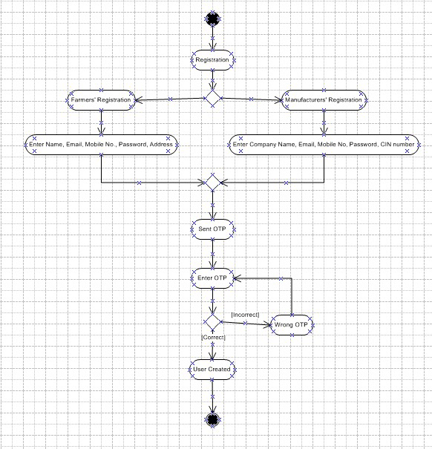

Login Diagram:

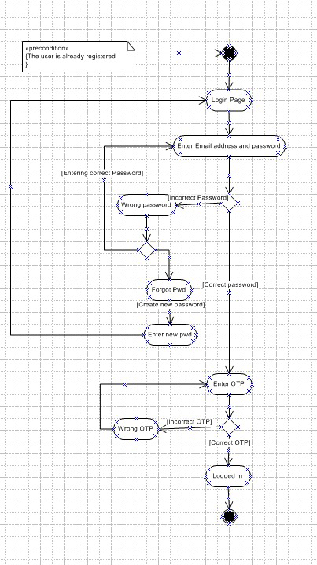

Add or Update the products:

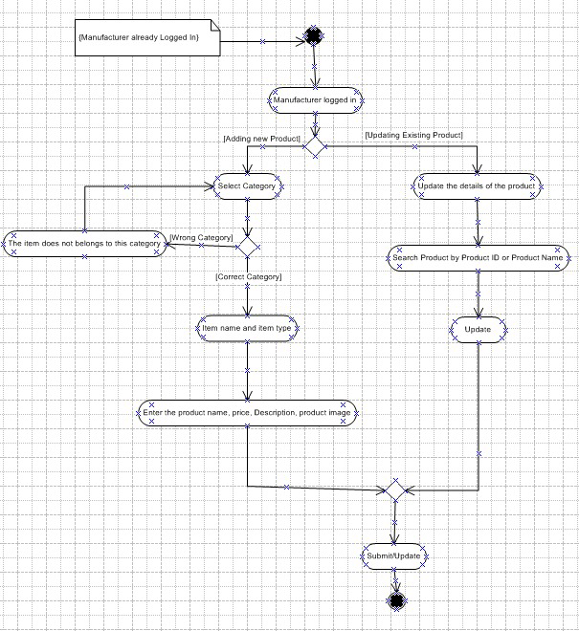

Searching the Product and Add to cart

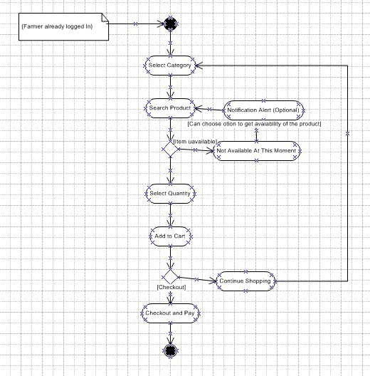

Payment and Delivery:

