**Question 1 – Audits - 5 Marks**

**4 Quarterly Audits are planned Q1 , Q2, Q3, Q4 for this Project What is your**

**knowledge on how these Audits will happen for a BA ?**

**Answer :-**Regular checks on the different phases and tasks involved in the Project.

These Audits happen on regular intervals and help understand progress of the project ,

And the to ensure that project Meets the object defined .

|  |  |  |
| --- | --- | --- |
| STAGE | QUARTER 1 Audit Repoort (Requirement gathreing ) | QUARTER 2 Audit Repoort (Requirement anallysis phase) |
| COMPLETED | 10 Weeks (Week 1 to 10) | 7 Weeks (Week 16 to 23) |
| CHECKLIST | BRD | UML Diagrams |
|  | Elicitation | Business to functional requirements mapping |
|  | Duplicate requirement report | Client signoff- Documets |
|  | Grouping of functionalities/feature client signoff | RTM Document version control |
|  | Email communicationTo,CC, BCC | Email communicationTo,CC, BCC |

|  |  |  |
| --- | --- | --- |
| STAGE | QUARTER 3 Audit Repoort (Design) | QUARTER 4 Audit Repoort (Developement) |
| COMPLETED | 7 Weeks (Week 30 to 37) | 20 Weeks (Week 40 to 60) |
| CHECKLIST | Utilisation of tools | JAD session Report |
|  | Documented Evidence on client communication | End User manual preparation |
|  | Stakeholder MOM | BA and Developer MOM |
|  |  |  |
|  | Email communicationTo,CC, BCC | Email communicationTo,CC, BCC |

|  |  |
| --- | --- |
| STAGE | QUARTER 5 Audit Repoort (Test) |
| COMPLETED | 20 Weeks (Week 58 to 78) |
| CHECKLIST | Test Case Summary |
|  | Training report to end user |
|  | lessons learnt documets |
|  |  |
|  | Email communicationTo,CC, BCC |

**Question 2 – BA Approach Strategy -** 6 Marks

**Answer : -**

What elicitation tech to apply: Requirement elicitation technique is the process of probing the information from the stakeholders, Requirement elicitation serves the foundation in documenting the requirements. Some of the Elicitation tech are as follows

Brainstorming, Documents analysis, Reverse Engineering, Focus groups, Observation,

JAD session etc.

How to do Stakeholder Analysis: Stakeholder analysis can be done by RACI matrix ,

Involves identifying stakeholders, Defining their roles and responsibilities within a project.

What documents to write: BRD, FRD, Use Case Documentation, Test case Documentation Etc.

What process to follow to sign off on the Documents: Signoff to be taken on the SRS document , Signoff can be taken by using mail confirmation from the client.

How to take approval from the client: Establish a formal meeting with the client, keep them informed and take regular feedback.

What communication channels to establish and implement: regular meeting, weekly status meeting, by weekly sprint meeting. monthly stakeholder update.

How to handle change request: CR form , do impact analysis, approval process Documentation.

How to update progress of the project to the stakeholder: monthly stakeholder update, weekly status meeting.

How to take signoff on the UAT – (Client project acceptance form) : Preparation UAT , Conduct UAT, FIX Issue , Acceptance form, Final Review meeting Obtain signoff.

**Question 3 – 3-Tier Architecture - 5 Marks**

**Explain and illustrate 3-tier architecture?**

Answer:-

APPLICATION LAYER: - Top most layer of the architecture, also known as Presentation Layer , It handles the user interface (UI) Components such as screens and pages.

BUSINESS LOGIC LAYER: - Middle layer of the architecture, Acts as an intermediary between the presentation layer and data storage layer. Layer contains core logic of the application. Ex . Printer or Payment gateway.

DATABASE LAYER: -

Bottom most layer of the architecture – responsible for storing and retrieving the data.

MS SQL, Oracle database.

**Question 4 – BA Approach Strategy for Framing Questions – 10 Marks**

**Answer :-**

1. 5W 1H Framework is usefull in obtaining the information and understanding a situation by answering the about (Why, What, Who, Where, When and How) .

* Who will use this application?
* What is the goal of this project , What prob are we trying to solve?
* Who is going to use this application/ Project?
* When this project will get completed?
* Why this particular feature is important ?
* How the project will be implemented ?

2. Confirm the Requirement is SMART before accepting it for development. A well informed requirement should be Smart . Specific, Measured , Actionable, Realistic, Traceable .

3.Stakeholder analysis –RACI Matrix , help define and clarify the roles and responsibilities within a team by obtaining who is Responsible , Accountable, Consulted, Informed for each task.

4.UML or Unified modelling language is a standardised way of diagramming and modelling software system to aid in design development and communication between team member.

**Question 5 – Elicitation Techniques - 6 Marks**

**As a Business Analyst, What Elicitation Techniques you are aware of? ( BDRFOWJIPQU)**

**Answer : -**

* **Brainstorming :** Brainstorming can be done individually or in group the ideas collected can be reviewed and analyse to be included in the system requirement. Ideas can come from the stakeholder/users. Not more then 8-12 people.
* **Documents analysis:** you may have a documentation of your existing system which could provide some input for the new system req.
* **Reverse Engineering :** (For migration project)In the situation where the software of an existing system has little or outdated documentation then it is necessary to understand that what sys actually does. Reverse engineering is an elicitation tech that can extract implementation requirement from the software code.

**Black box RE: The system/Product is studied without examining its internal structure.**

**White box RE: The inner working of the system is studied.**

* **Focus groups :** Focus group of 8-12 people share their elicit idea and attitude about a specific product .The participants share their impressions, preferences needs guided by a moderator.

Homogenous:

Heterogenous:

* **Observation :** observing shadowing users or even doing part of their jobs can provide information about the systems, processes, inputs and outputs. Passive and active.
* **Workshops** : Workshop may comprise 6-12 stakeholder working together to identify requirements. Workshop tend to be of a defined duration rather than outcome and may need to be briefly repeated in order to clarify or obtain further details.
* **JAD (Joint app developement) session:** is and extended and facilitated workshop.

It involves collaboration b/w stakeholder and system analyst to identify need and requirements in a concentrated and focused efforts.

* **Interview :** Interview the users or the stakeholders of the product is important for making a effective software. Without knowing there expectation we are highly unlikely to deliver the expected product. Interviewee should ask relevant questions and document the stakeholders response.
* **Prototyping** : Screen mockups can help the requirement gathering process when introduced at the time but if introduced too early can become problematic.
* **Questionnair(Survey) :** questionnaire can be useful for obtaining limited system requirement from the users. who have minor input or geographically remote. Design of the questionnaire and type of question is important and can influence the ans.

**Question 6 – This project Elicitation Techniques - 5 Marks**

**Which Elicitation Techniques can be used in this Project and Justify your selection of Elicitation Techniques?**

Brainstorming , JAD and questionnaire.

**Question 7 – 10 Business Requirements- 10 Marks**

**Make suitable Assumptions and identify at least 10 Business Requirements.**

BR001: User should be able to Search Agri products from the catalog.

BR002: User should be able to browse product through catalog.

BR003: User need to create User ID through Email and Password.

BR004: User should be able to add item to wish list.

BR005: User should be able to login using email id and secure password.

BR006: User should be able to pay through Cards / UPI or COD.

BR007: User should get the order status on mail.

BR008: User should get the Invoice over message and Watsapp and Email ID.

BR009: User Must get the ETA / track the product once the order is placed.

BR010: User should get the notification once the goods are available in stock.

**Question 8 –Assumptions- 5 Marks**

**List your assumptions**

**Answer: -**

Assumption 1- Farmers/Users have knowledge about good brands and agri Products.

Assumption 2- Due to government scheme and penetration of Banking, Farmer will be using Online banking/UPI for payments.

Assumption 3 – With large variety of options available farmers will prefer the online Web application.

Assumption 4 – Everyone is using the smartphones nowadays so must have an Email ID.

**Question 9 – This project Requirements Priority - 8 Marks**

|  |  |  |  |
| --- | --- | --- | --- |
| Req ID | Req name | Requirement description | Priority |
| BR001 | User search the product | User should be able to Search Agri products from the catalog. | 5 |
| BR002 | User browse the product | User should be able to browse product through catalog. | 4 |
| BR003 | User Create login | User need to create User ID through Email and Password . | 1 |
| BR004 | Add to wish list | User should be able to add item to wish list. | 10 |
| BR005 | User Login | User should be able to login using email id and secure password. | 3 |
| BR006 | Payment gateway | User should be able to pay through Cards / UPI or COD. | 6 |
| BR007 | check order status | User should get the order status on mail. | 7 |
| BR008 | Receive Invoice | User should get the Invoice over message and Watsapp and Email ID . | 8 |
| BR009 | User receives ETA and track order | User Must get the ETA / track the product once the order is placed . | 9 |
| BR010 | Update the catalog. | Manufacturer should be able to update the items in catalog | 2 |

**Question 10 – Use Case Diagram - 10 Marks**

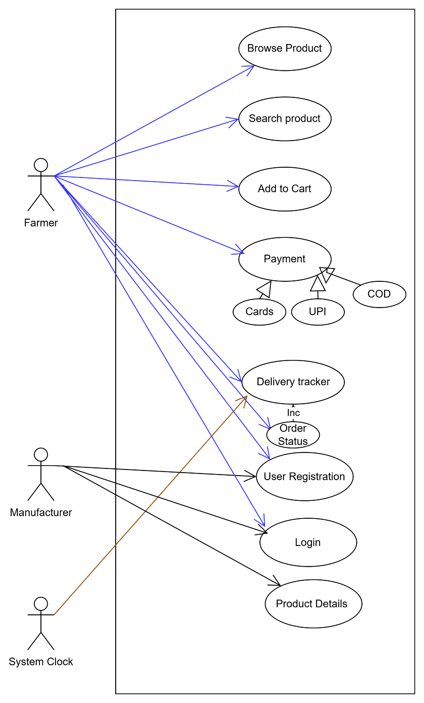

**Question 11 – (minimum 5) Use Case Specs - 15 Marks**

**Prepare use case specs for all use cases**

|  |  |
| --- | --- |
| Usecase ID | UC001 |
| Usecase name | Login |
| Created By | ABC |
| Date Created | 12-04-2025 |
| Actor | User ,Database |
| Description | Usecase discription of how the user can login into the application |
| Pre Condition | User should be registered with username and password |
| Post Condition | Successfully login into the system. |
| Normal flow of events/Basic flow | Login page appears as website home page.  User enters the Email ID and Password already created during reg.  User click on the login button .  User Successfully login to the application and land on the catalogue page. |
| Alternate flow | Login page appeared as the home page.  User click one the forgot password button.  User enters Email ID and click on reset password.  Receives reset password link on the Email .  Reset the password from the link . |
| Exception | Due to low/no internet connectivity , error pls check internet connection. |
| Frequency of use | High |
| Assumptions | It is assumed that user is registered  It is assumed that user has basis tech knowledge. |

|  |  |
| --- | --- |
| Usecase ID | UC002 |
| Usecase name | Add to Cart |
| Created By | ABC |
| Date Created | 20-01-2025 |
| Actor | User , Product DB |
| Description | Usecase discription of how the user can add product to cart |
| Pre Condition | User should be registered with username and password |
| Post Condition | Successfully added product to cart. |
| Normal flow of events/Basic flow | * User will login using email ID and password. * User will browse the products available in the cart. * User will select one or multiple product from the cart. * User will select Add to cart option. |
| Alternate flow | If user not able to find the product he can search the product by product name/ Comp name . |
| Exception | Product is out of stock , user may order later |
| Frequency of use | High |
| Assumptions | It is assumed that user is registered  It is assumed that the product catalog is updated on regular basis |

|  |  |
| --- | --- |
| Usecase ID | UC003 |
| Usecase name | search |
| Created By | ABC |
| Date Created | 21-03-2025 |
| Actor | User , Product DB |
| Description | Use case description of how the user can search and add to cart |
| Pre Condition | User should be registered with username and password |
| Post Condition | Successfully added product to Cart. |
| Normal flow of events/Basic flow | * User will login using email ID and password. * User will browse the products available in the cart. * User not able to find the product while browsing. * User can use the search option provided to sarch product by name or comp name . * User will select Add to cart option. |
| Alternate flow | User not able to find the product, they can send email requirement . |
| Exception | Product is out of stock , user may order later |
| Frequency of use | High |
| Assumptions | It is assumed that user is registered  It is assumed that the product catalog is updated on regular basis |

|  |  |
| --- | --- |
| Usecase ID | UC004 |
| Usecase name | Place order |
| Created By | ABC |
| Date Created | 25-01-2025 |
| Actor | User , Product DB, Bank DB |
| Description | Use case description of how user can order the product. |
| Pre Condition | User should be registered with username and password |
| Post Condition | Successfully placed order on the application. |
| Normal flow of events/Basic flow | * User will login using email ID and password. * User will finalise the cart and go to payment page. * User will select the payment method cards/UPI/ COD * Incase Transaction failed , Default payment mode is COD. * Once the payment is done same is updated in DB. * User receive Invoice over Email and text/Watsapp. |
| Alternate flow | If the payment is failed Payment method will be COD. |
| Exception | Payment not completed due to bank server issue or network issue. |
| Frequency of use | High |
| Assumptions | It is assumed that user is registered  It is assumed that the user is used to online banking and UPI. |

|  |  |
| --- | --- |
| Usecase ID | UC005 |
| Usecase name | Delivery |
| Created By | ABC |
| Date Created | 01-04-2025 |
| Actor | User , Product DB |
| Description | Use case description of how product is delivered. |
| Pre Condition | User should have registered with correct and detailed address. |
| Post Condition | Order succefully delivered to customer. |
| Normal flow of events/Basic flow | * Manufacturer/Vendor receives the order. * Vendor get the product packed in required quantity. * Product dispatched to the registered address. * ETA is updated in DB on reg interval. * Once the parcel is delivered confirmation is sent to user and updated in DB. |
| Alternate flow | If the Product is not delivered, Address will be confirmed and then attempt will be made to redeliver. |
| Exception | ETA not met or product could not reach due to bad weather or any other reason. |
| Frequency of use | High |
| Assumptions | It is assumed that user is registered  It is assumed user has provided correct and details address.  Location is reachable . |

**Question 12 – (minimum 5) Activity Diagrams - 15 Marks**

**Activity diagrams**

**Answer -** An activity diagram is UML diagram that visually represents the flow of activities within the system.

How the system is responding according the user expectations/interaction.

**Login activity:-**

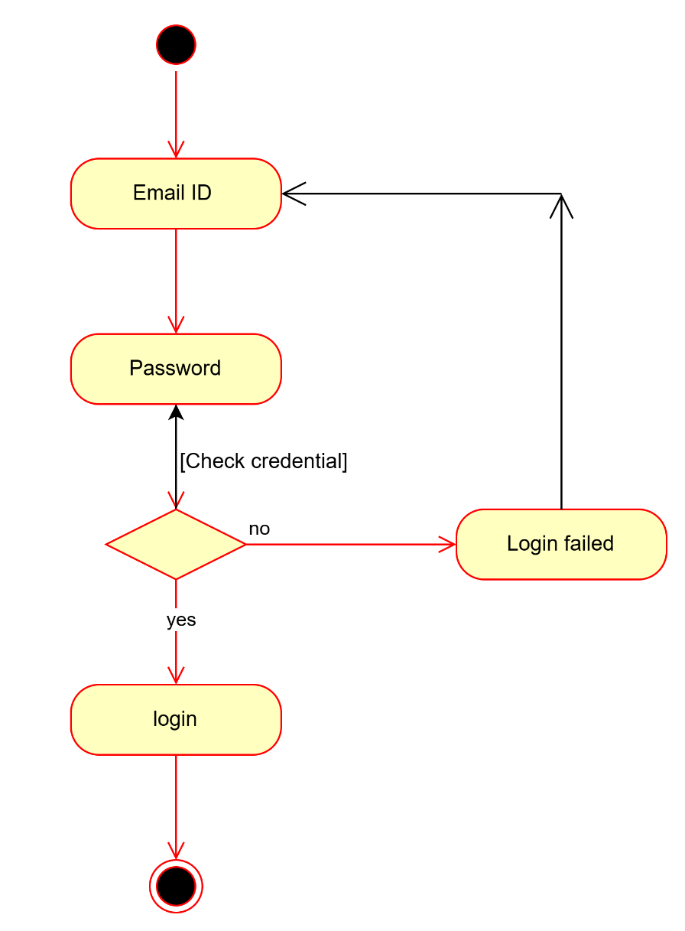

**Product delivery:**

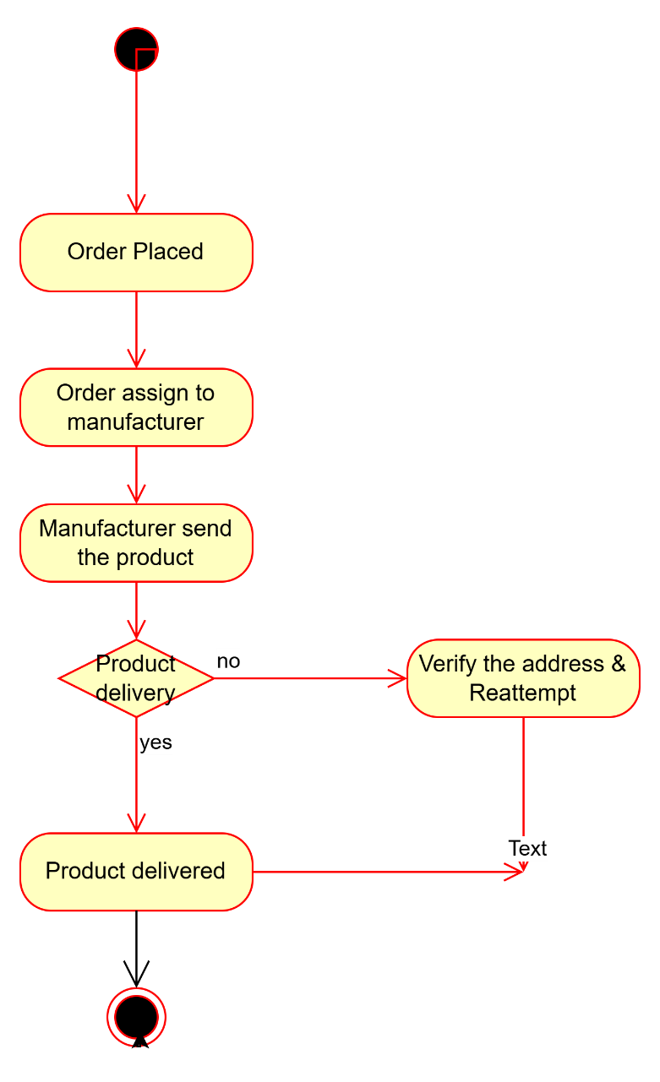

**Payment-**

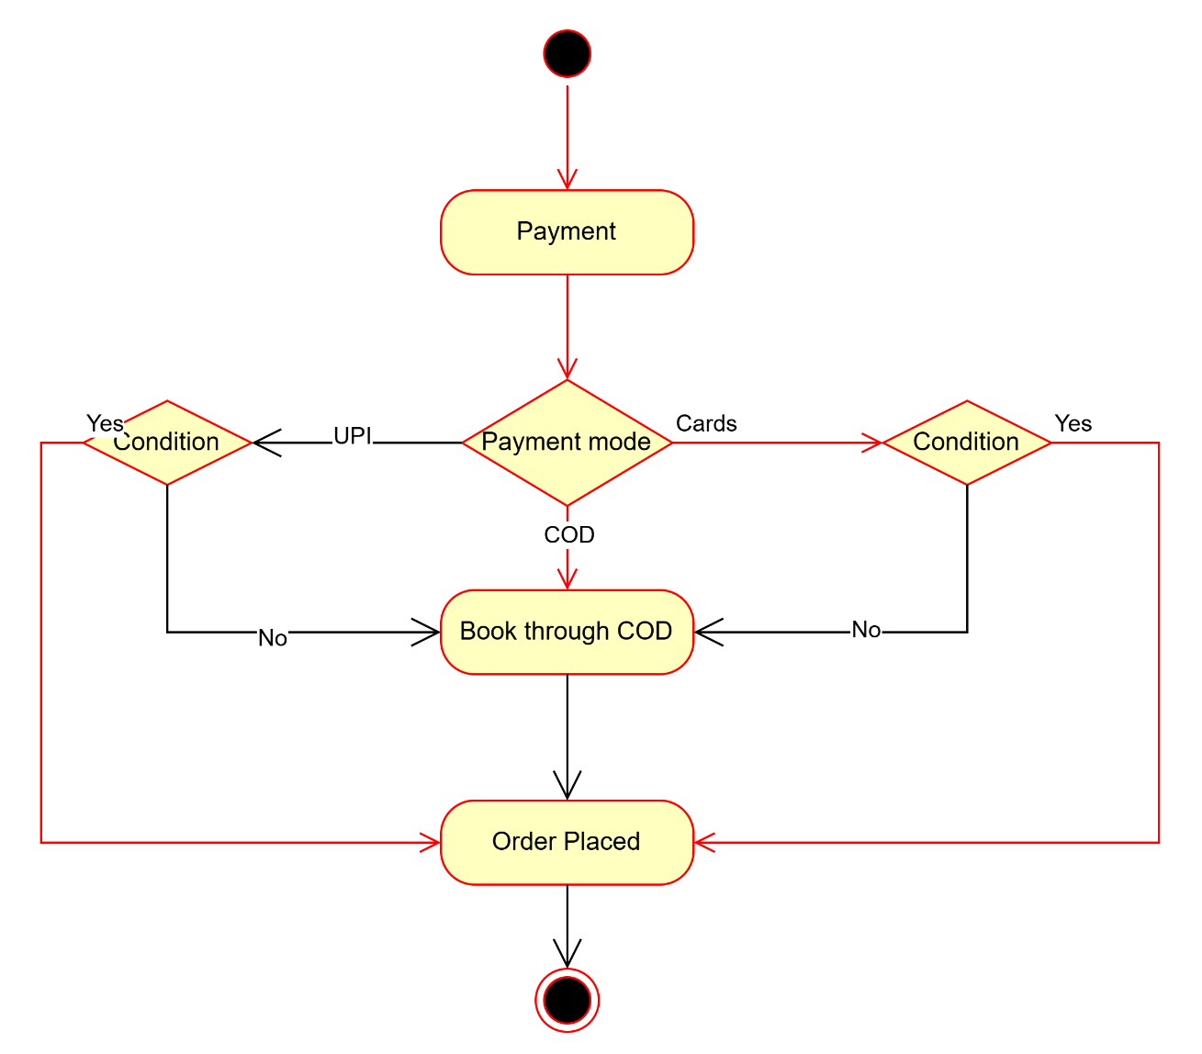

**Select Product:-**

**CHECK ORDER STATUS**

