**Use Case Document: Medical Claims**

**1. Use Case Name**

Medical Claims Processing

**2. Use Case Description**

This use case describes the process of handling medical claims from submission to approval, including validation, processing, and final decision-making.

**3. Actors**

**Primary Actors**

* Claimant (Patient or Insured Person)
* Claims Processor
* Insurance Company System

**Secondary Actors**

* Medical Provider
* Regulatory Authority

**4. Basic Flow**

1. Claimant submits a medical claim through the portal.
2. The system validates the claim details.
3. The claim is forwarded to the claims processor for review.
4. Claims processor verifies the provided documents.
5. The system checks for policy coverage and eligibility.
6. The claim is approved, denied, or sent for further review.
7. The decision is communicated to the claimant.
8. If approved, payment is processed and transferred to the claimant or medical provider.

**5. Alternate Flow**

* If required documents are missing, the system notifies the claimant to provide additional information.
* If a manual review is needed, the claim is flagged for further investigation by an expert.
* If fraud is suspected, the claim is escalated to the regulatory authority.

**6. Exceptional Flows**

* If the system encounters a failure in validation, an error message is displayed.
* If the claimant provides incorrect or incomplete data multiple times, their account may be temporarily locked.
* If the insurance policy does not cover the claimed amount, a partial approval may be issued.

**7. Pre-Conditions**

* Claimant must have an active insurance policy.
* Medical service must have been provided and documented.
* Claim submission portal must be functional.

**8. Post-Conditions**

* Claim is either approved, denied, or flagged for further review.
* Payment is processed if the claim is approved.
* Claimant is notified of the final decision.

**9. Assumptions**

* All required medical documents are available at the time of claim submission.
* The system has up-to-date policy and coverage details.
* Internet connectivity is available for claim submission and processing.

**10. Constraints**

* The maximum claim processing time is 10 business days.
* Claims exceeding a predefined threshold require additional verification.
* Only registered claimants and providers can submit claims.

**11. Dependencies**

* The system relies on medical provider records for verification.
* Regulatory guidelines must be followed for claims processing.
* Payment processing depends on the availability of banking services.

**12. Inputs and Outputs**

**Inputs**

* Claim details (patient information, diagnosis, treatment details)
* Supporting documents (bills, prescriptions, medical reports)
* Policy information (coverage, terms, conditions)

**Outputs**

* Approval/Rejection notification
* Payment details and transaction confirmation
* Reports for regulatory compliance

**13. Business Rules**

* Only claims within the policy coverage will be processed.
* Claims with missing or incorrect information will be rejected.
* Fraudulent claims will be flagged and escalated.
* Approved claims must be processed within the predefined SLA timeframe.

**14. Miscellaneous Information**

* System should support integration with third-party healthcare providers.
* Claims should be auditable for legal and regulatory purposes.
* Historical claim data should be stored for at least five years.
* The system should provide real-time claim status updates to users.

Activity Diagrams

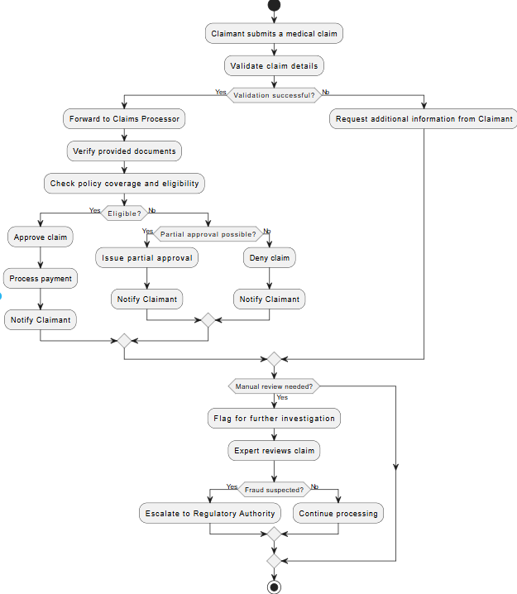

Use case diagram

–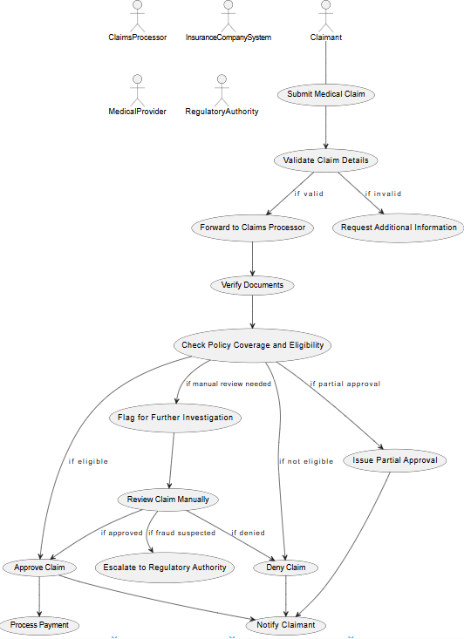

Document 7

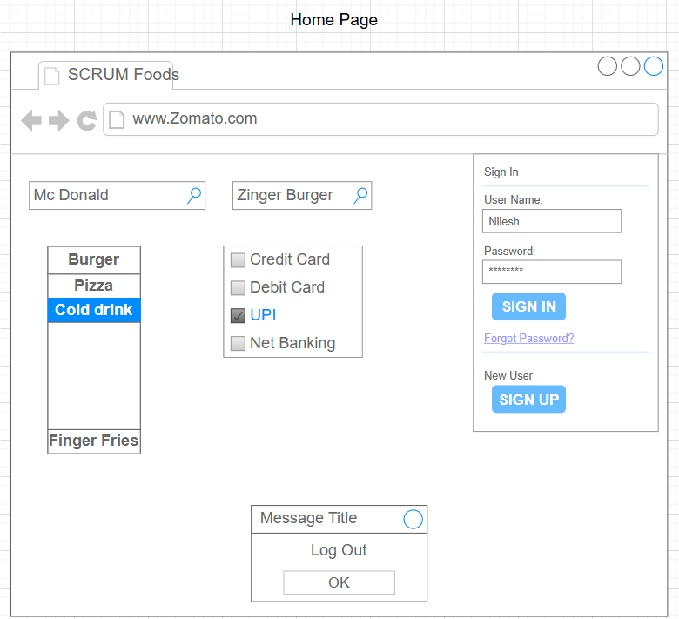

**Document 8- Tools-Visio and Axure**

I have used **Visio** extensively for creating flowcharts, data flow diagrams, and process maps, ensuring clear visual representation of system workflows. It helped in documenting business processes and system interactions effectively. Additionally, I utilized **Axure** for prototyping UI/UX designs, building interactive wireframes, and simulating user interactions. This was crucial in validating design concepts and gathering stakeholder feedback early in the project. Both tools streamlined communication between business analysts, developers, and designers, improving overall project efficiency.

**Business Analyst Experience in Project Phases**

**1. Requirement Gathering**

* Engaged with stakeholders, including business users, product owners, and subject matter experts, to understand business needs and objectives.
* Conducted stakeholder interviews, brainstorming sessions, and workshops to gather functional and non-functional requirements.
* Created Business Requirement Documents (BRD), User Stories, and Use Cases for better requirement documentation.
* Facilitated discussions to clarify expectations, constraints, and dependencies.

**2. Requirement Analysis**

* Analyzed collected requirements to ensure completeness, consistency, and feasibility.
* Collaborated with stakeholders to prioritize requirements based on business impact and technical feasibility.
* Worked closely with developers and testers to ensure alignment between business expectations and system capabilities.
* Created Requirement Traceability Matrices (RTM) to track requirement coverage across development and testing phases.

**3. Design**

* Assisted in designing workflows, wireframes, and prototypes in collaboration with UX/UI designers.
* Created process flow diagrams, data flow diagrams, and system interaction models using tools like PlantUML, Visio, or Lucidchart.
* Provided recommendations for system enhancements and improvements.
* Ensured alignment between business needs and technical architecture.

**4. Development**

* Acted as a bridge between the business and development teams, ensuring clear communication and addressing any requirement clarifications.
* Participated in daily stand-ups, sprint planning, and backlog grooming sessions in Agile environments.
* Reviewed development progress and provided feedback on functionality alignment with business goals.
* Supported developers by clarifying doubts related to requirements and ensuring smooth implementation.

**5. Testing**

* Worked with QA teams to develop test scenarios, test cases, and acceptance criteria based on business requirements.
* Conducted UAT (User Acceptance Testing) with business users to validate that the system meets the expected outcomes.
* Assisted in defect triaging and ensured timely resolution of reported issues.
* Ensured traceability between test cases and business requirements to confirm complete coverage.

**6. Deployment**

* Assisted in go-live activities, including release planning, deployment readiness checks, and business transition planning.
* Provided end-user training and prepared user manuals or training materials.
* Monitored system behavior post-deployment and coordinated with teams to resolve any immediate issues.
* Gathered feedback from stakeholders for future enhancements and continuous improvements.