**Question 1: Audits**

For a **Business Analyst (BA)**, quarterly audits (Q1, Q2, Q3, Q4) are conducted to ensure compliance, accuracy, and progress in the project lifecycle. Here’s how these audits typically happen:

**1. Requirement Validation Audit (Q1)**

* Ensuring all business requirements are gathered, documented, and approved.
* Checking if the Business Requirements Document (BRD) and Functional Requirement Specification (FRS) are complete.
* Verifying stakeholder approvals and sign-offs.

**2. Process Compliance Audit (Q2)**

* Reviewing the BA Approach Strategy, ensuring adherence to elicitation methods, documentation formats, and approval workflows.
* Validating the use of correct templates (Use Cases, Activity Diagrams, etc.).
* Checking if stakeholders are engaged through status reports and meetings.

**3. Traceability & Change Management Audit (Q3)**

* Ensuring the traceability matrix maps each requirement to implementation.
* Reviewing Change Request Logs to confirm all modifications are approved and documented.
* Checking impact assessments for changes and proper implementation tracking.

**4. Progress & Communication Audit (Q4)**

* Evaluating weekly status reports, stakeholder meetings, and communication logs.
* Ensuring project milestones align with the planned timeline.
* Reviewing User Acceptance Testing (UAT) sign-off documentation.

**Question 2: BA Approach Strategy**

1. **Requirement Elicitation Techniques** – RE is the process of digging out the information from the stakeholder requirement elicitation serves the foundation in documenting the requirement

Brainstorming, Prototyping, Document Analysis, Interviews.

1. **Stakeholder Analysis** - RACI Matrix for role identification.
2. **Documentation** - BRD (Business Requirements Document), FRS (Functional Requirement Specification), Use Cases, and Activity Diagrams.
3. **Approval Process** - Conduct review meetings, get approvals via email or digital signature.
4. **Communication Channels** - Establish emails, Slack, Microsoft Teams, and regular status meetings.
5. **Change Management** - Use a Change Request form, impact assessment, and approvals.
6. **Progress Updates** - Weekly status reports and monthly stakeholder review meetings.
7. **UAT Signoff** - Conduct UAT sessions, get sign-off via the Client Acceptance Form.

**Question 3: 3-Tier Architecture**

3-tier architecture separates the application into three layers:

1. **Presentation Layer** - User interface (web/mobile app) for farmers and manufacturers.

**Responsibilities:**

this layer is responsible for displaying information to the user and collecting input from the user.

It is the user interface (UI) of the application and typically includes web pages, mobile apps, or desktop applications.

1. **Business Logic Layer** - Processes requests, handles rules, and connects the presentation and database layers.

**Responsibilities:**

This layer contains the core functionality and business rules of the application.

It processes user inputs from the presentation layer and interacts with the data access layer to perform CRUD (Create, Read, Update, Delete) operations.

1. **Data Layer** - Stores and manages application data in databases.

**Responsibilities:**

This layer is responsible for managing data storage and retrieval.

It interacts with the database to perform data operations required by the business logic layer.

Screen, pages, Validation on page, company specific logic, Functionality

|  |
| --- |
| Application Layer |

All reusable component, frequently changing component governing body rule and regulation , compliance

|  |
| --- |
| Business logic layer |

Data base component connecting to database

|  |
| --- |
| Data layer |

**Question 4: BA Approach Strategy for Framing Questions**

1. **5W 1H (Who, What, When, Where, Why, How):**

Who are the users of the system?

What are the goals and challenges of the system?

When do stakeholders expect the project to be completed?

Where will the system be used?

Why is the project important?

How should the features be implemented?

1. **SMART Principles:**

Ensure questions are Specific, Measurable, Achievable, Relevant, and Time-bound.

1. **RACI Framework:**

Clarify questions to identify who is Responsible, Accountable, Consulted, and Informed for each task or requirement.

1. **Alignment with 3-Tier Architecture:**

Ensure questions address all three layers: Presentation (UI/UX requirements), Business Logic (functionalities and workflows), and Data (storage and retrieval).

1. **Use Cases and Use Case Specs:**

Frame questions to identify specific user interactions and detailed specifications for functionalities.

1. **Activity Diagrams:**

Ask questions to clarify workflows and process sequences.

1. **Models and Page Designs:**

Gather inputs on visual designs, mockups, and wireframes to ensure the user interface meets stakeholder expectations.

**Question 5: Elicitation Techniques**

**Techniques**:

* **B** – Brainstorming – Brainstorming can be done either individually or in group the idea collected during the Brainstorming session are reviewed or analyzed
* **D** - Document Analysis – Document analysis is done through reading a document and understand the product process and Project
* **R** – Reverse engineering also called back engineering is the process of extracting knowledge or design information from anythings man made and reproducing anything based on the extracted information
* **F** - Focus Groups – A focus group is a means to elicit ideas and attitude about a specific product, service or opportunity in an interactive group environment
* **O** – Observation – observing shadowing users or doing a part of their job can provides information of existing processes input and output
* **W** – Workshop – A requirement workshop is a structured approach to capture requirement Workshop may be used to scope discover define prioritize and reach closure on requirement for the target system
* **J** – JAD – joint application development application developed through jad has higher customer satisfaction and less number of errors as user is directly involved in the development process
* **I** – Interviews – interview is a systematic approach where interviewee is going to ask relevant question related to software and documenting the responses
* **P** – Prototyping - Prototyping is an attractive idea for complicated and large system for which there is no manual process or existing system to help determing the requirement
* **Q** – Questionnaires – Questionnaires can be usefiull for obtaining limited system requirement details from the user / stakeholder who have minor input or are geographically remote
* **U** - Use Cases - Developing use case scenarios to define system interactions from a user's perspective.

**Question 6: Elicitation Techniques Justification**

**Question 6: Elicitation Techniques Justification** For this project, the following elicitation techniques can be applied, with justifications for their selection:

1. **Prototyping**

**Justification**: Since the project involves designing a user-friendly web/mobile interface, prototyping is essential to visualize the product catalog, login pages, search functionality, and payment gateways. It allows stakeholders to see and provide feedback on the interface and functionality.

1. **Use Case Specifications**

**Justification**: Use cases help define interactions between users (farmers, manufacturers, and admin) and the system. For example, "Farmers searching for products" or "Manufacturers uploading product details" can be documented for clarity.

1. **Document Analysis**

**Justification**: Reviewing existing agricultural product catalogs, logistics data, and related documents helps understand current processes and requirements. It also identifies gaps that the new system needs to address.

1. **Brainstorming**

**Justification**: Engaging stakeholders like Peter, Kevin, and Ben in brainstorming sessions can generate ideas for features like payment options, delivery tracking, and user-friendly navigation.

1. **Interviews**

**Justification**: Conducting one-on-one interviews with Mr. Henry, the committee, and key stakeholders allows for an in-depth understanding of expectations and specific requirements for the application.

These techniques ensure comprehensive requirement gathering and stakeholder alignment, critical to the project's success. Let me know if you’d like detailed scenarios or elaborations on any technique!

**Question 7: Business Requirements**

1. **BR001** – Farmers should be able to search for products (fertilizers, seeds, pesticides) by category or keywords.
2. **BR002** – Manufacturers should be able to upload and manage their product listings.
3. **BR003** – Farmers should be able to create an account and log in securely.
4. **BR004** – Farmers should have a shopping cart and wish list for storing selected products temporarily.
5. **BR005** – The system should support multiple payment methods, including UPI, Credit/Debit cards, and COD.
6. **BR006** – Farmers should receive email confirmations for account registration and orders placed.
7. **BR007** – A delivery tracking system should provide real-time updates on orders.
8. **BR008** – The platform should provide a simple, intuitive user interface suitable for non-tech-savvy farmers.
9. **BR009** – Admins should have the capability to manage user accounts and monitor platform activities.
10. **BR010** – A reporting feature should generate analytics on sales, popular products, and user activities for the admin.

**Question 8: Assumptions**

1. Internet connectivity will be available in remote farming areas for application access.

2. Farmers and manufacturers have basic knowledge of using smartphones or computers.

3. The platform will initially target a specific region with the potential for future expansion.

4. Secure payment gateway integration will handle financial transactions.

5. Logistics and delivery services will be managed by partnered third-party providers.

6. Manufacturers will regularly update their product listings for availability and pricing.

7. A simple multilingual interface will be developed to cater to farmers speaking regional languages.

8. Adequate training or documentation will be provided to users for onboarding and smooth operation.

**Question 9: Requirements Priority**

|  |  |  |  |
| --- | --- | --- | --- |
| Req ID | Req Name | Req Description | Priority |
| BR001 | Farmer Search for Products | Farmers should be able to search for available products in fertilizers, seeds, and pesticides. | 10 |
| BR002 | Manufacturers Upload Their Products | Manufacturers should be able to upload and display their products in the application. | 9 |
| BR003 | User Registration and Login | Farmers and manufacturers should be able to create accounts and log in using secure credentials. | 8 |
| BR004 | Product catalogue | A product catalogue should display all available fertilizers, seeds, and pesticides for browsing. | 8 |
| BR005 | Payment Integration | Multiple payment options like COD, Credit/Debit card, and UPI should be available for transactions. | 9 |
| BR006 | Order Confirmation Email | Users should receive an email confirmation regarding their order details and status. | 7 |
| BR007 | Delivery Tracking | A delivery tracker should be available to monitor the status and location of the order. | 9 |
| BR008 | Admin Management | The system should allow admins to manage user accounts and resolve issues. | 6 |
| BR009 | |  | | --- | |  |  |  | | --- | | Product and Order Reports | | Sales and order analytics should be available for manufacturers and admins. | 5 |
| BR010 | |  | | --- | |  |  |  | | --- | | Wishlist or Buy-Later Option | | Farmers should be able to add products to a wishlist or buy-later list for future purchase. | 6 |

**Steps to Deliver Requirements to the Project Team:**

1. **Gather Details:** Analyze the requirements provided by stakeholders.
2. **Create UML Diagrams:**
   * Use case diagrams to show interactions between actors (Farmers, Manufacturers, Admin, System).
   * Activity diagrams for workflows such as searching products, making payments, and tracking orders.
3. **Design Mock-Ups:**
   * Screen layouts for login, product catalog, product search, and order tracking.
   * Ensure mock-ups align with user experience goals.
4. **Documentation:**
   * Write detailed specifications (Use Case Specs, BRD, and FRS).
5. **Review and Feedback:** Conduct walkthroughs with stakeholders and project teams to confirm understanding.

**QUESTION NO 10**

**USE CASE DIAGRAM**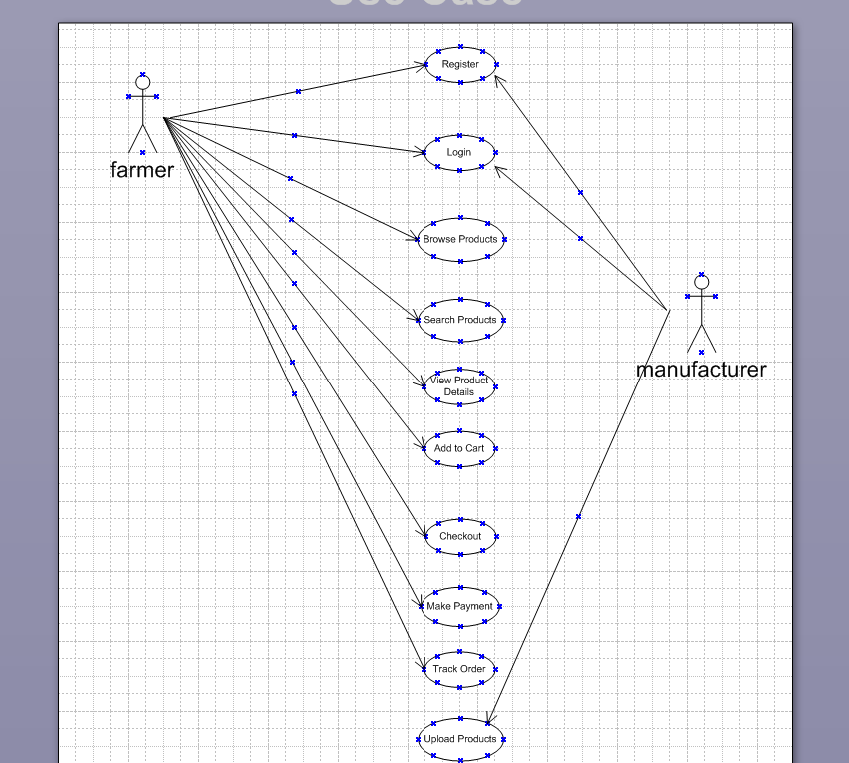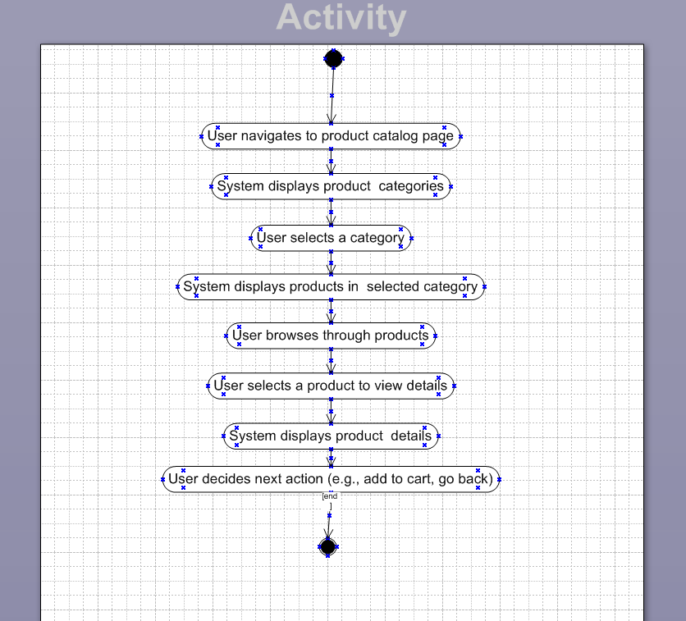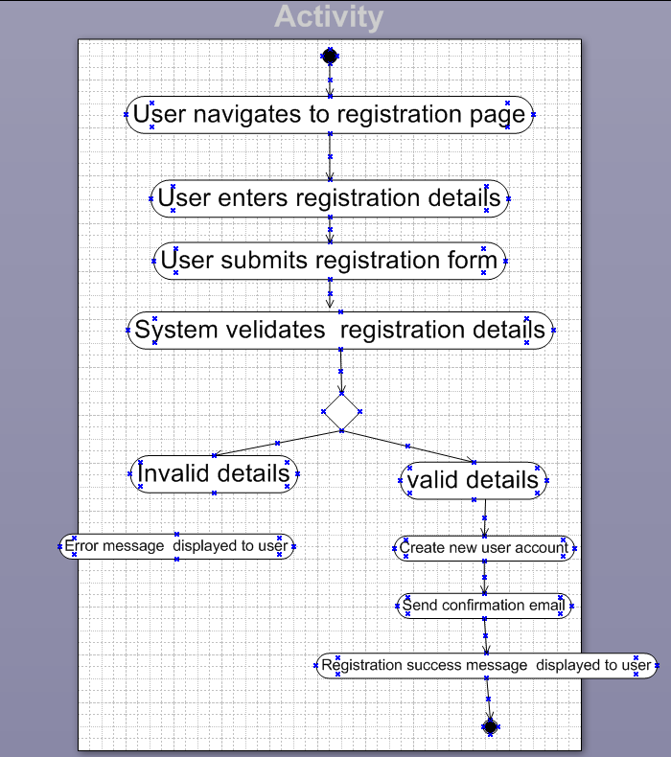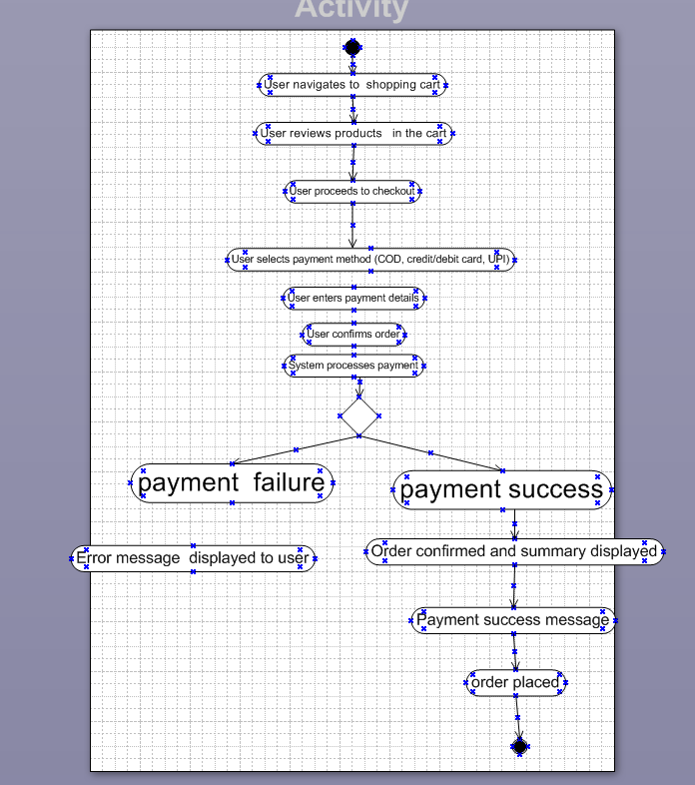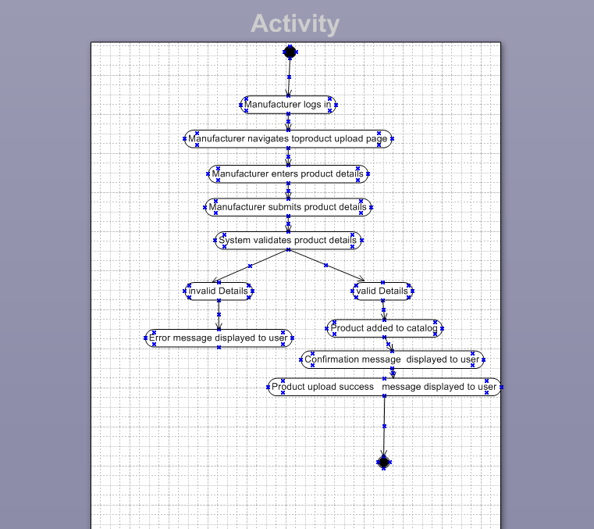

**QUESTION NO 11**

**Use Case 1: User Login**

|  |  |
| --- | --- |
| **Use Case ID:** | **U001** |
| **Use Case Name:** | **User Login** |
| **Brief Description:** | **The user logs into the system using valid credentials.** |
| **Actors:** | **User (Farmer/Manufacturer)** |
| **Pre-Condition:** | **The user must be registered in the system.**  **The system must be available and online.** |
| **Basic Flow:** | 1. **The user opens the login page.** 2. **The user enters a valid username and password.** 3. **The system verifies the credentials.** 4. **The user is granted access to the dashboard.** |
| **Alternative Flow** | **If credentials are incorrect, an error message is displayed, and the user is asked to retry.** |
| **Exceptional Flow:** | **If the system is down, an appropriate error message is displayed.** |
| **Post-Condition:** | **The user successfully logs into the system.** |
| **Scenarios:** | **Invalid credentials entered** |

**Use Case 2: Browse Products**

|  |  |
| --- | --- |
| **Use Case ID:** | **U002** |
| **Use Case Name:** | **Browse Products** |
| **Brief Description:** | **The user browses through available products in the catalog.** |
| **Actors:** | **User (Farmer)** |
| **Pre-Condition:** | **The user must be logged into the system.**  **Products must be available in the catalog.** |
| **Basic Flow:** | 1. **The user navigates to the product catalog.** 2. **The system displays a list of available products.** 3. **The user can view product details.** |
| **Alternative Flow** | **If no products are available, a message is displayed.** |
| **Exceptional Flow:** | **If the system fails to load products, an error message is shown.** |
| **Post-Condition:** | **The user successfully browses available products.** |
| **Scenarios:** | **No products found in the catalog.** |

**Use Case 3: Search for a Product**

|  |  |
| --- | --- |
| **Use Case ID:** | **U003** |
| **Use Case Name:** | **Search for a Product** |
| **Brief Description:** | **The user searches for a specific product in the catalog.** |
| **Actors:** | **User (Farmer)** |
| **Pre-Condition:** | **The user must be logged into the system.**  **Products should be available in the catalog.** |
| **Basic Flow:** | **The user enters a keyword in the search bar.**  **The system retrieves relevant products.**  **The user views search results.** |
| **Alternative Flow** | **If no matching products are found, a message is displayed.** |
| **Exceptional Flow:** | **If the system search function fails, an error message is shown.** |
| **Post-Condition:** | **The user successfully views search results.** |
| **Scenarios:** | **No matching products found.** |

**Use Case 4: Add to Cart**

|  |  |
| --- | --- |
| **Use Case ID:** | **U004** |
| **Use Case Name:** | **Add to Cart** |
| **Brief Description:** | **The user adds a selected product to the shopping cart.** |
| **Actors:** | **User (Farmer)** |
| **Pre-Condition:** | **The user must be logged into the system.**  **The product must be available in stock.** |
| **Basic Flow:** | 1. **The user selects a product.** 2. **The user clicks the "Add to Cart" button.** 3. **The system adds the product to the user's cart.** |
| **Alternative Flow** | **If the product is out of stock, an error message is displayed.** |
| **Exceptional Flow:** | **If the cart function fails, an error message is displayed.** |
| **Post-Condition:** | **The product is added to the user's cart.** |
| **Scenarios:** | **Product goes out of stock after selection.** |

**Use Case 5: Payment Processing**

|  |  |
| --- | --- |
| **Use Case ID:** | **U005** |
| **Use Case Name:** | **Payment Processing** |
| **Brief Description:** | **The user makes a payment for selected items in the cart.** |
| **Actors:** | **User (Farmer)** |
| **Pre-Condition:** | **The user must have items in the cart.**  **The user must have a valid payment method.** |
| **Basic Flow:** | **The user selects the checkout option.**  **The user chooses a payment method.**  **The system processes the payment.**  **The user receives a confirmation message.** |
| **Alternative Flow** | **If payment fails, the user is notified and asked to retry.** |
| **Exceptional Flow:** | **If the payment gateway is down, an error message is displayed.** |
| **Post-Condition:** | **The payment is successfully processed, and the order is placed.** |
| **Scenarios:** | **Payment failure due to insufficient funds.** |