**Enterprise Procurement Management System**

**Definition of Done (DoD) – Enterprise Procurement Management System**

As Per Agile Extension to the BABOK® Guide v2, Definition of Done is a technique where the team agrees on, and prominently displays, a list of criteria which must be met before a backlog item is considered done.

The **Definition of Done (DoD)** is a set of criteria that must be met for a user story, task, or feature to be considered **completed and ready for release**. It ensures consistency, quality, and adherence to business requirements across the development lifecycle.

* Deliver high-quality, production-ready features
* Maintain alignment with business and user expectations
* Ensure code is tested, reviewed, and deployable
* Reduce technical debt and improve maintainability

**1. Produced Code for Presumed Functionalities**

* The development team has written and committed the necessary code for features like **Supplier Management, Purchase Order & Approval Workflow, Invoice Processing & Payment Tracking, and Reporting & Analytics**.
* All major business rules, workflows, and validations are implemented as per requirements.

**2. Assumptions of User Story Met**

* Each user story is implemented as per business expectations.
* Edge cases and exceptions (e.g., supplier re-verification, PO cancellation, invoice dispute resolution) have been considered.
* User roles (procurement managers, finance teams, vendors) interact as defined in workflows.

**3. Project Builds Without Errors**

* The application compiles successfully without errors or missing dependencies.
* Build scripts, pipelines, and CI/CD processes execute without failures.

**4. Unit Tests Written and Passing**

* Developers have written **unit tests** for core business logic (e.g., PO approval rules, invoice matching).
* Test coverage meets project guidelines (e.g., at least **80% coverage** for critical modules).
* All unit tests pass without failures before the feature is marked as complete.

**5. Project Deployed on the Test Environment Identical to Production**

* The feature is deployed in a **staging/test environment** that mirrors the production setup (same database, APIs, authentication methods).
* Performance, security, and integration testing are conducted on this environment.

**6. Tests on Devices/Browsers Listed in the Project Assumptions Passed**

* The system has been tested on all **required browsers (Chrome, Edge, Firefox) and devices (desktop, tablets, mobile screens)** to ensure compatibility.
* Procurement managers, finance teams, and suppliers can access the system without UI issues.

**7. Feature Ok-ed by UX Designer**

* The UX/UI team has reviewed the **supplier onboarding screens, PO workflow UI, invoice processing forms, and reporting dashboards** to ensure usability and adherence to design guidelines.
* Any UI improvements requested have been implemented before final approval.

**8. QA Performed & Issues Resolved**

* The **QA team** has tested the feature against **functional, integration, regression, and performance** test cases.
* Any critical/blocker issues have been resolved before deployment.

**9. Feature is Tested Against Acceptance Criteria**

* Each **user story's acceptance criteria** are met.
* For example:
  + A **supplier should receive a confirmation email** after registration.
  + A **purchase order should not proceed without manager approval** if it exceeds a certain threshold.
* Automated and manual acceptance tests are conducted.

**10. Feature Ok-ed by Product Owner**

* The **Product Owner (PO)** has reviewed and approved the feature based on business expectations.
* No further changes are required before moving to production.

**11. Refactoring Completed**

* Any **code improvements (performance optimization, redundant code removal)** have been done after implementation.
* Example: Optimizing database queries in invoice tracking to **reduce load time from 5s to 2s**.

**12. Any Configuration or Build Changes Documented**

* Changes to **APIs, database schema, environment variables, or deployment scripts** are documented.
* Example: If a new **currency conversion API** is added for international suppliers, its integration details are recorded.

**13. Documentation Updated**

* **User guides, API documentation, and process workflows** are updated.
* Example: The **procurement approval matrix** and new system behaviour are documented for finance teams.

**14. Peer Code Review Performed**

* Code has been reviewed by at least **one senior developer** before merging.
* Best practices, security, and scalability considerations are checked.
* Example: SQL queries in invoice reports are optimized after peer review to prevent slow performance.

**Product Vision**

|  |  |  |  |
| --- | --- | --- | --- |
| **Scrum Project Name:** | **Enterprise Procurement Management System (EPMS)** | | |
| **Venue:** | FLEX, Chennai | | |
| **Date:13/03/2025** | **Start time:**  Mar 2025 | **End time:**  OCT 2025 | **Duration:**  8 Monts |
| **Client:** | COEPD, Hyderabad | | |
| **Stakeholder list:** | Business Owners / Executives | Procurement Department | Finance & Accounting Team |
| Product Owner | Scrum Master | Development Team |
| QA Team | IT & Infrastructure Team | Compliance & Legal Team |
| Vendors / Suppliers | End Users (Procurement Officers, Finance Managers, etc.) | |
| **Scrum Team** | | | |
| **Scrum Master:** | Mr. Naveen |  |  |
| **Product owner:** | Mr. Kumaran |  |  |
| **Scrum Developer 1:** | Mr. Vagai Selvan |  |  |
| **Scrum Developer 2:** | Mr. Kathir |  |  |
| **Scrum Developer 3:** | Mr. Mogan |  |  |
| **Scrum Developer 4:** | Ms. Roopashri |  |  |
| **Scrum Developer 5:** | Mr. Paranthaman |  |  |

|  |
| --- |
| **Vision** |
| The **Enterprise Procurement Management System (EPMS)** aims to **streamline and automate procurement workflows**, ensuring **efficiency, transparency, and compliance** across all purchasing activities. By leveraging **Agile and the SCRUM framework**, the system will deliver an intuitive, scalable, and secure platform for managing supplier interactions, purchase orders, approvals, invoices, and reporting—empowering businesses to optimize procurement operations and reduce costs. |

**Target Group**

|  |  |
| --- | --- |
| **Target Group** | **Description** |
| **Procurement Teams** | Manage supplier selection, purchase orders, and approvals. |
| **Finance Departments** | Oversee invoice processing, payments, and cost control. |
| **Department Heads & Approvers** | Approve purchase requests and manage budgets. |
| **IT Teams** | Ensure system integrations, security, and compliance. |
| **Suppliers & Vendors** | Register, submit quotations, receive purchase orders, and track payments. |
| **Regulatory & Audit Bodies** | Ensure compliance with procurement policies and financial regulations. |

**Needs**

|  |  |
| --- | --- |
| **Need** | **Why It’s Important?** |
| **Automation of Procurement Workflows** | Reduces manual efforts and human errors in procurement processes. |
| **Improved Cost Control** | Ensures better budget allocation and prevents unnecessary spending. |
| **Supplier Performance Management** | Tracks vendor reliability, delivery timelines, and compliance. |
| **Compliance & Audit Readiness** | Ensures all procurement activities meet internal and regulatory requirements. |
| **Seamless ERP & Financial System Integration** | Enables smooth data exchange between procurement, accounting, and inventory systems. |
| **User-Friendly Experience** | Provides an intuitive platform for procurement teams and suppliers to collaborate efficiently. |

**Product & Their Value**

|  |  |
| --- | --- |
| **Product Feature** | **Value Delivered** |
| **Supplier Management** | Ensures seamless vendor onboarding, contract management, and performance tracking to enhance supplier relationships and mitigate risks. |
| **Purchase Order & Approval Workflow** | Reduces processing time for purchase orders, prevents unauthorized spending, and ensures proper approval hierarchies. |
| **Invoice Processing & Payment Tracking** | Automates invoice verification, 2-way/3-way matching, and payment tracking, reducing financial discrepancies and manual errors. |
| **Reporting & Analytics** | Provides real-time insights into procurement trends, supplier performance, and cost savings, enabling data-driven decision-making. |
| **System Integrations** | Ensures seamless connectivity with **ERP, accounting, inventory, and compliance systems**, reducing duplicate data entry and improving efficiency. |

**User stories**  
 User Stories are a representation of the customer need and are expressed as a small, concise statement of a feature needed to deliver value.

|  |  |  |  |
| --- | --- | --- | --- |
| **User story No:US101**  Supplier Management | **Tasks:1** | | **Priority: High** |
| **Value statement:**  As a **Procurement Manager**, I want to approve/reject supplier applications based on predefined criteria so that only compliant vendors are onboarded. | | | |
| **BV: 70** | | **CP: 5** | |
| **Acceptance criteria:**   * Suppliers must submit mandatory documents (e.g., Tax ID, Business License). * Approval or rejection with comments is recorded. * Notifications sent to suppliers on approval/rejection. | | | |

|  |  |  |  |
| --- | --- | --- | --- |
| **User story No:US102**  Supplier Management | **Tasks:2** | | **Priority: High** |
| **Value statement:**  As a **Supplier**, I want to update my business profile and certifications so that I remain eligible for procurement contracts. | | | |
| **BV: 90** | | **CP: 3** | |
| **Acceptance criteria:**   * Suppliers can log in and update contact details, licenses, and certifications. * System notifies procurement team of any critical updates. | | | |

|  |  |  |  |
| --- | --- | --- | --- |
| **User story No:US103** Supplier Management | **Tasks:3** | | **Priority: High** |
| **Value statement:**  As a **Procurement Analyst**, I want to track supplier performance metrics (on-time delivery, quality score) so that I can assess vendor reliability. | | | |
| **BV: 80** | | **CP: 8** | |
| **Acceptance criteria:**   |  | | --- | | * System generates performance reports for each supplier. | | * Vendors receive periodic feedback reports. | | * Procurement teams can mark "preferred" suppliers based on Performance | | | | |

|  |  |  |  |
| --- | --- | --- | --- |
| **User story No:US104 Purchase Order & Approval Workflow** | **Tasks:1** | | **Priority: High** |
| **Value statement:**  As a **Buyer**, I want to request a purchase order by selecting from an approved supplier list so that I can ensure compliance with procurement policies. | | | |
| **BV: 100** | | **CP: 13** | |
| **Acceptance criteria:**   * System restricts PO creation to pre-approved vendors. * Purchase request must include item details, quantity, and estimated cost. | | | |

|  |  |  |  |
| --- | --- | --- | --- |
| **User story No:US105** Purchase Order & Approval Workflow | **Tasks:3** | | **Priority: High** |
| **Value statement:**  As an **Approver**, I want to receive purchase order approval requests via email and mobile notifications so that I can review and approve them quickly. | | | |
| **BV: 80** | | **CP: 7** | |
| **Acceptance criteria:**   * Approvers receive real-time notifications * Approvers can approve/reject via web or mobile. * Approval logs are maintained for audit purposes. | | | |

|  |  |  |  |
| --- | --- | --- | --- |
| **User story No:US106** Purchase Order & Approval Workflow | **Tasks:2** | | **Priority: High** |
| **Value statement:**  As a **Finance Officer**, I want to verify budget availability before approving a purchase order so that I can ensure controlled spending. | | | |
| **BV: 60** | | **CP: 3** | |
| **Acceptance criteria:**   * System checks available budget for the department before approval. * Approver gets an alert if budget is exceeded. | | | |

|  |  |  |  |
| --- | --- | --- | --- |
| **User story No:US107** Invoice Processing & Payment Tracking | **Tasks:6** | | **Priority: High** |
| **Value statement:**  As a **Finance Manager**, I want to automate 3-way invoice matching (PO, invoice, and goods received) so that I can minimize payment discrepancies. | | | |
| **BV: 100** | | **CP: 8** | |
| **Acceptance criteria:**   * System matches invoices with POs and goods received records. * Discrepancies trigger alerts for manual review. * Approved invoices proceed for payment. | | | |

|  |  |  |  |
| --- | --- | --- | --- |
| **User story No:US108** Invoice Processing & Payment Tracking | **Tasks:2** | | **Priority: High** |
| **Value statement:**  As a **Supplier**, I want to receive automated payment status updates so that I can track my pending invoices. | | | |
| **BV: 50** | | **CP: 3** | |
| **Acceptance criteria:**   * Payment status updates sent via email/SMS. * Suppliers can log in to view payment history. | | | |

|  |  |  |  |
| --- | --- | --- | --- |
| **User story No:US109** Reporting & Analytics | **Tasks:4** | | **Priority: High** |
| **Value statement:**  As a **Procurement Analyst**, I want to generate spend analysis reports so that I can identify cost-saving opportunities. | | | |
| **BV: 90** | | **CP: 13** | |
| **Acceptance criteria:**   * Reports include total spend by department, category, and supplier. * System highlights areas with potential cost reduction. | | | |

|  |  |  |  |
| --- | --- | --- | --- |
| **User story No:US110** Reporting & Analytics | **Tasks:1** | | **Priority: High** |
| **Value statement:**  As a **Compliance Officer**, I want to track and audit procurement activities so that I can ensure adherence to regulations. | | | |
| **BV: 30** | | **CP: 1** | |
| **Acceptance criteria:**   * System maintains logs of all procurement actions. * Users can filter audit trails by date, user, and action type. | | | |

|  |  |  |  |
| --- | --- | --- | --- |
| **User story No:US111** System Integrations | **Tasks:3** | | **Priority: High** |
| **Value statement:**  As an **IT Administrator**, I want to ensure single sign-on (SSO) integration with our corporate directory so that users can log in securely. | | | |
| **BV: 60** | | **CP: 8** | |
| **Acceptance criteria:**   * Users can log in using corporate credentials. * Multi-factor authentication (MFA) is enabled. | | | |

|  |  |  |  |
| --- | --- | --- | --- |
| **User story No:US112** System Integrations | **Tasks:2** | | **Priority: High** |
| **Value statement:**  As a **Finance Team Member**, I want the system to integrate with our ERP’s general ledger so that purchase transactions are automatically recorded. | | | |
| **BV: 60** | | **CP: 3** | |
| **Acceptance criteria:**   * Approved POs sync with the general ledger. * Invoices update in the financial system automatically. | | | |

**Agile PO Experience**

**Product Owner**

Product Owner is the role on the team that represents the interests of all stakeholders, defines the features of the product, and prioritizes the product backlog. He is responsible for defining the product's features, functionalities, and overall vision, ensuring it aligns with the business goals and customer needs.

❖ In Scrum, a product owner serves as the liaison between multiple areas of an organization. This person communicates with business stakeholders and collaborates closely with Scrum teams to keep all areas of the business informed on a project's development.

❖ The product owner develops a vision of a product's function and operation, which in turn allows this Scrum team member to define product features and break those features into product backlog items.

❖ As a Product Owner Following are my responsibilities in this project Enterprise Procurement Management System (EPMS)

**1. Market Analysis**

**Key Contributions:**

* Conducted a **competitive analysis** to compare existing procurement solutions (SAP Ariba, Coupa, Jaggaer) with our EPMS.
* Engaged with **stakeholders (Procurement, Finance, IT, Suppliers)** to identify gaps in current procurement processes.
* Identified **key differentiators** such as:
  + Streamlined **supplier onboarding** with automated compliance checks.
  + AI-driven **spend analysis and cost-saving recommendations**.
  + Integration with existing **ERP and accounting systems**.

**Challenges & Solutions:**

**Challenge:** Lack of clear market data on procurement pain points.  
**Solution:** Conducted surveys with key users to validate assumptions and define **real user needs**.

**2. Enterprise Analysis**

**Key Contributions:**

* Analysed **business workflows** to align EPMS with organizational goals.
* Defined **KPIs** such as **procurement cycle time reduction, supplier compliance rate, and invoice processing time**.
* Collaborated with **finance, legal, and IT teams** to ensure compliance with **procurement policies and regulatory requirements**.

**Challenges & Solutions:**

**Challenge:** Resistance to process automation from traditional procurement teams.  
**Solution:** **Change management strategy** with **training sessions and pilot rollouts**.

**3. Product Vision and Roadmap**

**Key Contributions:**

* Created a clear Product Vision:
  + *“A seamless, automated, and intelligent procurement system that enhances supplier collaboration, reduces processing time, and ensures compliance.”*
* Developed a **product roadmap** in phases:
  + **Phase 1**: Supplier onboarding & PO workflow.
  + **Phase 2**: Invoice automation & ERP integration.
  + **Phase 3**: Advanced analytics & AI-driven insights.

**Challenges & Solutions:**

**Challenge:** Conflicting feature demands from different departments.  
**Solution:** Used **MoSCoW prioritization** to ensure focus on high-impact features.

**4. Managing Product Features**

**Key Contributions:**

* Defined **key modules**:
  + **Supplier Management**
  + **Purchase Order Workflow**
  + **Invoice Processing**
  + **Reporting & Analytics**
* Ensured each feature had **clear business goals and acceptance criteria**.

**Challenges & Solutions:**

**Challenge:** Overlapping features with existing ERP.  
**Solution:** Mapped dependencies and ensured non-duplicative functionalities.

**5. Managing Product Backlog**

**Key Contributions:**

* Maintained a **well-defined backlog** categorized into:
  + **New Features**
  + **Enhancements**
  + **Technical Debt**
  + **Bugs**
* Conducted **backlog refinement meetings** to ensure all items were updated.

**Challenges & Solutions:**

**Challenge:** Frequent scope changes from business teams.  
**Solution:** Established a **change control process** with impact assessment.

**6. Prioritization of User Stories**

**Key Contributions:**

* Used **Value vs. Effort matrix** for prioritization.
* Prioritized based on:
  + **Business Value (BV)**
  + **Complexity Points (CP)**
  + **User Impact**
  + **Regulatory Requirements**

**7. Reprioritization Based on Stakeholders' Needs**

**Key Contributions:**

* Conducted **regular stakeholder meetings** to reassess priorities.
* Adjusted backlog based on **market trends, compliance updates, and feedback**.

**8. Epics Planning**

**Key Contributions:**

* Defined high-level Epics:
  + EPIC-001: Supplier Management
  + EPIC-002: Purchase Order Workflow
  + EPIC-003: Invoice Processing & Payment
* Broke epics into manageable user stories.

**Challenges & Solutions:**

**Challenge:** Dependencies between epics caused delays.  
**Solution:** Implemented cross-team coordination sessions to resolve blockers.

**9. Managing Overall Iteration Progress**

**Key Contributions:**

* Used burn-down charts & velocity tracking to monitor progress.
* Adjusted sprint scope based on team velocity & stakeholder feedback.

**10. Sprint Progress Review**

**Key Contributions:**

* Ensured demo-ready increments were delivered.
* Evaluated sprint success based on working software and business impact.

**11. Reprioritization of Sprints and Epics If Needed**

**Key Contributions:**

* Reprioritized based on:
  + Urgent compliance needs
  + Integration challenges
  + Customer feedback
* Adjusted the roadmap for maximum value delivery.

**12. Sprint Retrospectives with Business Analyst**

**Key Contributions:**

* Identified process improvements for backlog refinement.
* Addressed bottlenecks in requirement clarification.

**13. Agile Ceremonies Managed**

| **Meeting** | **Your Role as Product Owner** |
| --- | --- |
| **Sprint Planning** | Ensured user stories met **Definition of Ready (DoR)** |
| **Daily Scrum** | Monitored team progress, resolved blockers |
| **Sprint Review** | Validated delivered features, gathered feedback |
| **Sprint Retrospective** | Identified process improvements |
| **Backlog Refinement** | Updated and prioritized stories |

**14. User Stories Creation (Structure & Elements)**

**Key Contributions:**

* Ensured user stories followed **INVEST (Independent, Negotiable, Valuable, Estimable, Small, Testable)**.
* Created well-structured stories including:
  + **Story No**: US-101, US-102...
  + **Tasks**: Development, Testing, UX Design...
  + **Priority**: High, Medium, Low
  + **Acceptance Criteria**: Clear, testable conditions
  + **Business Value (BV) & Complexity Points (CP)**: Prioritization based on ROI

**Example User Story:**

**Story No**: US-101  
**Feature**: Supplier Onboarding  
**As a** Procurement Manager  
**I want to** approve/reject supplier applications based on compliance criteria  
**So that** only qualified vendors are onboarded.

**Acceptance Criteria**:

* Supplier must submit Tax ID & Business License.
* Approval/Rejection must be recorded.
* Supplier receives a notification.

**BV=80; CP: 5**

**Product backlog:**

|  |  |  |  |  |  |  |
| --- | --- | --- | --- | --- | --- | --- |
| **User Story ID** | **User Story** | **Tasks** | **Priority** | **BV** | **CP** | **Sprint** |
| **US-101** | As a Procurement Manager, I want to onboard suppliers by verifying compliance documents, so that only qualified vendors can be added. | - Develop supplier registration form  - Implement document upload feature  - Create approval workflow  - Send notifications on approval/rejection  - Test supplier onboarding process | High | 90 | 5 | Sprint 1 |
| **US-102** | As a Procurement Officer, I want to create and submit a purchase order, so that procurement requests can be processed. | - Develop PO creation UI  - Implement PO submission workflow  - Validate PO details before submission  - Test PO submission process | High | 85 | 5 | Sprint 1 |
| **US-103** | As a Department Head, I want to approve or reject purchase orders, so that only valid orders proceed. | - Develop approval UI  - Implement approval logic  - Send notifications on approval/rejection  - Test approval workflow | High | 80 | 5 | Sprint 2 |
| **US-104** | As a Finance Manager, I want to match invoices with purchase orders, so that payments are only made for verified transactions. | - Develop invoice processing module  - Implement PO-invoice matching logic  - Create exception handling for mismatches  - Test invoice verification | High | 95 | 8 | Sprint 2 |
| **US-105** | As a Supplier, I want to track my invoices and payment status, so that I can monitor my transactions. | - Develop invoice tracking dashboard  - Integrate payment status updates  - Test invoice tracking feature | Medium | 70 | 6 | Sprint 3 |
| **US-106** | As a Procurement Analyst, I want to generate reports on procurement trends, so that I can analyse spending patterns. | - Develop reporting module  - Implement data visualization for trends  - Test report generation | Medium | 75 | 7 | Sprint 3 |
| **US-107** | As a System Admin, I want to manage user roles and permissions, so that system access is controlled. | - Develop user role management UI  - Implement role-based access control (RBAC)  - Test user access permissions | High | 85 | 6 | Sprint 4 |
| **US-108** | As a Compliance Officer, I want to audit procurement transactions, so that I can ensure regulatory compliance. | - Develop audit log feature  - Implement search & filtering for audits  - Test compliance tracking | Medium | 70 | 6 | Sprint 4 |

|  |  |  |  |  |  |
| --- | --- | --- | --- | --- | --- |
| **User Story ID** | **User Story** | **Tasks** | **Owner** | **Status** | **Estimated Effort (Hours)** |
| **US-101** | As a Procurement Manager, I want to onboard suppliers by verifying compliance documents, so that only qualified vendors can be added. | - Develop supplier registration form  - Implement document upload feature  - Create approval workflow  - Send notifications on approval/rejection  - Test supplier onboarding process | Developer 1  Developer 2  QA Tester | In Progress | 16 |
| **US-102** | As a Procurement Officer, I want to create and submit a purchase order, so that procurement requests can be processed. | - Develop PO creation UI  - Implement PO submission workflow  - Validate PO details before submission  - Test PO submission process | Developer 3  QA Tester | To Do | 14 |
| **US-103** | As a Department Head, I want to approve or reject purchase orders, so that only valid orders proceed. | - Develop approval UI  - Implement approval logic  - Send notifications on approval/rejection  - Test approval workflow | Developer 4  QA Tester | In Progress | 12 |
| **US-104** | As a Finance Manager, I want to match invoices with purchase orders, so that payments are only made for verified transactions. | - Develop invoice processing module  - Implement PO-invoice matching logic  - Create exception handling for mismatches  - Test invoice verification | Developer 2  Developer 5  QA Tester | To Do | 18 |
| **US-105** | As a Supplier, I want to track my invoices and payment status, so that I can monitor my transactions. | - Develop invoice tracking dashboard  - Integrate payment status updates  - Test invoice tracking feature | Developer 3  QA Tester | To Do | 14 |
| **US-106** | As a Procurement Analyst, I want to generate reports on procurement trends, so that I can analyse spending patterns. | - Develop reporting module  - Implement data visualization for trends  - Test report generation | Developer 1  Developer 4  QA Tester | In Progress | 16 |

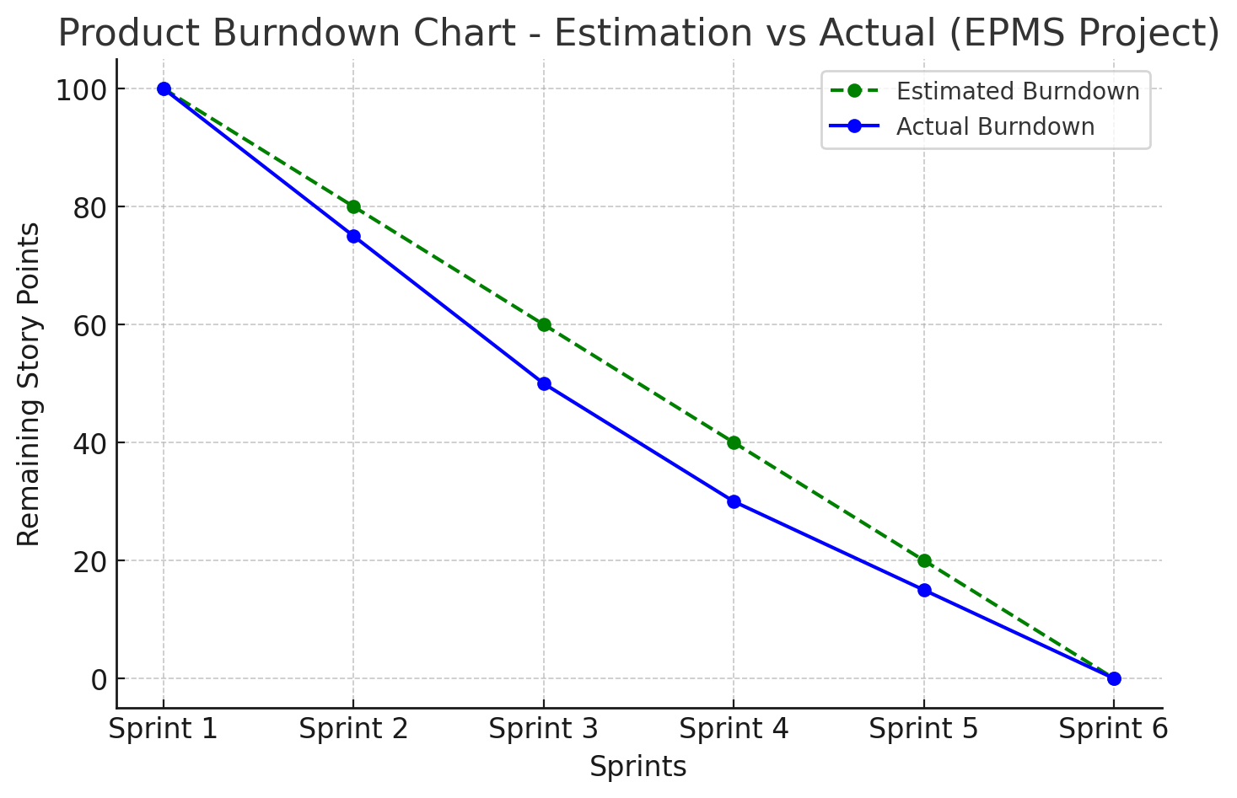

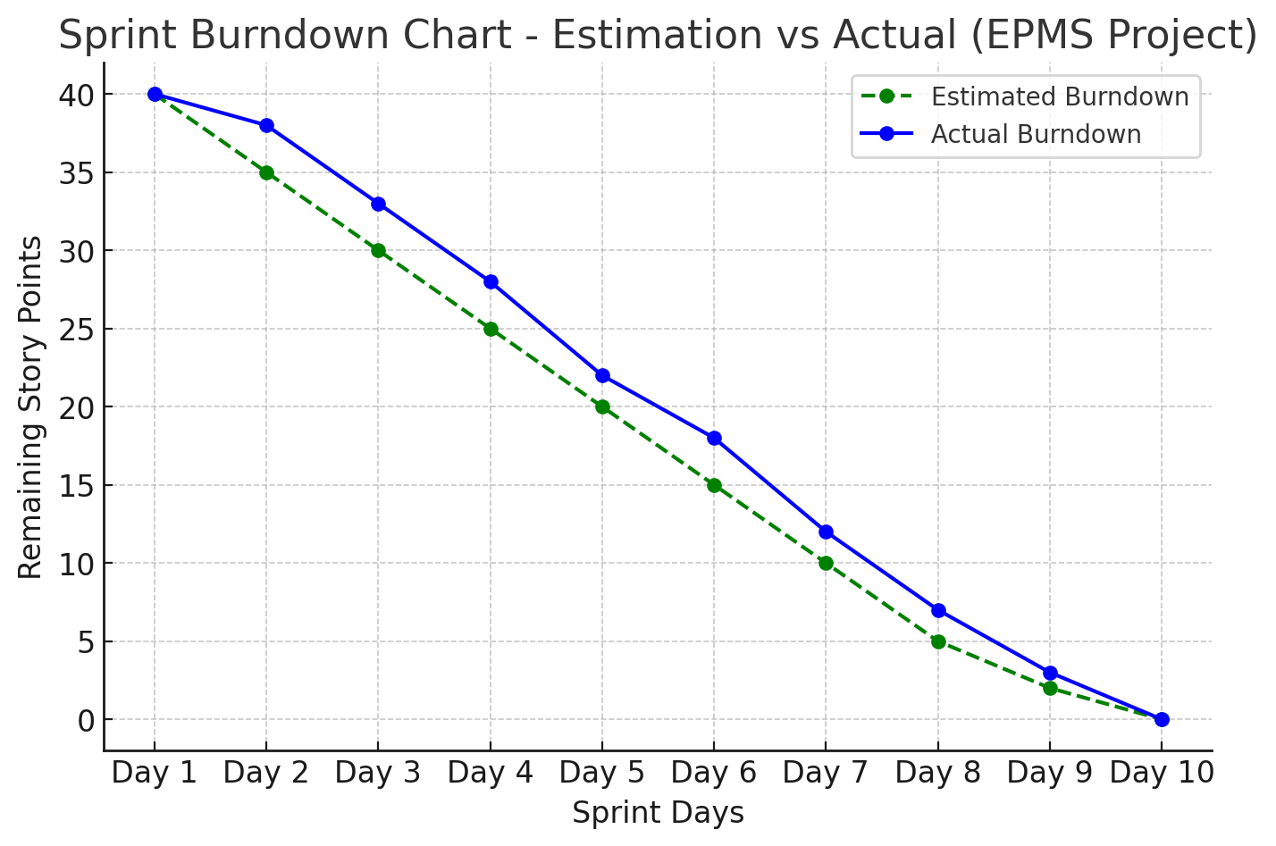

Sprint Meetings  
**Sprint Planning meeting-EPMS**

|  |  |
| --- | --- |
| **Section** | **Details** |
| **Date** | 13/03/2025 |
| **Time** | 09.00 AM |
| **Location** | MS Teams |
| **Prepared By** | Product Owner |
| **Attendees** | Product Owner, Scrum Master, Development Team, QA Team, Procurement |

**Agenda Topics**

|  |  |  |
| --- | --- | --- |
| **Topic** | **Presenter** | **Time Allotted** |
| Overview of Sprint Goals | Product Owner | 10 min |
| Review of Product Backlog Items | Scrum Master | 15 min |
| Selection of User Stories for Sprint | Development Team | 20 min |
| Task Breakdown & Assignments | Development Team | 25 min |
| Story Point Estimation | Scrum Team | 15 min |
| Identifying Dependencies & Risks | Development Team & PO | 15 min |
| Definition of Ready & Done Review | Scrum Master | 10 min |
| Commitment & Sprint Plan Finalization | Scrum Team | 10 min |

**Other Information**

|  |  |
| --- | --- |
| **Section** | **Details** |
| **Observers** | [List of any additional stakeholders observing] |
| **Resources** | - Product Backlog  - Sprint Goal Document  - Agile Estimation Techniques (Story Points)  - Prior Sprint Reports (if applicable) |
| **Special Notes** | - Any last-minute backlog refinement  - Adjustments based on business priority changes |

|  |  |
| --- | --- |
| **Section** | **Details** |
| **Sprint Goal** | Implement procurement features such as supplier management, purchase order workflow, invoice tracking, and reporting for the current sprint. |
| **Planned User Stories** | **Example:**  - US-101: Supplier onboarding & compliance verification  - US-102: Purchase order creation & submission  - US-104: Invoice matching with purchase orders |
| **Task Breakdown** | Each user story is broken down into development, testing, and integration tasks. |
| **Effort Estimation** | Assign story points to each user story based on complexity (BV & CP values). |
| **Dependencies** | - Supplier approval API integration  - Finance system sync for invoice matching |
| **Definition of Ready** | User stories must be well-defined with clear acceptance criteria. |
| **Definition of Done** | - Code developed and tested  - Passed QA testing  - Reviewed by Product Owner  - Deployed in a test environment |
| **Sprint Commitment** | Development team commits to delivering agreed user stories within the sprint. |
| **Next Steps** | Assign tasks to developers & QA, update sprint backlog, begin development. |

**Daily Stand-up Meeting Document – EPMS**

|  |  |
| --- | --- |
| **Section** | **Details** |
| **Meeting Name** | Daily Stand-up – EPMS Project |
| **Date & Time** | 12/03/2025 10.00 AM |
| **Attendees** | Development Team, Scrum Master, Product Owner |
| **Format** | Each team member answers:  1. What did I do yesterday?  2. What will I do today?  3. Are there any blockers? |
| **Current Sprint Progress** | **Example:**  - Supplier onboarding feature **In Progress**  - Purchase order workflow **Ready for Testing**  - Invoice matching **Blocked due to API dependency** |
| **Impediments** | - Delay in supplier API integration  - Pending test cases for PO approval workflow |
| **Action Items** | - Resolve API delay with external team  - Assign additional resources for testing |
| **Next Steps** | Continue development, QA testing, and resolve blockers. |

**Sprint Review Meeting Document – EPMS**

|  |  |
| --- | --- |
| **Section** | **Details** |
| **Meeting Name** | Sprint Review Meeting – EPMS Project |
| **Date & Time** | 17/03/2025 3.00PM |
| **Attendees** | Product Owner, Scrum Master, Development Team, Procurement & Finance Stakeholders |
| **Sprint Goals** | - Demonstrate completed procurement features  - Gather feedback from stakeholders  - Update backlog based on business priorities |
| **Demonstration** | **Example Demo Items:**  - Supplier management portal  - Purchase order approval workflow  - Invoice processing dashboard |
| **Feedback from Stakeholders** | **Example:**  - Procurement team requests an additional status filter for POs  - Finance team wants better invoice tracking details |
| **Backlog Updates** | - Add a new user story for PO status filtering  - Adjust invoice tracking UI based on feedback |
| **Pending Items** | - Integration with ERP system pending for next sprint |
| **Next Steps** | - Plan next sprint based on feedback  - Address minor UI improvements before deployment |

**Sprint Retrospective Meeting Document – EPMS**

|  |  |
| --- | --- |
| **Section** | **Details** |
| **Meeting Name** | Sprint Retrospective Meeting – EPMS Project |
| **Date & Time** | 21/03/2025 6.00 PM |
| **Attendees** | Scrum Master, Development Team, Product Owner |
| **Discussion Format** | **1. What went well?**  **2. What didn’t go well?**  **3. What can we improve?** |
| **Key Achievements** | **Example:**  - Successfully implemented supplier onboarding workflow  - Automated invoice matching with PO |
| **Challenges & Bottlenecks** | **Example:**  - API integration delays caused sprint backlog spillover  - Late requirement changes from stakeholders |
| **Improvement Actions** | **Example:**  - Plan API dependencies in advance  - Schedule earlier stakeholder review to minimize last-minute changes |
| **Next Steps** | - Implement process improvements in the next sprint  - Adjust backlog to account for pending items |