Nurturing Process - Capstone Project3– Part -1/2 V2D2 August 2024

A customer can make a payment either by Card or by Wallet or by Cash or by Net banking.
Q1. Draw a Use Case Diagram - 4 Marks
Answer - 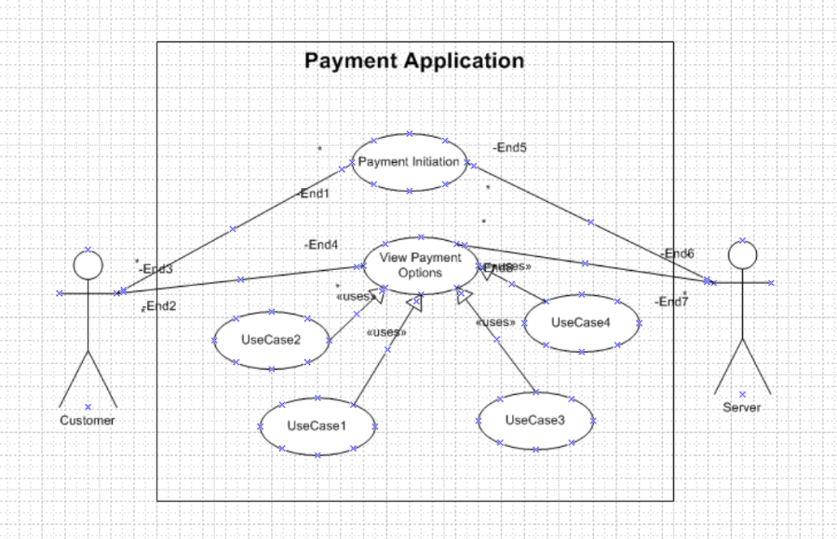

Q2. Derive Boundary Classes, Controller classes, Entity Classes. - 4 Marks
- Answer - Boundary Classes (User Interaction Layer)
Represent interfaces through which users interact with the system.
Example in project:
    - LoginPage (Farmer/Manufacturer login)
    - ProductCatalogPage (display fertilizers, seeds, pesticides)
    - CheckoutPage (payment gateway, COD/UPI options)
- Controller Classes (Logic / Control Layer)
Handle the flow between boundary and entity classes.
Example in project:
    - LoginController (validates user credentials)
    - ProductController (handles search, add to cart)
    - OrderController (manages order placement, payment, delivery tracking)
- Entity Classes (Database / Data Layer)
  - Represent core business objects stored in database.
  - Example in project:
    - Farmer (FarmerID, Name, Address, Email, Password)
    - Manufacturer (CompanyID, Product details)
    - Product (ProductID, Category: Fertilizer/Seed/Pesticide, Price, Stock)
    - Order (OrderID, FarmerID, ProductID, PaymentStatus, DeliveryStatus)

Q3. Place these classes on a three tier Architecture. - 4 Marks
Answer - Placement of Classes on 3-Tier Architecture
- User Layer (Presentation Layer)
Interfaces farmers and manufacturers use.
Classes:
    - LoginPage
    - ProductCatalogPage
    - CheckoutPage
- Business Logic Layer
Handles rules, validations, and flow of the system.
Classes:
    - LoginController
    - ProductController
    - OrderController
- Data Tier (Database Layer)
Stores and retrieves system data.
Classes:
    - Farmer
    - Manufacturer
    - Product
    - Order

Q4. Explain Domain Model for Customer making payment through Net Banking - 4 Marks
Answer - A domain model represents the main objects (entities) and their relationships in a business scenario.
For payment through Net Banking in your Online Agriculture Product Store, the following domain elements are involved:
- Customer (Farmer)
Attributes: CustomerID, Name, Email, AccountDetails
Role: Initiates payment after placing an order.
- Order
Attributes: OrderID, OrderDate, TotalAmount, PaymentStatus
Role: Links customer with purchased products.
- Payment
Attributes: PaymentID, Amount, Mode (Net Banking), Status
Role: Records transaction details.
- Bank
Attributes: BankID, BankName, IFSC Code
Role: Provides authentication and processes payment.
- Transaction
Attributes: TransactionID, Timestamp, ConfirmationNumber
Role: Tracks success/failure of payment.

Q5. Draw a sequence diagram for payment done by Customer Net Banking –
Answer – A sequence diagram is a type pf interaction diagram used in software engineering and system design to illustrate how process operate with one another and in what order
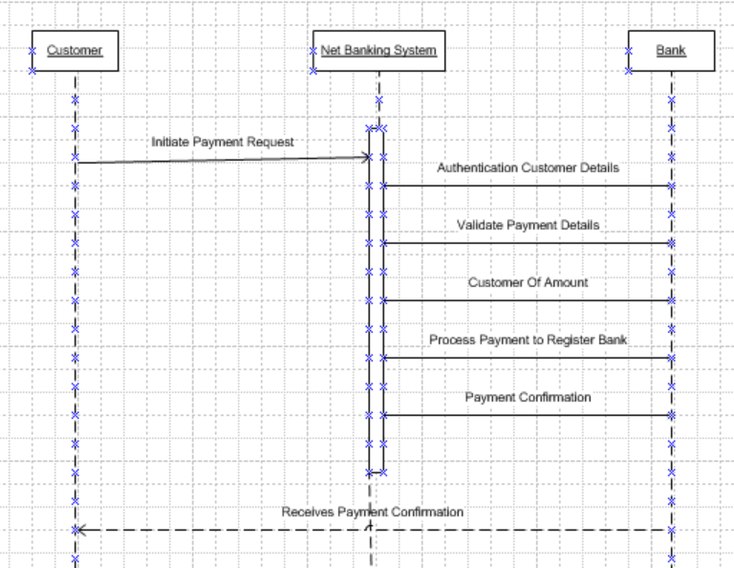

Q6. Explain Conceptual Model for this Case –
Answer - Conceptual Model is a high-level representation of the system that shows the main entities, their attributes, and relationships without going into technical details.
It helps stakeholders understand the overall business structure before moving to design or database modeling.

For Online Agriculture Products Store (Case Study)
Main Entities (Nouns):
- Customer → customerID, name, email, address
- Product → productID, productName, category, price, stockQty
- Order → orderID, orderDate, totalAmount, status
- Payment → paymentID, paymentType (Net Banking, UPI, Card), paymentStatus
- Admin → adminID, name, role
Relationships:
- Customer places Order (1-to-many)
- Order contains Product(s) (many-to-many)
- Order has Payment (1-to-1)
- Admin manages Product catalog (1-to-many)

Q7. What is MVC architecture? Explain MVC rules to derive classes from use case diagram and guidelines to place classes in 3-tier architecture
Answer - MVC Architecture
- MVC stands for Model-View-Controller, a design pattern used to separate an application into three interconnected components.
- It helps organize code, makes maintenance easier, and improves scalability.
1. Model (Entity Classes – Data Layer):
- Represents the business logic and data.
- Classes here deal with database operations, entities (like Customer, Product, Payment).
2. View (Boundary Classes – Presentation Layer):
- Represents the UI (User Interface).
- Shows data to the user and captures input.
- Examples: Login page, Payment form, Shopping cart screen.
3. Controller (Control Classes – Business Logic Layer):
- Acts as a bridge between Model and View.
- Handles user requests, applies business rules, and updates both Model and View.

Rules to Derive Classes from Use Case Diagram
- Boundary Classes (View/UI Layer):
Derived from actors’ interactions in the use case diagram.
Example: If Customer interacts with “Login”, then LoginForm boundary class is created.
- Controller Classes (Business Logic Layer):
Derived from system operations in the use case diagram.
Each use case generally maps to one controller class.
Example: For “Process Payment” → PaymentController.
- Entity Classes (Data Layer):
Derived from nouns in the use case / business domain.
Example: Customer, Product, Order, Payment.

Guidelines to Place Classes in 3-Tier Architecture
- Presentation Tier (User Layer): Contains Boundary classes (Views) → UI pages, forms, screens.
- Business Logic Tier: Contains Controller classes → Handles workflows, validations, system operations.
- Data Tier (Database Layer): Contains Entity classes (Models) → Deals with database tables, CRUD operations.

Q8. Explain BA contributions in project (Waterfall Model – all Stages)
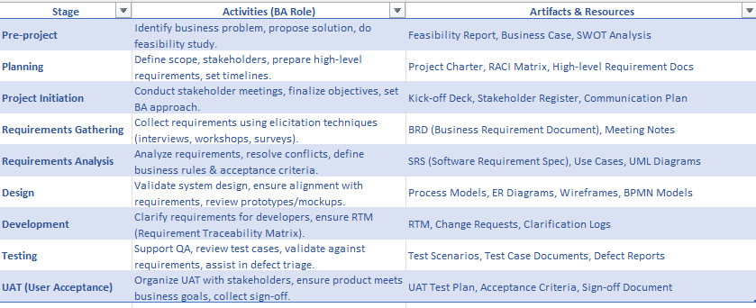

Q9. What is conflict management? Explain using Thomas – Kilmann technique
Answer - Conflict Management
Conflict management is the process of handling disagreements or clashes between stakeholders, team members, or departments in a project in a constructive way so that it does not affect the project progress.
A Business Analyst (BA) often faces conflicts (e.g., between customer needs and technical feasibility) and must resolve them effectively.
Thomas–Kilmann Conflict Management Technique
The Thomas–Kilmann model (TKI) explains 5 different styles of managing conflict, based on two dimensions:
- Assertiveness (concern for own needs)
- Cooperativeness (concern for others’ needs)
The 5 Styles are:
- Competing (High Assertiveness, Low Cooperation)
Forcing own decision, suitable in urgent situations.
Example: When strict deadlines must be met.
- Collaborating (High Assertiveness, High Cooperation)
Win–Win solution, both parties work together.
Example: BA works with customer + developer to balance requirements and feasibility.
- Compromising (Medium Assertiveness, Medium Cooperation)
Each party gives up something to reach a middle ground.
Example: Customer reduces features, developer agrees on faster delivery.
- Avoiding (Low Assertiveness, Low Cooperation)
Ignoring or postponing conflict.
Example: Minor issue that doesn’t impact project immediately.
- Accommodating (Low Assertiveness, High Cooperation)
Sacrificing own needs to satisfy others.
Example: BA accepts minor change request to maintain client relationship.

Q10. List down the reasons for project failure –
Answer - Projects often fail due to multiple factors. The key reasons are:
- Unclear Requirements – Poorly defined or changing requirements cause scope creep.
- Lack of Stakeholder Involvement – Stakeholders not engaged in decision-making lead to misalignment.
- Poor Planning & Estimation – Incorrect timelines, budgets, or resource estimation result in delays.
- Inadequate Communication – Miscommunication between BA, developers, and clients creates confusion.
- Scope Creep – Adding new features without proper approval leads to uncontrolled growth.
- Insufficient Testing – Poor quality assurance results in defects and failures post-delivery.
- Weak Risk Management – Ignoring potential risks (technical, financial, operational) impacts project success.
- Lack of Skilled Resources – Shortage of skilled team members delays and lowers quality.
- Unrealistic Deadlines – Pressure to deliver fast without feasibility check results in failure.
- Poor Project Management – Weak leadership and monitoring lead to inefficiency.

Q11. List the Challenges faced in projects for BA
Answer - Challenges Faced by Business Analyst in Projects
- Unclear Requirements – Stakeholders often provide vague or incomplete requirements.
- Changing Requirements (Scope Creep) – Continuous changes create confusion in documentation and delivery.
- Multiple Stakeholders with Conflicts – Balancing conflicting needs of different stakeholders is difficult.
- Communication Gaps – Misunderstandings between business teams and technical teams.
- Time Constraints – Limited time for requirement gathering, analysis, and validation.
- Prioritization Issues – Difficulty in deciding which requirements are critical vs optional.
- Technical Constraints – Lack of technical knowledge may limit understanding of feasibility.
- Resistance to Change – End users or stakeholders resist adopting new systems.
- Documentation Overload – Preparing detailed BRD, SRS, and use cases under tight deadlines.
- Testing & Validation Pressure – Ensuring requirements are properly tested within limited time.
Q12. Write about Document Naming Standards –
Answer - Document Naming Standards
Document Naming Standards are a set of rules or guidelines used to create consistent, clear, and easily identifiable names for project documents. They ensure that everyone in the project team can quickly locate, understand, and manage documents without confusion.
Key Points of Naming Standards:
- Project Identifier – Include the project name or code.
Example: OAPS (Online Agriculture Product Store).
- Document Type – Mention whether it is BRD, SRS, Test Case, Use Case, etc.
Example: BRD, SRS, TCD.
- Version Control – Add version number to track updates.
Example: V1.0, V2.1.
- Date Format – Use standard date format (YYYYMMDD).
Example: 20250908.
- Author/Owner (Optional) – Initials of creator or owner can be included.
Example: MJ (Manuish J).

Example for Your Project:
- OAPS_BRD_V1.0_20250908.docx → Business Requirement Document.
- OAPS_SRS_V1.1_20250910.docx → System Requirement Specification.
- OAPS_TestCases_V2.0_20250915.xlsx → Test Case Document.

Q13. What are the Do’s and Don’ts of a Business analyst
Answer -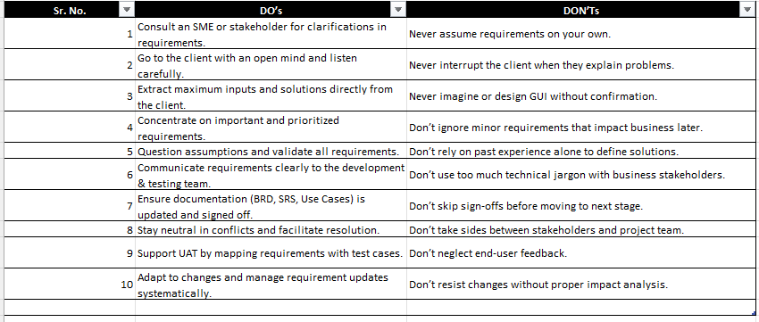

Q14. Difference between Packages and Sub-systems
Answer –
Aspect | Packages | Sub-systems
Definition | A package is a grouping mechanism in UML to organize classes, interfaces, and diagrams. | A subsystem is a higher-level component of the system that represents a complete functional unit.
Purpose | Used mainly for logical grouping and structuring of models. | Represents a major functional area of the system (e.g., Payment Subsystem).
Granularity | Smaller and lightweight; organizes elements. | Larger and heavyweight; represents a full system module.
Example | Customer Package, Order Package. | Inventory Management Subsystem, Payment Gateway Subsystem.

Q15. What is Camel-Casing? Where is it used?
Answer - Definition:
Camel-casing is a naming convention in programming where multiple words are joined together without spaces, and each word after the first begins with a capital letter.
Types:
- lowerCamelCase → first letter of the first word is lowercase. Example: customerName, orderDate.
- UpperCamelCase (PascalCase) → first letter of every word is uppercase. Example: CustomerName, OrderDate.
Usage in Project:
- Variable names – e.g., productName, farmerId.
- Method names – e.g., calculateTotal().
- Class names (PascalCase) – e.g., PaymentService, OrderController.
- Database attributes in modern projects – e.g., orderStatus, productPrice.

Q16. Illustrate Development Server & BA’s Access Rights
Answer - Development Server
- A test environment where developers build, integrate, and test new features before moving them to QA (Quality Assurance) or Production.
- It is not live for customers; only the project team uses it.
- Example in your Agriculture Store Project:
Developers deploy features like Register/Login, Browse Products, Add to Cart on the Dev Server first for internal checks.

BA’s Access Rights on Dev Server
- Read-only / Validation Access → BA can log in as a user to verify features.
- Requirement Validation → BA ensures developed functionality matches documented requirements.
- Traceability Check → BA links user stories & requirements to what is built.
- Collaboration with Testers → BA supports testers in clarifying requirements.
- No Coding Access → BA cannot change or deploy code; only developers/admins do that.

Q17. What is Data Mapping
Amswer - Definition:
Data Mapping is the process of linking data fields from one source to corresponding data fields in a target system. It ensures that data is transferred, transformed, and stored correctly when moving between databases, systems, or applications.
Key Points:
- Source → Target: Connects how data from the source system will appear in the target system.
- Data Transformation: Handles changes in format (e.g., DD/MM/YYYY → MM-DD-YYYY).
- Ensures Consistency: Prevents data loss or mismatch during migration or integration.
- Used in: Data migration, system integration, ETL (Extract, Transform, Load) processes, and reporting.

Q18. What is API. Explain how you would use API integration in the case of your application Date format is dd-mm-yyyy and it is accepting some data from Other Application from US whose Date Format is mm-dd-yyyy
Answer - Definition:
API (Application Programming Interface) is a set of rules, protocols, and tools that allow two different software systems to communicate and exchange data with each other.
- %

API Integration in My Application (Online Agriculture Products Store):
In our project, the store application needs to accept customer/order/payment data from another external application (say, a US-based system). However, there is a data format mismatch for date fields:
- Our Application Standard: dd-mm-yyyy
- US Application Standard: mm-dd-yyyy

How API Handles This Case:
- API Request:
The US application sends order data (e.g., 09-08-2025 meaning September 8, 2025).
- Middleware / API Integration Logic:
API parses the incoming date.
Applies a transformation rule to convert mm-dd-yyyy → dd-mm-yyyy.
Example: 09-08-2025 → 08-09-2025.
- Validation:
Check for invalid dates (e.g., 13-25-2025 → invalid).
Ensure leap years and time zones are handled.
- API Response:
After transformation, the corrected data is saved in the Agriculture Store database.
API responds with “Success” or “Error” messages.

Advantages of API Integration Here:
- Maintains data consistency between different systems.
- Reduces manual effort of correcting dates.
- Enables seamless global operations (our system in India, external app in US).
- Improves customer experience with accurate data (orders, payments, delivery dates).

