Prep 1 – Part 3

A requirement Is basically the need of the client. This need or requirement will transform into a solution while taking various shapes and forms as it progresses from each stage of SDLC.

Types of requirements:

1. Business requirement
2. Stake holder requirement
3. Solution requirements

a. Functional requirement

b. Nonfunctional requirement

Functional requirements:

Describe the behavior and information that the solution will manage. They describe capabilities the system will able to perform in terms of behaviors or operations specific information technology application actions or responses.

Functional requirement defines the specific behaviors, functions or operations of a system. They describe what the system should do outlining the necessary tasks, actions, activities. It must perform to achieve its objectives.

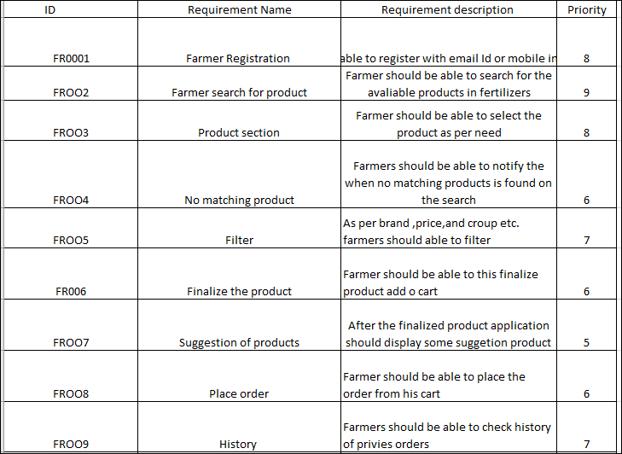

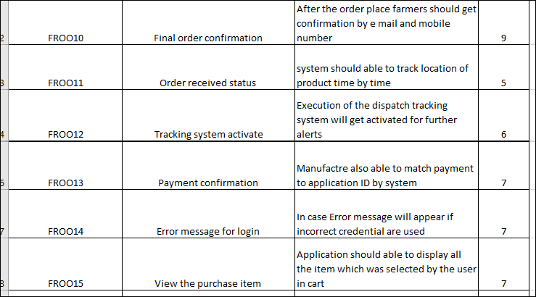

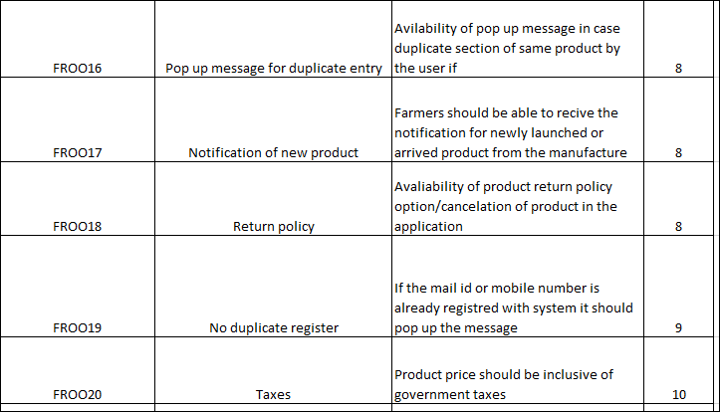

2. Non- Functional Requirements:

It Capture conditions that do not directly relate to the behavior or functional of the solution, but rather they describe environmental condition under which the solutions must remain effective like capacity, speed, security or qualities that the system must have. They are also known as quality or supplementary requirements.

It will describe the qualities and attributes of a system, focusing on how the system performs rather than specific behavior or functions.

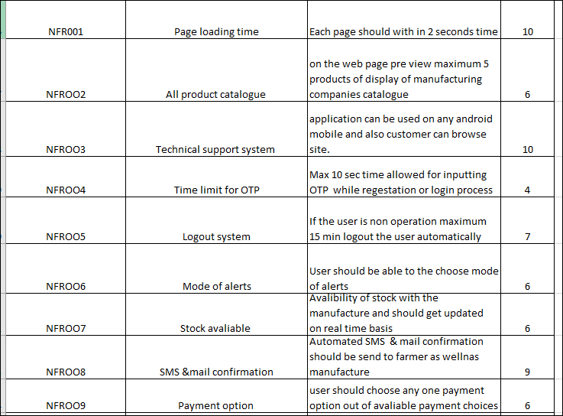

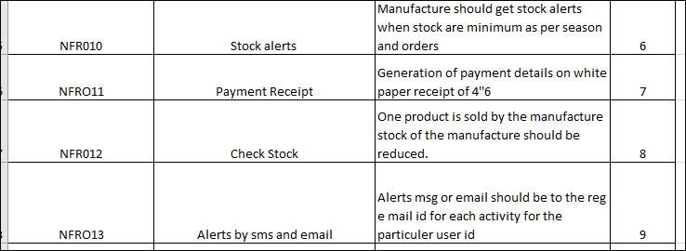

3. 5 wire frame and prototype



Microsoft Viso: Transform complicated text and tables that are hard to understand into visual diagrams that communicate inform at glance. Micro soft Visio is a diagraming and vector graphics application used to create daigrame,flow charts ,and other represents of complex information.

Balsamic: Is a rapid wire framing tool used to create mockups and porotype of user interfaces

Azure: A software tool primarily used for creating interactive prototypes and wireframes for website and applications, focusing on functionality and user interactions testing, rather than solely visual aesthetics. Azure is a more advanced prototyping tool used to create high-fidelity, interactive wireframes and prototype for web and mobile applications.

RTM Diagram:

**Requirements Traceability Matrix** is a document that links requirements to other project artifacts (like test cases, code, or design documents) to ensure that all requirements are met and that the project deliverables are aligned with the initial needs.

|  |  |  |  |  |  |  |  |  |  |
| --- | --- | --- | --- | --- | --- | --- | --- | --- | --- |
| ID | Requirement Name | Requirement description | Design | Code | Unit Testing | component testing | System Testing | SIT | UAT |
| FR0001 | Farmr registratioin | Farmer should be able to the registered with e mail id or mobile in to the application | Completed | Completed | Completed | Completed | Completed | Completed | Completed |
| FR0002 | Farmer search for product | Farmer should be able to search for the avliable products in fertilizers ,seeds,pestisides, | Completed | Completed | Completed | Completed | Completed | Completed | Completed |
| FR0003 | Product selection | Farmer should be able to select the product as need | Completed | Completed | Completed | Completed | Completed | Completed | Completed |
| FR0004 | Farmer compare the product | Farmer should be able to view various product on same screen for comparision purpose with product other the manufactures | Completed | Completed | Completed | Completed | Completed | Completed | Incompleted |
| FR0005 | Filter | As per brand price and croup etc. Farmer should able to filter | Completed | Completed | Completed | Incomplete | Incompleted | Incompleted | Incompleted |
| FR0006 | Finalize the product | Farmer should be able to add his finalize product add to cart | Completed | Completed | Completed | Incomplete | Incompleted | Incompleted | Incompleted |
| FR0007 | Suggestion of products | After the finalized product application should display some suggestion products | Completed | Completed | Completed | Incomplete | Incompleted | Incompleted | Incompleted |
| FR0008 | Place order | Farmer should able to place the order from his cart list | Completed | Completed | Completed | Completed | Completed | Incompleted | Incompleted |
| FR0009 | History | Farmer should also be able to check history of prives orders | Completed | Completed | Completed | Completed | Incompleted | Incompleted | Incompleted |
| FR0010 | Payment | system should pop up the available payment option for ex. Cash, card, upi, and COD etc.. | Completed | Completed | Completed | Incomplete | Incompleted | Incompleted | Incompleted |
| FR0011 | Final order confirmation | After the order place farmers should get confirmation by e mail and mobile number | Completed | Completed | Incomplete | Incomplete | Incompleted | Incompleted | Incompleted |
| FR0012 | Order received status | System should able to track location of products of time by time | Completed | Completed | Completed | Completed | Completed | Incompleted | Incompleted |
| FR0013 | Tracking system activate | Execution of dispatch tracking system will get activated for further alerts | Completed | Completed | Incomplete | Incomplete | Incompleted | Incompleted | Incompleted |
| FR0014 | Payment confirmation | Manufactures also able to match payment to application ID by system | Completed | Completed | Incomplete | Incomplete | Incompleted | Incompleted | Incompleted |
| FR0015 | Error message for login | Incase error message will appear if incorrect credential are used | Completed | Completed | Completed | Incomplete | Incompleted | Incompleted | Incompleted |
| FR0016 | View the purchase item | Application should able to display all the item which was selected by the user in cart | Completed | Completed | Completed | Incomplete | Incompleted | Incompleted | Incompleted |
| FR0017 | Pop up message for duplicate entry | Availability of pop message in case of duplicate selection of same product by user if any | Completed | Completed | Completed | Completed | Completed | Incompleted | Incompleted |
| FR0018 | Notification of new product | Farmers should be able to receive the notification for newly launched or arrived product from the manufacture | Completed | Completed | Completed | Completed | Completed | Completed | Incompleted |
| FR0019 | Return policy | Availability of product return policy option / Cancelation of product in the application | Completed | Completed | Completed | Incomplete | Incompleted | Incompleted | Incompleted |
| FR0020 | No duplicate register | If the mail id or mobile number is already registered with system if should pop the message | Incomplete | Incomplete | Incomplete | Incomplete | Incompleted | Incompleted | Incompleted |
| FR0021 | Taxes | Product price should be inclusive of government taxes | Completed | Completed | Completed | Completed | Completed | Completed | Completed |
| NFR001 | Pagr loading timing | Each page should loading with 2 second time | Completed | Completed | Completed | Completed | Completed | Completed | Completed |
| NFR002 | All product catalogue | on the web page preview maximum 5 products are display of manufacturing companies catalogues | Completed | Completed | Completed | Completed | Completed | Completed | Completed |
| NFR003 | Technical support system | Application can be used on any android mobile and also customer can browser site | Completed | Completed | Completed | Completed | Incompleted | Incompleted | Incompleted |
| NFR004 | Time limit for otp | Max 10 sec allowed for inputting voting while registration or login process | Completed | Completed | Completed | Incomplete | Incompleted | Incompleted | Incompleted |
| NFR005 | Logout system | If the user is non operation maximum 15 minutes logout the user automatically | Completed | Completed | Completed | Incomplete | Incompleted | Incompleted | Incompleted |
| NFR006 | Mode of alerts | User should able to choose mode of alerts | Completed | Completed | Completed | Completed | Incompleted | Incompleted | Incompleted |
| NFR007 | Stock available | Availability of stock with the manufactured and should get upgraded on real time basis | Completed | Completed | Completed | Completed | Incompleted | Incompleted | Incompleted |
| NFR008 | SMS & mail confirmation | Automated SMS & Email confirmation should be send to farmer as well as manufacturer | Completed | Completed | Incomplete | Incomplete | Incompleted | Incompleted | Incompleted |
| NFR009 | Payment option | User should choose any one payment option out of available payment choice | Completed | Completed | Incomplete | Incomplete | Incompleted | Incompleted | Incompleted |
| NFR010 | Stock alerts | manufactures should get stock alerts when are stock are minimum are per5 season orders | Completed | Completed | Incomplete | Incomplete | Incompleted | Incompleted | Incompleted |
| NFR011 | Payment receipt | Generation of payment details on white paper receipts | Completed | Completed | Incomplete | Incomplete | Incompleted | Incompleted | Incompleted |
| NFR012 | Check stock | Once product is sold by the manufacture stock of the manufacture should be reduced | Completed | Completed | Incomplete | Incomplete | Incompleted | Incompleted | Incompleted |
| NFR013 | Alerts by SMS & Email | Alerts mgs or Email should be to the reg email id for each activity for the particular user id | Completed | Incomplete | Incomplete | Incomplete | Incompleted | Incompleted | Incompleted |
| NFR014 | Disable policy | User id should be disable if not log in for 1 year | Incomplete | Incomplete | Incomplete | Incomplete | Incompleted | Incompleted | Incompleted |
| NFR015 | Taxation system | 10% Government taxes should be added to the product final price | Incomplete | Incomplete | Incomplete | Incomplete | Incompleted | Incompleted | Incompleted |

5 TEST CASE DOCUMENTS

A test case document is a detailed outline used by testers to ensure that a software application or system is working as expected.

TEST CASE DOCUMENT

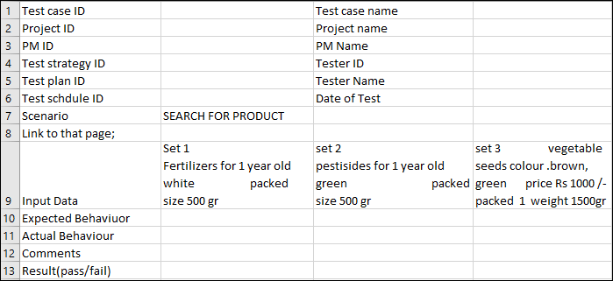

6 Draw DB Schema and Entity relationship diagram

DB Schema: is a blueprint outline the structure of a database, including its tables, fields, relationships, constraints and other characteristics.

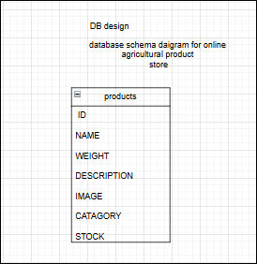

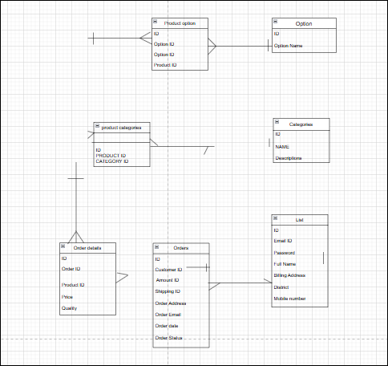

Entity Relationship diagram;( ERD) is a visual representation of the relationships between entities in a database. It depicts the entities ( such as tables),attributes (properties or fields) and relationship between them.

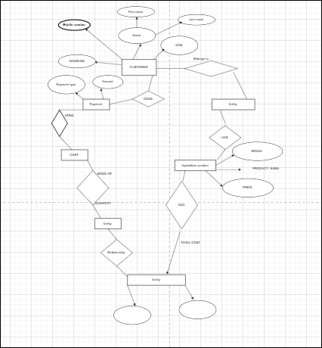

7

Data Flow Diagram: Data flow diagram uses graphical symbols to illustrates the paths, processes and storage repositories for data from the point enters a system until

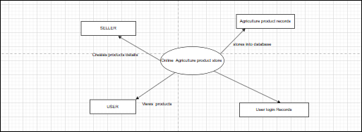

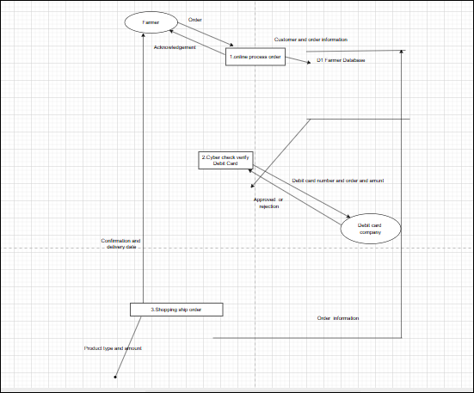

8

Change request: A change request is a formal proposal to alert a system, product, or project.

1 Understand the scope of change request and document the change request.

2 do the important analysis - project scope, schedule, budget, resource, and risks.

3 prioritize change requests based on its urgency, importance, impact on project

4 Seek approval from the project sponcer of the change request.

5 Communicate the change request and its potential impacts to all relevant stakeholders, including the project team.

9

CHANGE REQUEST Vs ENHANCEMENT

CHANGE REQUEST:

Initially BA should check the change request whether it is a defect from previous installation or not. if it is a defect then it is assigned to the technical team else.

BA should be doing the following.

1. Impact analysis:

A process that examines the potential consequences of a decision, action, or event .it helps identify risks, benefits, and stakeholders affected.it includes

2 Feasibility Study:

Possibility of doing a project within some constraints like technology, Budget and time.

3 Effort Estimation:

Effort estimation is the process of predicting how much time, resources, effort are needed to complete a task or project.

ENHANCEMENT:

An enhancement request is a piece of functionally that was not specified at the time that the code was written, or extension to what is already present.

10. ESTIMATIONS:

*PM - $ 130/Hr.,

PM work very month 60 hr. for entire he worked 1080 hr.

Total work Cost $64800

* Sol Architect - $55/Hr.,

Sol architect work every month 80 Hr.

For entire project he work1440 Hr.

Total work $115200

* Programmers - $ 50 /Hr.

Programmers work for every moth 90 Hr.

For entire project he works 1620 Hr.,

Total work cost $145800

* Sr programmers -$80/Hr.

Sr. programmers work every month 85 Hr.

For entire project he works 1530 Hr.,

Total work costs $122400

* Network engineer - $80/hr.
* NE work every month 65 HR

For entire project he works 1170 HR

Total cost $93600/-

* DBA - $80/HR

DBA work every month 70 HR

For entire project he works 1260 HR

Total work cost $88200

* BA -60/HR

BA works every month 90 HR

For entire project he works 1260 HR

Total work cost $145800

Total man hours required for project – 9720 HR

Total cost for the project -$775,800/-

11 UAT

Planning: In this step, blue prints are made implement UAT testing for every feature that needs to test and minimum standard for accepting the test.

Designing: Here the test case are designed to hide all the possibilities of software package in a real world environment.

UAT Testers: A testing team consists of a end users that meet the criteria for implementing testing they should know the test case to run and understand functionalities.

BUG Fixing; Whatever Bugs are found in the UAT Testing the development team should work on them and make it software error free.

Sign off; After removing all the bugs, the testing team indicates accept of the completion of the bugs. In phase, all the stakeholders come to a conclusion that the software is ready to GO LIVE and sign off.

12 PROJECT CLOSURE DOCUMENT.

The project closure doc prepaid the main purpose document of to make note of what make went wrong the correct approach adopted deposit vive and negatives during the project. Varies initiatives taken by the team issues face by the members and solution obtaining in short this document is existing of to improve performance team member in further .in short closure report is a tool for management to accesses success of the project and its team member.

