**Nurturing Process – Agile Deliverables**

**AI-Driven Moderation Enhancer - Agile Documents**

**Document 1:** **Definition of Done**

Definition of Done (DoD) is a technique described in the *Agile Extension to the BABOK® Guide v2*.

* It represents a list of criteria that must be fulfilled before a backlog item is considered complete.
* The DoD must be:
  + Well-defined
  + Unambiguous
  + Measurable
  + Agreed-upon by the team
  + Shared and visible to all team members
* The best way to represent DoD is through a checklist.
* This checklist should demonstrate the agreed value and quality of a user story.
* The checklist must include:
  + Acceptance criteria – to satisfy customer requirements.
  + Quality criteria – to meet the product's quality standards.
* The Definition of Done can be applied at different levels of Agile project work, including:
  + User Story Level
  + Sprint Level
  + Release Level

**Definition of Done Checklist – User Story Level**

* Code is produced for the intended functionality.
* All assumptions related to the User Story are fulfilled.
* Acceptance criteria are satisfied and reviewed by Product Owner.
* Project builds without errors.
* Unit tests are written and passing.
* Project is deployed on a test environment identical to production.
* Tests across devices/browsers listed in assumptions are successful.
* Feature is reviewed and approved by UX Designer.
* QA validation is complete; all identified issues are resolved.
* Peer code review is performed.
* Feature passes acceptance testing.
* Code refactoring (if needed) is complete.
* Configuration or build changes are documented.
* Required technical/user documentation is updated.

**Definition of Done Checklist – Sprint Level**

* Sprint Goal is met.
* All committed stories fulfill their individual DoD.
* Features are integrated into the main branch with no conflicts.
* Increment is ready for demo.
* Regression testing completed.
* Stakeholders have reviewed the increment during Sprint Review.

**Definition of Done Checklist – Release Level**

* All required epics and stories for the release are completed.
* User Acceptance Testing (UAT) is complete and signed off.
* Release notes and end-user documentation are finalized.
* Training for end-users (if required) is delivered.
* Feature is deployed to production or staging.
* Performance metrics and business KPIs validated.

**Notes:**

* The DoD is reviewed during backlog refinement and improved during retrospectives.
* It ensures all Scrum Team members (Developers, QA, PO, UX, BA, Scrum Master) align on quality.
* Prominently displayed in the team’s workspace or Agile board.

**Document 2 - Product Vision**

The Product Vision is a concise and aspirational statement that describes the long-term goal and desired future state of a product. It articulates the what and the why behind the product's existence, outlining the problem it aims to solve and the value it will deliver to its users and the organization.

### AIME Project:

For content moderation teams and digital safety stakeholders, who need to ensure platform safety and compliance, the AI-Driven Moderation Enhancer (AIME) is an intelligent content moderation solution that accurately detects and flags inappropriate content using NLP and Computer Vision. Unlike traditional manual review systems, AIME empowers teams with real-time AI insights, automation, and reduced moderation workload, delivering a safer digital experience.

|  |  |  |  |  |  |  |
| --- | --- | --- | --- | --- | --- | --- |
| **Scrum Project Name:** | AIME Project |  |  |  |  |  |
| **Venue:** | Hyderabad |  |  |  |  |  |
| **Date:** | 20-04-2025 |  |  |  |  |  |
| **Client:** | Henry |  |  |  |  |  |
| **Stakeholder List:** | Priya | Arjun | Kiran | Rohan | Srihan | Shivani |
|  |  |  |  |  |  |  |
|  |  |  |  |  |  |  |
|  |  |  | Scrum Team |  |  |  |
| **Scrum Master:** | Rakesh |  |  |  |  |  |
| **Product Owner:** | Sirisha |  |  |  |  |  |
| **Scrum Developer 1:** | Swathi |  |  |  |  |  |
| **Scrum Developer 2:** | Swetha |  |  |  |  |  |
| **Scrum Developer 3:** | Krishna |  |  |  |  |  |
| **Scrum Developer 4:** | Sharath |  |  |  |  |  |
| **Scrum Developer 5:** | Nikitha |  |  |  |  |  |

|  |  |  |  |
| --- | --- | --- | --- |
| **Vision:** |  |  |  |
| **Target Group**  Market: Social media, forums, streaming platforms, e-learning, news publishers.  Target Users: Content Moderators, Compliance Officers, Trust & Safety Teams. | **Needs**  Problem the Product solves - Manual moderation is slow, inconsistent, and costly. High volume content is hard to manage.  Benefit -   |  | | --- | | Faster moderation, reduced manual effort, better compliance, improved user experience |  |  | | --- | |  | | **Product**  Product -   |  | | --- | | AI-Driven Moderation Enhancer (AIME) – NLP + CV based moderation solution |  |  | | --- | |  |   desirable - Real-time analysis, context-aware moderation, platform integration, feedback-based learning.  Feasible - 6-month Scrum project, 2 Cr INR budget, using proven AI/ML stacks | **Value**  Benefit the company:   |  | | --- | | Saves cost, improves efficiency, enhances safety reputation, attracts B2B clients |  |  | | --- | |  |   Business goals - - 85% accuracy in detection - 60% reduction in manual effort - UAT satisfaction ≥ 90%  Business model - SaaS (Subscription-based) - B2B Licensing - Optional Freemium tier |

**Document 3: User stories:**

|  |  |  |
| --- | --- | --- |
| **User Story No: US 01** | **Tasks: 3** | **Priority: High** |
|  |  |  |
| **Value Statement:**  As a Content Moderator  I want to flag comments containing hate speech automatically  So that I can focus on reviewing critical content only |  |  |
|  |  |  |
| **BV: 8** | **CP: 5** |  |
| * Acceptance Criteria: * Comments with predefined hate terms are flagged - 90% accuracy in test data - Dashboard displays flagged items in real-time. |  |  |
|  |  |  |
|  |  |  |

**Document 4: Agile PO Experience:**

#### **Role of Product Owner (PO)**

The Product Owner (PO) owns the **vision of the product** based on market demand and industry expertise.

#### **Key Responsibilities of the PO:**

* **Market Analysis**
  + Study of market needs and demand.
  + Identification of existing/similar products.
* **Enterprise Analysis**
  + Evaluate potential market opportunities.
  + Perform due diligence for feasibility.
* **Product Vision & Roadmap**
  + Define clear product vision based on analysis.
  + Build a product roadmap with high-level features and release timelines.
* **Managing Product Features**
  + Prioritize features based on criticality and Return on Investment (ROI).
  + Manage and align stakeholder expectations.
  + Plan and prioritize Epics and Features.
* **Product Backlog Management**
  + Prioritize and re-prioritize user stories based on feedback.
  + Conduct backlog grooming/refinement.
  + Plan and manage Epics and user story flow.
* **Iteration and Sprint Progress Management**
  + Review sprint progress regularly.
  + Adjust Epics or sprints based on performance or stakeholder input.
  + Collaborate with the Business Analyst during retrospectives for continuous improvement.

#### **Scrum Ceremonies Handled in This Project:**

* Sprint Planning Meeting
* Daily Scrum Meeting
* Sprint Review Meeting
* Sprint Retrospective Meeting
* Backlog Refinement Meeting

#### **User Story Creation – Key Inclusions**

* User Story No.
* Tasks to be performed
* Priority Level
* Acceptance Criteria
* Business Value (BV)
* Complexity Points (CP)

#### **Product Owner in Scrum**

* Acts as the **bridge between business and development teams**.
* Keeps all departments informed of product progress.
* Continuously communicates with stakeholders.
* Breaks down **features into manageable user stories** for the backlog.

**Document 5: Product and sprint backlog and product and sprint burndown charts.**

**Product Backlog:**

|  |  |  |  |  |  |  |
| --- | --- | --- | --- | --- | --- | --- |
| **User Story ID** | **User Story** | **Tasks** | **Priority** | **BV** | **CP** | **Sprint** |
| US01 | As a Moderator,   |  | | --- | | I want to detect hate speech in comments |  |  | | --- | |  | | Text analysis using NLP, model training, testing | High | 8 | 5 | 1 |
| US02 | |  | | --- | | As a system, I want to flag violent images using CV |  |  | | --- | |  | | Image dataset curation, model training, QA | High | 10 | 8 | 2 |

**Sprint Backlog:**

|  |  |  |  |  |  |
| --- | --- | --- | --- | --- | --- |
| **User Story ID** | **User Story** | **Tasks** | **Owner** | **Status** | **Estimated Effort** |
| US01 | Detect hate speech in comments | |  | | --- | | NLP model setup |  |  | | --- | |  | | Sr.Developer | In Progress | 10 |
| US02 | |  | | --- | | Model accuracy testing |  |  | | --- | |  | | Accuracy testing | Developer | Done | 8 |

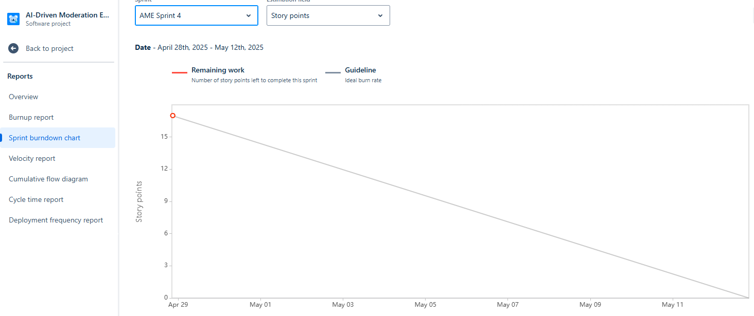

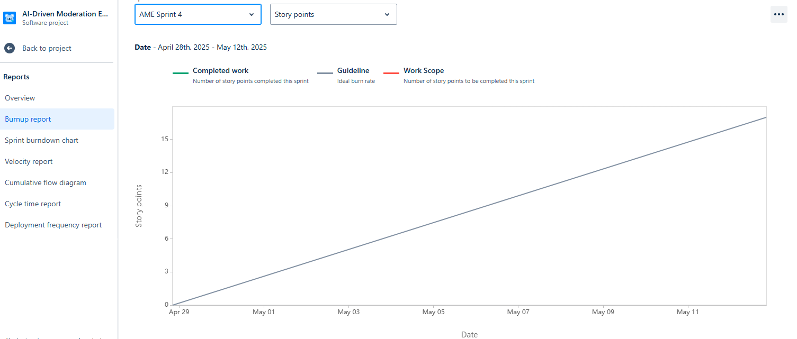

**Document 6: Sprint Meetings**

**Meeting Type 1: Sprint Planning meeting**

|  |  |
| --- | --- |
| **Date** | 01-04-2025 |
| **Time** | 10:30 AM |
| **Location** | Hyderabad |
| **Prepared by** | Sirisha |
| **Attendees** | Priya, Arjun, Kiran, Rohan, Srihan, Shivani |

**Agenda Topics:**

|  |  |  |
| --- | --- | --- |
| **Topic** | **Presenter** | **Time Alloted** |
| |  | | --- | | Review Product Backlog |  |  | | --- | |  | | PO | 2 hours |
| |  | | --- | | Define Sprint Goal |  |  | | --- | |  | | PO | 1 hour |

**Other Information:**

|  |  |
| --- | --- |
| **Observers** | Priya, Arjun, Kiran, Rohan, Srihan, Shivani |
| **Resources** | |  | | --- | | JIRA, Confluence, Zoom, Whiteboard, etc. |  |  | | --- | |  | |
| **Special Notes** | Sprint Duration – 2 weeks, Focus on high-priority user stories; Ensure Definition of Done is understood. |

**Meeting Type 2: Sprint Review Meeting:**

|  |  |
| --- | --- |
| **Date** | 16-04-2025 |
| **Time** | 12:30 PM |
| **Location** | Hyderabad |
| **Prepared by** | Sirisha |
| **Attendees** | Priya, Arjun, Kiran, Rohan, Srihan, Shivani |

|  |  |  |  |
| --- | --- | --- | --- |
| **Sprint Status** | **Things to demo** | **Quick Updates** | **What’s Next** |
| Sprint Goal achieved | Functionalities and list of features improvements by the team | Product updates | Upcoming Priorities, Product Backlog Changes |

**Meeting Type 3: Sprint Retrospective Meeting:**

|  |  |
| --- | --- |
| **Date** | 24-04-2025 |
| **Time** | 02:30 PM |
| **Location** | Hyderabad |
| **Prepared by** | Sirisha |
| **Attendees** | Priya, Arjun, Kiran, Rohan, Srihan, Shivani |

|  |  |  |  |  |
| --- | --- | --- | --- | --- |
| **Agenda** | **What went well** | **What didn’t go well** | **Questions** | **Reference** |
| Sprint Retrospective | Collaboration between AI engineers and content moderators. | Model training took longer than estimated | More frequent backlog refinement sessions. | Improve communication during mid-sprint clarifications. |

**Meeting Type 4: Daily Stand-up meeting:**

|  |  |
| --- | --- |
| **Question** | **Name/Role** |
| **Monday** | **Tuesday** | **Wednesday** | **Thursday** | **Friday** |
| **What did you do yesterday?** | **Developer 1** | Finalized the NLP model for hate speech detection. | Finalized the NLP model for hate speech detection. | Finalized the NLP model for hate speech detection. | Finalized the NLP model for hate speech detection. | Finalized the NLP model for hate speech detection. |
| **Developer 2** | Completed unit testing for the moderation dashboard. | Completed unit testing for the moderation dashboard. | Completed unit testing for the moderation dashboard. | Completed unit testing for the moderation dashboard. | Completed unit testing for the moderation dashboard. |
| **Developer 3** | |  | | --- | | Updated acceptance criteria for flagged content user story. |  |  | | --- | |  | | |  | | --- | | Updated acceptance criteria for flagged content user story. |  |  | | --- | |  | | |  | | --- | | Updated acceptance criteria for flagged content user story. |  |  | | --- | |  | | |  | | --- | | Updated acceptance criteria for flagged content user story. |  |  | | --- | |  | | |  | | --- | | Updated acceptance criteria for flagged content user story. |  |  | | --- | |  | |
| **What will you do today?** | **Developer 1** | Start integration of the Computer Vision API into the main application. | Start integration of the Computer Vision API into the main application. | Start integration of the Computer Vision API into the main application. | Start integration of the Computer Vision API into the main application. | Start integration of the Computer Vision API into the main application. |
| **Developer 2** | Conduct UAT testing for flagged content moderation. | Conduct UAT testing for flagged content moderation. | Conduct UAT testing for flagged content moderation. | Conduct UAT testing for flagged content moderation. | Conduct UAT testing for flagged content moderation. |
| **Developer 3** | |  | | --- | | Update sprint burndown chart and refine backlog stories with the PO. |  |  | | --- | |  | | |  | | --- | | Update sprint burndown chart and refine backlog stories with the PO. |  |  | | --- | |  | | |  | | --- | | Update sprint burndown chart and refine backlog stories with the PO. |  |  | | --- | |  | | |  | | --- | | Update sprint burndown chart and refine backlog stories with the PO. |  |  | | --- | |  | | |  | | --- | | Update sprint burndown chart and refine backlog stories with the PO. |  |  | | --- | |  | |
| **What is blocking your progress?** | **Developer 1** | Awaiting updated labeled datasets from Data Engineering team. | Awaiting updated labeled datasets from Data Engineering team. | Awaiting updated labeled datasets from Data Engineering team. | Awaiting updated labeled datasets from Data Engineering team. | Awaiting updated labeled datasets from Data Engineering team. |
| **Developer 2** | Delay in UI design handoff from UX team. | Delay in UI design handoff from UX team. | Delay in UI design handoff from UX team. | Delay in UI design handoff from UX team. | Delay in UI design handoff from UX team. |
| **Developer 3** | Need clarification from Product Owner on acceptance criteria for graphic content detection. | Need clarification from Product Owner on acceptance criteria for graphic content detection. | Need clarification from Product Owner on acceptance criteria for graphic content detection. | Need clarification from Product Owner on acceptance criteria for graphic content detection. | Need clarification from Product Owner on acceptance criteria for graphic content detection. |