- Dairy Product Inventory Management Project
Business Requirements Document (BRD)
Table of Contents
- Introduction
- Requirement Scope
- Functional Requirements
- Non-Functional Requirements
- Dependencies
- Risks
- Resource Requirements
- High-Level Budget
- Business Glossary
Business Requirements Document (BRD)
Dairy Product Inventory Management Project

1. Document Revision History
Version | Date | Author | Description | Review Status
1.0 | 2025-01-24 | [Your Name] | Initial Draft | Pending
1.1 | TBD | [Reviewer Name] | Updated based on feedback | In Progress
1.2 | TBD | [Approver Name] | Final Approval | Approved

2. Approvals
Role | Name | Title | Signature | Date
Project Sponsor | COEPD | Director | [Signature] | [Date]
Project Manager | Sasti Gowtham | PMO Lead | [Signature] | [Date]
Business Analyst | Praveen | Sr. Analyst | [Signature] | [Date]
IT Lead | Ambuja | IT Manager | [Signature] | [Date]

3. RACI Matrix
Task | Responsible | Accountable | Consulted | Informed
Requirements Gathering | BA | PM | Stakeholders | IT Team
System Design | IT Lead | PM | Operations | Stakeholders
Development | Developers | IT Lead | QA | PM
Testing | QA | PM | BA | IT Lead
Deployment | IT Lead | PM | Stakeholders | BA

4. Introduction
The Dairy Product Inventory Management project aims to optimize the supply chain for delivering milk and other dairy products directly to end customers. The system will track inventory levels, manage orders, and provide real-time delivery tracking.

5. Business Goals
- Ensure accurate inventory tracking and minimize waste.
- Improve order fulfilment efficiency.
- Enhance customer satisfaction with real-time order updates.
- Streamline supply chain operations.
- Provide data-driven insights for better decision-making.

6. Business Objectives
- Automate inventory management to reduce manual efforts.
- Implement an order tracking system to enhance visibility.
- Optimize delivery schedules to reduce delays.
- Provide a user-friendly platform for customers to place orders.
- Enable secure online payment options.

7. Executive Summary
This document outlines the requirements for an end-to-end dairy product inventory management system. The system will help manage product inventory, track orders, optimize deliveries, and provide insightful reports to business stakeholders for better operational control.

8. Business Rules
- Orders must be fulfilled within 24 hours of placement.
- Products nearing expiration will be prioritized for sale.
- Customers must prepay for bulk orders.
- Inventory updates must occur in real-time across all channels.
- Discounts are applied based on order volume.

9. Project Background
Currently, the business relies on manual inventory tracking and order fulfilment, leading to inefficiencies and errors. The new system aims to digitize and automate these processes to enhance accuracy and customer satisfaction.

10. Project Objectives
- Develop an automated inventory management system.
- Enhance delivery tracking with real-time notifications.
- Provide insightful analytics for demand forecasting.
- Integrate with existing ERP and financial systems.
- Ensure system scalability for future expansion.

11. Project Scope
In Scope:
- Product inventory management.
- Order tracking and notifications.
- Customer ordering portal.
- Reporting and analytics dashboards.
- Mobile application for delivery personnel.
Out of Scope:
- International deliveries.
- Integration with third-party logistics providers.

12. Assumptions
- Internet connectivity is stable at all operational locations.
- Adequate staff training will be provided before system rollout.
- All stakeholders will actively participate in requirement gathering.

13. Project Constraints
- Budget limitations for system development.
- Fixed deadline for implementation within 6 months.
- Compliance with local food safety regulations.

14. Project Risks
Risk ID | Description | Probability | Impact | Mitigation Strategy
R1 | System downtime during peak hours | High | High | Load testing and infrastructure scaling
R2 | Data security breaches | Medium | High | Implement encryption and secure access
R3 | Resistance to change from staff | High | Medium | Provide proper training and support
R4 | Inventory discrepancies due to system errors | Medium | High | Frequent audits and reconciliation

15. Business Process Overview
Current (Legacy) System:
- As this is a new project initiation, there is not existing Legacy system to document. We have new proposed solution to be approved by all the stakeholders.
Proposed Solution:
- Automated inventory updates in real-time.
- Online order processing with tracking features.
- Mobile app integration for delivery tracking.
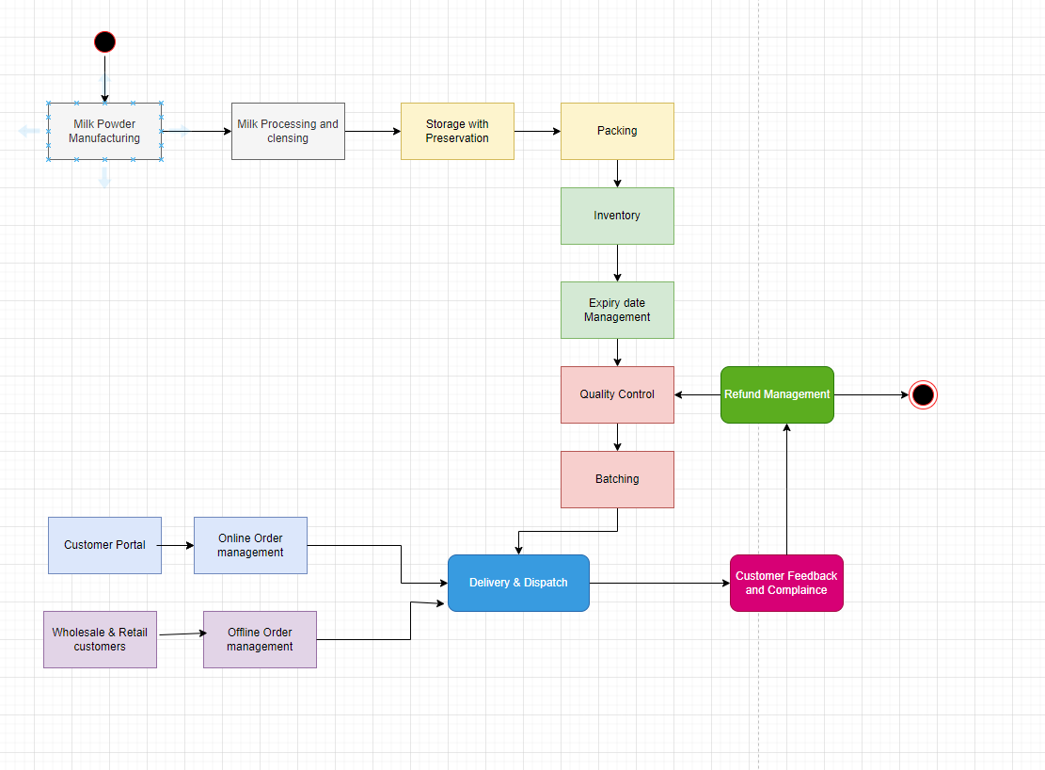

16. List of Business Requirements
BR ID | Description
BR-001 | The system should allow real-time inventory updates.
BR-002 | Customers should be able to place orders through a web portal.
BR-003 | Orders should have a tracking feature with live updates.
BR-004 | Delivery agents should have mobile access to order details.
BR-005 | The system should generate automated reports on stock levels.

17. Stakeholders
Stakeholder Name | Role | Contact Information
John Doe | Business Owner | john.doe@company.com
Jane Smith | Project Manager | jane.smith@company.com
Mark Taylor | IT Manager | mark.taylor@company.com
Alex Brown | Business Analyst | alex.brown@company.com

18. Dependencies
- Availability of accurate product master data.
- Integration with third-party delivery service providers.
- Availability of trained personnel for system usage.
- Timely approvals from regulatory bodies.

19. Approvals
Role | Name | Title | Signature | Date
Business Owner | COEPD CEO | Director | [Signature] | [Date]
Project Manager | Sasti Gowtham | PMO Lead | [Signature] | [Date]
IT Lead | Neeraj Goel | IT Manager | [Signature] | [Date]

This BRD provides a comprehensive overview of the Dairy Product Inventory Management project, outlining objectives, requirements, stakeholders, and expected outcomes.

- Process flow diagram for Milk Manufacturing and customer delivery system with Inventory management:

Resources Required
1. Human Resources:
Development Team:
- Project Manager – Oversees project timeline, scope, and resources.
- Business Analyst – Gathers requirements, analyzes workflows, and ensures alignment with business needs.
- UI/UX Designer – Designs an intuitive interface for web and mobile platforms.
- Software Developers:
  - Frontend Developer (React, Angular, or Vue.js)
  - Backend Developer (Node.js, Python, or PHP)
  - Database Administrator (SQL, NoSQL databases)
  - Mobile Developer (iOS/Android if applicable)
- Quality Assurance (QA) Engineer – Conducts testing and ensures system stability.
- DevOps Engineer – Manages deployment and cloud infrastructure.
- Support Staff – For post-deployment maintenance and user support.
Operational Staff:
- Inventory managers for system usage.
- IT support for troubleshooting.
- Training personnel for onboarding employees.

2. Hardware Resources:
- Servers: Cloud-based (AWS, Azure, Google Cloud) or on-premises servers for hosting the application.
- Workstations: Computers/laptops for employees to access the system.
- Barcode Scanners & RFID Readers: For tracking milk inventory in warehouses.
- Storage Devices: For data backup and archiving.
- Networking Equipment: Routers, switches, and internet connectivity.
- IoT Sensors (Optional): For monitoring milk storage conditions like temperature.

3. Budget Considerations:
Estimated budget allocation based on key areas:
- Software Development: $30,000 - $80,000 (based on complexity)
- Hardware Procurement: $15,000 - $50,000
- Cloud Hosting & Maintenance: $5,000 - $20,000 annually
- Training & Support: $5,000 - $10,000
- Marketing & Miscellaneous Costs: $3,000 - $8,000
Total Estimated Budget: $60,000 - $160,000 (flexible based on scale and scope).

Development Plan
Phase 1: Planning & Requirement Analysis (2-4 weeks)
- Conduct stakeholder meetings to gather requirements.
- Define system objectives, key features, and user roles.
- Create a project roadmap and budget estimation.
Phase 2: System Design (4-6 weeks)
- Develop wireframes and UI/UX designs.
- Define the system architecture (frontend, backend, database).
- Select appropriate technologies (e.g., React, Node.js, MySQL).
Phase 3: Development (8-12 weeks)
- Frontend Development: Build dashboards for inventory tracking.
- Backend Development: Implement business logic and API connections.
- Database Setup: Design schema for milk inventory records.
- Integration: Connect with IoT devices (if applicable) for monitoring.
Phase 4: Testing (4-6 weeks)
- Perform unit testing, system testing, and user acceptance testing (UAT).
- Fix bugs and optimize system performance.
Phase 5: Deployment (2-4 weeks)
- Deploy the system on cloud or on-premises infrastructure.
- Provide training sessions for employees.
- Launch system in pilot mode before full-scale rollout.
Phase 6: Maintenance & Updates (Ongoing)
- Provide ongoing technical support and updates.
- Gather user feedback for continuous improvements.

Assessment 2:
- Introducing Myself:
Subject: Introduction – Myself as Business Analyst for the Upcoming Engagement
Dear BKI (Bangkok Insurance)
I hope you are doing well.
My name is G M Sasti Gowtham, and I am pleased to introduce myself as the Business Analyst assigned to collaborate with you and your team for the upcoming project. With an MBA in International Business Management and 10 years of experience in the IT industry, I bring a strong background in business analysis and product ownership, particularly within the telecom and insurance sectors.
My primary objective is to work closely with your team to initiate the business understanding process, ensuring that we gather the right requirements, identify key business goals, and align our solutions to meet your strategic objectives effectively. I am committed to facilitating seamless communication, bridging the gap between technical and business teams, and driving value through well-defined processes and insights.
I look forward to our collaboration and am eager to contribute to the project's success. Please feel free to reach out to me for any initial discussions or clarifications. I will be scheduling an introductory meeting shortly to outline the next steps.
Looking forward to working with you.

Best regards,
G M Sasti Gowtham
Business Analyst
Sastigm@gmail.com
Mobile: +91 8867357183

- Prepare BRD and SDS for Online store

Business Requirements Document (BRD)
Online Cosmetics Store

1. Document Revision History
Version | Date | Author | Description | Review Status
1.0 | 2025-01-24 | Sasti Gowtham | Initial Draft | Pending
1.1 | TBD | Sandeep | Updated based on feedback | In Progress
1.2 | TBD | Sandeep | Final Approval | Approved

2. Approvals
Role | Name | Title | Signature | Date
Project Sponsor | Mind tree | Director | [Signature] | [Date]
Project Manager | Sabari Deepak | PMO Lead | [Signature] | [Date]
IT Lead | Neeraj | IT Manager | [Signature] | [Date]
Business Analyst | Sasti Gowtham | Sr. Analyst | [Signature] | [Date]

3. RACI Matrix
Task | Responsible | Accountable | Consulted | Informed
Requirements Gathering | BA | PM | Stakeholders | IT Team
UI/UX Design | Designers | PM | Marketing | Stakeholders
Development | Developers | IT Lead | QA | PM
Testing | QA | PM | BA | IT Lead
Deployment | IT Lead | PM | Stakeholders | BA

4. Introduction
The online cosmetics store project aims to provide customers with an engaging e-commerce platform to purchase cosmetics products conveniently. The system will feature a user-friendly interface, secure payment options, and seamless order management.

5. Business Goals
- Increase online sales of cosmetic products.
- Improve customer engagement and retention.
- Streamline the order fulfilment process.
- Provide personalized shopping experiences.
- Leverage data analytics for better marketing strategies.

6. Business Objectives
- Develop a feature-rich e-commerce website and mobile application.
- Offer various payment methods, including digital wallets and credit cards.
- Implement a loyalty program to reward returning customers.
- Provide real-time order tracking for better transparency.
- Optimize website performance for a seamless user experience.

7. Executive Summary
This document outlines the requirements for developing an online store to sell cosmetics. The project aims to provide an intuitive online shopping experience, featuring advanced functionalities like product recommendations, order tracking, and personalized marketing campaigns to improve customer satisfaction and drive revenue growth.

8. Business Rules
- Orders must be processed within 24 hours.
- Customers can return eligible products within 15 days.
- Discounts are applied automatically based on the promotional calendar.
- Inventory levels must be updated in real time.
- A customer can only use one discount coupon per order.

9. Project Background
Currently, the company relies on physical retail stores and social media sales. The lack of a dedicated e-commerce platform has resulted in missed opportunities in the growing online cosmetics market. This project aims to address these gaps by launching a fully functional online store.

10. Project Objectives
- Build a scalable and secure online store.
- Enable multi-channel order processing (web and mobile).
- Improve operational efficiency through automation.
- Offer a personalized shopping experience with AI-driven recommendations.
- Ensure compliance with regulatory e-commerce standards.

11. Project Scope
In Scope:
- Website and mobile application development.
- Secure payment gateway integration.
- AI-based product recommendation system.
- Order and inventory management system.
- Loyalty and referral program implementation.
Out of Scope:
- Brick-and-mortar store integration.
- International shipping functionality.
- Customer service outsourcing.

12. Assumptions
- Sufficient budget and resources will be available for project execution.
- Customer data will be provided by the marketing team for personalization.
- The website will be optimized for desktop and mobile devices.

13. Project Constraints
- The project must be completed within 6 months.
- Budgetary constraints limit the use of premium third-party services.
- Compliance with local and international e-commerce regulations is mandatory.

14. Project Risks
Risk ID | Description | Probability | Impact | Mitigation Strategy
R1 | Payment gateway integration failure | High | High | Backup payment methods, testing
R2 | Security vulnerabilities in the platform | Medium | High | Regular security audits
R3 | Vendor delays in product supply | High | Medium | Implement backup supplier options
R4 | User resistance to digital platform | Medium | High | Marketing and training efforts

15. Business Process Overview
Current (Legacy) System:
- NA
Proposed Solution:
- Dedicated e-commerce website with automated order tracking.
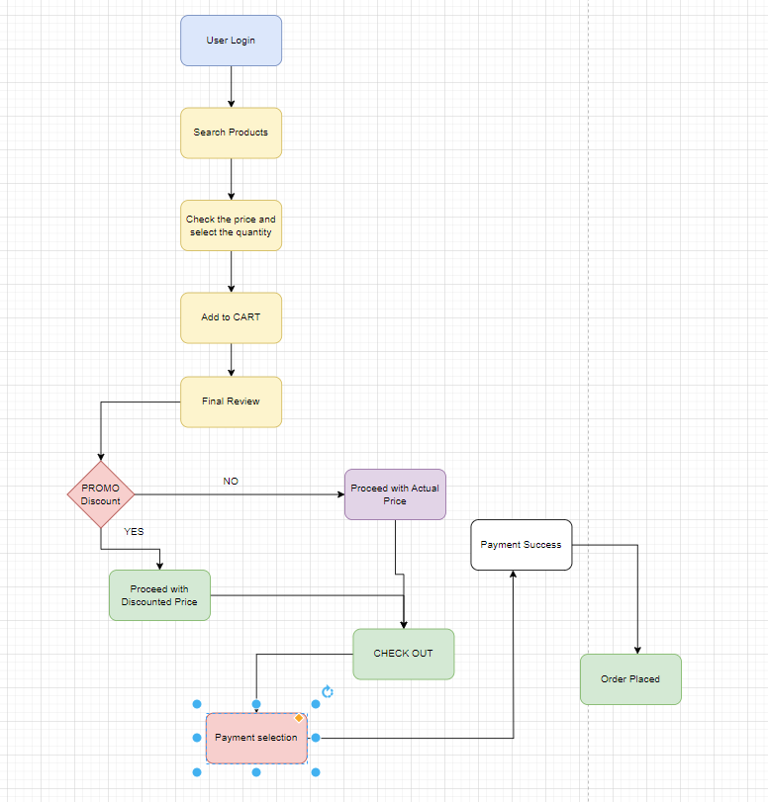

16. List of Business Requirements
BR ID | Description
BR-001 | The system should support user registration and profile management.
BR-002 | Customers should be able to search for and filter products.
BR-003 | The platform must support multiple payment methods.
BR-004 | The system should provide order tracking and notifications.
BR-005 | A loyalty rewards system should be implemented.
BR-006 | The platform should include AI-based product recommendations.
BR-007 | Customers should be able to leave product reviews.

17. Stakeholders
Stakeholder Name | Role | Contact Information
John Doe | Business Owner | john.doe@company.com
Jane Smith | Project Manager | jane.smith@company.com
Mark Taylor | IT Manager | mark.taylor@company.com
Alex Brown | Business Analyst | alex.brown@company.com
Lisa White | Marketing Head | lisa.white@company.com

18. Dependencies
- Availability of product images and descriptions from suppliers.
- Third-party payment gateway service readiness.
- Hosting infrastructure availability and scalability.
- Compliance with data protection laws such as GDPR.

19. Approvals
Role | Name | Title | Signature | Date
Project Sponsor | John Doe | Director | [Signature] | [Date]
Project Manager | Jane Smith | PMO Lead | [Signature] | [Date]
IT Lead | Mark Taylor | IT Manager | [Signature] | [Date]
Finance Head | Sarah Johnson | Finance Manager | [Signature] | [Date]

Software Requirement Specification (SRS)
1. Introduction
1.1 Purpose
This document provides detailed software requirements for the online cosmetic store to ensure all business objectives are met.
1.2 Scope
The software will provide a platform to manage products, process orders, handle payments, and facilitate customer interactions.
1.3 Definitions and Acronyms
- SKU: Stock Keeping Unit
- CMS: Content Management System
- API: Application Programming Interface
2. Functional Requirements
2.1 User Management
- Registration via email and social media accounts.
- Profile management (update name, address, etc.).
- Password reset functionality.
2.2 Product Catalog
- Categories and subcategories for products.
- Search and filter by price, brand, and ratings.
- Product detail pages with images and descriptions.
2.3 Shopping Cart
- Add/remove items from the cart.
- View cart summary and estimated total cost.
- Apply discount codes.
2.4 Order Management
- Order tracking functionality.
- View order history.
- Order cancellation and refund process.
2.5 Payment Integration
- Support for multiple payment gateways (PayPal, Stripe, Credit/Debit Cards).
- Secure payment processing with encryption.
2.6 Reviews and Ratings
- Customers can leave reviews and rate products.
- Reviews can be moderated by the admin.
2.7 Admin Panel
- Manage product listings and inventory.
- View and process orders.
- Generate sales reports.

3. Non-Functional Requirements
3.1 Performance
- The system should respond within 2 seconds for 90% of the requests.
- Load balancing should be implemented.
3.2 Security
- User data should be encrypted.
- System should comply with GDPR regulations.
3.3 Usability
- The UI should follow best practices for accessibility.
- Support for multiple languages.
3.4 Scalability
- System should be able to accommodate increasing traffic.

4. System Architecture
4.1 High-Level Overview
- Frontend: React.js or Angular
- Backend: Node.js with Express
- Database: MySQL or MongoDB
- Hosting: AWS or Azure
4.2 API Design
- RESTful API for frontend-backend communication.
5. Acceptance Criteria
- Users can browse and purchase products successfully.
- Admin can manage inventory efficiently.
- Payments are processed securely.
6. Appendix
- References to competitor analysis.
- Industry standards followed in the project.
_________________________________________________________________________________________

- Make an ERD for Online shopping system:

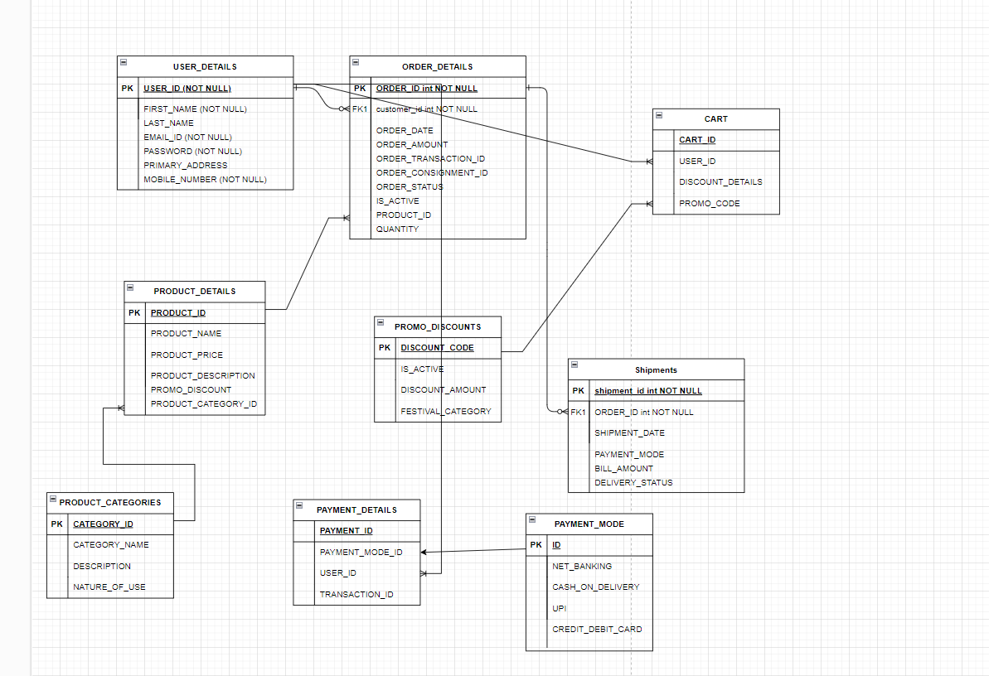

- Write 40 user stories for Online shopping system.
User Story 1: User Registration
Description: As a user, I want to create an account so that I can save my personal details for future purchases.
Acceptance Criteria:
- User can register using an email and password.
- The system validates email format and password strength.
- A confirmation email is sent after registration.
- Duplicate email registration is restricted.
- User profile is created after successful registration.
Business Value: Improves customer retention by enabling personalized experiences.
Complexity Points: 3

User Story 2: Login Functionality
Description: As a user, I want to log in securely to access my account and purchase history.
Acceptance Criteria:
- Users can log in using registered email and password.
- Incorrect credentials show an appropriate error message.
- Users can reset forgotten passwords.
- Successful login redirects to the homepage.
- Login session persists until the user logs out.
Business Value: Enhances customer trust by providing secure access.
Complexity Points: 3

User Story 3: Browse Products
Description: As a user, I want to browse various cosmetics so that I can choose what to buy.
Acceptance Criteria:
- Products are categorized (e.g., skincare, makeup, haircare).
- Users can view product thumbnails and short descriptions.
- Search functionality is available.
- Filters for price, brand, and ratings are functional.
- Pagination is implemented for a large number of products.
Business Value: Increases potential purchases by simplifying product discovery.
Complexity Points: 5

User Story 4: Product Details Page
Description: As a user, I want detailed information about a product so that I can make an informed purchase decision.
Acceptance Criteria:
- Displays product images, price, and detailed descriptions.
- Includes customer reviews and ratings.
- Shows availability (in stock or out of stock).
- Includes a "similar products" section.
- Provides an option to add the product to the cart.
Business Value: Improves customer confidence in making purchases.
Complexity Points: 4

User Story 5: Add to Cart
Description: As a user, I want to add items to my cart so that I can review them before purchasing.
Acceptance Criteria:
- Users can add multiple products to the cart.
- Quantity adjustment is supported.
- Real-time cart total is displayed.
- Items are retained in the cart even after logging out.
- Users can remove items from the cart.
Business Value: Simplifies the shopping process, encouraging users to buy more.
Complexity Points: 3

User Story 6: View Cart
Description: As a user, I want to view my cart so that I can confirm selected products.
Acceptance Criteria:
- All added products are displayed with quantity and price.
- A total cost summary is visible.
- Users can proceed to checkout from the cart page.
- Users can edit the cart from this page.
- Estimated shipping costs are displayed.
Business Value: Reduces friction during the purchase process.
Complexity Points: 2

User Story 7: Secure Checkout
Description: As a user, I want a secure checkout process to ensure my payment information is safe.
Acceptance Criteria:
- Users can review their order summary.
- Users can enter shipping and billing information.
- Multiple payment methods are supported (credit card, PayPal, etc.).
- Checkout pages are HTTPS secured.
- Confirmation message is displayed after successful payment.
Business Value: Builds trust, reducing cart abandonment.
Complexity Points: 5

User Story 8: Order Confirmation
Description: As a user, I want an order confirmation to ensure my purchase was successful.
Acceptance Criteria:
- Displays a summary of the order.
- Sends confirmation email with order details.
- Shows estimated delivery time.
- Includes a unique order ID.
- Provides a link to track the order.
Business Value: Provides transparency, improving user satisfaction.
Complexity Points: 2

User Story 9: Search Products
Description: As a user, I want a search bar to quickly find the products I’m looking for.
Acceptance Criteria:
- The search bar is available on every page.
- Displays autocomplete suggestions based on keywords.
- Handles typos and partial matches.
- Shows relevant products with thumbnails and prices.
- Displays “no results found” message for invalid searches.
Business Value: Reduces time spent finding products, improving user experience.
Complexity Points: 4

User Story 10: Filter Products
Description: As a user, I want to filter products to narrow down choices.
Acceptance Criteria:
- Filters include price, brand, ratings, and availability.
- Multiple filters can be applied simultaneously.
- Results update dynamically when filters are applied.
- Users can clear all filters with one click.
- Filters persist while navigating categories.
Business Value: Simplifies the decision-making process for users.
Complexity Points: 3

User Story 11: Track Orders
Description: As a user, I want to track my order so that I know when it will arrive.
Acceptance Criteria:
- Order tracking is available via a unique ID.
- Shows status (processing, shipped, delivered).
- Displays estimated delivery date.
- Includes tracking link for shipping provider.
- Users receive status updates via email.
Business Value: Enhances post-purchase satisfaction and trust.
Complexity Points: 3

User Story 12: Product Reviews
Description: As a user, I want to leave reviews for products I’ve purchased.
Acceptance Criteria:
- Only verified buyers can leave reviews.
- Reviews include a star rating and comment.
- Reviews are displayed in chronological order.
- Users can edit or delete their reviews.
- The average rating is displayed on the product page.
Business Value: Builds trust by showcasing user feedback.
Complexity Points: 4

User Story 13: Wishlist
Description: As a user, I want to add products to a wishlist so that I can purchase them later.
Acceptance Criteria:
- Users can add and remove items from the wishlist.
- Wishlist items are saved to the user’s account.
- Users can move wishlist items to the cart.
- Displays the price and availability of items.
- Items in the wishlist are visible across devices.
Business Value: Encourages users to return and complete purchases.
Complexity Points: 3

User Story 14: Apply Coupons
Description: As a user, I want to apply discount coupons during checkout to save money.
Acceptance Criteria:
- A field to enter coupon codes is available at checkout.
- Valid coupons apply discounts to the total amount.
- Users are notified of invalid or expired coupons.
- Only one coupon can be applied per order.
- The discounted total is updated in real time.
Business Value: Attracts users and promotes customer loyalty.
Complexity Points: 4

User Story 15: Multiple Languages Support
Description: As a user, I want to view the site in my preferred language for better understanding.
Acceptance Criteria:
- Users can select a language from the site’s settings.
- All page’s update to the selected language.
- Default language is based on the user’s location.
- Language preference is saved for logged-in users.
- Currency is adjusted based on language selection.
Business Value: Expands user base by accommodating non-English speakers.
Complexity Points: 5

User Story 16: Personalized Recommendations
Description: As a user, I want personalized product recommendations based on my browsing history.
Acceptance Criteria:
- Recommendations are displayed on the homepage and product pages.
- Uses recent searches and purchases to suggest products.
- Updates dynamically with user activity.
- Users can hide unwanted recommendations.
- Recommends trending products for new users.
Business Value: Increases sales by promoting relevant products.
Complexity Points: 5

User story 17: User Profile Management
Description: As a user, I want to update my account details, including my address and payment information, so that I can ensure my orders are delivered correctly.
Acceptance Criteria:
- Users can update their personal details (name, email, phone number).
- Users can add, edit, or delete their saved addresses.
- Users can securely save and update payment methods.
- System validates address fields before saving.
- Changes are saved and reflected immediately.
Business Value: Enhances user convenience and ensures accurate deliveries.
Complexity Points: 3

User story 18: Admin Panel for Inventory Management
Description: As an admin, I want to manage product inventory so that I can add, edit, and remove products from the catalogue.
Acceptance Criteria:
- Admins can add new products with images, descriptions, and pricing.
- Existing products can be edited for updates in stock or details.
- Products can be removed from the catalogue.
- System logs all inventory changes.
- Admins receive confirmation before deleting products.
Business Value: Ensures an updated and accurate product catalogue.
Complexity Points: 5

User story 19. Push Notifications for Sales
Description: As a user, I want to receive push notifications for sales and offers so that I don’t miss out on discounts.
Acceptance Criteria:
- Users can enable/disable notifications from settings.
- Notifications are sent for ongoing and upcoming sales.
- Clicking on a notification redirects to the relevant product page.
- Notifications are personalized based on user preferences.
- Users can set preferences for notification frequency.
Business Value: Increases user engagement and sales conversion.
Complexity Points: 4

User story 20. Gift Cards
Description: As a user, I want to purchase and redeem gift cards so that I can use them or gift them to others.
Acceptance Criteria:
- Users can purchase gift cards of various denominations.
- Gift cards can be sent via email to recipients.
- Users can redeem gift cards during checkout.
- The system tracks the remaining balance after redemption.
- Expiry dates are clearly displayed on gift cards.
Business Value: Encourages gifting and increases revenue.
Complexity Points: 5
User story 21. Subscription Service
Description: As a user, I want to subscribe to monthly deliveries of my favorite products to ensure I never run out.
Acceptance Criteria:
- Users can subscribe to eligible products with different plans.
- Automatic monthly billing is supported.
- Users can pause or cancel subscriptions anytime.
- Subscription status and history are accessible in the user profile.
- Users receive reminders before each renewal.
Business Value: Ensures recurring revenue and customer loyalty.
Complexity Points: 5
User story 22. Multi-currency Support
Description: As a user, I want to view product prices in my local currency for better cost estimation.
Acceptance Criteria:
- The system detects user location and sets the default currency.
- Users can manually switch currency from settings.
- Prices update dynamically based on the selected currency.
- Currency exchange rates are updated regularly.
- Checkout reflects prices in the selected currency.
Business Value: Expands customer reach across different regions.
Complexity Points: 4

User story 23. AI Beauty Advisor
Description: As a user, I want personalized beauty recommendations based on my skin type and preferences.
Acceptance Criteria:
- Users can input skin type and preferences via a short quiz.
- AI recommends products based on user input and browsing history.
- Recommendations update dynamically as preferences change.
- Users can provide feedback on recommendations to refine results.
- AI explains why a product is recommended.
Business Value: Enhances user experience and product discovery.
Complexity Points: 5

User story 24. AR Try-On
Description: As a user, I want to virtually try on makeup products to see how they look before purchasing.
Acceptance Criteria:
- Users can access AR try-on for eligible products.
- Facial recognition accurately places makeup on key features.
- Multiple shades can be tried in real-time.
- Users can capture and share their try-on images.
- Works across web and mobile platforms.
Business Value: Enhances customer confidence and reduces returns.
Complexity Points: 5

User story 25. Live Chat Support
Description: As a user, I want to chat with support in real-time to resolve my queries quickly.
Acceptance Criteria:
- A live chat widget is accessible on every page.
- Support agents can respond in real-time.
- Chat history is saved for future reference.
- Offline mode allows users to submit queries.
- Users receive email notifications for missed chats.
Business Value: Improves customer service and satisfaction.
Complexity Points: 4

User story 26. Order Cancellation
Description: As a user, I want to cancel my order before it ships to avoid unwanted purchases.
Acceptance Criteria:
- Users can cancel orders before the shipping process begins.
- Refunds are processed automatically for prepaid orders.
- Users receive email confirmation upon cancellation.
- Cancellation option is disabled for shipped orders.
- Order status updates reflect the cancellation.
Business Value: Reduces unnecessary returns and improves user control.
Complexity Points: 3

User story 27. Return/Refund Policy
Description: As a user, I want to initiate a return or refund for eligible products if they don’t meet my expectations.
Acceptance Criteria:
- Return requests can be initiated within the eligible timeframe.
- Users can select return reasons and upload proof if needed.
- Refunds are processed via the original payment method.
- Return status tracking is available in the user profile.
- Users receive email notifications on refund progress.
Business Value: Builds trust and encourages risk-free purchases.
Complexity Points: 4
User story 28. Loyalty Program
Description: As a user, I want to earn points for my purchases so that I can redeem them for discounts on future orders.
Acceptance Criteria:
- Users earn points based on the purchase amount.
- Points can be redeemed during checkout for discounts.
- The system displays accumulated points in the user profile.
- Points expire after a certain period if unused.
- Users receive notifications about available points and redemption options.
Business Value: Encourages repeat purchases and increases customer loyalty.
Complexity Points: 4

User story 29. Social Media Login
Description: As a user, I want to log in using my Google or Facebook account to save time.
Acceptance Criteria:
- Users can log in using Google or Facebook credentials.
- First-time social logins create an account automatically.
- Users can link/unlink social accounts from profile settings.
- The system securely retrieves and stores profile details.
- Failed login attempts show appropriate error messages.
Business Value: Simplifies the login process and increases registration rates.
Complexity Points: 3

User story 30. Out of Stock Notifications
Description: As a user, I want to receive notifications when an out-of-stock product is available again.
Acceptance Criteria:
- Users can subscribe for back-in-stock notifications.
- Notifications are sent via email and push notifications.
- Users can manage their notification preferences.
- The system updates product availability status automatically.
- The notification includes a direct link to the product page.
Business Value: Increases sales opportunities for previously unavailable products.
Complexity Points: 3

User story 31. Blog Section
Description: As a user, I want to read beauty-related blog articles to stay updated on trends and tips.
Acceptance Criteria:
- Blog articles are categorized by topics (e.g., skincare, makeup).
- Users can comment on blog posts.
- Articles include images and embedded videos.
- A search bar allows users to find relevant content.
- Users can share blog posts on social media.
Business Value: Improves user engagement and brand credibility.
Complexity Points: 4

User story 32. Video Reviews
Description: As a user, I want to upload and view video reviews to better understand product quality.
Acceptance Criteria:
- Users can upload video reviews for purchased products.
- Videos undergo moderation before appearing publicly.
- Users can rate and comment on video reviews.
- Videos autoplay when hovered over.
- Uploaded videos appear on product pages.
Business Value: Enhances customer trust and provides a richer shopping experience.
Complexity Points: 5

User story 33. Bulk Purchase Discounts
Description: As a user, I want to get discounts when purchasing products in bulk to save money.
Acceptance Criteria:
- Discount tiers are displayed for bulk purchases.
- Discounts apply automatically at checkout.
- Bulk purchase discounts are displayed on product pages.
- Users are notified about bulk discount eligibility.
- The discount is reflected in the order summary.
Business Value: Encourages larger order volumes and increases revenue.
Complexity Points: 4

User story 34. Referral Program
Description: As a user, I want to refer friends and earn rewards when they make a purchase.
Acceptance Criteria:
- Users receive a unique referral link.
- Referrals are tracked in the user’s account.
- Rewards are granted after a successful purchase.
- Users can share referral links via social media.
- Notifications are sent when rewards are earned.
Business Value: Increases customer acquisition and engagement.
Complexity Points: 4

User story 35. Dark Mode
Description: As a user, I want to toggle between light and dark themes for better viewing comfort.
Acceptance Criteria:
- Users can switch themes from account settings.
- The selected theme persists across sessions.
- Text and UI elements adjust for readability.
- Default mode is based on system settings.
- A smooth transition effect occurs when switching themes.
Business Value: Enhances accessibility and improves user experience.
Complexity Points: 3

User story 36. Compare Products
Description: As a user, I want to compare multiple products side by side to make an informed decision.
Acceptance Criteria:
- Users can add up to 3 products for comparison.
- The system displays key features and prices in a table format.
- Users can remove items from the comparison.
- Comparisons are accessible from the cart and product page.
- Visual differences are highlighted for easy evaluation.
Business Value: Improves decision-making and increases sales conversion.
Complexity Points: 4

User story 37. QR Code Sharing
Description: As a user, I want to share product pages via QR codes to easily recommend them to others.
Acceptance Criteria:
- Each product page has a QR code generator.
- Users can download or print the QR code.
- Scanning the QR code leads to the product page.
- QR codes are optimized for both desktop and mobile.
- Users can share the QR code via messaging apps.
Business Value: Simplifies product sharing and improves user engagement.
Complexity Points: 3

User story 38. Donation Options
Description: As a user, I want to donate a portion of my purchase to a charity to support good causes.
Acceptance Criteria:
- Users can choose a donation amount during checkout.
- A list of supported charities is displayed.
- The donation amount is reflected in the order summary.
- Users receive an acknowledgment for their donation.
- Donation totals are shown in the user profile.
Business Value: Enhances brand reputation and customer goodwill.
Complexity Points: 4

User story 39. Page Load Optimization
Description: As a user, I want fast-loading pages for a seamless shopping experience.
Acceptance Criteria:
- Images are optimized for faster loading.
- Lazy loading is implemented for off-screen elements.
- Browser caching is utilized effectively.
- Minified CSS and JS files are used.
- Pages load within 3 seconds under normal conditions.
Business Value: Improves user experience and reduces bounce rates.
Complexity Points: 4

User story 40. Accessibility Features
Description: As a user with disabilities, I want accessibility features to navigate the site easily.
Acceptance Criteria:
- The site supports screen readers.
- Keyboard navigation is fully functional.
- High contrast mode is available for better readability.
- All interactive elements are labelled appropriately.
- Accessibility compliance (WCAG) is ensured.
Business Value: Expands market reach and ensures inclusivity.
Complexity Points: 5

