Question 1 – BPM - 5 Marks

* Identify Business Process Model for Online Agriculture Store – (Goal, Inputs, Resources, Outputs, Activities, Value created to the end Customer)

1. Goal – To make Online agriculture store for all farming needs, mobile app, facilitate farmers to buy from our online store and gain profit.
2. Inputs - search for farming product, select Quantity, enter delivery location, payment mode (Credit card, debit card, Net banking, UPI, Wallet, cash), Confirm order.
3. Resources – Payment gateway, collaboration with manufacturing unit, suppliers, logistics, store room/ go downs, workers, stock management software (to manage stocks IN/OUT), Internet access.
4. Outputs – placement of orders, order confirmation SMS, login OTPs,
5. Activities – Log in, search for product, add to cart, payment gateway, confirmation of order, delivery of product.
6. Value created to the end Customer – delivery of faming essentials needs to farmers for better cultivation of crops

Question 2 – SWOT - 5 Marks

* SWOT analysis

1. Strengths-

* End to end support for farmers
* Easy access to different variety of farming needs.
* At home delivery

1. Weakness

* Supply management (availability of products)
* Rates
* Maintaining the Quality of products (original products)
* Software break down
* Data misplace
* Trust issues

1. Opportunities

* Larger market to cover
* Supply of farming tools and motors
* One and only stop for all essentials requirements for all type of farming

1. Threats

* New Competitor in the market
* GST and other taxes imposable by government
* Damage of products during logistics
* Software hacking manipulation of data.

Question 3 – Feasibility study - 5 Marks

* Feasibility study

1. Technology (JAVA) - Java is a highly feasible option for developing an e-commerce platform for agricultural needs due to its scalability, security, and robust ecosystem. However, organizations should consider developer expertise and cost factors before finalizing their technology stack.

For rapid development, Spring Boot with a micro services architecture is recommended, coupled with a secure cloud-based infrastructure for scalability and performance.

1. Hardware – Based on storage, backup system, Network infrastructure
2. Software – Based on shopping cart software, content management and payment gateway software system.
3. Trained Resources -

1 project manager

1 senior java developer

3 JAVA developer

1 Network Admin

1 Data Admin

2 Testers

1. Budget - 2 crores
2. Time Frame - 18 Months

* GAP analysis

|  |  |  |
| --- | --- | --- |
|  | AS-IS | TO-BE |
| Pricing | Farmers rely on middle man for their farming needs | Eliminates middle man and increase profit margins |
| Orders | Farmers manually place orders via call or local visit | Can be ordered at comfort of home and at any time 24*7 |
| Availability | Less or limited availability of vide range of products | Large scale and diverse availability of different range of products |
| Delivery | Has to visit the local/nearby city store for purchase | It is delivered at home |
| Comparison | Limited resources | Multiple company products to compare |
| reviews | Local review/ mouth of word | Review from nationwide farmers |
| scalability | Very difficult to scale | Easily scalable with no additional infrastructures |
| advancement | Low to no advancement/ up gradation with tools and equipment’s | Fully upgraded tools and equipment’s |
| Service | Near to No | Collaboration with service provider for better and easy maintenance |

* Question 5 – Risk Analysis - 10 Marks

1. Competitor
2. System breakdown
3. Breakdown in logistics
4. Delivery of project on time (scope risk)
5. Price variation
6. System hack / malfunction
7. BA risk- incomplete requirements, inexperience of the Domain, handling of change request.

* Question 6 – Stakeholder Analysis (RACI Matrix) - 8 Marks

1. Responsible - Mr. Henry, Mr Pandu, Mr Dooku, Mr Karthik,
2. Accountable - Mr Vandanam, Ms. Juhi, Mr Teyson, Ms Lucie, Mr Tucker, Mr Bravo, Mr Mike and John. Mr Jason, Ms Alekya, Mr Siddhesh
3. Consulted - Peter, Kevin and Ben
4. Informed- Mr. Henry

* Question 7 – Business Case Document - 8 Marks

1. **Problem/Opportunity- Farmers in the rural or remote location does not have the facility or availability of farming essentials like seeds, fertilizers, pesticides, tools, advance machineries.**
2. **Proposed Solution: online store for all farming needs. By developing an online platform which can be used at any time of the day, no need of going to local market with wide variety of grains, multiple manufacturing company fertilizers / pesticides all available under one roof. This store cuts down middle man which will increase profit margins.**
3. **Resources required – This is a long run process and needs to maintain the inventories in the go downs. We need go Downs, logistics (3rd party or self), workers, trolleys, computers with barcode scanners, software to manage inventories, etc.**
4. **Benefits: As farming is an ongoing never ending and a direct supply of goods and chemicals required from the manufacturing, increases profit margins between company and farmers.**
5. **Time frame to recover ROI – It depends widely on the time that require to set up the business, awareness among the people about our online store for farming essentials. Approximately it must be around 2-3 years.**

* Question 8 – Four SDLC Methodologies - 8 Marks

Development of E-Commerce platform. As E-commerce is always evolving around with new feature, requirement according to customer satisfaction. There will always be an improvements and changes that needs to be done with no clear cut requirements mentioned. As sequential model cuts down handling change in the project this won’t be the best option. Iterative, Evolutionary, Agile can be of considerate. As all 3 have feedback process. Considering E-commerce platform with multiple product list and functions which need to be developed and tested simultaneously. This project can be deployed with multiple versions, where having a basic prototype with basic features and then adding addition functions to it. As detailed initial requirements are not defined here. Evolutionary model would be not a great option to consider. Agile with its iterative approach and flexibility, allows for rapid adaptation to market changes and customer feedback.

* Question 9 – Waterfall RUP Spiral and Scrum Models – 8 Marks

Waterfall, RUP, Spiral, Scrum models of SDLC are of great importance in its own way. As this methodologies are meant for different requirements process and delivery of product. This process are meant for delivery of product in 18 months this product can be

* Question 10 – Waterfall Vs V-Model - 5 Marks

|  |  |
| --- | --- |
| Waterfall | V- Model |
| Low cost | Expensive |
| Testing activity starts at later stage | Testing activity starts with the first stage |
| More in linear way | Don’t move in linear way |
| Less customer involvement | More customer involvement |

* Question 11 – Justify your choice - 3 Marks
* As a BA, I would go for V model. As this is a small project and testing and review process is done side by side.
* Question 12 – Gantt Chart - 5 Marks

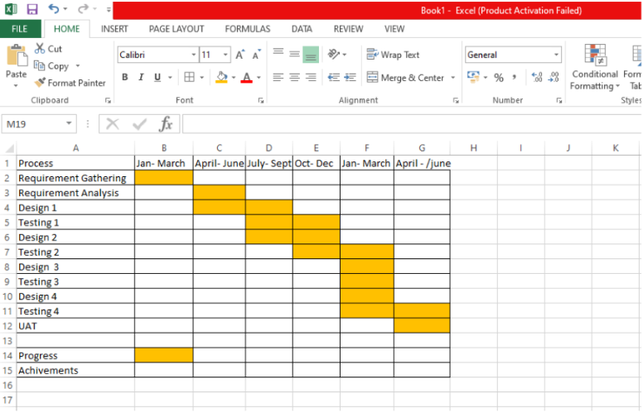

* Question 13 – Fixed Bid Vs Billing - 5 Marks

|  |  |
| --- | --- |
| Fix biding | Billing |
| A project where the contractor agrees to complete a project for a set price, regardless of the actual time or resources used | Encompasses the process of creating invoices and collecting payments for work completed, often based on time and materials or other agreed-upon methods. |
| The scope of work is clearly defined and agreed upon upfront. | The scope of the project is not very well clear and can vary upon time. |
| Provides the client with budget certainty and predictability | The client is billed for the actual cost of the project plus a predetermined fee or margin |

* Question 14 – Preparer Timesheets of a BA in various stages of SDLC - 20 marks

Design Timesheet of a BA

|  |  |  |  |  |  |
| --- | --- | --- | --- | --- | --- |
| SR No. | Task | Actionable items | Start time | End Time | Duration |
| 1 | Identify the stakeholders- meeting | To list down stakeholders | 10:00 | 11:00 | 1 Hrs |
| 2 | Client meeting | A zoom meeting with client to gather requirements | 11:00 | 13:00 | 2 Hrs |
| 3 | BRD document | Interaction with SME | 14:00 | 15:00 | 1 Hrs |
| 4 | Requirements sorting | Requirement analysis | 15:00 | 16:00 | 2 Hrs |
| 5 | Team meeting | Team discussion for process handling | 16:30 | 19:00 | 2.5 Hrs |
| Total | | | | | 7.5 Hrs |

➢ Development Timesheet of a BA – Development team will code for the product and as a BA i wil analysis the output as per the requirements.

➢ Testing Timesheet of a BA – The BA will make sure the coding and testing part goes hand in hand.

➢ UAT Timesheet of a BA – BA will make sure the UAT must performed with in stipulated time

➢ Deployment n Implementation Timesheet of a BA – BA will make sure the deployment at client site and working condition is maintained and handled by supporting team.