Part 2/2 Evaluation

Document 6- Please prepare a use case diagram, activity diagram, and a use case specification

document.

Ans 6.

Use Case Diagram of HRMS System

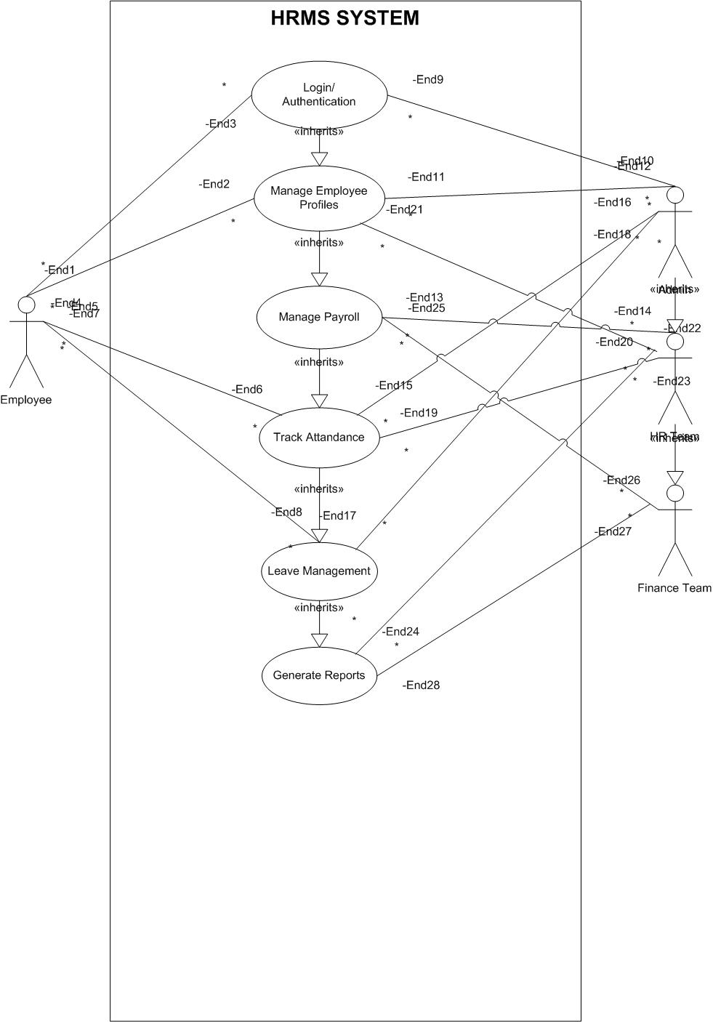

Activity Diagram

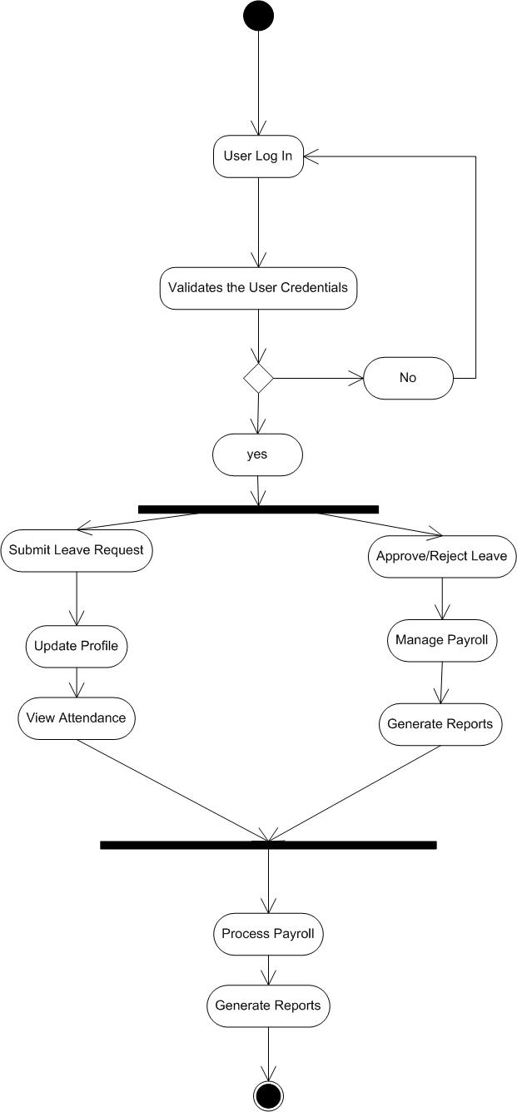

Use Case Specification Document

1. Project Information

|  |  |
| --- | --- |
| Field | Details |
| Project Name | HRMS System |
| Customer Name | Transcend Staffing Solutions |
| Project Version | 1.0 |
| Project Sponsor | Vipul Aggarwal |
| Project Manager | Smita Aggarwal |
| Date | 1-01-2025 |

**2. Introduction**

**2.1 Purpose**

This document provides a detailed description of each use case in the **HRMS System**. It outlines the actors, preconditions, main flow, alternate flows, and postconditions to ensure all requirements are met during development.

**3. Use Case List**

Here’s a list of key use cases included in the system:

|  |  |  |
| --- | --- | --- |
| Use Case ID | Use Case Name | Actors |
| UC001 | Login | Employee, Admin |
| UC002 | Manage Employee Profiles | Admin |
| UC003 | Manage Payroll | Admin, Finance Team |
| UC004 | Track Attendance | Employee, Admin |
| UC005 | Leave Management | Employee, Admin |
| UC006 | Generate Reports | Admin, Finance Team |

4. Use Case Specifications

Use Case: UC001- Login

|  |  |
| --- | --- |
| Attribute | Details |
| Use Case ID | UC001 |
| Use Case Name | Login |
| Actor(s) | Employee, Admin |
| Description | Allows authorized users to log in and access the HRMS System. |
| Preconditions | 1. User must be registered in the system. 2. Valid username and password required. |
| Postconditions | 1. The user is logged in successfully. 2. The system grants role-based access to the user. |
| Normal Flow | 1. The user navigates to the login page. 2. Enter username and password. 3. System validates credentials. 4. Redirect to the respective dashboard. |
| Alternate Flow(s) | 1a. If credentials are incorrect, show an error message. 1b. If the account is locked, notify the user. |
| Exceptions | 1. Network error prevents login. 2. System maintenance |

Use Case: UC002 – Manage Employee Profiles

|  |  |
| --- | --- |
| Attribute | Details |
| Use Case ID | UC002 |
| Use Case Name | Manage Employee Profiles |
| Actor(s) | Admin |
| Description | Allows Admin to add, update, and view employee profiles. |
| Preconditions | 1. Admin must be logged in. 2. Admin must have appropriate permissions. |
| Postconditions | 1. Employee profile is created/updated. 2. Changes are saved in the database. |
| Normal Flow | 1. Admin selects 'Manage Employee Profiles' option. 2. Adds/Updates employee information. 3. Submits the changes. 4. System confirms and updates records. |
| Alternate Flow(s) | 1a. If required fields are missing, system prompts for completion. 1b. If invalid data is entered, error message is shown. |
| Exceptions | 1. Database connectivity issues. 2. Unauthorized access attempt. |

Use Case: UC003 – Manage Payroll

|  |  |
| --- | --- |
| Attribute | Details |
| Use Case ID | UC003 |
| Use Case Name | Manage Payroll |
| Actor(s) | Admin, Finance Team |
| Description | Allows Admin and Finance Team to process payroll and generate pay slips. |
| Preconditions | 1. User must be logged in with appropriate privileges. 2. Employee salary data must be available. |
| Postconditions | 1. Payroll processed successfully. 2. Payslips generated and saved. |
| Normal Flow | 1. Admin/Finance Team selects 'Manage Payroll'. 2. Enters data for salary processing. 3. System processes payroll. 4. Generates payslips. |
| Alternate Flow(s) | 1a. If salary data is missing, system prompts for corrections. 1b. If errors occur during processing, system notifies user. |
| Exceptions | 1. Payment gateway failure. 2. Data synchronization error. |

Use Case: UC004 – Track Attendance

|  |  |
| --- | --- |
| Attribute | Details |
| Use Case ID | UC004 |
| Use Case Name | Track Attendance |
| Actor(s) | Employee, Admin |
| Description | Allows the system to track and store employee attendance using biometric devices. |
| Preconditions | 1. Biometric system should be configured. 2. Employee profile must be active. |
| Postconditions | 1. Attendance data is recorded. 2. Reports can be generated from recorded data. |
| Normal Flow | 1. Employee checks in/out using biometric. 2. System captures data. 3. Admin can view attendance records. |
| Alternate Flow(s) | 1a. If device fails, manual entry option is provided. |
| Exceptions | 1. Device malfunction. 2. Network failure. |

Use Case: UC005 – Leave Management

|  |  |
| --- | --- |
| Attribute | Details |
| Use Case ID | UC005 |
| Use Case Name | Leave Management |
| Actor(s) | Employee, Admin |
| Description | Allows employees to apply for leave and Admin to approve/reject requests. |
| Preconditions | 1. Employee must be logged in. 2. Leave quota should be available. |
| Postconditions | 1. Leave status is updated. 2. Notifications are sent to the user. |
| Normal Flow | 1. Employee applies for leave. 2. Admin reviews and approves/rejects the request. 3. System updates leave status. |
| Alternate Flow(s) | 1. a. If the leave quota is exhausted, the system notifies the user. 1b. Admin can modify leave requests if necessary. |
| Exceptions | 1. Incorrect data input. 2. Leave approval delay. |

Use Case: UC006 – Generate Reports

|  |  |
| --- | --- |
| Attribute | Details |
| Use Case ID | UC006 |
| Use Case Name | Generate Reports |
| Actor(s) | Admin, Finance Team |
| Description | Allows Admin and Finance Team to generate detailed HRMS reports. |
| Preconditions | 1. User must be logged in. 2. Data must be available for generating reports. |
| Postconditions | 1. Reports are generated successfully. 2. Reports can be exported or viewed. |
| Normal Flow | 1. User selects 'Generate Reports'. 2. System fetches relevant data. 3. Generates and displays reports. 4. User downloads/export the reports. |
| Alternate Flow(s) | 1a. If data is incomplete, system prompts to correct it. 1b. If report generation fails, notify the user. |
| Exceptions | 1. System performance issues. 2. Database query errors. |

**5. Assumptions & Constraints**

* The system should comply with security protocols (e.g., data encryption, role-based access).
* Internet connectivity is required for real-time attendance tracking.

**6. Approval**

|  |  |  |  |
| --- | --- | --- | --- |
| **Role** | **Name** | **Signature** | **Date** |
| **Project Sponsor** | **Vipul Aggarwal** |  | **1-01-2025** |
| **Project Manager** | **Smita Aggarwal** |  | **24-01-2025** |
| **Business Owner** | **Deepak Sachdeva** |  | **14-01-2025** |

Document 7- Screens and pages

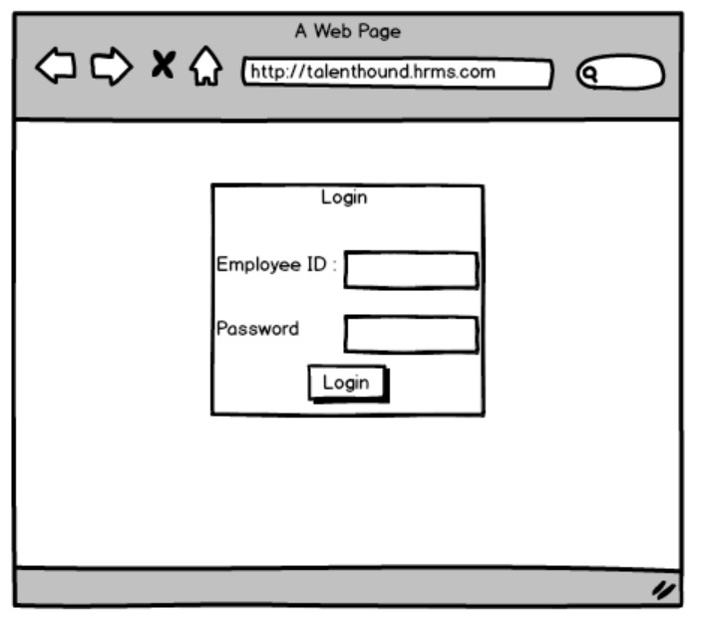

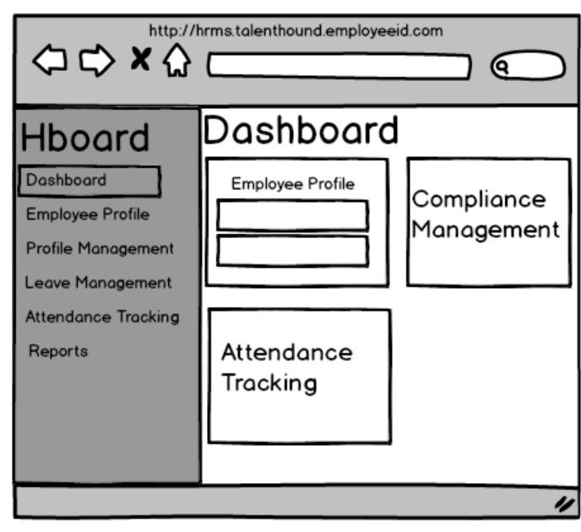

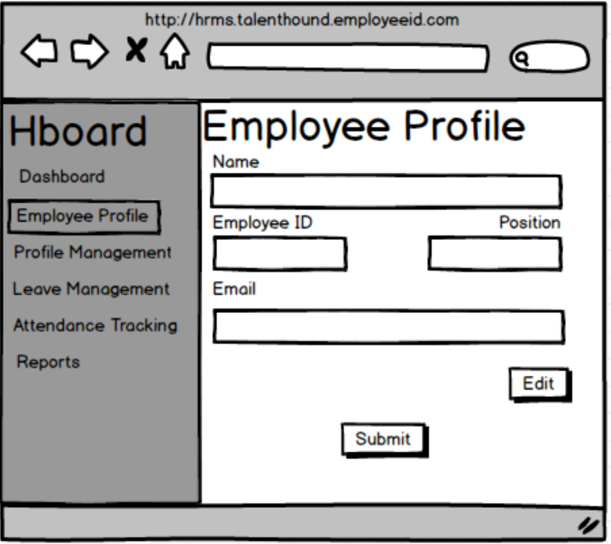

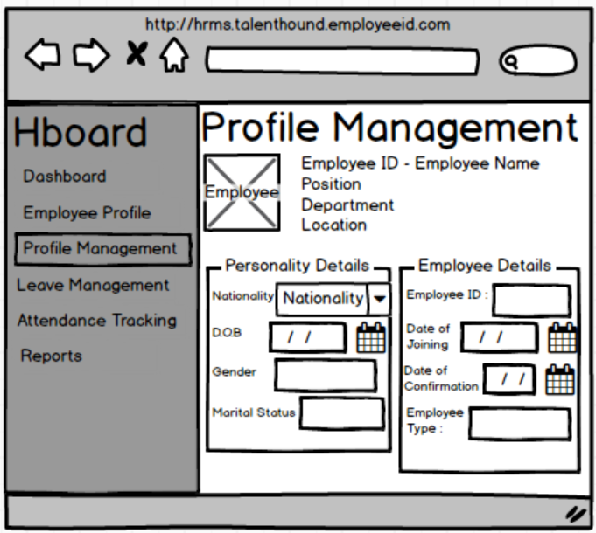

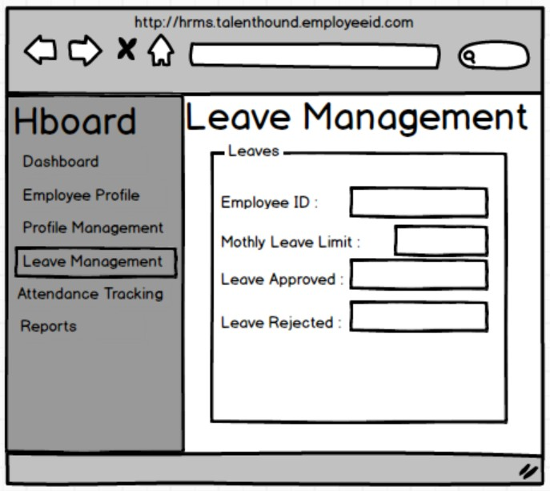

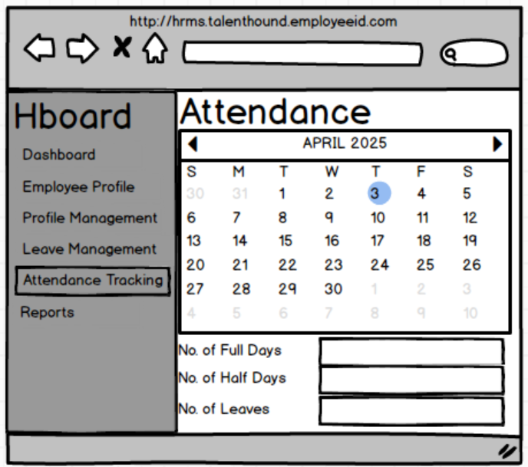

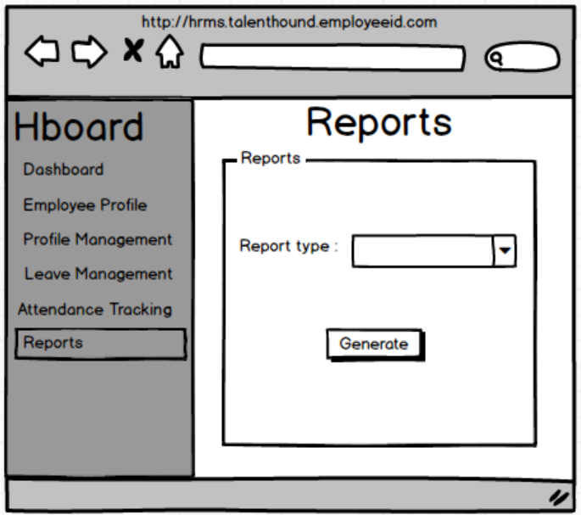

Document 8- Tools-Visio and Axure

**Experience Using Visio and Axure on the HRMS Project**

**Microsoft Visio:**

* Used Visio to create AS-IS and TO-BE process flow diagrams, swimlane diagrams, and system architecture models.
* Designed workflow charts to visually represent HRMS functionalities like onboarding, leave requests, and payroll approvals.
* Helped stakeholders easily understand complex business processes through visual representations.
* Supported design and requirement validation sessions using detailed Visio diagrams.
* Ensured process flows aligned with business goals and technical feasibility.

**Axure RP:**

* Created interactive wireframes and low/high-fidelity prototypes to showcase UI design concepts.
* Used Axure to simulate user interactions, helping stakeholders visualize the final product before development.
* Incorporated feedback from UI/UX sessions to refine screen designs early in the lifecycle.
* Enabled effective collaboration with design and development teams by providing click-through prototypes.
* Improved overall requirement clarity and reduced design-related rework during development.

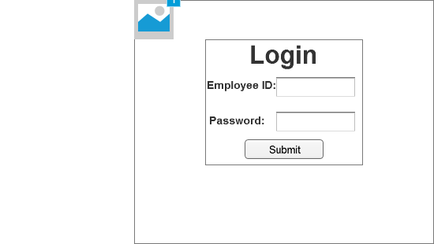

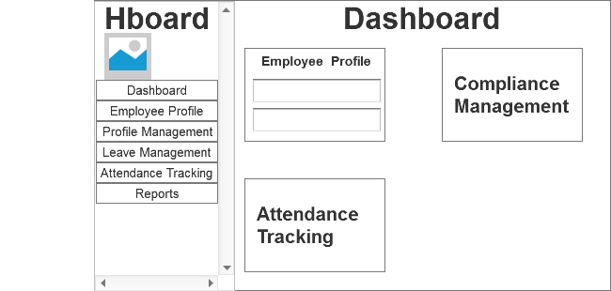

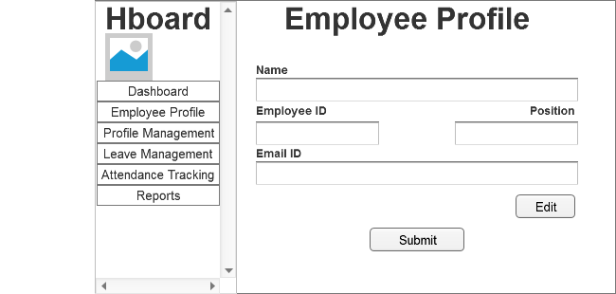

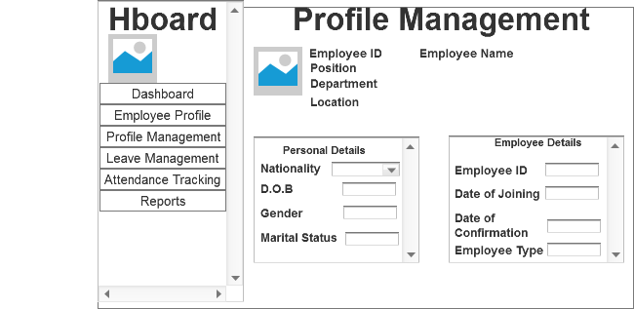

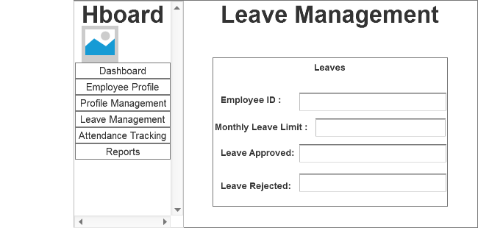

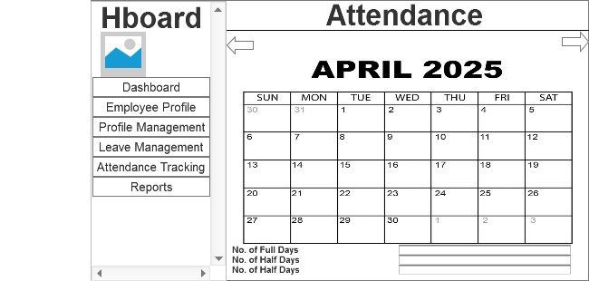

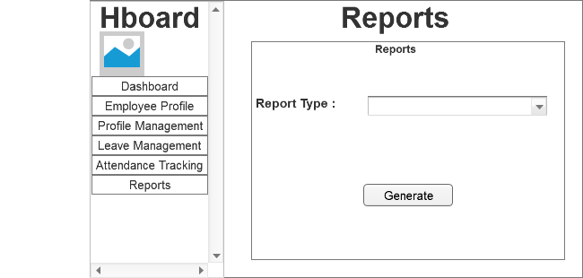

Document 9- BA experience

My experience as a BA in the following phases:

1. Requirement gathering:
2. Requirement Analysis:
3. Design:
4. Development:
5. Testing:
6. Deployment:

Ans 9.

**My Experience as a Business Analyst Across SDLC Phases**

**1. Requirement Gathering**

In the requirement gathering phase, I conducted interviews, workshops, and stakeholder sessions to understand business needs.

**Tools I Used:**

* I used Microsoft Word to document the Business Requirement Document (BRD).
* Google Forms and Excel helped me gather survey responses from users.
* I facilitated virtual meetings using Microsoft Teams and Zoom.
* To collaborate and maintain a single source of truth, I documented notes and action items in Confluence.

**2. Requirement Analysis**

I analyzed and validated the gathered requirements to ensure they aligned with business goals and were technically feasible.

**Tools I Used:**

* I created process flow diagrams and swimlane diagrams in Lucidchart and Microsoft Visio to represent the current and proposed systems.
* I maintained a Requirement Traceability Matrix (RTM) using Excel to ensure each requirement was testable and accounted for.
* I logged and refined user stories and epics in JIRA for Agile teams.

**3. Design**

During the design phase, I worked closely with UX/UI designers and architects to ensure the system design reflected user needs.

**Tools I Used:**

* I reviewed and provided feedback on wireframes and mockups using Figma and Axure.
* For visual representation of workflows, I used Draw.io to create user flow diagrams.
* I collaborated with designers via Slack and documented screen logic in Confluence.

**4. Development**

I liaised between stakeholders and the development team in the development phase, helping clarify requirements and track progress.

**Tools I Used:**

* I managed user stories and sprint tasks in JIRA and Azure DevOps.
* I responded to developer queries using Slack and Teams, ensuring timely clarifications.
* I tracked change requests using a controlled Change Request Log in Excel and facilitated impact analysis.

**5. Testing**

I worked with QA teams to ensure the solution met requirements through system testing and UAT.

**Tools I Used:**

* I created and reviewed test cases using TestRail and managed test execution status.
* I tracked bugs and issues using JIRA and ensured they were resolved in line with acceptance criteria.
* I used Excel-based RTM to verify complete test coverage.
* I conducted UAT sessions with business users and obtained sign-offs via formal UAT forms.

**6. Deployment**

During deployment, I supported go-live readiness, user training, and ensured a smooth handover.

**Tools I Used:**

* I prepared training documents and user manuals using MS PowerPoint and Word.
* I delivered training through Zoom and Microsoft Teams, and tracked attendance using Excel.
* I supported the post-deployment phase using ServiceNow for logging issues and change requests.
* I coordinated sign-off using a Project Acceptance Form signed by key stakeholders.