1. **Functional Requirements**

**Identify minimum 20 functional requirements**

|  |  |  |  |
| --- | --- | --- | --- |
| **Req ID** | **Reg Name** | **Req Description** | **Priority** |
| FR0001 | Farmer Registration | Farmers should be able to register with the application | 10 |
| FR0002 | Farmer Search for Products | Farmers should be able to search for available products in fertilizers, seeds and pesticides | 10 |
| FR0003 | Shopping Cart | Allow farmers to add product to cart and review | 7 |
| FR0004 | Payment Processing | Provide secure payment processing options to customers | 7 |
| FR0005 | Order Management | Allow farmers to view their order history and track the status | 6 |
| FR0006 | Search | Implement a search bar to allow customers to find products | 5 |
| FR0007 | Product Reviews and Ratings | Allow customers to leave reviews and ratings for products they have purchased to help other customers make informed decisions | 4 |
| FR0008 | Wishlist | Allow customers to save products they are interested | 8 |
| FR0009 | Shipping & Delivery | Provide customers with shipping options and estimated delivery | 5 |
| FR0010 | Return & Refund Policy | Outline the return and refund policy for customers to ensure a positive customer experience and minimize customer complaints | 5 |
| FR0011 | Availability of Product | If the product is out of stock or sold out, it will be mentioned below the product. The inventory updates will be integrated at the backend. | 8 |
| FR0012 | Search Products | After selecting a particular product category, customers will further be able to filter products based on different attributes available on products like price, newly added, category | 9 |
| FR0013 | Availability of Product | If the product is out of stock or sold out, it will be mentioned below the product. The inventory updates will be integrated at the backend. | 8 |
| FR0014 | New Deals and Festive Offers | Banners of all deals and offers will be showcased on homepage, so that user can view all products under that deal or offer in one click | 7 |
| FR0015 | Company Logo and Name | Users will be able to view the company logo and name | 8 |
| FR0016 | Search | When three words for search are typed in the search bar, the auto suggestions give suggestions to users as they enter their search query into the search box | 8 |
| FR0017 | Buy Now | On clicking on 'Buy Now', the customer will be re-directed to the checkout page - Payment Gateway | 9 |
| FR0018 | Product Comparison | Farmers can view multiple products and compare them to their liking | 7 |
| FR0019 | Product Delivery | Farmers should get real time notifications on their order progress | 6 |
| FR0020 | Product Return | Farmers should be able to initiate return of products if it is of bad quality or broke while shipping | 8 |

1. **Minimum 5-page designs**

**Make wireframe and prototypes**

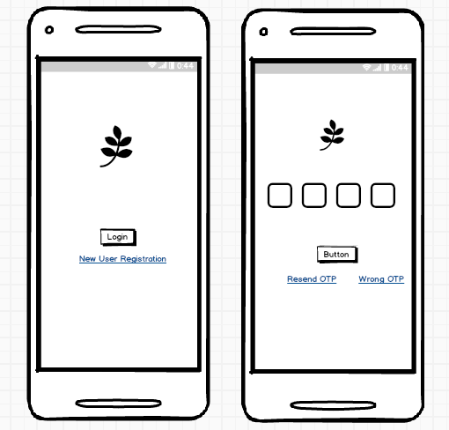

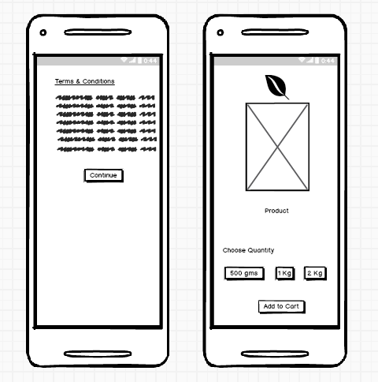

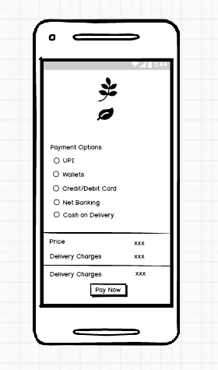

1. **Tools (Visio, Balsamiq)**

**Make a note of tools using for above concepts.**

MS Visio : Microsoft Visio is a popular tool for creating diagrams, flowcharts and wireframes. It offers a wide range of templates and shapes to create visual representations of processes and systems.

Balsamiq : Balsamiq is a wireframing tool that allows you to create low-fidelity wireframes quickly. It has a simple and intuitive interface, making it easy to sketch out ideas and concepts.

Axure RP : Axure RP is a powerful prototyping and wireframing tool that enables you to create interactive and dynamic prototypes. It offers advanced features for creating complex interactions and user flows.

These tools can assist you in visualizing and prototyping your design concepts effectively. It’s important to explore their features and determine which tool best fits your specific needs and preferences.

1. **RTM**

**A business analyst’s key responsibilities are to keep track of the requirements and make sure that no requirement is missed.**

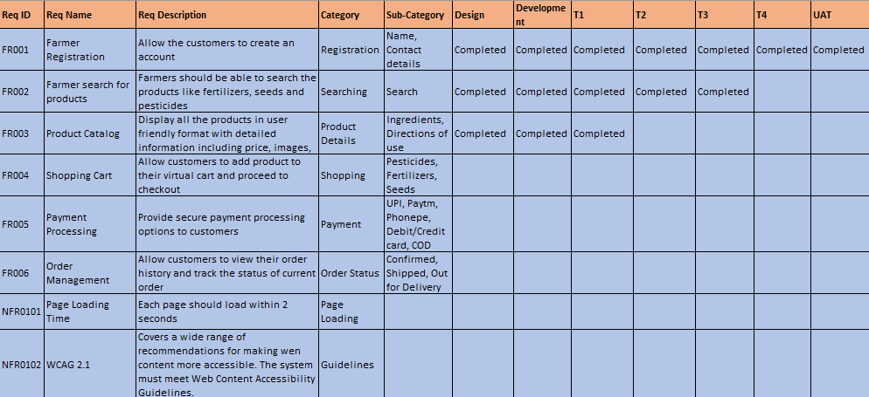

1. **Prepare 10 test case documents.**

|  |  |  |  |
| --- | --- | --- | --- |
| **Test Case ID** | TC001 | **Test Case Name** |  |
| **Project ID** | OAA | **Project Name** | Online Agriculture Product Store |
| **PM ID** |  | **PM Name** | Mr Vandanam |
| **Tester Strategy ID** |  | **Tester ID** |  |
| **Test Plan ID** |  | **Tester Name** | Mr. Jason |
| **Test Schedule ID** |  | **Date of Test** | 01-Feb-25 |
| **Scenario** | To authenticate a successful user login on gmail.com | | |
| **Link to that page** |  | | |
| **Input Data** | Name, Contact No, Email ID | | |
| **Expected Behaviour** | Once user name and password are entered, the web page redirects to the user’s inbox, displaying and highlighting new emails at the top. | | |
| **Actual Behaviour** | The web page redirects to the user’s inbox, displaying and highlighting new emails at the top, upon entering user name and password. | | |
| **Comments** | NA | | |
| **Result (Pass/Fail)** | Pass | | |

|  |  |  |  |
| --- | --- | --- | --- |
| **Test Case ID** | TC002 | **Test Case Name** |  |
| **Project ID** | OAA | **Project Name** | Online Agriculture Product Store |
| **PM ID** |  | **PM Name** | Mr Vandanam |
| **Tester Strategy ID** |  | **Tester ID** |  |
| **Test Plan ID** |  | **Tester Name** | Miss Alekya |
| **Test Schedule ID** |  | **Date of Test** | 02-Feb-25 |
| **Scenario** | Seller Product Creation | | |
| **Link to that page** |  | | |
| **Input Data** | Product ID, Product pictures, Product Prices | | |
| **Expected Behaviour** | Authenticated sellers can access authorized product creation panels under authorized categories | | |
| **Actual Behaviour** | Authorized products creation panels can be accessed by Authenticated sellers under authorized categories | | |
| **Comments** | NA | | |
| **Result (Pass/Fail)** | Pass | | |

|  |  |  |  |
| --- | --- | --- | --- |
| **Test Case ID** | TC003 | **Test Case Name** |  |
| **Project ID** | OAA | **Project Name** | Online Agriculture Product Store |
| **PM ID** |  | **PM Name** | Mr Vandanam |
| **Tester Strategy ID** |  | **Tester ID** |  |
| **Test Plan ID** |  | **Tester Name** | Mr. Jason |
| **Test Schedule ID** |  | **Date of Test** | 03-Feb-25 |
| **Scenario** | Filter results | | |
| **Link to that page** |  | | |
| **Input Data** | Product key names and product alternative names | | |
| **Expected Behaviour** | The user should be able to see results with default search criteria when at least one of the filter parameter isn’t mandatory | | |
| **Actual Behaviour** | The page should show results depending upon the search criteria entered in filter parameter | | |
| **Comments** | NA | | |
| **Result (Pass/Fail)** | Pass | | |
|  |  | | |
| **Test Case ID** | TC004 | **Test Case Name** |  |
| **Project ID** | OAA | **Project Name** | Online Agriculture Product Store |
| **PM ID** |  | **PM Name** | Mr Vandanam |
| **Tester Strategy ID** |  | **Tester ID** |  |
| **Test Plan ID** |  | **Tester Name** | Mr. Jason |
| **Test Schedule ID** |  | **Date of Test** | 04-Feb-25 |
| **Scenario** | Filter results | | |
| **Link to that page** |  | | |
| **Input Data** | Product colour alternatives, product quantity, product quality | | |
| **Expected Behaviour** | Test that all the product details are displayed correctly and that no empty/invalid details are displayed | | |
| **Actual Behaviour** | It would show all the product details exactly as per the filter criteria | | |
| **Comments** | NA | | |
| **Result (Pass/Fail)** | Pass | | |

|  |  |  |  |
| --- | --- | --- | --- |
| **Test Case ID** | TC005 | **Test Case Name** |  |
| **Project ID** | OAA | **Project Name** | Online Agriculture Product Store |
| **PM ID** |  | **PM Name** | Mr Vandanam |
| **Tester Strategy ID** |  | **Tester ID** |  |
| **Test Plan ID** |  | **Tester Name** | Mr. Jason |
| **Test Schedule ID** |  | **Date of Test** | 05-Feb-25 |
| **Scenario** | Shopping Cart | | |
| **Link to that page** |  | | |
| **Input Data** | Item price, Item quantity | | |
| **Expected Behaviour** | Test that all added items have at least a quantity, price and delete option associated with it. | | |
| **Actual Behaviour** | It should reflect the selected product with quantity and price calculated | | |
| **Comments** | NA | | |
| **Result (Pass/Fail)** | Pass | | |

|  |  |  |  |
| --- | --- | --- | --- |
| **Test Case ID** | TC006 | **Test Case Name** |  |
| **Project ID** | OAA | **Project Name** | Online Agriculture Product Store |
| **PM ID** |  | **PM Name** | Mr Vandanam |
| **Tester Strategy ID** |  | **Tester ID** |  |
| **Test Plan ID** |  | **Tester Name** | Mr. Jason |
| **Test Schedule ID** |  | **Date of Test** | 06-Feb-25 |
| **Scenario** | Checkout Page | | |
| **Link to that page** |  | | |
| **Input Data** | Item price, coupon details, price breakup | | |
| **Expected Behaviour** | User should be shown the total amount with the necessary breakup as applicable | | |
| **Actual Behaviour** | It will display each product’s price and the total value as well | | |
| **Comments** | NA | | |
| **Result (Pass/Fail)** | Pass | | |

|  |  |  |  |
| --- | --- | --- | --- |
| **Test Case ID** | TC007 | **Test Case Name** |  |
| **Project ID** | OAA | **Project Name** | Online Agriculture Product Store |
| **PM ID** |  | **PM Name** | Mr Vandanam |
| **Tester Strategy ID** |  | **Tester ID** |  |
| **Test Plan ID** |  | **Tester Name** | Miss Alekya |
| **Test Schedule ID** |  | **Date of Test** | 07-Feb-25 |
| **Scenario** | Payment Page | | |
| **Link to that page** |  | | |
| **Input Data** | Saved payment method, card numbers, UPI, Customer ID of Net Banking | | |
| **Expected Behaviour** | For returning customers, they should be redirected to log in for checkout | | |
| **Actual Behaviour** | It would redirect the returning customers to log in for checkout | | |
| **Comments** | NA | | |
| **Result (Pass/Fail)** | Pass | | |

|  |  |  |  |
| --- | --- | --- | --- |
| **Test Case ID** | TC008 | **Test Case Name** |  |
| **Project ID** | OAA | **Project Name** | Online Agriculture Product Store |
| **PM ID** |  | **PM Name** | Mr Vandanam |
| **Tester Strategy ID** |  | **Tester ID** |  |
| **Test Plan ID** |  | **Tester Name** | Mr. Jason |
| **Test Schedule ID** |  | **Date of Test** | 08-Feb-25 |
| **Scenario** | Session log out if page left idle for more than 10 minutes | | |
| **Link to that page** |  | | |
| **Input Data** | Timer for page loading | | |
| **Expected Behaviour** | Maintain a session for each user and test verify the sessions times out after a while | | |
| **Actual Behaviour** | It would maintain a session for each user and test verify the sessions times out after a while | | |
| **Comments** | NA | | |
| **Result (Pass/Fail)** | Pass | | |

|  |  |  |  |
| --- | --- | --- | --- |
| **Test Case ID** | TC009 | **Test Case Name** |  |
| **Project ID** | OAA | **Project Name** | Online Agriculture Product Store |
| **PM ID** |  | **PM Name** | Mr Vandanam |
| **Tester Strategy ID** |  | **Tester ID** |  |
| **Test Plan ID** |  | **Tester Name** | Miss Alekya |
| **Test Schedule ID** |  | **Date of Test** | 09-Feb-25 |
| **Scenario** | Shipment and delivery | | |
| **Link to that page** |  | | |
| **Input Data** | Payment done and order confirmed | | |
| **Expected Behaviour** | Order number generation and status of order showing | | |
| **Actual Behaviour** | Order placed and order number generated and order status displaying | | |
| **Comments** | NA | | |
| **Result (Pass/Fail)** | Pass | | |

|  |  |  |  |
| --- | --- | --- | --- |
| **Test Case ID** | TC010 | **Test Case Name** |  |
| **Project ID** | OAA | **Project Name** | Online Agriculture Product Store |
| **PM ID** |  | **PM Name** | Mr Vandanam |
| **Tester Strategy ID** |  | **Tester ID** |  |
| **Test Plan ID** |  | **Tester Name** | Mr. Jason |
| **Test Schedule ID** |  | **Date of Test** | 10-Feb-25 |
| **Scenario** | App installation/Uninstallation | | |
| **Link to that page** |  | | |
| **Input Data** | device details, auto fill up, contact number | | |
| **Expected Behaviour** | The application is installed and works correctly/ The application is uninstalled. The app’s icon isn't displayed on the device's OS. | | |
| **Actual Behaviour** | Application should be installed and working correctly when downloaded and should get deleted when uninstalled | | |
| **Comments** | NA | | |
| **Result (Pass/Fail)** | Pass | | |
|  |  | | |

1. **DB Design**

**After the requirements are thoroughly explained to the entire project team by Business Analyst, the Database architects have decided to do the database design and to represent the in-flow and out-flow of data.**

**Draw Database Schema and ER diagram.**

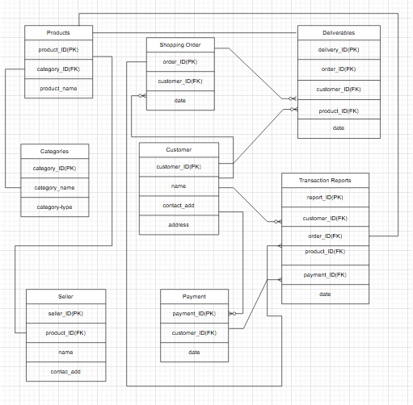

1. **Data Flow Diagram**

**What is data flow diagram? Draw a data flow diagram to represent the in-flow and out-flow of data when a farmer is placing an order for the product.**

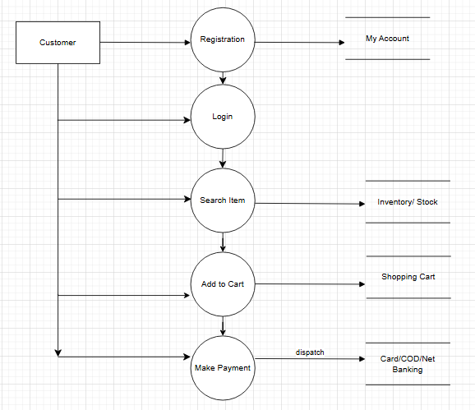

1. **Change request**

**Due to change in the Government Taxation Structure. We should change the Tax structure. How do you handle change requests in a project?**

Handling change requests in a project involves a systematic process to ensure that changes are effectively managed while minimizing disruption to the project’s scope, timeline and resources.

Here are the steps typically followed to handle change requests:

* Change Request Identification – Identify and document the change request, including the specific details of the requested change, the reason for the change, and its potential impact on the project.
* Change Impact Analysis – Access the impact of the change on various aspects of the project such as scope, timeline, cost, resources and risks. Evaluate the feasibility and implications of implementing the change.
* Change Evaluation – Review the change request with key stakeholders, including project sponsors, clients and relevant team members. Discuss the potential benefits, risks and trade-offs associated with the change. Consider the project’s objectives, constraints and priorities in the evaluation process.
* Change Prioritization – Prioritize the change request based on the urgency, impact and alignment with project goals. Determine whether the change is critical and must be implemented immediately or can be scheduled for future phase or release.
* Change Approval – Obtain formal approval from the appropriate stakeholders, such as project sponsors or change control boards. Ensure that all the stakeholders are in agreement regarding the change and its implications.
* Change Implementation – Incorporate the approved change into the project plan, including any necessary adjustments to the scope, schedule, budget or resources. Communicate the change to the project team and other relevant stakeholders. Update project documentation, such as requirements, design and test plans, to reflect the approved change.
* Change Communication – Communicate the approved change to all the relevant parties, including team members, clients and other stakeholders. Clearly explain the reasons for the change, its impact on the project, and any adjustments to expectations or deliverables.
* Change Tracking and Documentation – Track and document all approved changes, including the rationale, approvals and implemented modifications. Maintain a change log or change register to ensure transparency and accountability throughout the project.
* Change Control and Monitoring – Continuously monitor the impact of implemented changes on the project’s progress, risks and quality. Maintain open lines of communication with stakeholders to address any concerns or issues related to the approved changes. Monitor the project’s overall alignment with the revised scope, timeline and objectives.

1. **Change Request vs an Enhancement**

**As the project is in process, Ben and Kevin have contacted you. The reason is to inform you that they want the farmers to sell their crop yields through this application i.e farmers should be able to add their crop yields or products and display to general public and should be able to sell them. They also want to introduce Auction system for their crop yields. As a BA, what will be your response? Is this a change request or an enhancement???**

As a Business Analyst, my response to Ben and Kevin’s request would be to classify it as an enhancement rather than a change request. A change request typically involves modifications to existing functionality or requirements, while an enhancement introduces new features or capabilities that were not initially specified.

In this case, the request to allow farmers to add their crop yields, display them to the general public and enable selling through the application represents an enhancement because it introduces new functionality that goes beyond the initial scope of the project. Additionally, the introduction of an auction system for crop yields adds another layer of functionality to the application.

To address this enhancement request, I would follow the standard process for handling new requirements:

* Requirement Gathering – I would meet with Ben and Kevin to gather detailed requirements for the new functionality. This would involve understanding the specific features they envision, such as the process for farmers to add and manage their crop yields, the display of products to the public, and the implementation of the auction system.
* Impact Analysis – I would analyze the impact of these enhancements on the existing project scope, timeline, budget and resources. This assessment would help determine the feasibility and potential implications of incorporating the requested features.
* Stakeholder Analysis – I would identify and involve relevant stakeholders, such as the project sponsor, development team, and other key personnel, to assess their perspectives and gather their inputs on the potential enhancements.
* Documentation and Communication – I would document the detailed requirements and changes in the project scope, and communicate them to the project team, stakeholders, and any other parties involved. This would ensure everyone is aware of the proposed enhancements and their implications.
* Evaluation and Prioritization – I would work with the project team and stakeholders to evaluate the value and priority of the requested enhancements. This evaluation would consider factors such as the potential benefits, impact on project goals, alignment with business objectives, available resources.
* Planning and Execution – If the enhancements are deemed feasible and approved, I would update the project plan, schedule and resources accordingly. I would collaborate with the development team and other stakeholders to incorporate the new features into the supplication, ensuring proper testing and quality assurance.

By treating this request as an enhancement, the project can effectively manage the additional requirements and deliver the desired functionality while considering the impact on the ongoing project.

1. **Estimations**

**Come up with estimations – How many Manhours required**

Estimating the number of man-hours required for the requested enhancements (adding crop yields, displaying them to the public and implementing an auction system) would depend on various factors, including the complexity of the features, the size of the used. Without specific details about the project, it’s challenging to provide an accurate estimation. However, I can offer a general guideline based on industry standards and experience:

1. Requirement Gathering and Analysis: 10-20 man-hours
2. This includes meetings with stakeholders, gathering detailed requirements, analyzing the impact and documenting the enhancements.
3. Design and Architecture: 20-40 man-hours
4. This involves designing the system components, database structure and user interface for the new features. It also includes identifying the necessary changes to accommodate the enhancements.
5. Development and Coding: 40-80 man-hours
6. The actual development of the new features , including backend and frontend coding, integration with existing modules, implementation of the auction system.
7. Testing and Quality Assurance: 20-40 man-hours
8. This phase involves writing test cases, performing unit testing, integration testing and ensuring the proper functioning and stability of the added features.
9. Development and User Acceptance Testing (UAT): 10-20 man-hours
10. Deploying the updated system to a testing environment, conducting user acceptance testing and resolving any issues identified during UAT.
11. Documentation and Training: 10-20 man-hours
12. Documenting the new features, updating user manuals or guides and providing training or support materials for farmers and users.

It’s important to note that these estimations are rough figures and can vary significantly depending on the complexity and scale of the enhancements, the team’s productivity and other project-specific factors. It’s recommended to involve the development team in the estimation process to get a more accurate assessment based on their expertise and knowledge of the project.

1. **UAT**

**Project has finally completed all the stages i.e. design, development, testing etc. Now it is the role of a business analyst to contact the client for testing of the final product and have successfully complete it. How are you going to handle this situation? And once it is done, what will be the process to close the project?**

**Explain UAT Acceptance process.**

To handle the situation of testing the final product and successfully completing it, the business analyst can follow these steps:

* + 1. UAT Planning – Prepare a plan for User Acceptance Testing (UAT) in consultation with the client. This plan should include the scope of testing, test scenarios, test data and timelines.
    2. Test Environment Setup – Ensure that the required test environment is set up and available for the client to perform testing. This may include providing access to the testing environment, necessary test accounts and any additional resources needed for testing.
    3. Test Execution – Cordinate with the client to execute the planned test scenarios. Monitor the testing progress, provide support for any questions or issues that arise and track the test results.
    4. Defect Management – If any defects are identified during UAT, document them in a structured manner, including detailed steps to reproduce the problem. Communicate the issues to the development team for resolution.
    5. Defect Resolution – Collaborate with the development team to address the reported defects. Verify the fixes provided by the development team and retest the affected areas.
    6. Sign-off – Once all test scenarios have been executed, defects have been resolved and the system meets the user’s acceptance criteria, provide formal sign-off or approval. This signifies that the client accepts the product as meeting their requirements.
    7. UAT Closure – Document the UAT results, including the test execution summary, any outstanding issues and the overall assessment of the product. Communicate the closure of UAT to all stakeholders involved in the testing process.

The UAT Acceptance process ensures that the final product meets the client’s expectations and is ready for deployment. It serves as a final validation before the project is considered complete and ready for closure.

Regarding the process to close the project, it typically involves the following steps:

1. Final Documentation – Ensure all the project related documentation is complete, including requirements, design documents, test cases and user manuals. Review and update these documents to reflect the final product.
2. Project Review – Conduct a project review meeting with key stakeholders, including the client, to discuss the overall project performance, achievements and lessons learnt. Gather feedback and suggestions for improvement.
3. Project Closure Report – Prepare a project closure report summarizing the project’s objectives, deliverables, timeline, budget and overall success. Include any improvement metrics or performance indicators.
4. Handover or Deployment – Cordinate with the necessary teams, such as deployment or operations, to ensure a smooth transition of the final product to the production environment. Provide any necessary training or documentation to support the deployment process.
5. Post-Project Evaluation – After the product is deployed and operational, conduct a post-product evaluation to access its performance, gather user feedback and identify any areas for further improvement.
6. **Project Closure Document**

**Explain Project Closure Document**

A project closure document is a comprehensive report that summarizes the entire project’s lifecycle, outcomes and lessons learnt. It serves as a formal record of the project’s completion and provides important information for future reference. The document typically includes the following sections:

1. Project Overview – This section provides an overview of the project, including its objectives, scope and stakeholders involved. It summarizes the project’s purpose and sets the context for the closure report.
2. Project Achievements – Here, the document highlights the key achievements and deliverables of the project. It outlines the successful completion of milestones, tasks and any significant accomplishments that were achieved.
3. Project Timeline and Budget – This section provides an overview of the project timeline, highlighting the start and end dates, major phases and milestones. It also includes information on the project’s budget, including any significant deviations or changes.
4. Lessons Learnt – The lessons learnt section reflects on the project’s successes and the challenges. It includes a comprehensive analysis of what worked well and what could have been improved. It highlights valuable insights and recommendations for future projects.
5. Stakeholder Feedback – This section gathers feedback from key stakeholders involved in the project. It includes their opinions, suggestions and any concerns they may have expressed. The feedback helps in assessing the overall satisfaction and identifying areas for improvement.
6. Risks and Issues – The closure document discusses the risks and issues encountered throughout the project. It outlines the actions taken to mitigate these risks and resolve any issues that arose during the project’s lifecycle.
7. Project Performance – This section evaluates the project’s performance against the defined objectives and success criteria. It assesses factors such as scope adherence, timeline adherence, budget performance, quality of deliverables and customer satisfaction.
8. Project Sign-off – The closure document includes formal sign-offs or approval from key stakeholders, indicating their acceptance and satisfaction with the project’s outcomes. This signifies the official closure of the project.
9. Project Documentation – This section provides an overview of the project documentation, including the list of documents produced, their location and accessibility for future reference.
10. Next Steps and Recommendations – The closure document outlines any recommended action or next steps following the project’s closure. It may include suggestions for further improvements, additional tasks or follow-up activities.

The project closure document serves as a final report that captures the project’s journey, outcomes and key learnings. It provides a reference for future projects, helps in evaluating project success and facilitates knowledge transfer to stakeholders involved in the project.