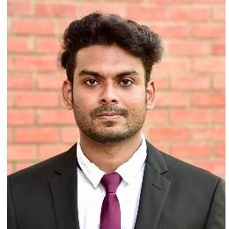AJAS ASHARAF

# SUMMARY

Young Passionate, Cross- Functional & a creative professional with a desire to make a distinctive mark on the corporate world. Pursued MBA focused on Finance & Marketing all with a goal of aggressively growing the business or idea

# EXPERIENCE

**Business Trainee**, 08/2022 – 01/2025

**ICICI PRUDENTIAL LIFE INSURANCE -** Bangalore**,** Karnataka

* Handling Client Portfolio
* Reviewing the credentials provided by the customers and integrate with dashboard
* Researched and resolved Customer issues on Investment Portfolios
* Cross checking of the consumer provided credentials with Issuance/Under-writing Team
* Final closure call with customer.

# EDUCATION AND TRAINING

MBA, 07/2022

**St Aloysius College, AIMIT** - Mangalore, Karnataka

BCOM, 02/2020

**IGNOU** - Trivandrum, Kerala

# CERTIFICATIONS

* The Complete Investment Banking Program With Financial Modelling at Jobaaj
* Completed Data Analyst Course (SQL, POWER BI) at Udemy
* Stock Market Indices Course" at Coursera
* "Introduction to Corporate Finance'' at Coursera
* Certified as Proficient in "Advanced Microsoft Excel"
* Add on Course completed on "Personal Financial Planning"

# REFERENCES

References available upon request.

# CONTACT

**Address:** Bangalore Karnataka

**Phone:** 7736844331

**Email:** [ajazashraf00@gmail.com](mailto:ajazashraf00@gmail.com) **WWW:** [www.linkedin.com/in/ajas-](http://www.linkedin.com/in/ajas-) ashraf-0449871a3

# SKILLS

* Excel, Google Sheets
* Financial Reporting
* Analytical Thinking
* Team Management
* Leadership qualities
* Power BI, Sql
* Email Etiquette's
* Communication Skills

# LANGUAGES

**Malayalam:** First Language

**English:** C1

Advanced (C1)

**Hindi:** B1

Intermediate (B1)

**Tamil:** B2

Upper Intermediate (B2)