**Online Agriculture Products Store**

Mr. Henry, after being successful as a businessman and has become one of the wealthiest persons in the city. Now, Mr. Henry wants to help others to fulfil their dreams. One day, Mr. Henry went to meet his childhood friends Peter, Kevin and Ben. They live in a remote village and do farming. Mr. Henry asked his friends if they are facing any difficulties in their day-to-day work.

Peter told Mr. Henry that he is facing difficulties in procuring fertilizers which are very important for farm. Kevin said that he is also facing the same problem in-case of buying seeds for farming certain crops. Ben raised his concern on lack of pesticides which could help in greatly reducing pests in crops.

After listening to all his friends’ problems, Mr. Henry thought that this is a crucial problem faced not only by his friends but also by so many other farmers. So, Mr. Henry decided to make an online agriculture product store to facilitate remote area farmers to buy agriculture products. Through this Online Web / mobile Application, Farmers and Companies (Fertilizers, seeds and pesticides manufacturing Companies) can communicate directly with each other.

The main purpose to build this online store is to facilitate farmers to buy seeds, pesticides, and fertilizers from anywhere through internet connectivity. Since new users are involved, Application should be user friendly.

This new application should be able to accept the product (fertilizers, seeds, pesticides) details from the manufacturers and should be able to display them to the Farmers. Farmers will browse through these products and select the products what they need and request to buy them and deliver them to farmers location. Mr. Henry has given this project through his Company SOONY. In SOONY Company, Mr Pandu is Financial Head and Mr Dooku is Project Coordinator. Mr. Henry , Mr Pandu , and Mr Dooku formed one Committee and gave this project to APT IT SOLUTIONS company for Budget 2 Crores INR and

18 months Duration under CSR initiative. Peter, Kevin and Ben are helping the Committee and can be considered as Stakeholders share requirements for the Project.

Mr Karthik is the Delivery Head in APT IT SOLUTIONS company and he reached out to Mr Henry through his connects and bagged this project. APT IT SOLUTIONS company have Talent pool Available for this Project. Mr Vandanam is project Manager, Ms. Juhi is Senior Java Developer, Mr. Teyson, Ms Lucie, Mr Tucker, Mr Bravo are Java Developers. Network Admin is Mr Mike and DB Admin is John. Mr Jason and Ms Alekya are the Tester. And you joined this team as a BA.

**Your Team**

**Project Manager - Mr Vandanam**

**Senior Java Developer - Ms. Juhi**

**Java Developers - Mr Teyson, Ms Lucie, Mr Tucker, Mr Bravo**

**Network Admin - Mr Mike**

**DB Admin - Mr John.**

**Testers - Mr Jason and Ms Alekya**

**BA – You**

Fertilizers, seeds, pesticides details from the manufacturers and should be able to display them to the Farmers. To gather the business requirements from the client, you went to SOONY and met Mr. Henry. When Mr. Henry was asked about the project and what are they expecting from the project, Mr. Henry stated that he is expecting to have a login for all its users (fertilizers, seeds, pesticides manufacturers and Farmers) , a product catalog of fertilizers, seeds, pesticides, a search option to search for products, payment process, and delivery tracking.

After doing the stakeholder analysis, you have found out that Peter, Kevin, Ben are the key stakeholders and you have scheduled an appointment to meet them. After meeting with them and trying to gather the stakeholder requirements, **Kevin said that, a Farmer should be able to browse through the products** **catalog once they visit the website and need to have a search option so that they can search for any product they need. Peter said that, if a farmer wants to buy any product or add them to buy-later list, they need to login first using their email id and password.**

**If it is a new user, then they can create a new account by submitting their email ID and creating a secure password. Ben added saying that, Farmers needs to have an easy-to-use payment gateway which should include cash-on-delivery (COD), Credit/Debit card and UPI options so that the user’s experience should be better. Kevin mentioned that, a user gets an email confirmation regarding their order status. A delivery tracker to track the whereabouts of their order**.

**Question 1 – Functional Requirements - 15 Marks**

**Identify minimum 20 functional requirements**

**Functional Requirements**

|  |  |  |  |
| --- | --- | --- | --- |
| Req id | **Req Name** | **Req Description** | **Priority** |
| FR001 | User Registration | Users (Farmers and Manufacturers) shall be able to register using an email ID and password. | 10 |
| FR002 | User Login | Registered users shall be able to log in to the application using their credentials. | 10 |
| FR003 | View Product catalog | Farmers shall be able to view categorized product listings (fertilizers, seeds, pesticides). | 9 |
| FR004 | Search Product | Farmers shall be able to search products | 10 |
| FR005 | Product filtering | Farmers shall be able to filter products based on price, company, and category. | 8 |
| FR006 | Add to cart | Farmers shall be able to add one or more products to a shopping cart before purchasing. | 9 |
| FR007 | Place order | Farmers shall be able to place orders for selected products in their cart. | 10 |
| FR008 | Order confirmation | System shall send an email confirmation to farmers upon successful order placement. | 9 |
| FR009 | Payment – with different modes | System shall support payment options including COD, UPI, and credit/debit cards. | 10 |
| FR010 | Track Order delivery | Farmers shall be able to track the delivery status of their orders through the system. | 9 |

**Non- Functional Requirements**

|  |  |  |  |
| --- | --- | --- | --- |
| Req id | **Req Name** | **Req Description** | **Priority** |
| NFR001 | Usability | The application shall be user-friendly | 10 |
| NFR002 | Performance | The system must load pages within 3 seconds | 9 |
| NFR003 | Response Time | The application should respond to user within 2 second | 8 |
| NFR004 | Availability | The application shall be available 24x7 for users to access services. | 9 |
| NFR005 | Security | The system shall encrypt user data (passwords, payment info) using industry-standard encryption protocols. | 10 |
| NFR006 | Data Privacy | User data shall be stored securely and not shared with third parties without consent. | 10 |
| NFR007 | Compatibility | The application shall be compatible with modern browsers (Chrome, Firefox, Safari) and mobile OS (Android, iOS). | 8 |
| NFR008 | Maintainability | The system shall be designed in modular architecture to allow for future updates and maintenance. | 8 |
| NFR009 | Accessibility | The application shall follow accessibility standards (e.g., WCAG 2.1) for differently-abled users. | 7 |
| NFR010 | Localization | The application shall support regional languages along with English | 6 |

**Question 2–Minimum 5-page designs**

**Make wireframe and prototypes**

**1.Home Page**

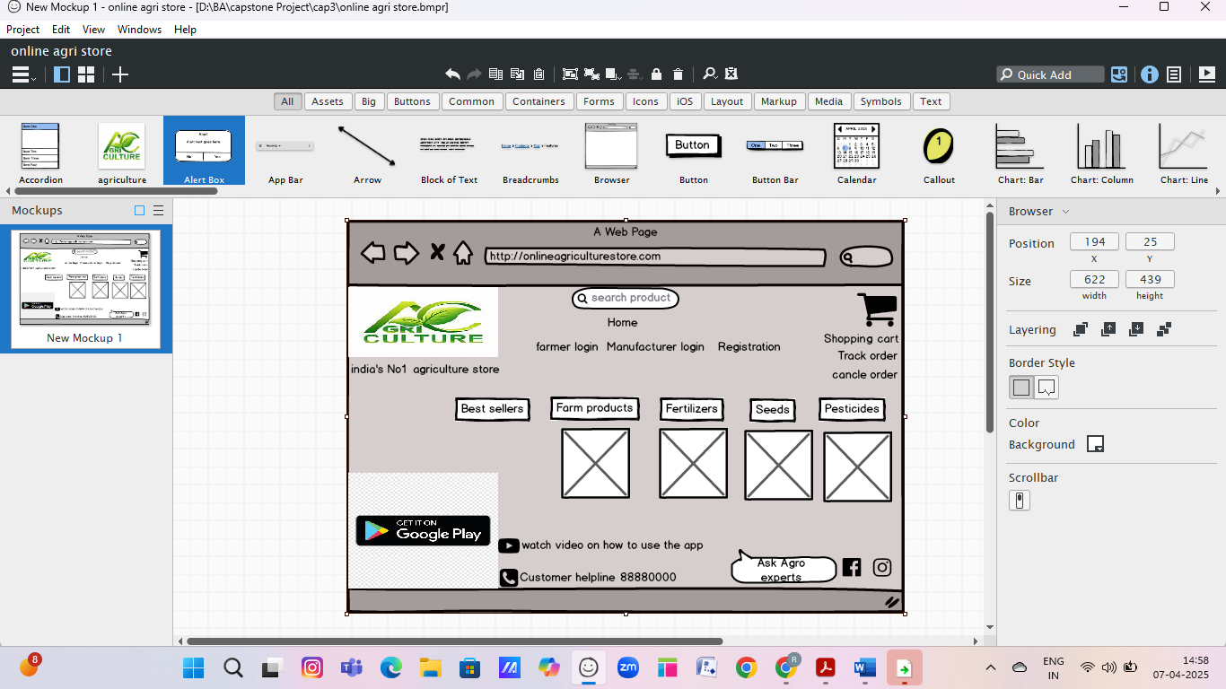

**Registration Page**

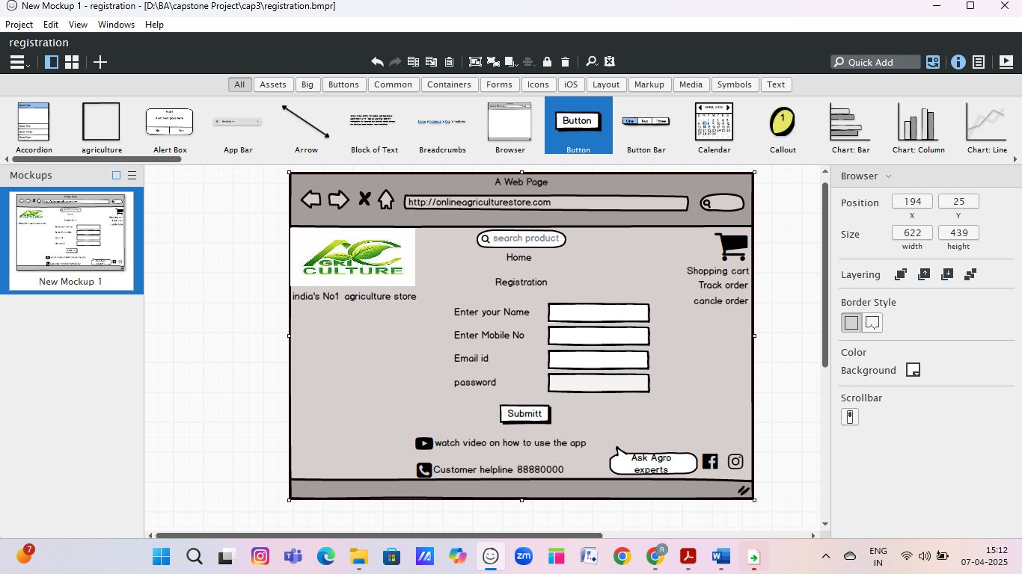

**Login Page**

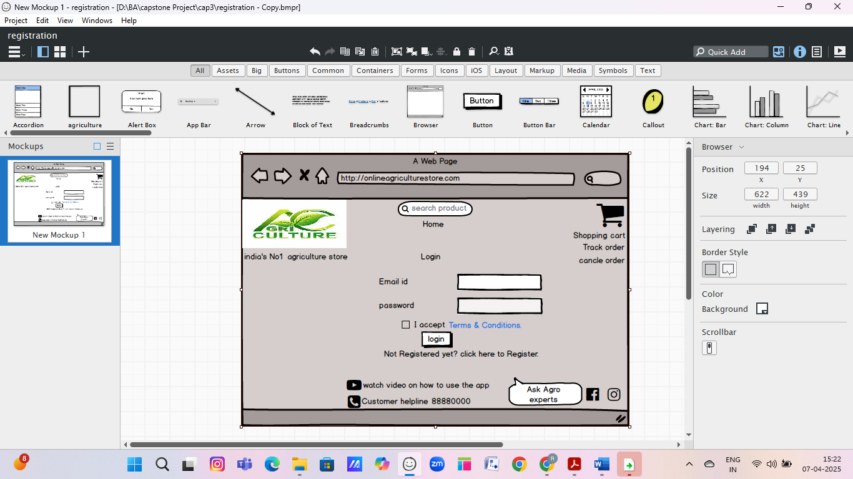

**Shop by categories/Product Category**

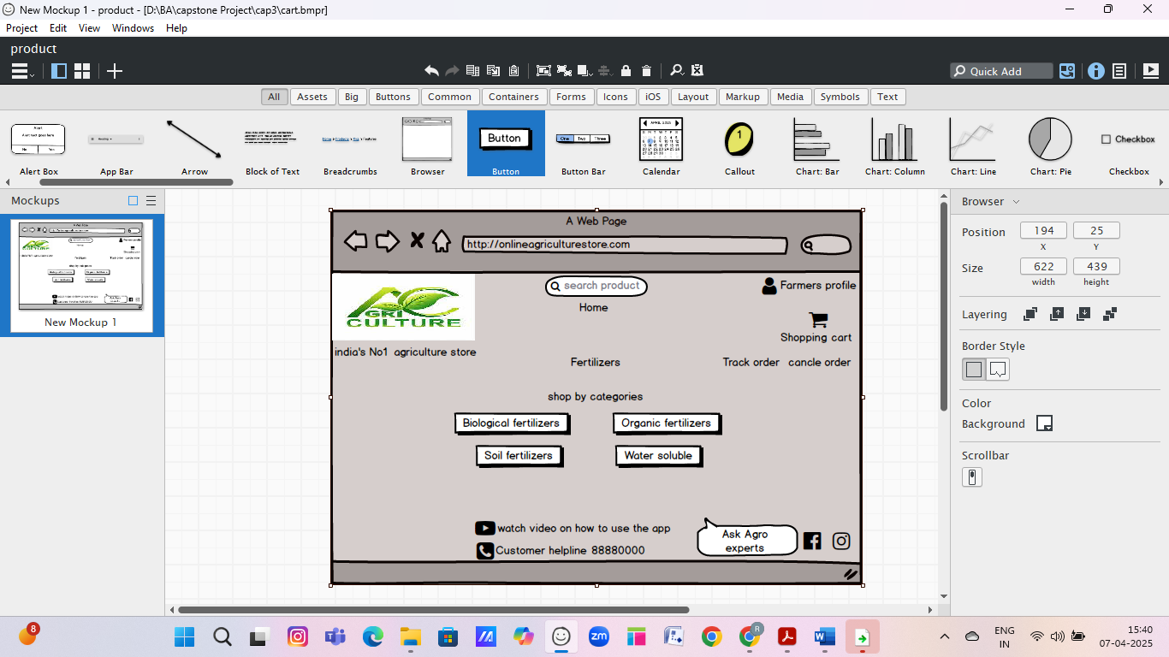

**Shopping Cart**

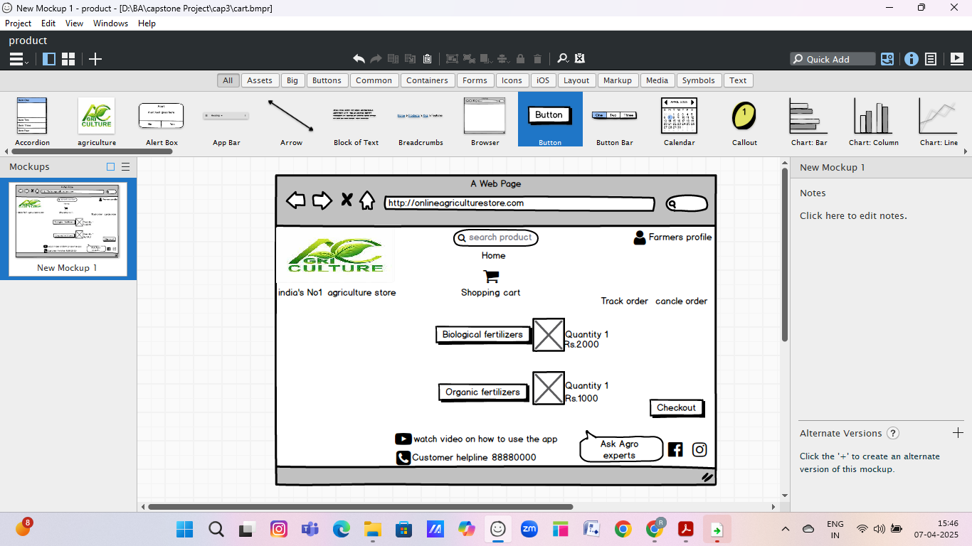

**Checkout**

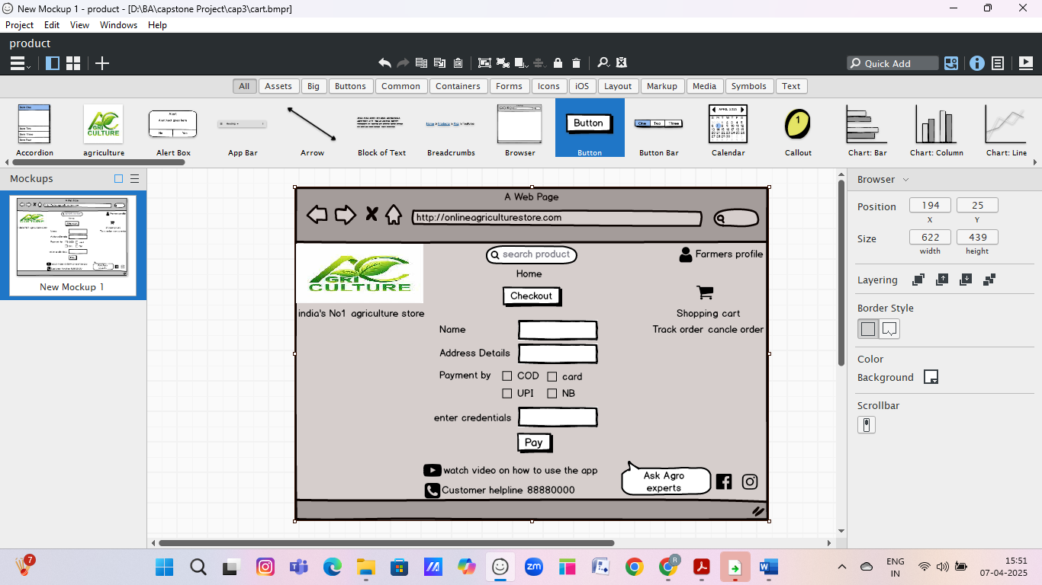

**Question 3 – Tools (Visio, Balsamiq) - 15 Marks**

**Make a note of the Tools, which you are using for above concepts.**

|  |
| --- |
| **Microsoft Visio** |

|  |  |  |
| --- | --- | --- |
| Used for creating UML diagrams, such as Use Case Diagrams, Activity Diagrams, and Entity Relationship Diagrams (ERD) to model functional workflows and data flow.   |  | | --- | | **Balsamiq** |  |  | | --- | | Used for creating low-fidelity/rapid **wireframes and prototypes** for key pages like Home Page, Login, Product Catalogue, Product Details, Cart, and Order Tracking. It helped visualize the UI/UX for stakeholders.  **Axure**  **Is more advanced** prototyping tool used to create high**-**fidelity, interactive wireframes and prototype for web and mobile application.  **Question 4 – RTM - 6 Marks**  **A business analyst’s key responsibilities are to keep track of the requirements and make sure that no requirement is missed.**  **Mr. Henry and peter have approached you regarding the current status of the project. How will you tackle this situation?** | |

**Prepare RTM**

**RTM- Requirement traceability Matrix.**

It is the document used to track the requirements throughout the project life cycle, ensuring that they are met and no requirements are missed out**.**

|  |  |  |  |  |  |  |  |  |  |
| --- | --- | --- | --- | --- | --- | --- | --- | --- | --- |
| **Req id** | **Req Name** | **Req Description** | **Design** | **D1** | **T1** | **T2** | **T3** | **T4** | **UAT** |
| **FR001** | User Registration | Farmers and manufacturers can register with email and password | **Checkmark with solid fill** | **Checkmark with solid fill** | **Checkmark with solid fill** | **Checkmark with solid fill** | **Checkmark with solid fill** | **Close with solid fill** | **Close with solid fill** |
| **FR002** | User login | Login functionality with secure password validation | **Checkmark with solid fill** | **Checkmark with solid fill** | **Checkmark with solid fill** | **Checkmark with solid fill** | **Checkmark with solid fill** | **Close with solid fill** | **Close with solid fill** |
| **FR003** | View product catalog | Farmers can browse categorized product listings | **Checkmark with solid fill** | **Checkmark with solid fill** | **Checkmark with solid fill** | **Checkmark with solid fill** | **Checkmark with solid fill** | **Close with solid fill** | **Close with solid fill** |
| **FR004** | Product search | Farmers can search products by name/type/category | **Checkmark with solid fill** | **Checkmark with solid fill** | **Checkmark with solid fill** | **Checkmark with solid fill** | **Close with solid fill** | **Close with solid fill** | **Close with solid fill** |
| **FR00** | Add to cart | Ability to add selected products to cart | **Checkmark with solid fill** | **Checkmark with solid fill** | **Checkmark with solid fill** | **Checkmark with solid fill** | **Close with solid fill** | **Close with solid fill** | **Close with solid fill** |
| **FR006** | Place Order | Complete checkout process with selected items | **Checkmark with solid fill** | **Checkmark with solid fill** | **Checkmark with solid fill** | **Checkmark with solid fill** | **Close with solid fill** | **Close with solid fill** | **Close with solid fill** |
| **FR007** | Payment | Support UPI, COD, and Card payment options | **Checkmark with solid fill** | **Checkmark with solid fill** | **Checkmark with solid fill** | **Checkmark with solid fill** | **Close with solid fill** | **Close with solid fill** | **Close with solid fill** |
| **FR008** | Delivery Tracking | Allow farmers to track their order status | **Checkmark with solid fill** | **Checkmark with solid fill** | **Checkmark with solid fill** | **Checkmark with solid fill** | **Close with solid fill** | **Close with solid fill** | **Close with solid fill** |
| **FR009** | Product upload | Manufacturers can upload and manage product details | **Checkmark with solid fill** | **Checkmark with solid fill** | **Checkmark with solid fill** | **Checkmark with solid fill** | **Close with solid fill** | **Close with solid fill** | **Close with solid fill** |
| **FR010** | Email Notification | Send confirmation emails after registration and order placement | **Checkmark with solid fill** | **Checkmark with solid fill** | **Checkmark with solid fill** | **Checkmark with solid fill** | **Close with solid fill** | **Close with solid fill** | **Close with solid fill** |

**D1- Development**

**T1-Unit Testing**

**T2-Integration Testing**

**T3-System Testing**

**T4-Regression Testing**

|  |  |  |  |  |  |  |  |  |  |
| --- | --- | --- | --- | --- | --- | --- | --- | --- | --- |
| Req id | **Req Name** | **Req Description** | **Design** | **D1** | **T1** | **T2** | **T3** | **T4** | **UAT** |
| NFR001 | Usability | The application shall be user-friendly | **Checkmark with solid fill** | **Checkmark with solid fill** | **Checkmark with solid fill** | **Checkmark with solid fill** | **Close with solid fill** | **Close with solid fill** | **Close with solid fill** |
| NFR002 | Performance | The system must load pages within 3 seconds | **Checkmark with solid fill** | **Checkmark with solid fill** | **Checkmark with solid fill** | **Checkmark with solid fill** | **Close with solid fill** | **Close with solid fill** | **Close with solid fill** |
| NFR003 | Response Time | The application should respond to user within 2 second | **Checkmark with solid fill** | **Checkmark with solid fill** | **Checkmark with solid fill** | **Checkmark with solid fill** | **Close with solid fill** | **Close with solid fill** | **Close with solid fill** |
| NFR004 | Availability | The application shall be available 24x7 for users to access services. | **Checkmark with solid fill** | **Checkmark with solid fill** | **Checkmark with solid fill** | **Checkmark with solid fill** | **Close with solid fill** | **Close with solid fill** | **Close with solid fill** |
| NFR005 | Security | The system shall encrypt user data (passwords, payment info) using industry-standard encryption protocols. | **Checkmark with solid fill** | **Checkmark with solid fill** | **Checkmark with solid fill** | **Checkmark with solid fill** | **Close with solid fill** | **Close with solid fill** | **Close with solid fill** |
| NFR006 | Data Privacy | User data shall be stored securely and not shared with third parties without consent. | **Checkmark with solid fill** | **Checkmark with solid fill** | **Checkmark with solid fill** | **Checkmark with solid fill** | **Close with solid fill** | **Close with solid fill** | **Close with solid fill** |
| NFR007 | Compatibility | The application shall be compatible with modern browsers (Chrome, Firefox, Safari) and mobile OS (Android, iOS). | **Checkmark with solid fill** | **Checkmark with solid fill** | **Checkmark with solid fill** | **Checkmark with solid fill** | **Close with solid fill** | **Close with solid fill** | **Close with solid fill** |
| NFR008 | Maintainability | The system shall be designed in modular architecture to allow for future updates and maintenance. | **Checkmark with solid fill** | **Checkmark with solid fill** | **Checkmark with solid fill** | **Checkmark with solid fill** | **Close with solid fill** | **Close with solid fill** | **Close with solid fill** |
| NFR009 | Accessibility | The application shall follow accessibility standards (e.g., WCAG 2.1) for differently-abled users. | **Checkmark with solid fill** | **Checkmark with solid fill** | **Checkmark with solid fill** | **Checkmark with solid fill** | **Close with solid fill** | **Close with solid fill** | **Close with solid fill** |
| NFR010 | Localization | The application shall support regional languages along with English | **Checkmark with solid fill** | **Checkmark with solid fill** | **Checkmark with solid fill** | **Checkmark with solid fill** | **Close with solid fill** | **Close with solid fill** | **Close with solid fill** |

**D1- Development**

**T1-Unit Testing**

**T2-Integration Testing**

**T3-System Testing**

**T4-Regression Testing**

**Question 5 – 10 Test Case Documents - 10 Marks**

**Prepare 10 Test Case Documents**

|  |  |  |  |  |  |
| --- | --- | --- | --- | --- | --- |
| **Test Case ID** | **Test case Description** | **Test steps** | **Test Data** | **Actual Result** | **Pass/fail** |
| |  | | --- | | TC001 |  |  | | --- | |  | | Verify User Registration | **1**. Go to Sign Up → **2**. Enter Email & Password → 3. Click Register | Email: user1@test.com, Password:123 | New user is created and redirected to login page |  |
| TC002 | Verify User Login | 1. Enter valid credentials → 2. Click Login | Email: user1@test.com, Password:123 | User is logged in and lands on homepage |  |
| TC003 | Verify Product Search | 1. Enter "fertilizer" in search bar → Click Search | fertilizer | List of fertilizers is displayed |  |
| |  | | --- | | TC004 |  |  | | --- | |  | | Verify Add to Buy Later | 1. Click on product → 2. Click “Add to Buy Later” | NA | Product saved in "Buy Later" list |  |
| TC005 | Verify Place Order | 1. Select product → 2. Add to Cart → 3. Checkout | NA | Order is placed and Order ID is generated |  |
| TC006 | Verify Payment UPI | 1. Choose UPI → 2. Enter UPI ID → 3. Pay | UPI ID: test@upi | Payment successful, order status updated |  |
| TC007 | Verify Payment COD | 1. Choose Cash on Delivery → 2. Confirm order | NA | Order placed with COD as payment method |  |
| TC008 | Verify Email Confirmation | 1. Place an order → 2. Check email | NA | Order confirmation email is received |  |
| TC009 | Verify View Order History | 1. Go to Profile → 2. Click on Orders | NA | User sees list of all previous orders |  |
| TC010 | Verify Delivery Tracking | 1. Click on a placed order → 2. Click "Track Order" | Order ID: O1001 | Real-time tracking info is shown |  |

**Question 6 – DB Design – 8 Marks**

**After the requirements are thoroughly explained to the entire project team by business analyst, the Database architects have decided to do the database design and also to represent the in-flow and out-flow of data. Draw database schema and ER diagram**

A **Database Schema** is like a **blueprint** of how data is organized in a database. Including its Tables, fields, relationships, constraints and other characteristics.

**An ERD(Entity relationship diagram)** is a visual representation of relationship between entities in a database. It depicts the entities such as tables, attributes (properties or fields) and relationships between them.

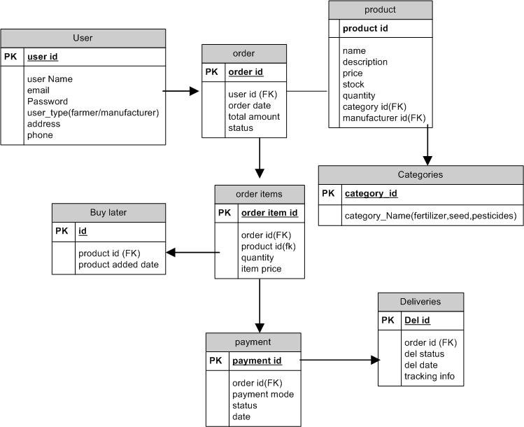

**ERD**

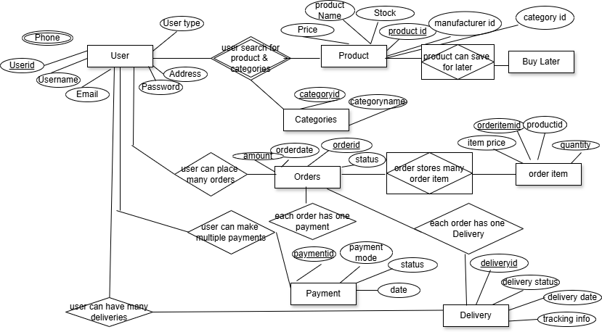

**Question 7 – Data Flow Diagram - 3 Marks**

**What is a data flow diagram? Draw a data flow diagram to represent the in-flow and out-flow of data when a Farmer is placing an order for the product.**

A Data Flow Diagram (DFD) is a graphical representation used to visualize the flow of data within a system. It shows:

* External entities (like users or systems)
* Processes (actions or operations)
* Data stores (where data is held)
* Data flows (movement of data between entities, processes, and stores)

DFDs help in understanding how data moves through a system — from input to processing to output.

**Scenario: Farmer Places an Order (DFD - Level 1)**

Below is a **Level 1 DFD** that shows how a **Farmer places an order** in the Online Agriculture Product Store.

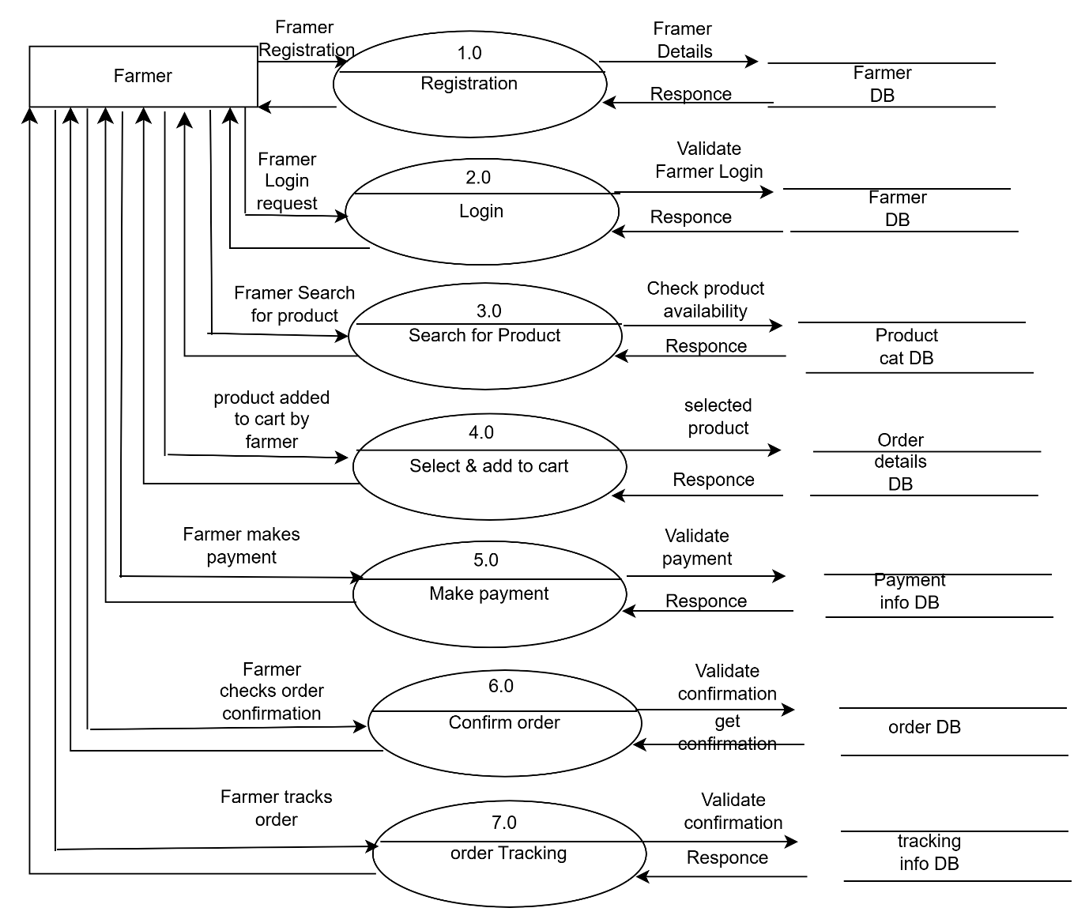

**Question 8 – Change Request - 10 Marks**

**Due to change in the Government Taxation structure. we should change the Tax structure How do you handle change requests in a project?**

**A change request is a formal proposal to alter a system, product or project.**

1. Understand the scope of change request and document the change request.
2. Do the impact analysis- project scope, schedule, budget, resources and risk.
3. Prioritize the change request based on its urgency, importance, impact on project.
4. Seek approval from the project sponsor from the change request.
5. Communicate the change request and its potential impact to all relevant stake holder, including the project team.

**Change Request Table Format**

|  |  |  |  |  |  |  |
| --- | --- | --- | --- | --- | --- | --- |
| CR ID | Title | Description | Impacted module | Status | Owner | Approval Date |
| CR-001 | Tax Structure Update | Modify Tax Logic as per Govt Rules | Checkout, invoice DB | In progress | BA/ Dev | DD-MM-YYYY |

Detailed Format

|  |  |
| --- | --- |
| **Field** | **Detail/Description** |
| Change Request ID | CR-001 |
| Project Name | Online Agriculture Product Store |
| Date of Request | [DD/MM/YYYY] |
| Raised By | [Name of the requester – e.g., Mr. Pandu] |
| Change Title | Update Tax Structure as per New Government Norm |
| Change Description | Government has revised the taxation rules. Need to update tax percentages applied to products in the system **including invoice generation, and price display**. |
| Reason for Change Request | Compliance with latest government tax policies |
| Impact Analysis | Affects   * Checkout Modul * Invoice Module * Product Pricing * Database Tax Table * Reports |
| Priority | High/Medium/Low |
| Estimated efforts | To be filled by developer / PM eg- 16 hrs |
| Approval Status | Pending/Approved/Rejected |
| Approver Name | Mr Donku/Mr Kartik/Mr Pandu |
| Approval Date | If Approved- filled here |
| Assigned To | Developer/Tester/ BA |
| Implementation Date | DD-MM-YYYY |
| UAT Status | Passed / failed/ in progress |

**When there's a change like Government Taxation Structure, here’s how a Business Analyst (BA) typically handles it:**

|  |  |
| --- | --- |
| **Step** | **Action** |
| **1** | Receive and Record the Request |
| **2** | Analyse the Change |
| **3** | Impact Analysis |
| **4** | Update Requirements |
| **5** | Seek Approval |
| **6** | Plan Implementation |
| **7** | Test Thoroughly |
| **8** | Communicate Changes |
| **9** | Deploy the Change |
| **10** | Post-Implementation Review |

**Question 9 – Change Request Vs an Enhancement - 5 Marks**

**As the project is in process, Ben and Kevin have contacted you. The reason is to inform you that they want the Farmers to sell their crop yields through this application i.e. Farmers should be able to add their crop yields or products and display to general public and should be able to sell them. They also want to introduce Auction system for their Crop yields. As a BA, what will be your response?**

**Is this a change request or an enhancement???**

-

|  |  |
| --- | --- |
| **Change Request** | **Enhancement** |
| A change to an existing feature | A new feature or module |
| Modifies current functionality | Adds new functionality |
| Within existing business goals | Expands project scope or objectives |
| Updating tax structure as per new law | Adding Farmer-to-Consumer selling & Auction system |

* **As a BA, what will be your response?**

**Is this a change request or an enhancement???**

This is not just a minor change, but a significant expansion of the original project scope.

In this case, Add an **Auction system** for these yields and allow **Farmers to sell their own crop yields** via the same platform, would be considered an Enhancement as it involves adding new features to the system. As a business analyst you should document the requirement and work with the development team to determine the feasibility and impact of the new feature. You should also consider the potential benefits, risk and cost associated with the enhancement before making any recommendation to the client.

**Question 10 – Estimations - 6 Marks**

**Come up with estimations – How many Manhours required**

|  |  |  |
| --- | --- | --- |
| **Task** | **Team role** | **Estimated Hours** |
| Requirement Gathering | BA | 200 hrs |
| Use Case & UML Modelling | BA | 120 hrs |
| Wireframes & UI Design | UI/UX Designers | 300 hrs |
| Backend Development (APIs, Logic) | Java Developers | 1000 hrs |
| Frontend Development (Web/Mobile) | Java Developers | 900 hrs |
| Database Design & Setup | DB Admin | 200 hrs |
| Integration & Network Setup | Network Admin | 150 hrs |
| Testing (Functional, UAT, Bug Fix) | Tester | 400 hrs |
| Deployment & Support | Developer/Tester | 250 hrs |
| Project Management & Coordination | PM | 300 hrs |

**Question 11 – UAT – 6 Marks**

**Project has finally completed all the stages i.e., design, development, testing etc. Now, it is the role of a business analyst to contact the client for testing of the final product and have to successfully complete it. How are you going to handle this situation? And once it is done, what will be the process to close the project?**

**Explain UAT Acceptance process**

**BA’s Role in UAT & Handling the Situation:**

|  |  |  |
| --- | --- | --- |
| **Step** | **Activity** | **Details** |
| **1** | Schedule UAT with Client | Contact Mr. Henry and stakeholders like Peter, Kevin, Ben. Set up a UAT schedule. |
| **2** | Prepare UAT Plan & Test Scenarios | Draft UAT plan including timeline, team involved, test scenarios, and expected outcomes. |
| **3** | Environment Setup | Ensure UAT environment is identical to production. Coordinate with dev/QA team. |
| **4** | Train Users | Conduct a training session/demo for farmers and stakeholders |
| **5** | Conduct UAT Testing | Monitor testing, collect feedback, and log issues. Provide test cases or checklists. |
| **6** | Track Defects/Issues | Ensure any bugs or issues raised by users are tracked and fixed**.** |
| **7** | |  | | --- | |  |  |  | | --- | | Obtain Sign-Off | | Once users are satisfied, get a formal UAT Sign-Off from the client (Mr. Henry & team). |

**What is UAT?**

User Acceptance Testing (UAT) is the final phase of software testing where the client/end-users test the system in a real-world scenario to confirm if it meets the business requirements and is ready for production.

**Step-by-Step UAT Process**

**1. Planning**

* Identify the **UAT team** (stakeholders, key users, BAs, testers).
* Define **UAT scope**, objectives, and **entry/exit criteria**.
* Prepare the **UAT test environment** (similar to production).

**2. Test Case Preparation**

* Based on business requirements and use cases, the BA prepares **UAT test cases**.
* These test cases simulate **real user scenarios** (e.g., “Farmer places an order”).

**3. UAT Execution**

* Users execute test cases in the UAT environment.
* They validate each feature (login, product search, order, payment, etc.).
* Any **bugs, errors, or issues** are reported to the development team.

**4. Defect Reporting and Fixes**

* Issues are logged and **tracked by BA/QA**.
* Developers fix the issues.
* Re-testing is done to verify that the issues are resolved.

**5. Sign-Off**

* Once all test cases **pass** and critical issues are resolved, users give their **approval**.
* A **UAT sign-off document** is signed by the client/stakeholders.

**6. Go-Live Decision**

* After UAT sign-off, the system is marked as **ready for deployment** to production.

**Project Closure Process (Post-UAT):**

|  |  |
| --- | --- |
| **Stage** | **Action** |
| 1. Final Delivery | Deliver final tested application to the client. |
| 2. Documentation Handover | Share user manuals, technical documentation, admin guides. |
| 3. Knowledge Transfer | Train client-side users/admins on system usage |
| 4. Post-Deployment Support | Offer support window (e.g., 1 month) to fix any live issues. |
| 5. Closure Meeting | Final meeting with client and internal team. Lessons learned |
| 6. Project Sign-Off | Official closure document signed by client. |
| 7. Archive Documents | Store project docs, emails, and assets for record-keeping |

**Question 12 – Project Closure Document - 6 Marks**

**Explain Project closure document**

* A project closure document also known as a project closure report- is a formal document that summarizes the key outcomes, lessons learned, and final details of the completed project.
* It serves as a comprehensive record of the project’s accomplishments, challenges and overall performance, providing valuable insights for stakeholders and future projects.

**Points to be included in the project closure documents are-**

* Project overview
* Achievements
* Lessons Learned
* Quality Assurance
* Resource Utilization
* Risk Management
* Challenges

|  |  |  |  |
| --- | --- | --- | --- |
| Sr No | **Points to be included** | **Details** | **Reference Link** |
| 1 | Did the client signed off UAT testing | Yes | Signed by Mr. Henry |
|  | Date of the Sign Off | Signed off on **10-Apr-2025** |
| Name of the Resource | Mr. Henry, Mr. Pandu, Mr. Dooku | SOONY Committee Member |
| 2 | **Objectives of the project** |  |  |
|  | User friendliness | Achieved |  |
|  | Customer Satisfaction | ROI in 6 months |  |
|  | More categories | Achieved |  |
| 3 | **Functionalities worked on** |  |  |
|  | Secure payment processing | Achieved |  |
|  | Categories | Achieved |  |
| 4 | **Infrastructure** |  |  |
|  | Software installed | Achieved |  |
|  | Laptop Purchased | Achieved |  |
| 5 | **Funding** |  |  |
|  | Amount approved | ₹2 Crores INR | Project Budget Sheet (Budget_Approval.xlsx) |
|  | Amount Used | |  | | --- | |  |  |  | | --- | | ₹1.82 Crores INR | |
| 6 | **Overall project information** |  |  |
|  | Escalation | 2 minor issues related to payment gateway – resolved in testing phase | Feedback Form Summary (UAT_Feedback.pdf) |
|  | Customer Satisfaction | Very High |
| 7 | **Value to the company** | * Enhanced brand value for SOONY via CSR * Access to rural market insights |  |