# **Document 1: Business Case**

**Why is this project initiated?**

A. **Manual Authentication Delays**: The current process is slow and inefficient, delaying product approvals.

**Regulatory Compliance**: Ensuring adherence to government rules, pricing policies, and stock availability is critical.

**Error Reduction**: Manual verification increases the risk of inconsistencies and approval errors.

**Faster Product Listing**: Automating the process improves efficiency, speeds up supplier onboarding, and enhances user experience.

**What are the current problems?**

A. **Manual Authentication Process**: Product approvals are handled manually, causing delays and inefficiencies.

**High Risk of Errors**: Inconsistent verification leads to compliance issues, pricing discrepancies, and stock inaccuracies.

**Time-Consuming Supplier Onboarding**: Slow approval processes increase waiting time for suppliers to list products.

**Regulatory Non-Compliance**: Manual checks may miss critical government regulations, risking penalties and product removals.

**Scalability Challenges**: As supplier demand grows, manual processing cannot keep up, limiting business expansion.

**With this project how many problems could be solved?**

A. By implementing the automated product authentication system, we can effectively solve the following five major problems:

**Eliminate Manual Authentication Delays:** Automation ensures faster product approvals, reducing supplier onboarding time.

**Improve Accuracy & Reduce Errors:** Automated validation minimizes human errors, ensuring correct pricing, stock availability, and compliance.

**Ensure Regulatory Compliance:** The system enforces government rules and platform policies, preventing non-compliant product listings.

**Enhance Supplier Experience:** Faster approvals and accurate listings increase supplier satisfaction, improving platform reliability.

**Enable Scalability & Business Growth:** Automation allows the system to handle increased supplier demand without adding manual workload.

**What are the resources required?**

A.  **Human Resources**

* **Project Manager**: Oversees project execution and ensures timely delivery.
* **Business Analysts**: Define requirements, document processes, and bridge the gap between stakeholders and developers.
* **Developers & Engineers**: Build, integrate, and optimize the automated authentication system.
* **QA/Testers**: Conduct testing (unit, integration, UAT) to ensure system accuracy and reliability.
* **Compliance & Legal Experts**: Ensure adherence to government regulations and pricing policies.
* **Training & Support Team**: Train suppliers and admins on the new system and provide ongoing support.

**Technology Resources**

* **Software Development Tools**: Programming languages (e.g., Python, Java), frameworks, and APIs.
* **Cloud Infrastructure**: Hosting services like AWS, Azure, or on-premise servers.
* **Database Management System**: MySQL, PostgreSQL, or NoSQL for handling product data.
* **Testing & Debugging Tools**: Automated testing frameworks for functional and compliance checks.

**Financial Resources**

* **Budget Allocation**: Funds for development, software licensing, cloud hosting, and maintenance.
* **Training & Support Costs**: Resources for onboarding suppliers, technical training, and helpdesk services.

**Time & Schedule**

* **Project Timeline**: A structured phase-wise plan following the Waterfall model.
* **Milestones & Deliverables**: Defined checkpoints for requirement gathering, development, testing, and deployment.

**How much organizational change is required to adopt this technology?**

**A.** The implementation of an automated product authentication system will require moderate to significant organizational changes, including:

**1. Process Changes**

* Transition from manual verification to automated authentication, requiring new workflows and system integration.
* Streamlining supplier onboarding by enforcing system-based compliance checks.

**2. Workforce Adaptation**

* Training for employees (admins, compliance teams) to use the new system effectively.
* Redefining roles – Manual verification teams may shift to exception handling and compliance oversight instead of routine approvals.

**3. System Integration & Technical Adjustments**

* Seamless integration with the existing e-commerce platform and supplier database.
* Data migration to ensure product information aligns with the new validation criteria.

**4. Policy & Compliance Updates**

* Standardizing new validation rules to align with government regulations and platform policies.
* Continuous monitoring and updates to improve system accuracy over time.

**Time frame to recover ROI?**

**A.** Estimated ROI recovery: 12-18 months with continuous financial benefits beyond this period. The investment will result in cost reduction, compliance assurance, and revenue growth for long-term sustainability.

**How to identify Stakeholders?**

**A.**

**1. Identify Directly Impacted Users**

* Suppliers/Vendors: Businesses listing products on the e-commerce platform.
* Platform Administrators: Manage product approvals and ensure compliance.
* Compliance & Legal Teams: Ensure adherence to government regulations.

**2. Identify Decision Makers & Influencers**

* Senior Management & Executives: Approve funding and strategic direction.
* Project Manager & Business Analysts: Oversee planning, execution, and requirements gathering.
* IT & Development Teams: Responsible for system design, implementation, and integration.

**3. Identify External Stakeholders**

* Government & Regulatory Authorities: Define and enforce e-commerce compliance rules.
* End Customers: Indirect stakeholders affected by product availability and pricing accuracy.

**4. Engage Stakeholders for Feedback**

* Conduct meetings, surveys, and requirement workshops to understand expectations.
* Prioritize stakeholders based on influence, interest, and impact on the project.

# **Document 2: BA Strategy**

## Introduction

This document outlines the structured approach for Business Analysis in project execution. It defines the key methodologies, stakeholder engagement processes, documentation standards, approval workflows, communication strategies, change management protocols, project tracking mechanisms, and final sign-off procedures to ensure a successful project lifecycle.

## Requirement Elicitation Techniques -

To gather comprehensive project requirements, I will use:  
**Workshops & Interviews**: Engaging stakeholders (suppliers, compliance teams, IT, and management).  
**Surveys & Questionnaires**: Collecting supplier pain points and automation expectations.  
**Document Analysis:** Reviewing existing processes, compliance policies, and platform guidelines.  
**Use Case Analysis:** Defining user interactions for seamless system integration.

## Stakeholder Analysis (RACI) -

**Responsible**: Developers, BA, Compliance Team

**Accountable**: Project Manager, Senior Management

**Consulted**: Suppliers, Legal Team, IT Admins

**Informed**: End Customers, Support Teams

## Documentation to Prepare -

**Business Requirement Document (BRD)**: Defines objectives, scope, and high-level needs.  
**Functional Requirement Document (FRD):** Specifies system functionality and workflows.  
**Non-Functional Requirements (NFRs)**: Performance, security, compliance expectations.  
**Process Flow Diagrams & Use Cases**: Visualizing supplier product authentication flow.  
**Requirement Traceability Matrix (RTM)**: Ensures all requirements are tracked and met.

## Process for Document Sign-Off -

Draft Document → Review with Stakeholders → Feedback Incorporation → Final Approval from Client & Project Sponsor → Sign-Off & Version Control

**Sign-Off Methods:**  
Digital Signatures via Email  
Document Management Tools (SharePoint, Confluence)  
Formal Client Approval Meetings

## Approval Process from Client -

**Formal Review Meetings**: Present findings and gain alignment.  
**Client Walkthroughs**: Demonstrating requirements and workflows.  
**Approval Checklists**: Ensuring all key points are covered before sign-off.

## Communication Channels to Establish -

**For Internal Teams:**

* Slack/Microsoft Teams: Instant communication & daily stand-ups.
* JIRA/Asana/Trello: Task tracking and status updates.

**For Clients & External Stakeholders:**

* Email & Scheduled Meetings: Formal updates & approvals.
* Weekly Reports: Project progress and milestone tracking.
* Demo Sessions: Showcasing implementation at key stages.

## Handling Change Requests (CRs) –

**CR Documentation**: Capture reason, impact analysis, priority.  
**Impact Assessment:** Analyze feasibility, timeline, and cost impact.  
**Approval from Stakeholders:** PM and Client approval based on impact.  
**Implementation & Testing**: Develop, test, and integrate changes.  
**Update RTM & Documents:** Ensure traceability and alignment.

## Project Progress Updates to Stakeholders -

**Weekly Status Reports**: Shared with senior management and clients.  
**Bi-Weekly Sprint Reviews:** Updates on completed tasks & blockers.  
**Dashboard Tracking**: Using JIRA, Confluence, or Excel for project status visualization.

## UAT & Client Project Acceptance Sign-Off -

Steps for UAT (User Acceptance Testing):  
**Prepare UAT Test Cases:** Cover all functional and compliance scenarios.  
**Client UAT Execution:** Guide stakeholders through test cases.  
**Defect Logging & Resolution:** Track & fix issues before go-live.  
**Final Client Approval:** Obtain formal sign-off via:

* Client Project Acceptance Form
* Digital Approval Email
* Formal Meeting with Sign-Off Confirmation

# **Document 3: Functional Specifications**

|  |  |
| --- | --- |
| Project Name: | VeroTrack |
| Customer Name: | ABC EF LTD. |
| Project version: | 1.0 |
| Project sponsor: | Henry James |
| Project manager: | Jane smith |
| Project Initiation Date: | 12 March 2025 |

## Functional Requirement Specification

|  |  |  |  |
| --- | --- | --- | --- |
| Req. ID | Req. Name | Req. Description | Priority |
| FR001 | User Authentication & Role-Based Access | |  | | --- | | Suppliers must log in securely and have role-based permissions to manage products. |  |  | | --- | |  | | High |
| FR002 | Product Upload & Validation | Suppliers should upload product details like images, descriptions, pricing, and stock availability. | High |
| FR003 | Automated Compliance Check | System verifies product compliance with government regulations, pricing limits, and stock requirements before approval. | High |
| FR004 | Approval Workflow for Product Listings | Products must pass through an automated/manual approval process based on predefined conditions. | High |
| FR005 | Real-Time Status Tracking | Suppliers can track product approval status (Pending, Approved, Rejected) and receive notifications. | Medium |
| FR006 | Admin Dashboard for Monitoring | Admins can review product submissions, override approvals, and monitor compliance violations. | High |
| FR007 | |  | | --- | | Audit Log & Reporting |  |  | | --- | |  | | |  | | --- | | System maintains logs of all product submissions, approvals, and modifications for compliance tracking. |  |  | | --- | |  | | Medium |
| FR008 | Integration with Payment & Inventory Systems | System syncs with inventory databases and integrates with payment systems for price compliance. | High |

## Document 4- Requirement Traceability Matrix

|  |  |  |  |  |  |  |  |  |
| --- | --- | --- | --- | --- | --- | --- | --- | --- |
| Req. ID | Req. Name | Req. Description | Design | D1 | T1 | D2 | T2 | UAT |
| FR001 | User Authentication & Role-Based Access | |  | | --- | | Suppliers must log in securely and have role-based permissions to manage products. |  |  | | --- | |  | | Yes | Pending | No | Pending | No | No |
| FR002 | Product Upload & Validation | Suppliers should upload product details like images, descriptions, pricing, and stock availability. | Yes | Yes | Pending | No | No | No |
| FR003 | Automated Compliance Check | System verifies product compliance with government regulations, pricing limits, and stock requirements before approval. | Yes | Pending | No | No | No | No |
| FR004 | Approval Workflow for Product Listings | Products must pass through an automated/manual approval process based on predefined conditions. | Yes | Yes | Pending | No | No | No |
| FR005 | Real-Time Status Tracking | Suppliers can track product approval status (Pending, Approved, Rejected) and receive notifications. | Yes | Pending | No | No | No | No |
| FR006 | Admin Dashboard for Monitoring | Admins can review product submissions, override approvals, and monitor compliance violations. | Yes | Yes | Pending | No | No | No |
| FR007 | |  | | --- | | Audit Log & Reporting |  |  | | --- | |  | | |  | | --- | | System maintains logs of all product submissions, approvals, and modifications for compliance tracking. |  |  | | --- | |  | | Yes | Pending | No | No | No | No |
| FR008 | Integration with Payment & Inventory Systems | System syncs with inventory databases and integrates with payment systems for price compliance. | Yes | Yes | Pending | No | No | No |

# **Business Requirements Document (BRD)**

**Project Name:** VeroTrack

**Project ID:** 1234

**Project Version:** 1.0

**Author:** Srikar

**Project Sponsor:** Henry James

**Project Manager:** Jane Smith

**Contents**

* Document Revision
* Approvals
* RASCI CHART for the document
  + Codes used in RASCI CHARTS
  + RASCI CHARTS
* Introduction
  + Business Goals
  + Business objectives
  + Business roles
  + Background
  + Project Objectives
  + Project scope
    - In scope Functionality
    - Out scope functionality
* Assumptions
* Constraints
* Risk
  + Technological Risks
  + Skills Risks
  + Political Risks
  + Business Risks
  + Requirements Risks
  + Other Risks
* Business process Overview
  + Legacy system
  + Proposed recommendation To-be
* Business Requirements
* Appendices
  + List Of acronyms
  + Glossary of teams
  + Related documents

**Document Revision**

|  |  |  |
| --- | --- | --- |
| Date | Version No. | Document Changes |
| 03/12/2025 | 0.1 | Initial Draft |

**Approvals**

|  |  |  |  |  |
| --- | --- | --- | --- | --- |
| Role | Name | Title | Signature | Date |
| Project sponsor | Henry James | Executive |  |  |
| Project Manager | Jane smith | PM Lead |  |  |
| System architect | Charan | Operations |  |  |
| Development lead | Varun | Tech lead |  |  |
| User Experience lead | Chaitanya |  |  |  |
| Quality Lead | Nikitha | QA manager |  |  |
| Content lead | Arjun |  |  |  |

**RACI Chart for This Document**

**Codes Used in RASCI Chart**

* **R** - Responsible
* **A** - Accountable
* **S** - Supportive
* **C** - Consulted
* **I** - Informed

**RASCI CHART**

|  |  |  |  |  |  |
| --- | --- | --- | --- | --- | --- |
| Task | Project sponsor | Project manager | Business Owner | Development lead | Quality Lead |
| Define Project Scope | A | R | C | I | I |
| Requirement Gathering | C | R | A | S | I |
| System Design & Architecture | I | C | S | A | I |
| Development & Implementation | I | S | I | R | C |
| Testing & Quality Assurance | I | I | I | C | R |
| Deployment & Go Live | I | R | I | S | A |
| Post-Deployment Support | C | R | A | S | S |

**Introduction**

**Business goals**

**Streamline Supplier Onboarding & Product Listings**: Simplify and automate the process for suppliers to upload and manage products while ensuring compliance.

**Enhance Approval & Compliance Process**: Implement automated verification for regulations, pricing, and stock availability to reduce manual effort and approval delays.

**Improve Transparency & Efficiency**: Provide real-time status tracking, notifications, and dashboards for better monitoring and decision-making.

**Ensure Scalability & Integration**: Develop a scalable system that integrates with inventory and payment platforms for seamless operations.

**Business Objectives**

**Implement an Automated Product Approval System:** Reduce manual validation efforts by integrating automated compliance checks.

**Ensure Regulatory Compliance:** Develop a system that verifies government policies, pricing regulations, and stock availability before product approval.

**Enhance Supplier Experience:** Provide an intuitive platform with real-time status updates, notifications, and seamless product listing workflows.

**Optimize Operational Efficiency:** Minimize approval delays, improve tracking mechanisms, and streamline stakeholder collaboration.

**Integrate with Existing Systems:** Ensure seamless connectivity with inventory management and payment processing systems for accurate data synchronization.

**Business rules**

**Supplier Authentication:** Only registered and verified suppliers can list products on the platform.

**Compliance Verification:** All listed products must comply with government regulations, pricing policies, and stock availability requirements before approval.

**Approval Workflow:** Products must pass an automated compliance check before being reviewed by the approval team.

**Pricing Guidelines:** Suppliers must adhere to predefined price ranges based on category and market regulations.

**Stock Availability:** Products listed must have real-time stock updates; out-of-stock items cannot be displayed for purchase.

**Audit & Reporting:** All product submissions, modifications, and approvals must be logged for tracking and compliance audits.

**Restricted Product Categories:** Certain product categories (e.g., regulated or prohibited items) must undergo additional verification before listing.

**Integration with External Systems:** The platform must sync with inventory databases and payment gateways to ensure data accuracy.

**Background**

In the current e-commerce system, suppliers face challenges in listing their products due to manual approval processes and compliance requirements. Every product must meet government regulations, pricing policies, and stock availability conditions before being approved for listing. Currently, authentication and validation are performed manually by a dedicated team, leading to delays, inefficiencies, and potential errors.

To overcome these challenges, this project aims to automate compliance checks, streamline product approvals, and enhance the supplier experience while ensuring regulatory adherence. By implementing a structured workflow based on the Waterfall Model, the project will deliver a scalable, efficient, and transparent system for product listing and approval.

**Project Objectives**

**Automate Product Approval & Compliance Checks:** Reduce manual efforts by implementing an automated system for verifying government regulations, pricing, and stock availability.

**Enhance Supplier Onboarding & Product Listing Process:** Provide a seamless and user-friendly platform for suppliers to list and manage their products efficiently.

**Improve Approval Workflow & Tracking:** Implement a structured review process with real-time status tracking and notifications for suppliers.

**Ensure Regulatory Compliance & Audit Readiness:** Maintain accurate records of product submissions, approvals, and modifications for compliance tracking and audits.

**Integrate with Inventory & Payment Systems:** Ensure seamless data synchronization with inventory databases and payment gateways for accurate stock and pricing updates.

**Project scope**

**In-Scope**

**Supplier Registration & Authentication:** Implement a secure login and verification process for suppliers.  
**Product Upload & Validation:** Enable suppliers to submit product details while ensuring compliance with government regulations. **Automated Compliance Checks:** Develop a system to verify pricing, stock availability, and regulatory adherence before approval.  
**Approval Workflow Implementation:** Automate product approvals with manual intervention only when necessary.  
**Real-Time Status Tracking & Notifications:** Provide suppliers with updates on product approval progress.  
**Integration with External Systems:** Connect with inventory management and payment gateways for seamless data flow.  
**Audit Logs & Reporting**: Maintain a detailed history of product submissions, modifications, and approvals for compliance tracking.

**Out of Scope**

**Marketing & Promotions**: The project does not include promotional campaigns for listed products.  
**End-User Purchase Experience:** The focus is on supplier-side functionalities, not the customer-facing e-commerce experience.  
**Custom Pricing Negotiations:** Pricing adherence is automated; negotiations between suppliers and the platform are excluded.

**Assumptions**

**Suppliers Have Valid Credentials**: All suppliers registering on the platform are verified and authorized to list products.

**Regulatory Requirements Are Clearly Defined:** Government rules and compliance criteria are well-documented and accessible for automation.

**Stable Internet & System Availability:** The platform will have minimal downtime and function reliably for suppliers and administrators.

**Data Provided by Suppliers Is Accurate:** Suppliers are responsible for ensuring the correctness of their product details, stock availability, and pricing.

**Manual Approval Is Required Only for Exceptions:** Most product listings will be processed through automated validation, with manual checks for flagged cases.

**System Will Integrate with Existing Inventory & Payment Platforms:** External system APIs will be available and functional for seamless data synchronization.

**Stakeholders Will Provide Timely Approvals:** Key project decisions, sign-offs, and UAT approvals will be completed as per the project timeline.

**Constraints**

**Regulatory Compliance Requirements:** The system must strictly adhere to government policies and industry regulations, which may change over time.

**Limited Automation Scope:** While automation is implemented, some product approvals may still require manual intervention, affecting processing speed.

**Integration Dependencies:** The project relies on third-party inventory management and payment gateway integrations, which may introduce delays or compatibility issues.

**Supplier Data Accuracy:** The system assumes that suppliers provide correct product details; any discrepancies may impact approval timelines.

**Fixed Project Timeline (Waterfall Model):** Since the project follows the Waterfall approach, changes to requirements after the initial phase may be difficult to accommodate.

**Resource Availability:** Project success depends on the timely involvement of developers, compliance teams, and key stakeholders.

**System Performance & Scalability:** The platform must handle an increasing number of suppliers and product listings without performance issues.

**Risks**

**Regulatory Changes:** Government policies and compliance requirements may change, requiring system updates.

**Supplier Non-Compliance:** Suppliers may fail to adhere to pricing, stock availability, or regulatory guidelines, leading to approval delays.

**Integration Failures:** Issues with third-party inventory management or payment gateway integrations could impact system functionality.

**Manual Approval Bottlenecks:** If automated checks are insufficient, excessive manual approvals may slow down the process.

**Data Inaccuracy:** Incorrect or outdated product details from suppliers may cause approval rejections and operational inefficiencies.

**System Downtime or Performance Issues:** High traffic or unexpected technical failures could impact platform usability.

**Stakeholder Delays:** Delays in approvals, decision-making, or feedback from key stakeholders could affect project timelines.

**Limited User Adoption:** Suppliers may resist adopting the new system, requiring additional training and support.

**Business Process Overview**

**Legacy System (AS-IS)**

The current e-commerce platform operates with a manual and semi-automated process for supplier onboarding, product listing, and compliance verification. The system faces inefficiencies due to human intervention at multiple stages.

**Key Challenges in the Legacy System**

**Manual Supplier Verification:** Suppliers are onboarded through a manual verification process, leading to delays.

**Time-Consuming Product Approval:** Every product submission undergoes manual review for compliance, slowing down the listing process.

**No Automated Compliance Checks:** Pricing, stock availability, and regulatory adherence checks are done manually, increasing the risk of errors.

**Lack of Real-Time Tracking:** Suppliers have limited visibility into the status of their product approvals, leading to frequent follow-ups.

**Dependency on Manual Processes:** Approval teams handle large volumes of submissions, leading to inefficiencies and bottlenecks.

**Limited System Integration:** The platform lacks seamless integration with inventory management and payment gateways, requiring manual reconciliation.

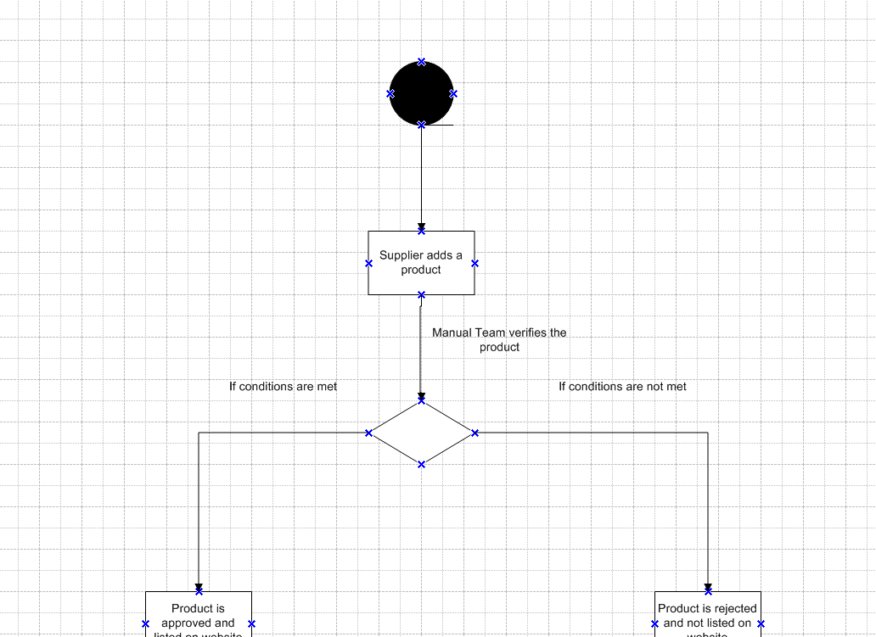

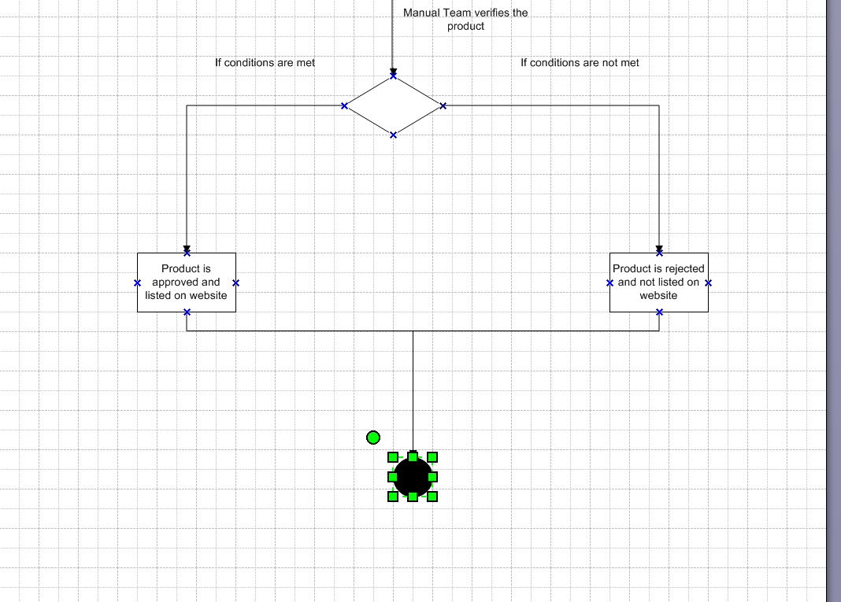

**Proposed Recommendations (TO-BE)**

To overcome the inefficiencies of the current system, the proposed solution focuses on automation, process optimization, and seamless integration.

Key Recommendations

**Automated Supplier Onboarding:** Implement an online registration and verification system to streamline supplier authentication.

**Structured Product Listing Process:** Introduce a guided submission form with built-in validations to ensure data accuracy.

**Automated Compliance Checks:** Develop a rule-based engine to verify pricing, stock availability, and regulatory adherence before approval.

**Approval Workflow Optimization:** Enable auto-approval for compliant listings while flagging exceptions for manual review.

**Real-Time Tracking & Notifications:** Provide suppliers with dashboards and automated alerts on approval status.

**System Integration:** Seamlessly connect with inventory management and payment gateways for real-time updates.

**Audit & Reporting Mechanism:** Implement automated logging of all transactions and approvals for compliance tracking.

**Business Requirements**

**Functional Requirements**

Supplier Registration & Authentication  
Product Listing Submission & Validation  
Automated Compliance Checks (Pricing, Stock, Regulations)  
Approval Workflow with Auto-Approval & Manual Review  
Real-Time Tracking & Notifications for Suppliers  
Integration with Inventory Management & Payment Gateways  
Audit Logging & Compliance Reporting  
User Role Management & Access Control

**Non-Functional Requirements**

System Performance & Scalability  
High Availability & Minimal Downtime  
Data Security & Compliance with Industry Standards  
User-Friendly Interface & Accessibility  
API Integration for Seamless Data Flow  
Error Handling & Exception Management  
Regular System Backups & Disaster Recovery Plan  
Responsive Customer Support & Training Resources

**Traceability Matrix**

|  |  |  |  |  |  |  |  |  |
| --- | --- | --- | --- | --- | --- | --- | --- | --- |
| Req. ID | Req. Name | Req. Description | Design | D1 | T1 | D2 | T2 | UAT |
| FR001 | User Authentication & Role-Based Access | |  | | --- | | Suppliers must log in securely and have role-based permissions to manage products. |  |  | | --- | |  | | Yes | Pending | No | Pending | No | No |
| FR002 | Product Upload & Validation | Suppliers should upload product details like images, descriptions, pricing, and stock availability. | Yes | Yes | Pending | No | No | No |
| FR003 | Automated Compliance Check | System verifies product compliance with government regulations, pricing limits, and stock requirements before approval. | Yes | Pending | No | No | No | No |
| FR004 | Approval Workflow for Product Listings | Products must pass through an automated/manual approval process based on predefined conditions. | Yes | Yes | Pending | No | No | No |
| FR005 | Real-Time Status Tracking | Suppliers can track product approval status (Pending, Approved, Rejected) and receive notifications. | Yes | Pending | No | No | No | No |
| FR006 | Admin Dashboard for Monitoring | Admins can review product submissions, override approvals, and monitor compliance violations. | Yes | Yes | Pending | No | No | No |
| FR007 | |  | | --- | | Audit Log & Reporting |  |  | | --- | |  | | |  | | --- | | System maintains logs of all product submissions, approvals, and modifications for compliance tracking. |  |  | | --- | |  | | Yes | Pending | No | No | No | No |
| FR008 | Integration with Payment & Inventory Systems | System syncs with inventory databases and integrates with payment systems for price compliance. | Yes | Yes | Pending | No | No | No |

**Appendices**

**List of Acronyms**

BA – Business Analyst

UAT – User Acceptance Testing

ROI – Return on Investment

RACI – Responsible, Accountable, Consulted, Informed

ILS – Integrated Logistics Support

API – Application Programming Interface

FR – Functional Requirement

NFR – Non-Functional Requirement

ERP – Enterprise Resource Planning

RFP – Request for Proposal

TBD – To Be Determined

TCO – Total Cost of Ownership

UI – User Interface

UX – User Experience

SLA – Service Level Agreement

KPIs – Key Performance Indicators

GDPR – General Data Protection Regulation

QA – Quality Assurance

**Glossary of Terms**

**Business Analyst (BA):** A professional responsible for gathering requirements, analyzing business needs, and ensuring solutions meet organizational goals.

**User Acceptance Testing (UAT):** The final phase of testing where end-users validate if the system meets business requirements.

**Return on Investment (ROI):** A financial metric used to evaluate the profitability of an investment.

**Responsible, Accountable, Consulted, Informed (RACI):** A framework for defining roles and responsibilities in a project.

**Integrated Logistics Support (ILS):** A management approach that ensures all aspects of a system's lifecycle are integrated efficiently.

**Application Programming Interface (API):** A set of protocols that allow different software applications to communicate.

**Functional Requirement (FR):** A specific functionality that a system must perform to meet business needs.

**Non-Functional Requirement (NFR):** A requirement that defines the system's quality attributes such as performance, security, and usability.

**Enterprise Resource Planning (ERP):** A software system that integrates core business processes like finance, HR, and supply chain management.

**Request for Proposal (RFP):** A document that outlines project requirements and invites vendors to submit proposals.

**Total Cost of Ownership (TCO):** The overall cost of implementing and maintaining a system over its lifecycle.

**User Interface (UI):** The visual and interactive elements of a software application that users interact with.

**User Experience (UX):** The overall experience of a user when interacting with a system, focusing on ease of use and satisfaction.

**Service Level Agreement (SLA):** A contract between a service provider and a client that defines service expectations and responsibilities.

**Key Performance Indicators (KPIs):** Measurable values used to evaluate the success of a business objective.

**General Data Protection Regulation (GDPR):** A regulatory framework for data protection and privacy in the European Union.

**Quality Assurance (QA):** A process to ensure that a product or service meets defined quality standards before deployment.

**Related Documents**

Business Requirements Document (BRD)

Functional Requirements Specification (FRS)

Non-Functional Requirements Document (NFRD)

Stakeholder Analysis Document

Requirement Traceability Matrix (RTM)

Process Flow Diagrams

Risk Management Plan

Change Request Document (CRD)

User Acceptance Testing (UAT) Plan

Project Implementation Plan