**CAPSTONE PROJECT 1 PART 3**

**Question 1** – Functional Requirements - 155 Marks

**Identify minimum 20 functional requirements**   
 **Functional Requirements (FRs)**: Define **what** the system should do. They describe features, actions, or operations that the system must perform.

**Functional Requirements:**

|  |  |  |  |
| --- | --- | --- | --- |
| Req ID | Req Name | Req Description | Priority |
| FR0001 | Farmer Registration | Farmers should be able to register with the application. | 8 |
| FR0002 | Farmer Login | Farmers should be able to log in using their email ID and password. | 9 |
| FR0003 | Manufacturer Registration | Manufacturers should be able to register with the application. | 8 |
| FR0004 | Manufacturer Login | Manufacturers should be able to log in using their email ID and password. | 9 |
| FR0005 | Product Catalog Display | Farmers should be able to view a categorized product catalog (fertilizers, seeds, pesticides). | 8 |
| FR0006 | Search Products | Farmers should be able to search for products by name, category, or keywords. | 9 |
| FR0007 | Upload Products | Manufacturers should be able to upload product details, including images and pMANGOs. | 8 |
| FR0008 | Add to Cart | Farmers should be able to add products to their cart for purchase. | 9 |
| FR0009 | Buy-Later List | Farmers should be able to add products to a "buy-later" list for future reference. | 7 |
| FR0010 | Payment Gateway | Farmers should be able to pay using COD, UPI, and Credit/Debit Card options. | 10 |
| FR0011 | Order Placement | Farmers should be able to place orders for selected products. | 10 |
| FR0012 | Order Confirmation | Farmers should receive an order confirmation email after placing an order. | 8 |
| FR0013 | Delivery Tracking | Farmers should be able to track the status of their orders in real time. | 9 |
| FR0014 | Inventory Management | The system should manage and update product inventory automatically. | 8 |
| FR0015 | Multi-Language Support | Farmers should be able to choose their preferred language for using the platform. | 6 |
| FR0016 | Product Reviews | Farmers should be able to add reviews and ratings for purchased products. | 6 |
| FR0017 | Notification System | Farmers should receive notifications for updates on their orders or delivery status. | 7 |
| FR0018 | Admin Management | Admin should be able to monitor user accounts and product listings. | 7 |
| FR0019 | Report Generation | The system should generate sales reports for manufacturers. | 6 |
| FR0020 | Customer Support | Farmers and Manufacturers should be able to raise tickets for support issues. | 7 |

**Non-Functional Requirements (NFRs)**: Define **how** the system should work. They describe performance, security, scalability, and usability aspects.  
 **Non-Functional Requirements:**

|  |  |  |  |
| --- | --- | --- | --- |
| Req ID | Req Name | Req Description | Priority |
| NFR0101 | Page Loading Time | Each page should load within 2 seconds for optimal user experience. | 9 |
| NFR0102 | WCAG Compliance | The system must meet Web Content Accessibility Guidelines (WCAG 2.1). | 8 |
| NFR0103 | System Uptime | The system should ensure 99.9% uptime to support continuous operations. | 9 |
| NFR0104 | Scalability | The application should handle up to 10,000 concurrent users without performance degradation. | 8 |
| NFR0105 | Data Security | All user data, including payment information, should be encrypted using 256-bit encryption. | 10 |
| NFR0106 | Mobile Responsiveness | The application must be fully responsive and accessible on all screen sizes (mobile, tablet, desktop). | 9 |
| NFR0107 | Performance | The system should handle 500 transactions per second during peak load. | 8 |
| NFR0108 | Localization | The application should support localization for at least 3 regional languages. | 7 |
| NFR0109 | Browser Compatibility | The application must support the latest versions of Chrome, Firefox, Edge, and Safari. | 8 |
| NFR0110 | Backup and Recovery | Data backups should occur daily, and recovery time in case of system failure should be under 2 hours. | 9 |

**Question 2**–Minimum 5 page designs - **15 Marks**

**Make wireframe and prototypes**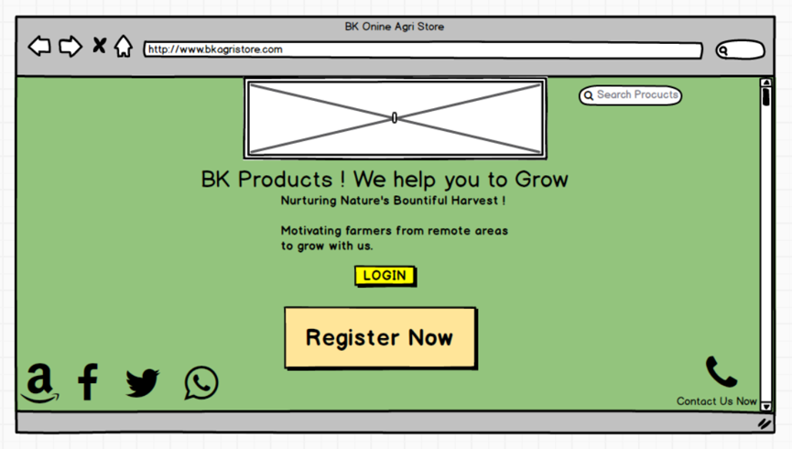  
  
  
  
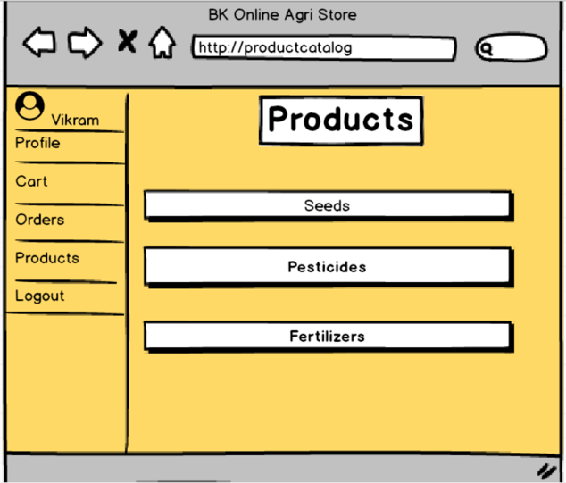  
  
  
  
  
  
  
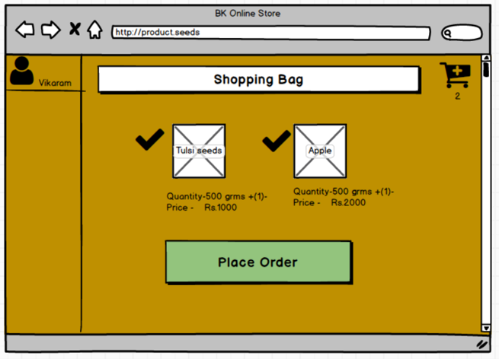  
  
  
  
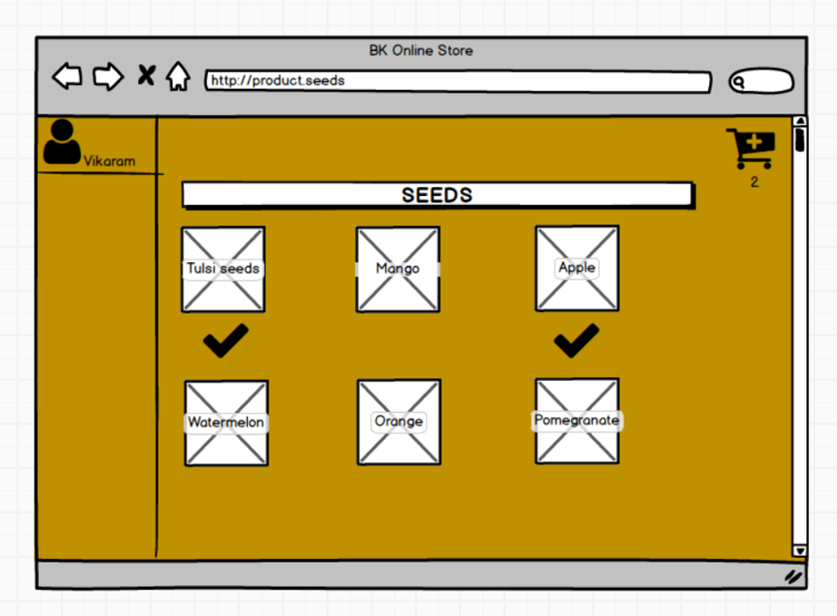  
  
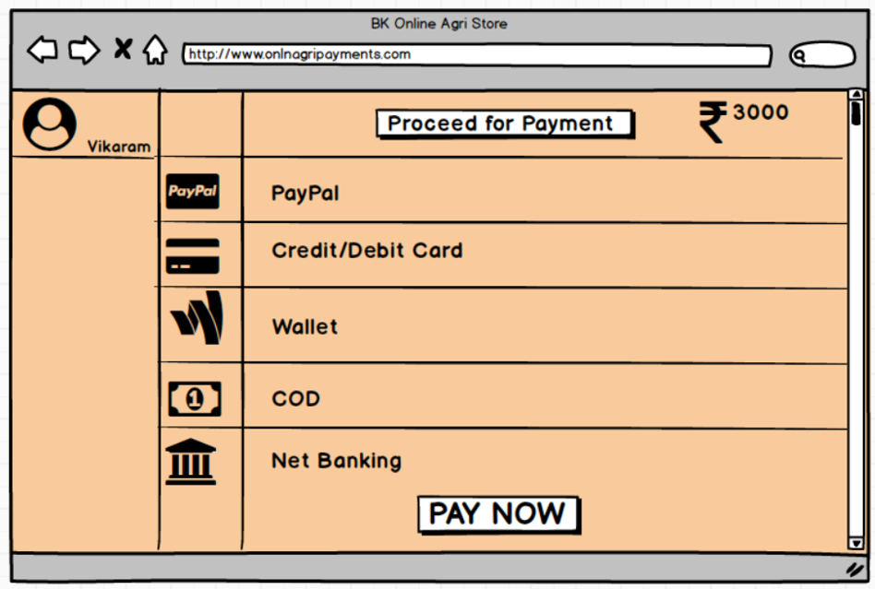  
  
  
  
**Question 3 – Tools (Visio, Balsamiq) - 15 Marks**

**Make a note of the Tools, which you are using for above concepts**Microsoft Visio is a powerful diagramming and vector graphics tool. It helps create detailed flowcharts, network diagrams, organizational charts, and more. Its intuitive interface and wide range of templates make it ideal for visualizing complex processes, business workflows, and systems. It's extensively used in business and IT projects.

Balsamiq is a user-friendly wireframing tool designed for creating low-fidelity mockups and prototypes of user interfaces. It allows designers to sketch out website or app layouts quickly with pre-built components, helping teams to communicate ideas and gather feedback early in the design process. Its simplicity aids in fast iteration.

Axure is an advanced prototyping tool that allows users to create high-fidelity, interactive wireframes for web and mobile applications. It supports dynamic content, conditional logic, and user interactions, enabling designers to build functional prototypes. Axure is often used by UX/UI designers for detailed design mockups and user testing. **Question 4 –** RTM **- 6 Marks**  
**A business analyst’s key responsibilities are to keep track of the requirements and make sure that no requirement is missed. Mr. Henry and peter have approached you regarding the current status of the project. How will you tackle this situation?** **Prepare RTM**

It is a document to track the requirements throughout the project lifecycle, ensuring that they are met and that no requirements are overlooked.  
  
Here’s the **RTM in proper tabular format** for better readability:

| **Req ID** | **Req Name** | **Req Description** | **Design** | **Code** | **Unit Testing (UT)** | **CI (Component Testing)** | **ST (System Testing)** | **SIT (System Integration Testing)** | **UAT (User Acceptance Testing)** |
| --- | --- | --- | --- | --- | --- | --- | --- | --- | --- |
| FR001 | User Registration | User should register themselves | Complete | Complete | Complete | Complete | Complete | Complete | Incomplete |
| FR002 | Search Product | User should be able to search products | Complete | Complete | Complete | Complete | Incomplete | Incomplete | Incomplete |
| FR003 | Request Product Details | User should be able to request details of products | Complete | Complete | Complete | Complete | Incomplete | Incomplete | Incomplete |
| FR004 | Add Products to Cart | User should be able to add products to the cart | Complete | Complete | Complete | Complete | Incomplete | Incomplete | Complete |
| FR005 | Buy Products | User should be able to buy the products | Complete | Complete | Complete | Complete | Incomplete | Incomplete | Incomplete |
| FR006 | Payment Gateway Integration | Support UPI, COD, and Credit/Debit payments | Complete | Complete | Complete | Complete | Incomplete | Incomplete | Incomplete |
| FR007 | Order Tracking | User should track their order status and location | Complete | Complete | Complete | Complete | Incomplete | Incomplete | Incomplete |
| FR008 | Manage Manufacturers' Products | Manufacturers should upload/display products | Complete | Complete | Complete | Complete | Complete | Complete | Incomplete |
| FR009 | Notification/Email Updates | Send email updates for order status | Complete | Complete | Complete | Complete | Incomplete | Incomplete | Incomplete |
| FR010 | User Profile Management | Farmers should manage their profiles and details | Complete | Complete | Complete | Complete | Incomplete | Incomplete | Incomplete |

**Question 5 –** 10 Test Case Documents - **10 Marks  
Prepare 10 Test Case Documents**A test case document is a detailed outline used by testers to ensure that a software application or system is working as expected.  
**Test case 1**

|  |  |  |  |  |  |
| --- | --- | --- | --- | --- | --- |
| **Test Case ID** | TC001 | **Test Case Name** | Search for Fertilizers | | |
| **Project ID** | PRJ001 | **Project Name** | Online Agriculture Store | | |
| **PMID** | PMID001 | **PM Name** | Mr. Vandanam | | |
| **Test Strategy ID** | TS001 | **Tester ID** | T001 | | |
| **Test Plan ID** | TP001 | **Tester Name** | Mr. Jason | | |
| **Test Schedule ID** | SCH001 | **Date of Test** | 2023-10-15 | | |
| **Scenario** | Search for "**Organic Fertilizer**" | | | | |
| **Link to the page** | Product Catalog Page | | | | |
| **Input data** | **Set 1:** Organic Fertilizer | **Set 2** Urea | **Set 3** NPK | **Set 4** Compost | **Set 5** Manure |
| **Expected Behavior** | Display 15 products matching "Organic Fertilizer" | Display15 products matching " Urea" | Display 15 products matching "NPK" | Display 15 products matching "COMPOST" | Display 15 products matching "MANURE" |
| **Actual Behavior** | Displayed 12 products instead of 15 | Displayed 12 products instead of 15 | Displayed 12 products instead of 15 | Displayed 12 products instead of 15 | Displayed 12 products instead of 15 |
| **Comments** | The result didn’t match the expected count. Check product filter. | The result didn’t match the expected count. Check product filter | The result didn’t match the expected count. Check product filter | The result didn’t match the expected count. Check product filter | The result didn’t match the expected count. Check product filter |
| **Result (Pass/Fail)** | Fail | Fail | Fail | Fail | Fail |

|  |  |  |  |  |  |
| --- | --- | --- | --- | --- | --- |
| **Test Case ID** | TC002 | **Test Case Name** | Search for SEEDS | | |
| **Project ID** | PRJ001 | **Project Name** | Online Agriculture Store | | |
| **PMID** | PMID001 | **PM Name** | Mr. Vandanam | | |
| **Test Strategy ID** | TS001 | **Tester ID** | T002 | | |
| **Test Plan ID** | TP002 | **Tester Name** | Mr. Jason | | |
| **Test Schedule ID** | SCH002 | **Date of Test** | 2023-10-15 | | |
| **Scenario** | Search for " **Seeds**" | | | | |
| **Link to the page** | Product Catalog Page | | | | |
| **Input data** | **Set 1:** TULSI Seeds | **Set 2** MANGO Seeds | **Set 3** Apple Seeds | **Set 4** Watermelon Seeds | **Set 5** ORANGE Seeds |
| **Expected Behavior** | Display 15 products matching "TULSI Seeds" | Display 15 products matching " MANGO Seeds " | Display 15 products matching " Apple Seeds " | Display 15 products matching " Watermelon Seeds " | Display 15 products matching " ORANGE Seeds" |
| **Actual Behavior** | Displayed 12 products instead of 15 | Displayed 12 products instead of 15 | Displayed 12 products instead of 15 | Displayed 12 products instead of 15 | Displayed 12 products instead of 15 |
| **Comments** | The search function worked as expected. | The search function worked as expected. | The search function worked as expected. | The search function worked as expected. | The search function worked as expected. |
| **Result (Pass/Fail)** | Pass | Pass | Pass | Pass | Pass |

TEST 3

|  |  |  |  |  |  |
| --- | --- | --- | --- | --- | --- |
| **Test Case ID** | TC003 | **Test Case Name** | Search for Pesticides | | |
| **Project ID** | PRJ001 | **Project Name** | Online Agriculture Store | | |
| **PMID** | PMID001 | **PM Name** | Mr. Vandanam | | |
| **Test Strategy ID** | TS001 | **Tester ID** | T003 | | |
| **Test Plan ID** | TP001 | **Tester Name** | Mr. Jason | | |
| **Test Schedule ID** | SCH001 | **Date of Test** | 2023-10-15 | | |
| **Scenario** | Search for " **Pesticides** " | | | | |
| **Link to the page** | Product Catalog Page | | | | |
| **Input data** | **Set 1: Pesticides** | **Set 2** Insecticide | **Set 3** Fungicide | **Set 4**Weedicide | **Set 5** Rodenticide |
| **Expected Behavior** | Display 15 products matching "Pesticides " | Display 15products matching "Insecticide "" | Display 15 products matching " Fungicide " | Display 15 products matching " Weedicide " | Display 15 products matching " Rodenticide " |
| **Actual Behavior** | Displayed 14 products, one missing | Displayed 14 products, one missing | Displayed 14 products, one missing | Displayed 14 products, one missing | Displayed 14 products, one missing |
| **Comments** | Possible issue with data fetching. Needs investigation. | Possible issue with data fetching. Needs investigation. | Possible issue with data fetching. Needs investigation. | Possible issue with data fetching. Needs investigation. | Possible issue with data fetching. Needs investigation. |
| **Result (Pass/Fail)** | FAIL | FAIL | FAIL | FAIL | FAIL |

**TEST 4**

|  |  |  |  |  |  |
| --- | --- | --- | --- | --- | --- |
| **Test Case ID** | TC004 | **Test Case Name** | Add to Cart | | |
| PRJ001 | PRJ001 | **Project Name** | Online Agriculture Store | | |
| **PMID** | PMID001 | **PM Name** | Mr. Vandanam | | |
| **Test Strategy ID** | TS001 | **Tester ID** | T002 | | |
| **Test Plan ID** | TP001 | **Tester Name** | Ms. Alekya | | |
| **Test Schedule ID** | SCH002 | **Date of Test** | 2023-10-17 | | |
| **Scenario** | Add "Organic Fertilizer" to Cart | | | | |
| **Link to the page** | Product Details Page | | | | |
| **Input data** | **Set 1:** Organic Fertilizer | **Set 2** Urea | **Set 3** NPK | **Set 4** Compost | **Set 5** Manure |
| **Expected Behavior** | Product added to cart successfully | Product added to cart successfully | Product added to cart successfully | Product added to cart successfully | Product added to cart successfully |
| **Actual Behavior** | Product added successfully to cart | Product added successfully to cart | Product added successfully to cart | Product added successfully to cart | Product added successfully to cart |
| **Comments** | No issues encountered during the test. | No issues encountered during the test. | No issues encountered during the test. | No issues encountered during the test. | No issues encountered during the test. |
| **Result (Pass/Fail)** | PASS | PASS | PASS | PASS | PASS |

**TEST 5**

|  |  |  |  |  |  |
| --- | --- | --- | --- | --- | --- |
| **Test Case ID** | TC005 | **Test Case Name** | Checkout Process | | |
| **Project ID** | PRJ001 | **Project Name** | Online Agriculture Store | | |
| **PMID** | PMID001 | **PM Name** | Mr. Vandanam | | |
| **Test Strategy ID** | TS001 | **Tester ID** | T002 | | |
| **Test Plan ID** | TP001 | **Tester Name** | Ms. Alekya | | |
| **Test Schedule ID** | SCH002 | **Date of Test** | 2023-10-17 | | |
| **Scenario** | Proceed to Checkout | | | | |
| **Link to the page** | Checkout Page | | | | |
| **Input data** | **Set 1:** Click “Proceed to Checkout” | **Set 2** Click “Proceed to Checkout” | **Set 3** Click “Proceed to Checkout” | **Set 4** Click “Proceed to Checkout” | **Set 5** Click “Proceed to Checkout” |
| **Expected Behavior** | Display order summary and payment options (COD,paypal,wallet,Credit/Debit, UPI) | Display order summary and payment options (COD,paypal,wallet,Credit/Debit, UPI) | Display order summary and payment options (COD,paypal,wallet,Credit/Debit, UPI) | Display order summary and payment options (COD,paypal,wallet,Credit/Debit, UPI) | Display order summary and payment options (COD,paypal,wallet,Credit/Debit, UPI) |
| **Actual Behavior** | Order summary and payment options displayed correctly | Order summary and payment options displayed correctly | Order summary and payment options displayed correctly | Order summary and payment options displayed correctly | Order summary and payment options displayed correctly |
| **Comments** | All payment methods were visible and functional. | All payment methods were visible and functional. | All payment methods were visible and functional. | All payment methods were visible and functional. | All payment methods were visible and functional. |
| **Result (Pass/Fail)** | PASS | PASS | PASS | PASS | PASS |

**TEST 6**

|  |  |  |  |  |  |
| --- | --- | --- | --- | --- | --- |
| **Test Case ID** | TC006 | **Test Case Name** | Payment Gateway | | |
| **Project ID** | PRJ001 | **Project Name** | Online Agriculture Store | | |
| **PMID** | PMID001 | **PM Name** | Mr. Vandanam | | |
| **Test Strategy ID** | TS006 | **Tester ID** | T002 | | |
| **Test Plan ID** | TP001 | **Tester Name** | Ms. Alekya | | |
| **Test Schedule ID** | SCH003 | **Date of Test** | 2023-10-18 | | |
| **Scenario** | Select Payment Method (UPI) | | | | |
| **Link to the page** | Checkout Page | | | | |
| **Input data** | **Set 1:** UPI | **Set 2** Credit/Debit Card | **Set 3** COD |  |  |
| **Expected Behavior** | Payment processed successfully, order confirmation displayed | Payment processed successfully, order confirmation displayed | Payment processed successfully, order confirmation displayed |  |  |
| **Actual Behavior** | Payment processed with UPI, order confirmation displayed | Payment processed with UPI, order confirmation displayed | Payment processed with UPI, order confirmation displayed |  |  |
| **Comments** | The UPI method worked smoothly without issues. | The UPI method worked smoothly without issues. | The UPI method worked smoothly without issues. |  |  |
| **Result (Pass/Fail)** | PASS | PASS | PASS |  |  |

**TEST 7**

|  |  |  |  |  |  |
| --- | --- | --- | --- | --- | --- |
| **Test Case ID** | TC007 | **Test Case Name** | Delivery Tracking | | |
| **Project ID** | PRJ001 | **Project Name** | Online Agriculture Store | | |
| **PMID** | PMID001 | **PM Name** | Mr. Vandanam | | |
| **Test Strategy ID** | TS007 | **Tester ID** | T003 | | |
| **Test Plan ID** | TP001 | **Tester Name** | Mr. Jason | | |
| **Test Schedule ID** | SCH003 | **Date of Test** | 2023-10-18 | | |
| **Scenario** | Track Order Status | | | | |
| **Link to the page** | Delivery Tracking Page | | | | |
| **Input data** | **Set 1:**   |  | | --- | | Order ID: 12345 |  |  | | --- | |  | |  |  |  |  |
| **Expected Behavior** | Display real-time delivery status (e.g., "Out for Delivery") |  |  |  |  |
| **Actual Behavior** | Order status updated as "Out for Delivery" |  |  |  |  |
| **Comments** | Real-time tracking displayed as expected. |  |  |  |  |
| **Result (Pass/Fail)** | PASS |  |  |  |  |

**TEST 8**

|  |  |  |  |  |  |
| --- | --- | --- | --- | --- | --- |
| **Test Case ID** | TC008 | **Test Case Name** | Manufacturer Upload | | |
| **Project ID** | PRJ001 | **Project Name** | Online Agriculture Store | | |
| **PMID** | PMID001 | **PM Name** | Mr. Vandanam | | |
| **Test Strategy ID** | TS001 | **Tester ID** | T004 | | |
| **Test Plan ID** | TP001 | **Tester Name** | Ms. Alekya | | |
| **Test Schedule ID** | SCH004 | **Date of Test** | 2023-10-19 | | |
| **Scenario** | Upload New Product | | | | |
| **Link to the page** | Manufacturer Dashboard | | | | |
| **Input data** | **Set 1:** Upload Organic Fertilizer” | **Set 2** Upload SEEDS” | **Set 3** Upload Pesticides” |  |  |
| **Expected Behavior** | Product uploaded successfully and visible in the catalog | Product uploaded successfully and visible in the catalog | Product uploaded successfully and visible in the catalog |  |  |
| **Actual Behavior** | Product uploaded and appeared correctly in the catalog | Product uploaded and appeared correctly in the catalog | Product uploaded and appeared correctly in the catalog |  |  |
| **Comments** | Successful upload, no issues. | Successful upload, no issues. | Successful upload, no issues. |  |  |
| **Result (Pass/Fail)** | PASS | PASS | PASS |  |  |

**TEST 9**

|  |  |  |  |  |  |
| --- | --- | --- | --- | --- | --- |
| **Test Case ID** | TC009 | **Test Case Name** | User Registration | | |
| **Project ID** | PRJ001 | **Project Name** | Online Agriculture Store | | |
| **PMID** | PMID001 | **PM Name** | Mr. Vandanam | | |
| **Test Strategy ID** | TS005 | **Tester ID** | T004 | | |
| **Test Plan ID** | TP001 | **Tester Name** | Ms. Alekya | | |
| **Test Schedule ID** | SCH005 | **Date of Test** | 2023-10-19 | | |
| **Scenario** | Register New Farmer | | | | |
| **Link to the page** | Registration Page | | | | |
| **Input data** Email, Password | **Set 1:** mail: farmer@test.com | **Set 2** Password: 123456 |  |  |  |
| **Expected Behavior** | Account created successfully, confirmation email sent | Account created successfully, confirmation email sent |  |  |  |
| **Actual Behavior** | Account created and confirmation email sent | Account created and confirmation email sent |  |  |  |
| **Comments** | Registration process was smooth. | Successful upload, no issues. |  |  |  |
| **Result (Pass/Fail)** | PASS | PASS |  |  |  |

**TEST 10**

|  |  |  |  |  |  |
| --- | --- | --- | --- | --- | --- |
| **Test Case ID** | TC010 | **Test Case Name** | Feedback Submission | | |
| **Project ID** | PRJ001 | **Project Name** | Online Agriculture Store | | |
| **PMID** | PMID001 | **PM Name** | Mr. Vandanam | | |
| **Test Strategy ID** | TS005 | **Tester ID** | T004 | | |
| **Test Plan ID** | TP001 | **Tester Name** | Ms. JASON | | |
| **Test Schedule ID** | SCH006 | **Date of Test** | 2023-10-16 | | |
| **Scenario** | Submit Feedback for Product | | | | |
| **Link to the page** | Product Details Page | | | | |
| **Input data** Email, Password | **Set 1**Rating: 5 Stars | **Set 2** Comment: "Great product!" |  |  |  |
| **Expected Behavior** | Feedback submitted successfully, visible in product reviews | Feedback submitted successfully, visible in product reviews |  |  |  |
| **Actual Behavior** | Feedback was submitted and visible in the reviews | Feedback was submitted and visible in the reviews |  |  |  |
| **Comments** | Feedback functionality worked correctly. | Feedback functionality worked correctly. |  |  |  |
| **Result (Pass/Fail)** | PASS | PASS |  |  |  |

**Question 6 –** DB Design **– 8 Marks  
After the requirements are thoroughly explained to the entire project team by business analyst, the Database architects have decided to do the database design and also to represent the in-flow and out-flow of data. Draw database schema and ER diagram**DB Schema is a blueprint that outlines the structure of a database, including its tables, fields, relationships, constrains and other characteristics.

DB Schema is a combination of tables and records  
  
Farmers  
  
Supplier  
  
Transaction   
  
Login  
  
We can arrange above attribute in tabular form

|  |  |
| --- | --- |
| Farmers | SUPPLIER |
| Need farmer’s details like name, email id, mob no. | Product details |
|  | Product pMANGO |
| Billing | Login |
| Payment options | Login page for farmers and Supplier |
| Payment confirmation | Login through mail id or Mob. No. |
| Payment slip | Open the home page which has a product gallery |

**ER diagram**

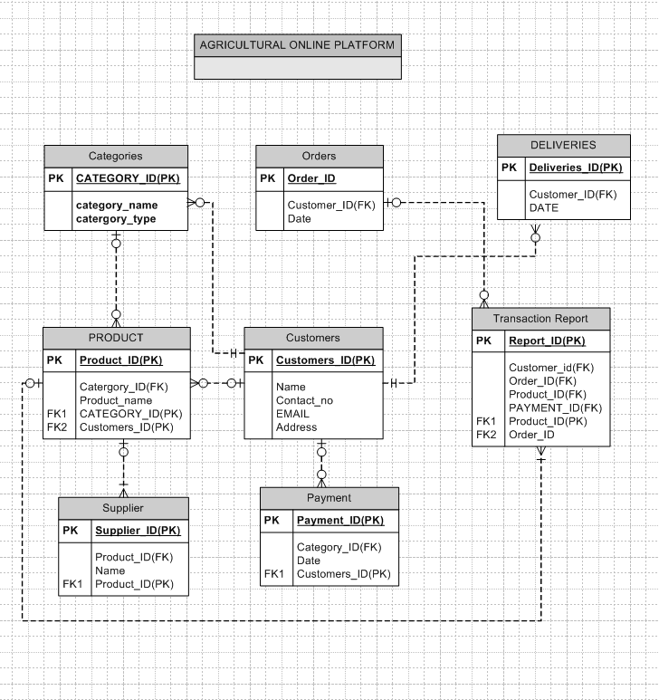

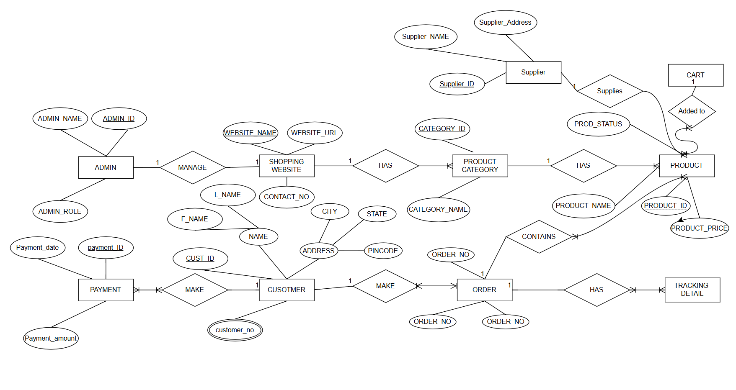  
  
  
 **Question 7 –** Data Flow Diagram **- 3 Marks**

**What is a data flow diagram? Draw a data flow diagram to represent the in-flow and out-flow of data when a Farmer is placing an order for the product**A Data Flow Diagram (DFD) illustrates how information moves within a system using symbols like rectangles, circles, and arrows. It shows data inputs, outputs, storage points, and paths between them. DFDs can be simple overviews or detailed, multi-level diagrams. They help visualize and analyze systems, making them useful for both technical and non-technical audiences. However, they are less effective for visualizing interactive or real-time systems. 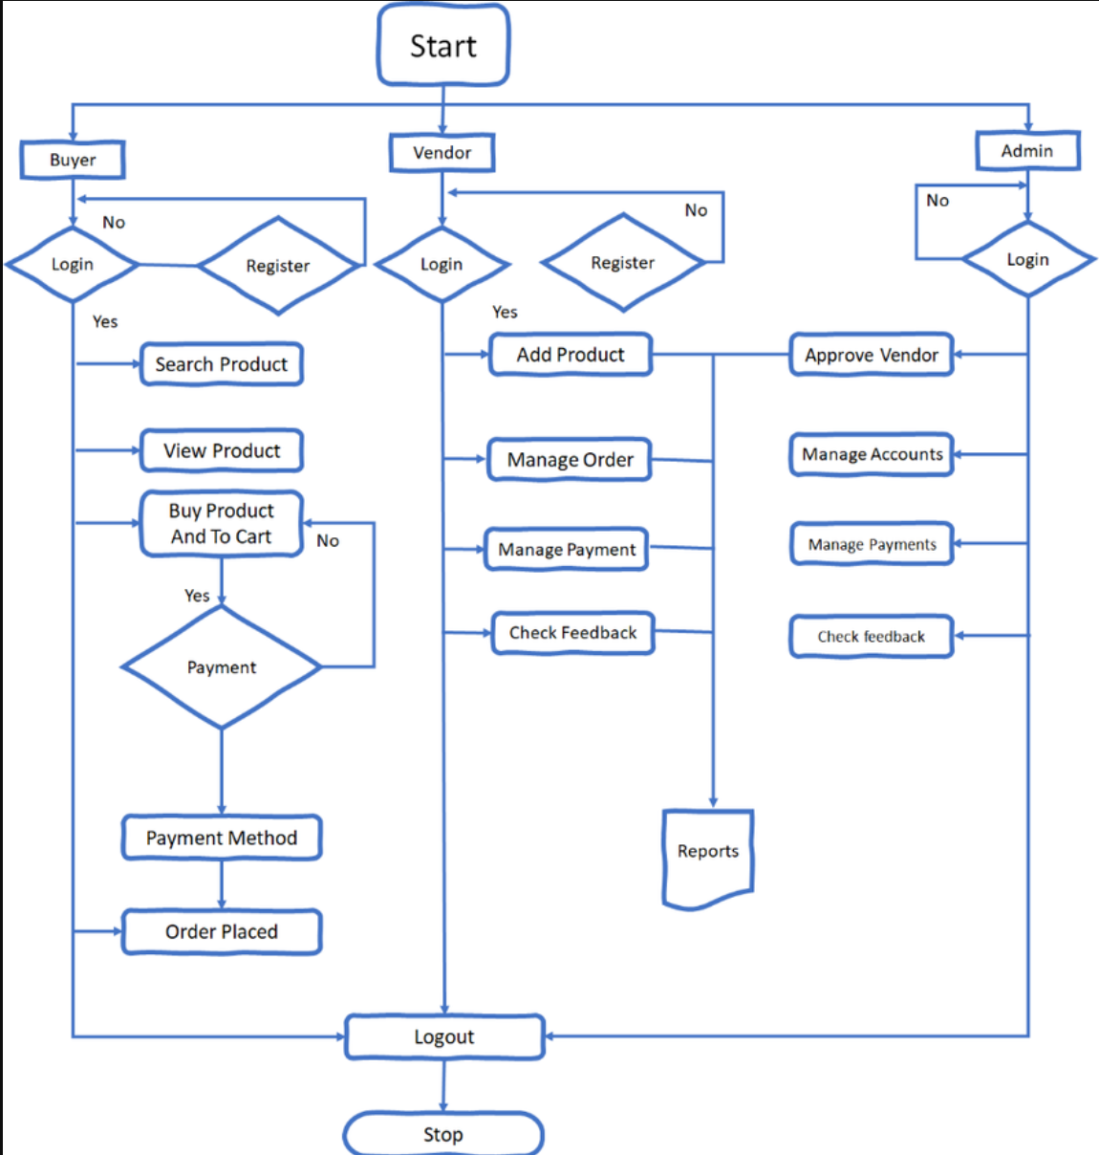  
**Question 8 – Change Request - 10 Marks**

**Due to change in the Government Taxation structure . we should change the Tax structure How do you handle change requests in a project**

A change request is a formal proposal to alter a system, product, or project,

1. Understand the scope of change request and document the change request

2. Do the impact analysis-projeet scope, schedule, budget, resources, and risks

3. Prioritize change requests based on its urgency, importance, impact on project

4. Seek approval from the project sponsor for the change request

5. Communicate the change request and its potential impacts to all relevant stakeholders, including the project team.

**Question 9 – Change Request Vs an Enhancement - 5 Marks  
  
As the project is in process, Ben and Kevin have contacted you. The reason is to inform you that they want the Farmers to sell their crop yields through this application i.e. Farmers should be able to add their crop yields or products and display to general public and should be able to sell them. They also want to introduce Auction system for their Crop yields. As a BA, what will be your response? Is this a change request or an enhancement???**As a Business Analyst, to figure out if a request is a change request or an enhancement, we look at a few things:

1. **Understand the Request:** First, we need to figure out exactly what the request is. Is it asking to change something that already exists, or is it adding something new?
2. **Analyze the Impact:** Next, we check how this request will affect the project. Will it change the scope, timeline, or budget?
3. **Evaluate the Priority:** We also need to know how important this request is. Is it something critical that needs to happen now, or can it wait?
4. **Determine the Type:** After considering the above, we can decide whether it's a change request (modifying an existing feature) or an enhancement (adding something new).
5. In this case, since the request introduces a new feature after a few months with no changes to what was originally planned, this is a **change request** and not an enhancement. An enhancement would typically be about improving something that already exists, like making a feature more user-friendly.  
     
     
     
     
     
     
    **Question 10 – Estimations - 6 Marks   
   Come up with estimations – How many Manhours required**To estimate the total man-hours required for the project, we calculate the effort required for each role based on the allotted duration. Assuming a **standard work schedule of 40 hours per week**, each person works **160 hours per month** and **80 hours per 15 days**.
6. **Business Analyst (BA)**
   * **First Duration:** 3 months → 3months×160 hours/month=480hours
   * **Second Duration:** 2 months → 2months×160hours/month=320hours
   * **Total BA Hours:** **800 hours**
7. **Project Manager (PM)**
   * **First Duration:** 1 month → 1×160=1601 \times 160 = 1601×160=160 hours
   * **Second Duration:** 15 days → 120 hours
   * **Total PM Hours:** **240 hours**
8. **Senior Developer & Java Team**
   * **Total Developers:** 5 (1 Senior Developer + 4 Java Developers)
   * **Duration:** 5 months
   * **Total Hours:** 5×5×160=4,0005 \times 5 \times 160 = 4,0005×5×160=**4,000 hours**
9. **Java Developers (Separate 15-day task)**
   * **Total Java Developers:** 4
   * **Duration:** 15 days
   * **Total Hours:** 4×80=3204 \times 80 = 3204×80=**320 hours**
10. **Testers**
    * **Total Testers:** 2
    * **Duration:** 4 months
    * **Total Hours:** 2×4×160=1,2802 \times 4 \times 160 = 1,2802×4×160=**320 hours**
    * Final Total Man-Hours Calculation= **800 hours+240 hours+4,000 hours+320 hours+320 hours=6640**

**Justication**

1. **Project Complexity:** Given the effort distribution, this is a **large-scale project** as it exceeds **1,500 man-hours**.
2. **Realistic Estimation:** The calculation considers the **actual team size, assigned tasks, and duration**, ensuring accuracy.
3. **Sufficient Resources:** The available workforce can complete the project within the **18-month timeline** without exceeding capacity.

**Question 11 – UAT – 6 Marks   
Project has finally completed all the stages i.e., design, development, testing etc. Now, it is the role of a business analyst to contact the client for testing of the final product and have to successfully complete it. How are you going to handle this situation? And once it is done, what will be the process to close the project?**

**Explain UAT Acceptance process**

**To address the situation, below steps can be followed:**

* **Preparation of UAT:** Ensure the product meets all requirements and is defect-free before UAT.
* **Reach Out to Client:** Contact the client to schedule UAT, providing necessary documentation.
* **Conduct UAT:** Collaborate with the client to test the product and resolve any issues.
* **Obtain Approval:** Once UAT is complete, get client approval via a UAT Project Acceptance Form.
* **Wrap Up:** Finalize the project by delivering the product and completing all tasks, securing client approval that the project is complete.  
  We can use a project completion document to summarize the project’s outcomes, deliverables, insights, and overall achievements. It’s crucial to obtain approval from the client or stakeholders, confirming their acceptance of the deliverables and acknowledging the project’s conclusion.

**WHAT IS UAT PROCESS  
Planning:** In this step, Blue Prints are made to implement UAT testing for every feature that needs to test and minimum standards for accepting the test.

**Designing:**Here the Test cases are designed to hide all the possibilities of software packages in a real world environment.

**UAT Testers:** A Testing team consists of a end users that meet the criteria for implementing testing, They should know the test cases to run and understand the functionalities**.**

**Bug Fixing: Wh**atever Bugs are found in the UAT Testing, the development team should work on them and make it software error free.

**Sign Off:** After removing all the bugs, the testing team indicates acceptance of the completion of the bugs. In this phase, all the stakeholders come to a conclusion that the software is ready to GO LIVE and sign it off. **Question 12 – Project Closure Document - 6 Marks**

**Explain Project closure document  
  
A project closure document, also known as a project closure report is a formal document that summarizes the key outcomes, lessons learned, and final details of a completed project.**

**It serves as a comprehensive record of the project's accomplishments, challenges, and overall performance, providing valuable insights for stakeholders and future projects**

**Points to be included in the Project closure, document are: Project Overview, Achievements, Lessons Learned, Quality Assurance, Resource Utilization,Risk Management, Challenges**

| **S.No** | **Points to Include** | **Details** | **Reference Link** |
| --- | --- | --- | --- |
| 1 | Did the client sign off on UAT Testing? |  |  |
|  | Date of the signoff: | 15th October 2023 | Business Scope Document |
|  | Name of the resource: | Mr. Vandanam (Project Manager) | UAT Signoff Document.docx |
| 2 | Objectives of the Project |  |  |
|  | User Friendliness | Achieved - The application is intuitive and easy to use for farmers. |  |
|  | Customer Satisfaction | ROI expected in 12 months due to increased farmer engagement. |  |
|  | More Categories | Achieved - Fertilizers, Seeds, and Pesticides are available. |  |
| 3 | Functionalities Worked On |  |  |
|  | Secure Payment Processing | Achieved - Integrated COD, Credit/Debit Card, and UPI options. |  |
|  | Product Catalog | Achieved - Farmers can browse and search for products easily. |  |
| 4 | Infrastructure |  |  |
|  | Software Installed | Achieved - Java, MySQL, and AWS for hosting. |  |
|  | Laptops Purchased | Achieved - 10 laptops for the development team. |  |
| 5 | Funding |  |  |
|  | Amount Approved | Rs. 2 Crores | Finance Breakdown.docx |
|  | Amount Used | Rs. 1.85 Crores |  |
| 6 | Overall Project Information |  |  |
|  | Escalations | 20 - Resolved within the project timeline. |  |
|  | Customer Satisfaction | High - Farmers and manufacturers have provided positive feedback. |  |
| 7 | Value to the Company |  |  |
|  | Positive/Negative | Positive - 95% - The company has gained a competitive edge in the agriculture sector. Increased farmer engagement and new projects in pipeline. |  |