**Question 1 – write Agile Manifesto**

**4 Values of Agile (as per the Agile Manifesto) \***

1. Individuals and interactions over processes and tools.

2. Working software over comprehensive documentation.

3. Customer collaboration over contract negotiation.

4. Responding to change over following a plan.

**12 Principles of Agile**

1. Customer satisfaction through early and continuous delivery of valuable software.

2. Welcome changing requirements, even late in development, for customer advantage.

3. Deliver working software frequently, from a couple of weeks to a couple of months.

4. Business people and developers must work together daily throughout the project.

5. Build projects around motivated individuals and give them the support they need.

6. Face-to-face communication is the most effective way of conveying information.

7. Working software is the primary measure of progress.

8. Agile processes promote sustainable development with a constant pace.

9. Continuous attention to technical excellence and good design enhances agility.

10. Simplicity—the art of maximizing the amount of work not done—is essential.

11. The best architectures, requirements, and designs emerge from self-organizing teams.

12. Regular reflection on how to become more effective, then adjusting accordingly.

**Question 2 – User Stories- Acceptance Criteria-BV-CP**

|  |  |  |
| --- | --- | --- |
| User Story1 | Task 1 | Priority:Highest |
| As a New Member  I want create an account  So that I can access the platform | | |
|  |
| BV : Rs 50000 | | CP : 5 |  |
| ACCEPTANCE CRITERIA  Users must enter a valid email, phone, and password.  A verification email is sent upon registration.Duplicate email registration should be blocked.  Password must meet security requirements | | |  |
|  |

|  |  |  |
| --- | --- | --- |
| User Story: 2 | Task :2 | Priority:Highest |
| As a shopper  I want save favourite items  So that I can purchase it later | | |
|  |
| BV : Rs 40000 | | CP: 4 |  |
| ACCEPTANCE CRITERIA  Users can add/remove items from the wishlist.  Wishlist persists across sessions.  Option to move items from wishlist to cart. | | |  |
|  |

|  |  |  |
| --- | --- | --- |
| User Story : 3 | Task : 3 | Priority:Highest |
| As a customer  I want review the product  So that I can help others to make informed choices | | |
|  |
| BV : Rs 60000 | | CP : 5 |  |
| ACCEPTANCE CRITERIA  Users can rate products from 1 to 5 stars.  Reviews must include at least 10 characters.  Option to edit or delete own reviews. | | |  |
|  |

|  |  |  |
| --- | --- | --- |
| User Story :4 | Task : 4 | Priority:Highest |
| As a Platform user  I want to receive order and promo alert  So that I can stay updated on important update | | |
|  |
| BV : 35000/- | | CP: 4 |  |
| ACCEPTANCE CRITERIA  Users receive notifications for order status changes.  Option to enable/disable promotional alerts.  Notifications available via email and in-app. | | |  |
|  |

|  |  |  |
| --- | --- | --- |
| User Story : 5 | Task :5 | Priority:Highest |
| As a subscriber  I want modify or cancel subscription  So that I can control recurring payment | | |
|  |
| BV : 70000/- | | CP:6 |  |
| ACCEPTANCE CRITERIA  Users can upgrade/downgrade or cancel subscriptions.  Subscription status updates in real time.  Email confirmation for change | | |  |
|  |

|  |  |  |
| --- | --- | --- |
| User Story : 6 | Task :6 | Priority:Highest |
| As a Buyer  I want Save and manage payment options  So that I can go for quick and secure checkout | | |
|  |
| BV : rs 55000 | | CP: 5 |  |
| ACCEPTANCE CRITERIA  Users can add/edit/delete payment methods.  Secure storage of payment details.  Default payment method selection. | | |  |
|  |

|  |  |  |
| --- | --- | --- |
| User Story : 7 | Task : 7 | Priority:Highest |
| As a customer  I want to store multiple delivery addresses  So that I can proceed for faster and flexible shipping | | |
|  |
| BV : 45000/- | | CP : 4 |  |
| ACCEPTANCE CRITERIA  Users can add/edit/delete multiple addresses.  Option to set a default address.  Address verification for accuracy. | | |  |
|  |

|  |  |  |
| --- | --- | --- |
| User Story : 8 | Task : 8 | Priority:Highest |
| As a user  I want to contact via chat or email  So that I can resolve my issues | | |
|  |
| BV : 60000/- | | CP : 5 |  |
| ACCEPTANCE CRITERIA  Users can submit support tickets.  Live chat available during business hours.  Email responses within 24 hours | | |  |
|  |

|  |  |  |
| --- | --- | --- |
| User Story : 9 | Task :9 | Priority:Highest |
| As a Buyer  I want to view past purchase  So that I can track spending and reorder easily | | |
|  |
| BV : 40000/- | | CP : 4 |  |
| ACCEPTANCE CRITERIA  Users can view a list of past orders.  Order details include date, amount, and status.  Option to reorder previous items. | | |  |
|  |

|  |  |  |
| --- | --- | --- |
| User Story : 10 | Task : 10 | Priority:Highest |
| As a customer  I want to request a return or refund  So that I can hassle free issue resolution | | |
|  |
| BV : 75000/- | | CP : 6 |  |
| ACCEPTANCE CRITERIA  Users can request a refund within a return window.  Refund status updates available.  Refund processed via the original payment method. | | |  |
|  |

|  |  |  |
| --- | --- | --- |
| User Story : 11 | Task :11 | Priority:Highest |
| As a admin  I want moniter user activity and sales  So that I can manage platform efficiently | | |
|  |
| BV : 90000/- | | CP : 7 |  |
| ACCEPTANCE CRITERIA  Dashboard shows real-time user activity.  Sales reports available for different time periods.  Option to manage users and orders. | | |  |
|  |

|  |  |  |
| --- | --- | --- |
| User Story : 12 | Task :12 | Priority:Highest |
| As a registered member  I want to login securely  So that I can access the account | | |
|  |
| BV : 65000/- | | CP : 4 |  |
| ACCEPTANCE CRITERIA  Error message for incorrect credentials.  Lock account after 5 failed attempts.  Password reset option available. | | |  |
|  |

|  |  |  |
| --- | --- | --- |
| User Story :13 | Task :13 | Priority:Highest |
| As a user who forgot the password  I want to reset easily  So that I can regain access | | |
|  |
| BV : 50000/- | | CP : 4 |  |
| ACCEPTANCE CRITERIA  Users request a reset via email.  Reset link expires in 15 minutes  New password must follow security rules | | |  |
|  |

|  |  |  |
| --- | --- | --- |
| User Story : 14 | Task : 14 | Priority:Highest |
| As a account holder  I want update my personal details  So that I can keep my personal details accurate | | |
|  |
| BV : 30000/- | | CP: 3 |  |
| ACCEPTANCE CRITERIA   Users can edit name, phone, and profile picture.  Email changes require re-verification.  Updates reflect immediately. | | |  |
|  |

|  |  |  |
| --- | --- | --- |
| User Story :15 | Task : 15 | Priority:Highest |
| As a security conscious user  I want to enable additional protection  So that I can safeguard the account | | |
|  |
| BV :80000/- | | CP: 6 |  |
| ACCEPTANCE CRITERIA  Option to enable 2FA via SMS or authenticator app.  Require a verification code for login.  Option to disable 2FA if needed. | | |  |
|  |

|  |  |  |
| --- | --- | --- |
| User Story : 16 | Task : 16 | Priority:Highest |
| As a logged in user  I want to access dashboard  So that I can view the account details | | |
|  |
| BV : 40000/- | | CP : 3 |  |
| ACCEPTANCE CRITERIA   Auto-redirect to dashboard after login.  Show account summary and key features.  Display notifications and messages. | | |  |
|  |

|  |  |  |
| --- | --- | --- |
| User Story : 17 | Task : 17 | Priority:Highest |
| As a browsing platform user  I want to search for product or services  So that I can find items quickly | | |
|  |
| BV : 95000/- | | CP : 6 |  |
| ACCEPTANCE CRITERIA  Search bar available on all pages.  Auto-suggestions while typing.  Relevant results displayed with filters. | | |  |
|  |

|  |  |  |
| --- | --- | --- |
| User Story : 18 | Task :18 | Priority:Highest |
| As a Buyer  I want to complete purchase  So that I can receive an order | | |
|  |
| BV : 100000/- | | CP : 7 |  |
| ACCEPTANCE CRITERIA  Secure checkout process.  Multiple payment options.  Order confirmation sent after payment. | | |  |
|  |

|  |  |  |
| --- | --- | --- |
| User Story : 19 | Task : 19 | Priority:Highest |
| As a buyer  I want to track the order  So that I can know the delivery details | | |
|  |
| BV : 85000/- | | CP : 5 |  |
| ACCEPTANCE CRITERIA   Order status updates available.  Estimated delivery date displayed.  Notifications for shipping and delivery. | | |  |
|  |

|  |  |  |
| --- | --- | --- |
| User Story : 20 | Task :20 | Priority:Highest |
| As a farmer  I want to view product details such as seeds, pesticides, and fertilizers on the online agriculture store  So that I can make informed decisions about what to buy | | |
|  |
| BV : 75000/- | | CP: 5 |  |
| ACCEPTANCE CRITERIA  Product details are displayed clearly on the product page  Information includes price, description, manufacturer, and usage instructions. | | |  |
|  |

|  |  |  |
| --- | --- | --- |
| User Story : 21 | Task : 21 | Priority:Highest |
| As a farmer   I want to search for products based on categories  So that I can quickly find the product I need | | |
|  |
| BV : 55000/- | | CP : 4 |  |
| ACCEPTANCE CRITERIA  Search functionality works across categories.  Categories are clearly defined and easy to select  Search results return relevant products. | | |  |
|  |

|  |  |  |
| --- | --- | --- |
| User Story : 22 | Task : 22 | Priority:Highest |
| As a customer   I want to create an account on the online store   So that I can save my information and track my orders | | |
|  |
| BV : 70000/- | | CP : 5 |  |
| Acceptance Criteria:  Account creation form is simple and clear.  Users can save their profile information securely. | | |  |
|  |

|  |  |  |
| --- | --- | --- |
| User Story 23 | Task 23 | Priority:Highest |
| As a seller  I want to manage my product inventory  So that I can ensure I have enough stock for orders | | |
|  |
| BV : 65000/- | | CP : 5 |  |
| ACCEPTANCE CRITERIA  Sellers can add, update, and remove products.  Inventory levels are displayed clearly. | | |  |
|  |

|  |  |  |
| --- | --- | --- |
| User Story 24 | Task 24 | Priority:Highest |
| As an admin  I want to monitor overall site performance  So that I can ensure the website is running smoothly and make improvements | | |
|  |
| BV : 80000/- | | CP: 5 |  |
| ACCEPTANCE CRITERIA  Performance metrics are displayed in real-time (e.g., page load time, user activity).  Admins can identify and address performance bottlenecks. | | |  |
|  |

|  |  |  |
| --- | --- | --- |
| User Story 25 | Task 25 | Priority:Highest |
| As a customer  I want to receive promotional offers via email  So that I can take advantage of discounts and deals | | |
|  |
| BV : 35000/- | | CP : 3 |  |
| ACCEPTANCE CRITERIA  Customers can opt-in to receive promotional emails.  Emails include relevant offers and product suggestions. | | |  |
|  |

|  |  |  |
| --- | --- | --- |
| User Story : 26 | Task : 26 | Priority:Highest |
| As a customer  I want to view recommendations based on my previous purchases  So that I can discover similar products I may like | | |
|  |
| BV : 50000/- | | CP: 4 |  |
| Recommendations are shown on the homepage and product pages.  Suggestions are relevant to the customer’s previous behavior. | | |  |
|  |

|  |  |  |
| --- | --- | --- |
| User Story : 27 | Task : 27 | Priority:Highest |
| As a seller   I want to enable free shipping on select orders  So that I can attract more customers and increase sales | | |
|  |
| BV : 60000/- | | CP : 4 |  |
| ACCEPTANCE CRITERIA  Sellers can specify the products eligible for free shipping.  Customers can see the free shipping option at checkout if applicable. | | |  |
|  |

|  |  |  |
| --- | --- | --- |
| User Story : 28 | Task : 28 | Priority:Highest |
| As an admin   I want to manage product categories  So that I can better organize the products and improve user navigation | | |
|  |
| BV : 55000/- | | CP : 4 |  |
| ACCEPTANCE CRITERIA  Admin can create, update, or delete product categories.  Products can be assigned to one or more categories. | | |  |
|  |

|  |  |  |
| --- | --- | --- |
| User Story 29 | Task 29 | Priority:Highest |
| As a customer   I want to receive notifications for price drops on products in my wishlist  So that I can buy them when they are more affordable | | |
|  |
| BV : 40000/- | | CP: 4 |  |
| ACCEPTANCE CRITERIA   Customers receive email or app notifications when a product on their wishlist drops in price.  Notifications should include the new price and a link to buy. | | |  |
|  |

|  |  |  |
| --- | --- | --- |
| User Story : 30 | Task : 30 | Priority:Highest |
| As a customer  I want to track my order status in real-time   So that I can know when my order will arrive | | |
|  |
| BV : 70000 | | CP : 5 |  |
| ACCEPTANCE CRITERIA  The system provides real-time updates for order processing, shipment, and delivery status.  Customers can view the estimated delivery date. | | |  |
|  |

|  |  |  |
| --- | --- | --- |
| User Story : 31 | Task : 31 | Priority:Highest |
| As an admin  I want to delete reviews that violate community guidelines  So that I can maintain a positive and respectful environment | | |
|  |
| BV : 30000/- | | CP : 4 |  |
| ACCEPTANCE CRITERIA  Admin can review and delete inappropriate product reviews.  A notification is sent to the user when their review is deleted. | | |  |
|  |

|  |  |  |
| --- | --- | --- |
| User Story : 32 | Task :32 | Priority:Highest |
| As a marketing manager   I want to segment customers based on their shopping behavior  So that I can create targeted marketing campaigns | | |
|  |
| BV : 85000/- | | CP :5 |  |
| ACCEPTANCE CRITERIA  Customers can be segmented based on their purchase history, preferences, and demographics.  Marketing campaigns can be targeted to specific customer segments. | | |  |
|  |

|  |  |  |
| --- | --- | --- |
| User Story :33 | Task :33 | Priority:Highest |
| As a customer  I want to check product availability in my location  So that I can know if the product can be shipped to my area | | |
|  |
| BV :50000 | | CP : 4 |  |
| ACCEPTANCE CRITERIA  The system checks the customer’s location and shows product availability.  Customers are informed if the product cannot be shipped to their location. | | |  |
|  |

|  |  |  |
| --- | --- | --- |
| User Story : 34 | Task :34 | Priority:Highest |
| As a seller  I want to set up recurring billing for subscription-based products  So that I can automate payments for customers who subscribe | | |
|  |
| BV : 65000 | | CP : 5 |  |
| ACCEPTANCE CRITERIA  Sellers can enable subscription options for their products.  Customers are charged automatically on their billing cycle. | | |  |
|  |

|  |  |  |
| --- | --- | --- |
| User Story : 35 | Task : 35 | Priority:Highest |
| As a customer  I want to view product comparisons  So that I can make a better purchase decision between similar items | | |
|  |
| BV : 75000 | | CP: 4 |  |
| ACCEPTANCE CRITERIA  Customers can select two or more products and compare key features like price, ratings, and specifications. | | |  |
|  |

|  |  |  |
| --- | --- | --- |
| User Story : 36 | Task : 36 | Priority:Highest |
| As a customer  I want to update my account details like email or address  So that I can ensure that my information is always current | | |
|  |
| BV : 45000 | | CP : 4 |  |
| Customers can edit their personal information in the account settings.  Changes are saved and reflected in the system immediately. | | |  |
|  |

|  |  |  |
| --- | --- | --- |
| User Story : 37 | Task : 37 | Priority:Highest |
| As an admin  I want to generate sales reports for the last quarter  So that I can analyze the business performance for the quarter | | |
|  |
| BV : 95000 | | CP : 5 |  |
| Admin can generate sales reports with various metrics like total sales, returns, and discounts.  Reports can be exported in CSV and PDF formats. | | |  |
|  |

|  |  |  |
| --- | --- | --- |
| User Story : 38 | Task : 38 | Priority:Highest |
| As a seller  I want to manage inventory alerts for low stock items  So that I can restock before running out of products | | |
|  |
| BV : 60000 | | CP: 5 |  |
| ACCEPTANCE CRITERIA  Sellers receive email alerts when stock levels fall below a set threshold.  The system automatically updates the product page to show "Low stock" if necessary. | | |  |
|  |

|  |  |  |
| --- | --- | --- |
| User Story :39 | Task : 39 | Priority:Highest |
| As a customer  I want to filter products by reviews and ratings  So that I can choose the highest-rated products | | |
|  |
| BV : 35000 | | CP : 4 |  |
| ACCEPTANCE CRITERIA  Customers can sort products based on average customer ratings.  A filter option allows users to select products with ratings of 4 stars or higher. | | |  |
|  |

|  |  |  |
| --- | --- | --- |
| User Story : 40 | Task :40 | Priority:Highest |
| As a seller   I want to offer custom gift wrapping for products  So that customers can choose gift wrapping options for special occasions | | |
|  |
| BV : 45000 | | CP : 3 |  |
| ACCEPTANCE CRITERIA  Sellers can enable gift wrapping options on product pages.  Customers can select gift wrapping during checkout. | | |  |
|  |

**Question 3– What is epic? Write 2 epics**

An epic is a large user story that cannot be completed in a single sprint and is broken down into smaller user stories. Epics typically represent high-level business needs or major features in a project.

Epic 1: Farmer Onboarding and Account Management

This epic focuses on enabling farmers to register on the platform, verify their identity, and manage their accounts. It ensures a seamless onboarding process for new users while allowing them to update their profile details as needed.

Epic 2: Online Marketplace for Agricultural Products

This epic involves developing an e-commerce platform where farmers can browse, compare, and purchase agricultural products such as seeds, fertilizers, and pesticides. It includes features like product search, filtering, detailed descriptions, and an easy checkout process.

**Question 4 –What is the difference between BV and CP**

|  |  |
| --- | --- |
| **BUSINESS VALUE** | **COMPLEXITY POINTS** |
| Business Value represents the importance or impact of a feature/task on the organization, customers, or users. | Complexity Points measure the effort, difficulty, and technical challenges required to complete a task |
| Business Value helps prioritize work based on the benefits it brings. | Complexity Points help estimate the effort required for development and resource allocation. |
| Business Value is usually assigned based on stakeholder input, revenue impact, or customer satisfaction. | Complexity Points are estimated using techniques like story points, T-shirt sizing, or function points. |
| Business Value is viewed from a business or customer standpoint | Complexity Points are viewed from a technical or development standpoint. |
| Business Value helps decide what should be done first. | Complexity Points help determine how much effort is needed to complete a task. |

**Question 5 –Explain about Sprint**

A sprint in Agile methodology is a fixed-length time period, usually ranging from 1 to 4 weeks, in which a team works on a specific set of tasks or user stories to deliver a potentially shippable product increment. The sprint begins with Sprint Planning, where the team selects tasks from the product backlog and commits to completing them within the sprint. Each day, the team holds a Daily Scrum or stand-up meeting to discuss progress and address any obstacles. At the end of the sprint, a Sprint Review is conducted to demonstrate the completed work to stakeholders, followed by a Sprint Retrospective where the team reflects on the sprint to identify improvements for the next iteration. Sprints ensure a continuous, iterative process of development and feedback, allowing teams to adapt and deliver value incrementally.

**Question 7 – What is impediments log? write 2 impediments**

An impediments log is a tool used in project management, especially in agile methodologies like Scrum, to track issues or obstacles that hinder the progress of a project. It helps identify, monitor, and resolve problems that affect the team's ability to meet their goals

1. Lack of Resources: A team member cannot continue their work because they don't have access to the necessary tools, software, or hardware required for the task.

2. Unclear Requirements: The project cannot progress efficiently due to vague or ambiguous requirements from stakeholders, which leads to confusion and delays.

3. Technical Issues: Ongoing problems with the software or infrastructure, such as bugs or system crashes, are preventing the team from making progress on their tasks.

4. Team Member Absences: Unexpected illness or personal issues lead to team members being unavailable, slowing down progress and affecting the overall delivery timeline.

5. Dependencies on External Vendors: The project is delayed due to waiting on deliverables or support from external vendors or third-party services, causing a bottleneck in the workflow.

**Question 8 – Explain Velocity of the Team**

The velocity of a team is the amount of work completed in a sprint, measured in story points or tasks.

Example: If a team completes 40 story points in a sprint, their velocity for that sprint is 40.

To calculate the velocity of a team, follow these steps:

1. Assign Story Points: Each task or user story in the sprint is assigned story points based on its complexity or effort required. These are usually agreed upon by the team during sprint planning.

2. Complete the Work: During the sprint, the team works on the tasks and completes them.

3. Sum Completed Story Points: At the end of the sprint, calculate the total story points of the tasks that were fully completed. Only count the tasks that are fully finished (i.e., "done").

4. Calculate Velocity: The total sum of completed story points is the team’s velocity for that sprint.

Eg :

In a sprint, the team completes 5 tasks with story points: 5, 8, 3, 13, and 5.

Total velocity = 5 + 8 + 3 + 13 + 5 = 34 story points

**Question 9 – Draw Sprint Burn Charts n Product Burn Down Charts**

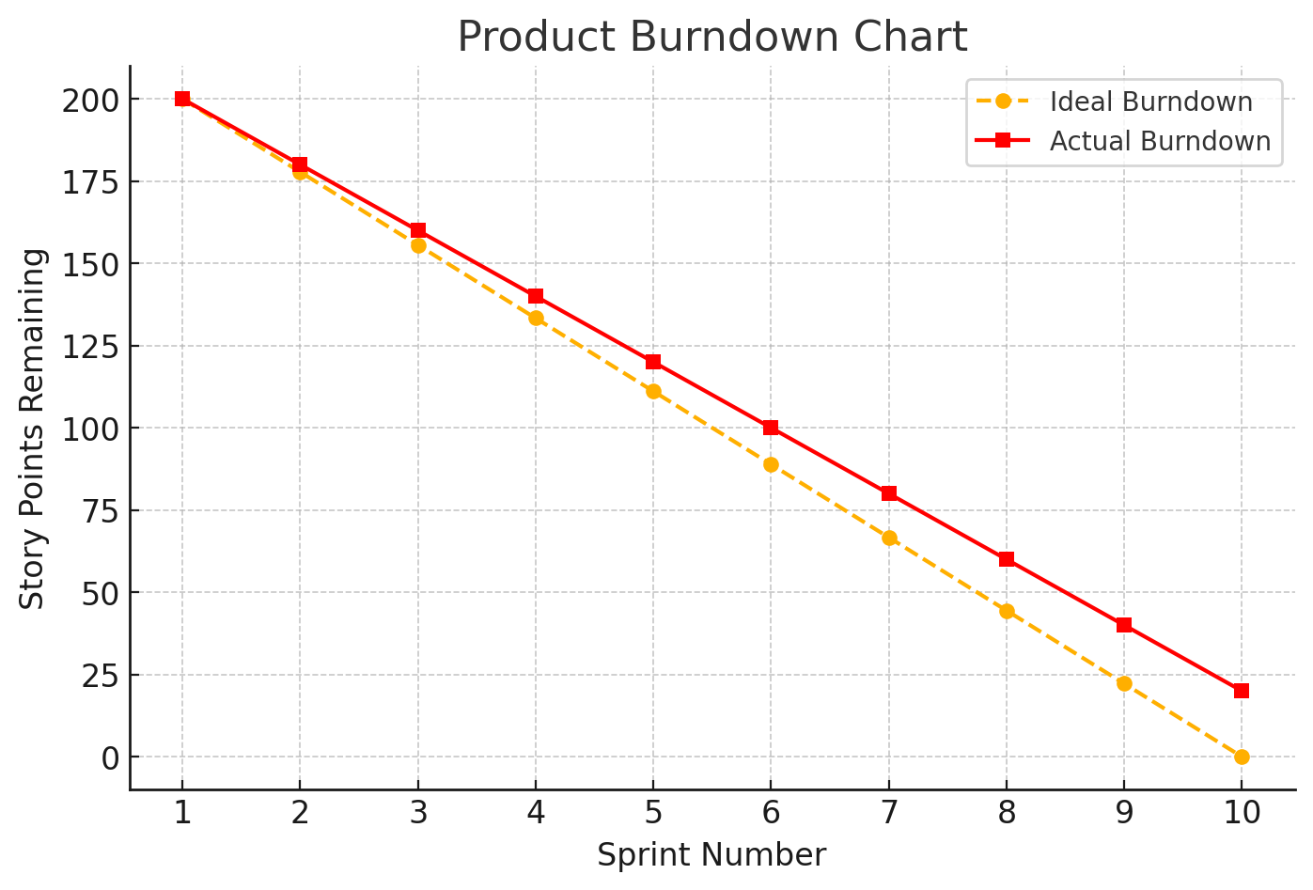

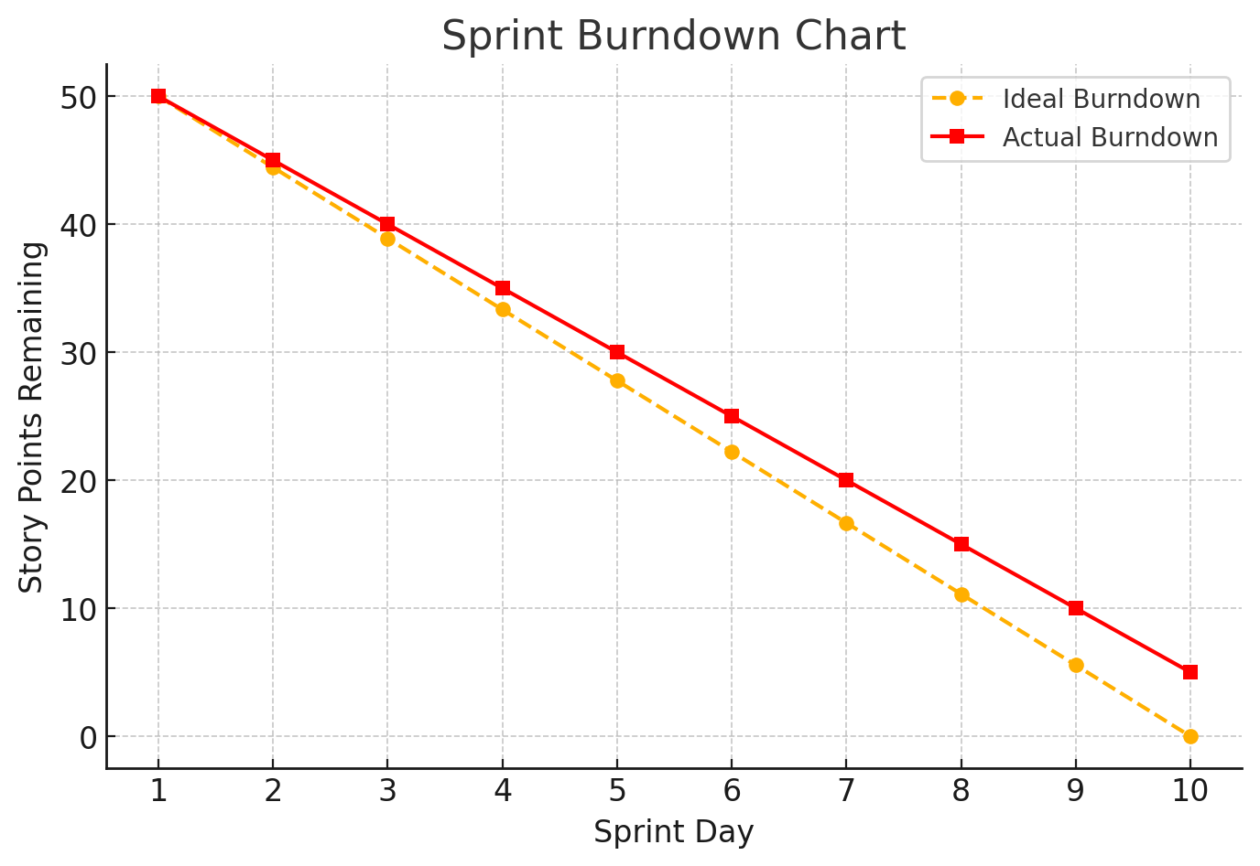

**Question 10 – Explain about Product Grooming**

Product grooming refers to the process of refining, improving, and organizing a product’s features, design, and user experience to meet customer needs and market demands. It involves various stages, including:

1. Feature Refinement: Evaluating and enhancing the core features of the product, ensuring that they align with customer expectations.

2. User Experience (UX) Improvement: Streamlining the design and functionality to make the product easy to use and visually appealing.

3. Market Adaptation: Adjusting the product based on market feedback, trends, and competitor analysis.

4. Quality Assurance: Conducting tests to ensure the product is reliable, functional, and free of defects.

5. Feedback Incorporation: Continuously collecting feedback from customers and stakeholders to make necessary changes or updates.

Product grooming is important in ensuring that a product stays relevant, competitive, and meets the evolving needs of users. It’s often done in iterations, especially for software or digital products, to ensure continuous improvement.

**Question 11 – Explain the roles of Scrum Master and Product Owner**

1. Scrum Master:

Facilitates the Scrum process by ensuring that the team adheres to Scrum practices and principles.

Removes any impediments or blockers that may hinder the team's progress.

Serves as a servant-leader, supporting the team and ensuring effective communication among all Scrum roles.

2. Product Owner:

Represents the stakeholders and ensures that the team works on the most valuable tasks by prioritizing the product backlog.

Provides a clear vision of the product and acts as a liaison between the development team and stakeholders.

Continuously refines and prioritizes the backlog based on feedback and changing market conditions.

|  |  |
| --- | --- |
| SCRUM MASTER | PRODUCT OWNER |
| Facilitates the scrum process and ensured team adherence to scrum practices. | Defines the product vision prioritizes the backlog, and ensures the team works on the most valuable features |
| Acts as a coach, removing obstacles to improve team performance | Makes key decisions on what features should be developed based on customer and market needs |
| Focus on the process and team dynamics. | Focus on the product, ensuring it delivers value to the customer and stakeholders. |

**Question 12 – Explain all Meetings Conducted in Scrum Project**

The Scrum Master plays a crucial role in facilitating various Scrum meetings to ensure the Scrum process runs smoothly. The meetings Scrum Masters are involved in are primarily centered around team coordination, removal of obstacles, and ensuring that Scrum practices are followed. Here are the key meetings that the Scrum Master conducts or facilitates:

1. Sprint Planning

Purpose: To plan the work for the upcoming sprint by selecting items from the product backlog that the team will work on during the sprint.

Role of Scrum Master: The Scrum Master facilitates the meeting, ensuring that it stays focused and that everyone understands the sprint goal and backlog items. They also help the team to break down large stories and ensure that the meeting does not exceed time constraints.

2. Daily Standup (Daily Scrum)

Purpose: A quick daily meeting where the team members synchronize their activities and discuss any impediments.

Role of Scrum Master: The Scrum Master facilitates this meeting, ensuring it remains time-boxed (usually 15 minutes). They ensure that the team stays focused on the three key questions (What did I do yesterday? What will I do today? Are there any blockers?) and assist in addressing any blockers that arise.

3. Sprint Review

Purpose: To inspect the increment (work completed) and adapt the product backlog if necessary based on stakeholder feedback.

Role of Scrum Master: While the Scrum Master doesn't directly contribute to the content of the Sprint Review, they facilitate the meeting, ensuring that it runs smoothly and that stakeholders, including the Product Owner, Development Team, and others, have the right opportunity to discuss the product increment and provide feedback.

4. Sprint Retrospective

Purpose: To reflect on the sprint and continuously improve the team's processes and interactions.

Role of Scrum Master: The Scrum Master facilitates this meeting, encouraging open and honest discussion among team members about what went well, what didn't, and how the team can improve. They ensure that actionable items for improvement are identified and tracked for implementation in the next sprint.

5. Backlog Refinement (Grooming)

Purpose: To review and prepare backlog items for future sprints. This includes clarifying, estimating, and prioritizing backlog items.

Role of Scrum Master: Although this meeting is mainly led by the Product Owner, the Scrum Master facilitates the session by ensuring it is focused and productive. They may also help the team break down large items, assist with any estimation activities, and ensure the backlog is well-defined for future sprints.

6. Impediment Removal

Purpose: To identify and remove any obstacles or impediments that are preventing the team from achieving their goals.

Role of Scrum Master: This meeting isn't a formal event, but the Scrum Master is responsible for identifying, addressing, and removing any obstacles that the team encounters. The Scrum Master may organize informal discussions with team members or stakeholders to help solve problems and ensure the team stays productive.

7. Coaching Sessions (Optional)

Purpose: To help the team better understand Scrum practices, improve their performance, and address any interpersonal issues.

Role of Scrum Master: The Scrum Master might conduct one-on-one or small group coaching sessions to support individual team members or groups. These sessions focus on improving Scrum understanding, team collaboration, or resolving issues within the team dynamics.

**Question 13 – Explain Sprint Size and Scrum Size**

Sprint Size: It refers to the duration of a sprint in Scrum, typically ranging from 1 to 4 weeks, within which the team completes a set of product backlog items.

Scrum Team Size: It refers to the ideal number of members in a Scrum team, usually between 3 to 9, including the Product Owner, Scrum Master, and Development Team. This size ensures effective communication and collaboration.

**Question 14 – Explain DOR and DOD**

Definition of Ready (DoR): It is a set of criteria that a user story must meet before it is considered ready to be worked on. It ensures that the team has all the necessary information to start the task.

Definition of Done (DoD): It is a set of criteria that a user story must meet to be considered complete. It ensures that the work is finished, tested, and meets quality standards.

Definition of Ready (DoR) Checklist:

[ ] User story is well-defined and understood.

[ ] Acceptance criteria are clearly defined.

[ ] Dependencies are identified and resolved.

[ ] Tasks are broken down and manageable.

[ ] The team has the necessary skills and resources to start.

[ ] Stakeholders are available for clarification, if needed.

Definition of Done (DoD) Checklist:

[ ] Code is written and reviewed.

[ ] Automated tests pass successfully.

[ ] Manual testing (if applicable) is complete.

[ ] Documentation (if required) is updated.

[ ] Code is merged and deployed (if applicable).

[ ] Feature is tested in staging or production.

[ ] No known critical bugs remain.

**Question 15 – Explain Prioritization Techniques and MVP**

Prioritization Techniques:

1. Eisenhower Matrix: A method that categorizes tasks based on urgency and importance to decide what to focus on.

2. MoSCoW Method: A prioritization technique that classifies tasks or features into Must Have, Should Have, Could Have, and Won't Have.

3. Value vs. Effort Matrix: A technique that evaluates tasks by comparing their value (impact) and the effort required to complete them.

MVP (Minimum Viable Product):

MVP is the most basic version of a product that includes only the essential features necessary to meet the needs of early users and gather feedback for future development

**Question 16 – Difference between Business Analyst n Product Owner**

|  |  |
| --- | --- |
| **Business Analyst** | **Product Owner** |
| Primarily focuses on analyzing business needs, gathering requirements, and ensuring solutions align with business objectives. | Focuses on defining the product vision, strategy, and prioritizing features to deliver value to customers. |
| Works closely with stakeholders to gather, document, and communicate business requirements. | Owns the product backlog, ensuring that the development team delivers the most valuable features first. |
| Provides recommendations based on data analysis and requirements gathering. | Makes final decisions about product features, prioritization, and release schedules. |
| Acts as a bridge between stakeholders (business users, IT) and the development team, ensuring requirements are clear. | Regularly engages with stakeholders, customers, and the development team to define and refine the product vision. |
| Delivers detailed functional specifications, use cases, and process models | Delivers and maintains a prioritized product backlog, making sure features meet business goals and user needs. |

**Question 17 – Prepare a sample Resume of 3yrs exp Product Owner**

**Resume**

**Vidyashree**

**[Your Contact Information]**

**[Your LinkedIn Profile] | [Your Email Address] | [Your Phone Number]**

**PROFESSIONAL SUMMARY**

**A detail-oriented and results-driven Product Owner with over 3 years of experience in driving the development**

**and delivery of digital products. Skilled in collaborating with cross-functional teams, prioritizing product**

**features, and ensuring alignment with business objectives. Passionate about delivering high-quality user experiences,**

**and continuously improving product functionality. Adept in Agile methodologies and product lifecycle management.**

**EXPERIENCE**

**Product Owner**

**Tata AIG General Insurance Company Ltd | [Dates of Employment]**

**- Led the development and enhancement of key digital products, ensuring alignment with business goals and customer needs.**

**- Collaborated with product managers, stakeholders, and development teams to define product roadmaps and prioritize features.**

**- Created detailed user stories, acceptance criteria, and product backlog items to guide development teams.**

**- Conducted regular sprint planning, backlog grooming, and retrospectives to ensure efficient Agile workflows.**

**- Worked closely with UX/UI teams to ensure the design and functionality of products met user expectations.**

**- Analyzed market trends and competitor products to identify opportunities for innovation and improvement.**

**- Coordinated with QA teams to ensure that products were thoroughly tested and met the required quality standards.**

**Associate Product Owner**

**XYZ Technologies | [Dates of Employment]**

**- Assisted in defining product vision and strategy based on market analysis and customer feedback.**

**- Supported the creation and refinement of user stories and product backlog items for the development team.**

**- Collaborated with cross-functional teams (design, development, QA) to ensure timely delivery of features.**

**- Monitored key product metrics and provided reports to stakeholders on performance and improvement areas.**

**- Engaged with customers to gather feedback and identify potential areas for product enhancement.**

**- Contributed to the product launch and go-to-market strategy, ensuring smooth product rollouts.**

**EDUCATION**

**Bachelor of Business Administration (BBA)**

**XYZ University | [Year of Graduation]**

**SKILLS & CERTIFICATIONS**

**- **Agile Methodology**: Scrum, Kanban, Sprint Planning, Backlog Grooming - **Product Management Tools**: Jira, Confluence, Trello, Asana**

**- **Data Analysis**: Google Analytics, Tableau, Microsoft Excel**

**- **User-Centered Design**: Wireframing, Prototyping, User Testing**

**- **Stakeholder Management**: Strong interpersonal skills for managing internal and external stakeholders**

**- **Communication**: Excellent written and verbal communication skills - **Product Roadmap Planning & Strategy\*\***

**- **Project Management**: Managing timelines, budgets, and resources**

**CERTIFICATIONS**

**- Certified Scrum Product Owner (CSPO)**

**- Agile Certified Practitioner (PMI-ACP)**

**- [Any additional relevant certifications]**

**PROJECTS**

**Online Agriculture Product Store Project**

**- Led the product development for an online store aimed at providing farmers access to agricultural products directly from manufacturers.**

**- Worked closely with development teams to define product features and ensure the platform’s usability.**

**- Monitored product performance metrics post-launch and identified areas for optimization.**

**LANGUAGES**

**- English (Fluent)**

**Any other languages known**