**Waterfall Model Documents**

**Document 6- Please prepare a use case diagram, activity diagram and a use case specification document.**

Use Case Diagram for **Lead Management System:**

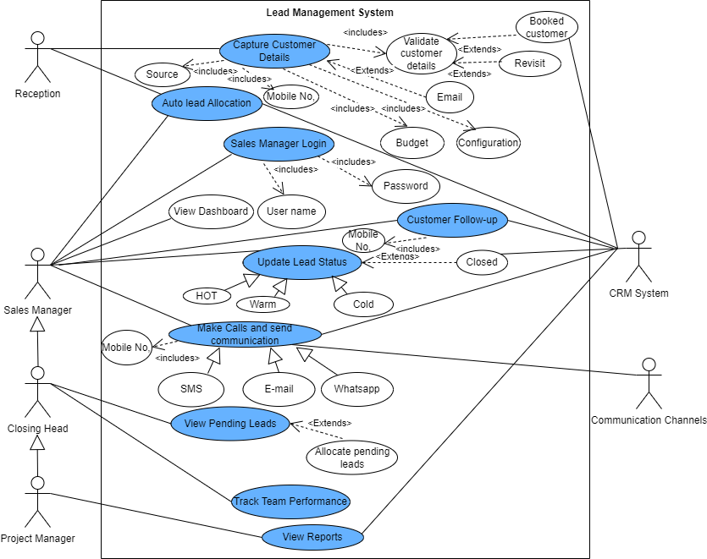

**ActivityDiagram-**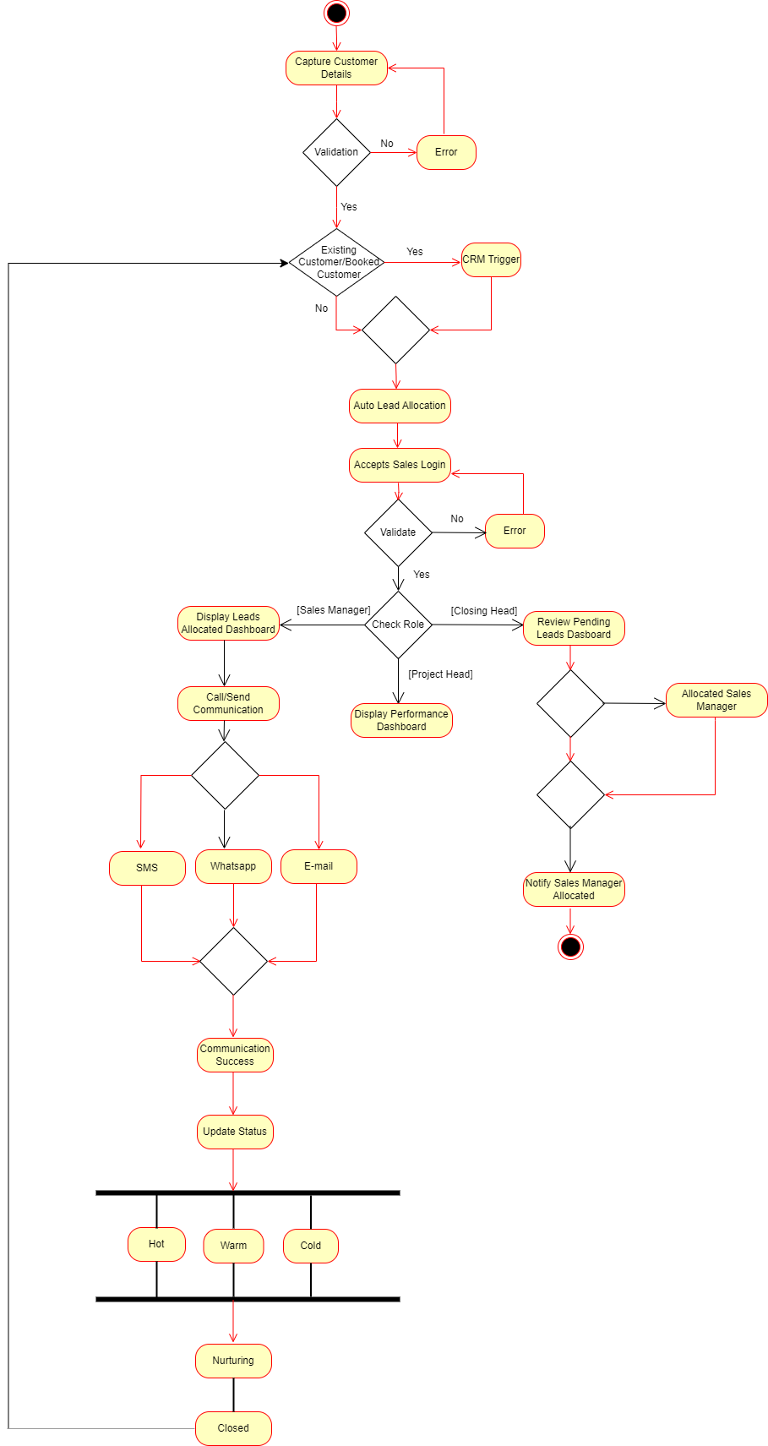

**Document 6- Use case specification**

**Use case specs: 1**

1) **Use case Spec:** Capture Customer Details

2) **Description:** The receptionist enters customer details such as phone number, email, source, requirement, and budget. If the customer already exists in the system, the CRM is triggered.

3) **Primary Actors:** Receptionist, Secondary Actor: CRM

4**) Pre-condition:** Active internet connection, mobile device, laptop, tab or PC. The receptionist must be logged into the system. The system must be connected to the CRM for validation.

5) **Post -condition:** If the customer is new, they are assigned to a sales manager. If the customer already exists, CRM processes the record.

6) **Basic flow:** Receptionist enters customer details (phone number, email, source, requirement, budget).

System validates customer details.

If new customer: Assign to a sales manager based on requirement and budget.

If existing customer: Trigger CRM process for follow-up.

7) **Alternate flow:** If the system finds that the customer is an existing or booked customer:

CRM system is triggered.

8) **Exceptional flow:** If the system finds missing or invalid data:

Prompt receptionist to correct the data.

Allow retry or cancel.

9) **Assumptions:** The receptionist is logged into the system and has the required permissions to enter and validate customer details.

The lead management system is connected to the CRM for checking existing customer records and handling booked customers.

10) **Constraint:** Only authorized receptionists can enter customer details into the system.

Phone number, email, source, requirement, and budget must be provided before proceeding.

Leads are allocated based on predefined rules (requirement and budget)

11) **Dependencies:** The system must validate customer details

The receptionist must enter complete and accurate customer details before system processes the lead.

12) **Input:** Name, Email, source, requirement.

13) **Output:** Validation success- New lead or existing booked customer

14) **Business rules:** Valid details must be entered, e-mail is optional.

The system must check for duplicate customers based on **phone number and email.**

I f customer is existing/Booked redirect to CRM or to previous allocated manager

15) **Misc. info:** User friendly.

**Use Case specs: 2**

1) **Use case Spec:** Auto Lead Allocation

**2) Description:** This use case describes the automated process of assigning leads to sales managers based on customer requirements and budget.

**3) Actors:** Reception, Sales Manager

**4) Pre-condition:** Active internet connection, mobile device, laptop or PC. Sales Managers must have active accounts and be available for lead allocation. Customer data must be entered correctly.

**5) Post -condition:**  The lead is either assigned to a Sales Manager or placed in an Unassigned Queue. The Sales Manager can view and act upon the lead. If closed, the CRM process is triggered.

**6) Basic flow:** The **Receptionist** enters the customer’s details, The **System** validates the information. The **System** matches the customer’s **requirement and budget** with available sales managers and allocates.

**7) Alternate flow:** If no matching Sales Manager is available, the lead remains **unassigned** until a Closing Head manually assigns it.

**8) Exceptional flow**:

a) Duplicate Lead Detected

b) Invalid Data Entry

**9) Assumptions**: Every lead has a budget and requirement to match with a Sales Manager. There are enough Sales Managers available for lead allocation. The CRM System handles existing customers efficiently.

**10) Constraint**: System accepts budgets in Indian System. Sales Manager **must follow up within 48 hours,** system **must allocate leads within 10 seconds**

**11) Dependencies**: only authorized users can access the dashboard.

**12) Input:** Customer Details **(Phone, Email, Source, Requirement, Budget)**

**13) Output:** Lead assigned to Sales Manager, Notification sent to Sales Manager, Unassigned leads report for Closing Head

**14) Business rules**: Leads **must be validated** before allocation. Closed leads automatically trigger **CRM post-sales handling.** Pending lead is assigned by Closing head.

**15) Misc. info**: Integration with **external CRM** systems can further streamline the process.

**Use case specs:3**

1) **Use case Spec:** Sales Manager Login

**2) Description:** **Sales Manager** logging into the system to access their dashboard, view assigned leads, and take necessary actions such as follow-ups and lead status updates.

**3) Actors:** Sales Manager

**4) Pre-condition:** Sales Managers active account

**5) Post -condition:** Sales Manager can **view and manage assigned leads.**

**6) Basic flow:** Successful login

**7) Alternate flow:**

Forgot password, Incorrect Role Assigned

**8) Exceptional flow**: If incorrect credentials are entered **3 times,** the account is **temporarily locked** for security reasons.

**9) Assumptions**: Sales manager should have basic computer knowledge, English

**10) Constraint**: Correct username should be provided by sales manager

**11) Dependencies**: **User Authentication System** for login validation

**12) Input:** Username & Password

**13) Output:** Dashboard is displayed

**14) Business rules**: **Failed login attempts** (3 times) will lock the account., user name is official e-mail id.

**15) Misc. info**: can upload PDF drawings.

**Use case specs:4**

1) **Use case Spec:** Customer Follow-up

**2) Description:** **Sales Manager** follows up with assigned customers

**3) Actors:** Sales Manager

**4) Pre-condition: Sales Manager must be logged in.**

**5) Post -condition:** Lead status is **updated** after follow-up.

**6) Basic flow:** Successful login for sales manager.

**7) Alternate flow:**

a) Customer Unavailable

**8) Exceptional flow**: Communication Failure

**9) Assumptions**: Customers may **respond immediately or require multiple follow-ups.**

**10) Constraint**: **Follow-ups must be logged within the system** for tracking**.**

**11) Dependencies**: **CRM System** for handling closed leads.

**12) Input: Sales Manager action** (Follow-up method, notes, updated status)

**13) Output:** Lead status update

**14) Business rules**: The system **automatically prioritizes** leads based on their status.

**15) Misc. info**: Sales manager can check status and add remarks.

**Use case specs:5**

1) **Use case Spec:** Make calls and send communications

**2) Description:** **Sales Manager** contacts customers through different communication channels (Call, Email, SMS, WhatsApp) for lead follow-up

**3) Actors:** Sales Manager; **Secondary Actors:** Communication Channels

**4) Pre-condition:** The **Sales Manager must be logged in.**

**5) Post -condition:** Order stage page should be displayed.

**6) Basic flow:** Successful communication through e-mail, SMS, WhatsApp

**7)Alternate flow:** Customer Not Available**,** Customer Requests More Information, **System** sends an automated email/SMS based on lead status.

**8) Exceptional flow**:

Communication Failure**,** Invalid Contact Details

**9) Assumptions**:System has **working integrations** with Email, SMS, and WhatsApp APIs. Sales Manager **has permission** to initiate and log communications.

**10) Constraint**: **Sales Managers cannot delete logs**, only update statuses.

**11) Dependencies**: **Communication API Providers** (Email, SMS, WhatsApp).

**12) Input: Sales Manager action** (Call, Email, SMS, WhatsApp)

**13) Output:** Communication log entry.

**14) Business rules**: **Leads marked as "Do Not Disturb (DND)"** cannot receive communications

**15) Misc. info**: Voice call recording integration could be considered for compliance tracking.

**Document7- Screens and pages**

**HOME PAGE**

* + 1. User Interface

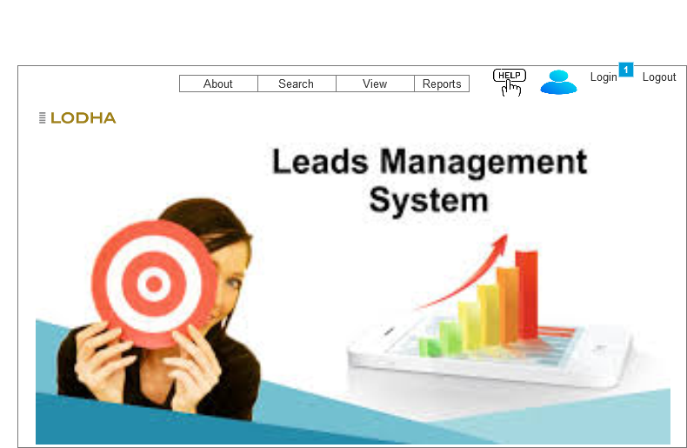

* + 1. Widget Table

|  |  |
| --- | --- |
| Footnote | Interactions |
| 1 | OnClick:  Case 1:  Open **LOG IN** in Current Window |

* 1. LOG IN
     1. User Interface

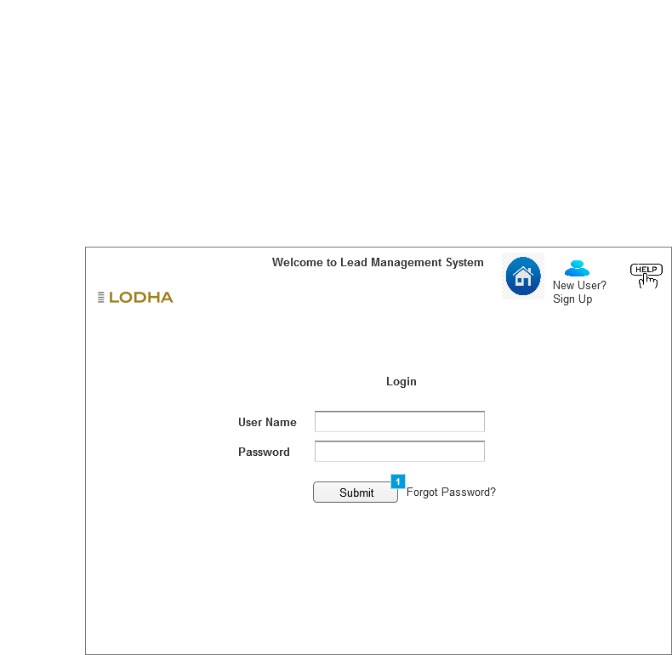

* + 1. Widget Table

|  |  |
| --- | --- |
| Footnote | Interactions |
| 1 | OnClick:  Case 1:  Open **Customer Registration** in Current Window |

Sales Manager Dashboard

User Interface

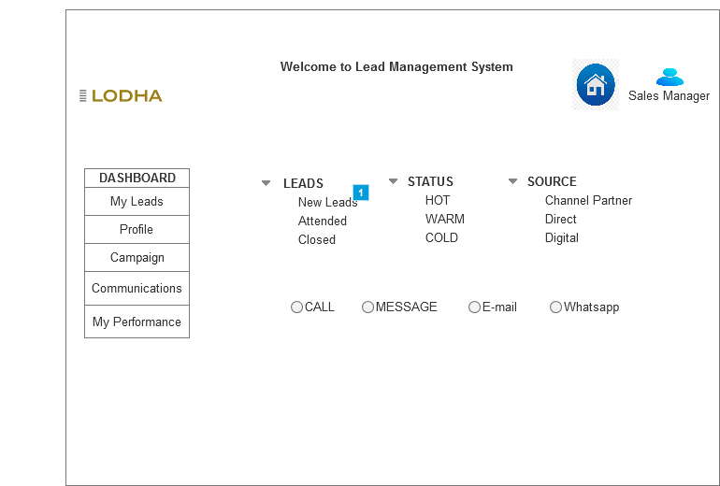

* + 1. Widget Table

|  |  |
| --- | --- |
| Footnote | Interactions |
| 1 | OnClick:  Case 1:  Open New Customer Allocated in Current Window |

* 1. New Customer Allocated
     1. User Interface

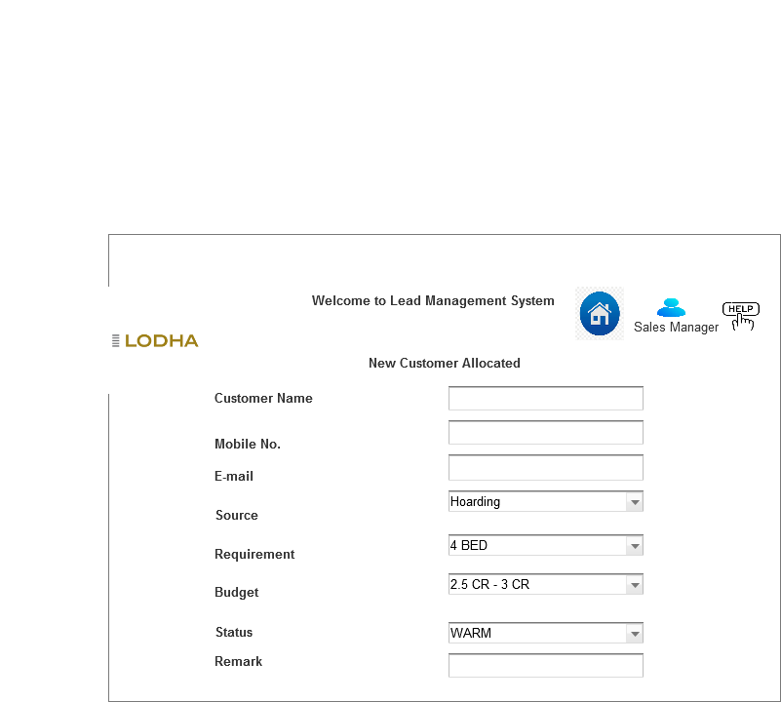

**Document 8- Tools-Visio and Axure**

1) **Ms. Visio**: - Microsoft Visio is software for drawing a variety of diagrams. These include flowcharts, org charts, data flow diagrams, process flow diagrams, business process modeling, swimlane diagrams, 3D maps, and many more. Basically Visio is a drag and drop tool in which variety of pre build shapes and designs are available using which we can create any diagram. Eg. We can create Use case diagrams, activity diagrams and swimlanes diagrams using MS visio tool. Out of above examples USE case will be drawn for user perspective and Activity diagrams as system perspective.

2) **Axure: -**

Axure RP is a design tool for creating highly interactive HTML prototypes for web, mobile, and desktop application projects. It is a UX design tool used for creating wireframes and interactive prototypes. Axure allows users to quickly create wireframes and prototypes from any rough ideas they may have. We can crate actual HTML page and link it online enabling client to see how the actual interface will tentatively be.

**Document 9- BA experience**

**My experience as BA in following phases:**

**1.Requirement gathering:**

To gather requirements, we used MOSCOW technique.

Client is not available for some period of time during this phase. So as a BA i need to source out point of contacts from his side and get the information asap.

I validate the requirements using FURPS technique

There are many requirements which are duplicated or repeated. We need to remove them immediately

Prototyping is used to give more specific requirements

**2.Requirement Analysis:**

We need to draw UML diagrams to visually describe the requirements

Activity diagrams also used to describe the process flow

Communicate the diagrams to team. Some team members might not agree with them and might make changes. As a BA we need to consider the points and make modifications

Prepare BRS and SRS

**3.Design:**

From the usecase diagrams, we prepare test cases

Communicate with client on design and solution documents

Write negative test cases as well along with positive test cases.

Do not miss a single test case. It might have huge impact on project development in later stages

Prepare test data for testing

Update RTM. This is must as we need to make sure that all the requirements are met

**4.Development:**

Organized JAD sessions

Clarifying queries of tech team during coding

There might be some team members who doesn't agree with the concept or who doesn’t cooperate during JAD sessions. As a BA i handle the situation gently and had one on one discussion with them. Explained how their actions are going to affect the project. Setup healthy environment within the team.

Referred diagrams to code the Unit

Conduct regular meetings with technical team and client which is challenging. Some team members might not be available for the meeting. Recording the session and providing that to missed one and having one to one discussion later with that missed person is all i need to do

**5.Testing:**

Prepare test cases from use cases

Perform high level testing

Test data is requested by BA from client

Updated RTM

Take signoff from client

Prepare client for UAT

**6.Deployment:**

Forwarded RTM to client which should be attached to project closure document

Coordinates to complete and share end user manuals

Plans and organizes training sessions

Make sure all the candidates attend the meeting