**Question 1– Functional Requirements**

**Functional Requirement:** It defines the specific behaviours, functions or operations of a system. They describe what the system should do, outlining the necessary tasks, actions, or activities it must perform to achieve the objectives.

**Non-Functional Requirement:** It describes the qualities and attributes of a system, focusing on how the system performs rather than specific behaviours or functions.

|  |  |  |  |
| --- | --- | --- | --- |
| **Req ID** | **Req Name** | **Req Description** | **Priority** |
| FR01 | User registration | The users should be able to register themselves on the application. | 9 |
| FR02 | User login | The users should be able to login to their respective accounts with the help of credentials. | 9 |
| FR03 | Uploading product details | Manufacturers should be able to upload all the details about their products. | 8 |
| FR04 | Product search | Farmers/users should be able to search all the products uploaded by the manufacturers. | 9 |
| FR05 | Search filter | Users should be able to apply the filters while searching the products as per their requirement. | 7 |
| FR06 | Product details | Users should be able to access all the basic details about the product and manufacturers which is uploaded on the application. | 9 |
| FR07 | Adding product to cart | Users should be able to add the products in cart as per their preferences. | 9 |
| FR08 | Payment method | The application should allow to display different payment methods to make a selection for the users. | 9 |
| FR09 | Checkout process | The application should allow users to proceed to checkout from the shopping cart. | 8 |
| FR10 | Order Confirmation | The application should send users the order confirmation via message/email once the order is placed. | 7 |
| NFR01 | Loading Time | Each page should load within 2 seconds under normal load conditions. | 8 |
| NFR02 | Response Time | System actions like product search, login, or checkout should execute within 2-3 seconds. | 8 |
| NFR03 | Language Support | The platform should support multiple languages, including regional ones, to cater to farmers in different areas. | 7 |
| NFR04 | Accessibility | The application should be accessible through web browsers and mobile devices. | 9 |
| NFR05 | Authentication | The system should allow the users to login with correct credentials only. | 8 |
| NFR06 | Data Protection | All the users’ data should be protected and encrypted during transmission and storage. | 9 |
| NFR07 | Maintenance | The system shall be easy to update and maintain. | 9 |
| NFR08 | Delivery Tracker | The delivery tracking system should update the order status in real time with location updates. | 8 |
| NFR09 | Payment Compliance | All transactions must comply with Reserve Bank of India (RBI) regulations for digital payments. | 8 |
| NFR10 | Scalability | The system shall be able to handle large number of users without performance degradation. | 7 |

**Question 2 – Minimum 5-page designs (Make wireframe and prototypes)**

**Wireframe:** A wireframe is a low-fidelity, basic visual representation of a webpage, app, or system. It focuses on structure, layout, and functionality without including design elements like colours, images, or typography.

**Prototype:** A prototype is an interactive, high-fidelity model of a design that mimics the final product's behaviour. It allows stakeholders to experience navigation, interactions, and flow before development.

**Wireframes:**

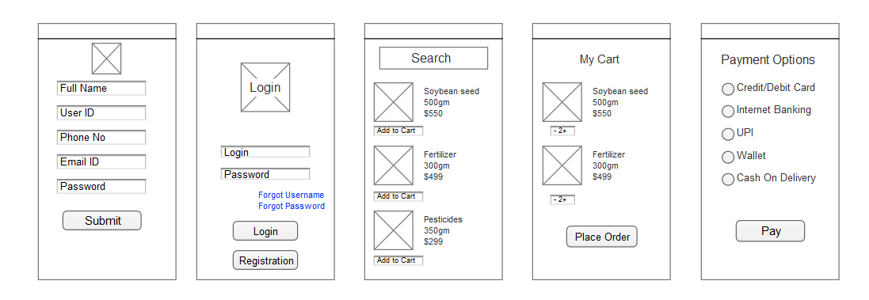

1. **Registration Page**

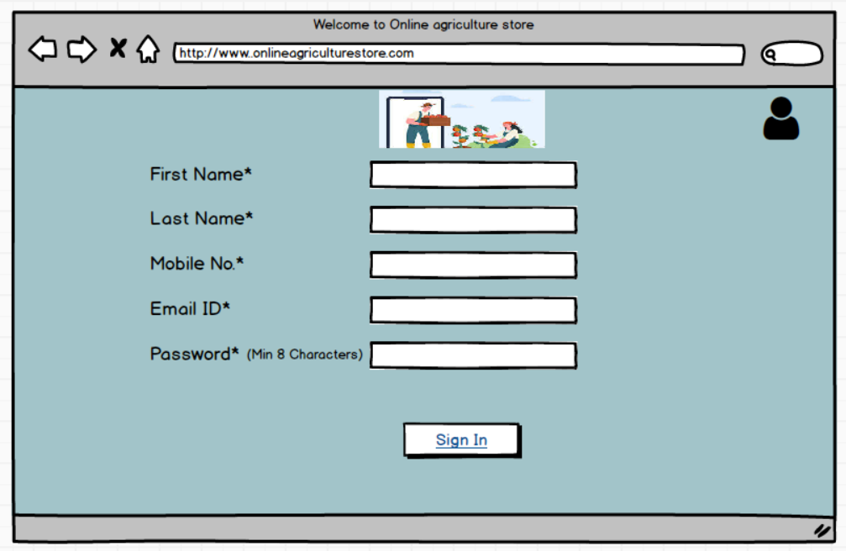

1. **Login Page**

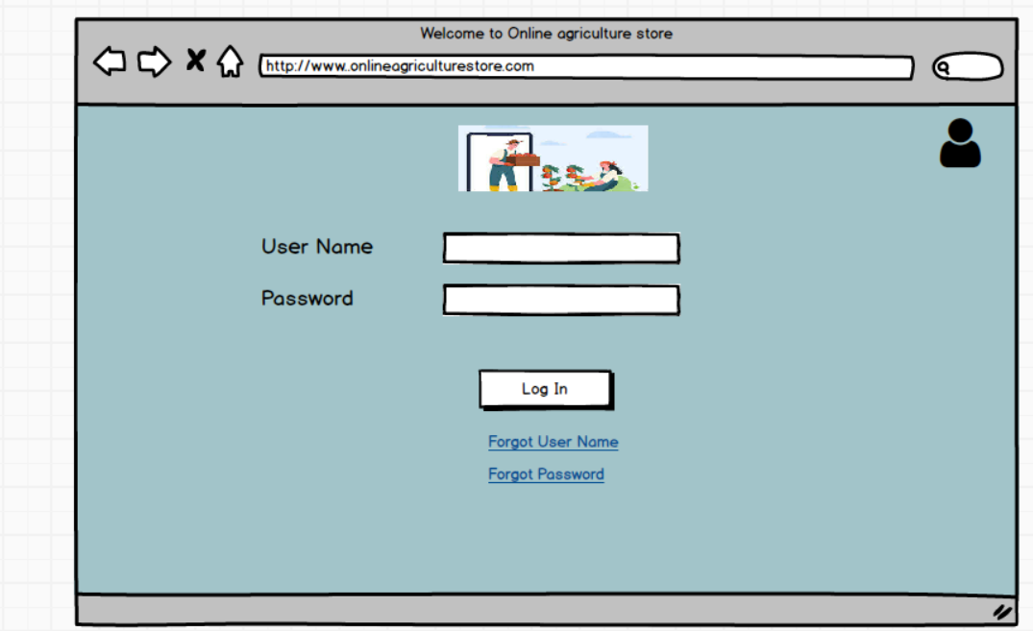

1. **Search Products**

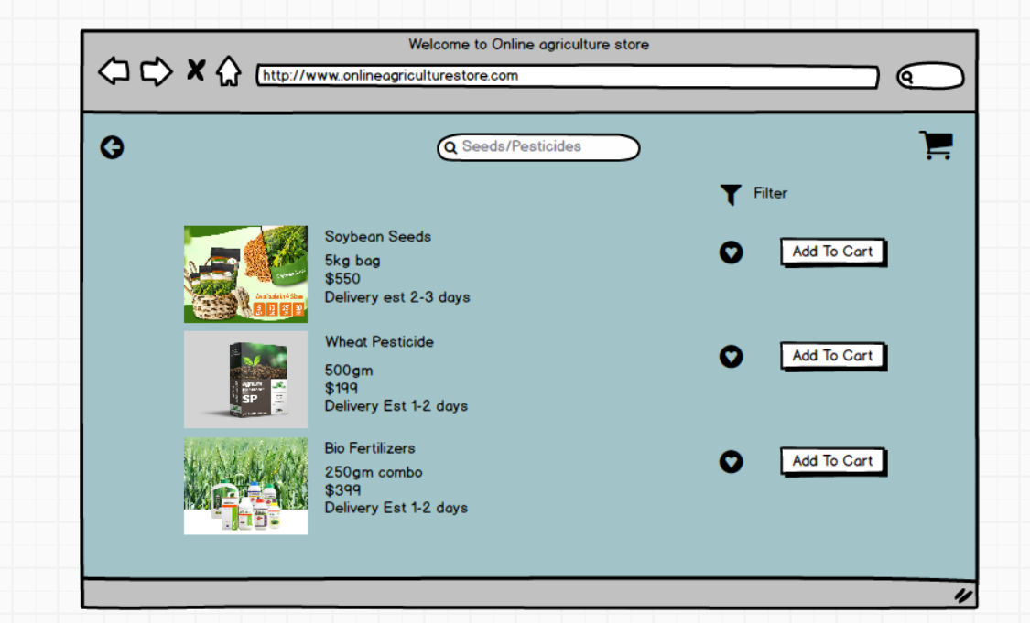

1. **Add to Cart**

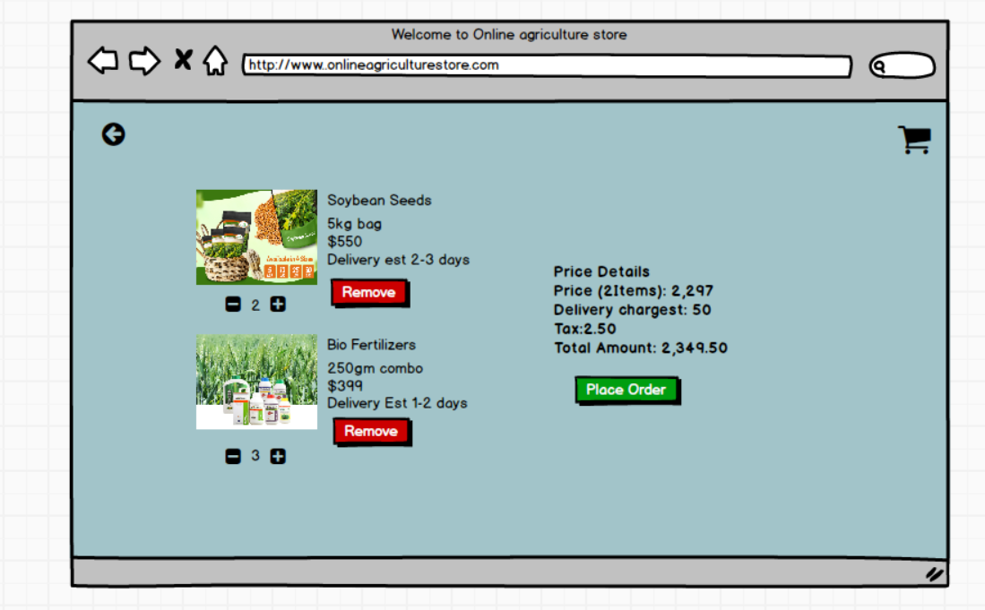

1. **Make Payment**

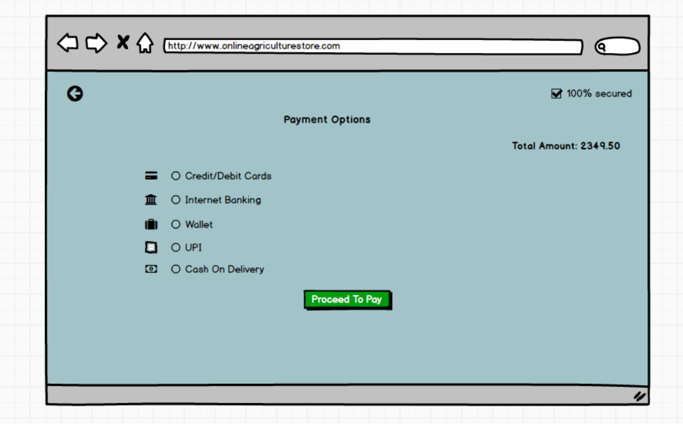

**Question 3 – Tools (Visio, Balsamiq)**

**Balsamiq** – It is a popular lightweight wireframing tool known for its simplicity and speed, enabling designers to quickly sketch out user interfaces and iterate on design ideas. Its hand-drawn style helps emphasize structure and layout over fine details, encouraging team collaboration and rapid ideation. Balsamiq's drag-and-drop interface, pre-built UI components, and real-time collaboration features make it easy to create and modify wireframes, while its low-fidelity design keeps the focus on functionality. However, its basic interactivity and limited features may not suffice for complex projects requiring high-fidelity mock-ups.

**Axure RP** – It is a robust tool designed for professionals needing to create detailed and interactive prototypes. It excels in complex projects with features like conditional logic, dynamic content, and advanced interactions. Axure RP's comprehensive environment supports wireframes, flowcharts, mock-ups, and specifications, offering extensive widget libraries, adaptive views, and HTML export options. While it provides precision and advanced functionalities, it has a steeper learning curve and higher cost, making it more suitable for professional designers and large-scale projects.

**Microsoft Visio** - Microsoft Visio is a diagramming and vector graphics tool used for creating flowcharts, organizational charts, network diagrams, UML diagrams, floor plans, and more. It provides various tools to help users visualize complex processes and systems.

**Question 4– RTM**

**RTM (Requirements Traceability Matrix)** is a document that links and tracks the requirements throughout the project lifecycle to ensure that all requirements are addressed, tested, and fulfilled. It serves as a mapping document between the requirements, design, development, testing, and user acceptance phases.

A business analyst’s key responsibilities are to keep track of the requirements and make sure that no requirement is missed.

Mr. Henry and peter have approached you regarding the current status of the project. How will you tackle this situation? Prepare RTM

|  |  |
| --- | --- |
| **Term** | **Definition** |
| D1 | |  | | --- | |  |   Development Phase 1: Initial coding or development of the requirement begins, focusing on core functionality. |
| T1 | Testing Phase 1 (Unit Testing): Individual components or modules are tested to ensure they meet specifications. |
| D2 | Development Phase 2: Enhancements or fixes based on unit testing are applied, extending the functionality further. |
| T2 | Testing Phase 2 (Component Testing): Testing interactions between components or modules to ensure seamless integration. |
| D3 | Development Phase 3: Final refinements and fixes after component testing; ensures the requirement is complete. |
| T3 | Testing Phase 3 (System Testing): End-to-end testing of the entire system to ensure it meets business requirements. |
| D4 | Development Phase 4: Final development or fixes for issues found during system testing before User Acceptance Testing (UAT). |
| T4 | Testing Phase 4 (User Acceptance Testing Preparation): Final validation before presenting to end users for acceptance. |
| UAT | User Acceptance Testing: End users validate the functionality and usability of the system against business needs. |

|  |  |  |  |  |  |  |  |  |  |  |  |
| --- | --- | --- | --- | --- | --- | --- | --- | --- | --- | --- | --- |
| **Req ID** | **Req Name** | **Design** | **D1** | **T1** | **D2** | **T2** | **D3** | **T3** | **D4** | **T4** | **UAT** |
| FR01 | User registration | Complete | Complete | Complete | Complete | Complete | Complete | Complete | Complete | Complete | Complete |
| FR02 | User login | Complete | Complete | Complete | Complete | Complete | Complete | Complete | Complete | Complete | Complete |
| FR03 | Uploading product details | Complete | Complete | Complete | In Progress | In Progress | Complete | Complete | Complete | Complete | Complete |
| FR04 | Product search | Complete | Complete | Complete | In Progress | In Progress | Complete | Complete | Complete | Complete | Complete |
| FR05 | Search filter | Complete | Complete | Complete | In Progress | In Progress | Complete | Complete | Complete | Complete | Complete |
| FR06 | Product details | Complete | Complete | Complete | Complete | Complete | In Progress | In Progress | Complete | Complete | In Progress |
| FR07 | Adding product to cart | Complete | Complete | Complete | Complete | Complete | In Progress | In Progress | Complete | Complete | In Progress |
| FR08 | Payment method | Complete | Complete | Complete | In Progress | In Progress | Complete | Complete | Complete | Complete | In Progress |
| FR09 | Checkout process | Complete | Complete | Complete | In Progress | In Progress | Complete | Complete | Complete | Complete | In Progress |
| FR10 | Order Confirmation | Complete | Complete | Complete | Complete | Complete | In Progress | In Progress | Complete | Complete | In Progress |
| NFR01 | Loading Time | Complete | Complete | Complete | Complete | Complete | Complete | Complete | Complete | Complete | Complete |
| NFR02 | Response Time | Complete | Complete | Complete | Complete | Complete | Complete | Complete | Complete | Complete | Complete |
| NFR03 | Language Support | Complete | Complete | Complete | Complete | Complete | Complete | Complete | Complete | Complete | Complete |
| NFR04 | Accessibility | Complete | Complete | Complete | Complete | Complete | Complete | Complete | Complete | Complete | Complete |
| NFR05 | Authentication | Complete | Complete | Complete | Complete | Complete | Complete | Complete | Complete | Complete | Complete |
| NFR06 | Data Protection | Complete | Complete | Complete | Complete | Complete | Complete | In Progress | In Progress | In Progress | In Progress |
| NFR07 | Maintenance | Complete | Complete | Complete | In Progress | In Progress | In Progress | In Progress | Complete | Complete | In Progress |
| NFR08 | Delivery Tracker | Complete | Complete | Complete | In Progress | In Progress | In Progress | In Progress | Complete | Complete | Complete |
| NFR09 | Payment Compliance | Complete | Complete | Complete | In Progress | In Progress | Complete | Complete | Complete | Complete | Complete |
| NFR10 | Scalability | Complete | In Progress | In Progress | In Progress | In Progress | In Progress | In Progress | In Progress | In Progress | In Progress |

**Question 5 – 10 Test Case Documents**

1. **User Registration**

|  |  |  |  |  |
| --- | --- | --- | --- | --- |
| **Test Case ID** | TC01 | **Test Case Name** | User Registration | |
| **Project ID** | PRJ001 | **Project Name** | Online Agriculture Products Store | |
| **PM ID** | PM001 | **PM Name** | Mr. Vandanam | |
| **Test strategy ID** | TS001 | **Tester ID** | T001 | |
| **Test plan ID** | TP001 | **Tester Name** | Ms. Alekya | |
| **Test schedule ID** | TSCH001 | **Date of Test** | 8 Nov 2025 | |
| **Scenario** | Verify that a user can register successfully. | | | |
| **Link to that page:** | Registration Page | | | |
| **Input Data** | **User Credential 1** | **User Credential 2** | **User Credential 3** | **User Credential 4** |
| Email: user1@mail.com | Email: user2@mail.com | Email: user3@mail.com | Email: user4@mail.com |
| Password: User1 | Password: User2 | Password: User3 | Password: User4 |
| **Expected behaviour** | User is able to register successfully on the online agriculture product store | | | |
| **Actual behaviour** | After entering mandatory fields, if user clicks on Register button, then system shows pop up saying ‘User created successfully’ | | | |
| **Comments** | NA | | | |
| **Result (Pass/Fail)** | Pass | | | |

1. **User Login**

|  |  |  |  |  |
| --- | --- | --- | --- | --- |
| **Test Case ID** | TC02 | **Test Case Name** | User Login | |
| **Project ID** | PRJ001 | **Project Name** | Online Agriculture Products Store | |
| **PM ID** | PM001 | **PM Name** | Mr. Vandanam | |
| **Test strategy ID** | TS001 | **Tester ID** | T001 | |
| **Test plan ID** | TP001 | **Tester Name** | Mr. Jason | |
| **Test schedule ID** | TSCH001 | **Date of Test** | 12 Nov 2025 | |
| **Scenario** | Verify that a user can login to the application successfully. | | | |
| **Link to that page:** | Login Page | | | |
| **Input Data** | **User Credential 1** | **User Credential 2** | **User Credential 3** | **User Credential 4** |
| Email: user1@mail.com | Email: user2@mail.com | Email: user3@mail.com | Email: user4@mail.com |
| Password: User1 | Password: User2 | Password: User3 | Password: User4 |
| **Expected behaviour** | User is able to login to the application successfully | | | |
| **Actual behaviour** | After entering username, password and captcha, if user clicks on ‘Login’ button, then system shows pop up saying ‘Login successfully’ | | | |
| **Comments** | NA | | | |
| **Result (Pass/Fail)** | Pass | | | |

1. **Adding Product Details by Manufacturer**

|  |  |  |  |  |
| --- | --- | --- | --- | --- |
| **Test Case ID** | TC03 | **Test Case Name** | Product Upload by Manufacturer | |
| **Project ID** | PRJ001 | **Project Name** | Online Agriculture Products Store | |
| **PM ID** | PM001 | **PM Name** | Mr. Vandanam | |
| **Test strategy ID** | TS001 | **Tester ID** | T003 | |
| **Test plan ID** | TP001 | **Tester Name** | Ms. Alekya | |
| **Test schedule ID** | TSCH003 | **Date of Test** | 18 Nov 2025 | |
| **Scenario** | Verify that manufacturers can upload product details. | | | |
| **Link to that page:** | Product Upload Page | | | |
| **Input Data** | **Product 1** | **Product 2** | **Product 3** | **Product 4** |
| Product Name: Fertilizer A | Product Name: Tomato Seed | Product Name: Urea Pesticide | Product Name: Pumpkin Seed |
| Description: Organic fertilizer | Description: Organic Seeds | Description: Organic pesticide | Description: Organic Seeds |
| Price: INR 500/kg | Price: INR 100/100gm | Price: INR 500/kg | Price: INR 100/100gm |
| **Expected behaviour** | Product is successfully added and visible in the product catalogue. Once login, User will search products on the basis of requirements, and he must be able to add products in the cart for purchase. | | | |
| **Actual behaviour** | After selecting required products, User clicks on Add to Cart option to add products in the cart for purchase. | | | |
| **Comments** | NA | | | |
| **Result (Pass/Fail)** | Pass | | | |

1. **Product Search**

|  |  |  |  |  |
| --- | --- | --- | --- | --- |
| **Test Case ID** | TC04 | **Test Case Name** | Product Search | |
| **Project ID** | PRJ001 | **Project Name** | Online Agriculture Products Store | |
| **PM ID** | PM001 | **PM Name** | Mr. Vandanam | |
| **Test strategy ID** | TS001 | **Tester ID** | T004 | |
| **Test plan ID** | TP001 | **Tester Name** | Mr. Jason | |
| **Test schedule ID** | TSCH004 | **Date of Test** | 22 Nov 2025 | |
| **Scenario** | Verify that users can search for products. | | | |
| **Link to that page:** | Search Page | | | |
| **Input Data** | **Keyword 1** | **Keyword 2** | **Keyword 3** | **Keyword 4** |
| Pesticide | Seed | Fertilizer | Organic |
| **Expected behaviour** | Relevant products are displayed in the search results. | | | |
| **Actual behaviour** | User enters a query, and relevant products appear with details. | | | |
| **Comments** | NA | | | |
| **Result (Pass/Fail)** | Pass | | | |

1. **Applying Search Filter**

|  |  |  |  |  |
| --- | --- | --- | --- | --- |
| **Test Case ID** | TC05 | **Test Case Name** | Applying Search Filters | |
| **Project ID** | PRJ001 | **Project Name** | Online Agriculture Products Store | |
| **PM ID** | PM001 | **PM Name** | Mr. Vandanam | |
| **Test strategy ID** | TS001 | **Tester ID** | T005 | |
| **Test plan ID** | TP001 | **Tester Name** | Ms. Alekya | |
| **Test schedule ID** | TSCH005 | **Date of Test** | 26 Nov 2025 | |
| **Scenario** | Verify that users can apply filters to search results. | | | |
| **Link to that page:** | Search Results Page | | | |
| **Input Data** | **Filter 1** | **Filter 2** | **Filter 3** | **Filter 4** |
| Price Range | Brand | Quantity | Organic/Chemical |
| **Expected behaviour** | Search results are refined based on the applied filters. | | | |
| **Actual behaviour** | User applies filters, and the product list updates accordingly. | | | |
| **Comments** | NA | | | |
| **Result (Pass/Fail)** | Pass | | | |

1. **View Product Details**

|  |  |  |  |  |
| --- | --- | --- | --- | --- |
| **Test Case ID** | TC06 | **Test Case Name** | View Product Details | |
| **Project ID** | PRJ001 | **Project Name** | Online Agriculture Products Store | |
| **PM ID** | PM001 | **PM Name** | Mr. Vandanam | |
| **Test strategy ID** | TS001 | **Tester ID** | T006 | |
| **Test plan ID** | TP001 | **Tester Name** | Mr. Bravo | |
| **Test schedule ID** | TSCH006 | **Date of Test** | 4 Dec 2025 | |
| **Scenario** | Verify that users can view detailed information about a product. | | | |
| **Link to that page:** | Product details | | | |
| **Input Data** | **Keyword 1** | **Keyword 2** | **Keyword 3** | **Keyword 4** |
| Product A | Product B | Product B | Product B |
| **Expected behaviour** | Product details are displayed correctly, including name, price, and manufacturer details. | | | |
| **Actual behaviour** | Clicking a product opens a detailed page with images, price, and specs. | | | |
| **Comments** | NA | | | |
| **Result (Pass/Fail)** | Pass | | | |

1. **Adding Product to Cart**

|  |  |  |  |  |
| --- | --- | --- | --- | --- |
| **Test Case ID** | TC07 | **Test Case Name** | Adding Products to Cart | |
| **Project ID** | PRJ001 | **Project Name** | Online Agriculture Products Store | |
| **PM ID** | PM001 | **PM Name** | Mr. Vandanam | |
| **Test strategy ID** | TS001 | **Tester ID** | T007 | |
| **Test plan ID** | TP001 | **Tester Name** | Mr. Jason | |
| **Test schedule ID** | TSCH007 | **Date of Test** | 8 Dec 2025 | |
| **Scenario** | Verify that users can add products to the shopping cart. | | | |
| **Link to that page:** | Product Page | | | |
| **Input Data** | **Keyword 1** | **Keyword 2** | **Keyword 3** | **Keyword 4** |
| Fertilizer A | Fertilizer B | Fertilizer B | Fertilizer B |
| **Expected behaviour** | Product is added to the cart successfully with the correct quantity. | | | |
| **Actual behaviour** | Clicking "Add to Cart" updates the cart with selected products. | | | |
| **Comments** | NA | | | |
| **Result (Pass/Fail)** | Pass | | | |

1. **Payment Options**

|  |  |  |  |  |
| --- | --- | --- | --- | --- |
| **Test Case ID** | TC08 | **Test Case Name** | Payment Options | |
| **Project ID** | PRJ001 | **Project Name** | Online Agriculture Products Store | |
| **PM ID** | PM001 | **PM Name** | Mr. Vandanam | |
| **Test strategy ID** | TS001 | **Tester ID** | T008 | |
| **Test plan ID** | TP001 | **Tester Name** | Mr. Jason | |
| **Test schedule ID** | TSCH008 | **Date of Test** | 14 Dec 2025 | |
| **Scenario** | Verify that users can select different payment options during checkout. | | | |
| **Link to that page:** | Payment Option | | | |
| **Input Data** | **Payment Option 1** | **Payment Option 2** | **Payment Option 3** | **Payment Option 4** |
| Credit/Debit Card | COD | UPI | Net Banking |
| **Expected behaviour** | Users can select the payment option successfully and proceed. | | | |
| **Actual behaviour** | User selects a payment method and successfully completes the transaction. | | | |
| **Comments** | NA | | | |
| **Result (Pass/Fail)** | Pass | | | |

1. **Order Confirmation**

|  |  |  |  |  |
| --- | --- | --- | --- | --- |
| **Test Case ID** | TC09 | **Test Case Name** | Order Confirmation | |
| **Project ID** | PRJ001 | **Project Name** | Online Agriculture Products Store | |
| **PM ID** | PM001 | **PM Name** | Mr. Vandanam | |
| **Test strategy ID** | TS001 | **Tester ID** | T009 | |
| **Test plan ID** | TP001 | **Tester Name** | Mr. Tucker | |
| **Test schedule ID** | TSCH009 | **Date of Test** | 18 Dec 2025 | |
| **Scenario** | Verify that users receive an order confirmation after completing the payment. | | | |
| **Link to that page:** | Order Confirmation | | | |
| **Input Data** | **Order ID 1** | **Order ID 2** | **Order ID 3** | **Order ID 4** |
| Order ID: 20230001 | Order ID: 20230002 | Order ID: 20230003 | Order ID: 20230004 |
| **Expected behaviour** | Order confirmation is sent to the user via email/message. | | | |
| **Actual behaviour** | After payment, user receives order confirmation with Order ID and expected delivery date. | | | |
| **Comments** | NA | | | |
| **Result (Pass/Fail)** | Pass | | | |

1. **Delivery Tracking**

|  |  |  |  |  |
| --- | --- | --- | --- | --- |
| **Test Case ID** | TC10 | **Test Case Name** | Delivery Tracking | |
| **Project ID** | PRJ001 | **Project Name** | Online Agriculture Products Store | |
| **PM ID** | PM001 | **PM Name** | Mr. Vandanam | |
| **Test strategy ID** | TS001 | **Tester ID** | T010 | |
| **Test plan ID** | TP001 | **Tester Name** | Ms. Alekya | |
| **Test schedule ID** | TSCH010 | **Date of Test** | 22 Dec 2025 | |
| **Scenario** | Verify that users can track their orders in real-time after placement. | | | |
| **Link to that page:** | Delivery tracking | | | |
| **Input Data** | **Order ID 1** | **Order ID 2** | **Order ID 3** | **Order ID 4** |
| Order ID: 20230001 | Order ID: 20230002 | Order ID: 20230003 | Order ID: 20230004 |
| **Expected behaviour** | Delivery tracking information is displayed with real-time updates. | | | |
| **Actual behaviour** | User can track order status updates from dispatch to delivery. | | | |
| **Comments** | NA | | | |
| **Result (Pass/Fail)** | Pass | | | |

**Question 6 – DB Design**

**Database Schema:**

A Database Schema is the structure or blueprint of a database that defines how data is organized. It includes tables, columns, data types, constraints, relationships, indexes, views, and stored procedures. Essentially**, it acts as the blueprint of the database and ensures consistency and data integrity.**

For the Online Agriculture Store database, below will be the schema examples:

* **Tables**: Users, Products, Orders.
* **Columns in Users**: UserID, Name, Email, Password.
* **Columns in Products**: ProductID, Name, Category, Price.
* **Columns in Orders**: OrderID, UserID, ProductID, Quantity, OrderDate.

**ER Diagram**

An ER Diagram is a visual representation of the database structure that shows how entities (tables) relate to each other. It uses entities (tables), attributes (columns), and relationships to visually depict how data is connected. ER diagrams make it easier to understand database design and relationships between entities.

**Components of ER Diagrams**

1. **Entities**: It is represented as rectangles.
2. **Attributes**: It is represented as ovals connected to entities (e.g., Name, Email).
3. **Relationships**: It is represented as diamonds connecting entities (e.g., Orders connects Users and Products).
4. **Primary Key**: Underlined attribute that uniquely identifies a record.
5. **Foreign Key**: Attribute that links to another table

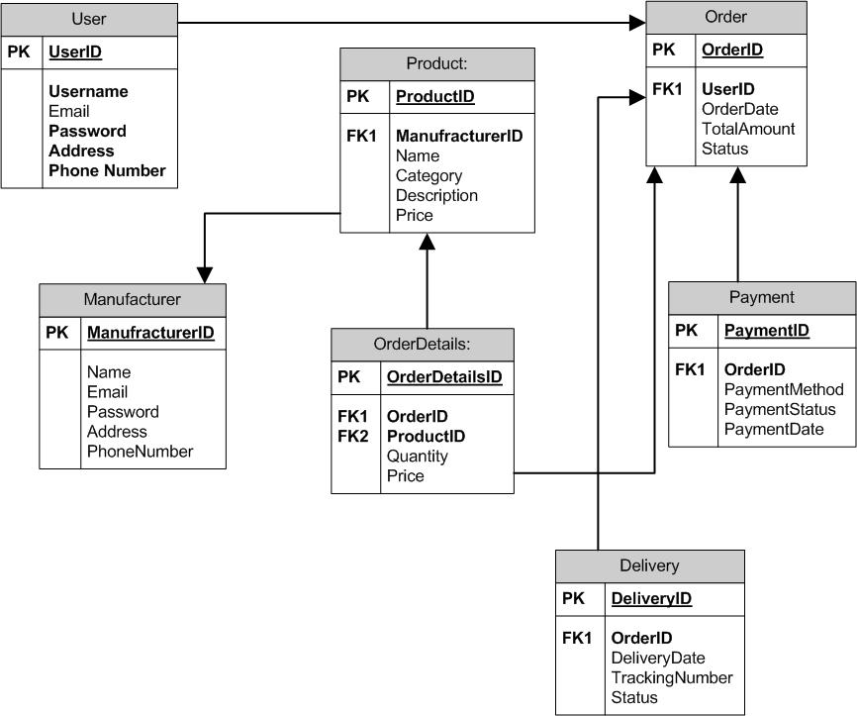

**Question 7 – What is a data flow diagram?**

A Data Flow Diagram (DFD) is a graphical representation of the flow of data within a system. It shows how data enters, is processed, and exits the system. DFDs are often used to analyze and model the structure of a system by illustrating:

* **External Entities:** External sources or destinations of data (Farmers).
* **Processes**: The operations or activities performed on the data (Seach Products, Place Order, Process Payment and Track Delivery).
* **Data Stores**: Where data is stored within the system (Product Catalogue, Order Database, Payment System and Delivery Tracking)
* **Data Flows:** The movement of data between entities, processes, and data stores.

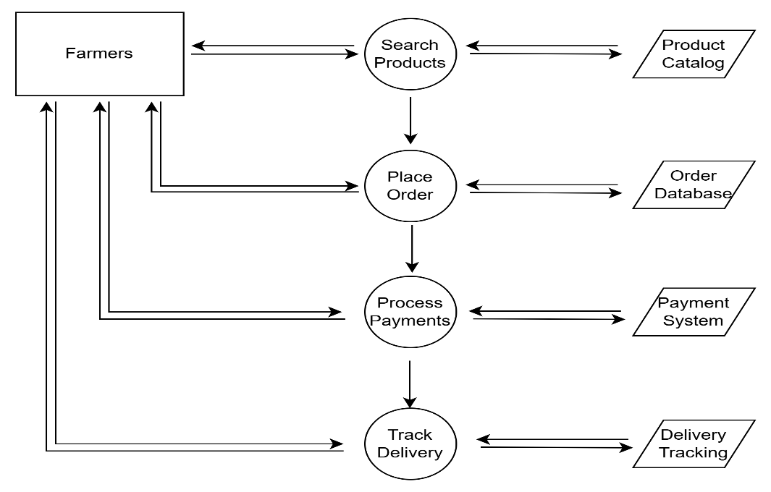

**Question 8 – Change Request**

A structured and systematic approach is necessary to deal with change requests in a project, especially if they are related to something like a change in the government taxation structure. This ensures that the change is appropriately evaluated, communicated, and implemented without negatively affecting the project's budget, timeline, or scope.

Here are the steps to respond to change requests:

1. **Change Request Received -** Formally receiving a change request by the project management team is the first step. The request typically arises because of an internal or external situation that calls for a change in the project's budget, timetable, or scope. In this case, the change request originates due to a modification in government taxation policies. The request is likely initiated by the finance or compliance team, alerting the project team about the necessity to align with new tax regulations. The project manager acknowledges this request and begins the formal process to address it.
2. **Change Request Documented** - Following receipt, the change request is formally recorded in a system or using a structured change request form. The details of the change are documented thoroughly, including the new tax rates, effective dates, and any related government mandates. The documentation may include references to official government notices or circulars. It also specifies how this impacts the project—such as modifications to financial systems, pricing models, or invoicing processes.
3. **Change Request Reviewed** The next step involves reviewing the change request to understand its validity, scope, and alignment with the project objectives. The project manager, key stakeholders, or the project team usually conduct this review. The project team reviews the change request to ensure it is valid and aligns with legal and regulatory requirements. Stakeholders assess the necessity and urgency of implementing the new taxation structure and discuss the high-level impact on the project deliverables.
4. **Performing Impact Analysis** - An impact analysis is conducted to determine how the suggested modification will impact the project after the change request has been examined and accepted as valid. A detailed impact analysis is conducted to determine how the change in taxation structure will affect different aspects of the project: Scope, Time, Budget and Risk.
5. **Updating Project Document** - The project documents, including the scope statement, project plan, and risk register, have been updated to reflect the required changes. These updates include adding tasks for updating tax calculation algorithms in the financial software and incorporating compliance reviews to ensure adherence to government-mandated changes. Additionally, the timeline and budget have been adjusted to account for these additional activities, ensuring that the project remains aligned with its objectives while addressing these new requirements.
6. **Change Control Board (CCB) -** A Change Control Board (CCB) is in responsible for examining and approving (or disapproving) project modifications in many organizations. The Change Control Board (CCB), including key stakeholders like finance, compliance, and IT leads, reviews the change. They assess the recommendations and impact analysis, then formally approve the change to proceed with implementation. The approval ensures alignment across departments and prevents scope creep.
7. **Communicate the Change -** Once the change is approved, all relevant teams are promptly informed. Internal teams, such as developers, testers, and finance, are briefed on the new requirements, while external stakeholders, including vendors and customers, are updated on changes to pricing, invoices, or tax display. Clear communication ensures everyone understands their roles during implementation.
8. **Implementing the Change -** The approved changes are implemented by updating financial and billing software to incorporate the new tax rates, adjusting reporting tools to reflect revised tax calculations, and conducting system testing to ensure the accurate application of the new tax rules.
9. **Monitor and Track the Implementation -** The project team closely monitors the implementation to ensure everything functions as intended by running test cases to validate tax calculations across various scenarios, monitoring system performance to prevent disruptions, and verifying that all updates comply with government requirements.
10. **Update Documentation and Close the Change Request -** After successful implementation, the project documentation is updated, including revisions to user manuals and tax documentation for end-users and updates to compliance records to reflect the new tax structure. Once verified and validated, the change request is formally closed, and a review is conducted to capture lessons learned.

This organized strategy ensures the smooth implementation of the tax structure change, minimizing any disturbances and ensuring adherence to governmental regulations.

**Question 9 – Change Request Vs an Enhancement**

As a Business Analyst, based on the request from Ben and Kevin to enable farmers to sell their crop yields and introduce an auction system, I would classify this as a change request rather than an enhancement.

The reason for this classification is as below:

1. **Significant Shift in Scope**: The request to allow farmers to sell their crop yields and introduce an auction system represents a fundamental change to the purpose of the application, expanding it into a broader marketplace. The original scope of the project is to provide a platform for farmers to place orders for agricultural products.
2. **New Functionality**: These features require new workflows, interfaces, business rules, and processes, none of which were part of the original scope or requirements.
3. **Impact on Timeline, Budget, and Resources**: These new features would fundamentally change the purpose and deliverables of the project, requiring a reassessment of the timeline, budget, and resources. Implementing these features would require additional development time, resources, and potentially an increased budget.
4. **Ongoing Process**: Any significant deviation from the baseline during the execution phase qualifies as a **change request**.
5. **Change Control Board (CCB):** It also allows the project stakeholders and the Change Control Board (CCB) to decide whether the new requirements should be integrated into the ongoing project. Any modification that impacts the scope in such a substantial way would need formal review and approval through a change request process. This ensures that the new features are properly evaluated for feasibility and alignment with the project's goals, and it provides a clear understanding of the impact on the project’s success.

**Question 10 – Estimations**

Estimating the number of man-hours required for developing the online agriculture product store involves breaking down the project into smaller tasks and estimating the effort required for each task.

**Types of projects on the basis of Man-Hours:**

**1. Small project – Upto 500 Man-Hours**

**2. Medium project – Upto 1000 Man-Hours**

**3. Large project – Upto 1500 Man-Hours**

Here's a high-level breakdown of tasks and their estimated man-hours:

1. **Project Planning and Requirements Gathering:**

* Task Breakdown: Defining project scope, requirement gathering and high-level system architecture planning.
* Estimated Man-Hours: 40 hours

1. **UI/UX Design**

* Task Breakdown: Design user-friendly interfaces for the web and mobile applications.
* Estimated Man-Hours: 90 hours

1. **Product Catalog Management**

* Develop features for manufacturers to upload product details and images.
* Estimated Man-Hours: 80 hours

1. **Search and Filter Functionality**
   * Implement search and filter options for farmers to easily find products.

* Estimated Man-Hours: 60 hours

1. **Frontend Development**

* Task Breakdown: Implement frontend functionalities for browsing products, placing orders, and making payments.
* Estimated Man-Hours: 150 hours

1. **Backend Development**

* Task Breakdown: Develop the backend infrastructure, including database design, server setup, and API development.
* Estimated Man-Hours: 120 hours

1. **Database Design and Setup**

* Task Breakdown: Designing database schema for key entities (Products, Users, Orders), performing data integrity checks, and optimizing database performance.
* Estimated Man-Hours: 40 hours

1. **Integration**

* Task Breakdown: Integrating payment gateways (COD, UPI, Cards), setting up email and SMS notifications for order updates, and linking delivery trackers with logistics APIs.
* Estimated Man-Hours: 80 hours

1. **Testing**

* Task Breakdown: Conducting unit testing, integration testing, system testing, stress testing for high traffic, security testing for vulnerabilities, and usability testing with stakeholder feedback.
* Estimated Man-Hours: 140 hours

1. **Deployment and Maintenance**

* Task Breakdown: Setting up servers, deploying the application, configuring CI/CD pipelines, and performing post-launch monitoring and bug fixes.
* Estimated Man-Hours: 60 hours

1. **Documentation**

* Task Breakdown: Creating user guides for farmers and manufacturers, preparing technical documentation, and drafting FAQs and troubleshooting guides for the SOONY team.
* Estimated Man-Hours: 30 hours

1. **Marketing and Awareness Integration**

* Task Breakdown: Designing a landing page for promotional campaigns, integrating social media and email marketing tools, and setting up analytics to track user acquisition and behaviour.
* Estimated Man-Hours: 30 hours

1. **Training for Stakeholders**

* Task Breakdown: Conducting onboarding sessions for the SOONY team, training farmers on app usability, and educating manufacturers on product catalog management.
* Estimated Man-Hours: 50 hours

1. **Continuous Monitoring**

* Task Breakdown: Setting up performance monitoring tools, implementing error reporting systems, and performing regular reviews during the warranty period.
* Estimated Man-Hours: 30 hours

**Total Estimated Man-Hours: 1000 hours**

This estimate may fluctuate depending on factors such as team expertise, project complexity, and unexpected challenges. Continuous monitoring and tracking of project progress will allow for adjustments to the estimates as needed during the development process.

**Question 11 – UAT**

**The UAT (User Acceptance Testing) process involves the client (and other key stakeholders) verifying that the product works according to the requirements and business needs. The process generally follows these stages:**

1. **Planning (Prepare for UAT)**

* Identify key stakeholders, including farmers, suppliers, and business owners, for UAT participation.
* Review business requirements, ensuring critical functionalities like product search, payment methods, and delivery tracking are included.
* Develop a UAT plan with defined scope, test cases, and timelines, and set up a staging environment for testing.

1. **Designing (Prepare the Product for UAT)**

* Align the product’s UI/UX with client and end-user expectations, ensuring ease of use for rural and tech-savvy users alike.
* Conduct a walkthrough of key features like browsing categories, adding products to cart, and order tracking with stakeholders.
* Prepare test cases and realistic datasets (e.g., agricultural product listings, regional pricing) for accurate testing scenarios.

1. **UAT Testing (Client Conducts UAT)**

* End-users execute test cases to validate functionality, such as searching for fertilizers, placing orders, and making payments.
* The BA monitors progress, collects feedback on missing features or usability issues, and logs them for resolution.
* Identify and address any concerns during testing, ensuring the system meets expectations for functionality and performance.

1. **Bug Fixing (Issue Resolution and Retesting**)

* Prioritize and resolve critical issues like payment gateway failures, incorrect pricing, or slow loading times.
* Facilitate retesting of fixed functionalities, ensuring all bugs are resolved and no new ones are introduced.
* Maintain regular updates with stakeholders on progress and timelines for final delivery.

1. **Sign-Off (Final Client Review**)

* Conduct a final review to confirm all requirements, such as delivery tracking and product catalogue functionality, are met.
* Obtain formal UAT sign-off from the client, signifying that the system is ready for deployment.
* Document feedback, summarize lessons learned, and transition to post-launch support for ongoing maintenance.

By following a structured approach to UAT planning, designing, testing, bug fixing, and sign-off, organizations can ensure that the final product meets user expectations, minimizes the risk of post-deployment issues, and maximizes user satisfaction.

**Question 12: Project Closure Document**

**A project closure document**, also known as a project closure report, is a formal document that summarizes the key outcomes, lessons learned, and final details of a completed project.

It serves as a comprehensive record of the project's accomplishments, challenges, and overall performance, providing valuable insights for stakeholders and future projects.

**Points to be included in the Project closure document are:**

* + 1. **Project Overview**
* Introduction to the project, including its objectives, scope, and key stakeholders.
* Overview of the project's lifecycle, including major milestones and phases.
  + 1. **Achievements**
* Highlight key successes and deliverables achieved during the project lifecycle.
* Quantitative outcomes, such as cost savings, improved efficiency, or increased revenue.
* Recognition of team contributions and innovations that added value.
  + 1. **Lessons Learned**
* Insights into what worked well and contributed to the project’s success.
* Identification of areas for improvement in processes, tools, or communication.
* Recommendations for future projects based on challenges faced and solutions implemented.
  + 1. **Quality Assurance**
* Overview of testing and validation activities to ensure deliverables met quality standards.
* Summary of defects or issues resolved and their impact on project outcomes.
* Final assessment of adherence to quality benchmarks and client satisfaction.
  + 1. **Resource Utilization**
* Analysis of resource allocation and usage (e.g., human, financial, and technical resources).
* Identification of over-utilized or under-utilized resources and their impact on the project.
* Recommendations for optimizing resource planning in future projects.
  + 1. **Risk Management**
* Summary of risks identified at the beginning of the project and their mitigation plans.
* Evaluation of how effectively risks were managed during the project.
* New risks encountered and lessons for better risk management in future projects.
  + 1. **Challenges**
* Key obstacles faced during the project and their impact on timelines or deliverables.
* Strategies or actions taken to address challenges and minimize disruptions.
* Evaluation of unresolved challenges and their implications for future efforts.

The Project Closure Document serves as a formal record of the project's completion and provides valuable insights and documentation for future reference, ensuring that the project's outcomes are captured and disseminated appropriately.

|  |  |  |  |
| --- | --- | --- | --- |
| **S/N** | **Points to Include** | **Details** | **Reference Link1** |
| **1** | **Did the client sign off on the**  **UAT testing** |  |  |
|  | Date of Signoff | 12-MAR-2026 | Business_Scope.docx |
|  | Name of the resource | Mr. Vedant |
| **2** | **Objectives of the project** |  |  |
|  | User friendliness | Achieved |  |
|  | Customer satisfaction | ROI (Return of Investment) in 6 to 12 months |  |
|  | More Categories | Achieved |  |
| **3** | **Functionalities worked on** |  |  |
|  | Secured payment process | Achieved | FRD.docx |
|  | Categories | Achieved |
| **4** | **Infrastructure** |  |  |
|  | Software installed | Achieved | Procurement.docx |
|  | Laptops purchased | Achieved |
| **5** | **Funding** |  |  |
|  | Amount approved | 2 Crores | Financialdetails.xlsx |
|  | Amount used | 2 Crores |
| **6** | **Overall project information** |  |  |
|  | Escalations | 30 |  |
|  | Customer satisfaction | High |  |
| **7** | **Value to the company** |  |  |
|  | Positive/Negative | Positive- 90%  Company has gained  successful integration of  processes, increased  turnover by 25%, increased  efficiency by 20% |  |