|  |
| --- |
| Question 1 – Functional Requirements - 15 Marks |

Identify minimum 20 functional requirements

Example :

Functional requirement: When an order is fulfilled, the local printer shall print a packing slip.

Non-Functional Requirement: Packing slips shall be printed on both sides of 4”x 6” white paper, the standard size for packing slips used by local printers.

ANSWER:-

|  |  |  |  |
| --- | --- | --- | --- |
| Req ID | Req Name | Req Description | Priority |
| FR001 | Farmer registration | Farmer should be able to register their detail on the portal | 9 |
| FR002 | Farmers login id password generate | Farmer should be able to generate login id password | 10 |
| FR003 | Manufacturer registration | Manufacturer should be able to register their id | 9 |
| FR004 | Manufacturer product details | Manufacturer should be able to update their product details | 9 |
| FR005 | Mode of payment | Farmer should able to select any mode of payment like COD,card payment ,net banking, upi | 8 |
| FR006 | Product display | the application should display the details o the product on the screen | 8 |
| FR007 | Add to cart | The farmer shouble able to add the product in the cart for purchase | 8 |
| FR008 | Apply the filter | The farmer should be able o apply the filter by category or by price,color,size | 8 |
| FR009 | Order confirmation | The user should be able to received the confirmation of the order | 8 |
| FR0010 | Return policy | Farmer should be able to apply the return mark and refund facility | 9 |
| FR0011 | Sharing the product | The users are able to share the product to other people | 7 |
| FR0012 | Search the history | User should be able to see the order history | 7 |
| FR0013 | Feedback for product | User are able to see the products feed back how actual is worked | 8 |
| FR0014 | Discount policy | Farmer should be allow to purchase the product on discount | 8 |
| FR0015 | Account management | Users should be allow to manage their account | 7 |
| FR0016 | Tracking delivery | Manufacture and farmer should be allow to track the odre | 9 |
| FR0017 | Customer care | Users are able to connect with customer car via chat email phone call | 9 |

NON FUCTIONAL:-

|  |  |  |  |
| --- | --- | --- | --- |
| Req ID | Req Name | Req Description | Priority |
| NFR001 | Stock availability | Stock availability shoud be updated on time | 10 |
| NFR002 | Internet connectivity | Users should have th internet connectivity | 10 |
| NFR003 | Net banking | Users should have a net banking to do the payment for order | 9 |
| NFR004 | Password updating | User should get the notification for change password | 8 |
| NFR005 | Time limitation for otp | OTP time limit should be 2 min for logon | 8 |
| NFR006 | Email | EMAIL should be updated in the app for notification | 8 |
| NFR007 | Logout facility | If the user is not access the page more than 5 mon the screen should be logout | 7 |
| NFR007 | GST | The price should be display with GST | 9 |
| NFR008 | Stock check | Once the product is sold ,the stock of the product should be reduced | 7 |

|  |
| --- |
| Question 2–Minimum 5 page designs - 15 Marks |

Make wireframe and prototypes

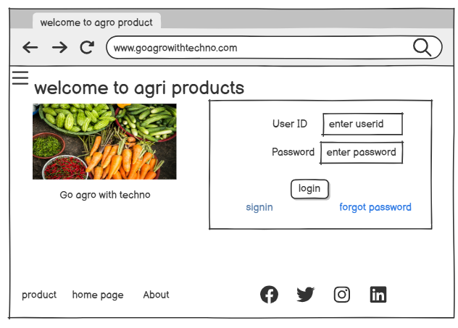

SIGNUP:

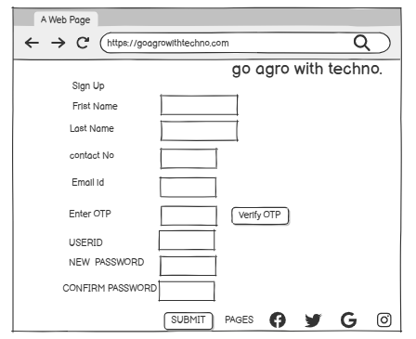

Add to cart:-

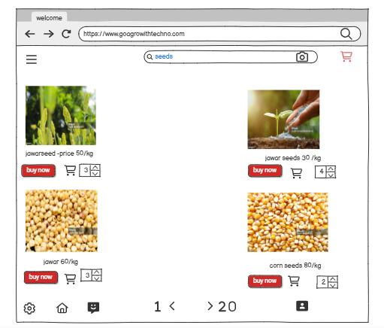

Place order details screen:

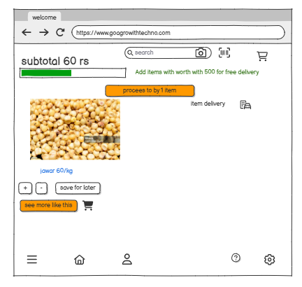

Place order:-

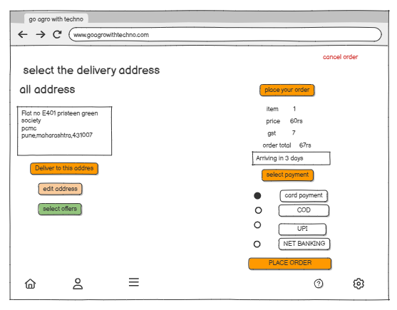

|  |
| --- |
| Question 3 – Tools (Visio, Balsamic) - 15 Marks |

Make a note of the Tools, which you are using for above concepts.

ANSWER:-

BALESMIC:- Balsamic is a effective tool for representing the software requirement in the form of wireframes. It helps to the software development and users to visualize how the project will looks like at very early stage of the project. This is the small demo where we cover all the basic steps needed to start with balsamic.

VISIO:- MS Visio is a graphic application use for create a diagram, flow chart, UML Diagram ,it is commonly use for the visual collaboration and process mapping, it can help to making a presentation ,floor plan . Ms Visio can connect with data sources like Excel, SQL Server, and SharePoint to create dynamic, data-driven diagrams.

Common use:

* Business process modelling
* Flowcharts
* Organizational charts
* Floor plans and engineering schematics
* Software and database modelling

1) Business process model:- it is flowchart method to create which display all the process in the project, it help to give a clear understanding of the process through the visual representation.

2) Floor plan:-A floor plan is the structure of room and specific place, architecture use it place the door, window and other project

3) Organisational charts:-it represent the rolls and reporting relationship in a business .it shows the structure of the organisation.

4) flowcharts:- flowchart shows the process step by step in a sequential order, this steps are need to be complete the process it can be used in multiple field.

|  |
| --- |
| Question 4 – RTM - 6 Marks |

A business analyst’s key responsibilities are to keep track of the requirements and make sure that no requirement is missed Mr. Henry and peter have approached you regarding the current status of the project. How will you tackle this situation?

|  |  |  |  |  |  |  |  |  |  |  |  |  |
| --- | --- | --- | --- | --- | --- | --- | --- | --- | --- | --- | --- | --- |
| REQ ID | REQ NAME | REQ DESCRIPATION | DESIGN | D1 | T1 | D2 | T2 | D3 | T3 | D4 | T4 | UAT |
| FR001 | Farmer registration | Farmer should be able to register their details | y | y | y | y | y | y | y | y | y | N |
| FR002 | Generate ID and password | Farmer able to generate id password | Y | Y | Y | Y | Y | Y | Y | Y | Y | N |
| FR003 | Add to cart | User should be able to add the product in the cart | y | y | y | y | y | y | y | y | y | N |
| FR004 | Filter | User should be able to apply the filter | y | y | y | y | y | y | y | N | N | N |
| FR005 | Search product | User should be able to search the product | y | y | y | y | y | y | y | y | y | N |
| FR006 | Offers | Farmer should be able to check and apply the offer during payment | y | y | y | y | N | N | N | N | N | N |
| FR007 | Address | Farmer should be able to change their delivery address | y | y | y | y | N | N | N | N | N | N |
| FR008 | Return policy | User should be able to return the product if there is any problem | y | y | N | N | N | N | N | N | N | N |
| FR009 | Manufacturer registration | Manufacturer able to register their details | y | y | y | y | y | y | y | y | y | N |
| FR0010 | Product upload | Manufacturer should be able to upload their product details | y | y | y | y | y | y | y | y | y | N |
| FR0011 | Documentation | Manufacturer should be able to link their firm documentation to portal | y | y | y | y | y | y | y | N | N | N |
| FR0012 | Notification | Manufacturer get the notification while after user places the order | y | y | N | N | N | N | N | N | N | N |
| FR0013 | Order confirmation | Farmer should get the confirmation via email and msg | y | y | y | y | y | y | y | N | N | N |
| FR0014 | Inventory update | Manufacturer should be able to get the notification of inventory updation status | y | y | y | y | N | N | N | N | N | N |
| FR0015 | Track the product | Farmer and manufacturer have the access to track the product | y | y | y | y | y | y | N | N | N | N |
| FR0016 | OTP | Farmers should get the OTP for safe payment | y | y | y | y | N | N | N | N | N | N |
| FR0017 | Expected delivery date | Farmer should be able to see the expected delivery date | Y | Y | Y | Y | Y | Y | Y | N | N | N |
| FR0018 | SimilarN product | Users able to see the similar product for comparision | y | y | N | N | N | N | N | N | N | N |
| FR0019 | Return and pickup | Users should be able to put the details of return or exchangeable product | y | y | N | N | N | N | N | N | N | N |
| FR0020 | Communication | Seller and buyer should be able to communicate with each other to avoid the misunderstanding | y | y | N | N | N | N | N | N | N | N |
| FR0021 | Mode of payment | User should be able to use any mode of payment | y | y | y | y | N | N | N | N | N | N |
| NFR001 | Page loading time | Portal page should be loan in 2 sec | y | y | y | y | y | y | y | y | y | N |
| NFR002 | Time limit for OTP | OTP will be valis for next 5 min for login | y | Y | Y | Y | N | N | N | N | N | N |
| NFR003 | SMS and EMAIL confirmation | Automated email and message should be sent to user | y | y | N | N | N | N | N | N | N | N |
| NFR004 | Internet | System should be connect with the system | y | y | y | y | y | y | y | y | y | N |
| NFR005 | Net banking | Bank details should be register in app for smooth payment | Y | Y | N | N | N | N | N | N | N | N |
| NFR006 | Change Password | User allow to change their password in 30 days | y | y | y | y | y | y | y | y | y | N |

|  |
| --- |
|  |

|  |
| --- |
| Question 5 – 10 Test Case Documents - 10 Marks |

Prepare 10 Test Case Documents

ANSWER:- TEST CASE DOCUMENT 1

|  |  |
| --- | --- |
| Test case for user login details |  |
| description | User need to login the details with user id and password |
| pre condition | user need a basic internet connection and gadget |

|  |  |  |  |  |  |  |
| --- | --- | --- | --- | --- | --- | --- |
| test scenario | test case | test step | test data | expected behaviour | post condition | status |
| verify the user login with user id and password | enter user id and password | enter user name | <valid user name> | done | home page | pass |
|  |  | enter password | <valid password> |  |  |  |
|  |  | click login button |  |  |  |  |

|  |  |  |  |  |  |  |
| --- | --- | --- | --- | --- | --- | --- |
| verify the user login with user id and password | enter user id and password | enter user name | <valid user name> | login not done | invalid password | fail |
|  |  | enter password | <invalid password> |  |  |  |
|  |  | click login button |  |  |  |  |

2)TEST CASE DOCUMENT:

|  |  |  |  |  |  |  |
| --- | --- | --- | --- | --- | --- | --- |
| test scenario | test case | test step | test data | expected behaviour | post condtion | status |
| user wants to browse the agriculture product | Brows product | 1.navigate the product  2.click different category  3.view the product details | search the seeds, fertilizer, pesticides | user can view all the product | product details page | pass |
| user wants to browse the agriculture product | Brows product | 1.navigate the product  2.click different category  3.view the product details | search the seeds, fertilizer, pesticides | user can view all the product | Search product not listed | Fail |
|  |  |  |  |  |  |  |

3) USE CASE DOCUMENT :-ADD TO CART

|  |  |  |  |  |  |  |
| --- | --- | --- | --- | --- | --- | --- |
| Test case | | product add to cart | | | | |
| description | | Ensure that users can add a product to their cart. | | | | |
| pre-condition | | User must be logged in. | | | | |
| test scenario | test case | | test step | test data | expected behaviour | post condition | | status |
| user want to add the product in car | adding product in to cart | | 1. Search product. 2. Select the product 3. add to the cart | select the data from CatLog | product successfully added | view the cart page | | pass |
| user want to add the product in car | adding product in to cart | | 1. Search product. 2. Select the product 3. add to the cart | not able to select the data | product successfully added | return to home page | | fail |

4) User test case document:- cash on delivery

|  |  |  |  |  |  |  |
| --- | --- | --- | --- | --- | --- | --- |
| Test case | | COD payment | | | | |
| description | | Ensure that user having a bank account for payment | | | | |
| pre -condition | | User must be logged in. | | | | |
| test scenario | test case | | test step | test data | expected behaviour | post condition | | status |
| check the availability of COD | Select the COD payment mod | | 1. Select product 2. Add to cart 3. click on "buy now" option 4.select the mode of payment COD | Upi , net banking, card payment, cod available | order placed successfully | home page | | pass |
| check the availability of COD | COD not available | | COD not available | Upi , net banking, card payment, cod available | Select another MOD | COD not available | | fail |

5) TEST CASE DOCUMENT:- DEBIT CARD PAYMENT

|  |  |  |  |  |  |  |
| --- | --- | --- | --- | --- | --- | --- |
| Test case | | debit card payment | | | | |
| description | | do the payment through the debit card | | | | |
| pre -condition | | ensure user must have the bank account and debit card for the payment | | | | |
| test scenario | test case | | test step | test data | expected behaviour | post condition | | status |
| Select the debit card as MOD | Select the COD payment mod | | 1. select debit card payment 2.enter the card number 3.enter the expiry date 4.cvv no 5.otp | valid debit card no, valid expiry date, valid cvv , valid OTP | order placed | order page | | pass |

6) TEST CASE DOCUMENT:-RETURN/CANCELLATION PRODUCT

|  |  |
| --- | --- |
| Test case | product cancellation process/return |
| description | user want to cancel the order |
| pre -condition | Ensure customer placed the order and log in application |
|  |  |
|  |  |

|  |  |  |  |  |  |  |
| --- | --- | --- | --- | --- | --- | --- |
| test schenario | test case | test step | test data | expected behaviour | post condtion | status |
| The product cancellation/return | The user want to cancel/return the product | 1. select the ordered product 2.click on return/cancel order 3.mark return reason/cancel 4.submit | 1.cancel/return select 2.select the pickup address | order successfully cancel/return | cancelation page | pass |

7)TEST CASE DOCUMENT:COUPEN CODE APPLY

|  |  |  |  |  |  |  |  |  |  |
| --- | --- | --- | --- | --- | --- | --- | --- | --- | --- |
| Test case | | coupon code apply | | | | | |  | |
| description | | user want to apply the coupon code while ordering the product | | | | | |  | |
| pre -condition | | customer has to place a order for coupon and need to login in application | | | | | |  | |
| test scenario | test case | | test step | test data | expected behaviour | post condition | status | |
| user should be able to apply the coupon code | user want to apply coupon code while place the order | | 1.select the product 2.bye now 3.apply suitable coupon 4.click on order | 1.coupen code accepted | coupon code successfully apply | payment page | pass | |

8) TEST CASE DOCUMENT:-ADD PRODUCT DETAILS

|  |  |  |  |  |  |  |
| --- | --- | --- | --- | --- | --- | --- |
| Test case | | Upload the product on portal | | | | |
| description | | seller need to add the product with details | | | | |
| pre -condition | | seller need a login to app and basic internet connection | | | | |
| test scenario | test case | | test step | test data | expected behaviour | post conditions | | status |
| product add to the portal | seller need to add their product with details | | 1.upload image 2.upload name 3.upload price 4.upload information | 1.image updated 2.name updated 3price updated | product is successfully add on the portal | home page | | pass |

9) TEST CASE DOCUMENT- SEARCHED PRODUCT

|  |  |  |  |  |  |  |
| --- | --- | --- | --- | --- | --- | --- |
| Test case | | Search product | | | | |
| description | | User wants to search the product | | | | |
| pre -condition | | user need to login app | | | | |
| test scenario | test case | | test step | test data | expected behaviour | post condition | | status |
| product search | enter the product name user want to search | | 1.enter the product name in search bar | 1.product name entered and searched | product successfully searched | show multiple searched product | | pass |

10) TEST USE CASES:-CREDIT CARD PAYMENT

|  |  |  |  |  |  |  |
| --- | --- | --- | --- | --- | --- | --- |
| Test case | | CREDIT CARD PAYMENT | | | | |
| description | | User want to do the payment through credit card | | | | |
| pre -condition | | user should have credit card and bank account | | | | |
| test scenario | test case | | test step | test data | expected behaviour | post condition | | status |
| user should be able to do the payment through the credit card | select the credit card as MOP | | 1.select the credit card option 2.enter expiry date 3.cvv no 4.otp | 1. credit card no 2. Expiry date 3. cvv 4.otp | payment successfully done | order page | | pass |

|  |
| --- |
| Question 6 – DB Design – 8 Marks |

After the requirements are thoroughly explained to the entire project team by business analyst, the Database architects have decided to do the database design and also to represent the in-flow and out-flow of data.

Draw database schema and ER diagram

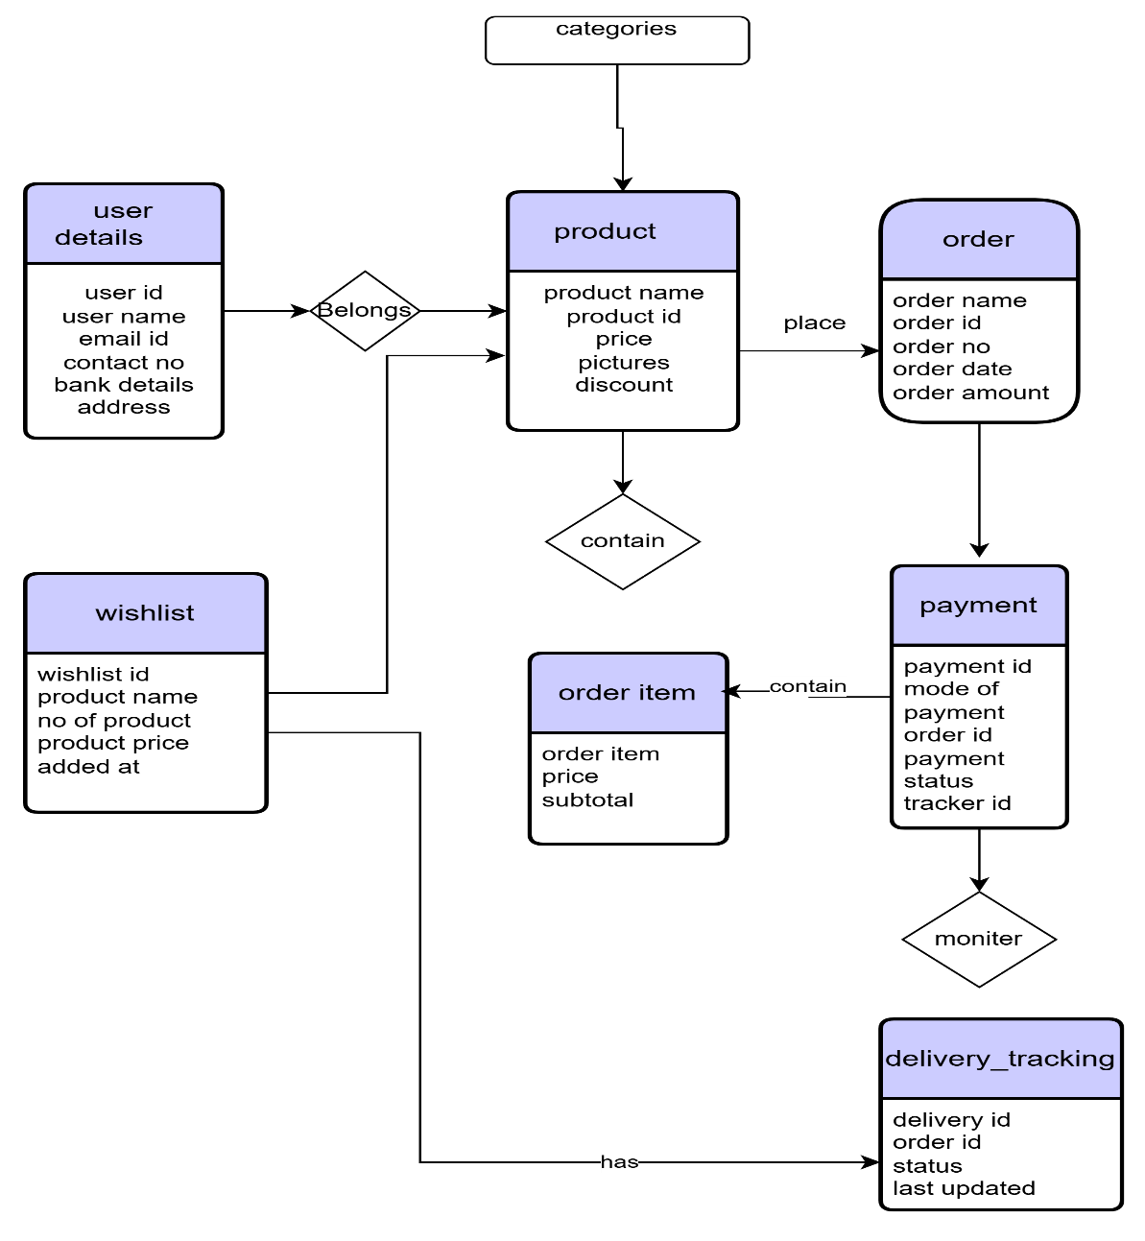

|  |
| --- |
| Question 7 – Data Flow Diagram - 3 Marks |

,

ANSWER :- A **Data Flow Diagram (DFD)** is a graphical representation of the flow of data through a system. It shows how data is input, processed, stored, and output within a system. DFDs help in understanding system functionality, data movement, and interactions between entities.

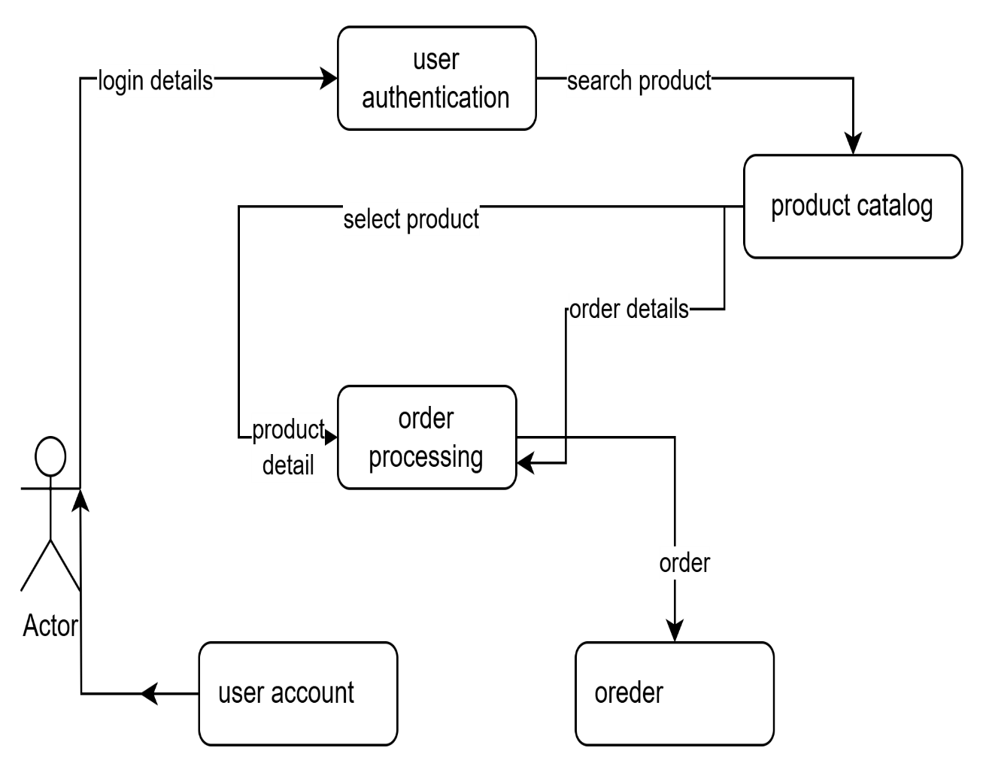

|  |
| --- |
| Question 8 – Change Request - 10 Marks |

Due to change in the Government Taxation structure. We should change the Tax structure how do you handle change requests in a project?

ANSWER:-

Generally in change request in that scenario when stakeholder, project team or user want to change the process or requirement but in this scenario government has change the tax structure so it is a compression for a change request so there is no need for feasibility study ,team should apply the change request according to the government.

* DOCUMENT THE CHANGE REQUEST : -

- Do the proper documentation of change request after identifying the same

- The taxation change request should be formally raised

- check what calculation need to be done

* IMPACT:-
* It will impact on time line to complete the change request
* It will impact on budget
* Do the analysis how the change request impact on product, compliances , timeline, budget
* APPROVAL:-
* Do the analysis of the change request
* Send the change request to the management committee for approval
* IMPLIMENTATION:-
* After approval update all the request to team member
* The developer will work on change request and modify the tax.
* Update the tax related data
* COMMUNICATION:-
* After the approval communicate the changes to farmer and manufacturer via e mail or contact number
* POST IMPLIMENTAION IMPACT:
* Monitor the transaction to ensure the change request is on the right path
* Take feedback from user if any issue

|  |
| --- |
| Question 9 – Change Request Vs an Enhancement - 5 Marks |

As the project is in process, Ben and Kevin have contacted you. The reason is to inform you that they want the Farmers to sell their crop yields through this application i.e. Farmers should be able to add their crop yields or products and display to general public and should be able to sell them. They also want to introduce Auction system for their Crop yields. As a BA, what will be your response?

Is this a change request or an enhancement???

ANSWER:-

Ben and Kevin’s request to allow farmers to sell their crop yields and introduce an auction system is a **major functional addition** to the original scope of the project. Initially, the application was designed as an **agriculture product store** for farmers to buy fertilizers, seeds, and pesticides from manufacturers. However, enabling farmers to sell their own products and introduce an auction system introduces a **new business model** within the application.

This request is a change request rather than the enhancement

* As per this case study the seller is manufacturer and farmer is buyer so this the B2C model
* But after this request this platform will convert in C2C model where farmer can sell their corps directly to the customer.
* Auction is additional function introduced which is not mentioned in the initial plan.

|  |
| --- |
| Question 10 – Estimations - 6 Marks |

Come up with estimations – How many Man-hours required?

Numbers of working hour in a day-8 hours

Numbers of resources-8 developers (40 hours per week)

Time period- 18 month (547 days) (78 week)

Weekend and public holiday-166

547-166=381

MANHOURS required =hours working per day* total number of team*number of days of working period

8 hours *8 resources*381 days= 24384

|  |
| --- |
| Question 11 – UAT – 6 Marks |

Project has finally completed all the stages i.e., design, development, testing etc. Now, it is the role of a business analyst to contact the client for testing of the final product and have to successfully complete it. How are you going to handle this situation? And once it is done, what will be the process to close the project?

Explain UAT Acceptance process

ANSWER:- As a Business Analyst, my role is crucial in ensuring that the final product aligns with the client's expectations and requirements. To check the product is ready to use for user without any errors and bugs.

* Ensure that all development, testing, and bug-fixing activities are complete, and the system is stable.
* Create a UAT plan to verify the application meets its business requirement with the documents like business use case, process flow diagram, BRD ,SRS
* List the key functionality base on the requirement
* Create a test cases for the client testing (e.g. login, search, ordering payment)
* Identify the key stake holder who represent or help the farmer and manufacturer to explain the application (kelvin, peter, ben)
* Coordinate with the client and stakeholders to conduct the testing in a structured manner.
* If there is any issue in UAT the BA will document them and send them to development team if needed
* Once the UAT successfully completed the client will sign off on the UAT document
* It means project is successfully completed and ready for the use
* So the system can move to the production
* Provide the training to farmer and manufacturer how to use the application
* Conduct the closure meeting with the stakeholder to announce the project officially closed

|  |
| --- |
| Question 12 – Project Closure Document - 6 Marks |

Explain Project closure document

ANSWER:

|  |  |
| --- | --- |
| Project name | Go agro with techno |
| Project sponsor | Mr Henry |
| Project manager | Mr. Vandanam |
| Client name | Soony company |
| Project timeline | 18 montha |
| Project budget | 2 cr INR |
| Delivery partner | APT solution |

Project overview:

Objectives & Goals

* Provide an online platform for farmers to buy fertilizers, seeds, and pesticides.
* Enable direct communication between farmers and manufacturing companies.
* Implement an easy-to-use search and catalog system for products.
* Ensure secure login, payment options (COD, Credit/Debit, UPI), and order tracking.

|  |  |  |
| --- | --- | --- |
| 3.Key deliverables: |  |  |
|  |  |  |
| **Deliverable** | **Status** | **Remarks** |
| Online Web/Mobile Application | Completed | Fully tested and deployed |
| Product Catalog & Search Functionality | Completed | Farmers can browse products easily |
| Secure User Authentication | Completed | Farmers & manufacturers can log in |
| Order & Payment Processing | Completed | Supports COD, UPI, and Cards |
| Email Confirmation System | Completed | Automated order status updates |
| Order Tracking System | Completed | Allows farmers to track their orders |
| User Training & Documentation | Completed | User manuals provided |

4.UAT:

* Conduct the UAT session for check the product is ready for users with out any bugs and error
* Do proper documentation for the UAT
* Involved the stakeholder tester developer in UAT
* Help the farmer and manufacturer how to use the application
* Once the UAT is properly done the all stakeholder will signoff the form
* Do the official announcement the project is successfully completed

5. Sign-Off & Project Closure Approval

|  |  |  |  |
| --- | --- | --- | --- |
| Name | Role | Signature | Date |
| Mr. Henry | Project Sponsor | Signature | 01-04-2025 |
| Mr. Pandu | Financial Head | Signature | 01-04-2025 |
| Mr. Dooku | Project Coordinator | Signature | 01-04-2025 |
| Mr. Vandanam | Project Manager | Signature | 01-04-2025 |
| APT IT SOLUTIONS Rep | Vendor | Signature | 01-04-2025 |