**Question 01** – Functional Requirements. Identify minimum 20 functional requirements

**Ans-**

|  |  |  |  |
| --- | --- | --- | --- |
| Req ID | Req Name | Req Description | Priority |
| FR0001 | Farmer Login | Farmers should be able to login with the application | 8 |
| FR0002 | Farmer Search for Products Category | Farmers should be able to search for specific product category. | 8 |
| FR0003 | Product Images Zoom in | Product Images in the product detail page should have the option to zoom in. | 6 |
| FR0004 | Order status | The application should show order statuses: confirmed, processing, shipped, returned. | 5 |
| FR0005 | Share product information on Social media | Our product info should be shared on social platforms like Facebook, Instagram, Pinterest, and Linkedin. | 2 |
| FR0006 | Confirmation email after new account creation | The system sends a confirmation email when a new user account is created. | 7 |
| FR0007 | Cyber Security | Application should be shutdown in the case of a cyber attack. | 4 |
| FR0008 | Third party Integration | The application should be integrated with different payment gateways(third party). | 8 |
| FR0009 | User comments | Users comments should appear on the product detail page in the “Customer Reviews” page. | 3 |
| FR0010 | Payment priority | Paypal, Phonepay, GooglePay should be the priority payment. | 2 |
| NFR0101 | Find product easily | A customer should easily find the right product. | 8 |
| NFR0102 | Admin can assign roles and permissions | Only the system data admin can assign roles and change access permissions to the system. | 7 |
| NFR0103 | Homepage loading time | The website’s homepage should load in less than 4 seconds. | 6 |
| NFR0104 | Page loading time | The site should load in 3 seconds when the number of simultaneous users are > 10000 | 4 |
| NFR0105 | Login time | User should be able to logged in within 2-3 seconds. | 8 |
| NFR0106 | Handle multiple users at a time | The system should be able to handle 1 million users without performance degradation. | 5 |
| NFR0107 | Payment Processing Gateway | The payment processing gateway must be PCI DSS compliant. | 5 |
| NFR0108 | Date format | The date format must be as follows:  dd/mm/yy | 4 |
| NFR0109 | Error rate of payment details | The error rate of users submitting their payment details at the checkout page mustn’t exceed 10 percent. | 6 |
| NFR0110 | Email sending time | Emails should be sent with a latency of no greater than 12 hours. | 7 |

**Question 2**–Minimum 5 page designs

Ans-

Homepage design

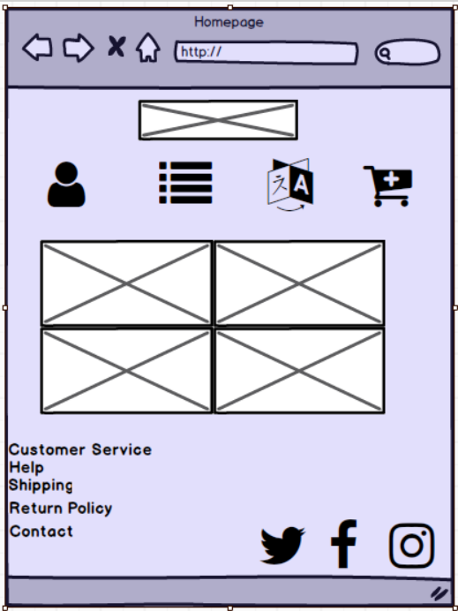

Category Name

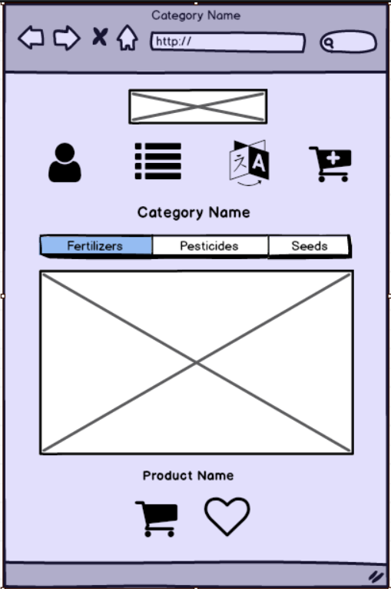

**Checkout Screen**

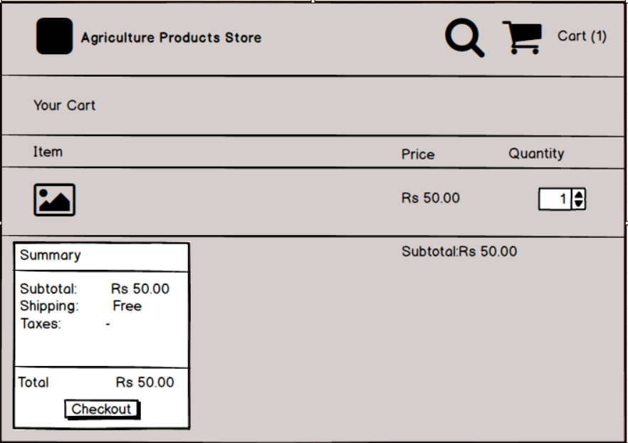

**Customer Information**

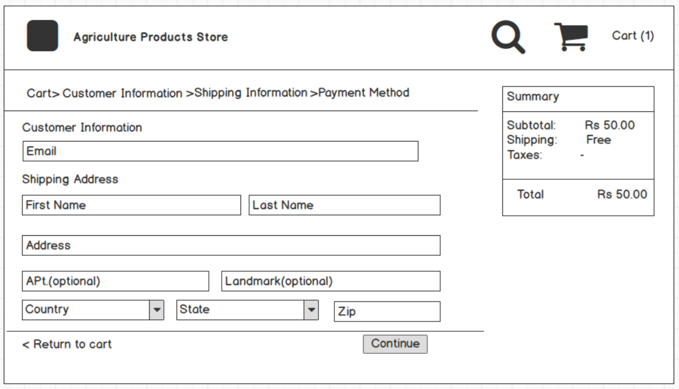

**User login**

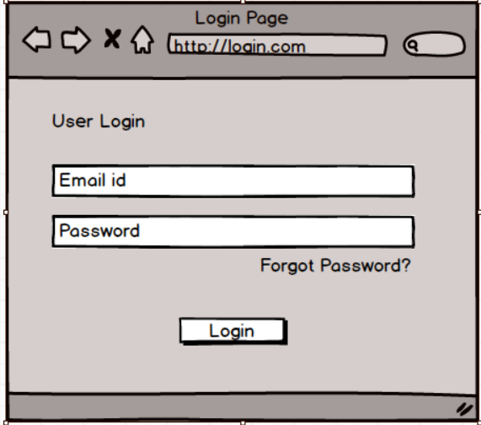

**Question 3** – Tools (Visio, Balsamiq)

Make a note of the Tools, which you are using for above concepts.

**Ans-**

**1.Visio-Vis**

1. **Microsoft Visio** is a diagramming tool to create simple as well as complex diagrams and vector graphics. It enables you to create detailed organization charts, floor plans and pivot diagrams according to your business needs.
2. It comes with inbuilt templates which helps you virtually create diagrams of any complexity like shape-based artwork or complex drawing.
3. Important file types available with Visio are VSD (Visio Drawing), VSS (Visio Stencil), and VST (Visio Template).
4. Stencils contain a collection of related shapes.
5. The Quick Access Toolbar allows you to add often used command so that you can easily access it as when needed.
6. The Ribbon is a panel which contains functional groupings of buttons and drop-down lists organized by tabs.
7. The File tab provides a centralized location which is called the Backstage View.
8. Home tab is a default tab in Visio.
9. Insert tab allows you to insert illustrations, diagram parts, links, and text.
10. Insert tab allows you to make changes in the background, page setup, borders, color schemes, and basic layout of your drawings.
11. Using the data tab, you can link your database data to shapes, create data graphics, and insert horizontal and vertical legend.
12. You can use this tab to import and export workflow and link an existing subprocess with a shape in a larger process.
13. Review tab offers you to add comments and check the spelling.
14. View tab allows you to personalize your view of the drawing screen. For that, various tools are given to add rulers, gridlines, guides, and page breaks.
15. Applications of Microsoft Visio are Business Process Diagrams, Organization Charts, Brainstorming Diagram, and Building Plan.
16. VISIO Provides diagramming capabilities to prepare various business engineering Software, and Database Architecture easily.
17. Prepare BPMN Models, Maps, and Diagrams. Prepare Flow Charts, Capture Brain Storming discussions, etc.
18. The ribbon interface is not as instinctive and hides some features.
19. Microsoft Visio doesn’t have features, like reverse engineering for database models.

**2.Balsamiq-**

1. Balsamiq Wireframes is a user interface design tool for creating wireframes (sometimes called mockups or low-fidelity prototypes).
2. You can use it to generate digital sketches of your idea or concept for an application or website, to facilitate discussion and understanding before any code is written.
3. The completed wireframes can be used for user testing, clarifying your vision, getting feedback from stakeholders, or getting approval to start development.
4. Balsamiq serves as an excellent tool, fulfilling all the requirements of Wireframing, collaboration and creativity. Its unique set of features enables the team member to do rapid Wireframing, get a consensus on the feature to be developed. This will eventually have the team aligned with functionality in terms of the layouts.
5. It also enables collaboration over different teams, so that a team member can collaborate with different co-located or remotely located teams. Its ability to export the wireframes in PDF/PNG formats allows for a flexibility, while sharing the wireframes with the teams.
6. We now know how Balsamiq is efficient for creating the wireframes on-the-fly. If we utilize this time early during the software development to set the expectations of the stakeholder, there will be a higher satisfaction among the stakeholders considering the minimal amount of time required to create the wireframe. This is the primary reason why Balsamiq is used by majority of the product organizations, where meeting customer/stakeholder relations are crucial.
7. For a Product Manager / UX Analyst, Balsamiq Mockups provide a platform to add value early in the development. By using its rich toolset, Product Manager / UX Analyst can drive the product seamlessly towards its success.
8. UI Library-

UI Library is categorized as per different screen elements. You can scroll horizontally on “All” section and get an idea about the screen elements available in Balsamiq.

Different basic screen elements categories available in Balsamiq.

* **All** − This covers all the UI elements present in Balsamiq. You can scroll horizontally to view/use them.
* **Assets** − For the purpose of introduction, these are the custom assets as uploaded by the user.
* **Big** − This category includes the screen elements, which are reasonably high in size/appearance. You can see the elements such as placeholders, browser window, iPad, iPhone in this category.
* **Buttons** − It includes all the button controls used in mobile/web wireframes. A typical example will be action button, checkbox, etc.
* **Common** − These are different shapes/controls used to denote the most common interactions.
* **Containers** − As the name suggests, it is inclusive of the Window, Field Set, Browsers, etc.
* **Forms** − All the UI controls related to a form are present in this category.
* **Icons** − At any given point, you might need to denote a particular operation by an icon. For instance, in the recent past, we have the floppy icon with the Save button. This category of controls will provide you with the icons required for this operation. Balsamiq has a huge collection of icons; feel free to check them!
* **iOS** − The UI controls, specific to Apple iOS mobile operating system, are available under this category.
* **Layout** − When representing a basic page/feature, it becomes important to represent the basic layout. The category layout includes most of them, such as Accordian, Horizontal/Vertical Tabs, etc.
* **Markup** − Suppose you want to add a comment on a particular control in the wireframe. The comment box is available in the markup. In addition, callouts are used to show interconnectivity in many of the scenarios. It is available under the Markup Category.
* **Media** − When it comes to showing an image/sound in our wireframe, related UI controls are available under the Media category.
* **Symbols** − The symbols are reusable components, which can reduce the time to create the most common elements.
* **Text** − As the name goes, all the UI controls related to text or paragraphs, such as Link Bar, Block of Text, Combo Box is available under this category.

**Question 4 – RTM**

**Ans-**

|  |  |  |  |  |  |  |  |  |  |  |  |  |
| --- | --- | --- | --- | --- | --- | --- | --- | --- | --- | --- | --- | --- |
| Req Id | Req  Name | Req  Description | Design | D1 | T1 | D2 | T2 | D3 | T3 | D4 | T4 | UAT |
| FR0001 | Farmer Login | Farmers should be able to login with the application | Completed | Completed | Pass | Completed | Pass | Completed | Pass | Completed | Pass | No run |
| FR0002 | Farmer Search for Products Category | Farmers should be able to search for specific product category. | Completed | Completed | Pass | Completed | Pass | Completed | Pass | Completed | Pass | Run successful |
| FR0003 | Product Images Zoom in | Product Images in the product detail page should have the option to zoom in. | Completed | Completed | fail | Completed | fail | Completed | Pass | Partial | Not done | No run |
| FR0004 | Order status | The application should show order statuses: confirmed, processing, shipped, returned. | Completed | Completed | Pass | Completed | Fail | In progress | Not done | In progress | Not done | No run |
| FR0005 | Share product information on Social media | Our product info should be shared on social platforms like Facebook, Instagram, Pinterest, and Linkedin. | Completed | Completed | Pass | Completed | Fail | In progress | Not done | In progress | Not done | No run |
| FR0006 | Confirmation email after new account creation | The system sends a confirmation email when a new user account is created. | Completed | Completed | Pass | Completed | Pass | Completed | Pass | Completed | Pass | Run  Successful |
| FR0007 | Cyber Security | Application should be shutdown in the case of a cyber attack. | Completed | Completed | Pass | Completed | Fail | In progress | Not done | In progress | Not done | No run |
| FR0008 | Third party Integration | The application should be integrated with different payment gateways(third party). | Completed | Completed | fail | Completed | Pass | Completed | Fail | Partial | Not done | No run |
| FR0009 | User comments | Users comments should appear on the product detail page in the “Customer Reviews” page. | In Progress | Not  done | Not  done | Not  done | Not  done | Not  done | Not  done | Not  done | Not  done | No run |
| FR0010 | Payment priority | Paypal, Phonepay, GooglePay should be the priority payment. | In Progress | Not  done | Not  done | Not  done | Not  done | Not  done | Not  done | Not  done | Not  done | No run |
| NFR0101 | Find product easily | A customer should easily find the right product. | Completed | Completed | Pass | Completed | Pass | Completed | Pass | Completed | Pass | Run  Successful |
| NFR0102 | Admin can assign roles and permissions | Only the system data admin can assign roles and change access permissions to the system. | Completed | Completed | Pass | Completed | Fail | In progress | Not done | In progress | Not done | No run |
| NFR0103 | Homepage loading time | The website’s homepage should load in less than 4 seconds. | Completed | Completed | Pass | Completed | Pass | Completed | Pass | Completed | Pass | No run |
| NFR0104 | Page loading time | The site should load in 3 seconds when the number of simultaneous users are > 10000 | Completed | Completed | Fail | Completed | Pass | Completed | Pass | Completed | Pass | Run  Successful |
| NFR0105 | Login time | User should be able to logged in within 2-3 seconds. | Completed | Completed | Pass | Completed | Pass | Completed | Pass | Completed | Pass | No  Run |
| NFR0106 | Handle multiple users at a time | The system should be able to handle 1 million users without performance degradation. | Completed | Completed | Pass | Completed | Pass | Completed | fail | Completed | Pass | No run |
| NFR0107 | Payment Processing Gateway | The payment processing gateway must be PCI DSS compliant. | Completed | Completed | Pass | Completed | Pass | Completed | Pass | Completed | Pass | Run  Successful |
| NFR0108 | Date format | The date format must be as follows:  dd/mm/yy | Completed | Completed | Pass | Completed | Pass | Completed | Pass | Partial | Not done | No run |
| NFR0109 | Error rate of payment details | The error rate of users submitting their payment details at the checkout page mustn’t exceed 10 percent. | Completed | Completed | Fail | Completed | Fail | Completed | Pass | Completed | Pass | No run |
| NFR0110 | Email sending time | Emails should be sent with a latency of no greater than 12 hours. | Completed | Completed | Fail | Completed | Pass | Completed | Pass | Completed | Pass | Run  Successful |

**Question 5** – 10 Test Case Documents

Prepare 10 Test Case Documents

**Ans-**

**Test Case Document 1-**

|  |  |  |  |  |  |  |  |
| --- | --- | --- | --- | --- | --- | --- | --- |
| **Test Case Id** | | PQ786TS003 | | **Test Case Name** | | Login | |
| **Project Id** | | PQ786 | | **Project Name** | | Online Agriculture Product Store | |
| **PM Id** | | 4869 | | **PM Name** | | Raman V | |
| **Test Strategy Id** | | PQ786TS001 | | **Tester Id** | | PQ101 | |
| **Test Plan Id** | | PQ786TP001 | | **Tester Name** | | Aman S | |
| **Test Schedule Id** | | PQ786TSV001 | | **Date of Test** | | 10/01/2022 | |
| **Test Case Description- Login-Positive Test Case** | | | | | | | |
| **Action** | **Input Data** | | **Expected Behaviour** | **Actual Behaviour** | **Comments** | | **Result**  **Pass/Fail** |
| Login-  Enter valid email id and password and hit login button. | Email:valid@gmail.com  Password:********** | | Login Success | Login Success | [Aman  10/01/2022]:  Login is Successful | | Pass |

**Test Case Document 2-**

|  |  |  |  |  |  |  |  |  |  |
| --- | --- | --- | --- | --- | --- | --- | --- | --- | --- |
| **Test Case Id** | | | PQ786TS003 | | **Test Case Name** | | | Login | |
| **Project Id** | | | PQ786 | | **Project Name** | | | Online Agriculture Product Store | |
| **PM Id** | | | 4869 | | **PM Name** | | | Raman V | |
| **Test Strategy Id** | | | PQ786TS001 | | **Tester Id** | | | PQ101 | |
| **Test Plan Id** | | | PQ786TP001 | | **Tester Name** | | | Aman S | |
| **Test Schedule Id** | | | PQ786TSV001 | | **Date of Test** | | | 10/01/2022 | |
| **Test Case Description- Login-Negative Test Case** | | | | | | | | | |
| **Sr**  **No** | **Action** | **Input Data** | | **Expected Behaviour** | | **Actual Behaviour** | **Comments** | | **Result**  **Pass/Fail** |
| 1. | Login-  Enter invalid email id and correct password and hit login button. | Email:invalid@gmail.com  Password:********** | | The email address that you have entered doesn’t match any account. | | The email address that you have entered doesn’t match any account | [Aman  10/01/2022]:Invalid Login attempt stopped. | | Pass |
| 2. | Login-  Enter valid email id and incorrect password and hit login button. | Email:valid@gmail.com  Password:******* | | The password that you have entered doesn’t match any account. | | The password that you have entered doesn’t match any account | [Aman  10/01/2022]:Invalid Login attempt stopped. | | Pass |

**Test Case Document 3-**

|  |  |  |  |  |  |  |  |  |  |  |  |  |  |  |  |  |
| --- | --- | --- | --- | --- | --- | --- | --- | --- | --- | --- | --- | --- | --- | --- | --- | --- |
| **Test Case Id** | | | | | PQ786TS003 | | | | | **Test Case Name** | | | | Registration | | |
| **Project Id** | | | | | PQ786 | | | | | **Project Name** | | | | Online Agriculture Product Store | | |
| **PM Id** | | | | | 4869 | | | | | **PM Name** | | | | Raman V | | |
| **Test Strategy Id** | | | | | PQ786TS001 | | | | | **Tester Id** | | | | PQ101 | | |
| **Test Plan Id** | | | | | PQ786TP001 | | | | | **Tester Name** | | | | Aman S | | |
| **Test Schedule Id** | | | | | PQ786TSV002 | | | | | **Date of Test** | | | | 11/01/2022 | | |
| **Test Case Description- Registration-Positive Test Case** | | | | | | | | | | | | | | | | |
| **Action** | | **Input Data** | | | | | **Expected Behaviour** | | | **Actual Behaviour** | | **Comments** | | | **Result**  **Pass/Fail** | |
| Enter valid email id and create password and hit Register button. | | Email:valid@gmail.com  Password:********** | | | | | Registration  Success | | | Registration  Success | | [Aman  10/01/2022]:  Registration  is Successful | | | Pass | |
| **Test Case Id** | | | | PQ786TS003 | | | | **Test Case Name** | | | | | Login | | | |
| **Project Id** | | | | PQ786 | | | | **Project Name** | | | | | Online Agriculture Product Store | | | |
| **PM Id** | | | | 4869 | | | | **PM Name** | | | | | Raman V | | | |
| **Test Strategy Id** | | | | PQ786TS001 | | | | **Tester Id** | | | | | PQ101 | | | |
| **Test Plan Id** | | | | PQ786TP001 | | | | **Tester Name** | | | | | Aman S | | | |
| **Test Schedule Id** | | | | PQ786TSV002 | | | | **Date of Test** | | | | | 11/01/2022 | | | |
| **Test Case Description- Registration-Negative Test Case** | | | | | | | | | | | | | | | | |
| **Sr**  **No** | **Action** | | **Input Data** | | | **Expected Behaviour** | | | **Actual Behaviour** | | **Comments** | | | | | **Result**  **Pass/**  **Fail** |
| 1. | Enter invalid email id and created password in correct format and hit Register  button. | | Email:invalid@gmail.com  Password:  ********** | | | The email address that you have entered doesn’t exists. | | | The email address that you have entered doesn’t exists. | | [Aman  11/01/2022]:  Invalid Register attempt stopped. | | | | | Pass |
| 2. | Enter valid email id and created password in incorrect format and hit Register  button. | | Email:valid@gmail.com  Password:  ******* | | | The password that you have entered doesn’t match format. | | | The password that you have entered doesn’t match  format. | | [Aman  11/01/2022]:  Invalid Register attempt stopped. | | | | | Pass |
| 3. | Enter duplicate email id. | | Email:  duplicate  @gmail.com | | | The email address is already in registered with this application. Please select another email address to continue Register. | | | The email address is already in registered with this application. Please select another email address to continue Register. | | [Aman  11/01/2022]:  Invalid Register attempt stopped. | | | | | Pass |

**Test Case Document 5-**

|  |  |  |  |  |  |  |  |
| --- | --- | --- | --- | --- | --- | --- | --- |
| **Test Case Id** | | PQ786TS003 | | **Test Case Name** | | Search Product | |
| **Project Id** | | PQ786 | | **Project Name** | | Online Agriculture Product Store | |
| **PM Id** | | 4869 | | **PM Name** | | Raman V | |
| **Test Strategy Id** | | PQ786TS001 | | **Tester Id** | | PQ102 | |
| **Test Plan Id** | | PQ786TP001 | | **Tester Name** | | Anuj B | |
| **Test Schedule Id** | | PQ786TSV003 | | **Date of Test** | | 11/01/2022 | |
| **Test Case Description- Search Product-Positive Test Case** | | | | | | | |
| **Action** | **Input Data** | | **Expected Behaviour** | **Actual Behaviour** | **Comments** | | **Result**  **Pass/**  **Fail** |
| Enter valid product name to search  product | Product name | | Correct Product display on screen | Correct Product display on screen | [Anuj  11/01/2022]:  Search product  is Successful | | Pass |

**Test Case Document 6-**

|  |  |  |  |  |  |  |  |
| --- | --- | --- | --- | --- | --- | --- | --- |
| **Test Case Id** | | PQ786TS003 | | **Test Case Name** | | Search product | |
| **Project Id** | | PQ786 | | **Project Name** | | Online Agriculture Product Store | |
| **PM Id** | | 4869 | | **PM Name** | | Raman V | |
| **Test Strategy Id** | | PQ786TS001 | | **Tester Id** | | PQ102 | |
| **Test Plan Id** | | PQ786TP001 | | **Tester Name** | | Anuj B | |
| **Test Schedule Id** | | PQ786TSV003 | | **Date of Test** | | 11/01/2022 | |
| **Test Case Description- Search Product-NegativeTest Case** | | | | | | | |
| **Action** | **Input Data** | | **Expected Behaviour** | **Actual Behaviour** | **Comments** | | **Result**  **Pass/**  **Fail** |
| Enter invalid product name to search  product | Invalid Product name | | Product doesn’t exists | Product doesn’t exists | [Anuj  11/01/2022]:  Invalid  Search product  is Successful | | Pass |

**Test Case Document 7-**

|  |  |  |  |  |  |  |  |
| --- | --- | --- | --- | --- | --- | --- | --- |
| **Test Case Id** | | PQ786TS003 | | **Test Case Name** | | View order details | |
| **Project Id** | | PQ786 | | **Project Name** | | Online Agriculture Product Store | |
| **PM Id** | | 4869 | | **PM Name** | | Raman V | |
| **Test Strategy Id** | | PQ786TS001 | | **Tester Id** | | PQ102 | |
| **Test Plan Id** | | PQ786TP001 | | **Tester Name** | | Anuj B | |
| **Test Schedule Id** | | PQ786TSV004 | | **Date of Test** | | 12/01/2022 | |
| **Test Case Description- View order details-Positive Test Case** | | | | | | | |
| **Action** | **Input Data** | | **Expected Behaviour** | **Actual Behaviour** | **Comments** | | **Result**  **Pass/**  **Fail** |
| Enter valid customer information (name, shipping address, mobile number, email address) to  check product details and pricing details. | Valid customer information (name, shipping address, mobile number ,email address) | | Correct order details display on screen | Correct order details display on screen | [Anuj  12/01/2022]:  View order details is Successful | | Pass |

**Test Case Document 8-**

|  |  |  |  |  |  |  |  |
| --- | --- | --- | --- | --- | --- | --- | --- |
| **Test Case Id** | | PQ786TS003 | | **Test Case Name** | | View order details | |
| **Project Id** | | PQ786 | | **Project Name** | | Online Agriculture Product Store | |
| **PM Id** | | 4869 | | **PM Name** | | Raman V | |
| **Test Strategy Id** | | PQ786TS001 | | **Tester Id** | | PQ102 | |
| **Test Plan Id** | | PQ786TP001 | | **Tester Name** | | Anuj B | |
| **Test Schedule Id** | | PQ786TSV004 | | **Date of Test** | | 12/01/2022 | |
| **Test Case Description- View order details-Negative Test Case** | | | | | | | |
| **Action** | **Input Data** | | **Expected Behaviour** | **Actual Behaviour** | **Comments** | | **Result**  **Pass/**  **Fail** |
| Enter invalid customer information (name, shipping address, mobile number, email address) to  check product details and pricing details. | Invalid customer information (name, shipping address, mobile number ,email address) | | Unable to display order details | Unable to display order details | [Anuj  12/01/2022]:  Unable to view  order details is Successful | | Pass |

**Test Case Document 9-**

|  |  |  |  |  |  |  |  |
| --- | --- | --- | --- | --- | --- | --- | --- |
| **Test Case Id** | | PQ786TS003 | | **Test Case Name** | | Select Product Category | |
| **Project Id** | | PQ786 | | **Project Name** | | Online Agriculture Product Store | |
| **PM Id** | | 4869 | | **PM Name** | | Raman V | |
| **Test Strategy Id** | | PQ786TS001 | | **Tester Id** | | PQ102 | |
| **Test Plan Id** | | PQ786TP001 | | **Tester Name** | | Anuj B | |
| **Test Schedule Id** | | PQ786TSV005 | | **Date of Test** | | 12/01/2022 | |
| **Test Case Description- Select Product Category-Positive Test Case** | | | | | | | |
| **Action** | **Input Data** | | **Expected Behaviour** | **Actual Behaviour** | **Comments** | | **Result**  **Pass/**  **Fail** |
| Enter valid  product category | Valid product category | | Correct product category display on screen | Correct product category display on screen | [Anuj  12/01/2022]:  Select product category is successful | | Pass |

**Test Case Document 10-**

|  |  |  |  |  |  |  |  |
| --- | --- | --- | --- | --- | --- | --- | --- |
| **Test Case Id** | | PQ786TS003 | | **Test Case Name** | | Select Product Category | |
| **Project Id** | | PQ786 | | **Project Name** | | Online Agriculture Product Store | |
| **PM Id** | | 4869 | | **PM Name** | | Raman V | |
| **Test Strategy Id** | | PQ786TS001 | | **Tester Id** | | PQ102 | |
| **Test Plan Id** | | PQ786TP001 | | **Tester Name** | | Anuj B | |
| **Test Schedule Id** | | PQ786TSV005 | | **Date of Test** | | 12/01/2022 | |
| **Test Case Description- Select Product Category-Negative Test Case** | | | | | | | |
| **Action** | **Input Data** | | **Expected Behaviour** | **Actual Behaviour** | **Comments** | | **Result**  **Pass/**  **Fail** |
| Enter invalid  product category | Invalid product category | | Unable to show product category. | Unable to show product category. | [Anuj  12/01/2022]:Invalid  Selection of product category is successful | | Pass |

**Question 6 – DB Design**

Draw database schema and ER diagram

Ans-

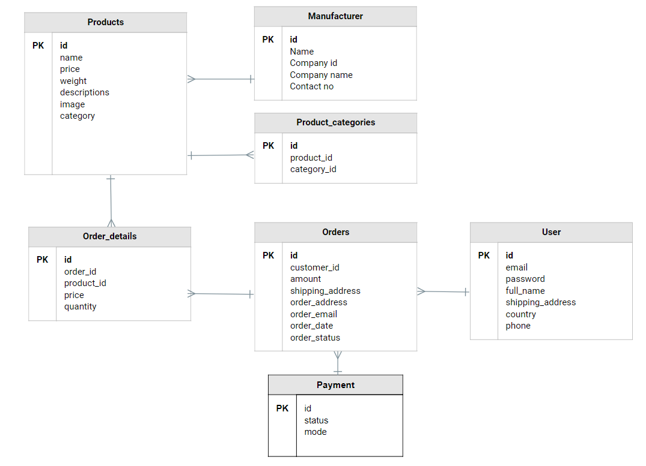

**ERD-**

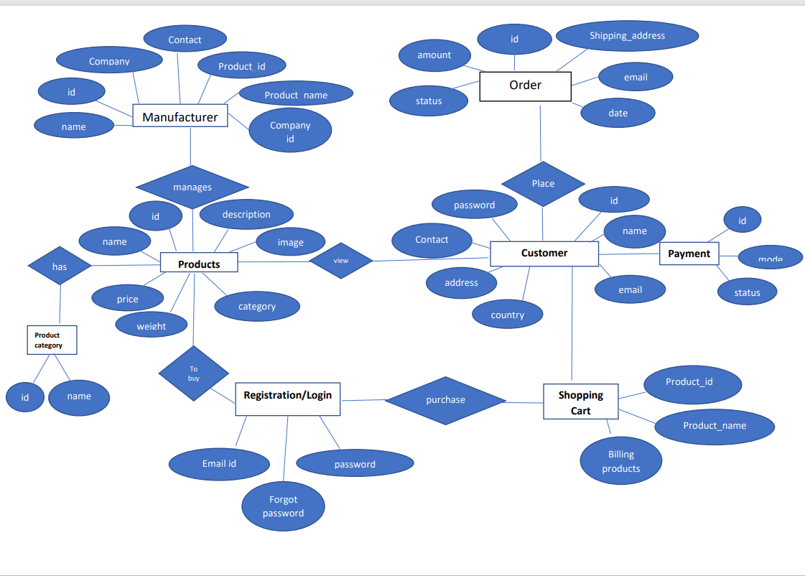

**Question 7** – Data Flow Diagram

**Ans-**

**DFD** is the abbreviation for **Data Flow Diagram**. The flow of data of a system or a process is represented by DFD. It also gives insight into the inputs and outputs of each entity and the process itself. DFD does not have control flow and no loops or decision rules are present. Specific operations depending on the type of data can be explained by a flowchart.

**User DFD Level 0-**

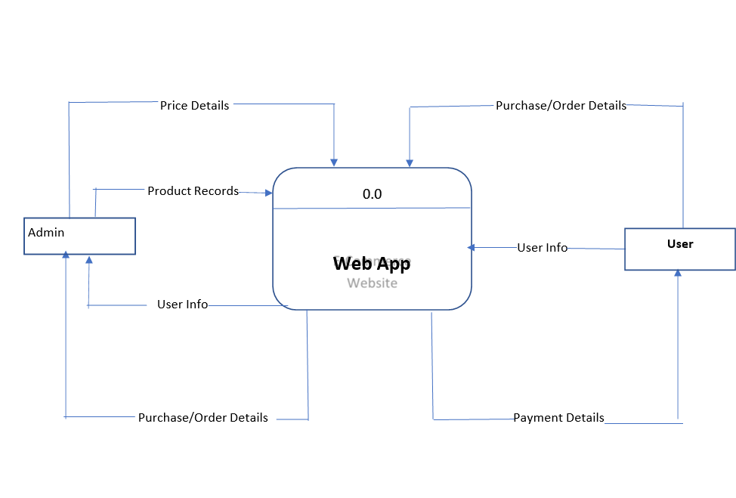

**Manufacturer DFD Level 0-**

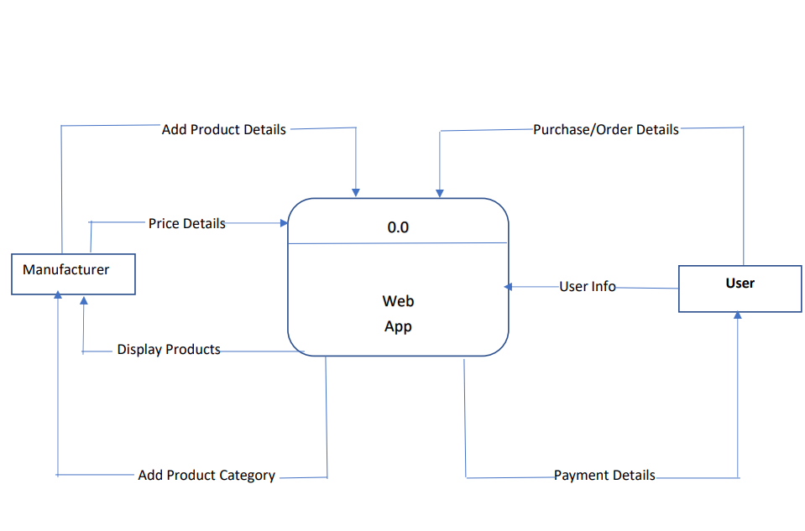



**Question 8** – Change Request

Due to change in the Government Taxation structure . we should change the Tax structure How do you handle change requests in a project?

**Ans-**

**Project name:**

|  |
| --- |
| Online Agriculture Product Store |

**Project Sponsor**: Mr. Akhilesh Gandhi

**Requested by: Mr. Kalpesh Patil (Head of Finance Department) Date: 15/08/2022**

|  |  |
| --- | --- |
|  |  |

**Request name: Changed Government Taxation Structure**

|  |  |
| --- | --- |
|  |  |

**Request number:** DEVK903334

**Change description:**

|  |
| --- |
| There is change in the Government Taxation structure. we should change the Tax structure. |

**Change reason:**

|  |
| --- |
| Recently, Government has changed Taxation structure. Taxes are increased by 5%. So by following Governments new tax increment policies we need to change our Tax structure with additional increment of 5%. |

**Impact of change:**

|  |
| --- |
| * **Scope**: There will be change in Project scope as budget of the project will increased due to increment in tax structure by 5%. * **Budget**: There will be change in Project budget, it will be impacted by increment in tax structure by 5%. It will get increased by 5%. * **Timeline**: There will be no impact on timeline of project deliverables. * **Resourcing**: There is no need for resourcing. |

**Proposed action:**

|  |
| --- |
| 1. First we need to check current taxation amount and associated project budget. 2. After overviewing that we need to increase amount of thes etaxes by 5%. 3. We need to finalise final project budget with additional tax amount. |

**Associated cost:**

|  |
| --- |
| Rs. 10,00,000/-(Ten Lakhs Rupees) |

**Approvals to Proceed:**

|  |  |  |  |  |  |
| --- | --- | --- | --- | --- | --- |
| |  |  |  |  | | --- | --- | --- | --- | | Originator/Date | Project Leader/Date | Sponsor/Date | Customer/Date | |  |

**Question 9** – Change Request Vs an Enhancement

As the project is in process, Ben and Kevin have contacted you. The reason is to inform you that they want the Farmers to sell their crop yields through this application i.e. Farmers should be able to add their crop yields or products and display to general public and should be able to sell them. They also want to introduce Auction system for their Crop yields. As a BA, what will be your response? Is this a change request or an enhancement???

**Ans**-This is an Enhancement.

1. An enhancement is an improvement while a project is a planned endeavour, usually with a specific goal and accomplished in several steps or stages.
2. As a BA, I will try to understand what Ben and Kevin are trying to convince me.
3. I will gather all knowledge behind what they have proposed.
4. As a BA, I will list down things Key stakeholders are expecting in addition.
5. I will assure them to come back with some solution for their demands after contacting higher authorities (Project Owner, Sponsor, SME, Project Manager).
6. I will document key stakeholders needs (or enhancements) in proper format. So that will be easily sharable to PO or PM.
7. As a BA, I will conduct separate meeting to discuss this enhancement with all stakeholders of Project.

**Question 10** – Estimations

Come up with estimations – How many Manhours required

**Ans-** 2944 Manhours will be required for this project.

**Question 11** – UAT

Project has finally completed all the stages i.e., design, development, testing etc. Now, it is the role of a business analyst to contact the client for testing of the final product and have to successfully complete it. How are you going to handle this situation? And once it is done, what will be the process to close the project?

Explain UAT Acceptance process

**Ans-**

* 1. **User Acceptance Testing (UAT)** is a type of testing performed by the end user or the client to verify/accept the software system before moving the software application to the production environment. UAT is done in the final phase of testing after functional, integration and system testing is done.
  2. **UAT Process**
* Analysis of Business Requirements
* Creation of UAT test plan
* Identify Test Scenarios
* Create UAT Test Cases
* Preparation of Test Data(Production like Data)
* Run the Test cases
* Record the Results
* Confirm business objectives

Step 1) Analysis of Business Requirements

One of the most important activities in the UAT is to identify and develop test scenarios. These test scenarios are derived from the following documents:

* Project Charter
* Business Use Cases
* Process Flow Diagrams
* Business Requirements Document(BRD)
* System Requirements Specification(SRS)

### Step 2) Creation of UAT Plan:

The UAT test plan outlines the strategy that will be used to verify and ensure an application meets its business requirements. It documents entry and **exit criteria for UAT, Test scenarios and test cases approach and timelines of testing**.

### Step 3) Identify Test Scenarios and Test Cases:

Identify the test scenarios with respect to high-level business process and create test cases with clear test steps. Test Cases should sufficiently cover most of the UAT scenarios. Business Use cases are input for creating the test cases.

### Step 4) Preparation of Test Data:

It is best advised to use live data for UAT. Data should be scrambled for privacy and security reasons. Tester should be familiar with the database flow.

### Step 5) Run and record the results:

Execute test cases and report bugs if any. Re-test bugs once fixed. [Test Management](https://www.guru99.com/test-management.html) tools can be used for execution.

### Step 6) Confirm Business Objectives met:

Business Analysts or UAT Testers needs to send a sign off mail after the UAT testing. After sign-off, the product is good to go for production. Deliverables for UAT testing are Test Plan, UAT Scenarios and Test Cases, Test Results and Defect Log.

* 1. **Exit criteria for UAT:**
* No critical defects open
* Business process works satisfactorily
* UAT Sign off meeting with all stakeholders
  1. After this ,create Project Closure Document and take sign off on it. Project closure process will end the project.

**Question 12** – Project Closure Document

Explain Project closure document

**Ans-**

1. A project closure report is the last deliverable submitted at the end of a project, and it measures the project's overall success. The project manager records details of every phase of the project and provides a way for both themselves and senior management to determine what parts of the project worked and what didn't. It also allows the company to analyse how to improve in the future and the best practices for future projects.
2. These reports show evidence of the team's hard work and how they completed their specific objectives. They may also include feedback from stakeholders and team members who worked on the project. Project closure reports are important because they can be used to close contracts, release project resources to the rest of the company, communicate final information to stakeholders and plan the operational transition.
3. Here is a list of common details featured in project closure reports:

* The original project guidelines, including stakeholder requests, budget and timeline
* Proof that objective goals were met
* Proof that the clients have received their deliverables
* Invoices from suppliers, stakeholders or other sources
* Release or transfer records of remaining resources
* Detailed performance reviews on each phase of the project
* Feedback from senior management, team members and stakeholders
* A separate folder with all project files and communication for archival purposes
* A request for project closure approval