Q 1) Identify minimum 20 Functional requirement ?

ANS :- Functional requirement define the specific behaviors, functions, or operations of system, they describe what the system should do , outlining the necessary tasks, actions or activities it must performs to achieve its objectives.

|  |  |  |  |
| --- | --- | --- | --- |
| Req ID | Req Name | Req Description | Priority |
| FR001 | LOGIN | User should login in the application. | 10 |
| FR002 | ID/PWD | Login should happen through the ID And password. | 10 |
| FR003 | Add to Cart | User should be able to add product to the cart. | 6 |
| FR004 | Search | User should be able to search the product directly with the help of search button. | 5 |
| FR005 | Application | The new platform should be user friendly for the user. | 4 |
| FR006 | Product details | User should get the all product details on the platform. | 6 |
| FR007 | Product Details | Product details should be display on the application. | 5 |
| FR008 | Payment | User should able to do payment via debit , credit, by UPI option. | 11 |
| FR008 | Cod | User should accept the cash on delivery,. | 7 |
| FR009 | Location | Application should have the location so that it can be helpful for tracking the order. | 5 |
| FR010 | Tracker | User should be able to track ther order. | 6 |
| FR011 | Add product/ cancel product | User should be able to add the product and same should be cancel the product. | 8 |
| FR012 | IF invalid password/ ID | IF use is logging into the application with the wrong ID/ password then error should be there like wrong passoword. | 5 |
| FR013 | New User involvement | User are new so them application should be user friendly. | 5 |
| FR014 | Farmers/ companies | User should get communication from the vendor by this application. | 7 |
| FR015 | New Application | Should accept the product. | 8 |
| FR016 | Select the product | User should able to select the product as he want s to. | 5 |
| FR017 | Buy later list | User should get the product from the buy liter from the list | 3 |
| FR018 | Payment gateway | User should be able to do payment by using different payment mode like UPI, Debit card, credit card, Wallet. | 10 |
| FR019 | Confirmation status | User should get the confirmation of the order. | 7 |
| FR020 | Delivery Tracker | User should get the delivery tracker for tracking their order. | 8 |

Q2 ) Make a wireframe and prototype?

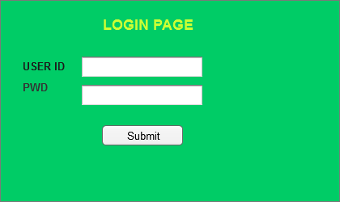

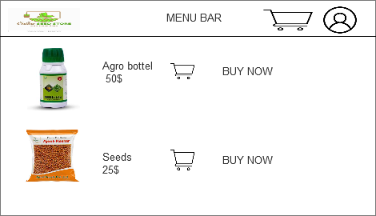

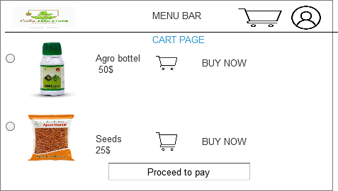

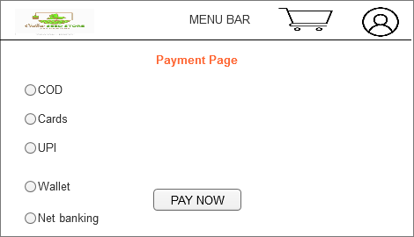

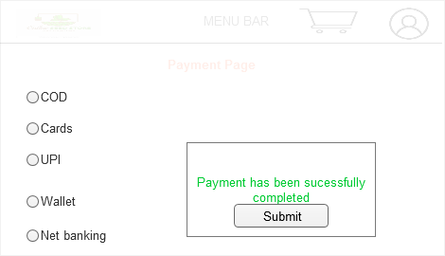

Q3 ) Tools Make a note of the tools , which you are using for above concepts?

ANS :- Microsoft visio is a diagramming and vector graphics application that allows user to create a wide range of diagrams such as flowchart, floor plan and mor it is widely used for both personal and professional purposes , especially in business and engineering fields .

Features :-

* Visio refers a variety of templates and shapes that users can drag and drop to quickly create professional diaram.
* User can customize and create their own stencils to suit specific needs, especially for technical or industry specific diagrams.
* Visio allows multiple user to work on the same diagrams simultaneously , making it easier to collaborate on projects.
* Visio allows user to link data from external source databases excel files directly to shapes within a diagram.
* Visio online allows user to access and work on visio diagram in the cloud it also supports real time collaboration.
* Visio is commonly used for the flowchart, diagram like usecase diagram , activity diagram and the sequence diagram. For drawing these drawing we required the ms visio tool.
* This tool is drag and drop tool shapes can be dragged and droped in to the canvas
* Also it uses the connector to define the relationships between shapes.
* We can add data , text and also we can modify the diagrams with the help of MSVISIO .

Conclusion :- Vision is a powerful tool for creating professional diagram and charts. It is especially useful in businesses, like IT and other industries where clear visual representation of complex ideas, processes and system is needed.

**Balsmiq :**- Balsamiq is a tool commonly used in the business analyst for making the wireframe a also it is useful for the mockups of website and application, it is widely used by the UX/UI designers, developers and product teams to visualize and prototype ideas early in the design process. Bellow are some key point about Balsamiq.

Features :=

* Balsamiq is known for its simple, hand drawn style that focuses on the layout and functionality rather than the final visual design. This helps to keep the focus on user experience and interaction.
* The tool offers a userfriendly interface where user can drage and drop component such as button, navigation bar, text boxes and form fields onto the canvas.
* With the help of balsamiq we an link dirrent screen or pages together to create and interactive prototype . allowing user to click through the wireframe and simulate navigation flows.
* You can export wireframes to pdf, png or other formats to share with stakeholder or integrate into presentations and reports.

Conclusion :- Balsamiq is an excellent tool for rapidly sketching out and prototyping ideas with a focus on layout and functionality. Its simplicity ease of use and collaboration dfeatures make it a popular choice for teams looking to quickly visualize user interfaces, validate ideas, and iterate on design before moving to higher fidelity stages.

Q4 ) RTM?

ANS :- It is a document to track the requirement throughout the project lifecycle, ensuring that they are met and that no requirement are overlooked. In this document we can know the thing like the client requirement are meeting or not so that purpose we are doing the RTM.

|  |  |  |  |  |  |  |  |  |  |
| --- | --- | --- | --- | --- | --- | --- | --- | --- | --- |
| REQ ID | REQ NAME | REQ DEC | DESIGN | Code | UT | CT | ST | SIT | UAT |
| FR001 | User Registration | User should register | Complete | Complete | complete | complete | comple | com | INComplete |
| FR002 | User request for detailed product | User should be able to request for the prodcut details | comp | com | comp | comp | incomp | incomp | incomp |
| FR003 | Add prodct to cart | User should be able to add the prodcut to cart | comp | comp | comp | comp | incomp | incomp | incomp |
| FR004 | Search product | User should be able to search a prodcut | comp | Comp | comp | comp | incomp | incomp | incomp |
| FR05 | BUY the prodcut | User shoul able to buy | comp | comp | comp | comp | incomp | incomp | incomp |

Question 5) TEST case document ?

ANS :- A test case document is a detailed outline used by testers to ensure that a software application or system is working as expected.

|  |  |  |  |  |  |  |
| --- | --- | --- | --- | --- | --- | --- |
| Test Case ID | Test case name | Objective | Pre-conditions | Test data | steps | Expected result |
| TC-001 | User registration | To verify the user can successfully register on the platform | User is not logged in | Valid name  Valid email  Valid phone | Enter the valid information email password. | User should be successfully registered and logged in. |
| TC-002 | Product search | TO verify that user can search for agriculture products | User is logged in to the website | Seeds, fertilizer | Search and tap the product search button and add it | All the list of product will be appear there. |
| TC-003 | Product add to cart | Verify that the user can add the product to the shopping cart | User is logged in and product are listed on the website | prdocuts | Navigate the seeds category page, select the product , click on the add cart | The selected product are successfully ad to the cart |
| TC-004 | Make a payment | Verify that the user can do the product after the shopping | User is logged into the application and selected some product | Payment option | Go to the payment tab after the shopping and click on the option of payment. | The user can do the payment of the select product and payment it will be successfully completed. |
| TC-005 | Payment gateways | Verify that the user is able to do the payment with the multiple option | User is logged in to the application , and after after the shopping should be able to the payment | mode | Click on the payment option and choose the method for the payment like, UPI, debit, credit. | Once the process is completed then payment can be done in multiple ways. |
| TC006 | Tracker | User should be able to track the order | User is logged in to it | Order No | Click on the application on the order tracking option . | You can easily track your order with the help of this option. |
| TC-007 | Delivery | TO verify the user is getting delivery of the prodcut | User is logged in to it, also has selected product . | Order ID | Once the order is completed then you will receive otp, sms | In this test case user will get SMS, and OTP after the completion of the order. |
| TC_008 | Product category | TO verify the user is able to browse the category | User is logged in to it. And product category are available |  | The option will show the variety of the product to the user | User can get the different kind of product which he required. |
| TC-009 | Payment failure | Verify that the system handle payment failure correctly | The user is logged in ,has item to the cart and is attempting to make a purchase |  | Navigate to the checkout page ad enter into the billing information , invalid payment details. | User will see the error of invalid credit card , then system will not proceed the further process. |
| TC-10 | Product reiew | Verify that the user can submit the product review | The user logged into it and has purchased already. |  | Go to the purchased summary , scroll down to the review section . | Review will be submitted successfully and will be displayed on the application. |

Q 6 ) DB DESIGN ?

ANS :- 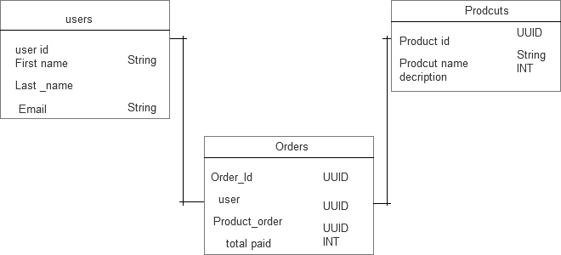



Question 7) Data flow diagram ?

ANS :-

Data flow Diagram for food ordering system .

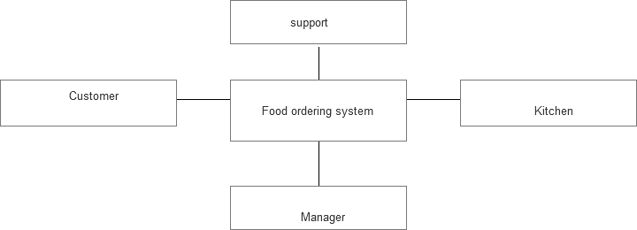

Question 8 ) Change request ?

Ans :- Handling a change request as a business analyst involves a structured approach to ensure that the requested change is assessed, communicated, and implemented effectively while minimizing negative impact. There are some point comes under the change request.

1. Receive and acknowledge the change request :- ensure the change request is formally documented with the relevant details.
2. Clarify the change request :- communicate with the requester to clarify the specifics of the change. In this we needs to understand why is being changed, what is being changed, and what are the outcomes or benefits of the change. And again evaluate the requirement assess how change will affect business process objectives, and stakeholders will t create additionlal value or cause disruption.
3. DO the impact analysis :- while handling the change request we also have to do the impact analysis technical impact, the budget impact technical cost and the overall budget cost it will increase or decrease so over impact analysis we have to do while handling the change request.
4. Update the requirement :- after the approval of the change request we need to revise the document for the better understanding about the project.
5. Get a approval :- if the impact analysis is complete present the change request , its impact, and your analysis to key stakeholders with managers, product owners, for approval .
6. Formal sign-off :- obtain formal sign –off from stakeholders on the change request to ensure everyone agrees with the decision to proceed or reject the request.
7. Communicate with stakeholder :- once the change is approved , communicate the change to all relevant stakeholders, including project team members, client and other impacted parties.
8. Manage expectation :- be transparent about how the change will affect the project scope, timeline , and cost . and set a realistic expectation.
9. Prioritize the change :- while handling the change request we also have to look at the prioritization of the change request that, based on their urgency, importance.

SO by following this structured approach , a business analyst can handle change request effectively, ensuring that the project stays on track, stakeholders are informed , and the change delivers value.

Question 9) Change request VS Enhancement ?

ANS :- There is a very huge difference between the change request and enhancement like change request is a formal process to request changes to the scope or functionality due to issue or missed requirement. In other side enhancement is a planned improvement or addition to an existing product aims to increasing its value or capabilities.

|  |  |  |
| --- | --- | --- |
| Aspect | Change request | Enhancement |
| Origin | Arises due to a problem, defect or new requirement | Initiated to improve or add new functionality. |
| Purpose | To fix issues, correct and comply with new regulation. | To improve upgrade, or to add new feature. |
| Nature | Reactive and corrective | Proactive and focused on product improvement |
| Example | Fixing bug, addressing a missed requirement | Adding a new feature, improving UI/UX |
| Approval process | Requires formal approval through a change control process. | May be part of a roadmap and can be prioritized less formally. |
| Impact on project | Often affects scope, timeline and cost | Can affect project roadmap but is more about value addition than rectification. |

Summary :- in the above case study problem the client wants to add some more feature fore the improvement of the project so its is not a change request it is a enhancement for the better development of the project.

Q10) Estimation ?

ANS :- Man hours are the required effort of the resources to complete the project So in the business analysis rule there are three type of project we have in the market small, medium and large .

* Small :- Upto 500 manhours
* Medium :- Upto 1000 manhours
* Large :- Upto 1500 manhours

Estimation is the study of the resources we required for completing the project so in this project we have received one budget along with the time duration so for the online agriculture store budget is 2 crore and the timeline for compleiging this project is 18 month so due to that reason this project will come under the medium project and for that we have Upto 1000 manhours.

* Good team and skilled person and employees are available.
* There is no need of the new trainees for these project.
* already the estimation of budget is well defined so there is not confusion in the budget of the project.
* For completing the project number of people they are available.
* So basically man hours and the estimation of the project is based on the teams and the budget and also on the duration.
* Project estimation is segregated into the three part small , medium and large.

Q11) Explain the UAT process ?

ANS :- User acceptance testing is a critical phase in the software development lifecycle.it involves testing the software to ensure it meets business requirement and is ready for deployment the UAT process typically follows these key steps.

* Define the scope :- clearly define the areas of the system that need to be tested based on business requirement .
* Select UAT tester :- choose end-users who will conduct the testing these should be individual who are familiar with the business process.
* Create UAT Test plan :- develop a plan outlining the objective scope, deliverbales, and timelines of UAT.
* Prepare the test environment :- set up a dedicated test environment that mirrors the production system as closely as possible.
* Test exaction :- The UAT tester execute the test cases, checking whether the software functions are expected from user perspective.
* Document result :- Record the results of the test cases, noting any issue or bugs that are found.
* Report issue :- if defects or issues are found during testing , they should be logged in a defect tracking system.
* Fix defect :- the development team address any defect or issues that are identified.
* Retest :- After defects are resolved, UAT testers retest to confirms the fixes.
* User feedback :- gather feedback from UAT testers regarding the system usability and functionality .
* Review Feedback :- analyze the feedback for potential improvement or adjustment.
* Sign-off :- once the software passes the UAT phase with no critical issues, the end users or stakeholders give formal approval to proceed to production.

The goal of UAT is to confirm that the software works in a real world business environment and to ensure it meets the users need before moving to production,

Q12 ) Project closure document ?

ANS :- a project closure document also known as closure report , it is the formal document that summarizes the key outcomes , lesson learned, and final details of a completed project.

* It serves as a comprehensive record of the project accomplishment , challenges and overall performance, providing valuable insights for stakeholders and future object.
* Project Overview :- in this online agriculture project the client wanted to build the plantform for the farmer for buying the seeds, fertilizer and some other product also with the help of IT solution,.
* Achievement :- In the achievement of this product there will be so many things are there like , solving the genuine problem of the farmer and giving them the plat form for buying the required product they wanted for their work .
* Lesson learned :- while doing work on this project there are so many lesson I learn about the requirement , while testing the product at each phase there was the new challenge was there . while handling the change request or working on each phase of the development of the project so many lesson learned.
* Resource Utilization ;- In the online agriculture store there are so many person or the team member were there like business analyst , project manager, tester, QA, SME, SR developer so while doing work on any project these are the pillar we required in order to complte the project.
* Risk Management : there are so many risk are involved while doing work on project like BA risk are there improper requirement gathering , lack of communication, change in requirement , coordination between stakeholders. Handling a big team these are the areas where we have too look into it more also the budget, scope , timeline, acceptance, mitigation, avoidance, and the transper so these are the method we are using for the Risk management .
* Challenges :- while doing work on this project several challenges were there like, appropriate requirement gathering , change in requirement , client unrealistic expectation , high demand of client , less resources, fulfilling the client desired demand about the product, coordination between team so these are the some of the challenges are there while doing work on the project.

|  |  |  |  |
| --- | --- | --- | --- |
| s. no | Point to include | Details | Reference link |
| 1 | Date of the signoff  Name of the resource | 25/12/2025 |  |
| 2 | Objective :- customer satisfactio | Achieved |  |
| 3 | Functionalities :- payment, features | achived |  |
| 4 | Infrastructure : software installed | Achieved |  |
| 5 | Funding approved | 2 crore | Finance docx |
| 6 | Overall project feed back | Good , customer satisfied. |  |
| 7 | Value to the company :- positive/negative | Positive – 90 % |  |