Assignment 2

Q1.
Subject: Introduction from Mastercard: your Business Analyst Partner
Hello Ken,
I hope this message finds you well. My name is Komal Pardeshi, and I am a Business analyst at Mastercard. I am excited to collaborate with you and your team as we embark on the business understanding process for the TRIC project.
At Mastercard, we specialize in handling announcements, service bulletins, and time deliverables. Our goal is to engage with clients to comprehend business objectives and challenges phased by clients. with 15 years of experience in the IT field, I am confident that we can work together to achieve your objectives.
To ensure a comprehensive understanding of your business needs, I propose scheduling an initial meeting to discuss your goals, challenges, and expectations. Please let me know your availability, and I will arrange the meeting for you.
Thank you for the opportunity to work with you. I look forward to a successful partnership.
Best regards,
Komal Pardeshi

Contents
1. Introduction 4
2. Goal of the Project 4
3. Objectives 4
4. Use Case Diagram 5
5
5. Use Case Specification: 5
1. Use Case: Browse Products 5
2. Use Case: Add Product to Cart 6
3. Use Case: Make a Purchase (Checkout) 7
4. Use Case: Manage Inventory 7
5. Use Case: Process Orders 8
6. Functional Requirements: 8
7. Non-Functional Requirements 9

- Introduction
The purpose of this document is to outline the software requirements for an Online Store system. This system will allow users to browse products, add them to their cart, place orders, and make payments securely. It will serve as an e-commerce platform for customers to shop online with ease and for administrators to manage the store’s inventory and orders.
- Goal of the Project
The primary goal of the Online store project is to develop a robust and user-friendly e-commerce platform that provides a seamless shopping experience for users while offering an efficient and manageable interface for store administrators. The system should support multiple users, integrate secure payment gateways, and allow for product management and order tracking.
- Objectives
- Provide a user-friendly interface for customers to search, browse, and purchase products.
- Implement a secure payment system with integration to payment gateways.
- Enable admin functionalities for inventory management, order tracking, and customer management.
- Provide features such as product search, sorting, filtering, and recommendations.
- Ensures scalability to handle increasing numbers of users and products.
- Implement responsive design for access via both desktop and mobile devices.
- Ensures high system availability and reliability.
- Use Case Diagram

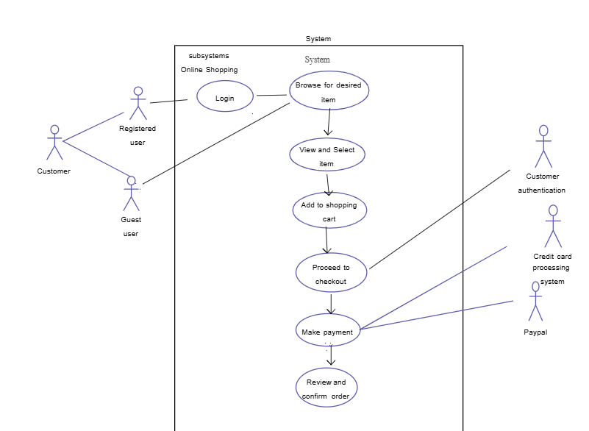

- Use Case Specification:
- Use Case: Browse Products
- Use Case Name: Browse Products
- Actors: Customer
- Description:
This use case describes how a customer browses through the product catalog searches for specific items, and applies filters to desired products.
- Preconditions:
- The customer must have access to the online store platform.
- The product catalog must be available in the system.
- Postconditions:
- The system displays a list of products matching the customer’s search or filters.
- If no matching products are found, an appropriate message is displayed.
- Main Flow:
- The customer visits the home page of the online store.
- The system displays featured and recommended products.
- The customer selects a category or uses the search bar to find products.
- The system displays relevant products with basic details.
- The customer applies filters to refine the results.
- The customer clicks on a product to view detailed information.
- Alternative Flows:
- A1: If the customer enters an invalid search term, the system displays a message: “No products found. Please try a different keywords.”
- A2: If the customer selects an empty category, the system displays a message: “No products available in the category.”
- Use Case: Add Product to Cart
- Use Case Name: Add Product to Cart
- Actors: Customer
- Description:
This use case describes how a customer adds a selected product to the shopping cart.
- Preconditions:
- The customer must be browsing the product catalog.
- The selected product must be available in stock.
5. Postconditions:
- The product is successfully added to the shopping cart.
- The system updates the cart count.
6. Main Flow:
- The customer selects a product from the product listing.
- The system displays the product details.
- The customer clicks the “Add to Cart”.
- The system adds the product to the cart and displays a success message.
- The customer can choose to continue shopping or proceed to checkout.
7. Alternative Flows:
- A1: If the selected product is out of stock, the system displays a message: ”This product is currently unavailable”.
- A2: If the customer tries to add more than the available quantity, the system dispels: “Only X item left in stock”.
- Use Case: Make a Purchase (Checkout)
- Use Case Name: Make a Purchase
- Actors: Customer
- Description:
This test case describes how a customer completes a purchase by providing shipping details and making payment.
- Preconditions:
- The customer must have products in their shopping cart.
- The customer must be logged in or provide guest checkout details.
5. Postconditions:
- The order is placed successfully, and the customer receives a confirmation.
- The system updates the inventory.
6. Main Flow:
- The customer reviews their cart and clicks “Proceed to Checkout”.
- The system prompts the customer to log in or continue as a guest.
- The customer enters shipping details.
- The customer selects a payment method and enters payment details.
- The system processes the payment.
- Upon successful payment, the system generates an order confirmation and sends an email.
- Alternative Flows:
- A1: If payment fails the system displays an error message and prompts the customer to retry.
- A2: If the customer enters invalid shipping details, the system prompts for corrections.
- Use Case: Manage Inventory
- Use Case Name: Manage Inventory
- Actors: Admin
- Description:
This test case describes how a admin adds, updates, or removes products in the inventory.
- Preconditions:
- The admin must be logged into the system.
5. Postconditions:
- The inventory is updated with new product data.
6. Main Flow:
- The admin logs into the dashboard.
- The admin selects “Manage Inventory.”
- The admin adds a new product or edits existing products.
- The admin saves changes.
- Alternative Flows:
- A1: If required product details are missing, the system displays an error message.
- A2: If the admin tries to delete a product that has pending orders, the system prevents deletion.
- Use Case: Process Orders
- Use Case Name: Process Orders
- Actors: Admin
- Description:
The use case describes how an admin processes customer orders for shipment.
- Preconditions:
- This must be existing orders in the system.
- The admin must be logged in.
5. Postconditions:
- The order status is updated.
- The customer receives a notification.
6. Main Flow:
- The admin logs into the dashboard.
- The admin selects “orders “and views pending orders.
- The admin verifies order details.
- The admin updates the order status to “Shipped”.
- The system notifies the customer.
- Alternative Flows:
- A1: If an order delayed, he system allows the admin to send a delay notification.
- A2: If an order is cancelled, the system updates the inventory and notifies the customer

- Functional Requirements:
- User Authentication: The system must support user login and registration for both customers and admins.
- Product Search: Customers must be able to search for products by name, category, or other criteria.
- Shopping Cart: Customers should be able to add, remove, and modify products in their cart.
- Order Processing: The system must process customer orders, update inventory, and notify customers of shipping status.
- Payment Integration: The system must integrate with secure payment gateways to process payments.
- Admin Dashboard: Admin should have access to a dashboard to manage products, orders customers and view sales reports.
- Non-Functional Requirements
- Performance:
- The system should handle at least 1000 concurrent users.
- The page load time should be under 2 seconds.
- Security:
- All user data should be encrypted.
- The system should use SSL for secure communication.
- Implement role-based access control for different user type (Admin, Customer).
- Scalability:
- The system should be scalable to accommodate increasing numbers of products and users over time.
- Availability:
- The system should be available 99.9% of the time, with regular backups and recovery procedures in place.

Q3. Make ERD dIAGRAM
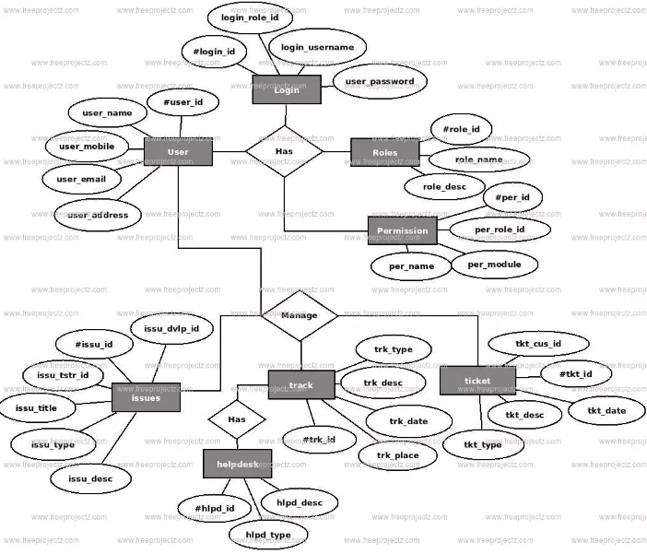

Q. 4 User story of shopping from e-commerce.

User Story No: 01 | Tasks: User Registration | Priority: High
As a CUSTOMER/USER – New User
I WANT – To create an account
SO THAT – I can track my orders
BV: 100 |  | CP:10
Acceptance Criteria: User can register with email/phone and password.

User Story No: 02 | Tasks: Login | Priority: High
As a CUSTOMER/USER: Registered User
I WANT- To login to my account
SO THAT – I can access my saved items
BV: 200 |  | CP: 9
Acceptance Criteria: User can log in using credentials

User Story No: 03 | Tasks: Password Reset | Priority: Medium
As a CUSTOMER/USER: Registered User
I WANT- To reset my password
SO THAT – I can regain access to my account
BV 300 |  | CP 5
Acceptance Criteria: User can reset a password via email/phone OTP

User Story No: 04 | Tasks: Browse Products | Priority: High
As a CUSTOMER/USER: Guest/Registered User
I WANT- To browse product categories
SO THAT – I can find what I need easily
BV 200 |  | CP 10
Acceptance Criteria: User can view categories and navigate through products

User Story No: 05 | Tasks: Search Products | Priority: High
As a CUSTOMER/USER: Guest/Registered User
I WANT- To search for the specific products
SO THAT – I can find what I want quickly
BV 400 |  | CP 10
Acceptance Criteria: Search functionality returns relevant results

User Story No: 06 | Tasks: Filter Products | Priority: High
As a CUSTOMER/USER: Guest/Registered User
I WANT- To filter products by price, brand, ratings
SO THAT – I can refine my choices
BV 300 |  | CP 3
Acceptance Criteria: Filters work correctly for refining search

User Story No: 07 | Tasks: Sort Products | Priority: Medium
As a CUSTOMER/USER: Guest/Registered User
I WANT- To sort products by price, popularity
SO THAT – I can find the best options easily
BV 400 |  | CP 10
Acceptance Criteria: Sorting options function correctly

User Story No: 08 | Tasks: View Product Details | Priority: High
As a CUSTOMER/USER: Guest/Registered User
I WANT- To view detailed product descriptions
SO THAT – I can make an informed purchase
BV 400 |  | CP 3
Acceptance Criteria: User can see descriptions, reviews, and specs

User Story No: 09 | Tasks: Add to Wish lists | Priority: Medium
As a CUSTOMER/USER: Registered User
I WANT- To save products for later
SO THAT – I don’t lose track of items I like
BV 500 |  | CP 5
Acceptance Criteria: Users can add/remove items from their wish lists

User Story No: 10 | Tasks: Add to Cart | Priority: High
As a CUSTOMER/USER: Guest/Registered User
I WANT- To add products to my cart
SO THAT – I can purchase multiple items easily
BV: 200 |  | CP: 9
Acceptance Criteria: Items appear in the cart and persist correctly

User Story No: 11 | Tasks: Update cart quantity | Priority: High
As a CUSTOMER/USER: Registered User
I WANT- To update the quantity of items in my cart
SO THAT – I can adjust my order before checkout
BV 300 |  | CP 6
Acceptance Criteria: User can increase/decrease quantity before checkout

User Story No: 12 | Tasks: Remove from Cart | Priority: High
As a CUSTOMER/USER: Registered User
I WANT- To remove unwanted items from my cart
SO THAT – I can manage my purchase list efficiently
BV 400 |  | CP 5
Acceptance Criteria: User can remove items from the cart

User Story No: 13 | Tasks: Apply Discount Codes | Priority: Medium
As a CUSTOMER/USER: Registered User
I WANT- To apply for a discount or coupon
SO THAT – I can save money on my order
BV 400 |  | CP 4
Acceptance Criteria: Validate discount codes are applied at checkout

User Story No: 14 | Tasks: Proceed to Checkout | Priority: High
As a CUSTOMER/USER: Registered User
I WANT- To complete my purchase
SO THAT – I can place my order successfully
BV 400 |  | CP 2
Acceptance Criteria: Users can proceed from cart to checkout

User Story No: 15 | Tasks: Enter the Shipping Address | Priority: High
As a CUSTOMER/USER: Registered User
I WANT- To provide my address
SO THAT – My order gets delivered to the right location
BV 500 |  | CP 5
Acceptance Criteria: User can enter and save shipping details

User Story No: 16 | Tasks: Choose Payment Method | Priority: High
As a CUSTOMER/USER: Registered User
I WANT- To select my preferred payment method
SO THAT – I can pay conveniently
BV 500 |  | CP 10
Acceptance Criteria: Users can choose between various payment options

User Story No: 17 | Tasks: Pay Securely | Priority: High
As a CUSTOMER/USER: Registered User
I WANT- To make a secure payment
SO THAT – My transaction is safe
BV 100 |  | CP 8
Acceptance Criteria: Secure payment processing is in place

User Story No: 18 | Tasks: Receive Order confirmation | Priority: High
As a CUSTOMER/USER: Registered User
I WANT- To receive an order confirmation email/SMS
SO THAT – I know my order has been placed successfully
BV 200 |  | CP 7
Acceptance Criteria: Order confirmation email is sent

User Story No: 19 | Tasks: Track Order Status | Priority: High
As a CUSTOMER/USER: Registered User
I WANT- To track my order's shipping status
SO THAT – I can anticipant delivery time
BV 500 |  | CP 5
Acceptance Criteria: User can view real-time order status updates.

User Story No: 20 | Tasks: Cancel Order | Priority: Medium
As a CUSTOMER/USER: Registered User
I WANT- To cancel my order before shipment
SO THAT – I can change my mind before it’s too late
BV 200 |  | CP 5
Acceptance Criteria: Users can cancel before shipment

User Story No: 21 | Tasks: Return/Exchange Order | Priority: Medium
As a CUSTOMER/USER: Registered User
I WANT- To return orders exchange products
SO THAT – I can fix issues with my purchase
BV 500 |  | CP 2
Acceptance Criteria: Return/exchange request system is in place

User Story No: 22 | Tasks: View Order History | Priority: Medium
As a CUSTOMER/USER: Registered User
I WANT- To see my past purchase
SO THAT – I can track my previous orders
BV 200 |  | CP 10
Acceptance Criteria: User can access their order history

User Story No: 23 | Tasks: Rate and Review Products | Priority: Medium
As a CUSTOMER/USER: Registered User
I WANT- To leave reviews on products
SO THAT – I can help others with their buying decisions
BV 500 |  | CP 10
Acceptance Criteria: User can submit product ratings and reviews

User Story No: 24 | Tasks: Get Customer Support | Priority: High
As a CUSTOMER/USER: Guest/Registered User
I WANT- To contact customer service
SO THAT – I can track my previous orders
BV 100 |  | CP 3
Acceptance Criteria: Live chat, email, and phone support options available

User Story No: 25 | Tasks: Receive Personalized Recommendations | Priority: Medium
As a CUSTOMER/USER: Registered User
I WANT- To see product recommendations
SO THAT – I can discover items I might like
BV 500 |  | CP 5
Acceptance Criteria: Personalized recommendations are based on browse in history

User Story No: 26 | Tasks: Save Payment Information | Priority: Medium
As a CUSTOMER/USER: Registered User
I WANT- To store my credentials securely
SO THAT – I can checkout faster next time
BV 100 |  | CP 10
Acceptance Criteria: Users can securely save payment details

User Story No: 27 | Tasks: Guest Checkout | Priority: High
As a CUSTOMER/USER: Guest User
I WANT- To purchase without creating an account
SO THAT – I can buy quickly without signup
BV 200 |  | CP 10
Acceptance Criteria: Guest users can complete purchases

User Story No: 28 | Tasks: Subscribe to notifications | Priority: Medium
As a CUSTOMER/USER: Registered User
I WANT- To receive email/SMS alerts
SO THAT – I stayed informed about offers and order updates
BV 500 |  | CP 5
Acceptance Criteria: Users can opt-in/out of notifications

User Story No: 29 | Tasks: Request Invoice | Priority: Medium
As a CUSTOMER/USER: Registered User
I WANT- To gate an invoice for my purchase
SO THAT – I need proof of my transaction
BV 100 |  | CP 10
Acceptance Criteria: Users can download invoices

User Story No: 30 | Tasks: Report a Defective Product | Priority: Medium
As a CUSTOMER/USER: Registered User
I WANT- To report a damaged product
SO THAT – I can get a replacement/refund
BV 200 |  | CP 10
Acceptance Criteria: Users can report defective items and request action

User Story No: 31 | Tasks: Compare Products | Priority: Medium
As a CUSTOMER/USER: Guest/Registered User
I WANT- To compare multiple products
SO THAT – I can make a better decision
BV 500 |  | CP 5
Acceptance Criteria: Comparison feature available

User Story No: 32 | Tasks: Earn Loyalty Points | Priority: Low
As a CUSTOMER/USER: Registered User
I WANT- To earn points for purchases
SO THAT – I get rewards for shopping
BV 100 |  | CP 3
Acceptance Criteria: Loyalty points system in place

User Story No: 33 | Tasks: Redeem Loyalty Points | Priority: Low
As a CUSTOMER/USER: Registered User
I WANT- To use my points for discounts
SO THAT – I save money on future orders
BV 200 |  | CP 2
Acceptance Criteria: Points redemption at checkout

User Story No: 34 | Tasks: Subscribe to Membership | Priority: Medium
As a CUSTOMER/USER: Registered User
I WANT- To join a premium membership
SO THAT – I get exclusive discounts and benefits
BV 500 |  | CP 2
Acceptance Criteria: Membership subscription and benefits active

User Story No: 35 | Tasks: View Related Products | Priority: Medium
As a CUSTOMER/USER: Guest/Registered User
I WANT- To see similar or complementary items
SO THAT – I can find everything I need easily
BV 100 |  | CP 10
Acceptance Criteria: Related product suggestions product pages

User Story No: 36 | Tasks: Share Products | Priority: Low
As a CUSTOMER/USER: Guest/Registered User
I WANT- To share product links on social media
SO THAT – I can recommend items to friends
BV 200 |  | CP 7
Acceptance Criteria: Social media sharing buttons available

User Story No: 37 | Tasks: Multi-Currency Support | Priority: Medium
As a CUSTOMER/USER: International User
I WANT- To see the price in my currency
SO THAT – I understand the cost in my local money.
BV 500 |  | CP 5
Acceptance Criteria: Prices automatically convert based on location

User Story No: 38 | Tasks: Auto-Suggest Search | Priority: Medium
As a CUSTOMER/USER: Guest/Register User
I WANT- To see suggestions while typing search
SO THAT – I find products faster
BV 100 |  | CP 10
Acceptance Criteria: Auto suggestions appear in the search bar

User Story No: 39 | Tasks: Voice Search | Priority: Low
As a CUSTOMER/USER: Guest/Registered user
I WANT- To search using voice commands
SO THAT – I can shop hands-free
BV 200 |  | CP 5
Acceptance Criteria: Voice search feature implemented

User Story No: 40 | Tasks: Buy Now Button | Priority: High
As a CUSTOMER/USER: Registered User
I WANT- To purchase a product immediately
SO THAT – I skip adding to cart and buy faster
BV 500 |  | CP 10
Acceptance Criteria: The “Buy Now” button places orders directly.

