COEPD – Traditional Development

Capstone Project1 – Part -3/3 – 100 Marks - Pass 60 % 12 Questions

Instructions to follow:

1. Copy paste (either image, diagram or text) is not entertained. If done, the document will not be evaluated.
2. After submission of the answers of this prep exam, You should be prepared to attend viva and justify your answers in the prep exams. If in Viva, participant is NOT justifying the answers, Viva will be repeated until Candidates justify 60% correctness.
3. Mentor calls are scheduled only if the participant have submitted their task at least for one time. (should apply their knowledge in this task first)
4. For attempting prep exams participant should be thorough on the topics using their references.
5. Please format the document properly (Always have a question no., question and answer).
6. Have a consistent format (Font name: Arial/ Calibri -Font size 12, Font Color: Black ).
7. Few Questions are related to the case study, check Questions thoroughly before you answer.
8. Answers should be elaborated in detail(*not as per the allotted marks).
9. Please focus on learning and applying the knowledge as this knowledge will be helpful in contributing at your BA job.
10. In the evaluation, students must answer all questions and should be able to justify at least 60% content and correctness of each answer.

Online Agriculture Products Store

Mr. Henry, after being successful as a businessman and has become one of the wealthiest persons in the city. Now, Mr. Henry wants to help others to fulfil their dreams. One day, Mr. Henry went to meet his childhood friends Peter, Kevin and Ben. They live in a remote village and do farming. Mr. Henry asked his friends if they are facing any difficulties in their day-to-day work.

Peter told Mr. Henry that he is facing difficulties in procuring fertilizers which are very important for farm. Kevin said that he is also facing the same problem in-case of buying seeds for farming certain crops. Ben raised his concern on lack of pesticides which could help in greatly reducing pests in crops.

After listening to all his friends’ problems, Mr. Henry thought that this is a crucial problem faced not only by his friends but also by so many other farmers. So, Mr. Henry decided to make an online agriculture product store to facilitate remote area farmers to buy agriculture products. Through this Online Web / mobile Application, Farmers and Companies (Fertilizers, seeds and pesticides manufacturing Companies) can communicate directly with each other.

The main purpose to build this online store is to facilitate farmers to buy seeds, pesticides, and fertilizers from anywhere through internet connectivity. Since new users are involved, Application should be user friendly.

This new application should be able to accept the product (fertilizers, seeds, pesticides) details fromthe manufacturers and should be able to display them to the Farmers. Farmers will browse throughthese products and select the products what they need and request to buy them and deliver them to farmers location.

Mr. Henry has given this project through his Company SOONY. In SOONY Company, Mr Pandu is Financial Head and Mr Dooku is Project Coordinator. Mr. Henry , Mr Pandu , and Mr Dooku formed one Committee and gave this project to APT IT SOLUTIONS company for Budget 2 Crores INR and

18 months Duration under CSR initiative. Peter, Kevin and Ben are helping the Committee and can be considered as Stakeholders share requirements for the Project.

Mr Karthik is the Delivery Head in APT IT SOLUTIONS company and he reached out to Mr Henry through his connects and Bagged this project. APT IT SOLUTIONS company have Talent pool Available for this Project. Mr Vandanam is project Manager, Ms. Juhi is Senior Java Developer, Mr Teyson, Ms Lucie, Mr Tucker, Mr Bravo are Java Developers. Network Admin is Mr Mike and DB Admin is John. Mr Jason and Ms Alekya are the Tester. And you joined this team as a BA.

Your Team

|  |  |  |
| --- | --- | --- |
|  | Project Manager - Mr VandanamSenior Java Developer - Ms. Juhi |  |
| Java Developers - Mr Teyson, Ms Lucie, Mr Tucker, Mr Bravo Network Admin - Mr Mike | | |
|  | DB Admin - Mr John. |  |
| Testers - Mr Jason and Ms Alekya |
| BA - You |

Fertilizers, seeds, pesticides details from the manufacturers and should be able to display them to the Farmers.

To gather the business requirements from the client, you went to SOONY and met Mr. Henry. When Mr. Henry was asked about the project and what are they expecting from the project, Mr. Henry stated that he is expecting to have a login for all its users (fertilizers, seeds, pesticides manufacturers and Farmers) , a product catalog of fertilizers, seeds, pesticides, a search option to search for products, payment process, and delivery tracking.

After doing the stakeholder analysis, you have found out that Peter, Kevin, Ben are the key stakeholders and you have scheduled an appointment to meet them. After meeting with them and trying to gather the stakeholder requirements, Kevin said that, a Farmer should be able to browse through the products catalog once they visit the website and need to have a search option so that they can search for any product they need. Peter said that, if a farmer wants to buy any product or add them to buy-later list, they need to login first using their email id and password. If it is a new user, then they can create a new account by submitting their email ID and creating a secure password. Ben added saying that, Farmers needs to have an easy-to-use payment gateway which should include cash-on-delivery (COD), Credit/Debit card and UPI options so that

the user’s experience should be better. Kevin mentioned that, a user gets an email confirmation regarding their order status. A delivery tracker to track the whereabouts of their order.

Identify Business Requirements (which includes Stakeholder Requirements)

BR001 – Farmers should be able to search for available products in fertilizers, seeds, pesticides

BR002 – Manufacturers should be able to upload and display their products in the application Make suitable Assumptions and identify at least 10 Business Requirements.

List your assumptions

Give Priority 1 to 10 numbers ( 1 being low priority – 10 being high priority) to these Requirements after discussions with the stakeholders

|  |  |  |  |
| --- | --- | --- | --- |
| Req ID | Req Name | Req Description | Priority |
| BR001 | Farmer Search for Products | Farmers should be able to search for available products in fertilizers, seeds, pesticides | 8 |
| BR002 | Manufacturers upload their Products | Manufacturers should be able to upload and display their products in the application | 8 |
|  |  |  |  |

Once the requirements are finalized, as a business analyst, one of the major roles is to act as a liaison between the client and the project team. To gather the requirements correctly from the client side and then to deliver those requirements to the project team in a way they understand.

To make the project team understand the requirements, you need to convert those requirements into UML diagrams and screen mock-ups.

You will draw use case diagram Prepare use case specs for all use cases

And you will all Activity diagrams required

Question 1 – Functional Requirements - 15 Marks

Identify minimum 20 functional requirements Example :

Functional requirement: When an order is fulfilled, the local printer shall print a packing slip.

Non-Functional Requirement: Packing slips shall be printed on both sides of 4”x 6” white paper, the standard size for packing slips used by local printers.

|  |  |  |  |
| --- | --- | --- | --- |
| Req ID | Req Name | Req Description | Priority |
| FR0001 | Farmer Registration | Farmers should be able to register with the application | 8 |
| FR0002 | Farmer Search for Products | Farmers should be able to search for available products in fertilizers, seeds, pesticides | 8 |
|  |  |  |  |
|  |  |  |  |
| NFR0101 | Page Loading Time | Each Page should load within 2 seconds time | 9 |
| NFR0102 | WCAG 2.1. | The system must meet Web Content Accessibility Guidelines WCAG 2.1. | 8 |
|  |  |  |  |
|  |  |  |  |

**Functional Requirement:**

|  |  |  |  |  |  |  |  |  |  |  |  |  |  |  |  |  |  |  |  |  |  |  |  |  |  |  |  |  |  |  |  |  |  |  |  |  |  |  |  |  |  |  |  |  |  |  |  |  |  |  |  |  |  |  |  |  |  |  |  |  |  |  |  |  |  |  |  |  |  |  |  |  |  |  |  |  |  |  |  |  |  |  |  |  |  |
| --- | --- | --- | --- | --- | --- | --- | --- | --- | --- | --- | --- | --- | --- | --- | --- | --- | --- | --- | --- | --- | --- | --- | --- | --- | --- | --- | --- | --- | --- | --- | --- | --- | --- | --- | --- | --- | --- | --- | --- | --- | --- | --- | --- | --- | --- | --- | --- | --- | --- | --- | --- | --- | --- | --- | --- | --- | --- | --- | --- | --- | --- | --- | --- | --- | --- | --- | --- | --- | --- | --- | --- | --- | --- | --- | --- | --- | --- | --- | --- | --- | --- | --- | --- | --- | --- |
| |  |  |  |  | | --- | --- | --- | --- | | User Reg | Req Name | Req Description | Priority | | FR0001 | Farmer Registration |  | 8 | | FR0002 | Farmer Login | Farmers should be able to register with the application using their personal details. | 8 | | FR0003 | Product Search | Farmers should be able to search for available products like fertilizers, seeds, and pesticides. | 8 | | FR0004 | Product Categories | Products should be categorized by type (fertilizers, seeds, pesticides) for easier navigation. | 7 | | FR0005 | Product Details | Farmers should be able to view detailed descriptions, prices, and stock availability for each product. | 8 | | FR0006 | Add to Cart | Farmers should be able to add selected products to their shopping cart. | 9 | | FR0007 | View Cart | Farmers should be able to view and edit the contents of their shopping cart before checkout. | 9 | | FR0008 | Online Payment | Farmers should be able to make payments using online payment methods like UPI, cards, and net banking. | 9 | | FR0009 | Order Confirmation | Farmers should receive an order confirmation with order details after successful payment. | 8 | | FR0010 | Order History | Farmers should be able to view their past orders and purchase details. | 7 | | FR0011 | Delivery Tracking | Farmers should be able to track the delivery status of their orders. | 7 | | FR0012 | Feedback Submission | Farmers should be able to submit feedback or reviews for purchased products. | 6 | | FR0013 | Bulk Order Support | Farmers should be able to place bulk orders for specific products. | 7 | | FR0014 | Farmer Support Chat | Farmers should have access to a support chat or helpline to resolve queries. | 8 | | FR0015 | Notifications | Farmers should receive notifications for order status, offers, and important updates. | 8 | | FR0016 | Product Recommendation | The system should recommend related or frequently bought products to farmers. | 7 | | FR0017 | Coupon Management | Farmers should be able to apply coupons or discounts during checkout. | 6 | | FR0018 | User Role Management | The system should support multiple user roles (Admin, Farmer, Supplier, etc.) with appropriate access. | 8 | | FR0019 | Supplier Management | Admins should be able to manage supplier information and their product inventory. | 7 | | FR0020 | Generate Reports | Admins should be able to generate sales, inventory, and feedback reports. | 7 | | |
|  |
|  |
|  |
|  |
|  |
|  |
|  |
|  |
|  |
|  |
|  |
|  |
|  |
|  |
|  |
|  |
|  |
|  |
|  |
|  |
|  |

Question 2–Minimum 5 page designs - 15 Marks

Make wireframe and prototypes

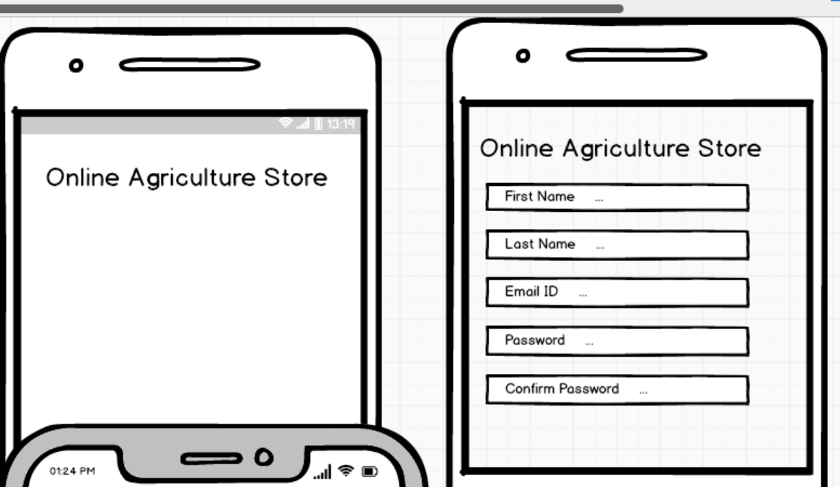

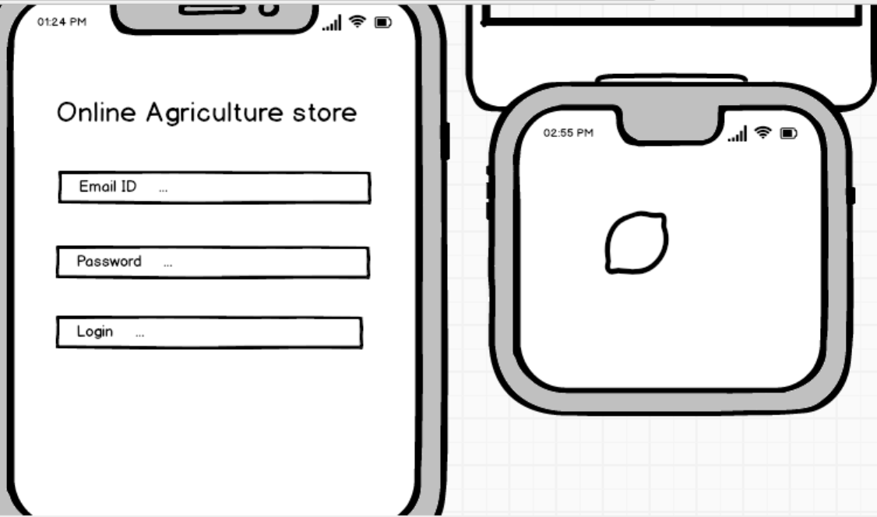

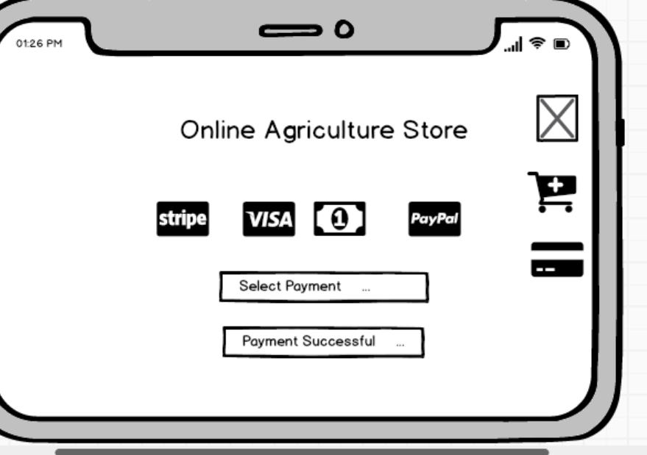



Question 3 – Tools (Visio, Balsamiq) - 15 Marks

Make a note of the Tools, which you are using for above concepts.

**Microsoft Visio:**

Microsoft Visio is a versatile diagramming tool that allows users to create a wide range of

diagrams, including flowcharts, organizational charts, and network diagrams. With its extensive

library of shapes and customization options, Visio enables users to visually represent complex

information and processes. It offers collaboration features, data linking capabilities, and seamless

integration with other Microsoft Office applications.

**Key components and features of Microsoft Visio:**

**Shapes:**

Visio provides a wide range of pre-defined shapes for various purposes such as flowcharts,

network diagrams, electrical diagrams, organizational charts, and more. Users can drag and drop

these shapes onto the canvas to create diagrams.

**Templates:**

Visio offers numerous templates tailored for specific types of diagrams. These templates come

with pre-defined shapes, connectors, and settings optimized for their respective diagram types,

making it easier for users to get started

**Stencil**

In Visio, stencils are collections of related shapes grouped together for easy access. Each

template typically comes with its own set of stencils containing shapes specific to the diagram

type. Users can also create custom stencils to organize their frequently used shapes.

**Connectors:**

Visio provides various types of connectors to link shapes together and illustrate relationships in

diagrams. Users can customize the appearance of connectors, such as line style, arrowheads,

and endpoints.

**Text and Formatting Tools:**

Users can add text to shapes and connectors to provide additional information or labels in their

diagrams. Visio offers a range of formatting tools for text, including font styles, sizes, colors, and

alignment options.

**Themes and Styles:**

Visio allows users to apply themes and styles to their diagrams to enhance visual consistency and

appeal. Themes can be applied to change the overall look and feel of a diagram, while styles can

be used to customize the appearance of individual shapes.

Grid and **Guides**:

Visio provides gridlines and guides to help users align and position shapes precisely on the

canvas. Gridlines can be customized in terms of spacing and visibility, while guides can be

dragged onto the canvas to serve as alignment aids.

**Data Linking**:

Visio offers the ability to link shapes and diagrams to external data sources such as Excel spread

sheets, databases, and SharePoint lists. This allows users to create dynamic diagrams that

update automatically based on changes in the underlying data.

**Collaboration and Sharing:**

Visio supports collaboration features such as commenting, reviewing, and co-authoring, allowing

multiple users to work on the same diagram simultaneously. Diagrams can also be shared and

published in various formats, including PDF, image files, and web pages.

**Integration with Other Microsoft Products**:

Visio integrates seamlessly with other Microsoft Office applications such as Word, Excel,

PowerPoint, and SharePoint. Users can embed Visio diagrams into Office documents or publish

them to SharePoint for easy access and sharing.

**Balsamiq:**

Balsamiq is a popular wireframing tool used for creating low-fidelity prototypes. It focuses on

simplicity and sketch-like designs to quickly visualize and communicate design ideas. With its

drag-and-drop interface and pre-built UI elements, Balsamiq allows users to rapidly iterate and

gather feedback on the basic structure and layout of a digital product. Axure: Axure is a powerful

prototyping tool that enables the creation of interactive and high-fidelity prototypes. It offers a wide

range of dynamic and interactive elements, such as animations, conditional logic, and data-driven

interactions. Axure allows designers to simulate user flows and test complex interactions before

the actual development phase, aiding in user testing and stakeholder communication

**Mockup Editor:**

The core component of Balsamiq is its mockup editor, where users can drag and drop various UI

elements (such as buttons, text boxes, images, and icons) onto a canvas to create wireframes and

mockups of their designs. The editor provides a simple and intuitive interface for building

prototypes quickly.

**UI Library:**

Balsamiq comes with a comprehensive library of pre-built UI components and symbols that users

can use in their designs. These components cover a wide range of UI elements commonly found

in web and mobile applications, including navigation bars, form controls, tables, and more.

**Customization Options:**

Users can customize the appearance of UI elements in Balsamiq, such as adjusting colors, fonts,

sizes, and styles, to match the desired look and feel of their designs. This allows for quick iteration

and experimentation during the wireframing process.

**Templates:**

Balsamiq offers a variety of pre-designed templates for different types of projects and applications,

including websites, mobile apps, desktop software, and more. These templates provide a starting

point for users to kickstart their designs and speed up the prototyping process.

**Linking and Interactivity:**

Balsamiq allows users to create clickable prototypes by linking mockup screens together to

simulate user interactions and navigation flows. This feature enables stakeholders to experience

the user interface firsthand and provide feedback on usability and functionality.

**Version Control and Collaboration:**

Balsamiq offers built-in version control and collaboration features that allow multiple team

members to work on the same project simultaneously. Users can share their designs with others,

track changes, leave comments, and iterate on designs collaboratively.

**Export and Integration**:

Balsamiq supports exporting mockups and prototypes in various formats, including PNG, PDF,

and interactive PDF. Additionally, it integrates with popular collaboration and project management

tools such as Jira, Confluence, Slack, and Google Drive, enabling seamless workflows within

development teams.

**Desktop and Web Versions:**

Balsamiq is available in both desktop and web-based versions, catering to different user

preferences and workflow requirements. The desktop version offers offline access and a

standalone application, while the web version provides browser-based access and real-time

collaboration capabilities.

Question 4 – RTM - 6 Marks

A business analyst’s key responsibilities are to keep track of the requirements and make sure that no requirement is missing

Mr. Henry and peter have approached you regarding the current status of the project. How will you tackle this situation?

Prepare RTM

|  |  |  |  |  |  |  |  |  |
| --- | --- | --- | --- | --- | --- | --- | --- | --- |
| Req ID | Req Name | Req Description | Design | D1 | T1 | …… | T4 | UAT |
| FR0001 | Farmer Registration | Farmers should be able to register with the application |  |  |  |  |  |  |
| FR0002 | Farmer Search for Products | Farmers should be able to search for available products in fertilizers, seeds, pesticides |  |  |  |  |  |  |
|  |  |  |  |  |  |  |  |  |
|  |  |  |  |  |  |  |  |  |
| NFR0101 | Page Loading Time | Each Page should load within 2 seconds time |  |  |  |  |  |  |
| NFR0102 | WCAG 2.1. | The system must meet Web Content Accessibility Guidelines WCAG 2.1. |  |  |  |  |  |  |
|  |  |  |  |  |  |  |  |  |
|  |  |  |  |  |  |  |  |  |

|  |  |  |  |  |  |  |  |  |  |  |
| --- | --- | --- | --- | --- | --- | --- | --- | --- | --- | --- |
| **Req ID** | **Req Name** | **Req Description** | **Design** | **Dev (Responsible)** | **T1** | **T2** | **T3** | **T4** | **UAT** | **Status** |
| FR0001 | Farmer Registration | Farmers should be able to register with the application | ✅ | Juhi (Senior Dev) | ✅ | ✅ | ✅ | ✅ | ✅ | Completed |
| FR0002 | Farmer Search for Products | Farmers should be able to search for products in fertilizers, seeds, pesticides | ✅ | Bravo (Java Dev) | ✅ | ✅ | ✅ | ✅ | ✅ | Completed |
| NFR0101 | Page Loading Time | Each page should load within 2 seconds | ✅ | Mike (Network Admin) | ✅ | ✅ | ✅ | ✅ | ✅ | Completed |
| NFR0102 | WCAG 2.1 Compliance | The system must meet WCAG 2.1 guidelines | ✅ | John (DB Admin) | ✅ | ✅ | ✅ | ✅ | ✅ | Completed |

✅ = Completed | ❌ = Pending

**Current Status Update for Mr. Henry & Peter:**

* **All requirements have been implemented and tested successfully.**
* **Functional and Non-Functional requirements are mapped properly in the RTM.**
* **UAT has been completed without major defects.**
* **Project is ready for deployment.**

Question 5 – 10 Test Case Documents - 10 Marks

Prepare 10 Test Case Documents

1. **User Test Case Registration**

|  |  |
| --- | --- |
| **Test Case ID** | **REG-001** |
| **Module** | User Registration |
| **Test Scenario** | Verify that a new user can successfully register. |
| **Pre-Conditions** | The user must have a valid email ID and phone number. |
| **Test Steps** | 1. Navigate to the registration page.2. Enter valid details (name, email, phone, password).3. Click on "Register".4. Verify the OTP received via email/SMS. |
| **Expected Result** | The user should be successfully registered and redirected to the login page. |
| **Status** | Pending |

**2. User Login Test Case**

|  |  |
| --- | --- |
| Test Case ID | LOGIN-002 |
| **Module** | Authentication |
| **Test Scenario** | Verify that a registered user can log in. |
| **Pre-Conditions** | The user must be registered with a valid email and password. |
| **Test Steps** | 1. Open the login page.2. Enter valid email and password.3. Click on "Login". |
| **Expected Result** | The user should be logged in and redirected to the dashboard. |
| **Status** | Pending |

3.**Product Search Test Case**

|  |  |
| --- | --- |
| Test Case ID | SEARCH-003 |
| **Module** | Search |
| **Test Scenario** | Verify that users can search for agricultural products. |
| **Pre-Conditions** | Products should be available in the system. |
| **Test Steps** | 1. Navigate to the search bar.2. Enter a product name (e.g., "Fertilizer").3. Click on "Search". |
| **Expected Result** | Relevant products should be displayed. |
| **Status** | Pending |

**4. Product Filtering Test Case**

|  |  |
| --- | --- |
| Test Case ID | FILTER-004 |
| **Module** | Product Filtering |
| **Test Scenario** | Verify that users can filter products by category, price, and brand. |
| **Pre-Conditions** | Products should have different categories and price ranges. |
| **Test Steps** | 1. Select a category (e.g., "Seeds").2. Choose a price range.3. Click on "Apply Filters". |
| **Expected Result** | Only relevant products should be displayed. |
| **Status** | Pending |

**5**. **Product Purchase Test Case**

|  |  |
| --- | --- |
| Test Case ID | PURCHASE-005 |
| **Module** | Product Order |
| **Test Scenario** | Verify that users can purchase a product successfully. |
| **Pre-Conditions** | The user must be logged in and have payment details. |
| **Test Steps** | 1. Select a product.2. Click on "Buy Now".3. Enter shipping details.4. Choose a payment method and complete payment. |
| **Expected Result** | Order should be placed successfully with a confirmation message. |
| **Status** | Pending |

**6. Payment Gateway Test Case**

|  |  |
| --- | --- |
| Test Case ID | PAYMENT-006 |
| **Module** | Payment |
| **Test Scenario** | Verify that the payment gateway processes transactions correctly. |
| **Pre-Conditions** | A valid payment method (credit card, UPI, or net banking). |
| **Test Steps** | 1. Select a product and proceed to checkout.2. Choose a payment method.3. Enter payment details and confirm. |
| **Expected Result** | The transaction should be successful, and an order confirmation should be displayed. |
| **Status** | Pending |

**7. Order Tracking Test Case**

|  |  |
| --- | --- |
| **Test Case ID** | **TRACK-007** |
| **Module** | Order Management |
| **Test Scenario** | Verify that users can track their orders. |
| **Pre-Conditions** | The user must have placed an order. |
| **Test Steps** | 1. Navigate to "My Orders". |
| 2. Click on "Track Order". |
| **Expected Result** | The order tracking details should be displayed. |
| **Status** | Pending |

**8. Cart Functionality Test Case**

|  |  |
| --- | --- |
| Test Case ID | CART-008 |
| **Module** | Shopping Cart |
| **Test Scenario** | Verify that users can add and remove products from the cart. |
| **Pre-Conditions** | The user must be logged in. |
| **Test Steps** | 1. Select a product and click "Add to Cart".2. Go to the cart and remove an item. |
| **Expected Result** | Products should be added or removed successfully. |
| **Status** | Pending |

**9.Customer Support Test Case**

|  |  |
| --- | --- |
| Test Case ID | SUPPORT-009 |
| **Module** | Customer Service |
| **Test Scenario** | Verify that users can contact customer support. |
| **Pre-Conditions** | The support system should be active. |
| **Test Steps** | 1. Click on "Contact Support".2. Enter a query and submit. |
| **Expected Result** | The query should be submitted successfully, and the user should receive a response. |
| **Status** | Pending |

**10.Logout Functionality Test Case**

|  |  |
| --- | --- |
| Test Case ID | LOGOUT-010 |
| **Module** | Authentication |
| **Test Scenario** | Verify that the user can log out successfully. |
| **Pre-Conditions** | The user must be logged in. |
| **Test Steps** | 1. Click on "Logout". |
| **Expected Result** | The user should be logged out and redirected to the login page. |
| **Status** | Pending |

Question 6 – DB Design – 8 Marks

After the requirements are thoroughly explained to the entire project team by business analyst, the Database architects have decided to do the database design and also to represent the in-flow and out-flow of data.

Draw database schema and ER diagram

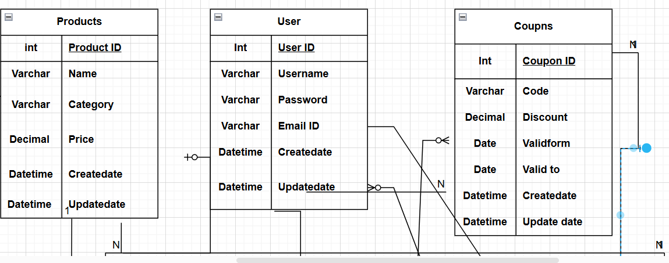

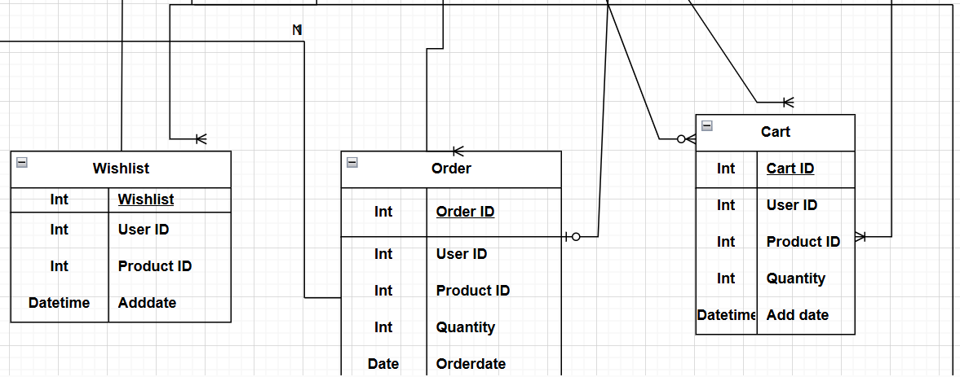

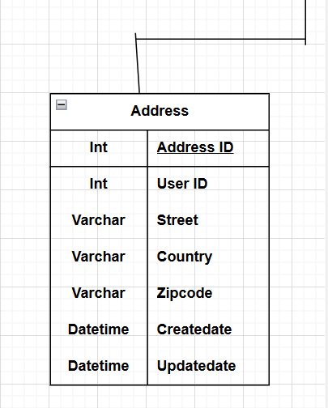

Question 7 – Data Flow Diagram - 3 Marks

What is a data flow diagram? Draw a data flow diagram to represent the in-flow and out-flow of data when a Farmer is placing an order for the product

**Data flow Diagram:** A **Data Flow Diagram (DFD)** is a visual representation of how data moves through a system. It shows where the data comes from, where it goes, and how it is processed.

It consists of:

1. **External Entities** – Sources or destinations of data (e.g., customers, suppliers).
2. **Processes** – Actions that transform data (e.g., order processing).
3. **Data Stores** – Where data is stored (e.g., databases, files).
4. **Data Flows** – Arrows showing how data moves between elements.

DFDs help in understanding and improving a system’s data flow, making it clear how information is handled within an organization or software system.

**Product list**

**Search Products**

**Customer**

**User List**

**Registration**

**Log in**

**User List**

**Account**

**Item/ Product List**

**Add Product to cart**

**Order List**

**Check out**

**Payment Process**

**Make a Payment**

True

Yes No

Shipping information

Question 8 – Change Request - 10 Marks

Due to change in the Government Taxation structure . we should change the Tax structure How do you handle change requests in a project?

1) Identify the scope of the change request and assess its impact on the project.

2) Analyze the cost and time required to implement the change request.

3) Evaluate the benefits of the change request and its alignment with project goals.

4) Prioritize the change request based on its urgency and importance.

5) Communicate the change request to all relevant stakeholders, including the client, project

manager, development team, and business analyst.

6) Update the project plan and documentation to reflect the change request.

7) Implement the change request and monitor its impact on the project.

8) Conduct testing and quality assurance to ensure the change request has been successfully

implemented.

9) Obtain approval from the client or other relevant stakeholders before finalizing the change

request.

10)Communicate the status and impact of the change request to all stakeholders, including

any updates to the project plan, timeline, or budget

Question 9 – Change Request Vs an Enhancement - 5 Marks

As the project is in process, Ben and Kevin have contacted you. The reason is to inform you that they want the Farmers to sell their crop yields through this application i.e. Farmers should be able to add their crop yields or products and display to general public and should be able to sell them. They also want to introduce Auction system for their Crop yields. As a BA, what will be your response?

Is this a change request or an enhancement???

This sounds like an enhancement request as it involves adding new features to the existing

project. As a BA, I would first gather more information from Ben and Kevin about the specific

requirements for adding crop yields and implementing an auction system. I would then assess the

impact of these changes on the project timeline, budget, and other existing requirements. If the

changes are feasible and align with the project goals, I would document the new requirements and

update the project plan and relevant stakeholders accordingly.

A change request and an enhancement are both terms used in software development and project

management, but they refer to slightly different things

Due to change in the Government Taxation structure. We should change the Tax structure

how do you handle change requests in a project?

1) Identify the scope of the change request and assess its impact on the project.

2) Analyse the cost and time required to implement the change request.

3) Evaluate the benefits of the change request and its alignment with project goals.

4) Prioritize the change request based on its urgency and importance.

5) Communicate the change request to all relevant stakeholders, including the client, project

manager, development team, and business analyst.

6) Update the project plan and documentation to reflect the change request.

7) Implement the change request and monitor its impact on the project.

8) Conduct testing and quality assurance to ensure the change request has been successfully

implemented.

9) Obtain approval from the client or other relevant stakeholders before finalizing the change

request.

10)Communicate the status and impact of the change request to all stakeholders, including

any updates to the project plan, timeline, or budget.

As the project is in process, Ben and Kevin have contacted you. The reason is to inform

you that they want the Farmers to sell their crop yields through this application i.e. Farmers

should be able to add their crop yields or products and display to general public and

should be able to sell them. They also want to introduce Auction system for their Crop

yields. As a BA, what will be your response?

Is this a change request or an enhancement???

This sounds like an enhancement request as it involves adding new features to the existing

project. As a BA, I would first gather more information from Ben and Kevin about the specific

requirements for adding crop yields and implementing an auction system. I would then assess the

impact of these changes on the project timeline, budget, and other existing requirements. If the

changes are feasible and align with the project goals, I would document the new requirements and

update the project plan and relevant stakeholders accordingly.

A change request and an enhancement are both terms used in software development and project

management, but they refer to slightly different things.

**Change Request:**

•A change request is typically a formal proposal to alter a product, system, or project in

some way.

•It often arises when there's a need to modify something that has already been defined or

implemented.

•Change requests can involve fixing defects, addressing issues, or making adjustments to

meet new requirements.

•They are usually submitted when there's a deviation from the initial plan or specification,

and they often require approval from stakeholders before implementation.

**Enhancement:**

•An enhancement, on the other hand, refers to an improvement or addition to a product or

system that goes beyond its original specifications.

•Enhancements are typically intended to add new features, improve existing functionality, or

enhance user experience.

•Unlike change requests, enhancements are often proactive and driven by a desire to make

the product better rather than fixing something that's broken.

•While change requests are often reactive, responding to identified problems or changes in

requirements, enhancements are more about adding value or staying competitive in the

market

Question 10 – Estimations - 6 Marks

Come up with estimations – How many Manhours required

Estimating the required manhours depends on the scope of the task, complexity, and resources available. Here's how I approach it:

1. **Understand the Task**: Break down the work into smaller tasks. For example, if we need to update the tax structure in the system, tasks might include analysis, development, testing, and deployment.
2. **Estimate Each Task**:
   * **Analysis**: 8 hours (to understand the new taxation structure and its impact).
   * **Development**: 40 hours (to update the tax calculation logic, reports, and database).
   * **Testing**: 24 hours (to test different tax scenarios, including edge cases).
   * **Deployment**: 8 hours (to deploy the changes to the live environment and perform final checks).
3. **Add Buffer**: Include a 10-15% buffer for unexpected delays or issues. For example, a buffer of 12 hours.
4. **Final Estimation**: Add up the hours:
   * Total = 8 (Analysis) + 40 (Development) + 24 (Testing) + 8 (Deployment) + 12 (Buffer) = **92 Manhours**.

This estimation ensures all aspects of the work are covered, allowing us to plan effectively.

4o

Question 11 – UAT – 6 Marks

Project has finally completed all the stages i.e., design, development, testing etc. Now, it is the roleof a business analyst to contact the client for testing of the final product and have to successfully complete it. How are you going to handle this situation? And once it is done, what will be the process to close the project?

Explain UAT Acceptance process

**UAT (User Acceptance Testing**) is the final stage of the software development lifecycle where the

end-users of the system test the product to ensure that it meets their requirements and is ready for

deployment. The UAT Acceptance process involves the following steps: Planning: The business

analyst works with the client to plan the UAT phase, including defining the scope, identifying the

test scenarios and cases, and setting the acceptance criteria. Test Execution: The end-users

perform the testing on the software product in a real-world environment and provide feedback on

its usability, functionality, and performance

**Issue Resolution**:

If any issues are identified during the UAT phase, they are recorded and addressed by the

development team. Sign-off: Once the UAT is completed successfully, the end-users sign-off on

the product, indicating that it meets their requirements and is ready for deployment. To close the

project, the following steps can be taken: Project Review: The business analyst conducts a project

review to ensure that all the requirements have been met, and the project objectives have been

achieved

**Documentation**

All project documentation, including requirements documents, design documents, test cases, and

project plans, are reviewed and updated

**Closure Meeting:**

A closure meeting is held with the stakeholders to discuss the success of the project, any lessons

learned, and future recommendations.

Project Closure Report:

The business analyst prepares a project closure report that includes the project review,

documentation updates, closure meeting outcomes, and any final recommendations.

Archiving:

The project documentation and artifacts are archived for future reference, and the project team is

disbanded

Question 12 – Project Closure Document - 6 Marks

Explain Project closure document

|  |  |  |  |
| --- | --- | --- | --- |
| **S No** | **Points to include** | **Details** | **Reference Link** |
| **1** | **Did the client off on the UAT**  **Testing** | |  |
|  | Date of Sign off | 5/10/2024 | Business_Scope.docx |
|  | Name of the resource |  |  |
| **2** | **Objectives of the Project** |  |  |
|  | User friendliness | Achieved |  |
|  | Customer Satisfaction | ROI (6 Months) |  |
|  | More Categories | Achieved |  |
| **3** | **Functionalities worked on** |  |  |
|  | Secured payment process | Achieved | FRD.docx |
|  | Categories | Achieved |  |
| **4** | **Infrastructure** |  |  |
|  | Software installed | Achieved |  |
|  | Laptop purchased | Achieved | Procurement.docx |
| **5** | **Funding** |  |  |
|  | Amount approved | 2 Croes |  |
|  | Amount Used | 2Croes | Financialdetails.xlsx |
| **6** | **Overall Project Information** | |  |
|  | Escalations | 30 |  |
|  | Customer Satisfaction | High |  |
| **7** | **Value to the company** |  |  |
|  | Positive/ Negative | Company has gained successful integration of process | |