**Question 1** – Functional Requirements - 15 Marks

**Answer 1**- Functional requirements are defined as navigation of screens through which the functionality is achieved. Functional requirements describe what a system or application should do, outlining the specific behaviours and functions it must support. They define the interactions between the system and its users or other systems, detailing what actions the system should perform in response to various inputs. Essentially, functional requirements specify the "what" of a system—what it should accomplish, what tasks it should perform, and what interactions it should support.

|  |  |  |  |
| --- | --- | --- | --- |
| **FUNCTIONAL REQUIREMENTS** | | | |
| **Req ID** | **Req Name** | **Req Description** | **Priority** |
| FR0001 | Farmer Registration | Farmers should be able to register with the application | 8 |
| FR0002 | Farmer Search for Products | Farmers should be able to search for available products in fertilizers, seeds, pesticides | 8 |
| FR0003 | Login | All the users should have a login functionality | 8 |
| FR0004 | Catalogue | Manufactures should be able to upload a product catalogue for all the available products. | 8 |
| FR0005 | Option add items to cart | Farmer should be able to add products to Cart. | 7 |
| FR0006 | Option remove items from cart | Farmer should be able to remove products from Cart. | 7 |
| FR0007 | Option to add items to wish list. | Farmers should be able to add product to their wish list/favourites. |  |
| FR0008 | View products | Registered & non registered user should be able to see the products or browse the products. | 7 |
| FR0009 | Payment method | Farmers should be able to pay on COD basis | 8 |
| FR0010 | Payment method | Farmers should be able to pay using credit or debit card | 8 |
| FR0011 | Payment method | Farmers should be able to pay using UPI | 8 |
| FR0012 | Email confirmation | Farmers should receive e-mail confirmation for placed order | 7 |
| FR0013 | Transaction ID | Transaction id should be generated for every purchase. | 6 |
| FR0014 | Dispatch details | Once material is dispatched shipper should be able to upload dispatch details on portal | 7 |
| FR0015 | Dispatch update to customer | Once dispatch details are uploaded by shipper. Farmer should receive a dispatch confirmation | 7 |
| FR0016 | Online tracking | Farmer should be able to track the delivery status online. | 7 |
| FR0017 | Delivery confirmation | The farmer and manufacturer should receive a delivery confirmation once items are delivered to customer. | 6 |
| FR0018 | Return goods | Farmer should be able to return the goods through online complaint for damaged or expired products. | 6 |
| FR0019 | Invoice generation | Upon successful payment farmer should receive Invoice copy along with payment confirmation. | 6 |
| FR0020 | Option to buy later | Registered buyer can keep the products in cart and can have an option for buy later. | 7 |

**NON-FUNCTIONAL** requirements are integration of external peripherals of system along with quality requirements. Non-functional requirements specify how a system should perform its functions, rather than what functions it should perform. They describe the quality attributes, constraints, and conditions under which a system must operate. These requirements focus on the "how" rather than the "what," and they address aspects such as performance, security, usability, and reliability. E.g.: Integration of external peripherals means barcode scanner, printer, swipe machine is integrated.

|  |  |  |  |
| --- | --- | --- | --- |
| **NON-FUNCTIONAL REQUIREMENTS** | | | |
| **Req ID** | **Req Name** | **Req Description** | **Priority** |
| NFR0101 | Page Loading Time | Each Page should load within 2 seconds time | 9 |
| NFR0102 | WCAG 2.1. | The system must meet Web Content Accessibility Guidelines WCAG 2.1. | 8 |
| NFR0103 | Language | Options to select regional local languages can be there. | 5 |
| NFR0104 | QR code | QR code should be printed on the packing slip. | 7 |
| NFR0105 | Payment Gateway | Payment gateway should be integrated to facilitate online payments | 9 |
| NFR0106 | High Availability | Application platform should be available 24*7 | 9 |
| NFR0107 | Scalability | System should be able to handle multiple millions of users. | 9 |
| NFR0108 | Resilient | System should automatically recover from failure | 9 |
| NFR0109 | Portability | Agriculture Store app should be functional in Desktop ,Laptop and mobile. | 9 |
| NFR0010 | Compatible application | Agriculture store app being online web/mobile application should be able to run on different operation systems Windows,Android,iOS. | 8 |

**Question 2**– Minimum 5 page designs - 15 Marks

Make wireframe and prototypes

**Answer2- Wireframes** are basic, visual representations of a design’s layout and structure. They serve as a blueprint for the design and are typically low-fidelity. **Prototypes** are more advanced models of a design that simulate how the final product will function. They can be interactive and provide a more realistic sense of the user experience.

**BALSMIQ 5 PAGES**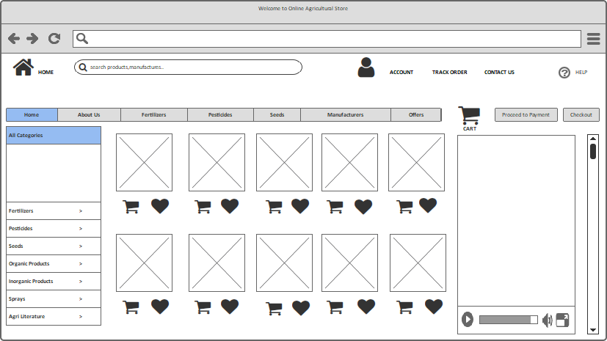

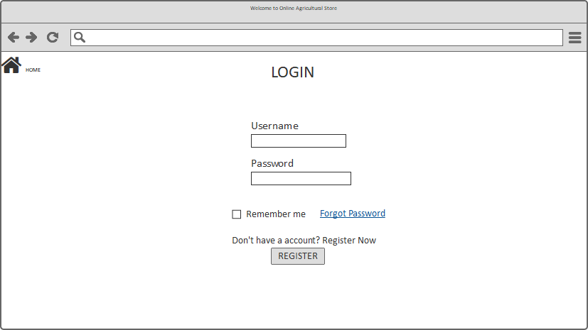

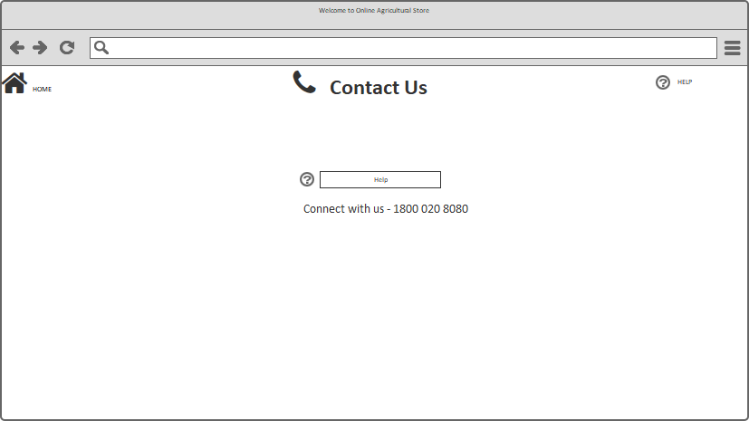

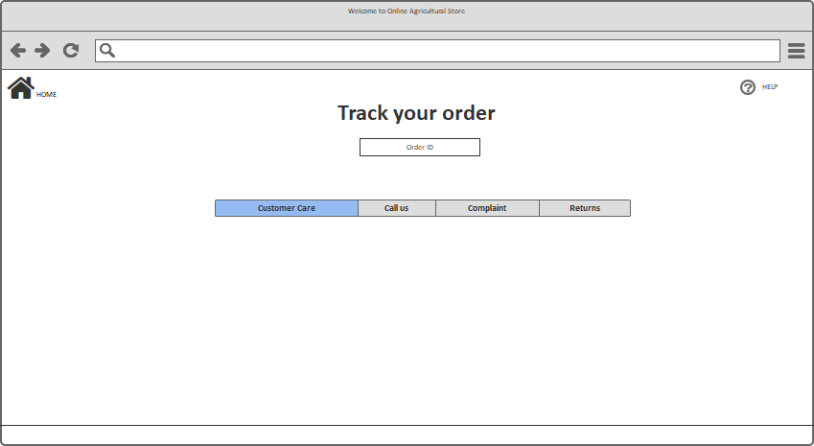

**AXURE 5 PAGES-**

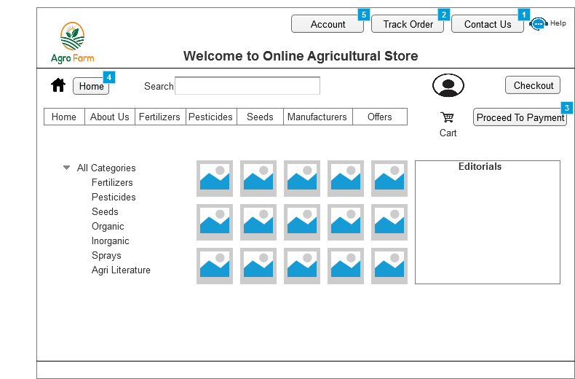

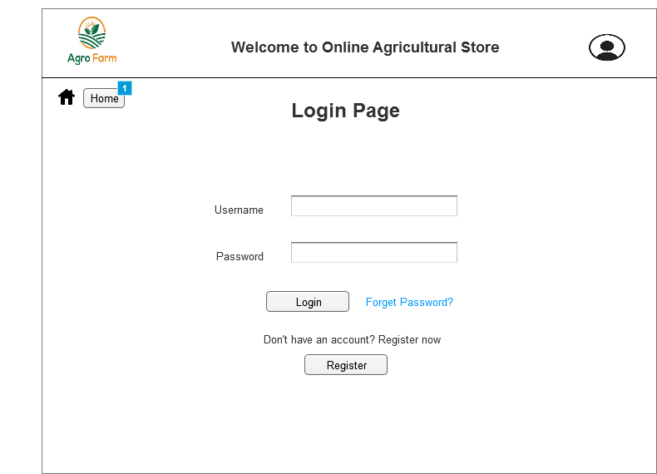

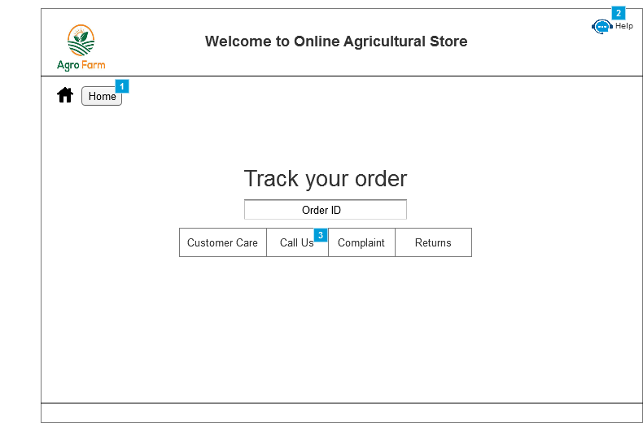

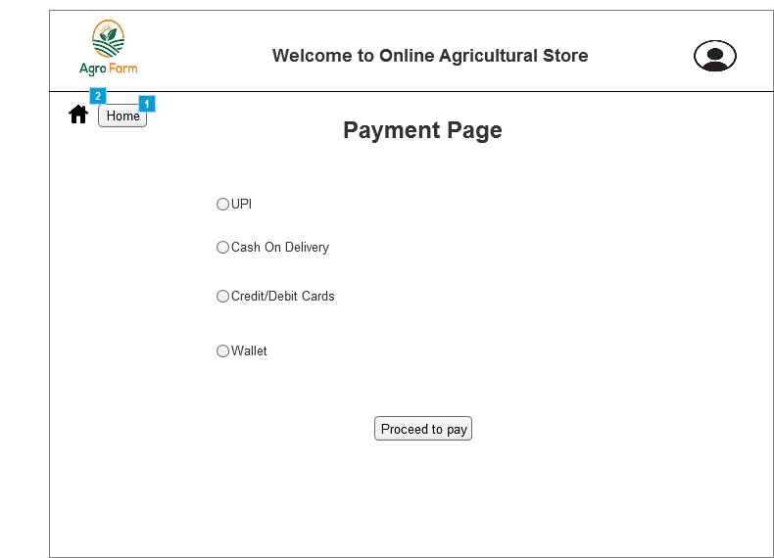

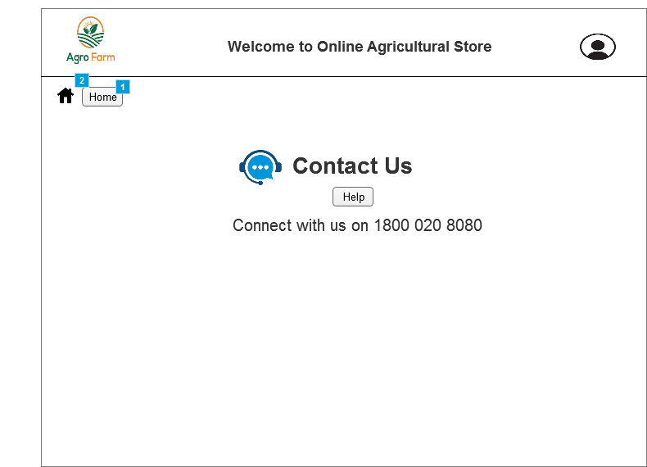

**Question 3** – Tools (Visio, Balsamiq) - 15 Marks

Make a note of the Tools, which you are using for above concepts.

**Answer3-**

**1)Ms. Visio:** - Microsoft Visio is software for drawing a variety of diagrams like flowcharts, org charts, data flow diagrams, network diagrams, process flow diagrams, business process modeling, swim lane diagrams, wireframes and prototypes, UML diagrams,3D maps, and many more. Basically Visio is a drag and drop tool in which variety of pre build shapes and designs are available using which we can create any diagram. E.g. We can create Use case diagrams, activity diagrams and swim lanes diagrams using MS Visio tool. Out of above examples USE case will be drawn for user perspective and Activity diagrams as system perspective.

Key Features of MS Visio:

1. **Templates and Shapes:** Provides a wide range of templates and Users can create or download custom shapes to meet specific needs.
2. **Drag-and-Drop Interface**
3. **Connectors and Auto-Layout:** Visio provides various types of connectors to link shapes and diagrams can be automatically organized to maintain a clean and organized appearance.
4. **Data Linking:** Users can link Visio diagrams to external data sources, such as Excel or SQL databases, to display live data in diagrams.
5. **Collaboration and Sharing:** **Integration with Office 365:** Visio integrates with other Microsoft Office tools, allowing for seamless sharing and collaboration. Collaborators can leave comments and annotations directly on the diagram.
6. **Customizable Appearance:** Users can customize shapes, colours, fonts.
7. **Hyperlinks and Interactivity:** Users can add hyperlinks to shapes or pages
8. **Export and Import:** Visio diagrams can be exported to various formats like PDF, image files, and web pages, or imported from other file types.

**2)Balsamiq** is a popular tool specifically designed for creating low-fidelity wireframes and mockups. It’s widely used in user interface (UI) and user experience (UX) design to sketch out the structure of a web page or application before diving into high-fidelity design.

**Key Features of Balsamiq:**

1. **Low-Fidelity Wireframing:** Balsamiq’s wireframes have a hand-drawn, sketch-like appearance, which helps focus on layout and functionality rather than detailed design elements. **Quick Prototyping as** Its simple interface allows for rapid creation of wireframes, making it easy to iterate and explore different design ideas.
2. **Drag-and-Drop Interface:** Balsamiq offers a drag-and-drop interface that simplifies adding and arranging UI components, such as buttons, text fields, and images.
3. **Predefined UI Components:** The tool includes a comprehensive library of standard UI elements and components, which can be easily dragged onto the canvas.Users can also create and save custom components to reuse across different projects.
4. **Interactive Prototypes:** Balsamiq allows you to create clickable prototypes by linking different wireframes together not as advanced as high-fidelity prototyping tools. Balsamiq’s interactions are useful for basic usability testing and flow visualization.
5. **Collaboration Features:**Users can leave comments and feedback directly on the wireframes, facilitating collaboration and discussion.Wireframes can be shared with stakeholders and team members through various formats, including PDF and image exports.
6. **History and Revisions:** Balsamiq maintains a version history, allowing you to track changes and revert to previous versions if needed.
7. **Integration:** Balsamiq integrates with various project management and collaboration tools like Jira, Confluence, and Trello, enhancing its utility in a broader workflow.
8. **Accessibility:** Balsamiq offers both a desktop application and a web-based version (Balsamiq Cloud), allowing users to work locally or online.

3) **Axure RP** is a design tool for creating highly interactive HTML prototypes for web, mobile, and desktop application projects. It is a UX design tool used for creating wireframes and interactive prototypes. Axure allows users to quickly create wireframes and prototypes from any rough ideas they may have. We can create actual HTML page and link it online enabling client to see how the actual interface will tentatively be.

**Key Features of Axure RP**

1. **Interactive Prototyping:** Axure allows you to create interactive prototypes with dynamic content that can change based on user interactions which can mimic real-world user experiences.
2. **Drag-and-Drop Interface:** Axure provides a drag-and-drop interface to add widgets, shapes, and components to your design canvas, making it easier to build and modify prototypes.
3. **Master Pages and Templates:** Changes made to a master page are reflected across all instances where it is used,also we can save and reuse common design elements and layouts.
4. **Responsive Design:** Helps creating prototypes that adapt to different screen sizes and orientations, ensuring your design works well on various devices.
5. **Collaboration and Feedback:** Axure supports team collaboration with cloud-based sharing, allowing multiple designers to work on the same project simultaneously. Stakeholders can leave comments directly on the prototype, facilitating feedback and discussions.
6. **Export Options:** Export your prototypes to HTML for sharing online or as images and PDFs for offline review.
7. **Integration:** Axure integrates with various tools and platforms like Jira, Confluence, and Slack to enhance workflow and project management.
8. **User Testing:** Conduct usability tests with interactive prototypes to gather feedback and refine your design before development.

4) **draw.io**, now known as **diagrams.net**, is a free and versatile online diagramming tool used for creating a wide range of diagrams and visual representations. It’s popular for its simplicity, ease of use, and integration capabilities.

**Key Features of draw.io:**

1. **Wide Range of Diagram Types:** Flowcharts,UML Diagrams,Network Diagrams, Organizational Charts, Wireframes and Mockups, Mind Maps
2. **User-Friendly Interface:** Use a library of pre-defined shapes or create custom shapes and templates and drag and drop feature makes entire interface user friendly.
3. **Collaboration Features:** We can collaborate with team members for working ,editing on same features ,helping interactions and discussion.
4. **Cloud storage integration** through G-drive, one drive drop box is possible
5. **Export formats:** supports various export formats JPEG, PNG, PDF, SVG, XML.

**Question 4** – RTM - 6 Marks

**Answer4- Requirements Traceability Matrix (RTM)** is a document used to ensure that all requirements of a project are met throughout the development process. It maps and traces the relationship between requirements and other project artefacts like design, implementation, testing, and validation.

* BA prepares RTM from SRS before Design phase starts. (BA is the owner of RTM)
* BA traces how requirement is dealt in each phase of development life cycle from Design till UAT.
* BA update RTM (during design phase-coding phase-testing phase)
* BA forwards RTM to client or the PM which should be attached to the Project Closure Document.

|  |  |  |  |  |  |  |  |  |  |  |  |  |
| --- | --- | --- | --- | --- | --- | --- | --- | --- | --- | --- | --- | --- |
| **Requirement ID** | **Requirement Name** | **Requirement Description** | **Design** | **D1** | **T1** | **D2** | **T2** | **D3** | **T3** | **D4** | **T4** | **UAT** |
| FR0001 | Farmer Registration | Farmers should be able to register with the application | Yes | Yes | Yes | Yes | Yes | Yes | Yes | No | No | Yes |
|
| FR0002 | Farmer Search for Products | Farmers should be able to search for available products in fertilizers, seeds, pesticides | Yes | Yes | Yes | Yes | Yes | Yes | Yes | No | No | Yes |
| FR0003 | Login | All the users should have a login functionality | Yes | Yes | Yes | Yes | Yes | Yes | Yes | No | No | Yes |
| FR0004 | Catalogue | Manufactures should be able to upload a product catalogue for all the available products. | Yes | Yes | Yes | Yes | Yes | Yes | Yes | No | No | Yes |
| FR0005 | Option add items to cart | Farmer should be able to add products to Cart. | Yes | Yes | Yes | Yes | Yes | Yes | Yes | No | No | Yes |
| FR0006 | Option remove items from cart | Farmer should be able to remove products from Cart. | Yes | Yes | Yes | Yes | Yes | Yes | Yes | No | No | Yes |
| FR0007 | Option to add items to wish list. | Farmers should be able to add product to their wish list/favourites. | Yes | Yes | Yes | Yes | Yes | Yes | Yes | No | No | Yes |
| FR0008 | View products | Registered & non registered user should be able to see the products or browse the products. | Yes | Yes | Yes | Yes | Yes | Yes | Yes | No | No | Yes |
| FR0009 | Payment method | Farmers should be able to pay on COD basis | Yes | Yes | Yes | Yes | Yes | Yes | Yes | No | No | Yes |
| FR0010 | Payment method | Farmers should be able to pay using credit or debit card | Yes | Yes | Yes | Yes | Yes | Yes | Yes | No | No | Yes |
|
| FR0011 | Payment method | Farmers should be able to pay using UPI | Yes | Yes | Yes | Yes | Yes | Yes | Yes | No | No | Yes |
|
| FR0012 | Email confirmation | Farmers should receive e-mail confirmation for placed order | Yes | Yes | Yes | Yes | Yes | No | No | No | No | No |
| FR0013 | Transaction ID | Transaction id should be generated for every purchase. | Yes | Yes | Yes | Yes | Yes | No | No | No | No | No |
| FR0014 | Dispatch details | Once material is dispatched shipper should be able to upload dispatch details on portal | Yes | Yes | Yes | Yes | Yes | No | No | No | No | No |
| FR0015 | Dispatch update to customer | Once dispatch details are uploaded by shipper. Farmer should receive a dispatch confirmation | Yes | Yes | Yes | Yes | Yes | No | No | No | No | No |
| FR0016 | Online tracking | Farmer should be able to track the delivery status online. | Yes | Yes | Yes | Yes | Yes | No | No | No | No | No |
| FR0017 | Delivery confirmation | The farmer and manufacturer should receive a delivery confirmation once items are delivered to customer. | Yes | Yes | Yes | Yes | Yes | No | No | No | No | No |
| FR0018 | Return goods | Farmer should be able to return the goods through online complaint for damaged or expired products. | Yes | Yes | Yes | Yes | Yes | No | No | No | No | No |
| FR0019 | Invoice generation | Upon successful payment farmer should receive Invoice copy along with payment confirmation. | Yes | Yes | Yes | Yes | Yes | No | No | No | No | No |
| FR0020 | Option to but later | Registered buyer can keep the products in cart and can have an option for buy later. | Yes | Yes | Yes | Yes | Yes | No | No | No | No | No |
| NFR0101 | Page Loading Time | Each Page should load within 2 seconds time | Yes | Yes | Yes | Yes | Yes | No | No | No | No | No |
| NFR0102 | WCAG 2.1. | The system must meet Web Content Accessibility Guidelines WCAG 2.1. | Yes | Yes | Yes | Yes | Yes | No | No | No | No | No |
| NFR0103 | Language | Options to select regional local languages can be there. | Yes | Yes | Yes | Yes | Yes | No | No | No | No | No |
| NFR0104 | QR code | QR code should be printed on the packing slip. | Yes | Yes | Yes | Yes | Yes | No | No | No | No | No |
| NFR0105 | High Availability | Application platform should be available 24*7 | Yes | Yes | Yes | Yes | Yes | No | No | No | No | No |
| NFR0106 | Scalability | System should be able to handle multiple millions of users. | Yes | Yes | Yes | Yes | Yes | No | No | No | No | No |
| NFR0107 | Resilient | System should automatically recover from failure | Yes | Yes | Yes | Yes | Yes | No | No | No | No | No |
| NFR0108 | Portability | Agriculture Store app should be functional in Desktop ,Laptop and mobile. | Yes | Yes | Yes | Yes | Yes | No | No | No | No | No |
| NFR0009 | Compatible application | Agriculture store app being online web/mobile application should be able to run on different operation systems Windows,Android,iOS. | Yes | Yes | Yes | Yes | Yes | No | No | No | No | No |

**Question 5** – 10 Test Case Documents - 10 Marks

Prepare 10 Test Case Documents

**Answer5-** Test Managers, Sr. Test Managers prepares this test case documents. It has 3 sections control information, scenarios and test data.BA must have idea as we facilitate UAT.

**Test Case Id**

**Test Case Name**

**Project ID**

**Project Name**

**PM ID**

**PM Name**

**Test Strategy ID**

**Tester Id**

**Test Plan ID**

**Tester Name**

**Test Schedule ID**

**Date of Test**

**Test Scenario/ Aim of**

**writing test case :**

**Precondition**

**Input Data**

**Expected**

**Behavior / Output**

**Actual**

**Behavior**

**Comments**

**Result**

**Pass/Fail**

**Bug Id**

PASS

-

To check wether login functionality is performing as required

active internet connection

Enter valid user id & password

successfull login and page should be diverted to landing page of application.

Upon entering correct ID & Password, landing page of application is being displayed

-

AGRI01TS001

1111

AGRI01TP001

Mr Jason and Ms Alekya

AGRI01TS001

15-10-2025

**Test Case Document**

AGRI-02

LOGIN

AGRI01

Online Agriculture Products Store

1111

Mr Vandanam

**Test Case Id**

**Test Case Name**

**Project ID**

**Project Name**

**PM ID**

**PM Name**

**Test Strategy ID**

**Tester Id**

**Test Plan ID**

**Tester Name**

**Test Schedule ID**

**Date of Test**

**Tesr Scenario/ Aim of**

**writing test case :**

**Precondition**

**Input Data**

**Expected**

**Behavior / Output**

**Actual**

**Behavior**

**Comments**

**Result**

**Pass/Fail**

**Bug Id**

Pre-installed application on mobile or open page on browser with active internet connection and user should have

valid email id, and mobile number.

Registration details like name, email id, mobile number

succesful registration

Registratrion function is performing as desired.

PASS

-

-

**Test Case Document**

AGRI-01

AGRI01

1111

AGRI01TS001

AGRI01TP001

AGRI01TS001

Registration

Online Agriculture Products Store

To check if the registration process is performing correctly

Mr Jason and Ms Alekya

15-10-2025

Mr Vandanam

1111

**Test Case Id**

**Test Case Name**

**Project ID**

**Project Name**

**PM ID**

**PM Name**

**Test Strategy ID**

**Tester Id**

**Test Plan ID**

**Tester Name**

**Test Schedule ID**

**Date of Test**

**Tesr Scenario/ Aim of**

**writing test case :**

**Precondition**

**Input Data**

**Expected**

**Behavior / Output**

**Actual**

**Behavior**

**Comments**

**Result**

**Pass/Fail**

**Bug Id**

-

AGRI-03

AGRI01

1111

AGRI01TS001

AGRI01TP001

AGRI01TS001

3 wrong attempts of entering password

wrong user ID & Password 3 times

Account locked message on screen should appear

After entering wrong id & password for 3 times, account locked message appeared.

-

PASS

Error message should appear after 3 unsuccessful attempts to login and account locked message should appear.

**Test Case Document**

Login failed

Online Agriculture Products Store

Mr Vandanam

1111

Mr Jason and Ms Alekya

15-10-2025

**Test Case Id**

**Test Case Name**

**Project ID**

**Project Name**

**PM ID**

**PM Name**

**Test Strategy ID**

**Tester Id**

**Test Plan ID**

**Tester Name**

**Test Schedule ID**

**Date of Test**

**Tesr Scenario/ Aim of**

**writing test case :**

**Precondition**

**Input Data**

**Expected**

**Behavior / Output**

**Actual**

**Behavior**

**Comments**

**Result**

**Pass/Fail**

**Bug Id**

-

AGRI-05

AGRI01

1111

AGRI01TS001

AGRI01TP001

AGRI01TS001

Singed in account, and add to cart option should be clicked

selected products

If product is selected as add to cart message should appear as product added to cart and in cart addition of product

with calculation for total amount to be paid should happen.

Performing as required

-

PASS

Farmers or user should be able to add required items to cart

**Test Case Document**

ADD ITMES TO CART

Online Agriculture Products Store

Mr Vandanam

1111

Mr Jason and Ms Alekya

15-10-2025

**Test Case Id**

**Test Case Name**

**Project ID**

**Project Name**

**PM ID**

**PM Name**

**Test Strategy ID**

**Tester Id**

**Test Plan ID**

**Tester Name**

**Test Schedule ID**

**Date of Test**

**Tesr Scenario/ Aim of**

**writing test case :**

**Precondition**

**Input Data**

**Expected**

**Behavior / Output**

**Actual**

**Behavior**

**Comments**

**Result**

**Pass/Fail**

**Bug Id**

FAIL-AGRI-04

AGRI-04

AGRI01

1111

AGRI01TS001

AGRI01TP001

AGRI01TS001

Manufacturers should have images in JPEG format available to upload on the portal with active internet and

manufacturer should be a registered user.

Product images in JPEG format

once image is uploaded on the portal in the assigned space on the portal, message should appear as, image uploaded

suggesfully.

Error in uploading images.

After uploading images still image is coming as blank

FAIL

In the event of manufacturing uploading products on portal, he should be able to upload the product.

**Test Case Document**

Uploading products on portal

Online Agriculture Products Store

Mr Vandanam

1111

Mr Jason and Ms Alekya

15-10-2025

**Test Case Id**

**Test Case Name**

**Project ID**

**Project Name**

**PM ID**

**PM Name**

**Test Strategy ID**

**Tester Id**

**Test Plan ID**

**Tester Name**

**Test Schedule ID**

**Date of Test**

**Tesr Scenario/ Aim of**

**writing test case :**

**Precondition**

**Input Data**

**Expected**

**Behavior / Output**

**Actual**

**Behavior**

**Comments**

**Result**

**Pass/Fail**

**Bug Id**

-

AGRI-05

AGRI01

1111

AGRI01TS001

AGRI01TP001

AGRI01TS001

Singed in account, and add to cart option should be clicked

selected products

If product is selected as add to cart message should appear as product added to cart and in cart addition of product

with calculation for total amount to be paid should happen.

Performing as required

-

PASS

Farmers or user should be able to add required items to cart

**Test Case Document**

ADD ITMES TO CART

Online Agriculture Products Store

Mr Vandanam

1111

Mr Jason and Ms Alekya

15-10-2025

**Test Case Id**

**Test Case Name**

**Project ID**

**Project Name**

**PM ID**

**PM Name**

**Test Strategy ID**

**Tester Id**

**Test Plan ID**

**Tester Name**

**Test Schedule ID**

**Date of Test**

**Tesr Scenario/ Aim of**

**writing test case :**

**Precondition**

**Input Data**

**Expected**

**Behavior / Output**

**Actual**

**Behavior**

**Comments**

**Result**

**Pass/Fail**

**Bug Id**

-

AGRI-07

AGRI01

1111

AGRI01TS001

AGRI01TP001

AGRI01TS001

Pre-signed in account and cart should not be empty. There should be at least 1 item in cart.

from cart select option for proceed to payment.

Purchaser should be diverted to the payemtn gateway if card payment or UPI payment is selected.

Upon clicking on proceed to payment user is being divered to payemtn gateway page.

-

PASS

Once required items are added to card and user wants to go ahead and process the online payment.

**Test Case Document**

Proceed to Payment

Online Agriculture Products Store

Mr Vandanam

1111

Mr Jason and Ms Alekya

15-10-2025

**Test Case Id**

**Test Case Name**

**Project ID**

**Project Name**

**PM ID**

**PM Name**

**Test Strategy ID**

**Tester Id**

**Test Plan ID**

**Tester Name**

**Test Schedule ID**

**Date of Test**

**Tesr Scenario/ Aim of**

**writing test case :**

**Precondition**

**Input Data**

**Expected**

**Behavior / Output**

**Actual**

**Behavior**

**Comments**

**Result**

**Pass/Fail**

**Bug Id**

-

AGRI-09

AGRI01

1111

AGRI01TS001

AGRI01TP001

AGRI01TS001

Insufficient account balance or in valid card details entered.

Attempt to make payment.

Error message should be received as unsuccesful payment attempt.

Performing as required.

-

PASS

If in some scenario farmer is getting an error as unsuccessful payment then he should be redirected from payment

portal to the Agriculture store cart page.

**Test Case Document**

Unsuccesful payment

Online Agriculture Products Store

Mr Vandanam

1111

Mr Jason and Ms Alekya

15-10-2025

**Test Case Id**

**Test Case Name**

**Project ID**

**Project Name**

**PM ID**

**PM Name**

**Test Strategy ID**

**Tester Id**

**Test Plan ID**

**Tester Name**

**Test Schedule ID**

**Date of Test**

**Tesr Scenario/ Aim of**

**writing test case :**

**Precondition**

**Input Data**

**Expected**

**Behavior / Output**

**Actual**

**Behavior**

**Comments**

**Result**

**Pass/Fail**

**Bug Id**

-

AGRI-08

AGRI01

1111

AGRI01TS001

AGRI01TP001

AGRI01TS001

active email id

succesful payment confirmation

Once succesful payment confirmation messageis received an auto generated emial should be recevied by purchaser on

their registered emial id.

Auto generated email is being received on the registed emial id.

-

PASS

Once the succesfull payment is made, purchaser should receive an email confirmation of the purchased items along

with detials.

**Test Case Document**

Email confimration

Online Agriculture Products Store

Mr Vandanam

1111

Mr Jason and Ms Alekya

15-10-2025

**Test Case Id**

**Test Case Name**

**Project ID**

**Project Name**

**PM ID**

**PM Name**

**Test Strategy ID**

**Tester Id**

**Test Plan ID**

**Tester Name**

**Test Schedule ID**

**Date of Test**

**Tesr Scenario/ Aim of**

**writing test case :**

**Precondition**

**Input Data**

**Expected**

**Behavior / Output**

**Actual**

**Behavior**

**Comments**

**Result**

**Pass/Fail**

**Bug Id**

-

AGRI-06

AGRI01

1111

AGRI01TS001

AGRI01TP001

AGRI01TS001

Pre signed in account and items should be availabel in cart

click on remove items from cart should be selected.

Once remove items from cart is selected, items should be removed and amount to be paid in total should be auto

calculated.

Performing as required

-

PASS

If user wants to remove those items from cart which were already selected by him and later on he deccides of not

buying the same.

**Test Case Document**

REMOVE ITEMS FROM CART

Online Agriculture Products Store

Mr Vandanam

1111

Mr Jason and Ms Alekya

15-10-2025

|  |  |  |  |  |  |  |  |  |  |  |  |  |  |  |  |  |  |
| --- | --- | --- | --- | --- | --- | --- | --- | --- | --- | --- | --- | --- | --- | --- | --- | --- | --- |
| **Question 6** -DB Design-8Marks |  |  |  |  |  |  |  |  |  |  |  |  |  |  |  |  |  |
| After the requirements are thoroughly explained to the entire project team by business analyst,  the Database architects have decided to do the database design and also to represent the in-flow and out-flow of data. | | | | | | | | | | | | | | | | | |
| Draw database schema and ER diagram  **Answer 6** – |  |  |  |  |  |  |  |  |  |  |  |  |  |  |  |  |  |



Page Loading Entities: NA

Mouse over Entities: Product_ categories

Page Submission Entities: NA

Page Loading Entities: NA

Mouse over Entities: NA

Page Submission Entities: Username,Password



Page Loading Entities: NA

Mouse over Entities: NA

Page Submission Entities: NA



Page Loading Entities: NA

Mouse over Entities: NA

Page Submission Entities: Order ID



Page Loading Entities: NA

Mouse over Entities: NA

Page Submission Entities: NA

**ER DIAGRAM** FOR AGRICULTURAL STORE

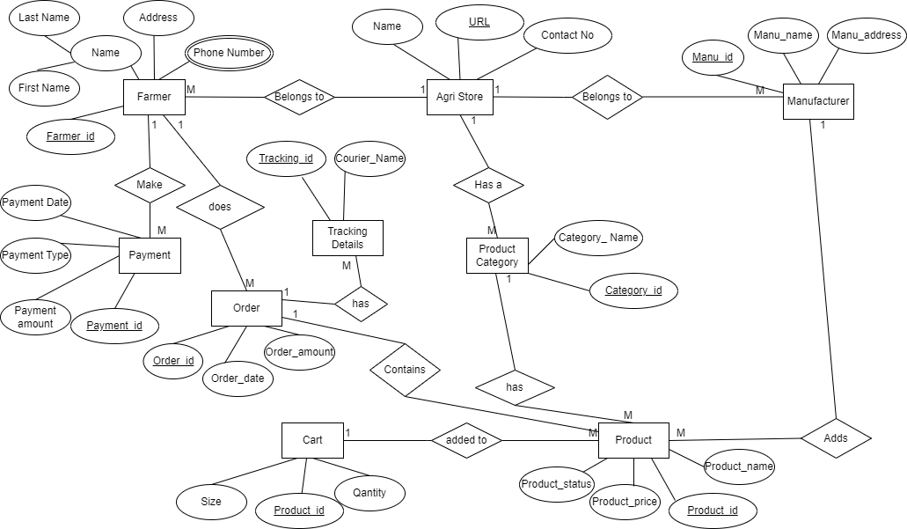

**DATABASE SCHEMA:**

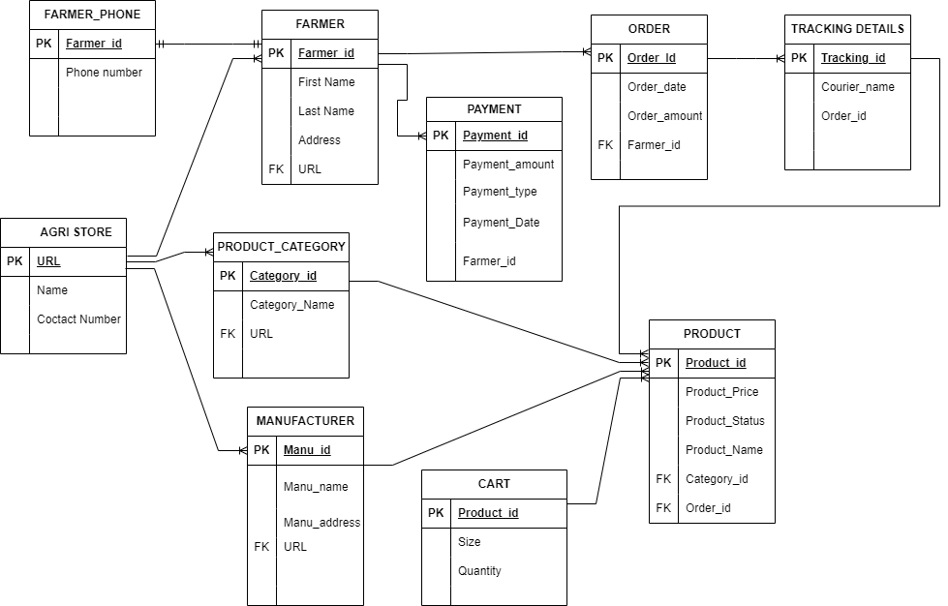

**Question 7** – Data Flow Diagram - 3 Marks

What is a data flow diagram? Draw a data flow diagram to represent the in-flow and out-flow of data when a Farmer is placing an order for the product.

**Answer7**- A data flow diagram is a graphical view of how data is processed in a system in terms of input and output.

The DFD contains some symbol for drawing the data flow diagram.

1)

**Data flow:** the route that data takes between the external entities, processes and data stores. It portrays the interface between the other components and is shown with arrows, typically labelled with a short data name.

2)

**Process:** any process that changes the data, producing an output. It might perform computations, or sort data based on logic, or direct the data flow based on business rules. A short label is used to describe the process.

3)

**Entity:** An outside system that sends or receives data, communicating with the system being diagrammed. They are the sources and destinations of information entering or leaving the system. They might be an outside organization or person, a computer system or a business system. They are also known as terminators, sources and sinks or actors. They are typically drawn on the edges of the diagram.

4)

**Data Store:** files or repositories that hold information for later use, such as a database table or a membership form. Each data store receives a simple label

**Rules:**

Each process should have at least one input and an output.

Each data store should have at least one data flow in and one data flow out.

Data stored in a system must go through a process.

All processes in a DFD go to another process or a data store.

**DFD levels:**

**DFD Level 0** is also called a Context Diagram. It’s a basic overview of the whole system or process being analysed or modelled. It’s designed to be an at-a-glance view, showing the system as a single high-level process, with its relationship to external entities. It should be easily understood by a wide audience, including stakeholders, business analysts, data analysts and developers.

**DFD Level 1** provides a more detailed breakout of pieces of the Context Level Diagram. You will highlight the main functions carried out by the system, as you break down the high-level process of the Context Diagram into its sub processes.

**DFD Level 2** then goes one step deeper into parts of Level 1. It may require more text to reach the necessary level of detail about the system’s functioning.

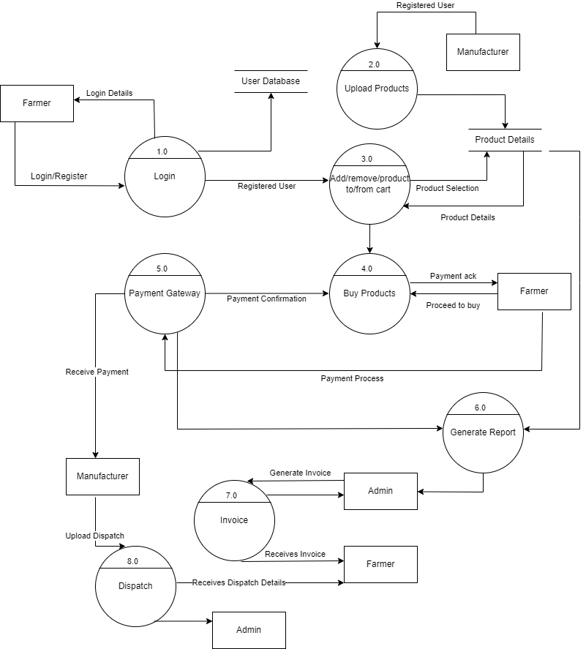

**Question 8** – Change Request - 10 Marks

Due to change in the Government Taxation structure. we should change the Tax Structure How do you handle change requests in a project?

**Answer 8**- A change request is where someone within a business proposes a change to a project. Change can be something very minimal, or could be a significant change.

Initially, BA should check the change request whether it is a defect from previous installations or not. If it is a defect, then it is assigned to the technical team else:

BA should do the following:

1. Feasibility Study (to accept the change)

2. Impact Analysis (to measure the change)

3. Effort Estimation (to implement the change)

Deciding how the change will be implemented, getting an idea of costs and the level of impact it will have on the project will all need to be analysed and the tasks related to putting the change request into action must be delegated to resources.

Change requests will be categorized as ‘in scope’ and will be delivered as part of the project by the established team, while some will be ‘out of scope’.

Small changes that are not going to cost a lot of money to implement or make significant impact to the delivery of the project will usually be classed as ‘in scope’. Larger changes that will cost considerably more, will require more work to review and approve the resources and costs and therefore are usually out of scope.

The process of someone submitting the change management request and the subsequent work to review and approve or reject it, then allocating ownership if it is approved, is referred to as change request management.

**BA should do the following when change is requested:**

* BA analyses the Change Request, is a real change, or defect discovered from previous need communications.
* Change manager or project manager must provide an initial approval if the BA needs to move further in analysing the change request.
* BA as well as PM ensure whether the Change Request is a complex one or just a minor one. This is important factor to decide whether or not to incorporate the changes.
* If the change is complex, it not only expands the scope of project but also drastically leads to increase in delivery time.
* BA will help stakeholders to understand the impact of change request on the organization and help to minimize the negative impact from change.

As a BA, handling change requests in a project, **due to significant factors like a change in government taxation structure**, I will follow systematic approach: -

**Assess the Change Request**:

Evaluate the necessity and urgency of the change. Gather information on how the new taxation structure impacts the project.

**Impact Analysis**:

Analyse how the change will affect project scope, timeline, budget, and resources. Involve relevant stakeholders to understand the broader implications.

**Stakeholder Consultation**:

Discuss the proposed changes with key stakeholders. Gather their feedback and concerns to ensure all perspectives are considered.

**Documentation**:

Document the change request, including details of the proposed changes, rationale, impact analysis, and stakeholder feedback.

**Approval Process**:

Present the change request to the project change control board or decision-makers for approval. Ensure that all relevant information is clear and accessible.

**Implementation Planning**:

Once approved, create a plan for implementing the change. Outline tasks, responsibilities, and timelines for integrating the new taxation structure into the project.

**Communication**:

Communicate the approved changes to all team members and stakeholders. Ensure everyone understands their roles in the updated plan.

**Monitor and Review**:

After implementation, monitor the impact of the changes on the project. Review progress regularly and be open to further adjustments as necessary.

**Document Lessons Learned**:

After the project, document what worked well and what didn’t regarding the change management process. This will help improve future change requests.

By following these steps, you can effectively manage change requests and ensure that your project remains on track despite necessary adjustments.

**Question 9** – Change Request Vs an Enhancement - 5 Marks

As the project is in process, Ben and Kevin have contacted you. The reason is to inform you that they want the Farmers to sell their crop yields through this application i.e. Farmers should be able to add their crop yields or products and display to general public and should be able to sell them. They also want to introduce Auction system for their Crop yields. As a BA, what will be your response?

Is this a change request or an enhancement???

**Answer 9- Change request:** A change request is a formal proposal for an alteration to some product or system

**Enhancement:** An enhancement request is a piece of functionality that was not specified at the time that the code was written, or an extension to what is already present.

The new requirement shared by Ben & Kevin is a completely new change that they are expecting in the current system or initial requirement gathering stage. This is a complete out of scope requirement. And is therefore and enhancement in the existing project. For handling such change, we need to first check on the following.

Since this requirement was not scoped as a part of the initial business requirement document, so as a BA I will carefully review the change in requirement with the PM and same will be managed by using proper change management/control technique.

1) BA will analyse the change request

2) Perform the feasibility study to accept the change of not

3) Perform impact analysis to measure impact on the project

4) Finally effort estimation to implement the change in the project.

5) BA we will document this change request.

6) Since this is a major change in the requirement project manager will provide an initial approval on the same.

7) as this is a major change then it is going to impact on the expand the scope of the project which will in turn increase the delivery time.

**Question 10** – Estimations - 6 Marks

Come up with estimations – How many Man-hours required?

**Answer10-** Considering 18 Months’ project and start date as 1st Jan 25 and end date as 31st Jun 26. Also considering 5 days working total 671 days will be required to complete this project and considering 8 hours per day approx. 5368 working hours will be required and we consider this as a large project.

|  |  |  |  |
| --- | --- | --- | --- |
| **Start Date** | **End Date** | **Duration** | **Time considering 8 workings hours per day** |
| 01-Jan-25 | 31-Mar-25 | 66 | 528 |
| 01-Apr-25 | 30-Apr-25 | 22 | 176 |
| 01-May-25 | 31-Jul-25 | 68 | 544 |
| 01-May-25 | 31-Jul-25 | 68 | 544 |
| 01-Aug-25 | 31-Oct-25 | 68 | 544 |
| 01-Aug-25 | 31-Oct-25 | 68 | 544 |
| 01-Nov-25 | 31-Jan-26 | 68 | 544 |
| 01-Nov-25 | 31-Jan-26 | 68 | 544 |
| 01-Feb-26 | 30-Apr-26 | 65 | 520 |
| 01-Feb-26 | 30-Apr-26 | 65 | 520 |
| 01-May-26 | 31-Jun-2026 | 45 | 360 |
|  | Total | 671 | 5368 |

**Question 11** – UAT – 6 Marks

Project has finally completed all the stages i.e., design, development, testing etc. Now, it is the role of a business analyst to contact the client for testing of the final product and have to successfully complete it. How are you going to handle this situation? And once it is done, what will be the process to close the project?

Explain UAT Acceptance process

**Answer 11-** UAT (User Acceptance Testing) is unique among the activities we undertake on our projects, because its focus is on people who are outside the team, and its primary purpose is not finding defects. User Acceptance Testing (UAT) is a crucial phase in the project lifecycle where end-users validate that the system meets their needs and requirements.

1) BA prepares test cases form the use cases or assist test managers to do so.

2) BA prepares clients for UAT

3) BA performs high level testing.

4) Test data is requested by BA from Client

**Once the above testing process is done following to be followed:**

1) Updates END user manual

2) UPDATES RTM

3) Takes sign off from client on CLIENT PROEJCT ACCEPTANCE FORM.

**Question 12** – Project Closure Document - 6 Marks

Explain Project closure document

**Answer 12-**The last step of a project is called project closure. Project managers use this term to indicate that the client has approved project deliverables for use. There must be a plan in place for continuing maintenance of the project or product.

Closing a project involves more than simply clearing off all the paperwork, completing any vendor contracts, and freeing the team to work on new projects. A project's end-of-project review ensures that all of the project's goals have been completed and that any remaining concerns, such as risk, have been resolved.

**Phases of Closing the Project:**

1) Formal Customer Sign-Off

2) Final Product Scope Analysis

3) Procurement or Other Contract Closure

4) Lessons Learned Documentation

**PROJECT CLOSURE REPORT**

|  |  |  |  |  |  |
| --- | --- | --- | --- | --- | --- |
| PROJECT NAME |  | |  | | |
| Online Agriculture Products store | | | | | |
|  |  | |  | | |
| PROJECT SPONSOR | | PROJECT MANAGER | | PROJECT START DATE | PROJECT END DATE |
| Mr. Henry | | Mr. Vandanam | | 1st Aug 2024 | 31st Jan 2026 |

**PROJECT SUMMARY**

|  |
| --- |
| Mr. Henry Owner of Soony , came up with the idea of creating a online platform after listening issues being faced by his farmer friends. He thought of creating an online agriculture product store to facilitate remote area farmers to buy agriculture products. Through this Online Web / mobile Application, Farmers and Companies (Fertilizers, seeds and pesticides manufacturing Companies) can communicate directly with each other. The main purpose to build this online store is to facilitate farmers to buy seeds, pesticides, and fertilizers from anywhere through internet connectivity. |

PROJECT ROLES & RESPONSIBILITIES

| NAME | ROLE | RESPONSIBILITIES |
| --- | --- | --- |
| Mr. Henry | Sponsor @ Soony | Business Stakeholders and project co-ordinator from Soony |
| Mr Pandu | Financial Head @ Soony | Handling financial aspects of the project. |
| Mr Dooku | Project Coordinator. @ Soony | Project co-ordinator |
| Mr Vandanam | Project Manager | Managing the production of the required deliverables |
| Mr Karthik | Delivery Head | making sure that services are being seamlessly delivered to the clients |
| Ms. Juhi | Senior Java Developer | responsible for the design, development, and management of Java-based applications |
| Mr Teyson | Java Developers | responsible for the design, development, and management of Java-based applications |
| Ms Lucie | Java Developers | responsible for the design, development, and management of Java-based applications |
| Mr Tucker | Java Developers | responsible for the design, development, and management of Java-based applications |
| Mr Bravo | Java Developers | responsible for the design, development, and management of Java-based applications |
| Mr Mike | Network Admin | ensure the stable operation of the computer networks. |
| Mr John. | DB Admin | ensure that data is available, protected from loss and corruption, and easily accessible as needed. |
| Mr Jason | Testers | Executing tests evaluate the results and document problems found. |
| Ms Alekya | Testers | Executing tests evaluate the results and document problems found. |
| Mr. Rohit | BA | responsible for bridging the gap between IT and the business determine requirements and deliver data-driven recommendations and reports to executives and stakeholders |

DELIVERABLES

| PLANNED | ACTUAL | COMMENTS |
| --- | --- | --- |
| To deliver Error free and working online agriculture product store software | Designed and developed required online agriculture product store software | Working and delivered as required |

EXPENSES

| PROJECT PHASE | PLANNED BUDGET | ACTUAL COSTS | COMMENTS |
| --- | --- | --- | --- |
| Full phase | 2 crore | 2 crore | As per budget |

SCHEDULE

| KEY MILESTONES | INITIAL DEADLINE | ACTUAL COMPLETION | COMMENTS |
| --- | --- | --- | --- |
| Completed and delivered the project on time | 31st Jun 2026 | 10th Jun 2026 | Completed project prior to deadline |

LESSONS LEARNED / RECOMMENDATIONS

|  |
| --- |
|  |

APPROVAL

| **NAME** | **TITLE** | **SIGNATURE** | **DATE** |
| --- | --- | --- | --- |
| Mr. Vandanam | Project Manager |  |  |

| **NAME** | **TITLE** | **SIGNATURE** | **DATE** |
| --- | --- | --- | --- |
|  |  |  |  |