**CAPSTONE PROJECT PREP 1 PART 3**

1. **Identify minimum 20 functional requirements?**

**Ans: Functional Requirements** will defines what behaviour system should do, focusing on specific functionalities, features, or tasks it must perform to meet user needs.

|  |  |  |
| --- | --- | --- |
| **Requirement ID** | **Requirement Title** | **Requirement Description** |
| FR001 | Product Browsing | Display all the product categories and its list under each category for user navigation. |
| FR002 | Product Filtering | Supports all the filters of the given product such as price, stock, category etc. |
| FR003 | Account Registration | Allows farmers to create an account with an online application |
| FR004 | Account Login | Allows farmers to login the application and manage the session users creation and termination |
| FR005 | Order Confirmation Mail | Sends all the details of the order confirmation to the farmers |
| FR006 | Search Functionality | Provide search option to view the products using keywords |
| FR007 | Add to Cart | Allows farmers to add their products in the cart for order confirmation |
| FR008 | Payment Gateways | Provides the secure payment gateways for ordering the product in the application |
| FR009 | Product Listing for manufacturers | Allows the manufacturers to update the product list like stock, price, category etc |
| FR010 | Delivery Trackers of Orders | Allows farmers to track real time delivery status of their orders |
| FR011 | Order updates notifications | Notifies the Farmers to receive real time notification for order updates via mail/SMS |
| FR012 | System Securities | Validates system user inputs including the registration, payment in secured access. |
| FR013 | Multi Devices Compatibility | Allows farmers to have access in both mobile as well as desktop to use their application |
| FR014 | Admins dashboard monitoring | Admins only have the access to monitor the users activity, sales, system health and product list in dashboard |
| FR015 | Management users | Allows and manage users like farmers, admins and manufacturers with permissions |
| FR016 | Buy Later feature | Allows Farmers to save their products in buy later option for reference |
| FR017 | Checkout | Allows Farmers to have smooth transition for checkout of order confirmation |
| FR018 | Cart Management | Allows Farmers to add, delete the product items in their carts |
| FR019 | Sales Report and Generation | Allows Admins to generate their sales report and user activity |
| FR020 | Feedback and Reviews | Allows farmers to leave their feedback of the apps and reviews of the product |
| FR021 | Audit System | Maintain logs of system activities for accountability |

**Non Functional Requirements** define how a non-behavioural system should perform, focusing on quality attributes such as performance, scalability, security, usability, and reliability

|  |  |  |
| --- | --- | --- |
| **Requirement**  **ID** | **Requirement Title** | **Requirement Description** |
| NFR001 | Response time | System should respond to user actions within 2 seconds for 90% of all interactions |
| NFR002 | Availability | System should maintain an uptime of 99.99 % to ensure uninterrupted service to users |
| NFR003 | Usability | User interface should be intuitive and require no more than 4 clicks to access any features. |
| NFR004 | Scalability | System must scale to support product catalog size and future growth in users. |
| NFR005 | Reliability | System should recover from critical failures within 20 minutes. |
| NFR006 | Performance | System should handle 1500 concurrent users without significant degradation in performance. |
| NFR007 | Security | All sensitive data must be encrypted which includes user credentials and payment details. |
| NFR008 | Accessibility | System must comply with their standards for accessibility to support users with disabilities |
| NFR009 | Testability | System must supports automated testing frameworks for faster regression testing |
| NFR010 | Authorisation | System must enforce role access control to restrict user permission based on roles like admin, manufacturers and farmers |
| NFR011 | Authentication | System must use different authentication for all admin and manufacture accounts |
| NFR012 | Compliances | System must comply with regulatory standards and with relevant legally like PCI |

1. **Make wireframe and prototypes?**

**Ans:** A **Wireframe** is basic visual representation of the application layout. It outlines the structure and the elements like buttons, text and navigation paths without focusing on colours, styles or graphics. It is **low fidelity** application, mainly the purpose of using it will be to plan the layout or functionality before visual design of the application.

A **Prototype** is an interactive graphic design that establish the final look and feel of the system. Also it allows stakeholders to visualise and interact with the product as if it were real. It is **high fidelity** application, and used to test functionality and design flow before development

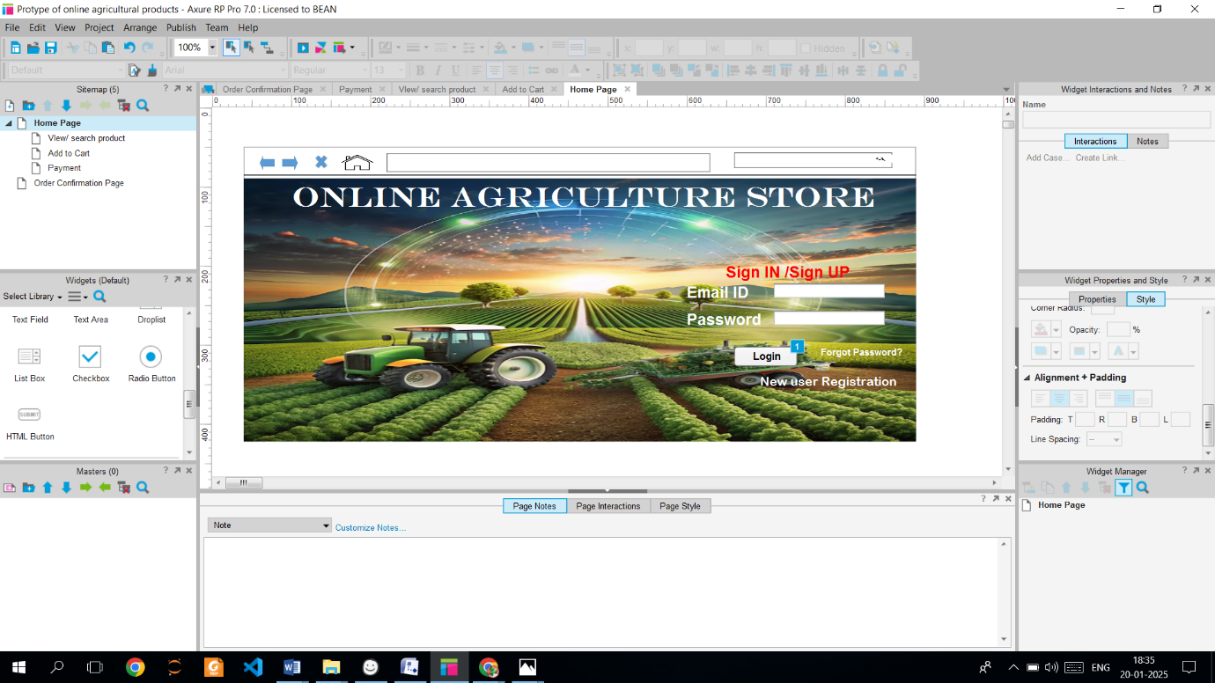

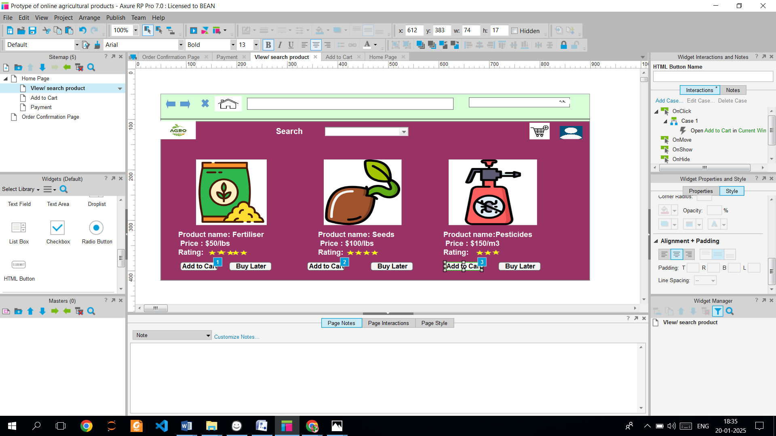

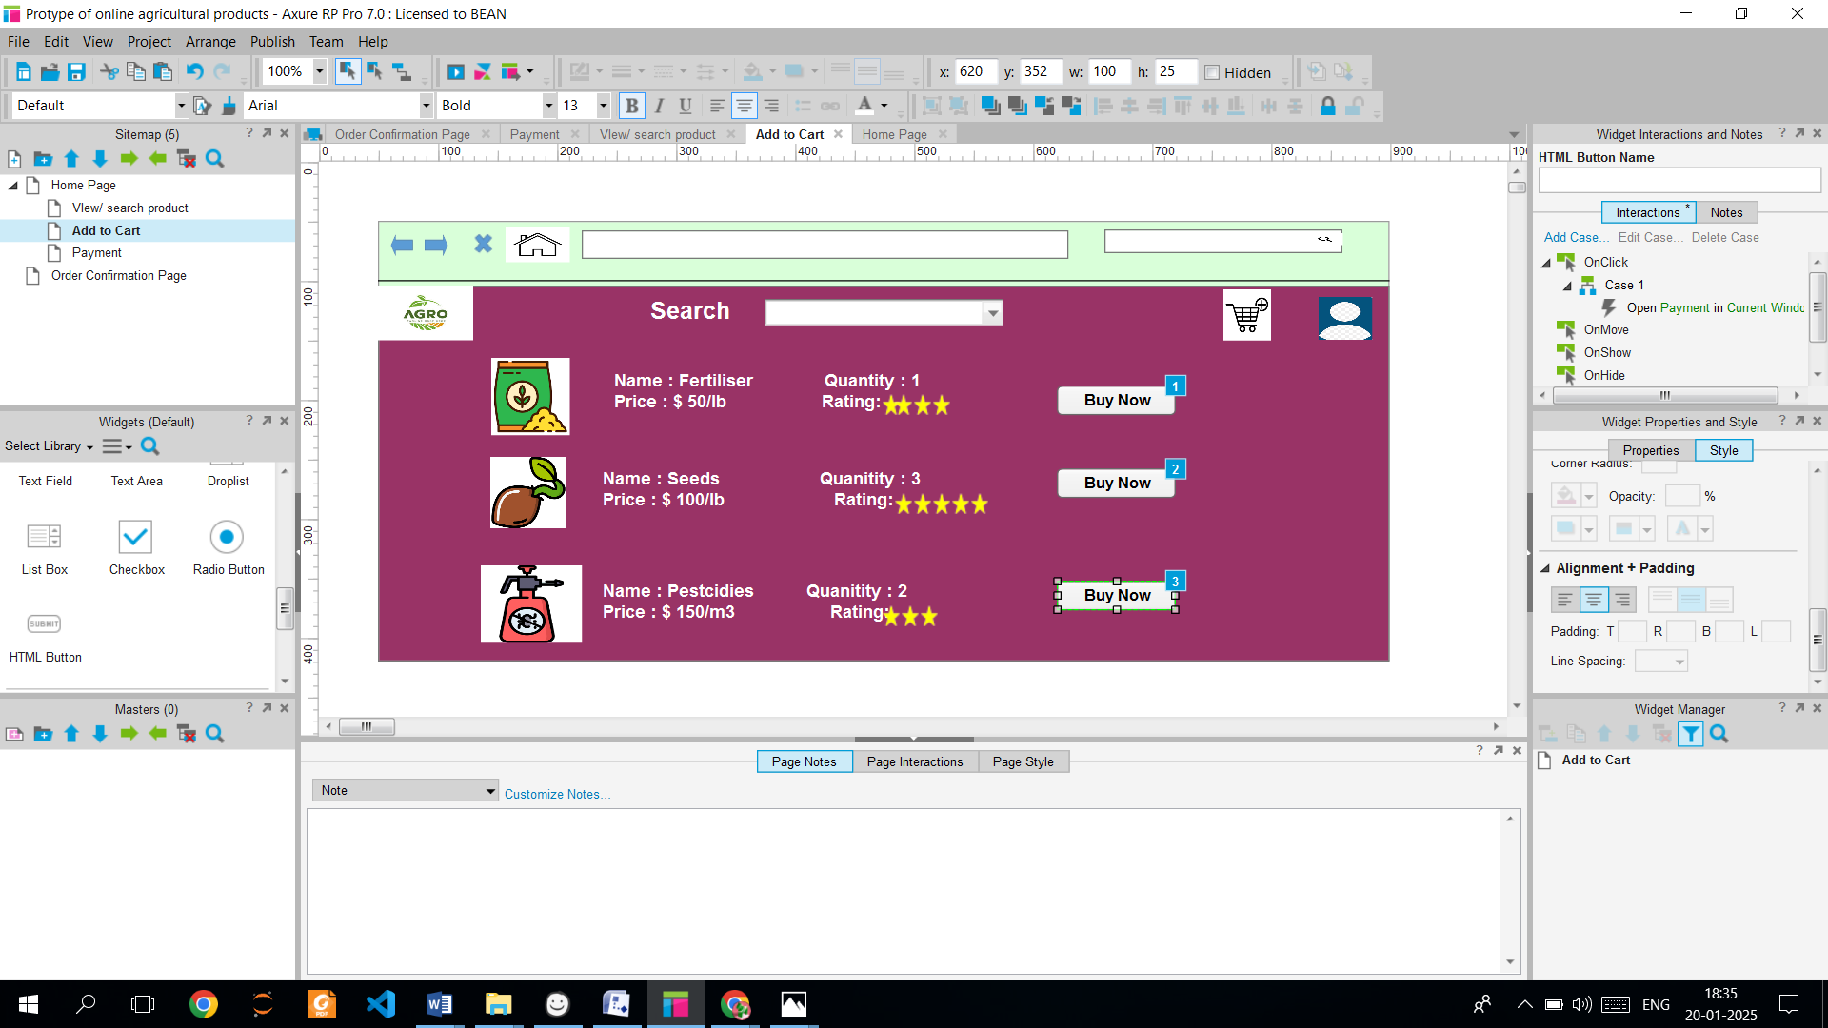

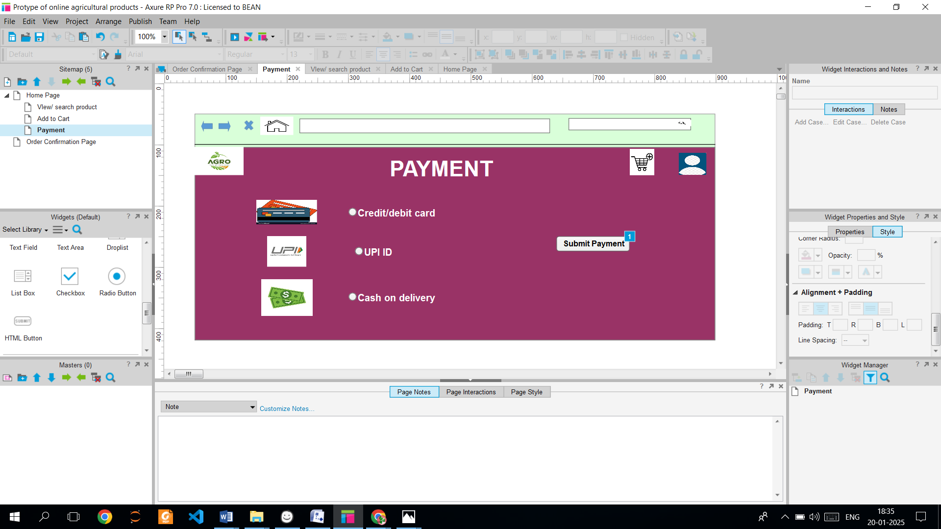

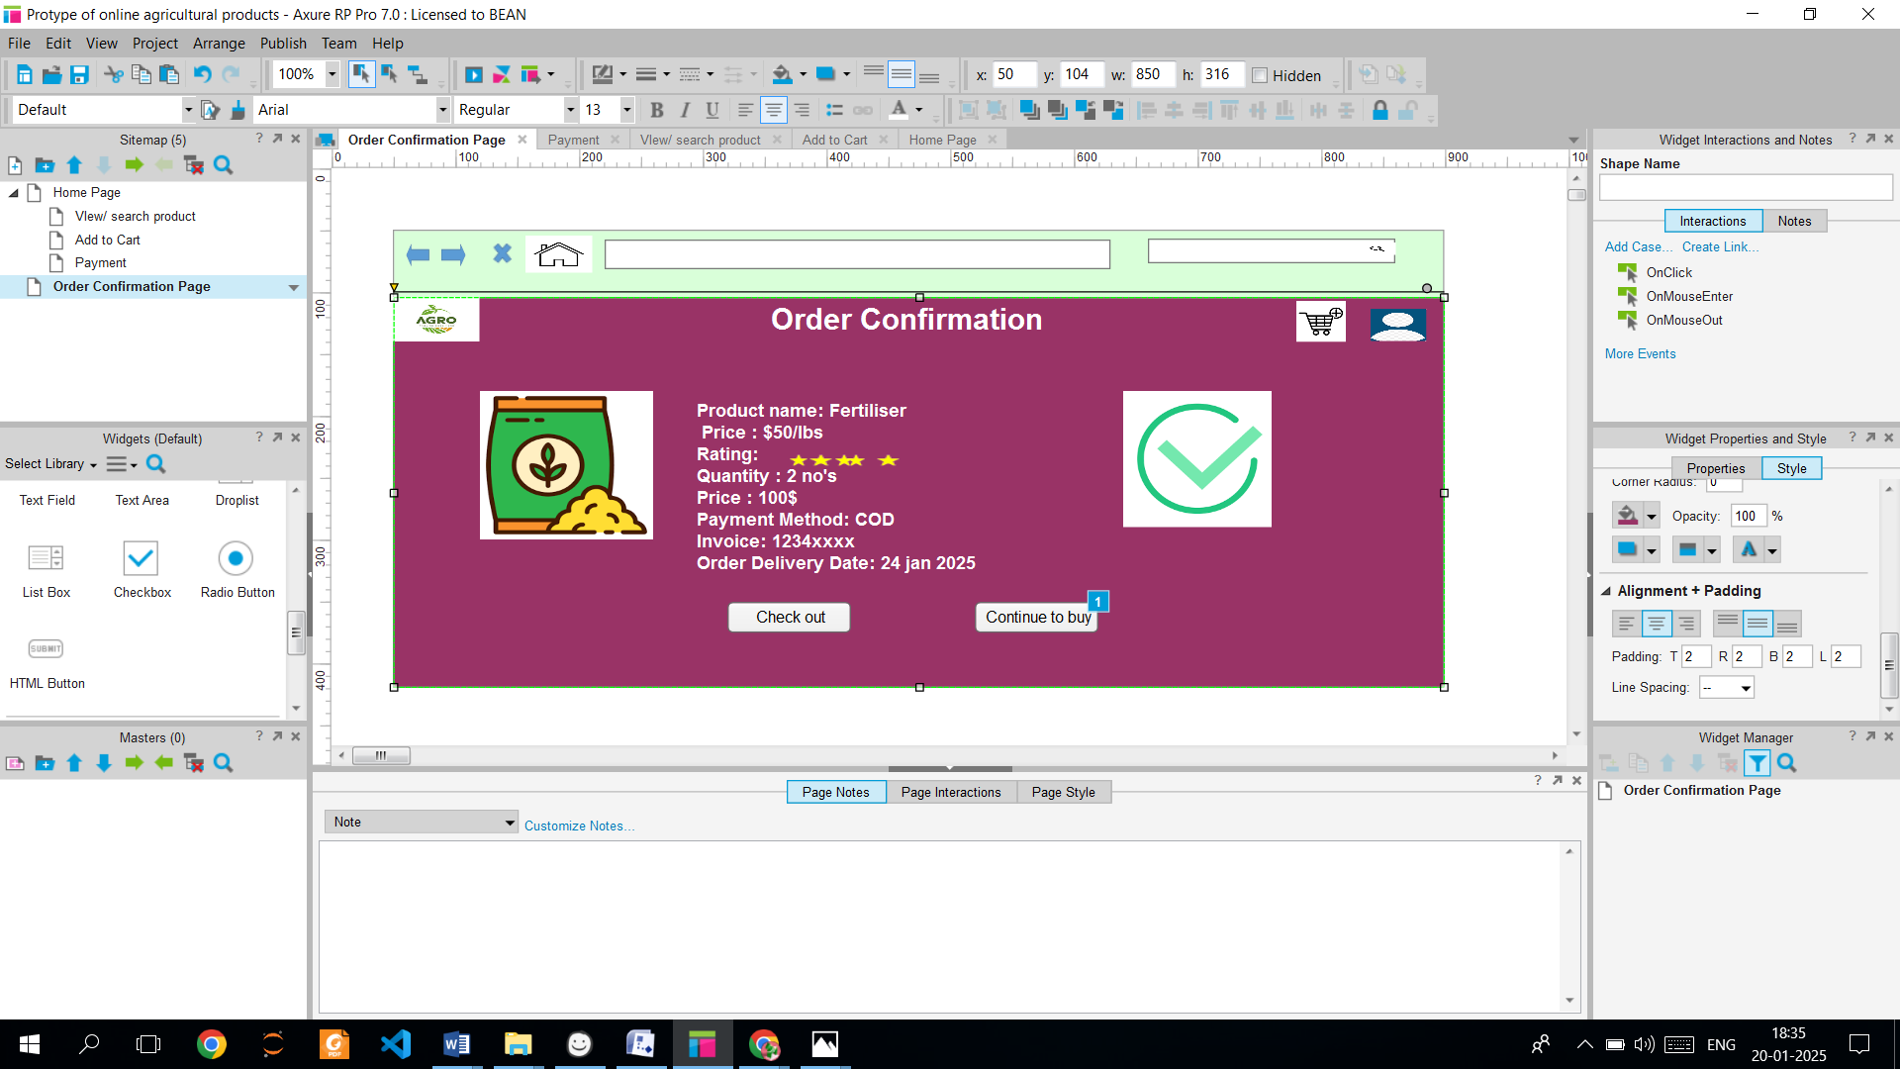

1. **Make a note of the Tools, which you are using for above concepts?**

**Ans:** So In this page design, we use BALSMIC and MS AZURE as tools for the concepts, which are

**BALSMIC –** It is wireframe tool which is used for blue print of websites and applications and also it used to create low fidelity apps, it focus on speed and making it ideal for early stage design and brainstorming.

Some of the features includes, it simplifies the wireframes process with prebuilt UI components. Mimics hand drawn design to encourage brainstorming and feedback. Available as cloud based platform and desktop.

**Advantages –** It is user friendly, quick prototyping which focuses on structure over visuals.

Sketch style visuals make stakeholders feel comfortable suggesting changes and affordable prices and uses in MACos, window and web app.

**Disadvantages –** Not suitable for advanced UX, cannot create fully interactive prototypes.

No high fidelity designs which lack for features

**MS AZURE –** It provides a suite of services and tools for Project management, development and deployment. Some of context of design tools like azure boards, devops, and clouds. Some of the features are, it creates dashboards to track project status and requirement. PM tool for tracking tasks, user stories and progress. In azure boards, which is an end to end development lifecycle management including testing. Works with tools like visual studio, and store and manage files, wireframes, and prototypes in cloud storage.

**Advantages** - It allows team collaboration in real time and communication. It supports all kinds of projects from any level of applications.

It enable remote access and seamless collaboration across teams

**Disadvantages –** It requires time to learn and set up for teams and costs huge. It may be too complex for small teams and some features pipelines and advanced workflows need expertise.

1. **A business analyst’s key responsibilities are to keep track of the requirements and make sure that no requirement is missed. RTM?**

**Ans:** RTM is a formal template document that traces and maps project requirement throughout the lifecycle to ensure they are tested and addresses each requirement. Also it links FR and NRs to some stages like design, development, testing by providing forward, backward and bidirectional traceability. It prevents scope creep and enhances quality and facilitates impact analysis during changes required.

**Functional Requirements RTM**

|  |  |  |  |  |  |  |  |  |  |
| --- | --- | --- | --- | --- | --- | --- | --- | --- | --- |
| **Requirement ID** | **Requirement Title** | **Requirement Description** | **Design** | **Code** | **Unit Testing** | **Component Testing** | **System Testing** | **System Interface testing** | **UAT** |
| FR001 | Product Browsing | Display all the product categories and its list under each category for user navigation. | Completed | Completed | Completed | Completed | Completed | In Progress | Incomplete |
| FR002 | Product Filtering | Supports all the filters of the given product such as price, stock, category etc. | Completed | Completed | Completed | Completed | Completed | In progress | Incomplete |
| FR003 | Account Registration | Allows farmers to create an account with an online application | Completed | Completed | Completed | Completed | Completed | Completed | Incomplete |
| FR004 | Account Login | Allows farmers to login the application and manage the session users creation and termination | Completed | Completed | Completed | Completed | Completed | Completed | Incomplete |
| FR005 | Order Confirmation Mail | Sends all the details of the order confirmation to the farmers | Completed | Completed | In progress | Incomplete | In Complete | In complete | Incomplete |
| FR006 | Search Functionality | Provide search option to view the products using keywords | Completed | Completed | Completed | In progress | In Completed | In completed | Incomplete |
| FR007 | Add to Cart | Allows farmers to add their products in the cart for order confirmation | Completed | Completed | In progress | In completed | In completed | In completed | In complete |
| FR008 | Payment Gateways | Provides the secure payment gateways for ordering the product in the application | Completed | In progress | In complete | In Complete | In Complete | In completed | In complete |
| FR009 | Product Listing for manufacturers | Allows the manufacturers to update the product list like stock, price, category etc | Completed | Completed | Completed | Completed | In progress | In complete | Incomplete |
| FR010 | Delivery Trackers of Orders | Allows farmers to track real time delivery status of their orders | Completed | In progress | In Completed | In completed | In Completed | In complete | Incomplete |
| FR011 | Order updates notifications | Notifies the Farmers to receive real time notification for order updates via mail/SMS | Completed | In Completed | In Completed | In completed | In Completed | In completed | In complete |
| FR012 | System Securities | Validates system user inputs including the registration, payment in secured access. | Completed | Completed | Completed | Completed | Completed | In Progress | Incomplete |
| FR013 | Multi Devices Compatibility | Allows farmers to have access in both mobile as well as desktop to use their application | Completed | In Completed | In completed | In Completed | In completed | In completed | In complete |
| FR014 | Admins dashboard monitoring | Admins only have the access to monitor the users activity, sales, system health and product list in dashboard | Completed | Completed | Completed | Completed | Completed | In Progress | Incomplete |
| FR015 | Management users | Allows and manage users like farmers, admins and manufacturers with permissions | Completed | Completed | Completed | In progress | In Completed | In completed | Incomplete |
| FR016 | Buy Later feature | Allows Farmers to save their products in buy later option for reference | Completed | Completed | Completed | Completed | In progress | In complete | Incomplete |
| FR017 | Checkout | Allows Farmers to have smooth transition for checkout of order confirmation | Completed | In Completed | In completed | In completed | In completed | In completed | Incomplete |
| FR018 | Cart Management | Allows Farmers to add, delete the product items in their carts | Completed | Completed | In progress | In completed | In completed | In completed | Incomplete |
| FR019 | Sales Report and Generation | Allows Admins to generate their sales report and user activity | Completed | Completed | Completed | In progress | In completed | In completed | Incomplete |
| FR020 | Feedback and Reviews | Allows farmers to leave their feedback of the apps and reviews of the product | Completed | In completed | In completed | In completed | In completed | In completed | Incomplete |
| FR021 | Audit System | Maintain logs of system activities for accountability | Completed | In completed | In completed | In completed | In completed | In completed | Incomplete |

**Non Functional Requirements RTM**

|  |  |  |  |  |  |  |  |  |  |
| --- | --- | --- | --- | --- | --- | --- | --- | --- | --- |
| **Requirement**  **ID** | **Requirement Title** | **Requirement Description** | **Design** | **Code** | **Unit Testing** | **Component Testing** | **System Testing** | **System Interface testing** | **UAT** |
| NFR001 | Response time | System should respond to user actions within 2 seconds for 90% of all interactions | Completed | Completed | Completed | Completed | Completed | In Progress | Incomplete |
| NFR002 | Availability | System should maintain an uptime of 99.99 % to ensure uninterrupted service to users | Completed | Completed | Completed | Completed | Completed | In progress | Incomplete |
| NFR003 | Usability | User interface should be intuitive and require no more than 4 clicks to access any features. | Completed | Completed | Completed | Completed | Completed | Completed | Incomplete |
| NFR004 | Scalability | System must scale to support product catalog size and future growth in users. | Completed | Completed | Completed | Completed | Completed | Completed | Incomplete |
| NFR005 | Reliability | System should recover from critical failures within 20 minutes. | Completed | Completed | In progress | Incomplete | In Complete | In complete | Incomplete |
| NFR006 | Performance | System should handle 1500 concurrent users without significant degradation in performance. | Completed | Completed | Completed | In progress | In Completed | In completed | Incomplete |
| NFR007 | Security | All sensitive data must be encrypted which includes user credentials and payment details. | Completed | Completed | In progress | In completed | In completed | In completed | In complete |
| NFR008 | Accessibility | System must comply with their standards for accessibility to support users with disabilities | Completed | In progress | In complete | In Complete | In Complete | In completed | In complete |
| NFR009 | Testability | System must supports automated testing frameworks for faster regression testing | Completed | Completed | Completed | Completed | In progress | In complete | Incomplete |
| NFR010 | Authorisation | System must enforce role access control to restrict user permission based on roles like admin, manufacturers and farmers | Completed | In progress | In Completed | In completed | In Completed | In complete | Incomplete |
| NFR011 | Authentication | System must use different authentication for all admin and manufacture accounts | Completed | In Completed | In Completed | In completed | In Completed | In completed | In complete |
| NFR012 | Compliances | System must comply with regulatory standards and with relevant legally like PCI | Completed | In Completed | In Completed | In completed | In Completed | In completed | In complete |

1. **Prepare 10 Test Case Documents?**

**Ans:** A test case documents which outlines the specific inputs including steps and outputs to validate a systems functionality against specified requirements. It involves ID, objective, preconditions, test data, expected, actual status and these document enables consistent, traceable testing throughout the SDLC. **1.**

|  |  |  |  |
| --- | --- | --- | --- |
| **Test case ID** | ACY00031 | **Test Case Name** | Login User |
| **Project ID** | ACY | **Project Name** | Online Agricultural Platform |
| **PM ID** | DRU | **PM Name** | Mr. Vandanam |
| **Test Strategy** | XIR00320 | **Tester ID** | R230 |
| **Test Plan ID** | XWO0301 | **Tester Name** | Mr Jason |
| **Test Schedule ID** | REQP201 | **Date of Test** | 21-01-2025 |

|  |  |  |
| --- | --- | --- |
| **Scenario : Login User** | | |
| **Link To Page:** | | |
|  | **SET 1** | **SET 2** |
| **Input** | Email:ABC@gmail.com  Password: abs123 | Email:ABC@gmail.com  Password:abs@123 |
| **Actual Result** | No special character in password | Login Successful |
| **Expected Result** | Login Successful | Login Successful |
| **Comments:** | Add special character in password | You have login successfully |
| **Result (Pass/Fail)** | Fail | Pass |

**2.**

|  |  |  |  |
| --- | --- | --- | --- |
| **Test case ID** | ACY0032 | **Test Case Name** | Search Products |
| **Project ID** | ACY | **Project Name** | Online Agricultural Platform |
| **PM ID** | DRU | **PM Name** | Mr. Vandanam |
| **Test Strategy** | XIR00321 | **Tester ID** | R231 |
| **Test Plan ID** | XWO0302 | **Tester Name** | Ms.Alekya |
| **Test Schedule ID** | REQP202 | **Data of Test** | 21-01-2025 |

|  |  |  |
| --- | --- | --- |
| **Scenario : Search Products** | | |
| **Link To Page:** | | |
|  | **SET 1** | **SET 2** |
| **Input** | Pumpkin seeds in orange colour | Pumpkin seeds |
| **Actual Result** | Pumpkin seeds | Orange Seeds |
| **Expected Result** | Pumpkin seeds | Pumpkin seeds |
| **Comments:** | You have searched the right product | Specify the colour |
| **Result (Pass/Fail)** | Pass | Fail |

**3.**

|  |  |  |  |
| --- | --- | --- | --- |
| **Test case ID** | ACY0033 | **Test Case Name** | Product Filtering |
| **Project ID** | ACY | **Project Name** | Online Agricultural Platform |
| **PM ID** | DRU | **PM Name** | Mr. Vandanam |
| **Test Strategy** | XIR00322 | **Tester ID** | R230 |
| **Test Plan ID** | XWO0303 | **Tester Name** | Mr Jason |
| **Test Schedule ID** | REQP203 | **Date of Test** | 22-03-2025 |

|  |  |  |
| --- | --- | --- |
| **Scenario : Product Filtering** | | |
| **Link To Page:** | | |
|  | **SET 1** | **SET 2** |
| **Input** | Mango seeds Price:39 quantity:100 | Mango sees Price: Rs 300  Quantity : 300 |
| **Actual Result** | Specific currency | Product filtered |
| **Expected Result** | Mango Seeds Price :Rs 39  Quantity: 100 | Product filtered |
| **Comments:** | Specify the location in user details | - |
| **Result (Pass/Fail)** | Fail | Pass |

**4.**

|  |  |  |  |
| --- | --- | --- | --- |
| **Test case ID** | ACY0034 | **Test Case Name** | Add to cart |
| **Project ID** | ACY | **Project Name** | Online Agricultural Platform |
| **PM ID** | DRU | **PM Name** | Mr. Vandanam |
| **Test Strategy** | XIR00324 | **Tester ID** | R231 |
| **Test Plan ID** | XWO0302 | **Tester Name** | Ms.Alekya |
| **Test Schedule ID** | REQP204 | **Data of Test** | 20-01-2025 |

|  |  |  |
| --- | --- | --- |
| **Scenario : Add to cart** | | |
| **Link To Page:** | | |
|  | **SET 1** | **SET 2** |
| **Input** | Pumpkin seeds  Price : 300$  Quanity : 2 | Pumpkin seeds  Price : 300$ |
| **Actual Result** | Pumpkin seeds | Specify the quantity |
| **Expected Result** | Product added in cart | Product added in cart |
| **Comments:** | - | - |
| **Result (Pass/Fail)** | Pass | Fail |

**5.**

|  |  |  |  |
| --- | --- | --- | --- |
| **Test case ID** | ACY0035 | **Test Case Name** | Payment UPI |
| **Project ID** | ACY | **Project Name** | Online Agricultural Platform |
| **PM ID** | DRU | **PM Name** | Mr. Vandanam |
| **Test Strategy** | XIR00325 | **Tester ID** | R230 |
| **Test Plan ID** | XWO0304 | **Tester Name** | Mr Jason |
| **Test Schedule ID** | REQP205 | **Date of Test** | 22-03-2025 |

|  |  |  |
| --- | --- | --- |
| **Scenario : Payment UPI** | | |
| **Link To Page:** | | |
|  | **SET 1** | **SET 2** |
| **Input** | uPI ID: avrsgr@okaxoc | UPI id: ovid@icic |
| **Actual Result** | Payment successful | Wrong ID |
| **Expected Result** | Payment Successful | Payment Successful |
| **Comments:** | - | Enter the valid id |
| **Result (Pass/Fail)** | Pass | Fail |

**6.**

|  |  |  |  |
| --- | --- | --- | --- |
| **Test case ID** | ACY00036 | **Test Case Name** | Manufacturers Product Update |
| **Project ID** | ACY | **Project Name** | Online Agricultural Platform |
| **PM ID** | DRU | **PM Name** | Mr. Vandanam |
| **Test Strategy** | XIR00326 | **Tester ID** | R231 |
| **Test Plan ID** | XWO0305 | **Tester Name** | Ms.Alekya |
| **Test Schedule ID** | REQP206 | **Data of Test** | 23-01-2025 |

|  |  |  |
| --- | --- | --- |
| **Scenario : Manufacturers Product Update** | | |
| **Link To Page:** | | |
|  | **SET 1** | **SET 2** |
| **Input** | Apple seeds quantity : 10 | Pesticides quanity : thirty |
| **Actual Result** | 10 | error |
| **Expected Result** | 10 | 30 |
| **Comments:** | Product Updated | Specify in numbers |
| **Result (Pass/Fail)** | Pass | Fail |

**7.**

|  |  |  |  |
| --- | --- | --- | --- |
| **Test case ID** | ACY0037 | **Test Case Name** | Sales Generation and Report |
| **Project ID** | ACY | **Project Name** | Online Agricultural Platform |
| **PM ID** | DRU | **PM Name** | Mr. Vandanam |
| **Test Strategy** | XIR00326 | **Tester ID** | R230 |
| **Test Plan ID** | XWO0307 | **Tester Name** | Mr Jason |
| **Test Schedule ID** | REQP207 | **Date of Test** | 20-03-2025 |

|  |  |  |
| --- | --- | --- |
| **Scenario : Sales report generation** | | |
| **Link To Page:** | | |
|  | **SET 1** | **SET 2** |
| **Input** | Click on the sales tab and select generate report | Click on the sales tab and select generate report |
| **Actual Result** | No reports found | Sales report Generated |
| **Expected Result** | Sales report generated | Sales report Generated |
| **Comments:** | - | - |
| **Result (Pass/Fail)** | Fail | Pass |

**8.**

|  |  |  |  |
| --- | --- | --- | --- |
| **Test case ID** | ACY0038 | **Test Case Name** | Order Confirmation |
| **Project ID** | ACY | **Project Name** | Online Agricultural Platform |
| **PM ID** | DRU | **PM Name** | Mr. Vandanam |
| **Test Strategy** | XIR00327 | **Tester ID** | R231 |
| **Test Plan ID** | XWO0308 | **Tester Name** | Ms Akeeya |
| **Test Schedule ID** | REQP208 | **Date of Test** | 19-01-2025 |

|  |  |  |
| --- | --- | --- |
| **Scenario : Order Confirmation** | | |
| **Link To Page:** | | |
|  | **SET 1** | **SET 2** |
| **Input** | Address, ph no | Ph no |
| **Actual Result** | Order confirmed | Order not confirmed |
| **Expected Result** | Order confirmed | Order confirmed |
| **Comments:** | - | Address not found |
| **Result (Pass/Fail)** | Pass | Fail |

**9.**

|  |  |  |  |
| --- | --- | --- | --- |
| **Test case ID** | ACY0039 | **Test Case Name** | New Registration |
| **Project ID** | ACY | **Project Name** | Online Agricultural Platform |
| **PM ID** | DRU | **PM Name** | Mr. Vandanam |
| **Test Strategy** | XIR00328 | **Tester ID** | R231 |
| **Test Plan ID** | XWO0309 | **Tester Name** | Ms Akeeya |
| **Test Schedule ID** | REQP209 | **Date of Test** | 10-01-2025 |

|  |  |  |
| --- | --- | --- |
| **Scenario : New registration user** | | |
| **Link To Page:** | | |
|  | **SET 1** | **SET 2** |
| **Input** | Email:abc@gmail.com  Password:abd329  Name:avd | Email:abc  Password:abc234  Name:abc |
| **Actual Result** | Registered Successful | Registration invalid |
| **Expected Result** | Registered Successful | Registration successful |
| **Comments:** | - | Mail wrong |
| **Result (Pass/Fail)** | Pass | Fail |

**10.**

|  |  |  |  |
| --- | --- | --- | --- |
| **Test case ID** | ACY0040 | **Test Case Name** | Reviews and feedback |
| **Project ID** | ACY | **Project Name** | Online Agricultural Platform |
| **PM ID** | DRU | **PM Name** | Mr. Vandanam |
| **Test Strategy** | XIR00329 | **Tester ID** | R230 |
| **Test Plan ID** | XWO0310 | **Tester Name** | Mr Jason |
| **Test Schedule ID** | REQP210 | **Date of Test** | 19-01-2025 |

|  |  |  |
| --- | --- | --- |
| **Scenario : Review and Feedback** | | |
| **Link To Page:** | | |
|  | **SET 1** | **SET 2** |
| **Input** | Good and 4 star! | Good and nice product |
| **Actual Result** | Review error | Review accepted |
| **Expected Result** | Review accepted | Review accepted |
| **Comments:** | No special characters included | - |
| **Result (Pass/Fail)** | Fail | Pass |

1. **After the requirements are thoroughly explained to the entire project team by business analyst, the Database architects have decided to do the database design and also to represent the in-flow and out-flow of data. Draw database schema and ER diagram?**

**Ans:** A **Database Schema** provides us the logical structure for the database which defines tables, datatypes, columns, constraints and relationship. Also it gives a blueprint of how data is stored and generated. It uses in tabular format (eg.SQL) and used by developers and DB architects

An **Entity-Relationship Diagram (ERD**) is a visual representation of the relationships between entities in a database. It shows tables (entities), columns (attributes) and relationship (1:1, 1: M, M: M). It uses in graphical format (Shapes and connectors) and used by designers, analyst in the database

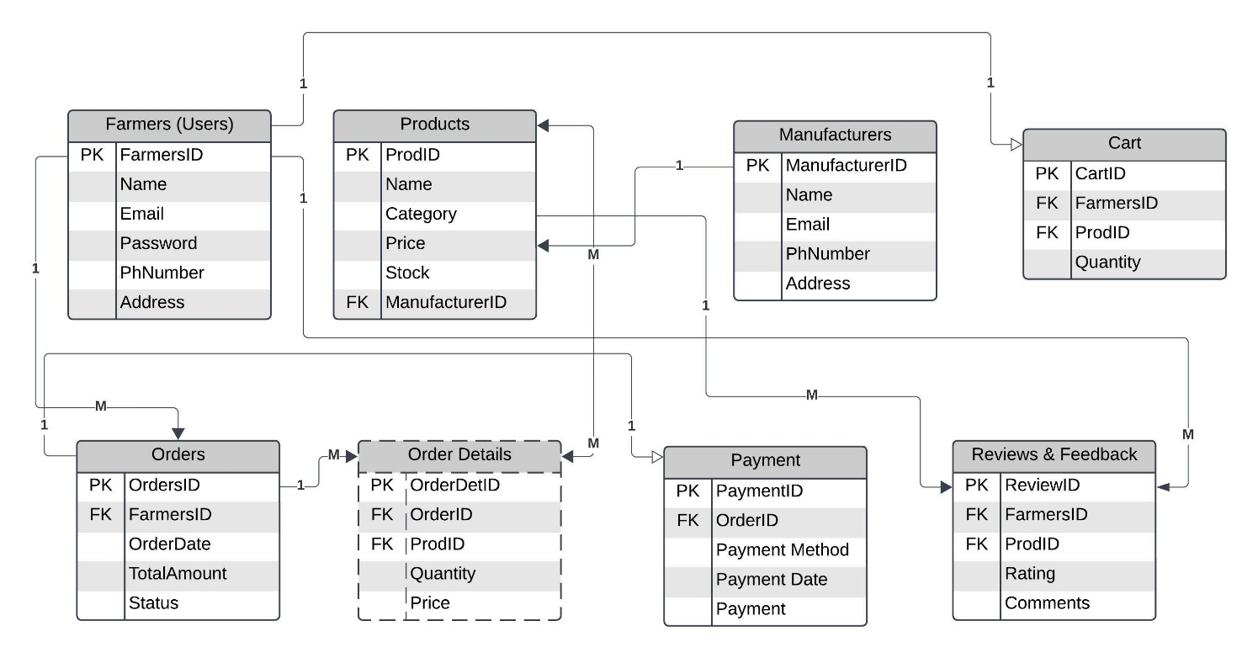

1. **What is a data flow diagram? Draw a data flow diagram to represent the in-flow and out-flow of data when a Farmer is placing an order for the product?**

**Ans:** A **Data flow Diagram (DFD)** is a visual representation of the data flow within a system. Some of the components includes processes (functions that manipulates the data), data stores (storage locations) and flows (flows of the data between components), external entities (source or destination of data outside the system). It illustrates how input data is transformed into output through various processes. When DFD designs, processes must have both inputs and outputs and data cannot flow directly between data stores and external entities without a process and data flows should be named to reflect their purpose.

It created in different levels, Level 0 – High level overview of the entire system with one main process node, Level 1 – breaks down this main process into sub process, Level 2 – beyond further decompose these processes to represent finer details.

Types of DFD**: Logical DFD –** which focuses on business process without delving into technical implementation.

**Physical DFD –** which highlights the technical details of the system implementation including hardware and software components.

**Advantages:** It facilitate stakeholder communication and help identify inefficiencies in process.

**Disadvantages:** They are limited and they do not represent the sequence of operation and become complex for large system

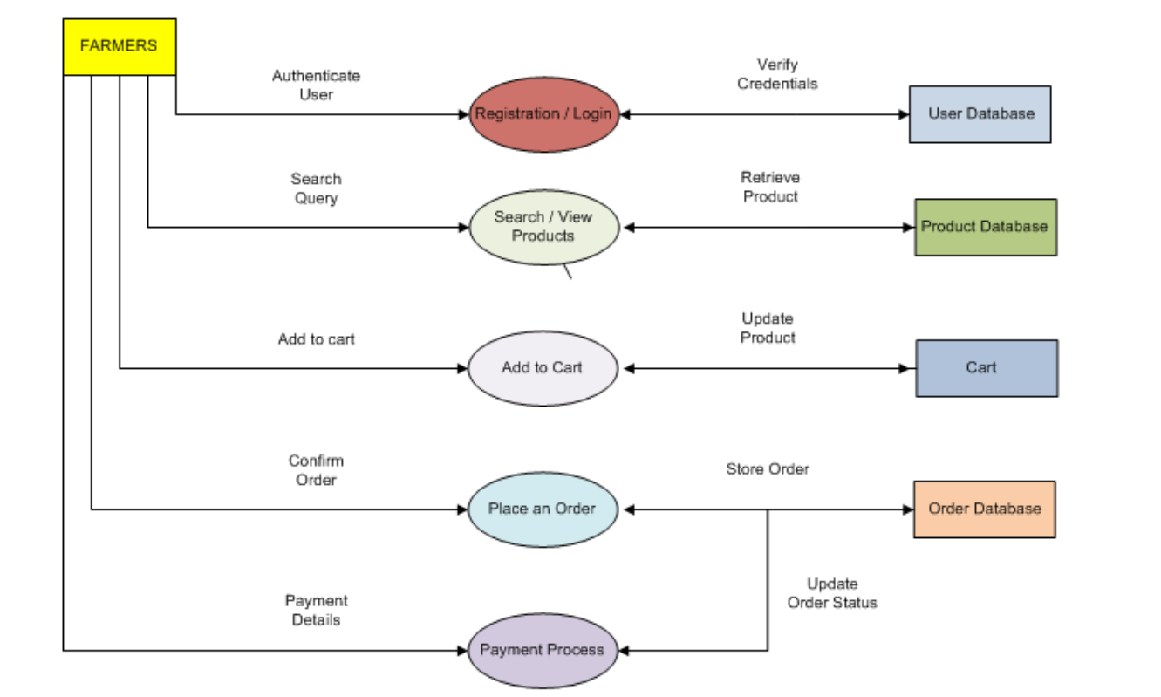

1. **Due to change in the Government Taxation structure. We should change the Tax structure how do you handle change requests in a project?**

**Ans:** A **Change Request** in a project shows the formal proposal to change any aspect includes scope, timeline, budget and resources. These are essential for addressing issues that arise during the course of project and ensuring the project remains aligned with its goals includes new features, altering deadlines and reallocating resources. It is require to submit when there is need to modify the existing project to new requirements, changing circumstances or unforeseen challenges that impact project objectives.

Steps includes in handling the change requests in a project,

* **Identify and access the Change:**

First clearly understand and gather all requirements regarding of the product taxation structure. Maintain the well recorded document who raise the change and the nature of the change request and ensure the change aligns with project goals and objectives.

* **Evaluate Impact Analysis / Feasibility Analysis:**

Evaluate the impact of the change on time, cost, resources and Project deliverables.

2.1 Work with the PM to assess how the change will affect the budget and schedule – **Cost and Time**

2.2 Do collaboration with developers, testers and Network admins to evaluate the technical risks of the change requests – **Technical Feasibility**

2.3 Risks – Create risk analysis like risk rating and identify any dependencies on other functionalities.

* **Prioritize the Change (Effort analysis):**

Rank the change requests and focus on changes with highest impact on the project’s success by considering some of the factors like

3.1 **Urgency** - determine if the change is time sensitive.

3.2 **Stakeholders Importance** - consider the priority level of the stakeholder change requests.

3.3 **value addition -** Evaluate how the change contributes the stakeholder’s satisfaction. Some of the tools like Effort vs benefit matrix (Priority matrix)

* **Documentation and Approval:**

Prepare the document (description, reason, results of impact analysis like cost, timeline and resource) and show the Change request to relevant stakeholders like committee members. Obtain necessary approval before implementation of the change. Also document the change request along the approval process.

* **Update Requirements and Design:**

Update the RTM and other documentation of the project. Modify the user stories, design to incorporate the change.

* **Communication :**

Communicate the change request with the project team including all the stakeholders and parties. Ensure all team members understand the scope and implication of the change. Regularly update the changes implementation, status to the stakeholders.

* **Implementation and Testing:**

Implement the change with regular check in on progress and conduct the testing to ensure the changes doesn’t affect with existing functionalities.

* **Feedback and Reviews:**

Communicate the availability to stakeholders for review and gather post implementation and make necessary adjustments based on feedback to ensure to assess satisfaction and successful project delivery.

1. **As the project is in process, Ben and Kevin have contacted you. The reason is to inform you that they want the Farmers to sell their crop yields through this application i.e. Farmers should be able to add their crop yields or products and display to general public and should be able to sell them. They also want to introduce Auction system for their Crop yields. As a BA, what will be your response?**

**Ans:**

|  |  |  |
| --- | --- | --- |
|  | **Change request** | **Enhancement** |
|  | Arises due to changes in business needs, regulations etc. It refers to modify in  The original project scope, requirements or functionalities that we already defined at the start of the project. So here,  farmer have ability to sell crop yields  and introduce an auction system was  never part of the originally defined project scope, this request constitutes a  change request. It alters initial objectives of the application, requiring re assessment of the scope, budget and timelines. | It is an addition to the current system that provides more values or  better usability but doesn’t necessarily alter the fundamental scope of  The project. So here the if the farmers already interact with manufacturers  with provisions included, then it simply expands request on the  Existing functionality. |
| **Identify the nature of the request** | To clarify whether selling crops and auctions were part of the original plan or new requirements. . If the features are new | To clarify whether selling crops and auctions were part of the original plan or new requirements. . If the features  are alter with existing |
| **Impact Analysis** | changes affect the factors like budget,  time and resource for a change request, | Evaluate how these changes fits with existing project timeline  without drastically altering the scope. |
| **Communicate**  **with Stakeholders** | to seek approval for the scope change, increase budget and extended timeline | Discuss the feasibility of incorporating the features within an current budget and schedule |
| **Documentation** | Create and detailed change  request document outlining the  new features, budget and their impact on the project | Update the RTM and other  project documents to include the  new features. |
| **Implementation**  **and Testing** | Work with development and testing teams to ensure new features are  correctly align with functionalities | |
| **Deployment** | Ensure the new features align with overall goals of the project and add value to  end users | |

As a BA, I will prefer **Change Request** for the project goal, because the original scope were fully focused on facilitating farmers to purchase products and selling crop yields, auction were not part of initial requirements. Also this would significantly impact the project timelines, budget and resource as adding these features requires redesigning parts of the application and introducing new roles like public buyers. If the original system already allowed some basic product sales and the auction system was extension so it takes enhancement and current system doesn’t support selling or auctions.

**10. Come up with estimations – How many Man-hours required**

**Ans:** The **Man hours** is the total amount of work effort of one person can complete in one hour. It’s a unit of measurement used to estimate the time required to complete a task or project when multiplied by the number of team members working on it.

We can Estimate the man hours, first we need break down the projects into smaller tasks or deliverables and define each task and its outcomes. Secondly, we need to identify the difficulty level and expertise required during each task and complex task usually take more time than simple ones. Understand the skill levels and availability of the team members assigned to the project. Add 10 -20 % of the time for meetings, review included. Finally add up all the man hours to get the total and share the estimation to the project stakeholders.

To estimate the man hours, first we need to identify the project size which classifies into three types,

**Small Size projects - < 500 hours**

**Medium Size Projects – 500 to 1000 hours**

**Large Size Projects - >1000 hours**

Considering the given Budget of 2 crores, with the time period of 18 months of 12 members in a team.

Assume each person works for 8 hours a day for 5 days in week.

SO , 18 *4.5 = **78 weeks**.

Man hours for each person = 8*5 = **40 hours/week**

Total working hours per person in 78 weeks = 40*78 = **3120 hours/person.**

Total team man hours = 3120*12 = **37440 man hours**

Additionally, we have to consume 10 – 20% of the total man hours to leave, meeting and review

So, Productive man hours = 37440 *(100-15)% = **31824 man hours**

So **we Requirement Gathering and Analysis**: 10% = **3182 man hours**

**Design (UI/UX architecture**) : 15% = 31824*15% = **4774 man hours**

**Development:** 40% = 31824*40% = **12730 man hours**

**Testing**: 20% = 31824*20% = **6365 man hours**

**Deployment:** 10% = 31824 *10% = **3182 man hours**

**Project Management**: 5% = 31824*5% = **1591 man hours**

**After change Request, Re Estimation of the Project man hours break down into:**

We have, Total team man hours = 3120*12 = **37440 man hours**

Productive man hours = 37440 *(100-15)% = **31824 man hours**

**For New requirements: (Crop Yield sale and auctions conduct in portal)**

|  |  |
| --- | --- |
| **Requirement Gathering and Analysis** | Gathering detailed requirements from Ben, kevin.  Document FRD, NFRD’s.  Finalize requirements with the team  **Estimated Time: 30 hours ( 1BA)** |
| **Design** | Design New interfaces for crop listing, buyer interactions and0 auction system with mock-ups and prototype for review and approval  **Estimated time : 60 hours** |
| **Development** | Implement Cod API for crop listing, auction system and payment integration and order tracking  Create interfaces for farmers and develop buyer facing pages for crops browsing, bidding and purchasing  **Estimated Time: 220 hours** |
| **DB admin** | Add new tables and fields for crop details, auction bids and buyer data  **Estimated time: 40 hours** |
| **Testing** | Perform Unit testing, integration testing and UAT test  **Estimated Time : 60 hours** |
| **Deployment** | Deploy new features to the live environment and train stakeholders on how to use the crop selling and auction functionalities  **Estimated Time: 20 hours** |
| **Total Man Hours** | **430 hours** |

**11 Project has finally completed all the stages i.e., design, development, testing etc. Now, it is the role of a business analyst to contact the client for testing of the final product and have to successfully complete it. How are you going to handle this situation? And once it is done, what will be the process to close the project? Explain UAT Acceptance process?**

**Ans:** A **UAT** is user acceptance testing which is the final phase of testing where the client validates and ensure that the product aligns with agreed business requirements and its specification and then move to deployment for using in real world scenarios.

Some of the UAT steps involved are,

* 1. **Define Acceptance Criteria:**

First clearly define the outline of the product that must meet for the client to accept and refer to the BRD or functional specifications. These criteria must include functionality, usability, performance and compliance requirements.

* 1. **Planning (Create UAT):**
* To understand what the business is trying to achieve through UAT that involves to define the scope, objectives and resources, timelines. In this step we need to identify key stakeholders, including all Business owners, farmers, and manufacturers for UAT participation.
* Review BRD or functionalities involves search/view products, add to cart, payment method and delivery tracking. Select the appropriate stakeholders who are familiar with the business process and will perform testing based on their core knowledge.
* Create UAT that includes all activities with timelines from test case creation to bug correction and Sign off.Identify the entry and exit for UAT and specify roles and responsibilities like BA, client, testers.Make sure the planning phase ensures that UAT process runs smoothly and efficiently
* Do risk analysis to identify possible risk that may affect the UAT process such as hardware/software issues or test cases error.
  1. **Design UAT:**
* Understand and review the BRD and user stories to ensure the test cases or UI/UX design product align with client and user expectations
* Conduct a walkthrough through key features by having test cases for UAT tester to follow which include description, input/output, actual result/expected result, Overall result.
* Prepare Test cases and real scenario’s data to perform for UAT testers to test and ensure that the test case design covers all the aspects of the application and satisfaction to stakeholders
  1. **UAT Testing & Bug fixing:**
* Tester are considers as end users or business stakeholders who define their requirements and business process to project stakeholders. They usually follow the designed test cases and execute in the system to validate functionality.
* As a BA, our responsible to monitor the progress and gather all feedback from users on missing features or bug issues or logs them for resolution.
* So document all the feedback and prioritize the issues and inform the development team to begin their process of bug fixing
* In this phase, BA need to collaborate with developers and tester to ensure the bugs and logs were understandable and facilitates them.
* Developers will fix the bugs and update the progress in the application. Testers will do retesting with BA to ensure the changes do not break other parts of the application.
* Once the bugs were fixed, UAT testers will retest all the issues and verifies it to ensure it is fully functional and these will be done before the application moves to deployment
  1. **Sign OFF :**
* Once all the test cases were executed and align with business requirements. This is the stage where the application ready for deployment.
* So conduct a final review to confirm all requirements ae met and obtain a formal UAT sign off document from the client to ensure that it meets business goal, objectives.
* Once the client signed off , then collect all the feedback, summarize flaws with the project so that it minimizes the risk of post deployment issues and maximise user satisfaction and do documentation for all these report.

**12.** **Explain Project closure document**

**Ans:** A **Project Closure Document** is a formal document used to signify the project completion by ensuring that all project activities includes all deliverables are handed over and the project is closed officially. It acts a reference point for stakeholders and helps in auditing, tracking lessons learned.

1. **Project Overview:**

* It gives us the overview of the project including its objectives, key stakeholders, milestones and phases.
* In our case study, our aim to create online web application to assist farmers in remote areas to purchase fertilisers, seeds and pesticides. The projects scope involved to design easy to use interface. In order to develop the lifecycle, we introduce V model methodology.

1. **Achievements:**

* It is used to Highlight the key successes and list all deliverables produced during the project. Also confirmation that all deliverables meet the agreed requirements and handed to client.
* Highlight the key recognition of team contributions to meet the milestones, who delivered the project from the complexity and innovations that value added to the products
* In our case study, we successfully developed the online application to purchase the agricultural products which is user friendly interfaces for the remote areas.

1. **Lesson Learned:**

* Summarise all the key insights or valuable lessons gained during the projects, such as faced difficulties particularly in terms of stakeholder’s management.
* In our case study, we have learnt that maintaining the regular contact with stakeholders were crucial and the flexibility of the V model is structured bringing changes to requirements and priories were essential.
* Managing the resources effectively allowed the team to overcome the challenges and meet milestones and Provide recommendation for future projects based on the challenges

1. **Quality Assurance:**

* To overview the testing and validation activities that involved continuously from the early stages of development to ensure all the functional and non-functional requirements were met.
* Summaries the testing defects and issues resolved and some of the regression testing which helps to identify and detailed test cases and quality checks helps the applications.
* Final assessment of project adhered to industry standards in software development and testing to meet the quality benchmarks and stakeholders satisfaction.

1. **Resource Utilization:**

* It was analysis of resource allocation which was key factor in project’s successful completion. Some of the resources with various skills and expertise includes developers, NM admins, DB admins, testers and also other resources like financial and non-financial resources.
* Identification of document any pending tasks that could not be addressed with the project and their impact of the resources
* To elaborated on optimisation of the resource planning which bring the project timelines and collaboration with technical team and business stakeholders .by identifying the over

1. **Risk Management:**

* It was the major impact of bring the project to success. By conducting the regular risk involves risk identification at beginning of the project and their mitigation of those risk bring on project success.
* Also, evaluation of the risk were managed during the project ensure the project proceeds in smooth flows. In our case study, we felt difficult in using the application in remote areas, so we mitigate the risks with the help of network admins.

1. **Challenges:**

* In our project we faced some challenges and key obstacles during the project were communication across a large team particular in remote areas and the unique needs of farmers to sell their crops product and conducting auctions so translating these requirement into real time application.
* Evaluation of unresolved challenges and strategies taken to address those challenges for future efforts to minimise disruptions

1. **Miscellaneous:**

* Provide a summary of the initial budget, actual expense and variance of the project financials. Confirm all the invoices have been paid and contracts have closed
* Include a formal approval section where the client acknowledges the successful completion of project and accepts the deliverables. Sign off serves as binding agreement that the project is completed.
* Document the archiving of project document and assets for future reference and specify the project documents such as user manuals, training materials which are given to client.
* Officially declare the project closed and list any transition activities to operation groups

|  |
| --- |
| **PROJECT CLOSURE DOCUMENT** |

|  |  |
| --- | --- |
| **SECTIONS** | **DETAILS** |
| **Project Name** | Online Agriculture Product Store |
| **Client Name** | Mr. Henry, SOONY Company |
| **Project Duration** | 18 months |
| **Budget** | 2 crore INR |
| **Delivery Partner** | APT IT solutions |
| **Objective** | Create an Online platform for farmers to buy agricultural products such as fertilisers, seeds and pesticides and to sell crop yields and facilitate auctions. |
| **Scope** | To purchase products such as fertilisers, seeds and pesticides and to sell crop yields and facilitate auctions. |
| **Key Stakeholders** | SOONY Company, Farmers, APT IT solutions team |
| **Final Deliverables** | Fully functional app, user manuals and training documents, crop auction and maintenance documentation |
| **Timelines** | Delivered within the agreed 18 month timeframe |
| **Budget Performance** | Completed within the 2 Crores INR Budget |
| **Achievements** | Successfully implemented all features |
| **Unresolved Issues** | None |
| **Successes** | Effective Communication and ensured timely issue resolution and smooth integration of mid project changes |
| **Challenges** | Managing scope changes and ensuring user friendly for non-technical users |
| **Team Acknowledgement** | Project Manager: Mr.Vandanam  Development Team: Ms Juhi, Mr.Teyson, Ms.Lucie, Mr.Tucker, Mr.Bravo  Admin Team: Mr. Mike, Mr. John  Testing Team: Mr. Jason, Ms. Alekya  BA: Mr.Sarath |
| **Archived Documents** | Requirements documents, design specifications, test cases, UAT results and delvierables |
| **Financial Closure** | Initial Budget: 2 Crore INR  Final Cost: 2 Crore INR  Pending Payments: None |
| **Handover items** | User manuals, source code, access credentials and maintenance documents |
| **Client Sign OFF** | The client acknowledges successful project completion  **Client Name: _________**  **Signature: ________**  **Date: __________** |
| **Closure Declaration** | The project is officially closed and transitioned to operations  **Project Manager Name: ________**  **Signature: __________**  **Date: _________** |