**Question 6 – Explain Product backlog and sprint back log?**

**Product Backlog:** The product backlog is a prioritized list of features needed for the product. It is maintained by product owner.

The items in the product backlog are know as **product backlog items** and are written as user stories.

In product backlog here the user stories are prioritize by using prioritizing techniques like MOSCOW , 100 dolor tests etc.

**Sprint Backlog :** The sprint backlog is a subset of the product backlog selected by the scrum team during the sprint review meeting.

It includes Product backlog Items, tasks, work in progress and done status.

|  |  |  |  |
| --- | --- | --- | --- |
| **PBI** | **TASKS** | **WIP** | **STATUS** |
|  |  |  |  |

**Question 9 – Draw Sprint Burn Charts n Product Burn Down Charts ?**

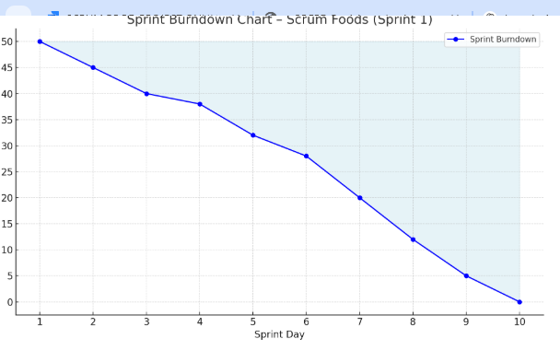

**Question 10 – Explain about Product Grooming ?**

**Product Grooming:** Product Grooming is also known as **Backlog Refinement,** is the process of reviewing, updating and prioritizing the product backlog items.

**Who will participate in product grooming meeting?** Product Owner, Scrum Master, Development Team .

**Product insights used for product grooming:**

1. Sprint Review Feedback
2. Retrospective Feedback
3. Stakeholder input
4. Bug reports
5. Usage analysis
6. Customer feedback and reviews

**Question 11 – Explain the roles of Scrum Master and Product Owner ?**

Business Analysis will play the role of Product owner.

Project Manager will play the role of Scrum Master.

**Scrum Master:** Scrum Master is responsible for facilitating the scrum process and ensure that the team follows the scrum rules.

They help the team to work together smoothly and remove any problems that slow down the work.

**Product owner:** Product owner decides what the team should build. They create and manage the product backlog , write user stories , set priorities based on business goals and customer needs.

They focus on the scrum team is building the right product in the right order.