**Waterfall Part 2/2**

Document 6- Please prepare a use case diagram, activity diagram and a use case specification document.

Answer ) Use case Diagram :- It is a high level diagram also known as mother of all diagrams. It shows how external interfaces interact with the proposed IT solution.

UCDs show the functionality of the system as a whole and not for individual functions. UCDs only show positive flows and do not show alternate or exceptional flows.

**Use case diagram:-**

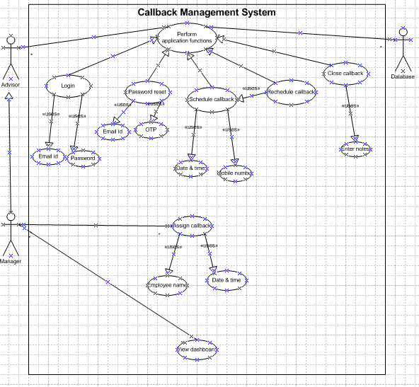

**Activity diagram: -** Activity diagram describes low from one activity to another happening within the system to show how a system should function to achieve the business, organisational and application goal.

These activities are operations happening within a system hence it shows flow from one operation to other. Activity diagram is drawn from a system point of view and not with end user point of view.

Activity diagrams not only help for creating a system from scratch but also for reverse engineering to understand how a current system operates and to make executable systems.

1. **Login :-**

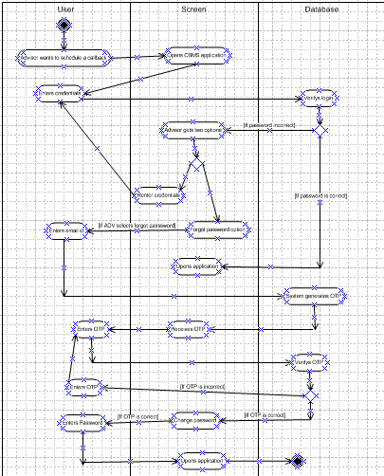

**2) Scheduling callback :-**

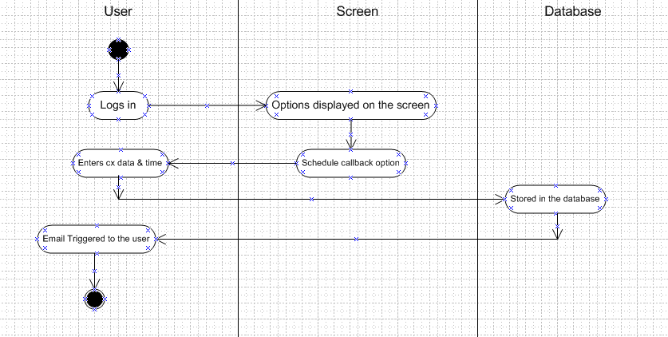  
  
**3) Rescheduling callback :-**  
  
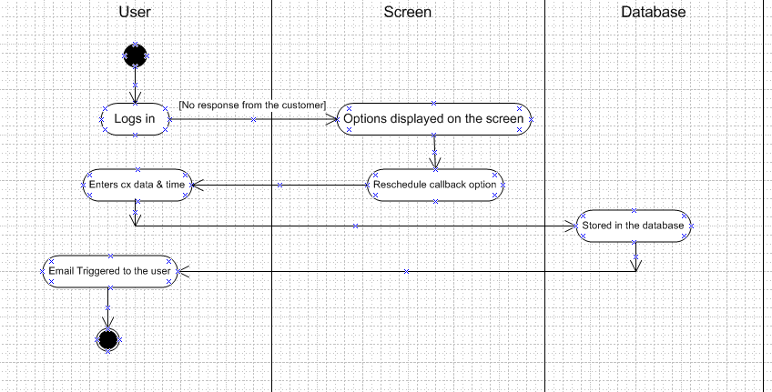  
  
**4) Close callback :-**

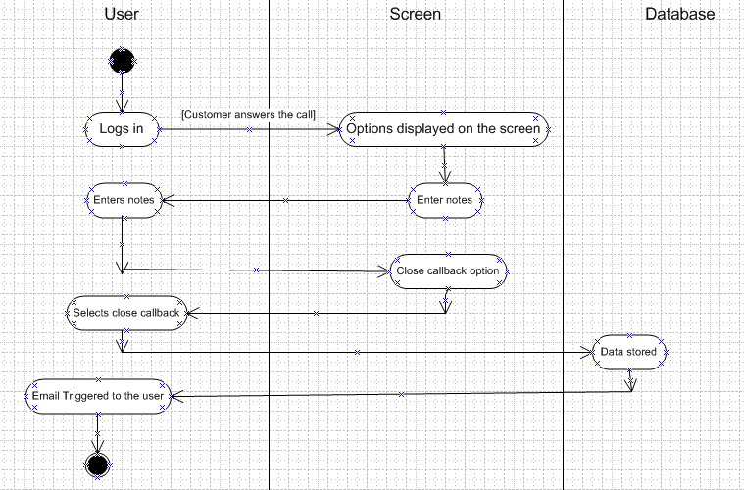

**5) Assign callback:**

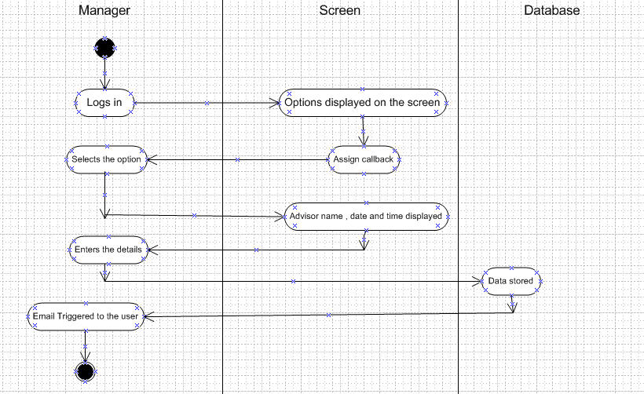

**Use case specification:** –

* **Use case spec**- login

· Description: - This use case specifies the essential steps to login

· Actors- Contact centre advisors, team managers and MIS team.

· Preconditions – active internet condition, browser compatible, registered work email address, active employee

· Post condition- home page should be displayed

· Basic flows:

1. The use case begins when the user opens the application/software application.
2. Customer gets the option like login
3. Customer enters the username and password
4. The system accepts the username and password
5. The home page is displayed to the customer
6. The use case ends here

· Alternate flow:

o password is wrong

o Username is wrong

o username and password are wrong

· Exceptional Flow:

Forget password, forget username

· Assumptions: users have basic computer knowledge; user is trained on how to use the software & a working internet.

· Constraints: username must be the organisations email, Password needs to have at least 1 special character, 1 small character, 1 big character and should be of 8 characters at least.

· Inputs: username and password

· Output: Login to homepage or error code.

· Business rules- username should use valid mail id password should use special character

· MIS information- interactive design and browser compatible.

* **Use case spec**: - Schedule a callback

· Description- This use case describes how a contact centre advisor will add the customer details to set a callback.

· Actor - Contact centre advisors, team managers

· Preconditions: - Active internet connection, employee successfully logged in.

· Postcondition: able to add customer details for callback and schedule a callback.

· Basic flow-

1. Advisor logs into his account,
2. Adds the customer contact details,
3. Selects date for callback,
4. Selects time for callback,
5. Schedules a callback

· Alternate flow: -

o Employee unable to login / forgets his password

o Error with saving the callback

· Exceptional Flow: while scheduling a callback an error pops up stating the call date selected is in the past

· Assumptions:

Working internet,

user can login with his username and password,

users should know how to schedule a callback

· Constraint: Need to add customer contact details and date and time to schedule a callback

· Dependencies: - Callback date to be in the future

· Output- A pop up of Callback scheduled and an email with the confirmation.

· Miscellaneous info- good looking pop up confirming a callback schedule and also a confirmation email.

* **Use case spec**- Assign callback to different user

· Description: - This use case specifies the essential steps to assign callback to a different advisor

· Actors- Managers, Contact centre advisors

· Preconditions – Manager access, Active callback schedule, active internet condition, browser compatible

· Post condition : - Callback assigned to a specific user with n email notification.

· Basic flows:

1. The use case begins when a manager wants to assign a scheduled callback to a different advisor due to some reason
2. A manager logs in to his account and views the dashboard,
3. Selects the callback to be assigned,
4. Selects the name of the employee to whom the callback will be assigned and
5. Clicks submit button

· Alternate flow:

o password is wrong

o Username is wrong

o username and password are wrong

o Manager is getting an error to assign the callback

· Exceptional Flow:

Forget password, forget username

· Assumptions: Customer service advisor has scheduled a callback.

· Constraints:- need to select the advisor and callback date and time.

· Inputs: advisor name, time and date of the callback

· Output: a pop up stating ‘callback assigned’ with a confirmation email.

* **Use case spec**- Reschedule callback

Description:- This use case specifies the essential steps to reschedule a callback.

· Actors- Managers, Contact centre advisors & application

· Preconditions – Active callback schedule, active internet condition, browser compatible, able to login.

· Post condition- callback rescheduled pop up along with a reminder email

· Basic flows:

1. The use case begins when the user opens the application/software application.
2. User has made a callback but the customer has requested for a callback some other time/day.
3. User selects the option of reschedule callback,
4. Enters callback date and time
5. Saves the callback

· Alternate flow:

o password is wrong

o Username is wrong

o username and password are wrong

· Exceptional Flow:

Forget password, forget username

· Assumptions: Advisor has a scheduled callback, the customer has requested for a callback

· Constraints: Callback date and time to be selected.

· Inputs: callback date and time

· Output: callback confirmation along with an email

* **Use case spec**- Close the callback

Description :- The use case begins when the user has made a callback and resolved the customers issue.

Actors :- Call centre advisor & customer

Preconditions :- A callback has been made and the customer was happy with the resolution

Post conditions :- Callback closed popup.

Basic flows:-

1. The advisor logs in and callback the customer,
2. The customer is happy with the resolution,
3. The advisor enters notes
4. And closes the callback
5. A pop up stating ‘Callback closed’ appears.

Alternate flow :-

o password is wrong

o Username is wrong

o Customer asks to reschedule a callback

· Exceptional Flow:

Forget password, forget username

· Assumptions: Advisor has a scheduled callback, the customer has requested for a callback ad the customer is happy to go ahead and close the callback request.

· Constraints: Callback date and time to be selected.

· Inputs: callback date and time

· Output: callback confirmation along with an email

* **Use case spec**- Password Reset

Description :- This use case describes the steps involved in resetting the password for the customer when he forgets his password.

Actors: - Customer service advisor and the application.

Preconditions:- Customer is a working employee and has forgotten his password

Postconditions:- Advisor able to login using the new password

Basic flow:-

1. The use case starts when the advisor has forgotten his password and then wishes to reset his password,
2. Advisors enters email id and selects ‘Forget password’ option,
3. An email with the new password is sent to the advisor,
4. Advisor uses the password to login and the use case is completed

Alternate flow:-

1. Advisor enters wrong email id,
2. Advisor uses wrong password
3. Advisor is not getting the reset password on his email id,

Exceptional Flow :-

1. Advisor remembers his password post requesting for a new password.

Assumptions: Advisor has forgotten his password and has a working email

· Constraints: Advisor needs to enter his organisation email id

· Inputs: Email id

· Output: Password reset successful pop up.

**Document 7-**

Screens and pages Please follow the following steps to create the mock-ups

1. Kindly use balsamic or Axure.

2. Always start with a home page of an application.

3. Take a feature and follow it to the end

a. Eg: Home page of SCRUM Foods

b. Select Login- Create a login page

c. Let’s assume, you want to search a restaurant

d. Search page- Type the restaurant name and select the dish

e. Add to cart page

f. Payment page

g. Logout page

**login page :**

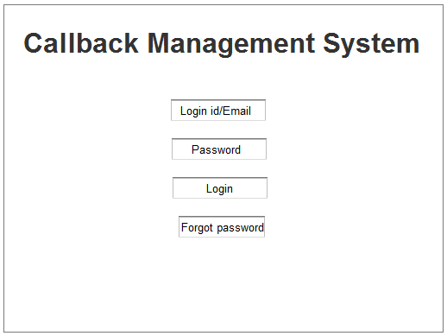

**2) Advisor dashboard :-**

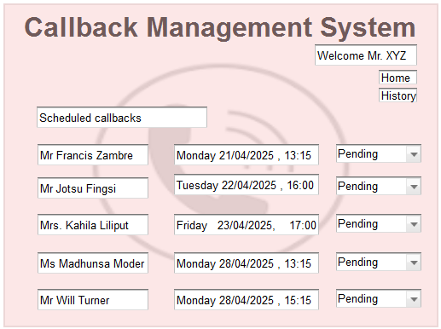

**3) Manager Dashboard :-**

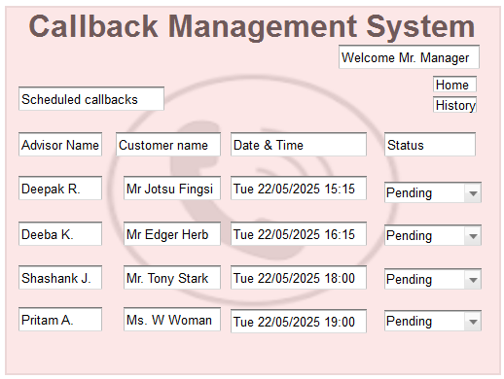

**4) Callback history :-**

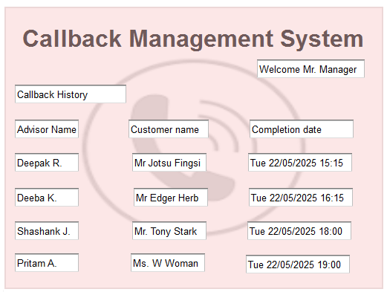

**5) Advisor history :-**

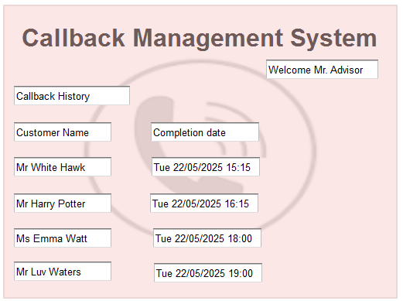

**6) Add notes :-  
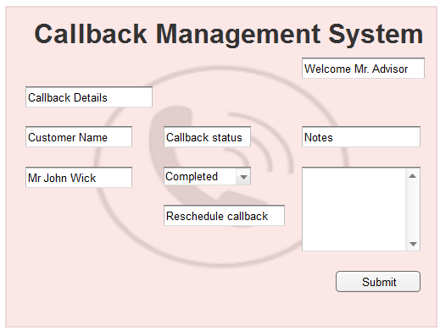  
  
7) Assign callback :-**

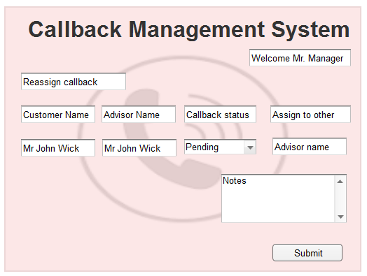

**8) Final page :-**

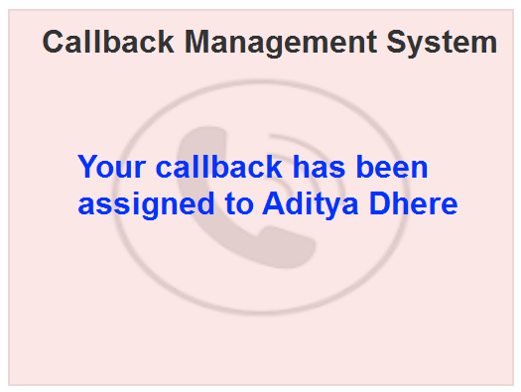

**Document 8**- Tools-Visio and Axure Write a paragraph on your experience using Visio and Axure for the project.

**a. Axure :** Axure is a popular tool used for creating use case diagrams and activity diagrams along with other diagrams like process flows, state chart diagram and other UML diagrams that help the business analyst model the requirements in a finer much explanatory form. I used Axuree to draw UML diagrams and also to present the same to development team for development of the application. It has easy drag and drop options that make the UML diagrams easy to create.

**b. Microsoft Visio:** Microsoft Visio is a versatile diagramming tool that allows users to create a wide range of diagrams, including flowcharts, organizational charts, and network diagrams. With its extensive library of shapes and customization options, Visio enables users to visually represent complex information and processes. It offers collaboration features, data linking capabilities, and seamless integration with other Microsoft Office applications.

I used MS Visio to draw high fidelity protypes making it easier for the development team to understand about the design of the intended application.

**Document 9- BA experience**

My experience as BA in following phases:

**1. Requirement gathering: -**

* To gather requirements, we first used various elicitation techniques that included Observation, interviews, brainstorming sessions and questionnaires to gather relevant data. These techniques proved to be very helpful in determining what are the requirements of the application and also helped to jot down the particular specifications.
* I then first sort the requirements by removing duplicate requirements, grouping similar requirements and reducing redundancy. By doing this I ensured that we have a clear idea about he requreiemtns to be worked upon.
* I used MOSCOW technique to prioritize requirements.
* I validate the requirements using FURPS technique
* I used MS Viso and Axure for prototyping.
* Once we had the requirements, I prepared a BRD document in association with the PM and teammates.

**2. Requirement Analysis:**

* I drew use case diagrams and activity diagrams along with preparing the use case description document. This use case diagrams helped to specify how the external factors like advisors and managers will be interacting with the proposed it system and the activity diagram helped to explain how each activity will be happening within the system.
* I communicated the diagram to the relevant teams for further development.
* I prepared FRD using the BRD and prepared FRS for the same.
* I prepared RTM to ensure that we keep a tap on all the requirements and do not miss on any of the requirements.
* I got the sign off on SRS from the Project head so we could go ahead with the other phases.

**3. Design:**

* From the use case diagrams, I helped the test managers to prepare test cases
* I communicated with the internal teams about the design and explained to them about the use cases diagrams and activity diagrams.
* I prepared end user manuals so that it would be convenient to train the users for the same.
* I communicated with the GUI designers to communicate the wireframe and mock up designs for the application.
* Updated the RTM to keep an eye on the design requirements.

**4. Development:**

● I organized JAD sessions to establish a communication ground for the development and the operations team so that the desired application would come into existence.

● I got involved in clarifying the queries of the tech team during coding regarding the controller classes.

● There were a few team members who did not agree with the with the design. As a BA i handle the situation gently and had one on one discussion with them. Explained how their actions

are going to affect the project & setup healthy environment within the team.

● I conduct regular follow up meetings with technical team to understand the progress of the application and also to see if we are aligned to the final goal.

● I would ensure that the meeting were scheduled well in advance and that the team members were made aware of the same by sharing reminder emails regarding the meetings and in case of any absences I made sure that the meeting was recorded and forwarded to the stakeholders.

● I also updated the RTM for development phase to keep a check on any misses if any.

Updated end user manuals as per the changes and made sure the document is up to date.

5. Testing:

● I prepared test cases from use cases . For each use case we conducted tests to ensure that all the functionalities are working and up to date

● Perform high level testing

● Test data is requested by BA from client

● Updated RTM

● Take signoff from client

● Prepare client for UAT

6. Deployment:

● Forwarded RTM to client which should be attached to project closure

document

● Coordinates to complete and share end user manuals

● Plans and organizes training sessions

● Make sure all the candidates attend the meetin