**Agile Manifesto:**

Agile manifesto has basically values and principles

There are 4 values

Individuals and interactions are given more importance than process and tools.

Customer collaboration: We should understand what customers want.

Open to change: We should be open to change how customers want.

Agreement and plan is given less importance. Face to face interaction is given more importance.

It’s like playing a game. To win a game we do lot of strategy.

Concept of backlogs: Backlog means what is completed, what needs to be completed.

To work on agile, we need clarity on agile process and on project.

12 Principles:

Satisfy the customer through continuous and early delivery of valuable software.

Welcome change in requirements even late in development.

Deliver working software continuously for couple of weeks.

Business people and developers work together daily throughout the project.

Be around motivated individuals.

Have face-to-face conversation.

Working software is measure of progress.

Sustainable development.

Have continuous attention.

Simplicity

Best architecture

Regular interval become more effective.

**User stories**

|  |  |  |  |
| --- | --- | --- | --- |
| User story no.1 | Task.1 | | Priority: High |
| As a customer  I want to login to my portal  So that I can get access to portal and buy the products | | | |
| BV:100 | | CP:3 | |
| Given As a registered customer  When I open the application  Then I should get login request  When I click on login  Then it should ask for user name and password  When I enter both  I should click on submit  Then I should be able to login if my username and password are correct  If they are wrong then I should get popup wrong password. | | | |

|  |  |  |  |
| --- | --- | --- | --- |
| User story no.2 | Task. | | Priority: |
| As a customer  I want to search for products  So that I can find the required product | | | |
| BV 200 | | CP 5 | |
| Given As a registered logged in customer  When I click on search bar  Then I should be able to type the name of required restaurants and press on search  When I press on search  Then I should get the list of restaurants similar to name in search  When I get the list of products  Then I should be able to scroll and see the features of all the restaurants. | | | |

|  |  |  |  |
| --- | --- | --- | --- |
| User story no.3 | Task. | | Priority: |
| As a customer  I want to see the menu of the restaurant  So that I can select product as per my interest. | | | |
| BV 200 | | CP 4 | |
| Given as a logged in customer  When I click on a restaurant  Then I should get menu option along with all other options  When I click on menu option  Then I should get list of all the items available in particular restaurants along with prices in each category. | | | |

|  |  |  |  |
| --- | --- | --- | --- |
| User story no.4 | Task. | | Priority: |
| As a customer  I want to order food  So that I can fulfill my hunger | | | |
| BV 200 | | CP3 | |
| Given As a logged in customer  When I select particular food item  Then I should get all the features along with price details for one order  When I click on place order  Then I Should get screen on asking for further payment and delivery address details  When I enter details and click on place order  Then I should get popup order placed. | | | |

|  |  |  |  |
| --- | --- | --- | --- |
| User story no.5 | Task. | | Priority: |
| As a logged in customer  I should be able to make the payment  So that I can complete my order | | | |
| BV 300 | | CP2 | |
| Given as a logged in customer  Then I click on do payment  Then it should display screen giving different available options for payment  When I select a particular option  Then it should ask for details related to that option  When I enter all details  Then it should display proceed to payment  When I click on proceed to payment  Then it should ask for OTP  When I enter OTP generated to my mobile  Then payment has to be done and display payment successful. | | | |

|  |  |  |  |
| --- | --- | --- | --- |
| User story no.6 | Task. | | Priority: |
| As a logged in customer  I should be able to cancel order  So that I can take back if order is misplaced | | | |
| BV 500 | | CP 5 | |
| Given as a logged in customer  When I click on cancel order  Then it should ask for reason to cancel  When I select a particular reason to cancel  Then it should show if any return amount along with OK button  When I press on OK  Then I should get notification order cancelled | | | |

|  |  |  |  |
| --- | --- | --- | --- |
| User story no.7 | Task. | | Priority: |
| As a logged in customer  I want to track my order  So that I can get the delivery status. | | | |
| BV 200 | | CP3 | |
| Given As a logged in customer  When I press on track the order  Then I should get status of order from start point to end point and present order location along with expected dates. | | | |

|  |  |  |  |
| --- | --- | --- | --- |
| User story no.8 | Task. | | Priority: |
| As a delivery boy  I want to login to the account  So that I can get access and proceed further | | | |
| BV 200 | | CP 4 | |
| Given as a delivery boy with login credentials  When I open website  Then I should find login option as delivery boy  When I click on login  Then it should ask for username and password  When I enter username and password and press OK  Then I should get logged in as delivery boy | | | |

|  |  |  |  |
| --- | --- | --- | --- |
| User story no.9 | Task. | | Priority: |
| As a delivery boy  I should be able to view orders  So that I can pick and deliver the product | | | |
| BV 400 | | CP 2 | |
| Given as a logged in delivery boy  When I click on view orders  Then I should be able to see the list of orders location wise as per delivery address  When I select a particular delivery address  Then I should get orders to be delivered to that address | | | |

|  |  |  |  |
| --- | --- | --- | --- |
| User story no.10 | Task. | | Priority: |
| As a delivery boy  I should be able to select and accept orders  So that I can select and accept orders as per delivery address | | | |
| BV 300 | | CP 4 | |
| Given as a logged in delivery boy  When I click on view orders  Then I should be able to see the list of orders location wise as per delivery address  When I select a particular delivery address  Then I should get orders to be delivered to that address and get accept option  When I press on accept option  Then I should get accesses to pick up and deliver the order | | | |

|  |  |  |  |
| --- | --- | --- | --- |
| User story no.11 | Task. | | Priority: |
| As a delivery boy  I should be Update the status of orders  So that customers can get continuous follow ups | | | |
| BV 200 | | CP3 | |
| Given As a logged in delivery boy  When I click on update status for a particular order  Then I should get space to give current location of package  When I enter the current location and click on OK  Then I should get popup Status updated | | | |

|  |  |  |  |
| --- | --- | --- | --- |
| User story no.12 | Task. | | Priority: |
| As a delivery boy I need access to payment  So that customers can do for COD Option category | | | |
| BV 500 | | CP4 | |
| Given As a logged in delivery boy  When I click on payment option  Then I should get options to select how customer is paying(COD/ Phone pay)  When I select COD I take cash from customer and click on payment option  When I select Phone pay then it should display barcode  Then the customer should be able to scan the code and do payment  When payment is done  Then it should display popup payment received | | | |

|  |  |  |  |
| --- | --- | --- | --- |
| User story no.13 | Task. | | Priority: |
| As a delivery boy I want to view feedback  So that I can get my performance improvement status | | | |
| BV 400 | | CP3 | |
| Given as a logged in delivery boy  When I click on view feedback of a particular customer  Then I should get displayed the feedback given to product delivered and delivery performance. | | | |

|  |  |  |  |
| --- | --- | --- | --- |
| User story no.14 | Task. | | Priority: |
| As a restaurant receptionist  I want to register in food delivery app  So that I can place my business in online platform | | | |
| BV 200 | | CP5 | |
| Given As restaurant business person  When I open food delivery app  Then I should get display register  When I click on register  Then It should ask for details like name location and others  When I enter all details  Then it should display To submit  When I click on submit  Then I should get pop up details entered in the platform | | | |

|  |  |  |  |
| --- | --- | --- | --- |
| User story no.15 | Task. | | Priority: |
| As a restaurant receptionist  I want to login in food delivery app  So that I can place daily update menus on the platform and receive and deliver orders | | | |
| BV 500 | | CP 4 | |
| Given As a restaurant manager  When I press login  Then it should ask for required details  When I enter details and press OK  Then I should be able to get into food delivery online portal | | | |

|  |  |  |  |
| --- | --- | --- | --- |
| User story no.16 | Task. | | Priority: |
| As a restaurant owner  I want to raise issues if there is any problem  So that I can solve it accordingly | | | |
| BV 400 | | CP 4 | |
| Given As a restaurant owner  When I click on raise issue for a particular incident.  Then I should get space to enter issue  When I enter issue and click on submit  Then I should get popup issue submitted and will be resolved within a specific time | | | |

|  |  |  |  |
| --- | --- | --- | --- |
| User story no.17 | Task. | | Priority: |
| As a restaurant owner  I must be able to logout from the food delivery online platform  So that I can come out of it once I completed the requirement | | | |
| BV 400 | | CP 4 | |
| Given As a restaurant owner  When I click on logout option  Then I should be able to logout from the application and I should get popup logged out successfully | | | |

|  |  |  |  |
| --- | --- | --- | --- |
| User story no.18 | Task. | | Priority: |
| As a regional admin  I want to login to online application  So that I can do my responsibilities | | | |
| BV 300 | | CP2 | |
| Given as a regional admin  When I click on regional admin login.  Then it should ask for username and password  When I enter them and click on login  Then I should get logged into the account | | | |

|  |  |  |  |
| --- | --- | --- | --- |
| User story no.19 | Task. | | Priority: |
| As a regional admin  I want to manage regional delivery boys and restaurants  So that I can carry forward regional activities peacefully | | | |
| BV 500 | | CP 4 | |
| Given as a regional admin  When I click on manage option  Then I should get the instructions to be applied and space to write my own  When I enter all instructions  Then I should be able to update them  When I update  Then they should be visible to delivery boys and restaurants. | | | |

|  |  |  |  |
| --- | --- | --- | --- |
| User story no.20 | Task. | | Priority: |
| As a regional admin  I want to view regional revenue  So that I can get idea of revenue generated region wise | | | |
| BV 300 | | CP 4 | |
| Given as a regional admin  When I click on view revenue  Then I should g et the list showing revenue generated by the hotels region wise and I should be able to view that and perform required analysis | | | |

|  |  |  |  |
| --- | --- | --- | --- |
| User story no.21 | Task. | | Priority: |
| As a admin  I want to login to application  So that I can perform my activities as admin | | | |
| BV 200 | | CP 4 | |
| Given As a registered admin  When I enter admin login  Then it should ask for username and password  When I enter user name and password  Then I should be able to click on submit  When I click on submit  Then I should be able to login to admin portal | | | |

|  |  |  |  |
| --- | --- | --- | --- |
| User story no.22 | Task. | | Priority: |
| As a admin I should be able to manage regional admin  So that I can give and order then=m instructions to be followed | | | |
| BV 400 | | CP 4 | |
| Given as a admin  When I click on manage option  Then I should get the instructions to be applied and space to write my own  When I enter all instructions  Then I should be able to update them  When I update  Then they should be visible to regional admin | | | |

|  |  |  |  |
| --- | --- | --- | --- |
| User story no.23 | Task. | | Priority: |
| As a admin I should be able to see the issues  So that I can trace them and suggest solution | | | |
| BV 300 | | CP 5 | |
| Given as a logged in admin  When I click on issues  Then I should be able to see the list of issues given by all users of application user wise  When I press on particular issue  Then I should see the issue in detailed description | | | |

|  |  |  |  |
| --- | --- | --- | --- |
| User story no.24 | Task. | | Priority: |
| As a admin I should be able to see the customer feedback  So that I can find out their opinions on different aspects | | | |
| BV400 | | CP 3 | |
| Given as a logged in admin  When I Click on view feedback  Then I should be able to see the list of feedbacks given by all users of application user wise  When I press on particular feedback  Then I should see the feedback in detailed description | | | |

|  |  |  |  |
| --- | --- | --- | --- |
| User story no.25 | Task. | | Priority: |
| As a admin  I want to logout from application  So that I can exit once I completed my target | | | |
| BV 100 | | CP 2 | |
| Given as a logged in admin  When I click on logout  Then I should be able to logout from application  Then I should get popup successfully logged out | | | |

|  |  |  |  |
| --- | --- | --- | --- |
| User story no.26 | Task. | | Priority: |
| As a business owner  I want to login to online application  So that I can do my responsibilities | | | |
| BV 500 | | CP 5 | |
| Given as a business owner  When I click on owner login.  Then it should ask for username and password  When I enter them and click on login  Then I should get logged into the account | | | |

|  |  |  |  |
| --- | --- | --- | --- |
| User story no.27 | Task. | | Priority: |
| As a business owner I should be able to see the issues  So that I can trace them and suggest solution | | | |
| BV 200 | | CP 5 | |
| Given as a logged in business owner  When I click on issues  Then I should be able to see the list of issues given by all users of application user wise  When I press on particular issue  Then I shoul d see the issue in detailed description | | | |

|  |  |  |  |
| --- | --- | --- | --- |
| User story no.28 | Task. | | Priority: |
| As a business owner I should be able to see the reports  So that I can trace them and derive analysis | | | |
| BV 400 | | CP 4 | |
| Given as a logged in business owner  When I click on reports  Then I should be able to see the list of reports updated  When I press on particular report  Then I should see the report and do required analysis | | | |

|  |  |  |  |
| --- | --- | --- | --- |
| User story no.29 | Task. | | Priority: |
| As a customer I want to view the price  So that I can check price before booking | | | |
| BV 500 | | CP 4 | |
| Given As a logged in customer  When I book order  Then I should be able to click on view price  When I click on view price  Then I should get price of that total order booking | | | |

|  |  |  |  |
| --- | --- | --- | --- |
| User story no.30 | Task. | | Priority: |
| As a restaurant owner  I want to provide time slots  So that I can display opening and closing time of restaurant | | | |
| BV 400 | | CP 4 | |
| Given as a logged in restaurant owner  When I click on open time  Then I should enter open time  When I click on closing time  Then I should enter closing time  When I click on submit  Then It takes open and close time and displays them in website. | | | |

|  |  |  |  |
| --- | --- | --- | --- |
| User story no.31 | Task. | | Priority: |
| As a customer I should see product category  So that I can get list of products category wise | | | |
| BV 200 | | CP 4 | |
| Given as a Logged in customer  When I select select a particular category like starters  Then I should get all the list of starters from various restaurants  When I select a particular starter  Then I should get all the details along with price | | | |

|  |  |  |  |
| --- | --- | --- | --- |
| User story no.32 | Task. | | Priority: |
| As a customer I want to add new address as I have changed my location | | | |
| BV 400 | | CP 2 | |
| Given as a logged in customer  When I click on add address  Then it should ask to add new details related to address  When I enter all details and press ok  Then I should get popup new address added successfully | | | |

|  |  |  |  |
| --- | --- | --- | --- |
| User story no.33 | Task. | | Priority: |
| As a customer I want to see list of frequently bought food items so that I can get some information | | | |
| BV 300 | | CP 4 | |
| Given As a logged in customer  When I press on frequently bought items  Then I should see the list of frequently bought items in that application  When I press on particular item  Then I should get the description of that item | | | |

|  |  |  |  |
| --- | --- | --- | --- |
| User story no.34 | Task. | | Priority: |
| As a customer I want add on in my order so that I can add some more requirements | | | |
| BV 500 | | CP 4 | |
| Given As a logged in customer  When place the order  Then I should get add on option  When I select add on product  Then that product should include along with the main product. | | | |

|  |  |  |  |
| --- | --- | --- | --- |
| User story no.35 | Task. | | Priority: |
| As a customer I want to see great offers so that I can make use of oppurtunity | | | |
| BV 500 | | CP 4 | |
| Given AS a logged in customer  When I click on great offers  Then I should able to see restaurants providing offers  When I select particular restaurant  Then I should see offers offered by that restaurant | | | |

|  |  |  |  |
| --- | --- | --- | --- |
| User story no.36 | Task. | | Priority: |
| As a customer I want to select veg option so that I will get list of all vegetarian items from all restaurants | | | |
| BV 400 | | CP 2 | |
| Given As a logged in customer  When I click on menu  Then it should ask for two options Veg and Non veg  When I press on Veg  Then I should get list of all Veg food items in all restaurants | | | |

|  |  |  |  |
| --- | --- | --- | --- |
| User story no.37 | Task. | | Priority: |
| As a customer I want to see previously ordered items so that I can reorder them | | | |
| BV 300 | | CP 4 | |
| Given As a logged in customer  When I press on previously ordered bar  Then I should get list of foods previously ordered in my account  When I select on a product  Then I should be able to reorder that | | | |

|  |  |  |  |
| --- | --- | --- | --- |
| User story no.38 | Task. | | Priority: |
| As a logged in customer I want to select preferred cuisine to select food of my choice | | | |
| BV 500 | | CP 3 | |
| Given As a logged in customer  When I press on cuisines  Then I should get list of cuisines available in all restaurants  When I select a particular cuisine  Then I should get food items related to that cuisine in all restaurants | | | |

|  |  |  |  |
| --- | --- | --- | --- |
| User story no.39 | Task. | | Priority: |
| As a customer I want to have nearest option so that I can select foods from restaurants nearest to my location | | | |
| BV 300 | | CP 3 | |
| Given As a logged in customer  When I select on nearest  Then I should get restaurants nearest to my location  When I select a particular restaurant  Then I should get all food items provided by that restaurant | | | |

|  |  |  |  |
| --- | --- | --- | --- |
| User story no.40 | Task. | | Priority: |
| As a customer I want to select food having rating 4.0+ so that I can have goodrating food | | | |
| BV 200 | | CP 4 | |
| Given As a logged in customer  When I click on Rating4.0+  Then I should get food items from all restaurants having above that rating  When I select particular food  Then I should be able to order that | | | |

**Epic:**

It I basically a high level requirement. It cannot be executed directly. It should be break down into smaller parts called user stories.

Example: Epic: Cart

User story: Add to cart

Edit cart

View cart

Proceed to checkout

Example: Epic: Soups

User story: Chicken soup

Mutton soup

Prawns soup

**Difference between Business Value and complexity points**

**Key Differences Between BV and CP:**

| **Aspect** | **Business Value (BV)** | **Critical Path (CP)** |
| --- | --- | --- |
| **Definition** | The worth or benefit brought by a project to the business. | The sequence of project tasks that directly affects the project's duration. |
| **Focus** | Focused on outcomes and benefits to the organization. | Focused on scheduling, task dependencies, and project timelines. |
| **Scope** | Broader scope, often considering long-term impact and strategic alignment. | Narrower scope, focused on project execution and timelines. |
| **Measurement** | Measured through KPIs, ROI, customer satisfaction, financial gain, etc. | Measured through task durations and dependencies to determine the longest path. |
| **Impact** | Impacts the organization’s strategic goals (revenue, cost-saving, market share). | Impacts the project’s ability to meet deadlines and deliver on time. |
| **Timeframe** | Often long-term and strategic. | Short-term and project-specific. |
| **Role of Business Analyst** | A BA helps define, measure, and align business value to project outcomes. | A BA identifies tasks, dependencies, and ensures that critical path activities are monitored to avoid delays. |
| **Example** | A new product launch increasing revenue or customer base. | A construction project with tasks like foundation work that must be completed on time. |

**Sprints:**

As we know in Agile we divide the entire project into sprints . Each sprint has one iteration.

The duration of each sprint is generally 2 to 3 weeks

Generally in scrum as a product owner we gather all requirements in form of epics and user stories in product backlog.

We after completing product refinement meeting we prepare sprint backlog.

Here we consider 4 parameters

Priority

Availability of resources

Effort estimation

Velocity

Based on this 4 parameters we prepare sprint backlog

For preparing sprint back log we conduct meeting called sprint planning meeting

After deciding the user stories to be worked in a sprint the scrum master will assign the user stories to each developer

Here as a BA we conduct daily meeting and gather the daily status

After completing sprint we have two meetings

Sprint review and sprint retrospective

Sprint review is explaining to the client how this went, how to work on them

Sprint retrospective is internal meeting for team to assess individual performance.

**Product backlog**

Product backlog is a list of the new features, changes to existing features, bug fixes, infrastructure changes, or other activities that a team may deliver in order to achieve a specific outcome.

Product backlog items take a variety of formats, with [user stories](https://www.agilealliance.org/glossary/user-stories/) being the most common. The team using the product backlog determines the format they chose to use and looks to the backlog items as reminders of the aspects of a solution they may work on.

A team owns its product backlog and may have a specific role – [product owner](https://www.agilealliance.org/glossary/product-owner/) – with the primary responsibility for maintaining the product backlog. The key activities in maintaining the product backlog include prioritizing product backlog items, deciding which product backlog items should be removed from the product backlog, and facilitating [product backlog refinement](https://www.agilealliance.org/glossary/backlog-grooming/).

Once the Team forecasts the number of stories they feel they can accomplish in the Sprint Backlog, there should be no additions or changes until the Sprint ends. However, if during the Sprint management or the Product Owner decide there is a feature of higher business value that needs to come into the Sprint, the [Product Owner](https://www.scruminc.com/product-owner/) should use the interruption procedure.

**Sprint backlog**

The Sprint Backlog is an ordered list of Product Backlog Items or Increments, preferably User or Job Stories, that will achieve the Sprint Goal and that [the Team](https://www.scruminc.com/scrum-team/) believes it can complete during the coming [Sprint](https://www.scruminc.com/sprint/). These items are pulled from the top of the Product Backlog during the [Sprint Planning](https://www.scruminc.com/sprint-planning/) Meeting.

**Each story should have a Point value assigned to it based on the**[estimated](https://www.scruminc.com/scrumlab-stub/)**amount of relative effort** it will take to complete the story. It is important that the Team estimates in [Points and not hours](https://www.scruminc.com/points-vs-hours/). The Team determines how best to work through the Sprint Backlog. However, when possible, they should work on the [highest value](https://www.scruminc.com/calculating-business-value/)**items first.**

**Impediment log**

Impediments are barricades, hurdles or obstacles and these are recorded in Impediment Logs. In terms of Scrum, they are “blockers” that prevent the Scrum Team from completing work, which in return impacts velocity. All challenges faced by the team will be recorded in the impediment log.

**Velocity:**

Sprint velocity is a metric that measures how much work an agile team can complete during a sprint cycle. It's calculated by dividing the number of backlog items by the length of the sprint in days. Velocity can be measured in story points, hours, or ideal days.

Sprint velocity is a descriptive metric that helps teams track their progress and estimate how much work they can handle in a sprint. It can also help teams make more accurate predictions about how fast they will go in future sprints.

**A sprint burn down chart**

A sprint burn down chart is a visual tool that tracks a team's progress towards a goal by showing the amount of work remaining and the time left to complete it.

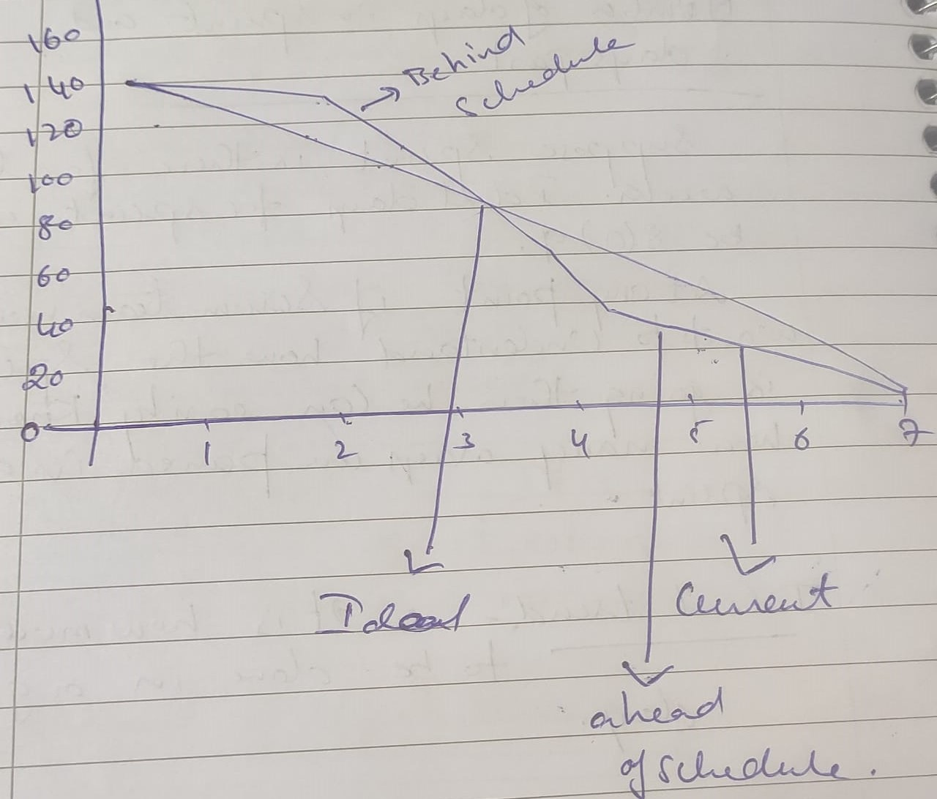**Product-Burn down-Chart**

A Product-Burn down-Chart depicts story points of all user stories in the so called product backlog, where the product backlog is a simple ranked list of all functional and non-functional requirements described as user stories. The chart displays story points for each completed sprint, so it depicts the completion of requirements over time. Backlog and Product-Burn down-Chart is usually updated at the end of each sprint. New user stories can be added and/or removed before each sprint planning meeting.

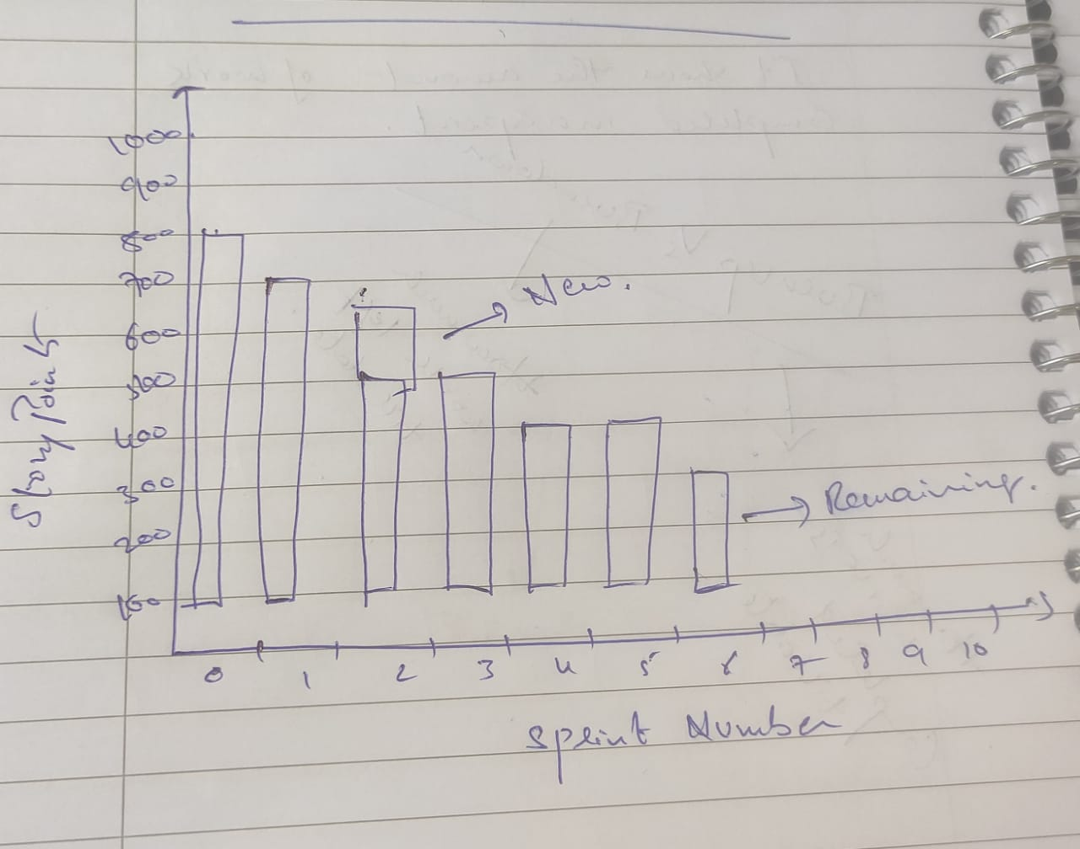

**Product grooming:**

Product grooming, also known as backlog refinement, is a Scrum ceremony where the product team reviews and prioritizes the product backlog:

* **Purpose**: To keep the backlog up to date and prepare items for upcoming sprints
* **Who attends**: The product manager, Scrum team, and other stakeholders
* **What happens**: The team discusses and prioritizes backlog items, such as user stories, bugs, and technical stories
* **What's accomplished**: Items are refined, reprioritized, and prepared for the next sprint
* **When it happens**: Usually in the middle of a sprint, along with planning and refinement meetings that alternate on the same day each week

Some tasks that might be performed during product grooming include:

* Removing user stories that are no longer relevant
* Reordering the priority of items
* Adding and correcting estimates
* Splitting user stories to fit the scope of the upcoming sprint
* Rewriting backlog items to be more expressive
* Deleting obsolete or no more need items

As defined in the [Scrum Guide](https://www.scrum.org/resources/scrum-guide), **product backlog grooming or refinement**is an ongoing process of validating requirements. A backlog is a document where all the requirements are collected and managed. The requirements come in the form of use cases or [user stories](https://www.altexsoft.com/blog/user-stories/). Some tasks performed during backlog grooming are:

* removing user stories that are no longer relevant,
* reordering the priority of items,
* adding and correcting estimates, and
* splitting user stories to fit the scope of the upcoming Sprint.

As a process, backlog grooming is a continuous activity of a Product Owner. As a Sprint event - backlog refinement meeting - it’s a workshop aimed at formulating the scope of the upcoming sprint and clarifying details of backlog items.

**Role of Scrum master:**

A scrum master's role is to facilitate and guide a scrum team in adopting and implementing the Scrum framework. They are responsible for ensuring that the team follows Scrum principles and practices, and that the Scrum process runs smoothly.

Here are some of the responsibilities of a scrum master:

* **Facilitate Scrum ceremonies**: Lead and organize Scrum ceremonies, such as daily stand-ups, sprint reviews, and demos
* **Remove impediments**: Identify and remove obstacles that are preventing the team from making progress
* **Coach the team**: Help the team improve their workflow and self-management skills
* **Promote collaboration**: Facilitate conversations between team members to resolve conflict and improve collaboration
* **Ensure Scrum principles are followed**: Ensure that the team is adhering to Scrum principles and values
* **Plan and execute sprints**: Work with the product owner and development team to plan and execute sprints
* **Create and maintain project timelines**: Create and maintain project timelines, and monitor progress against project goals

**Product owner:**

A product owner (PO) is a manager who connects the business and development teams to ensure the product meets the needs of the customer:

* **Acts as a customer advocate**

The PO represents the customer's needs and requirements to the development team.

* **Manages the product backlog**

The PO prioritizes and manages the product backlog, which is a to-do list of features to develop.

* **Defines user stories**

The PO creates clear descriptions of customer needs, called user stories, to ensure they can be completed within budget.

* **Runs user tests**

The PO runs user tests to get feedback from the customer and make adjustments.

* **Evaluates progress**

The PO evaluates the product's progress at each stage of development.

* **Answers questions**

The PO answers questions from the development team about user stories and tasks.

* **Liaises with stakeholders**

The PO acts as a liaison between the business, development, and other stakeholders, such as designers and marketers.

* **Prioritizes requirements**

The PO prioritizes requirements to ensure the product delivers maximum value to the customer.

* **Creates the product vision**

The PO creates the product vision and roadmap to accomplish the product's goals.

**Meetings Conducted in Scrum Project:**

Product refinement meeting:

As we know product backlog is a live document we as a BA along with Project manager conduct product refinement meeting to have a grab about the epics and user stories in the product backlog document.

Story point allocation meeting:

In order to assign the story points for each user story we conduct a story point allocation meeting in which the developers and testers are actively involved.

Sprint meetings:

Pre-sprint:

Sprint planning:

In order to plan user stories to be worked in a sprint we do sprint planning meeting. We consider 4 Factors like priority, availability of resources, effort estimation and velocity in this meeting.

During the sprint:

We track the progress of the work. We look on what has been done yesterday, what will be done today, what issues have been observed?

Post the sprint:

Sprint Review: After completing the sprint we explain to the client how the user stories have been developed. we will discuss about the activities carried out in the sprint.

Sprint Retrospective: This is internal meeting we share positive and negative aspects about our team members internally.

**DoD**

A shared understanding of when a project or product backlog item is complete. It's a list of criteria that must be met for a product to be considered "done". The DoD is a working agreement that ensures the product meets quality requirements. The development team, led by the Scrum Master, typically creates the DoD, but they should also get input from other stakeholders.

**DoR**

A list of criteria that must be met for a user story to be considered "ready" for development. It's used to determine if a task or user story is ready for the team to work on. Before assigning a task, team members should make sure it's well described and understood.

**Prioritization Techniques:**

MOSCOW:

The Moscow method is a prioritization technique used in management, [business analysis](https://en.wikipedia.org/wiki/Business_analysis), [project management](https://en.wikipedia.org/wiki/Project_management), and [software development](https://en.wikipedia.org/wiki/Software_development) to reach a common understanding with [stakeholders](https://en.wikipedia.org/wiki/Project_stakeholder) on the importance they place on the delivery of each [requirement](https://en.wikipedia.org/wiki/Requirements_analysis); it is also known as *Moscow prioritization* or *Moscow analysis*.

The term MOSCOW itself is an [acronym](https://en.wikipedia.org/wiki/Acronym) derived from the first letter of each of four prioritization categories: M - Must have, S - Should have, C - Could have, W - Won’t have.

KANO:

The Kano Model is an analysis tool to explore and measure customer needs. It’s a way to identify the basic needs of customers, as well as performance and excitement requirements. This model is based on the view that functionality is not the only measure of how ‘good’ a product. Customer emotions should also be taken into account.

The idea is that, as important as the basic functions of products or services are, adding new attractive features will help with customer satisfaction. For instance, when buying a new car, you’d expect the car to go faster when you accelerate. However, adding a virtual assistant feature would increase customer satisfaction and make you stand out from competitors.

Ranking:

We rank each and every requirement based on their importance, impact in the application.

We rank from 1 to 10 1—Top priority,, 10—Least priority.

Bubble sort:

To prioritize requirements using bubble sort technique, you take two requirements and compare them with each other. If you find out that one requirement has greater priority over the other, you swap them accordingly. You then continue in this way until the very last requirement is properly sorted

**MVP:**

A minimum viable product (MVP) is a simplified version of a product that has just enough features to be used by early customers. The goal of an MVP is to gather feedback from users to validate the product's basic idea and inform future development.

**Business Analyst Vs. Product owner**

* **Product owner**

Responsible for the product's vision, strategy, and development. They ensure the product meets the needs of the market and stakeholders, and develop strategies to align with the organization's goals. They also manage the product's development, including go-to-market strategy, product backlogs, sprint planning, and product increment evaluation.

* **Business analyst**

Responsible for defining the product's features, scope, and functionalities. They also work to ensure that the product's needs are aligned with the business's needs and the capabilities of the technology. Business analysts analyze and synthesize data from various sources, and work closely with stakeholders to understand their needs and elicit requirements.

**Here's a sample resume for a Product Owner with 3 years of experience:**

Akkineni Nageswar rao

Visakhapatnam

7780717997

nageswarroa.a@gmail.com

**Objective:**

To leverage my product ownership expertise, driving product success and customer satisfaction.

**Summary:**

Results-driven Product Owner with 3+ years of experience in Agile product management. Proven track record of delivering high-quality products, exceeding customer expectations, and driving business growth. Skilled in product vision, roadmap development, requirements gathering, prioritization, and stakeholder management.

**Professional Experience:**

Product Owner

Coserve software solutions, Hyderabad[March 2021-Present]

- Defined and maintained product vision, roadmap, and requirements

- Collaborated with cross-functional teams (Development, Design, QA)

- Prioritized and refined product backlogs

- Conducted stakeholder analysis and management

- Facilitated sprint planning, retrospectives, and demos

- Analyzed market trends, customer feedback, and data insights

- Improved product engagement by 30% through data-driven decisions

Product Owner Intern

BA Centric, Hyderabad[January 2021-March-2021]

- Assisted in product requirements gathering and analysis

- Contributed to product roadmap development

- Coordinated with development team

- Conducted customer interviews and usability testing

**Education:**

MBA [Marketing and operations]

Rajiv Gandhi University, Bangalore

[2019-2021]

**Certifications:**

Certified Scrum Product Owner (CSPO)

**Skills:**

- Agile product management

- Product vision and roadmap development

- Requirements gathering and prioritization

- Stakeholder management

- Communication and collaboration

- Data analysis and visualization

- Market research and competitive analysis

- Customer feedback and usability testing

- Jira, Asana, Trello, Microsoft Office