**Document 1- Business case document template**

Q1. Why is this project initiated?

A1. Banks operate in a highly regulated environment, where compliance with portfolio management rules is critical. Regulatory bodies frequently update compliance requirements, making manual tracking inefficient and leads to errors. The Portfolio Compliance Management System aims to reduce risks and improve regulatory compliance adherence, enhance operational efficiency, automate compliance monitoring, regulatory standards, and internal policies.

Q2. What are the current problems?

A2. Some of the Current problems which bank is facing are:

Outdated system: The existing compliance management system is outdated, lacks automation, and struggles with scalability, leading to inefficiencies in monitoring, reporting, and decision-making.

Manual Compliance Checks: Some of the current compliance checks are performed manually like KYC, bank statement analysis etc. leading to inefficiencies and potential errors.

Operational Delays: Manual intervention slows down decision-making and increases operational costs.

Q3. With this project how many problems could be solved?

A3. By implementing the project, Portfolio compliance management system we can address the below problems:

* Automation of Compliance Checks: Eliminates manual processes, reducing errors and increasing efficiency.
* Regulatory Adherence: Ensures real-time updates to comply with new regulatory changes.
* Data Centralization: Integrates data across systems for improved reporting and decision-making.
* Faster Decision-Making: Streamlines operations, enabling quicker responses to compliance issues.
* Audit Readiness: Maintains an audit trail for easy compliance tracking and regulatory reporting.

Q4. What are the resources required?

A4.

Stakeholders: Project team members from the bank’s compliance and IT departments

Technical Resources: Team size of 10 members is aligned for this project including 5 developers, 3 testers, a BA and PM.

Financial Resources: Budget allocation of Rs.10cr for software procurement, implementation, and maintenance, hardware and training.

Training Resources: Employee training sessions to ensure smooth adoption of the system. Rs.2 cr budget allotted for training resources.

Q5. How much organizational change is required to adopt this technology?

A5. To adopt the technology, organization has to change the below parameters to support the impact:

* Shift from manual to automated compliance processes.
* Need for staff training to use the new system effectively.
* Integration with existing banking systems to streamline operations.
* Change management strategies will be required to ensure user acceptance.

Q6. Time frame to recover ROI?

A6. It would take 1 year to recover the ROI as in the initial 3 months application will be in implementation and integration phase, initial compliance improvements. In the next 4 months, there will be a significant reduction in compliance costs, improved efficiency, and lower risk exposure. And in the final last 5 months of period there will be a full realization of cost savings, optimized workflows, and enhanced regulatory compliance.

Q7. How to identify Stakeholders?

A7. Stakeholders can be identified using:

**Primary Stakeholders:**

Compliance Department: Ensures regulatory adherence and monitors compliance risks.

Investment & Portfolio Managers: Uses the system to track compliance across portfolios.

IT Department: Responsible for system implementation, maintenance, and integration.

**Secondary Stakeholders:**

Regulators: Ensure the system meets regulatory compliance standards.

Senior Management: Oversee project implementation and financial impact.

Auditors: Use the system for compliance audits and reporting.

End Users (Employees): Trained to use the system for day-to-day operations.

**Document 2: BA Strategy**

As a Business Analyst, I will follow the Waterfall Model, a linear and sequential approach, ensuring each phase is completed before moving to the next.

**Requirements Gathering & Analysis**: Requirements gathered from different stakeholders of bank through elicitation techniques of document analysis, brainstorming and JAD.

**Stakeholder analysis using RASCI matrix**:

Responsible: IT department responsible for system implementation, maintenance, and integration.

Accountable: All investment & portfolio managers and compliance department who Uses the system to track compliance across portfolios and ensures regulatory adherence and monitors compliance risks are accountable.

Supporting: Regulators which ensure the system meets regulatory compliance standards.

Consulted: Senior Management who oversee project implementation and financial impact are consulted.

Informed: End Users (Employees) who gets trained to use the system for day-to-day operations are informed.

**Documents to Write:**

* Business requirement document (BRD)
* Functional Requirement Specification (FRS)
* Process Flow Diagrams
* User stories
* Test Plan
* UAT plan
* Training Plan & User Guide.

**Document sign off process:**

* Share draft documents with stakeholders for review and feedback.
* Incorporate feedback and revisions as necessary.
* Obtain formal signoff from stakeholders indicating their acceptance of the documents.
* Maintain version control to track changes and updates.

**Client approvals:**

* Schedule review meetings for project updates.
* Address feedback and document change requests.
* Obtain formal approvals via sign-off forms or email confirmation.
* Ensure alignment with compliance and legal teams before final approvals

**Communication Channels to Establish & Implement:**

* Establish regular meetings like weekly progress meetings, monthly reports with stakeholders to discuss project progress, issues and updates.
* Utilize email, project management software like JIRA, confluence etc and collaboration tools for asynchronous communication.
* Maintain an open-door policy for stakeholders to raise concerns or provide feedback.

**Change request handling:**

* Implement a Change Request Management Process.
* Maintain a Change Log for tracking modifications.
* Evaluate the impact of proposed changes on scope, timeline, budget.
* Obtain approval from the change control board before implementing changes.

**Progress reporting to Stakeholders:**

* Weekly and monthly reports with KPI tracking, project milestones, deliverables and risk.
* Conduct stakeholder meetings and presentations.
* Use dashboards for real-time project tracking.
* Maintain a Risk Register for proactive risk management.
* Highlight achievements, challenges, and upcoming tasks to keep stakeholders informed.

**User Acceptance Testing (UAT) & Sign-Off Process:**

* Develop UAT test scenarios based on business requirements.
* Conduct hands-on training sessions for end users.
* Facilitate UAT execution and collect feedback.
* Resolve issues and obtain formal UAT Sign-Off from stakeholders.

**Client Project Acceptance Form:**

* Prepare a Client Project Acceptance Form post-UAT.
* Ensure sign-off includes compliance validation.
* Archive acceptance records for audit and legal purposes.

This structured Waterfall Model approach ensures successful implementation, regulatory adherence, and operational efficiency of the Portfolio Compliance Management System.

**Document 3- Functional Specifications:**

**Project Details**

* Project Name: Portfolio Compliance Management System
* Customer Name: HDFC Bank
* Project Version: 6.0
* Project Sponsor: HDFC Bank
* Project Manager: Raghu
* Project Initiation Date: 02-04-2023

**Functional Requirement Specifications:**

|  |  |  |  |
| --- | --- | --- | --- |
| **Req ID** | **Req Name** | **Req Description** | **Priority** |
| FR0001 | Login | User should be able to login to the application | 9 |
| FR0002 | User Roles & Permissions | The system should allow role-based access control | 7 |
| FR0003 | Compliance Rules Engine | The system should automatically validate portfolio compliance based on predefined rules | 3 |
| FR0004 | Audit Trail | The system should maintain a detailed audit log of all compliance activities | 4 |
| FR0005 | Reporting & Dashboards | The system should generate real-time compliance reports and dashboards | 2 |
| FR0006 | Alerts & Notifications | The system should send automated alerts for compliance violations | 1 |
| FR0007 | Portfolio Monitoring | System should continuously monitor portfolios and flag any non-compliance scenarios in real-time, generating alerts for the user. | 1 |
| FR0008 | Data Export | Users should be able to export portfolio compliance data in multiple formats (PDF, Excel, etc.) for external reporting and analysis | 2 |
| FR0009 | Change Management | System should provide a feature to handle and track change requests related to portfolio compliance rules and configurations. | 3 |
| FR0010 | Integration with External Systems | System should support integration with third-party tools such as regulatory compliance databases and asset management platforms | 6 |
| FR0011 | Risk Assessment | System should provide tools to assess the risk level of portfolios and generate risk scores based on predefined criteria. | 8 |
| FR0012 | Portfolio Categorization | Users should be able to categorize portfolios based on parameters such as region, sector, or investment type. | 9 |
| FR0013 | Data Validation | System should implement robust validation rules to ensure the accuracy and completeness of portfolio compliance data. | 10 |
| FR0014 | Historical Data Analysis | System should allow users to analyze historical compliance data to identify trends and patterns. | 10 |
| FR0015 | Workflow Automation | Automate workflows for common processes, such as compliance rule creation and portfolio approval. | 9 |
| FR0016 | Access Analytics | System should track and provide analytics on system access, such as login frequency and duration, for monitoring purposes. | 5 |
| FR0017 | Regulatory Updates Notification | Provide automated updates and alerts when new compliance regulations are introduced or existing ones are modified. | 6 |
| FR0018 | Backup and Recovery | Ensure secure backups and provide recovery mechanisms for portfolio compliance data in case of system failure. | 5 |
| FR0019 | Real-Time Collaboration | Enable multiple users to collaborate on portfolio compliance tasks simultaneously with live updates. | 3 |
| FR0020 | Scheduled Reports | Allow users to schedule automatic generation and distribution of compliance reports at regular intervals. | 7 |

**Document 4- Requirement Traceability Matrix:**

|  |  |  |  |  |  |  |
| --- | --- | --- | --- | --- | --- | --- |
| **Req ID** | **Req Name** | **Req Description** | **Design** | **D1** | **T1** | **UAT** |
| FR0001 | Login | User should be able to login to the application | Yes | Yes | Yes | Yes |
| FR0002 | User Roles & Permissions | The system should allow role-based access control | Yes | Yes | Yes | Yes |
| FR0003 | Compliance Rules Engine | The system should automatically validate portfolio compliance based on predefined rules | Yes | No | No | No |
| FR0004 | Audit Trail | The system should maintain a detailed audit log of all compliance activities | Yes | Yes | Yes | Yes |
| FR0005 | Reporting & Dashboards | The system should generate real-time compliance reports and dashboards | Yes | Yes | Yes | Yes |
| FR0006 | Alerts & Notifications | The system should send automated alerts for compliance violations | Yes | No | No | No |
| FR0007 | Portfolio Monitoring | System should continuously monitor portfolios and flag any non-compliance scenarios in real-time, generating alerts for the user. | Yes | No | No | No |
| FR0008 | Data Export | Users should be able to export portfolio compliance data in multiple formats (PDF, Excel, etc.) for external reporting and analysis | Yes | Yes | Yes | Yes |
| FR0009 | Change Management | System should provide a feature to handle and track change requests related to portfolio compliance rules and configurations. | Yes | Yes | Yes | Yes |
| FR0010 | Integration with External Systems | System should support integration with third-party tools such as regulatory compliance databases and asset management platforms | Yes | No | No | No |
| FR0011 | Risk Assessment | System should provide tools to assess the risk level of portfolios and generate risk scores based on predefined criteria. | Yes | No | No | No |
| FR0012 | Portfolio Categorization | Users should be able to categorize portfolios based on parameters such as region, sector, or investment type. | Yes | No | No | No |
| FR0013 | Data Validation | System should implement robust validation rules to ensure the accuracy and completeness of portfolio compliance data. | Yes | No | No | No |
| FR0014 | Historical Data Analysis | System should allow users to analyze historical compliance data to identify trends and patterns. | Yes | No | No | No |
| FR0015 | Workflow Automation | Automate workflows for common processes, such as compliance rule creation and portfolio approval. | Yes | No | No | No |
| FR0016 | Access Analytics | System should track and provide analytics on system access, such as login frequency and duration, for monitoring purposes. | Yes | No | No | No |
| FR0017 | Regulatory Updates Notification | Provide automated updates and alerts when new compliance regulations are introduced or existing ones are modified. | Yes | No | No | No |
| FR0018 | Backup and Recovery | Ensure secure backups and provide recovery mechanisms for portfolio compliance data in case of system failure. | Yes | Yes | Yes | Yes |
| FR0019 | Real-Time Collaboration | Enable multiple users to collaborate on portfolio compliance tasks simultaneously with live updates. | Yes | No | No | No |
| FR0020 | Scheduled Reports | Allow users to schedule automatic generation and distribution of compliance reports at regular intervals. | Yes | No | No | No |

**Document 5 – BRD Template**

**PORTFOLIO COMPLIANCE MANAGEMENT SYSTEM**

**PR00120**

**V6**

**YASHWANTH**

Contents

1. Document Revisions ...........................................................................................................12 2. Approvals ...........................................................................................................................12 3. RASCI Chart for This Document ..........................................................................................12 Codes Used in RASCI Chart ..................................................................................................12 RASCI Chart ........................................................................................................................13 4. Introduction ........................................................................................................................13 4.1. Business Goals .............................................................................................................13 4.2. Business Objectives ......................................................................................................13 4.3. Business Rules ............................................................................................................. 13 4.4. Background ................................................................................................................. 13 4.5. Project Objective......................................................................................................... 13 4.6. Project Scope .............................................................................................................. 14 4.6.1. In Scope Functionality .......................................................................................... 14 4.6.2. Out Scope Functionality ....................................................................................... 14 5. Assumptions ...................................................................................................................... 14 6. Constraints ......................................................................................................................... 14 7. Risks ................................................................................................................................... 14 Technological Risks ................................................................................................................ 14 Skills Risks .............................................................................................................................. 14 Political Risks ......................................................................................................................... 15 Business Risks ........................................................................................................................ 15 Requirements Risks ............................................................................................................... 15 Other Risks ............................................................................................................................ 15 8. Business Process Overview ................................................................................................ 15 8.1. Legacy System (AS-IS).................................................................................................. 15 8.2. Proposed Recommendations (TO-BE) ......................................................................... 15 9. Business Requirements ...................................................................................................... 15 10. Appendices ..................................................................................................................... 17 10.1. List of Acronyms ...................................................................................................... 17 10.2. Glossary of Terms .................................................................................................... 17 10.3. Related Documents ................................................................................................. 17

1. **Document Revisions**

|  |  |  |  |
| --- | --- | --- | --- |
| Date | Version Number | Document changes | Approval date |
| 02-05-2023 | V1 | Initial Draft of documentation | 05-05-2023 |
| 10-05-2023 | V2 | Project objectives and success criteria | 12-5-2023 |
| 15-05-2023 | V3 | Stakeholder analysis and elicitation technique | 18-03-2023 |
| 20-05-2023 | V4 | Functional requirements and requirement traceability matrix | 22-05-2023 |
| 01-06-2023 | V5 | Updated priorities | 05-06-2023 |
| 15-06-2023 | V6 | Final review | 20-06-2023 |

1. **Approvals**

|  |  |  |  |  |
| --- | --- | --- | --- | --- |
| Role | Name | Title | Signature | Date |
| Project Sponsor | Deepak Parek | CEO | Deepak | 20-06-2023 |
| Business Owner | Renu Sud karnad | MD | Renu | 20-06-2023 |
| Project Manager | Raghu | Vice president | Raghu | 18-06-2023 |
| System Architect | Kumar | Senior Manager | Kumar | 18-06-2023 |
| Development Lead | Ram | Senior manager | Ram | 18-06-2023 |
| User Experience Lead | Ramesh | Manager | Ramesh | 18-06-2023 |
| Quality Lead | Pavan | Manager | Pavan | 18-06-2023 |
| Content Lead | Sruthi | Manager | Sruthi | 18-06-2023 |

1. **RASCI Chart**

Codes Used in RACI Chart

* *- Authorize document,
* R- Responsible,
* A- Accountable,
* S- Supports,
* C- Consulted,
* I- Informed

|  |  |  |  |  |  |  |  |
| --- | --- | --- | --- | --- | --- | --- | --- |
| Name | Position | * | R | A | S | C | I |
| Deepak Parek | CEO |  |  |  |  | C |  |
| Renu Sud karnad | MD | * |  | A |  | C |  |
| Raghu | Vice president | * |  | A |  |  |  |
| Kumar | Senior Manager |  | R |  |  |  |  |
| Ram | Senior manager |  | R |  |  |  |  |
| Ramesh | Manager |  |  |  |  |  | I |
| Pavan | Manager |  |  |  | S |  | I |
| Sruthi | Manager |  |  |  | S |  | I |

1. **Introduction**
   1. **Business goals:**
   * Ensure regulatory compliance in portfolio management.
   * Reduce manual compliance efforts and human errors.
   * Provide real-time compliance monitoring and alerts.
   * Enhance auditability and reporting capabilities.
   1. **Business Objectives**
   * Develop an IT solution that automates compliance monitoring.
   * Implement a mobile application for compliance tracking.
   * Provide role-based access control for secure operations.
   * Generate real-time compliance reports.
   1. **Business Rules**
   * Must comply with regulatory standards such as SEBI, Basel, and RBI.
   * Automated threshold alerts for policy violations.
   * Secure data encryption and user authentication protocols.
   1. **Background**
   * The bank currently relies on outdated system for compliance checks, leading to inefficiencies, time taking and risks.
   * New regulatory requirements necessitate automated solutions.
   * This project aims to reduce compliance violations and improve transparency
   1. **Project Objective**
   * Automate compliance validation for investment portfolios.
   * Provide seamless integration with existing bank systems.
   * Offer real-time analytics and compliance breach notifications.
   * Aligns with the organization’s business objectives by reducing manual efforts and ensuring timely regulatory reporting.
   1. **Project Scope**

**4.6.1 In Scope Functionality**

* + Automated Compliance Monitoring
  + Reports and dashboards for compliance insights.
  + Role-Based Access Control (RBAC)
  + Integration with Regulatory Databases
  + Real-Time Notifications & Alerts
    1. **Out of Scope Functionality**
  + Third-party investment advisory
  + Portfolio performance optimization
  + Tax calculations for investors

1. **Assumptions**

* The bank has all the necessary regulatory compliance data and documentation available before project initiation.
* Stakeholders will be available for requirement gathering, reviews, and approvals as per the project schedule.
* There is no significant change in compliance regulations during the project timeline
* The project timeline, budget, and scope are clearly defined and agreed upon.
* Data sources will be available and accessible for integration.

1. **Constraints**

* Compliance with strict regulatory requirements.
* Integration with existing banking systems.
* Budget and timeline limitations.
* Resources, including development and testing teams, are limited

1. **Risks**

**Technological Risks**

* Compatibility issues with legacy systems.
* Performance issues due to high transaction volumes.
* The likelihood of occurrence is medium but the impact of this risk is high.

**Skills Risks**

* Limited availability of compliance and IT experts.
* The likelihood of occurrence is high and the impact of this risk is high.

**Political Risks**

* Changes in regulatory requirements impacting project scope.
* The likelihood of occurrence is low and the impact of this risk is medium.

**Business Risks**

* Delayed implementation affecting regulatory compliance.
* The likelihood of occurrence is medium and the impact of this risk is high.

**Requirements Risks**

* Incomplete or misunderstood compliance requirements.
* The likelihood of occurrence is medium and the impact of this risk is medium.

**Other Risks**

* Includes risks like system downtime during migration or security breaches.
* The likelihood of occurrence is low and the impact of this risk is high.
* Implement robust backup and recovery mechanisms.

1. **Business Process overview**
   1. **Legacy System (AS-IS)**
   * Increased risk of errors and non-compliance penalties
   * Delays in identifying and reporting compliance breaches.
   * Lack of real-time monitoring and proactive alerts.
   1. **Proposed Recommendations (TO-BE)**
   * Automated compliance validation and reporting.
   * Centralized compliance dashboard
   * Integration with regulatory tools and third-party systems.

**Process flow diagram shown below:**

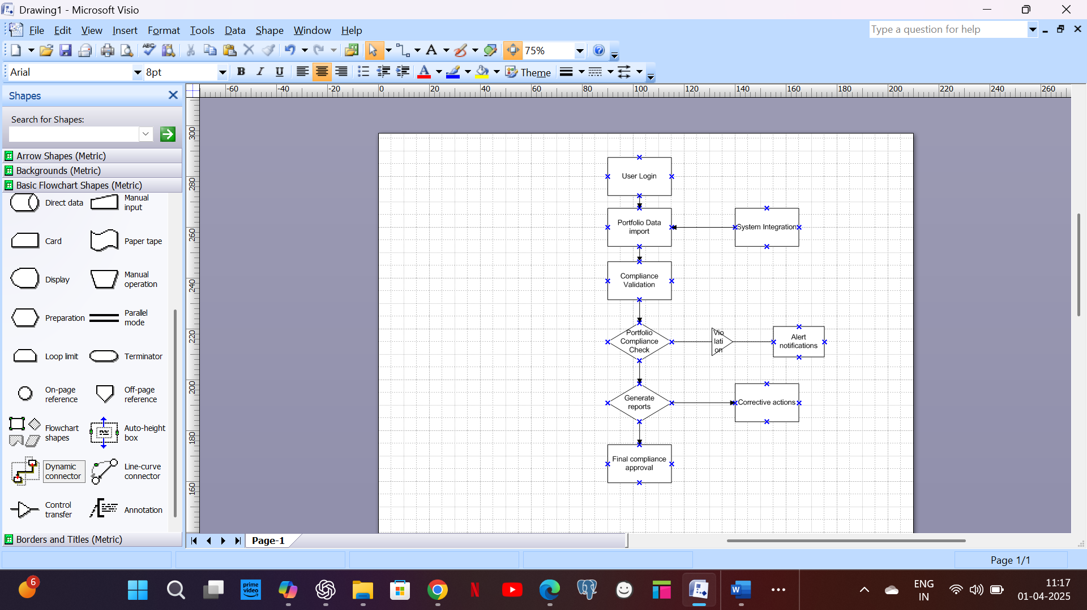

1. **Business Requirements**

|  |  |  |  |
| --- | --- | --- | --- |
| **Req ID** | **Req Name** | **Req Description** | **Priority** |
| BR0001 | Login | User should be able to login to the application | 9 |
| BR0002 | User Roles & Permissions | The system should allow role-based access control | 7 |
| BR0003 | Compliance Rules Engine | The system should automatically validate portfolio compliance based on predefined rules | 3 |
| BR0004 | Audit Trail | The system should maintain a detailed audit log of all compliance activities | 4 |
| BR0005 | Reporting & Dashboards | The system should generate real-time compliance reports and dashboards | 2 |
| BR0006 | Alerts & Notifications | The system should send automated alerts for compliance violations | 1 |
| BR0007 | Portfolio Monitoring | System should continuously monitor portfolios and flag any non-compliance scenarios in real-time, generating alerts for the user. | 1 |
| BR0008 | Data Export | Users should be able to export portfolio compliance data in multiple formats (PDF, Excel, etc.) for external reporting and analysis | 2 |
| BR0009 | Change Management | System should provide a feature to handle and track change requests related to portfolio compliance rules and configurations. | 3 |
| BR0010 | Integration with External Systems | System should support integration with third-party tools such as regulatory compliance databases and asset management platforms | 6 |
| BR0011 | Risk Assessment | System should provide tools to assess the risk level of portfolios and generate risk scores based on predefined criteria. | 8 |
| BR0012 | Portfolio Categorization | Users should be able to categorize portfolios based on parameters such as region, sector, or investment type. | 9 |
| BR0013 | Data Validation | System should implement robust validation rules to ensure the accuracy and completeness of portfolio compliance data. | 10 |
| BR0014 | Historical Data Analysis | System should allow users to analyze historical compliance data to identify trends and patterns. | 10 |
| BR0015 | Workflow Automation | Automate workflows for common processes, such as compliance rule creation and portfolio approval. | 9 |
| BR0016 | Access Analytics | System should track and provide analytics on system access, such as login frequency and duration, for monitoring purposes. | 5 |
| BR0017 | Regulatory Updates Notification | Provide automated updates and alerts when new compliance regulations are introduced or existing ones are modified. | 6 |
| BR0018 | Backup and Recovery | Ensure secure backups and provide recovery mechanisms for portfolio compliance data in case of system failure. | 5 |
| BR0019 | Real-Time Collaboration | Enable multiple users to collaborate on portfolio compliance tasks simultaneously with live updates. | 3 |
| BR0020 | Scheduled Reports | Allow users to schedule automatic generation and distribution of compliance reports at regular intervals. | 7 |

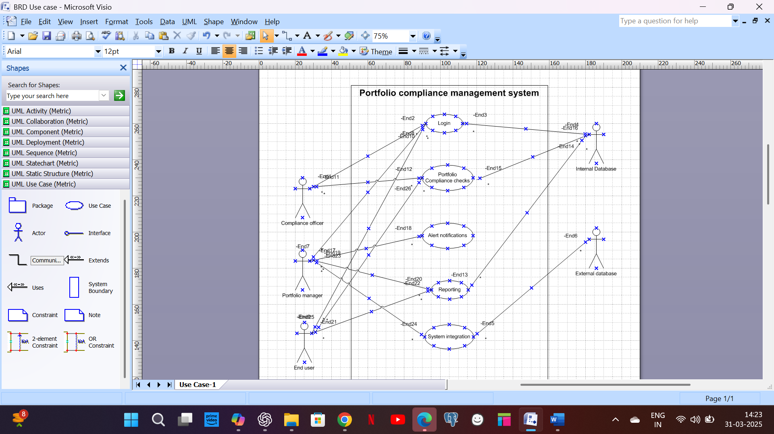

1. **Appendices**

**10.1. List of Acronyms**

* RBAC: Role-Based Access Control
* UAT: User Acceptance Testing
* BRD: Business requirement document

**10.2. Glossary of Terms**

* **Compliance Rule:** A predefined rule to check portfolio adherence to regulations.
* **Risk Alert:** Notification sent when compliance breach occurs.

**10.3. Related Documents**

* Compliance Policies & Guidelines
* Regulatory Standards Documentation