# ABW WATERFALL 3

USE CASE DIAGRAM

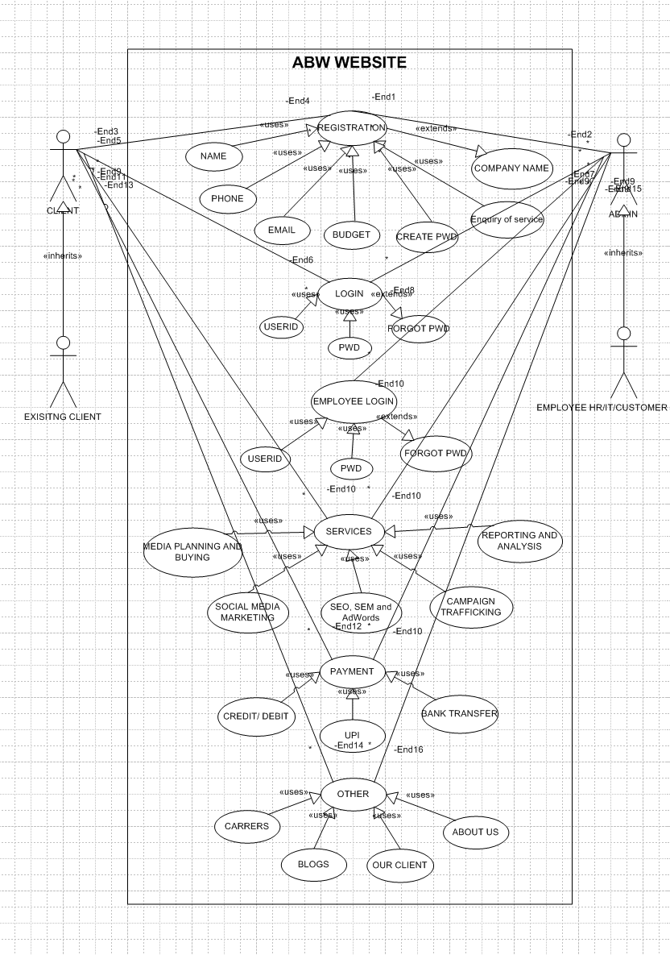

Activity diagram

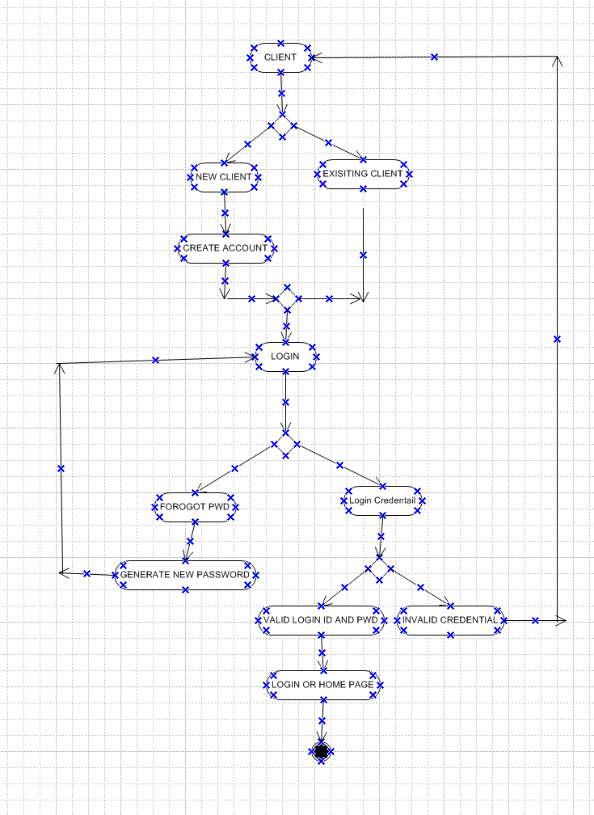

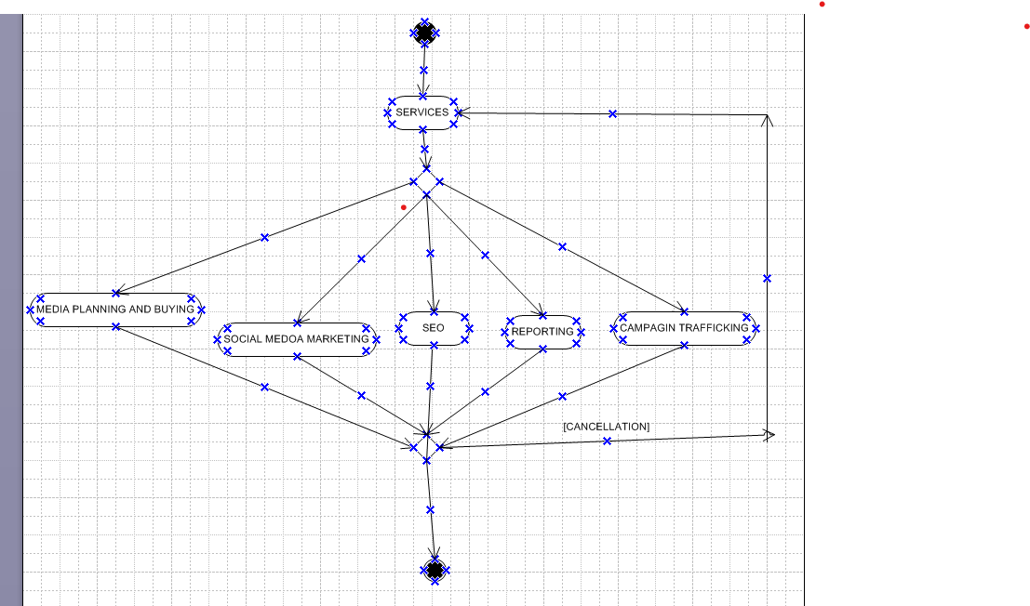

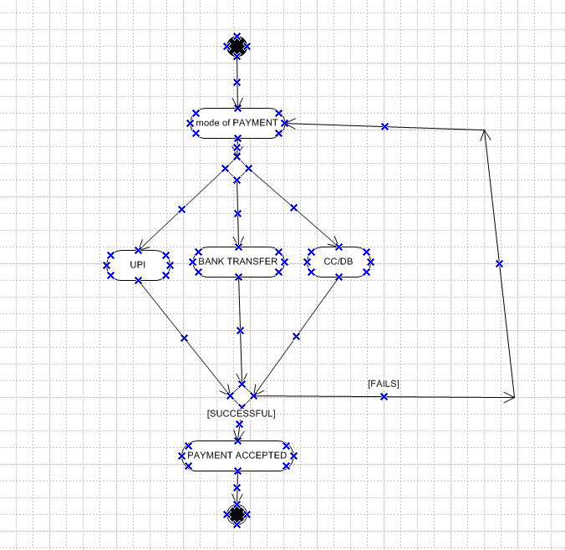

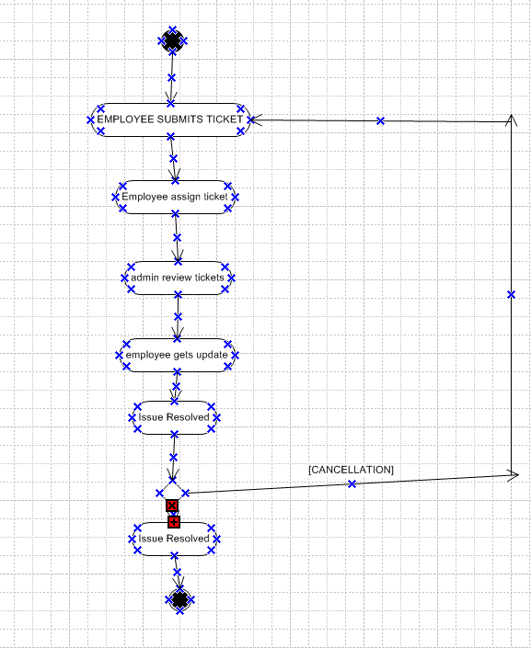

**Use Case Specification Document**  
**Project: ABW Digital Marketing Services Website**

**Use Case 1: Client Service Inquiry Submission**

**1. Use Case Name:** Client Service Inquiry Submission  
**2. Use Case Description:**  
This use case describes how a client submits a service inquiry through the website, how the system processes the request, and how the admin responds. The goal is to streamline client interactions and improve response time.

**3. Actors:**  
Primary Actor: Client  
Secondary Actor: Admin

**4. Basic Flow:**

1. Client visits the website and navigates to the "Contact Us" page.
2. Client fills out the inquiry form (name, email, service required, message).
3. System validates the form data (checks for empty fields, invalid inputs).
4. System saves the inquiry in the database.
5. System sends an automatic confirmation email to the client.
6. Admin logs into the system and views the inquiry.
7. Admin responds to the client via email or phone.
8. Inquiry is marked as resolved.

**5. Alternate Flow:**

* Client uses live chat instead of submitting a form.
* Client calls support, and admin logs the inquiry manually.

**6. Exceptional Flows:**

* Form submission fails due to missing data.
* Email system fails to send a confirmation.
* Admin does not respond within 24 hours, and the inquiry is escalated.

**7. Pre-Conditions:**

* Website and email services must be functional.

**8. Post-Conditions:**

* Inquiry is stored, and the client receives a confirmation.
* Admin responds and resolves the request.

**Use Case 2: Billing & Payment System**

**1. Use Case Name:** Billing & Payment System  
**2. Use Case Description:**  
Clients view invoices and make online payments.

**3. Actors:**  
Primary Actor: Client  
Secondary Actor: Finance Team, System

**4. Basic Flow:**

1. Client logs in and navigates to the billing page.
2. Client selects an invoice and chooses a payment method.
3. System processes the payment.
4. System updates the payment status and notifies the client.
5. Finance team verifies the transaction.

**5. Alternate Flow:**

* Client pays via bank transfer instead of online payment.
* Finance team manually updates payment records.

**6. Exceptional Flows:**

* Payment fails due to incorrect card details.
* System is unable to update payment status.
* Finance team detects a discrepancy in payment records.

**7. Pre-Conditions:**

* Client must have an active invoice.

**8. Post-Conditions:**

* Payment status is updated, and the invoice is marked as paid.

**Use Case 3: Employee Login & Access**

**1. Use Case Name:** Employee Login & Access  
**2. Use Case Description:**  
Employees log in to access the internal portal.

**3. Actors:**  
Primary Actor: Employee  
Secondary Actor: System

**4. Basic Flow:**

1. Employee enters login credentials.
2. System verifies authentication.
3. Employee accesses the dashboard.
4. Employee retrieves documents or training materials.

**5. Alternate Flow:**

* Employee logs in via mobile instead of desktop.

**6. Exceptional Flows:**

* Incorrect credentials entered.
* Employee account is locked due to multiple failed attempts.
* System downtime prevents login.

**7. Pre-Conditions:**

* Employee must be registered in the system.

**8. Post-Conditions:**

* Employee successfully accesses the portal.

**Use Case 4: Issue Ticketing System**

**1. Use Case Name:** Issue Ticketing System  
**2. Use Case Description:**  
Employees raise IT, HR, or admin issues via an online ticketing system.

**3. Actors:**  
Primary Actor: Employee  
Secondary Actor: Admin

**4. Basic Flow:**

1. Employee submits a support ticket.
2. System assigns the ticket to the relevant department.
3. Admin reviews and updates the ticket status.
4. Employee gets notification of progress.
5. Ticket is resolved and closed.

**5. Alternate Flow:**

* Employee contacts support directly via chat.

**6. Exceptional Flows:**

* System fails to assign a ticket to the right department.
* Employee does not receive status updates.
* Ticket remains unresolved for too long and is escalated.

**7. Pre-Conditions:**

* Employee must be logged in.

**8. Post-Conditions:**

* Issue is resolved, and the ticket is closed.

**Use Case 5: Admin Managing Client Inquiries**

**1. Use Case Name:** Admin Managing Client Inquiries  
**2. Use Case Description:**  
Admin reviews and responds to client inquiries.

**3. Actors:**  
Primary Actor: Admin  
Secondary Actor: Client

**4. Basic Flow:**

1. Admin logs in and views new inquiries.
2. Admin assigns inquiries to the relevant team.
3. Admin sends follow-up responses.
4. Inquiry is marked as resolved.

**5. Alternate Flow:**

* Inquiry is assigned to a different team if needed.

**6. Exceptional Flows:**

* Admin does not respond within the required time.
* Inquiry is misassigned.

**7. Pre-Conditions:**

* Admin must be logged in.

**8. Post-Conditions:**

* Inquiry is resolved successfully.

**Use Case 6: SEO Optimization & Content Update**

**1. Use Case Name:** SEO Optimization & Content Update  
**2. Use Case Description:**  
Admin updates website content for SEO and performance improvement.

**3. Actors:**  
Primary Actor: Admin  
Secondary Actor: System

**4. Basic Flow:**

1. Admin logs into the CMS (Content Management System).
2. Admin updates service descriptions, blogs, or metadata.
3. Admin saves changes.
4. System updates the website in real-time.

**5. Alternate Flow:**

* Content updates are scheduled instead of published immediately.

**6. Exceptional Flows:**

* System fails to save updates.
* Website crashes due to an update error.

**7. Pre-Conditions:**

* Admin must have editing permissions.

**8. Post-Conditions:**

* Website is updated successfully.

**Document 7- Screens and pages**

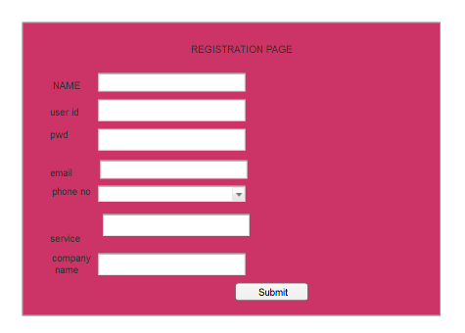  
  
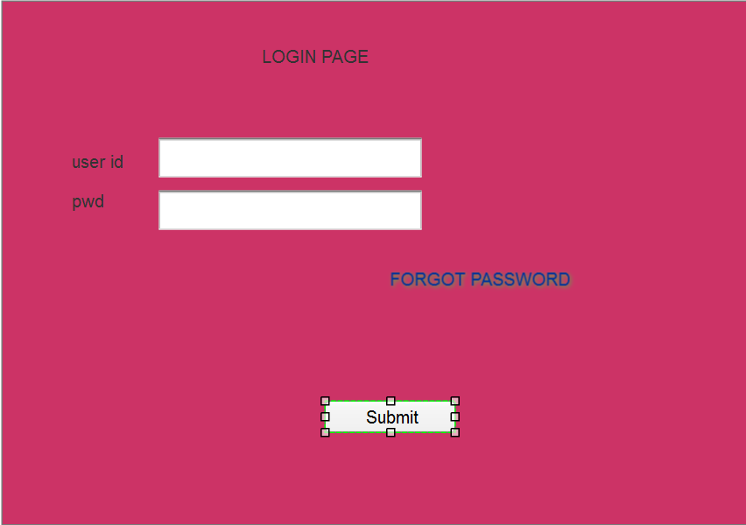

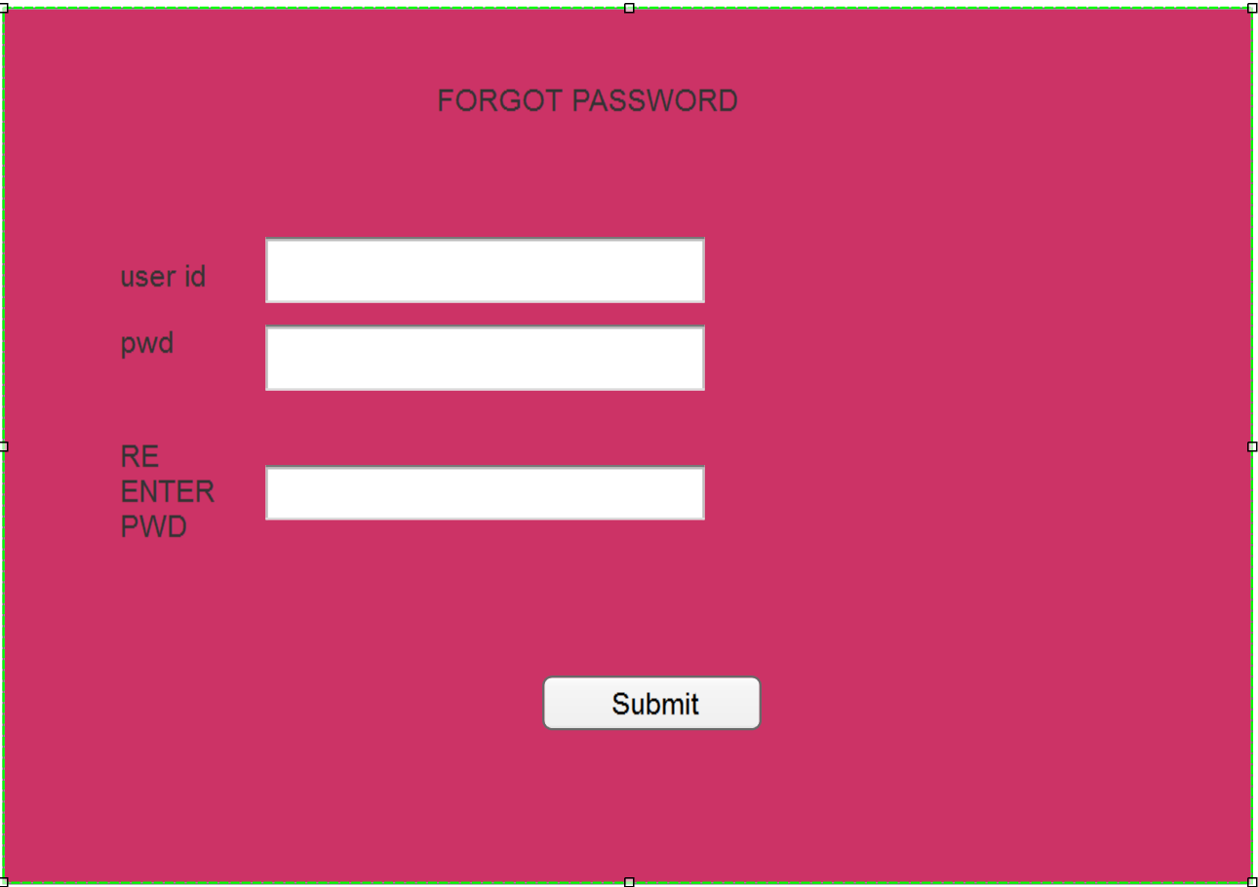

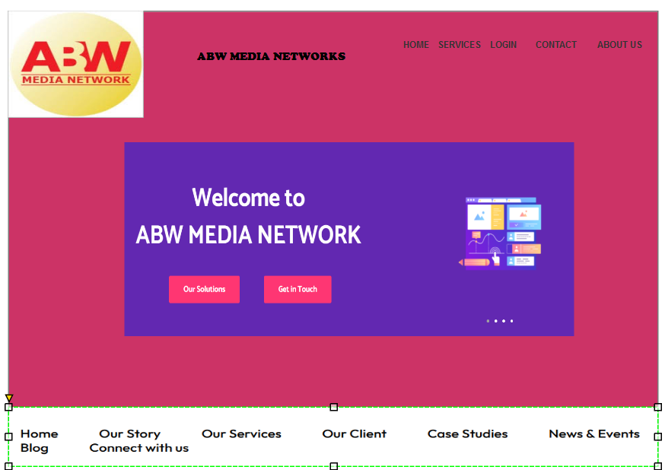

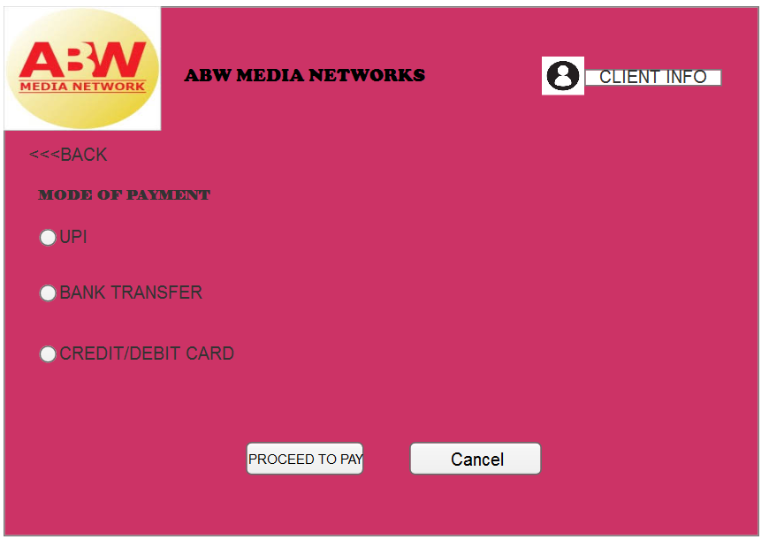

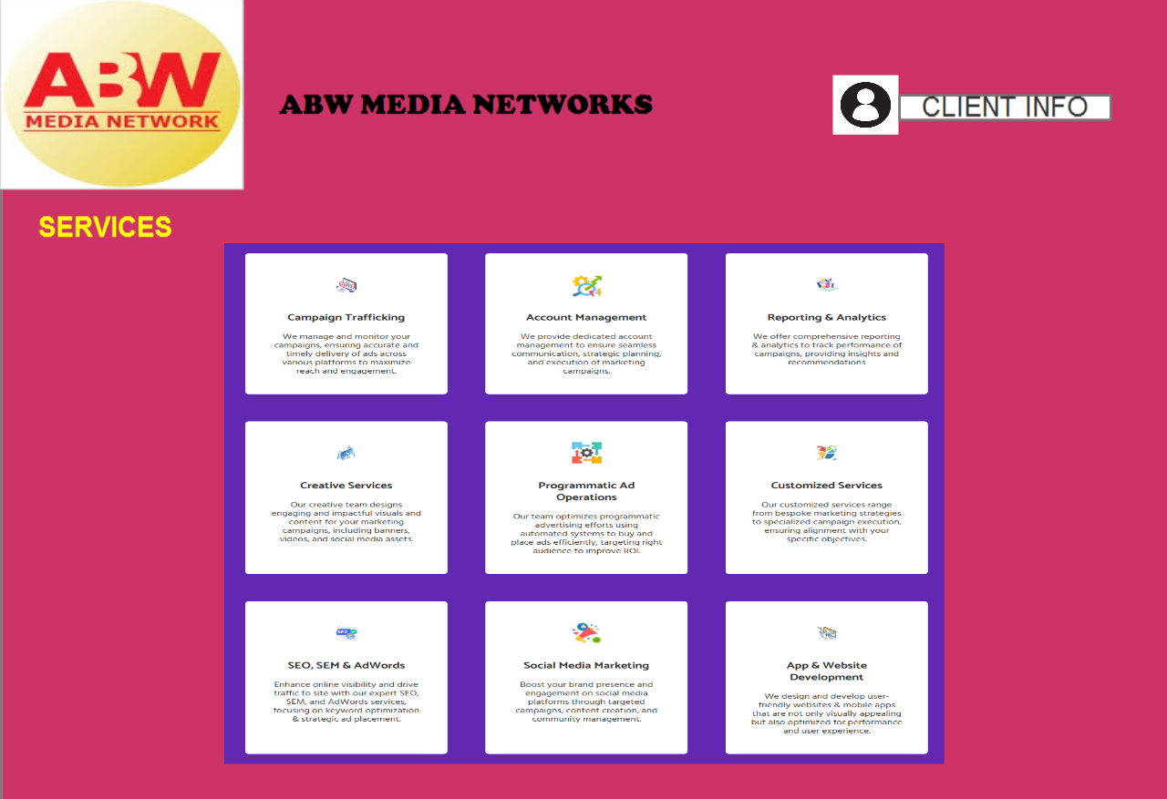

### **Experience Using Visio and Axure for the Project**

During this project, **Microsoft Visio and Axure** were essential tools for designing and visualizing various aspects of the system. **Visio** was used to create **process flow diagrams, use case diagrams, and activity diagrams**, helping to map out the business processes in a structured and clear format. The tool's drag-and-drop functionality and built-in UML shapes made it easy to develop **detailed system workflows**.

**Axure** was particularly useful for **MOCKUP** the website, allowing us to create interactive designs that helped visualize the user experience before development. The ability to simulate user interactions gave valuable insights into the usability of features like the **client inquiry system, employee portal, and billing section**.

Overall, using **Visio and Axure** improved **efficiency, collaboration, and accuracy**, ensuring that all system requirements were well-documented and visually represented.

**Business Analyst Experience in Project Phases**

Throughout this project, my role as a **Business Analyst (BA)** provided valuable hands-on experience in various phases, allowing me to enhance my analytical, problem-solving, and stakeholder management skills. Below is a reflection on my journey through each phase.

**1. Requirement Gathering:**

* I applied the **MoSCoW technique** to prioritize requirements effectively, ensuring that critical business needs were addressed first.
* One of the key challenges was the **unavailability of the client for a certain period**. I took the initiative to identify and collaborate with alternative points of contact to keep the process moving.
* I used the **RACI matrix** to clearly define roles and responsibilities among stakeholders, ensuring accountability throughout the project.
* Identifying and eliminating **duplicate and conflicting requirements** was a crucial step to maintain a clear and focused scope.
* Instead of prototyping, I utilized **mockups** to provide a visual representation of the system, making it easier for stakeholders to understand the requirements.

**2. Requirement Analysis:**

* Creating **UML diagrams** and **activity diagrams** significantly helped in visualizing system workflows and interactions.
* Engaging with the development team during this phase was insightful, as some members had different perspectives on system processes, requiring discussions and refinements.
* This phase required strong documentation skills as I was responsible for preparing the **Business Requirement Specification (BRS)** and **Software Requirement Specification (SRS)** while ensuring clarity for all stakeholders.

**3. Design:**

* From the finalized **use case diagrams**, I played a key role in preparing detailed **test cases** to cover all functional scenarios.
* One of my critical responsibilities was **bridging the gap between the client and the development team** regarding design expectations.
* Writing **both positive and negative test cases** was an enriching experience, as it reinforced the importance of anticipating real-world user interactions.
* I learned the impact of missing even a single test case, as it could lead to issues surfacing in later development stages.
* Preparing **test data** helped simulate various user conditions, improving test effectiveness.
* Updating the **Requirement Traceability Matrix (RTM)** ensured all documented requirements were mapped correctly to design and testing.

**4. Development:**

* I conducted **JAD (Joint Application Development) sessions**, facilitating discussions between business stakeholders and developers.
* Throughout development, I was actively involved in **resolving queries from the technical team**, ensuring alignment with business expectations.
* One of the biggest challenges was dealing with **team members who resisted changes or disagreed on certain requirements**. I handled such situations diplomatically, organizing one-on-one discussions and explaining the long-term impact on the project.
* Regular **stand-up meetings and stakeholder updates** required strong coordination skills, as scheduling conflicts often arose.

**5. Testing:**

* Creating **test cases from use cases** and ensuring full coverage of functional requirements was a key responsibility.
* Performing **high-level testing** allowed me to identify potential gaps in requirement understanding.
* I collaborated with the client to obtain **test data** that closely resembled real-world conditions.
* Ensuring that the **RTM was continuously updated** provided traceability for all requirements.
* One of the most challenging yet rewarding tasks was preparing the client for **UAT (User Acceptance Testing)** and ensuring a smooth **sign-off process**.

**6. Deployment:**

* As part of the project closure process, I **forwarded the RTM to the client** along with necessary documentation.
* I coordinated with various teams to ensure the creation and distribution of **end-user manuals**, making adoption easier.
* Organizing **training sessions for end users** was one of the most impactful activities, ensuring smooth transition and user onboarding.
* I actively monitored **training participation** and addressed any last-minute queries to ensure a complete understanding of the system before go-live.

This project provided me with **hands-on experience in handling challenges, refining requirements, collaborating with stakeholders, and ensuring a successful delivery**. It reinforced my ability to adapt, communicate effectively, and drive a project from initiation to completion as a **Business Analyst**.