**Agile Part 2nd**

**Document 1: Definition of Done**

A **DoD is a set of criteria** that a product increment must meet for the team to consider it complete and ready for customers. It is a shared understanding among the team members of when a product increment is ready for release, even when the increment is large and consists of many items. By clearly defining what “done” means to the project, an Agile team can focus on delivering value with every sprint and **minimizing rework**

The **Definition of Done (DoD)** ensures that a backlog item meets all the agreed-upon criteria before being considered complete. It includes:

* Acceptance criteria met
* Code is written, reviewed, and merged without errors
* Unit tests written and passed
* The feature is tested against acceptance criteria
* Deployment is done in a test environment
* QA testing is completed, and issues are resolved
* Approved by the Product Owner (PO)
* Documentation is updated
* Code refactored and optimized
* Peer code review performed

**On a COIN AI platform development project, example criteria in the DoD could include:**

* All code has been thoroughly tested via unit, integration, and end-to-end tests.
* Product increment has been deployed to a staging environment and tested by the team.
* Database connectivity is being checked
* Data of all coin partners is being made available and it is searchable based on few input parameters.
* Data is accurately displayed once account team search for partners in various domains.

**Document 2: Product Vision**

|  |  |  |  |
| --- | --- | --- | --- |
| **Scrum Project**  **Name:** | Coin AI Project |  |  |
| **Venue:** | TCS |  |  |
| **Date:** 8th March 2025 | **Start time:** 7:15 PM | **End time:** 10:15 PM | **Duration: 3 Hrs** |
| **Client:** Internal |  |  |  |
| **Stakeholder list:** | Business Analyst (Manish) | Scrum Mater | Developers |
| Project Manager | Tester | Product Owner | Innovation Champions |
| Account teams |  |  |  |
| **Scrum Team** | | | |
| **Scrum Master:** | Jyoti |  |  |
| **Product owner:** | Amit Chemburkar |  |  |
| **Scrum Developer 1:** | Nikhil Zope |  |  |
| **Scrum Developer 2:** | Anju Midha |  |  |
| **Scrum Developer 3:** | Balasubramanium |  |  |
| **Scrum Developer 4:** | Sheeba |  |  |
| **Scrum Developer 5:** | Aritra |  |  |

|  |  |  |  |
| --- | --- | --- | --- |
| * **Vision:** Develop an online platform for TCS account teams to search for Coin AI partners, replacing manual processes and Excel sheets. | | | |
| **Target group**  This project is initially be developed TCS Internal account teams’ usage.  The major target group or target audience for this coin project would be **TCS account teams and stakeholders**. | **Needs**  Eliminates manual email-based partner searches.  Centralizes partner data for efficiency.  Real & accurate data of the partners  Updated list of coin partners | **Product**  A web-based searchable IT platform which contains list of partners serving in multiple domains for various verticals or industries such as BFSI, Healthcare & Life science, CMI TTH etc and it also has the data of partners stored in database.  Integrated with AI for accurate and faster recommendations to the account teams. | **Value**  Faster partner search, **improving response times**.  **Reduces workload**, ensuring efficiency.  **Removal of manual based email reach out & search of partners.** |

* **Vision:** Develop an online platform for TCS account teams to search for Coin AI partners, replacing manual processes and Excel sheets.
* **Target Group:** The major target group or target audience for this coin project would be **TCS account teams** and **stakeholders**.
* **Market Segment:** IT consulting and enterprise AI solutions.
* **Needs:**
  + Eliminates manual email-based partner searches.
  + Centralizes partner data for efficiency.
  + Real & accurate data of the partners
  + Updated list of coin partners
* **Product:**
  + A web-based searchable IT platform which contains list of partners serving in multiple domains for various verticals or industries such as BFSI, Healthcare & Life science, CMI TTH etc and it also has the data of partners stored in database.
  + Integrated with AI for accurate and faster recommendations to the account teams.
* **Value:**
  + Faster partner search, **improving response times**.
  + **Reduces workload**, ensuring efficiency.
  + **Removal of manual based email reach out & search of partners.**

**Document 3: User Stories**

User stories describe functionality from an end-user perspective to ensure usability and business alignment.

|  |  |  |  |  |  |
| --- | --- | --- | --- | --- | --- |
| User Story No | Tasks | Priority | BV | CP | Acceptance Criteria |
| US01 | Search for partners | High | 8 | 3 | Users can search partners by domain and retrieve results instantly. |
| US02 | Filter by criteria | Medium | 6 | 2 | Users can refine search results by industry, location, and specialization. |
| US03 | View partner details | High | 8 | 3 | Users can see a detailed partner profile, including contact information, expertise, and past collaborations. |

|  |
| --- |
| **User story No: US** 001 |
| **Value statement:**  As a user I want to search for coin partners  so that I can identify the potential partners which could help the customer for the requirement. | | |
| **BV:100 CP: 1** | |
| **Acceptance criteria:**  Users can search partners by domain and retrieve results instantly. | | |

|  |
| --- |
| **User story No: US** 002 |
| **Value statement:**  As a user I want to filter the partners based on few parameter | | |
| **BV:20 CP: 2** | |
| **Acceptance criteria:**  Users can refine search results by industry, location, and specialization. | | |

|  |
| --- |
| **User story No: US** 003 |
| **Value statement:**  As a user I want to view partner detail | | |
| **BV:50 CP: 3** | |
| **Acceptance criteria:**  Users can see a detailed partner profile, including contact information, expertise, and past collaborations. | | |
| **User story No: US** 004 |
| **Value statement:**  As a user, I want to search for Coin AI partners so that I can find suitable partners quickly. | | |
| **BV:500 CP: 5** | |
| **Acceptance criteria:**  Users can search by domain and retrieve results instantly. | | |

|  |
| --- |
| **User story No: US** 006 |
| **Value statement:**  As a user, I want to filter search results by industry, location, and specialization to refine my partner search. | | |
| **BV:200 CP: 8** | |
| **Acceptance criteria:**  Users can refine searches based on filters. | | |

|  |
| --- |
| **User story No: US** 007 |
| **Value statement:**  As a user, I want to view detailed partner profiles to evaluate expertise and past collaborations | | |
| **BV:50 CP: 3** | |
| **Acceptance criteria:**  Users can see partner contact details, industry focus, and past projects. | | |

|  |
| --- |
| **User story No: US** 008 |
| **Value statement:**  As a user, I want to save my favorite partners for future reference. | | |
| **BV:100 CP: 3** | |
| **Acceptance criteria:**  Users can mark and retrieve favorite partners. | | |

|  |
| --- |
| **User story No: US** 009 |
| **Value statement:**  As an admin, I want to add new partners to the system so that the database remains up to date. | | |
| **BV:20 CP: 2** | |
| **Acceptance criteria:**  Admins can add partners with complete details. | | |

|  |
| --- |
| **User story No: US** 010 |
| **Value statement:**  As a user, I want to download partner reports so that I can share them with stakeholders. | | |
| **BV:20 CP: 2** | |
| **Acceptance criteria:**  Users can export search results in PDF/Excel. | | |

|  |
| --- |
| **User story No: US** 013 |
| **Value statement:**  As an admin, I want to set user permissions so that only authorized users can modify data. | | |
| **BV: 100 CP: 5** | |
| **Acceptance criteria:**  Role-based access control is enforced. | | |

|  |
| --- |
| **User story No: US** 015 |
| **Value statement:**  As a user, I want to receive AI-driven recommendations for partners based on past searches. | | |
| **BV:200 CP: 5** | |
| **Acceptance criteria:**  AI suggests relevant partners dynamically. | | |

|  |
| --- |
| **User story No: US** 016 |
| **Value statement:**  As an account team member, I want to track changes in partner data so that I stay informed. | | |
| **BV:200 CP: 3** | |
| **Acceptance criteria:**  Users receive alerts on partner profile updates. | | |

|  |
| --- |
| **User story No: US** 017 |
| **Value statement:**  As a product owner, I want to generate analytics on partner searches so that I can identify trends. | | |
| **BV:500 CP: 5** | |
| **Acceptance criteria:**  System provides reports on most-searched partners. | | |

|  |
| --- |
| **User story No: US** 019 |
| **Value statement:**  As a user, I want to get list of partners which are most searched | | |
| **BV:500 CP: 5** | |
| **Acceptance criteria:**  System provides reports on most-searched partners. | | |

|  |
| --- |
| **User story No: US** 020 |
| **Value statement:**  As a partner, I want to register on the portal so that account teams can search. | | |
| **BV:20 CP: 3** | |
| **Acceptance criteria:**  Partner should be able to register on the portal. | | |

**Document 4: Agile PO Experience**

The **Product Owner (PO)** plays a key role in ensuring that the product aligns with business needs and customer expectations. Responsibilities include:

* **Market Analysis:** Understanding the demand for AI partnerships, evaluating competitors, and identifying trends. Also, this depends on the fact that everything and anything can’t be built by single organization so they decided to identify partners which can helps TCS in solving problems where TCS itself don’t have solution of their own.
* **Enterprise Analysis:** Conducting due diligence on market opportunities to maximize value. The Product owner identified that currently TCS was lacking for a centralized IT platform which could help in tracking and filling customer requirement faster.
* **Product Vision & Roadmap:** Defining the strategic direction and feature timeline. The Product Owner identified the vision to Develop an online platform for TCS account teams to search for Coin AI partners, replacing manual processes and Excel sheets.
* **Managing Backlog:** Prioritizing and refining stories, ensuring alignment with business goals this help to track how much work is done and how much is pending so that we can adjust that in next sprint.
* **Sprint Progress:** Tracking development and making adjustments as needed.
* **Meetings Conducted:**
  + Sprint planning: Define upcoming sprint goals and assign tasks.
  + Daily stand-ups: Ensure team alignment and address blockers.
  + Sprint review: Demonstrate completed work to stakeholders.
  + Sprint retrospective: Evaluate what worked well and areas for improvement.
* From this project I have learned how to handle sprint meetings such as
* >Sprint planning meeting
* > Daily scrum meeting
* >Sprint review meeting
* > Sprint retrospective meeting
* >Backlog refinement meeting
* Also, User stories creation and what things will be included in user stories such as
* Story no
* Tasks
* Priority
* Acceptance criteria: What all parameters a user story should pass to be considered it to be done.
* BV & CP value: BV is the Business Value tells us the value that the feature will bring in the business & Cp is the complexity points i.e. how complex a feature is to be developed by the developers.
* In Scrum, a product owner serves as the liaison between multiple areas of an organization. This person communicates with business stakeholders and collaborates closely with Scrum teams to keep all areas of the business informed on a project's development.
* The product owner develops a vision of a product's function and operation, which in turn allows this Scrum team member to define product features and break those features into product backlog items.

**Document 5: Product & Sprint Backlog and Burndown Charts**

**Total we had 20 user stories which we divided into 5 sprints and than**

The **Product Backlog** is a prioritized list of work items that define the product's evolution, while the **Sprint Backlog** contains tasks planned for the current sprint.

**Product Backlog:**

|  |  |  |  |  |  |  |
| --- | --- | --- | --- | --- | --- | --- |
| User Story ID | User Story | Tasks | Priority | BV | CP | Sprint |
| US01 | Search partners | UI/Backend | High | 50 | 3 | Sprint 1 |
| US02 | Filter options | UI | Medium | 20 | 2 | Sprint 2 |

**Sprint Backlog:**

|  |  |  |  |  |
| --- | --- | --- | --- | --- |
| User Story ID | Tasks | Owner | Status | Estimated Effort |
| US01 | API Development | Dev 1 | In Progress | 5 days |
| US02 | UI Implementation | Dev 2 | Not Started | 4 days |

**Burndown Charts**

Burndown charts visually track progress, illustrating remaining work versus time. They help identify bottlenecks and ensure timely delivery.

* **Product Burndown Chart:** Tracks overall project progress.
* **Sprint Burndown Chart:** Focuses on the current sprint’s remaining workload.

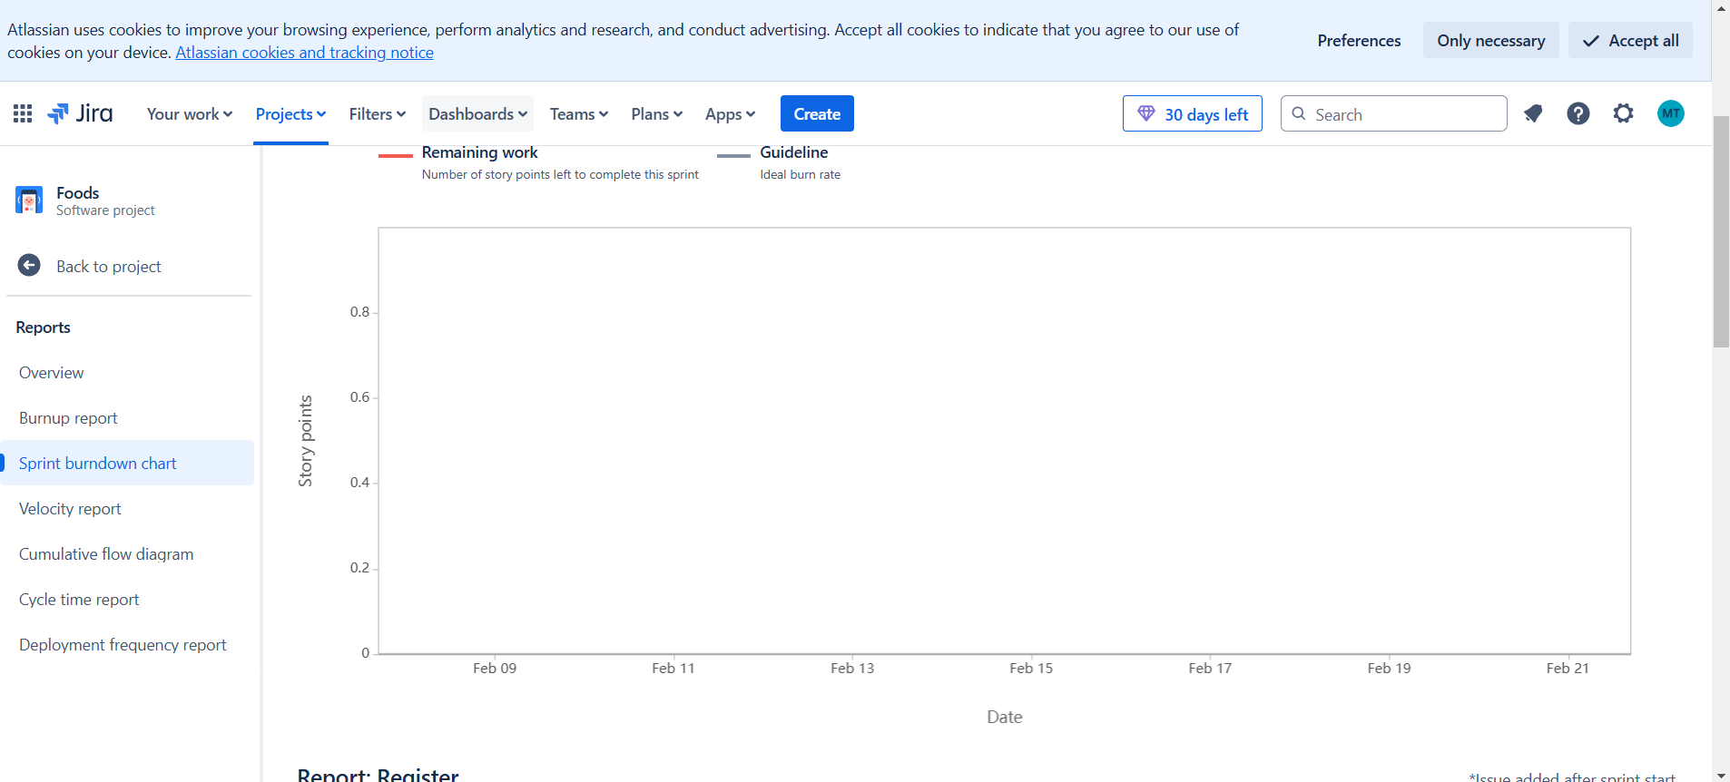

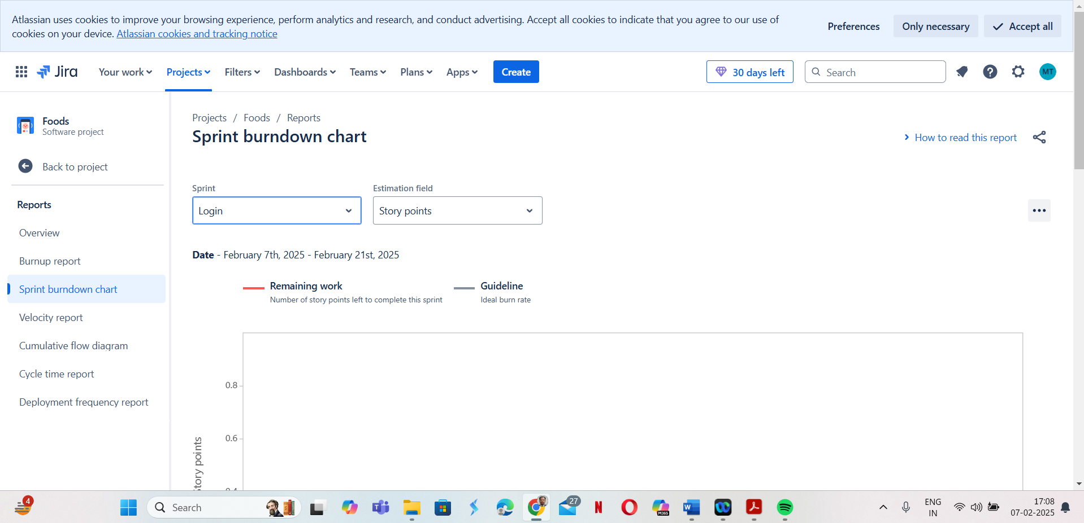

**Document 6: Sprint Meetings**

Agile development involves multiple meetings to maintain alignment and efficiency:

* **Sprint Planning:**
  + Define backlog items to be tackled in the sprint currently we had 3 sprints total.
  + Estimate effort and assign tasks – we had to complete 1 user story in each sprint.
  + Establish sprint goals – which we had decided in this phase.
* **Daily Stand-ups:**
  + What was completed yesterday? - we daily discussed on what task each one of completed yesterday – we use to have calls with developers, tester and everyone in one call and had the status of what each one of us is working on.
  + What is the plan for today? – In this we used to discuss what each one would work on and divide the work appropriately so that we could complete things on time.
  + Are there any blockers preventing progress? – In this we used to discuss with each other about the challenges and difficulty which any one was facing might be software or hardware such as internet connectivity issue or laptop issue or anything else that is hampering anyone to complete the assigned task for them on time.
* **Sprint Review:**
  + Demonstrate completed features to stakeholders – In this we showcased the development and features we had added to the stakeholders involved such as account teams and other teams to see if we should improve or change strategy while working.
  + Gather feedback for improvements – Once we showcased, we try to gather the feedback from the stakeholders regarding this.
  + Update backlog based on feedback – Once we got the feedback we try to bring them into our work and work on the points mentioned by the stakeholders so that the product come out to be more accurate of what customer actually wants.
* **Sprint Retrospective:**
  + Discuss what went well and what didn’t – In this phase we discussed what we had done well and what didn’t well and try to identify what could have done well and try to implement on those things in next sprint.
  + Identify action items to enhance efficiency in the next sprint – here we tried to identified what actions should be taken so that we could deliver more efficiently in next sprint.
  + Foster team collaboration and continuous improvement.

**Meeting Type 1: Sprint Planning meeting**

|  |  |
| --- | --- |
| **Date** | 11th March 25 |
| **Time** | 09:00 AM |
| **Location** | Indore |
| **Prepared By** | Amit Chemburkar |
| **Attendees** | Manish, Akash, Sagar, Piyush, Jyoti, Balasubramanium, Anju, Vasundhara |

**Agenda Topics**

|  |  |  |
| --- | --- | --- |
| **Topic** | **Presenter** | **Time allotted** |
| Sprint 1 | Amit | 1 month |
|  |  |  |

**Meeting Type 2: Sprint review meeting**

|  |  |
| --- | --- |
| **Date** | 11th April 25 |
| **Time** | 9:00 AM |
| **Location** | Indore |
| **Prepared By** | Amit |
| **Attendees** | Manish, Akash, Sagar, Piyush, Jyoti, Balasubramanium, Anju, Vasundhara |

|  |  |  |  |
| --- | --- | --- | --- |
| **Sprint status** | **Things to demo** | **Quick updates** | **What’s next** |
| Complete | User stories done in sprint 1 | Present user stories which were completed | Planning about sprint 2 |

**Meeting Type 3: Sprint retrospective meeting**

|  |  |
| --- | --- |
| **Date** | 11th April 25 |
| **Time** | 9:00 AM |
| **Location** | Indore |
| **Prepared By** | Amit |
| **Attendees** | Manish, Akash, Sagar, Piyush, Jyoti, Balasubramanium, Anju, Vasundhara |

|  |  |  |  |  |
| --- | --- | --- | --- | --- |
| **Agenda** | **What went well** | **What didn’t go well** | **Questions** | **Reference** |
| Retrospect’s on sprint 1 | Discuss on things which went well for the team what we could accomplish and what could not – discuss on why we couldn’t be achieved that. | Identify the areas which didn’t went well and why it didn’t go well – discuss with team and try to improve on those areas in next sprint. | Try to identify questions which could go well and what could not and try to seek questions with team members if they are facing any issue. | For sprint 1 |
|  |  |  |  |  |

**Meeting Type 4: Daily Stand-up meeting**

|  |  |  |  |  |  |  |  |  |  |  |
| --- | --- | --- | --- | --- | --- | --- | --- | --- | --- | --- |
| **Question** | **Name/Role** | | | **Week “1” (from 11/03/25 to 18/03/25)** | | | | | | |
| **Monday** | **Tuesday** | **Wednesday** | **Thursday** | **Friday** | **Saturday** | **Sunday** |
| **What did you do yesterday?** |  | **Priyanshu/Developer 1** |  | Commonly Worked on 1 module of user story1 | Worked on user story1 | Worked on user story1 | Worked on user story1 | Worked on user story1 | NA | NA |
| **Nikhil/Developer 2** |
| **Rahul/Developer 3** |
| **What will you do today?** |  | **Priyanshu/Developer 1** |  | Work on remaining part to complete the user story | Work on remaining part to complete the user story | Work on remaining part to complete the user story | Work on remaining part to complete the user story | Work on remaining part to complete the user story | NA | NA |
| **Nikhil/Developer 2** |
| **Rahul/Developer 3** |
| **What (if any) is blocking your progress?** |  | **Priyanshu/Developer 1** |  | Internet Issue and hardware issue & Laptop teams’ issue to be discussed | Most issues resolved  Except for Nikhil teams issue | No Issue | No new issue | No Issue | NA | Na |
| **Nikhil/Developer 2** |
| **Rahul/Developer**  **3** |