**Document 1: Definition of Done**

A DoD is a set of criteria that a product increment must meet for the team to consider it complete and ready for customers. It is a shared understanding among the team members of when a product increment is ready for release, even when the increment is large and consists of many items. By clearly defining what “done” means to the project, an Agile team can focus on delivering value with every sprint and minimizing rework.

It is important to note that one person does not create the Definition of Done. Instead, it is agreed upon by the entire project team, including developers, testers, product owners, and other stakeholders. This ensures a smoother process during sprints since everyone is using the DoD as a guide alongside any checklists before marking an item as complete.

The DoD for a project varies depending on the type of project and the team involved.

The below project DoD is when user story has completed all story points and is ready to release with product increment.

**Document 2- Product Vision**

|  |  |  |  |
| --- | --- | --- | --- |
| **Scrum Project Name:** | **Portfolio Monitoring and Risk management dashboard** | | |
| **Venue:** | **ICICI Towers** |  |  |
| **Date:** | **Start time: 20-4-2024** | **End time: 20-10-2024** | **Duration: 6 months** |
| **Client:** | **ICICI Bank** |  |  |
| **Stakeholder list:** | 1. **Executive members of board** 2. **Portfolio Managers** 3. **Credit risk team** 4. **Business team** | 1. **Developers** 2. **Testers** 3. **Product Owner** 4. **BA** 5. **PM** 6. **Scrum Master** |  |
| **Scrum Team** | | | |
| **Scrum Master:** | **Mohan** |  |  |
| **Product owner:** | **Yashwanth** |  |  |
| **Developer 1:** | **Raj** |  |  |
| **Developer 2:** | **Ravi** |  |  |
| **Developer 3:** | **Rehman** |  |  |
| **Developer 4:** | **Ravindra** |  |  |
| **Tester 1:** | **Bhupal** |  |  |
| **Tester 2:** | **Janardhan** |  |  |
| **BA:** | **Sidhu** |  |  |
| **PM:** | **Ajay** |  |  |
| **Vision:** To empower ICICI Bank with a unified, agile-driven project and portfolio monitoring ecosystem that provides real-time insights, enhances risk visibility, and allow strategic decision-making through an interactive Power BI dashboard. | | | |
| **Target Group:** | This product is mainly focused on large data and portfolios with multiple verticals and their business operations. Tracking the performance of these verticals at a consolidated level. Target group are internal stakeholder of bank like Executive leadership team, Portfolio managers, compliance managers, risk team, credit team, business team. | | |
| **Needs:** | The need for this product is to provide real time, centralized view of project and portfolio health. It provides proactive risk identification and tracking. Streamlined executive reporting with actionable insights. Seamless integration with existing tools. | | |
| **Product:** | A centralized, Power BI-based Agile dashboard for project and portfolio monitoring, integrated with risk management modules**.**  Real-time updates via data integrations. Custom KPI views for different stakeholders. Role-based access and drill-down capabilities. Embedded into ICICI’s internal systems for seamless access. Agile-friendly design for iterative improvement. This product is feasible to develop and provide interactive dashboard which integrate with the existing banking flatform and tools. | | |
| **Value:** | Thisproduct provides consolidated portfolio view to monitor and identify any risks underlying, take immediate actions upon. Maintaining portfolio health and reducing the probable bad debts to the company. In turn increase the brand of bank, investors confidence in performance metrics. Quick turnaround time creates greater impact in the portfolio to act. Easy to access multiple departments at a single time. Main business value for this product gives time, efforts, internal cost savings and value add to the bank. | | |

**Document 3: User stories**

|  |  |  |
| --- | --- | --- |
| User Story No: 1 | Tasks: 02 | Priority: Medium |
| As a credit team analyst,  I want to track the companies which deviates the financial parameters.  So that, I can take necessary mitigant actions. | | |
| BV: 300 | CP: 03 | |
| Acceptance Criteria:   * Displays the consolidated dashboard. * Select the region * Select the portfolio/vertical * Should able to show the filters to select deviation company of financial parameters. * Should display the list of companies which deviates financial ratios of Debt equity, Current ratio, etc. | | |

|  |  |  |
| --- | --- | --- |
| User Story No: 2 | Tasks: 02 | Priority: High |
| As a Business team,  I want to view the performance of different vertical sales  So that, I can make new strategies to reach targets. | | |
| BV: 500 | CP: 04 | |
| Acceptance Criteria:   * Displays the performance, sales of products with different verticals/departments. * Select region wise, product wise sales performance. | | |

|  |  |  |
| --- | --- | --- |
| User Story No: 3 | Tasks: 02 | Priority: Medium |
| As a Portfolio manager,  I want to track how project KPIs have changed over time  So that, I can identify long-term trends and anomalies | | |
| BV: 400 | CP: 03 | |
| Acceptance Criteria:   * Select the required portfolios through filters. * Select if region wise is required. * Displays the Trendlines visible for timeline, budget, risk movement * Highlight deviation thresholds | | |

|  |  |  |
| --- | --- | --- |
| User Story No: 4 | Tasks: 02 | Priority: Medium |
| As a Business head,  I want to track each zone employees allotted companies list  So that, I can reach to the accountable employee for respective company list. | | |
| BV: 300 | CP: 03 | |
| Acceptance Criteria:   * Select a company from any region. * Should display the respective employee who allotted for monitoring that company * Should also display their hierarchy reporting. * Should provide an option to change the employee’s name. | | |

|  |  |  |
| --- | --- | --- |
| User Story No: 5 | Tasks: 02 | Priority: High |
| As an IT Admin,  I want to assign the access to portfolios based on their employee’s roles and responsibilities  So that, I can adhere to banks internal policy and management guidelines. | | |
| BV: 200 | CP: 02 | |
| Acceptance Criteria:   * Display list of employees * Assign role level access to employee grades. * Should have an option to edit employee or change employee assignment. * Restrict employee access to admin sources. | | |

|  |  |  |
| --- | --- | --- |
| User Story No: 6 | Tasks: 02 | Priority: Medium |
| As a Risk manager,  I want to view escalation history and pending mitigation actions  So that, I can ensure risk response is timely and effective. | | |
| BV: 300 | CP: 02 | |
| Acceptance Criteria:   * Select a zone * Select the vertical * Select triggered companies * Check the risk status and any escalation timelines * Mitigation plans visible with status flags | | |

|  |  |  |
| --- | --- | --- |
| User Story No: 7 | Tasks: 03 | Priority: High |
| As a Compliance officer,  I want to track compliance-related metrics and alerts.  So that, I can flag verticals needing regulatory attention | | |
| BV: 500 | CP: 05 | |
| Acceptance Criteria:   * Select a zone * Select the vertical * Compliance issues summarized by departments * Escalations triggered for overdue audits. | | |

|  |  |  |
| --- | --- | --- |
| User Story No: 8 | Tasks: 02 | Priority: High |
| As a monitoring team,  I want to get alerted on sudden changes in KPIs.  So that, I can investigate anomalies before they escalate. | | |
| BV: 500 | CP: 03 | |
| Acceptance Criteria:   * Should display the list of companies assigned to respective employee * Able to get alert notifications to mail box. * Also, should be visible as news trigger at the bottom of the screen in the dashboard * Alerts should be sent to both employee and his/her immediate reporting. | | |

|  |  |  |
| --- | --- | --- |
| User Story No: 9 | Tasks: 02 | Priority: Medium |
| As a Leadership team,  I want to receive weekly dashboard insights via email or Teams  So that, I can stay updated without logging in every day. | | |
| BV: 300 | CP: 02 | |
| Acceptance Criteria:   * Based on the respective vertical heads, they should get their verticals reports weekly. * Reports scheduled and sent weekly * Configurable by user/team | | |

|  |  |  |
| --- | --- | --- |
| User Story No: 10 | Tasks: 02 | Priority: High |
| As a Executive board member,  I want to access project portfolio updates from my mobile device  So that, I can make quick decisions anytime. | | |
| BV: 800 | CP: 03 | |
| Acceptance Criteria:   * Mobile-responsive dashboard * View restricted to authorized users only | | |

**Document 4: Agile PO Experience**

As a Product Owner, I was responsible for defining the vision of the product based on domain expertise, market needs, and stakeholder inputs. I played a pivotal role in bridging the gap between the business and development teams, ensuring successful product delivery aligned with Agile principles.

Key Responsibilities:

* Market & Enterprise Analysis
  + Conducted thorough market research to understand customer needs and industry trends
  + Evaluated the presence of competing products and assessed market opportunities through due diligence
* Product Vision & Roadmap
  + Defined the product vision based on market demand and user pain points
  + Developed and maintained the product roadmap, highlighting high-level features and timelines
* Product Feature Management
  + Collaborated with stakeholders to gather and prioritize requirements
  + Evaluated and prioritized epics, features, and user stories based on ROI and business value
* Product Backlog Management
  + Created and maintained a well-prioritized product backlog
  + Regularly refined the backlog to align with changing business needs and stakeholder feedback
  + Planned epics and ensured traceability through consistent documentation
* Iteration & Sprint Management
  + Conducted and facilitated Agile ceremonies:
    - Sprint Planning
    - Daily Scrum
    - Sprint Review
    - Sprint Retrospective
    - Backlog Refinement
  + Monitored sprint progress and facilitated reprioritization when necessary to maintain delivery focus
* User Story Creation
  + Authored detailed user stories including:
    - Story Number
    - Task Breakdown
    - Priority
    - Acceptance Criteria
    - Business Value (BV) & Complexity Points (CP)

Key Learnings and Outcomes:

* Enhanced understanding of Agile deliverables and the importance of iterative development
* Developed strong communication and collaboration skills with cross-functional teams
* Successfully acted as a liaison between stakeholders and Scrum teams to ensure continuous delivery and value creation.

**Document 5: Product and sprint backlog and product and sprint burndown charts**

**Product backlog:**

|  |  |  |  |  |  |  |
| --- | --- | --- | --- | --- | --- | --- |
| User story ID | User story | Tasks | Priority | BV | CP | Sprint |
| PB001 | track the companies which deviates the financial parameters | 2 | Medium | 300 | 3 | 1 |
| PB002 | view the performance of different vertical sales | 2 | High | 500 | 4 | 1 |
| PB003 | track how project KPIs have changed over time | 2 | Medium | 400 | 3 | 1 |
| PB004 | track each zone employees allotted companies list | 2 | Medium | 300 | 3 | 1 |
| PB005 | assign the access to portfolios based on their employee’s roles | 2 | High | 200 | 2 | 2 |
| PB006 | view escalation PB002  history and pending mitigation actions | 2 | Medium | 300 | 2 | 2 |
| PB007 | track compliance-related metrics and alerts. | 3 | High | 500 | 5 | 2 |
| PB008 | to get alerted on sudden changes in KPIs. | 2 | High | 500 | 3 | 2 |
| PB009 | to receive weekly dashboard insights via email or Teams | 2 | Medium | 300 | 2 | 2 |
| PB010 | access project portfolio updates from my mobile device | 2 | Medium | 800 | 3 | 2 |

**Sprint backlog:**

|  |  |  |  |  |  |
| --- | --- | --- | --- | --- | --- |
| User story ID | User story | Tasks | Owner | Status | Estimated efforts(Story point) |
| PB001 | track the companies which deviates the financial parameters | 2 | Yashwanth | Done | 2 |
| PB002 | view the performance of different vertical sales | 2 | Yashwanth | Done | 3 |
| PB003 | track how project KPIs have changed over time | 2 | Yashwanth | In progress | 4 |
| PB004 | track each zone employees allotted companies list | 2 | Yashwanth | TO DO | 4 |

Sprint burndown chart:

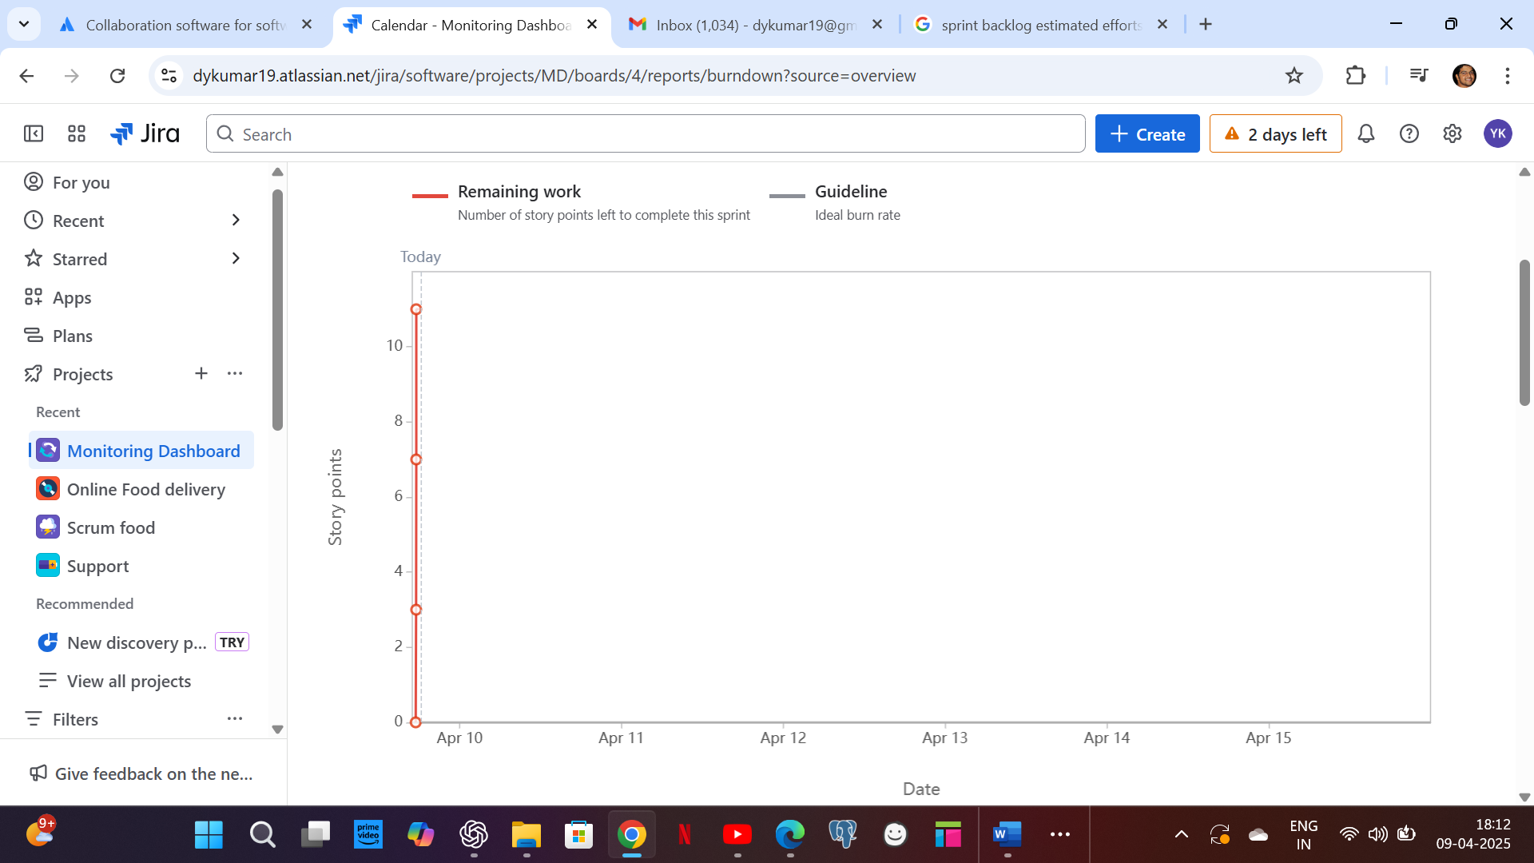

Product burndown chart: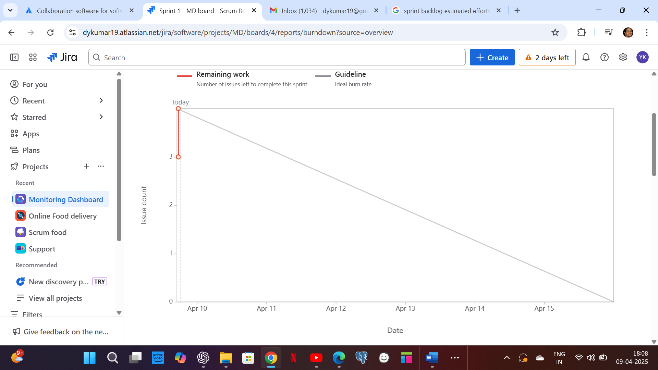

**Document 6: Sprint meetings**

**Observers**

|  |  |
| --- | --- |
| **Date** | 9-04-2025 |
| **Time** | 14:00 |
| **Location** | ICICI Towers |
| **Prepared by** | **Yashwanth** |
| **Attendees** | **Mohan, Yashwanth, Raj, Ravi, Rehman, Ravindra, Ajay** |

**Agenda Topics**

|  |  |  |
| --- | --- | --- |
| **TOPIC** | **Presenter** | **Time allotted** |
| Backlog items identification for upcoming sprint. | Yashwanth | 4 hrs |
| Assigning user stories to respective developers | Yashwanth | 3 hrs |

**Other Information**

|  |  |
| --- | --- |
| **Observers** | Raj, Ravi, Ajay. |
| **Resources** | Mohan, Yashwanth, Raj, Ravi, Rehman, Ravindra, Ajay |
| **Special Notes** | Considered sprint duration including public holidays and velocity of sprint has decided as 10 story points. |

**Meeting Type 2: Sprint review meeting**

|  |  |
| --- | --- |
| **Date** | 10-04-2025 |
| **Time** | 11:00 |
| **Location** | ICICI Towers |
| **Prepared by** | **Yashwanth** |
| **Attendees** | **Mohan, Yashwanth, Raj, Ravi, Rehman, Ravindra, Ajay** |

|  |  |  |  |
| --- | --- | --- | --- |
| **Sprint status** | **Things to demo** | **Quick updates** | **What’s next** |
| Completed with all assigned user stories | Ready to show demo for the role specific access dashboard. | Application can go live in this sprint with MVP. | UAT to conduct and take signoff for the current sprint. |

**Meeting Type 3: Sprint retrospective meeting**

|  |  |
| --- | --- |
| **Date** | 10-04-2025 |
| **Time** | 14:00 |
| **Location** | ICICI Towers |
| **Prepared by** | **Yashwanth** |
| **Attendees** | **Mohan, Yashwanth, Raj, Ravi, Rehman, Ravindra, Ajay** |

|  |  |  |  |  |
| --- | --- | --- | --- | --- |
| **Agenda** | **What went well** | **What didn’t go well** | **Questions** | **Reference** |
| To retrospect the previous sprint | Dashboard design has done with attractive and user friendly pages. | Data retrieval from different sources has faced a bit challenging. | How to handle any unexcepted situations with short timelines. | Scrum master inputs to consider for further planning |

**Meeting Type 4: Daily Stand-up meeting**

|  |  |  |  |  |  |  |
| --- | --- | --- | --- | --- | --- | --- |
| **Question** | **Name** | **Week 1(9-4-25 to 15-4-25)** | | | | |
|  |  | **Mon** | **Tue** | **Wed** | **Thu** | **Fri** |
| **What did you do yesterday?** | **Raj** | User story 1 – Story points 1 | User story 1 – story point 2 | User story 1 – story point 3 | User story 5 – story point 1 | User story 5 – story point 2 |
| **Ravi** | User story 2 – Story points 1 | User story 2 – story point 2 | User story 2 – story point 3 | User story 6 – story point 1 | User story 6 – story point 2 |
| **Rehman** | User story 3 – Story points 1 | User story 3 – story point 2 | User story 3 – story point 3 | User story 7 – story point 1 | User story 7 – story point 2 |
| **Ravindra** | User story 4– Story points 1 | User story 4 – story point 2 | User story 4 – story point 3 | User story 8 – story point 1 | User story 8 – story point 2 |
| **What will you do today?** | **Raj** | User story 1 – story point 2 | User story 1 – story point 3 | User story 5 – story point 1 | User story 5 – story point 2 | User story 5 – story point 3 |
| **Ravi** | User story 2 – story point 2 | User story 2 – story point 3 | User story 6 – story point 1 | User story 6 – story point 2 | User story 6 – story point 3 |
| **Rehman** | User story 3 – story point 2 | User story 3 – story point 3 | User story 7 – story point 1 | User story 7 – story point 2 | User story 7 – story point 3 |
| **Ravindra** | User story 4 – story point 2 | User story 4 – story point 3 | User story 8 – story point 1 | User story 8 – story point 2 | User story 8 – story point 3 |
| **What (if any) is blocking your progress?** | **Raj** | Identification of customer pain point is not clear. | NA | NA | NA | Integrating with existing system |
| **Ravi** | Design to confirm from customer | NA | NA | NA | NA |
| **Rehman** | Which role to be provided admin access. | To Check with client about req clarity | NA | NA | NA |
| **Ravindra** | NA | NA | NA | NA | NA |