**Question 1 - Functional Requirements - 15 Marks**  
  
Functional requirements define the specific behaviors, functions, or operations of a system. They describe what the system should do, outlining the necessary tasks, actions, or activities it must perform to achieve its objectives.  
  
These below are the functional requirements which cover various aspects of the online agriculture store, including user registration, product recommendation, shopping cart, manufacturer registration, wish list etc.  
  
Functional requirement: -  
  
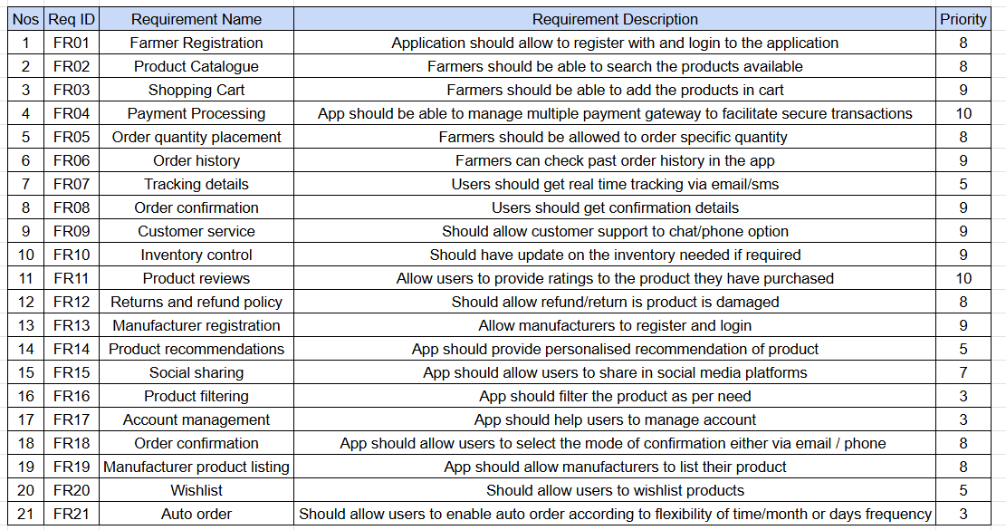  
  
Non Functional requirement: -  
  
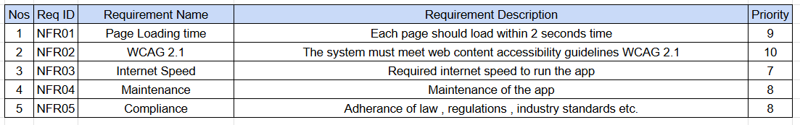  
  
  
  
**Question 2 - Minimum 5 page designs - 15 Marks**

Creating 5-page designs for reference to online agricultural store.  
  
1. Login page  
2. Search page  
3. Add to cart page  
4. Payment page  
5. Logout page  
  
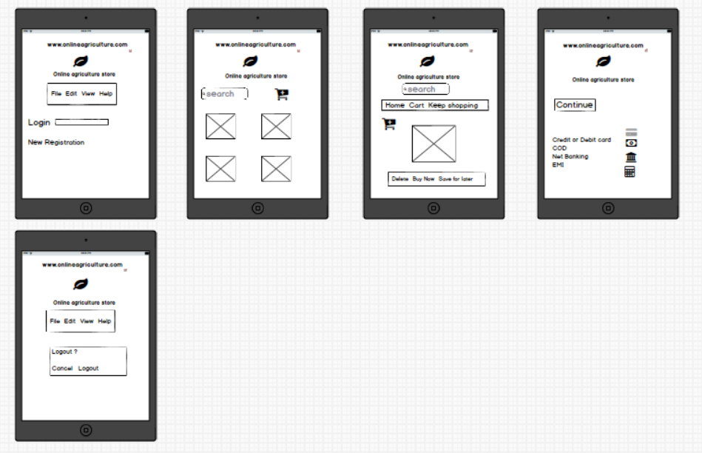  
  
  
 **Question 3 - Tools (Visio, Balsamiq) - 15 Marks**MS Visio – MS Visio is a diagramming and vector graphics application used to create diagrams, flowcharts, and other visual representations of complex information.  
  
Balsamiq – Balsamiq is a rapid wire framing tool used to create mockups and prototypes of user interfaces.  
  
Axure – Axure is a more advanced prototyping tool used to create high-fidelity, interactive wireframes and prototypes for web and mobile applications.  
  
  
*Wireframes are basic skeletal outline of a design // Mockups are more detailed visual representation with colors// Prototypes will allow users to interact with the interface and experience its functionality.   
  
  
**Question 4 - RTM - 6 Marks**It is a document to track the requirements throughout the project lifecycle, ensuring that they are met and no requirements are overlooked.  
  
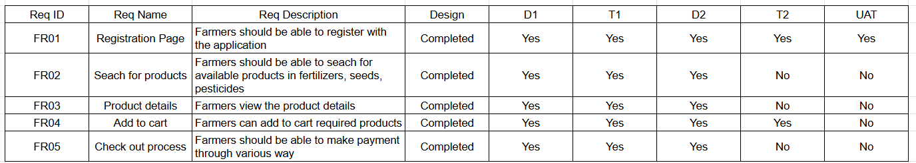  
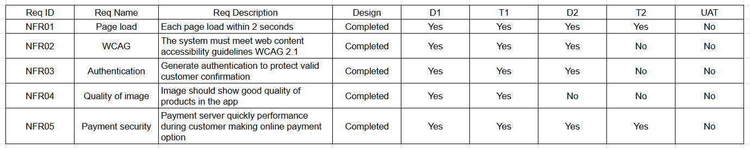  
  
 **Question 5 - 10 Test Case Documents - 10 Marks**A test case document is a detailed outline used by testers to ensure that a software application or system is working as expected.  
  
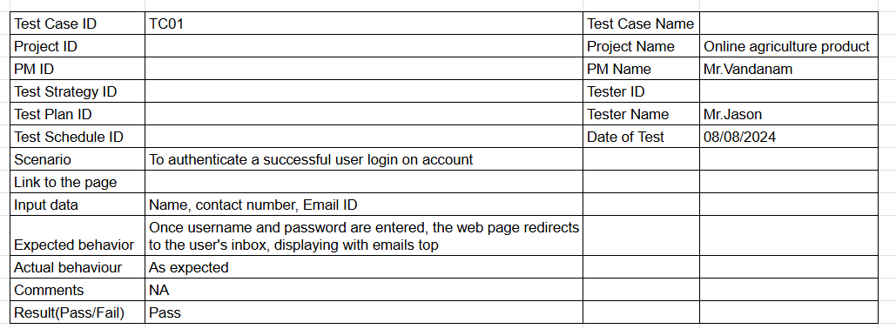  
  
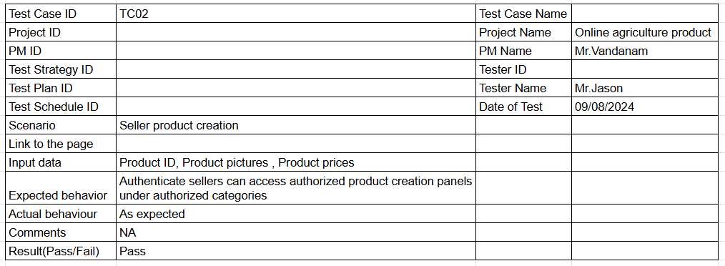  
  
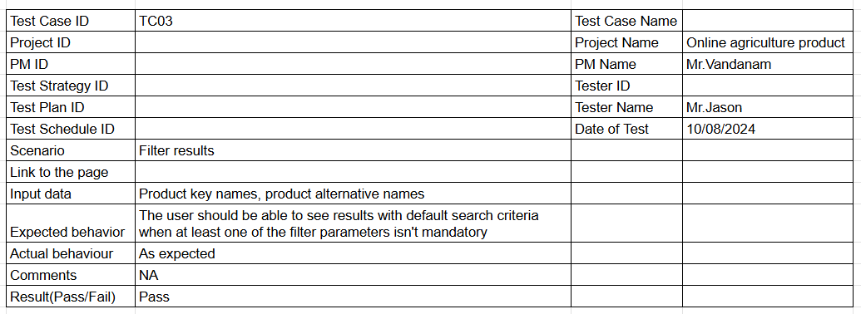  
  
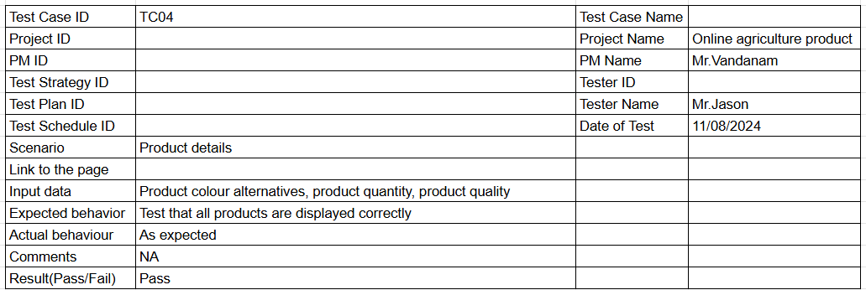  
  
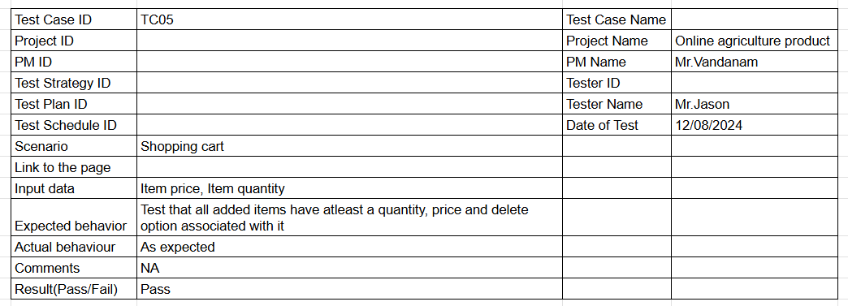  
  
  
  
  
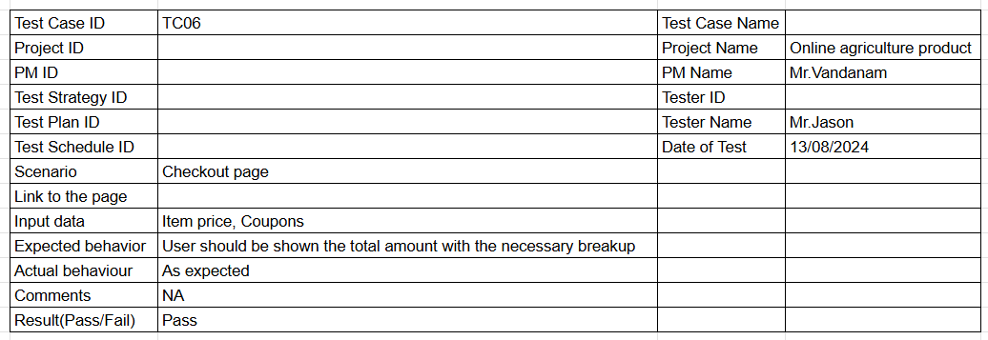  
  
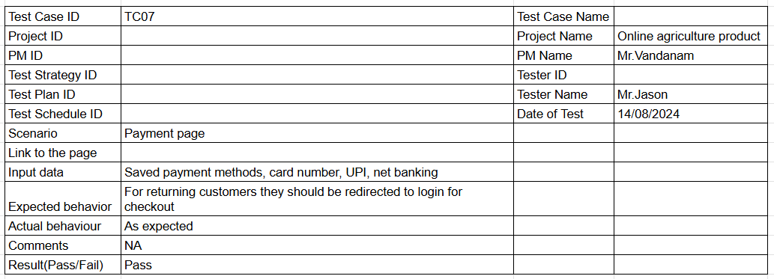  
  
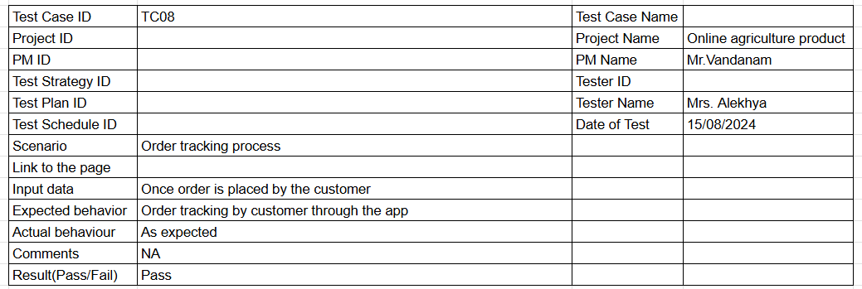  
  
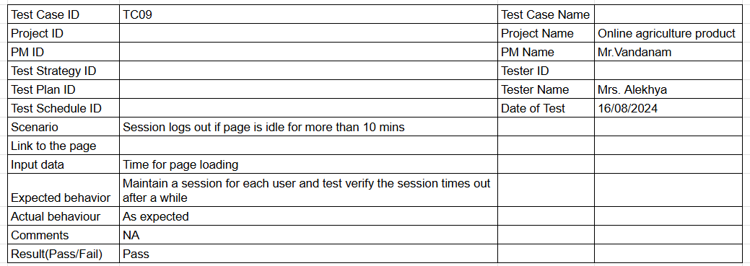  
  
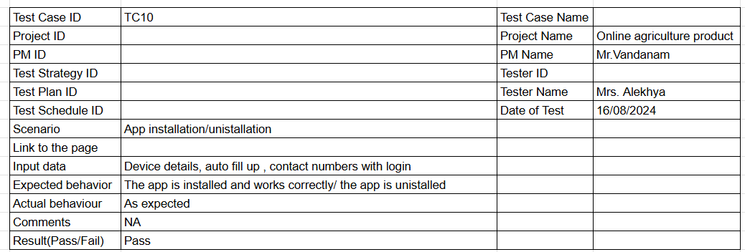  
  
  
  
**Question 6 – DB Design – 8 Marks**DB Schema is a blueprint that outlines the structure of a database, including its tables, fields, relationships, constraints, and other characteristics.  
  
An Entity-Relationship Diagram (ERD) is a visual representation of the relationships between entities in a database. It depicts the entities (such as tables), attributes (properties), and relationships between them.

|  |  |
| --- | --- |
| Products | |
|  |  |
| ­­­Varchar  Varchar  Varchar  Decimal  Datetime  Datetime | Name  Category  Description  Price  Created AT  Updated AT |

|  |  |
| --- | --- |
| User | |
|  |  |
| Int  Varchar  Varchar  Varchar  Datetime  Datetime | User ID  Name  Password  Email  Created AT  Updated AT |

|  |  |
| --- | --- |
| Coupon | |
|  |  |
| Int  Varchar  Decimal  Datetime  Datetime | Coupon ID  Code  Discount  Created AT  Updated AT |

|  |  |
| --- | --- |
| Orders | |
|  |  |
| Int  Int  Int  Int  Date | Order ID  User ID  Product ID  Quantity  Order Date |

|  |  |
| --- | --- |
| Cart | |
|  |  |
| Int  Int  Int  Int  Datetime | Cart ID  User ID  Product ID  Quantity  Added AT |

|  |  |
| --- | --- |
| Address | |
|  |  |
| Int  Int  Varchar Varchar  Datetime  Datetime | Address ID  User ID  Street/Zipcode  City/State/Country Created AT Updated AT |

**Question 7 – Data Flow Diagram - 3 Marks**A data flow diagram is the graphical representation of the flow of data through an information system. It visualizes the process, data stores and external entities that interact to produce or consume data.  
  
  
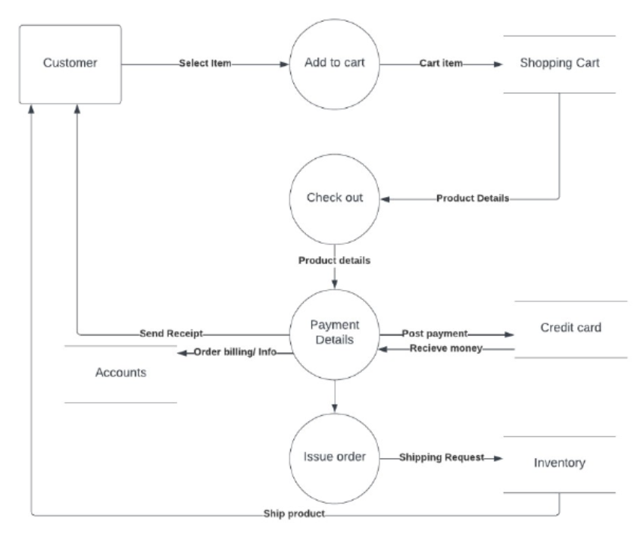  
  
  
 **Question 8** **– Change Request - 10 Marks**A change request is a formal proposal to alter a system, product or project.   
  
** The reason/business justification for the charge  
  
** Why the change is needed – giving detailed information on implications of not implementing the change – i.e. . Security   
risks, Government taxation, compliances etc.  
  
** Impact to the business of implementing the change – consideration should also be given to the risks and impact to the business of not implementing the change.  
  
** Required resources – including people, time and investment/costs.  
  
A change request is a vital tool in business analysis and change management. It provides a structured way for stakeholders to request changes, ensures that changes are reviewed and approved before they are implemented, and helps maintain project stability. By understanding the concept of a change request and its process, business analysts can better manage and control changes, leading to more successful projects.   
  
  
**Question 9 – Change Request Vs an Enhancement - 5 Marks**  
  
A change request is a formal proposal for an alteration to some product or system. In project management, a change request often arises when the client wants an addition or alteration to the agreed-upon deliverables for a project. Such a change may involve an additional feature or customization or an extension of service, among other things.  
  
  
  
An enhancement project is one in which new capabilities are added to an existing system. Enhancement projects might also involve correcting defects, adding new reports, and modifying functionality to comply with revised business rules or needs.  
  
So, this is an enhancement in the project.  
  
  
 **Question 10 – Estimations - 6 Marks**As per the case study, the duration of the project is 18 months and the current team size is around 15. This will come under medium project as the trained resources are available, trainers are not required. Hence, the required man hours will be 15 * 72 (no of weeks) * 30 (hrs. per week) = 21600 hrs /-  
  
  
**Question 11 –** **UAT – 6 Marks**Project has finally completed all the stages i.e. Design, development, testing etc. Now, it the role of a BA to contact the client for testing of the final product and have to successfully complete it.   
  
  
Planning: Blueprints are made to implement UAT testing for every feature that needs to test and minimum standards for accepting the test.  
  
Designing: Test cases are designed to hide all possibilities of software packages in a real world environment.  
  
UAT Testers: A testing team consists of an end user that meet the criteria for the implementation testing.  
  
Bug Fixing: The development team works on bugs that are found during UAT testing to make software error free.  
  
Sign Off: After removing all the bugs, the testing team indicates acceptance of the completion of the bugs. In this phase, all the stakeholders conclude that the software is ready to go live and sign it off.   
  
  
  
**Question 12 –** **Project Closure Document - 6 Marks**  
