Q1: 4 Quarterly Audits are planned for Q1, Q2, Q3, and Q4 for this Project What is your knowledge on how these Audits will happen for a BA?

A: internal audit checks how well a company maintains operational efficiency and manages accounting processes while complying with its standard rules and regulations conducting audits from time to time ensures the firms are strict enough to follow the administrative fundamentals and stick to a maximum accuracy rate so far as financial reporting is concerned

* Business analyst internal audits will go through the
* Whether the project is going with the company objective or not
* Whether the process is followed properly by BA or not
* Process of project improvements are being followed

|  |  |
| --- | --- |
| stage | Requirement Gathering stage |
| status | Success (week 1 to 5)-5 weeks |
| checklist | Elicitation report, BRD copy, Features client signoffs, communication via email to cc and BC |

|  |  |
| --- | --- |
| stage | Requirement analysis stage |
| status | Success (week 6to 16)-10weeks |
| checklist | UML diagrams, client signoff documents, Business-to-functional requirements mapping, RTM documents, Email communication CC, and BC |

|  |  |
| --- | --- |
| stage | Design phase stage |
| status | Success (week 17-37)-20 weeks |
| checklist | Use of Tools, stakeholder collaborations, check with Technical feasibility, Client communication documented evidence, Risk assessment, and email communication CC and BC. |

|  |  |
| --- | --- |
| stage | Development stage |
| status | Week( 38 to 63)-25 weeks |
| checklist | Coding, Functional implementation, code document, security considerations, document of code change and updates |

|  |  |
| --- | --- |
| stage | Testing phase |
| status | success |
| checklist | Review and validate test requirements, execute test cases and maintain test logs, collaborate with stakeholders for UAT and testing, Generate test reports, prepare defect summary, and document lessons learned. |

Q2: Before the Project is going to Kick Start, The Committee asked Mr. Karthik to submit the BA Approach Strategy

Write BA Approach strategy (As a business analyst, what are the steps that you would need to follow to complete a project – What Elicitation Techniques to apply, how to do Stakeholder Analysis RACI/ILS, What Documents to Write, What process to follow to Sign off on the Documents, How to take Approvals from the Client, What Communication Channels to establish n implement, How to Handle Change Requests, How to update the progress of the project to the Stakeholders, How to take signoff on the UAT- Client Project Acceptance Form )

A: Our team Project Manager - Mr. Vandanam Senior Java Developer - Ms. Juhi Java Developers - Mr. Teyson, Ms. Lucie, Mr. Tucker, Mr. Bravo Network Admin - Mr Mike DB Admin - Mr John. Testers - Mr. Jason and Ms. Alekya BA – Your technical Team has assembled to discuss the Project approach and has finalized follow 3-tier architecture for this project

* **Elicitation Techniques**: I would employ various methods such as interviews, workshops, surveys, observations, and prototyping to gather and analyze requirements from stakeholders
* **Stakeholder Analysis**: I would perform stakeholder analysis to identify and prioritize stakeholders based on their interest, involvement, and influence in the project.
* **RACI/ILS**: I would develop a RACI/ILS matrix to clearly define stakeholder roles and responsibilities, track issues, and ensure timely resolution.
* **Documentation**: I would create key documents including requirements specifications, functional and non-functional requirements, use cases, process flows, wireframes, and the test plan to communicate requirements to the development team.
* **Document Sign-Off Process**: I would establish a formal review and sign-off process, involving the development team, stakeholders, and project sponsors.
* **Client Approvals**: I would seek client approvals at each project phase to ensure their requirements are met and avoid last-minute surprises.
* **Communication Channels**: I would set up communication channels such as email, instant messaging, or project management tools to inform stakeholders about project progress and any changes.
* **Change Requests**: I would implement a change management plan to document, track, prioritize, and gain approval for any change requests before implementing them.
* **Progress Updates**: I would provide regular progress updates to stakeholders through reports, presentations, or status meetings, keeping them informed of the project status, risks, and issues
* **UAT Sign-Off**: I would create a UAT plan and test cases, ensuring the client signs off on the UAT and project acceptance form before deployment.

Q3: Explain and illustrate 3-tier architecture.

A: A three-tier architecture is a client-server software design pattern in which the application is divided into three interconnected layers, each responsible for a specific aspect of the application's functionality. The layers are:

**Presentation Tier:** The user interface layer lets users view and enter data into the system using web, mobile, or desktop applications.

**Application Tier:** The Application Tier is the middle layer that manages business logic, processes user input from the presentation tier, and communicates with the data tier to retrieve or update data.

**Data Tier:** The Data Tier is the bottom layer responsible for managing and storing data in databases, and for handling data retrieval and updates requested by the application tier.

Q4: Business Analysts should keep what points in their minds before they frame a Question to ask the Stakeholders.

(5W 1H – SMART – RACI – 3 Tier Architecture – Use Cases, Use case Specs, Activity Diagrams, Models, Page designs)

A: step1: Before going to frame some Questions we should take 5W1H

* What is the product
* What this project is initiated
* Who is getting benefits from this project
* Where the requirements are spotted
* When will the project be initiated
* How we should be doing this project

Step2: we should check whether the requirements collected are being SMART or not

S-specific

M-Measurable

A-Attenable

R- Realistic

T- Timebound

Step3: While preparing the question we need to figure out who comes under which category so we use the RACI matrix which is

* R-Responsible
* A-Accountable
* C-Consultant
* informed

Step4: Then we will prepare the 3tier architecture under 3 different categories

* Application layer
* Data layer
* Business layer

Step5: Then we will identify the use cases is prepare to know how the external system is interacting with the system

5Q) As a Business Analyst, What Elicitation Techniques are you aware of? (BDRFOWJIPQU)

A:

* **Brainstorming**: This technique generates ideas and gathers input from stakeholders. It encourages creative thinking to explore solutions or identify requirements.
* **Document Analysis**: Review existing documents such as business plans process flows and user manuals to extract relevant information and identify the gaps and areas for improvements.
* **Requirements Workshops**: Conduct group sessions with stakeholders to gather requirements clarify doubts resolve problems and ensure collaboration between the team.
* **Interviews**: one-on-one or group discussions with stakeholders to gather detailed information about their perspectives and uncover specific requirements.
* **Focus Groups**: gathering a selected group of stakeholders to discuss specific topics or areas of interest The group dynamics encourage interaction and exchange the ideas by providing valuable insights.
* **Observation**: Actively observing stakeholder's work environment processes and activities to gain a deep understanding of their needs challenges and workflows
* **Prototyping**: Creating a visual presentation or interactive model of the proposed solutions to gather feedback validate requirements and facilitate stakeholder understanding.
* **Questionnaires and surveys**: Disturbing structured questions or surveys to stakeholders to gather qualitative and quantitative data and opinions on specific topics or requirements.
* **Use cases**: Describing interactions between actors(users) and the system to illustrate how the system behaves and what actions should it support

6Q) Which Elicitation Techniques can be used in this Project and Justify your selection of Elicitation Techniques?

A: Based on the given project-based scenario these are the following elicitation techniques will be used:

**Prototyping:** It can be utilized to gather feedback and validate the requirements for the online product store As the application needs to be user-friendly. Creating a prototype can help visualize the user interface and functionalities It allows stakeholders including Mr henry Frind and other potential users to provide feedback on the proposed solution and make necessary changes before development.

**Use case specs:** Use case specialization can be employed to capture the interactions and sequences of actions between the various actors (Farmers and manufacturers and the online store)and the system being developed by documenting use cases the project team can identify the specific functionalities and requirements needs to facilitate the communication and transactions between farmers and manufactures the use case will provide a structured approach to elicit validate and prioritize the requirements for the online store.

**Document analysis:** The document analysis can be useful for understanding the existing challenges faced by the farmers and the inquiries expressed by MR henry's friends Analyzing any available documentation such as reports on agricultural issues framing practices or market research can provide insights into the specific problems related to procuring fertilizers seeds and pesticides it helps in identifying the key points and requirements that the online store can be addressed

**Brainstorming**: It is a session conducted with the stakeholders including Mr henry, Peter Kevin, and Ben to gather their perspectives and insights The session can focus on discussing the challenges faced by the farmer's potential features and functionalities of the online store and any additional requirements that may arise during the discussion Brain storm encourage collaboration and creativity allowing for the exploration of innocence solutions and capturing comprehensive requirements.

**Justification:**

By these elicitation techniques the project team will gather a wide range of requirements validate them through feedback and discussions and make sure that the online agricultural store addresses the needs of the farmers.

Fertilizers, seeds, and pesticides are details from the manufacturers and should be able to display them to the Farmers. To gather the business requirements from the client, you went to SOONY and met Mr. Henry. When Mr. Henry was asked about the project and what they expecting from the project, Mr. Henry stated that he hoped to have a login for all its users (fertilizers, seeds, pesticide manufacturers, and Farmers), a product catalog of fertilizers, seeds, pesticides, a search option to search for products, payment process, and delivery tracking. After doing the stakeholder analysis, you discovered that Peter, Kevin, and Ben are the key stakeholders and you have scheduled an appointment to meet them. After meeting with them and trying to gather the stakeholder requirements, Kevin said that a Farmer should be able to browse through the product catalog once they visit the website and need to have a search option so that they can search for any product they need. Peter said that, if a farmer wants to buy any product or add them to the buy-later list, they need to log in first using their email ID and password. If it is a new user, then they can create a new account by submitting their email ID and creating a secure password. Ben added that Farmers need to have an easy-to-use payment gateway which should include cash-on-delivery (COD), Credit/Debit card, and UPI options so that the user’s experience is better. Kevin mentioned that a user gets an email confirmation regarding their order status. A delivery tracker to track the whereabouts of their order.

**Business Requirements**

**BR001 – Product Search and Catalog:**

* **Farmers** should be able to browse through a catalog of products, including fertilizers, seeds, and pesticides, on the website.
* **Farmers** should have a search functionality to find specific products in the catalog.

**BR002 – User Authentication and Account Management:**

* **Farmers** must log in using their email ID and password to make purchases or add products to a buy-later list.
* **New users** (Farmers) should be able to create an account by submitting their email ID and creating a secure password.

**Stakeholder Requirements**

**Kevin’s Requirements:**

* **KR001:** Farmers need to browse the product catalog and use the search option to find products easily.

**Peter’s Requirements:**

* **KR002:** Farmers must log in to their accounts to buy products or add them to a buy-later list. New users should be able to create an account by submitting their email ID and setting a password.

7Q) Make suitable Assumptions and identify at least 10 Business Requirements

A: Assumptions:

- E-commerce platform for farmers to buy fertilizers, seeds, and pesticides.

- Product catalog with search functionality.

- Login system for farmers, manufacturers, and vendors.

- Account creation for new users with email and secure password.

- Payment options: COD, credit/debit cards, and UPI.

- Email confirmations for order status and delivery tracking.

- User-friendly interface for easy navigation and better user experience.

Business requirements:

* **BR001:** Product catalog with all fertilizers, seeds, and pesticides from various manufacturers and vendors.
* **BR002:** Search functionality for products by name, category, and brand.
* **BR003:** Login feature for farmers, manufacturers, and vendors.
* **BR004:** Account creation for new users via email and secure password.
* **BR005:** User-friendly interface with easy navigation.
* **BR006:** Payment gateway supporting COD, credit/debit cards, and UPI.
* **BR007:** Email confirmations for order status.
* **BR008:** Delivery tracking system for order whereabouts.
* **BR009:** Scalable platform for future growth and expansion.
* **BR010:** Secure infrastructure to protect user data and prevent breaches.

8Q) List your assumptions.

A:

* E-commerce platform for farmers to buy fertilizers, seeds, and pesticides.
* Product catalog with search functionality for items.
* Login system for farmers, manufacturers, and vendors; account creation with email and secure password.
* Payment options: COD, credit/debit cards, and UPI.
* Email confirmations for order status and delivery tracking.
* User-friendly interface with easy navigation.
* Secure infrastructure to protect user data and prevent breaches.

9Q) Give Priority 1 to 10 numbers (1 being low priority – 10 being high priority) to these Requirements after discussions with the stakeholders

A:

|  |  |  |  |
| --- | --- | --- | --- |
| Req ID | Req name | Req details | priority |
| **BR001** | Product Catalog | Product catalog with all fertilizers, seeds, and pesticides from various manufacturers and vendors. | 10 |
| BR002 | Search option | Search functionality for products by name, category, and brand. | 10 |
| BR003 | login | Login feature for farmers, manufacturers, and vendors. | 8 |
| BR004 | Account creating | Account creation for new users via email and secure password | 9 |
| BR005 | User interface | User-friendly interface with easy navigation | 8 |
| BR006 | payments | Payment gateway supporting COD, credit/debit cards, and UPI | 10 |
| BR007 | Order Status | Email confirmations for order status. | 10 |
| BR008 | Delivery status | Delivery tracking system for order whereabouts. | 9 |
| BR009 | Future growth | Scalable platform for future growth and expansion. | 5 |
| BR010 | security | Secure infrastructure to protect user data and prevent breaches | 3 |

10Q) Draw a use case diagram

A: 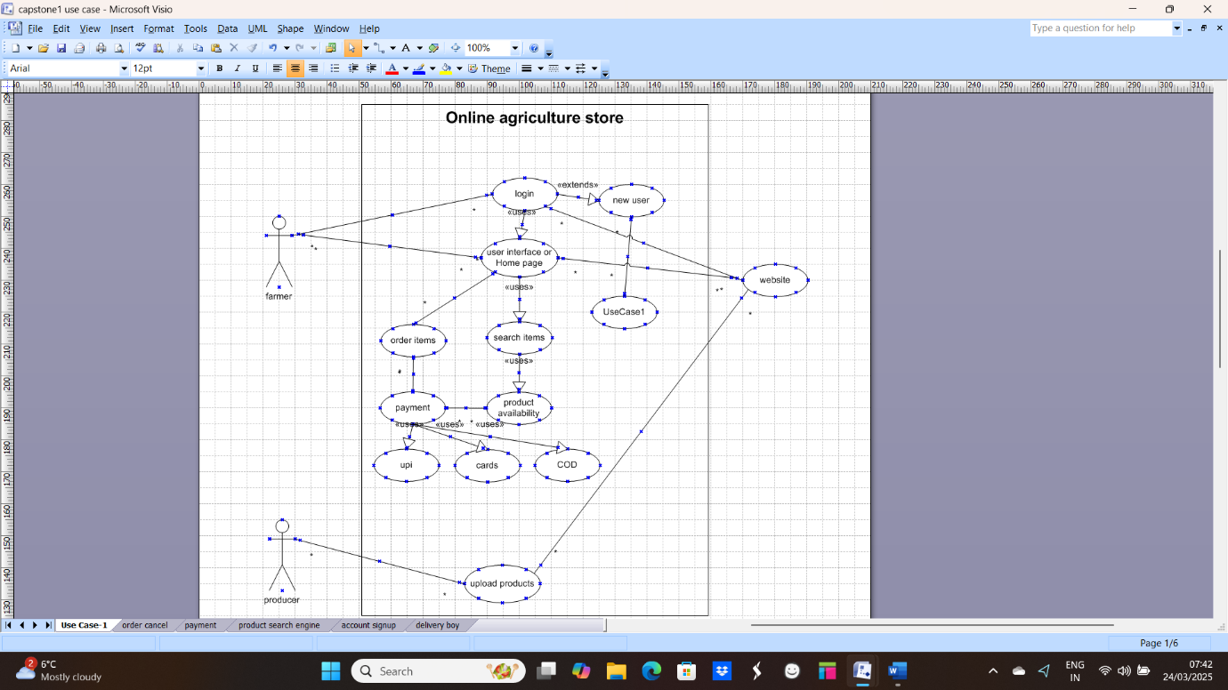

11Q) Prepare use case specs for all use cases

A: 1. **Login Use Case Specification**

* **Use Case**: Login
* **Description**: Input username and password to access the system.

**Actors:**

* Farmers
* Website

**Preconditions:**

* Active internet connection
* Browser compatibility (minimum 2 supported browsers)

**Postconditions:**

* Home page is displayed after successful login

**Basic Flow:**

1. The user enters the correct username and password.
2. System validates credentials.
3. The home page is displayed.

**Alternate Flows:**

1. Incorrect password:

The error message is displayed: "Incorrect password."

1. Incorrect username:

The error message is displayed: "Username not found."

1. Both username and password are incorrect:

The error message is displayed: "Invalid login credentials."

**Exceptional Flows:**

1. Forgot password:

The user selects "Forgot Password" and follows recovery steps.

1. Forgot Username:

The user selects "Forgot Username" and follows recovery steps.

**Assumptions:**

* Users have basic computer literacy.
* Users understand English.

**Constraints:**

* Usernames cannot contain special characters.

**Dependencies:**

* The user must be registered in the system.

**Inputs:**

* Username
* Password

**Outputs:**

* Status flag (success or failure)
* Error code (if applicable)

**Business Rules:**

* The username must be a valid email address.
* Password must include at least one special character.

Here’s a refined version of the three additional use case specifications in points:

Here’s the refined version of the two additional use case specifications in points:

**2)Add Products to Cart Use Case Specification**

Use Case: Add Products to Cart

Description: Adding two products to the shopping cart.

Dependencies:

The selected products should be available with the company.

Inputs:

- Chosen products to be added to the cart.

Constraints:

- Product availability must be confirmed before adding to the cart.

Outputs:

- The order progresses to the payment site.

Business Rules:

- Only Visa and Maestro cards are accepted for payment.

Missing Information:

- Design details for a visually appealing payment page.

**3)New User Registration Use Case Specification**

Use Case: New User Registration

Description: Register a new user and verify email via OTP.

Actors:

- Farmers

- Website

Preconditions:

- Active internet connection.

-The user has a Gmail account.

Postconditions:

- Users can register and log in to the website.

Basic Flow:

1. OTP verification is done via mobile.

2. Gmail verification is completed successfully.

Alternate Flows:

1. OTP is not sent to the mobile number.

2. Verification email is not sent to the Gmail account.

3. Neither OTP nor verification email is received.

Exceptional Flows:

1. A Gmail account does not exist.

2. The mobile number is out of service.

Assumptions:

- Users have basic knowledge of using mobile phones and Gmail.

- Users have a valid Gmail account.

Constraints:

- Both mobile number and Gmail must be verified to complete registration.

Dependencies:

- The user must have a Gmail account and a valid mobile number linked to it.

Inputs:

- OTP (One-Time Password)

- Gmail account details.

Outputs:

- Registration is completed, and the user can log in to the website

**4. Upload Products Use Case Specification**

Use Case: Upload Products

Description: Track items and refill stock.

Actors:

- Manufacturers

- Website

**Preconditions:**

- Stock replenishment data is generated.

- Easy control of website functionality for manufacturers.

**Postconditions:**

- Stock is available at all times for demanded products.

**Basic Flow:**

1. Stock information is provided correctly.

2. System updates stock levels.

**Alternate Flow:**

Stock information is not provided correctly:

- Error message: "Stock information incorrect."

Exceptional Flows:

1. The system takes too much time to show stock data.

2. No control over stock data displayed.

**Assumptions:**

- Manufacturers receive notifications about product stock levels.

**Constraints:**

- Stock cannot be refilled for just one product.

**Dependencies:**

- Stock is replenished if an order is placed.

Inputs:

- Refill signal sent to the manufacturer.

Outputs:

- Product availability status (available or not available).

Business Rules:

- New stock arrives only after the old stock is depleted.

Missing Information:

- Interactive design and browser compatibility details.

**5. Make Payment Use Case Specification**

Use Case: Make Payment

Description: Input card details and select payment options.

Actors:

- Farmers

- Website

Preconditions:

- Item must be present in the cart.

Postconditions:

- Farmer can make a payment via UPI, card, or cash on delivery (COD).

**Basic Flow:**

1. User initiates payment and completes the process successfully.

Alternate Flow:

1. Unable to make payment:

- Error message: "Payment failed."

Exceptional Flows:

1. The card is blocked.

2. UPI is not registered.

Assumptions:

- Users have basic knowledge of using cards and making UPI payments.

Constraints:

- Payments cannot be made using Google Pay (GPay).

Dependencies:

- Orders must be present in the cart.

Inputs:

- Card details or UPI information.

Outputs:

- Payment gateway success page or error page.

Business Rules:

- Card must be either VISA or Maestro.

Missing Information:

- Interactive design and browser compatibility details.

12Q) Activity diagrams

**A**

**1. Payment Diagram**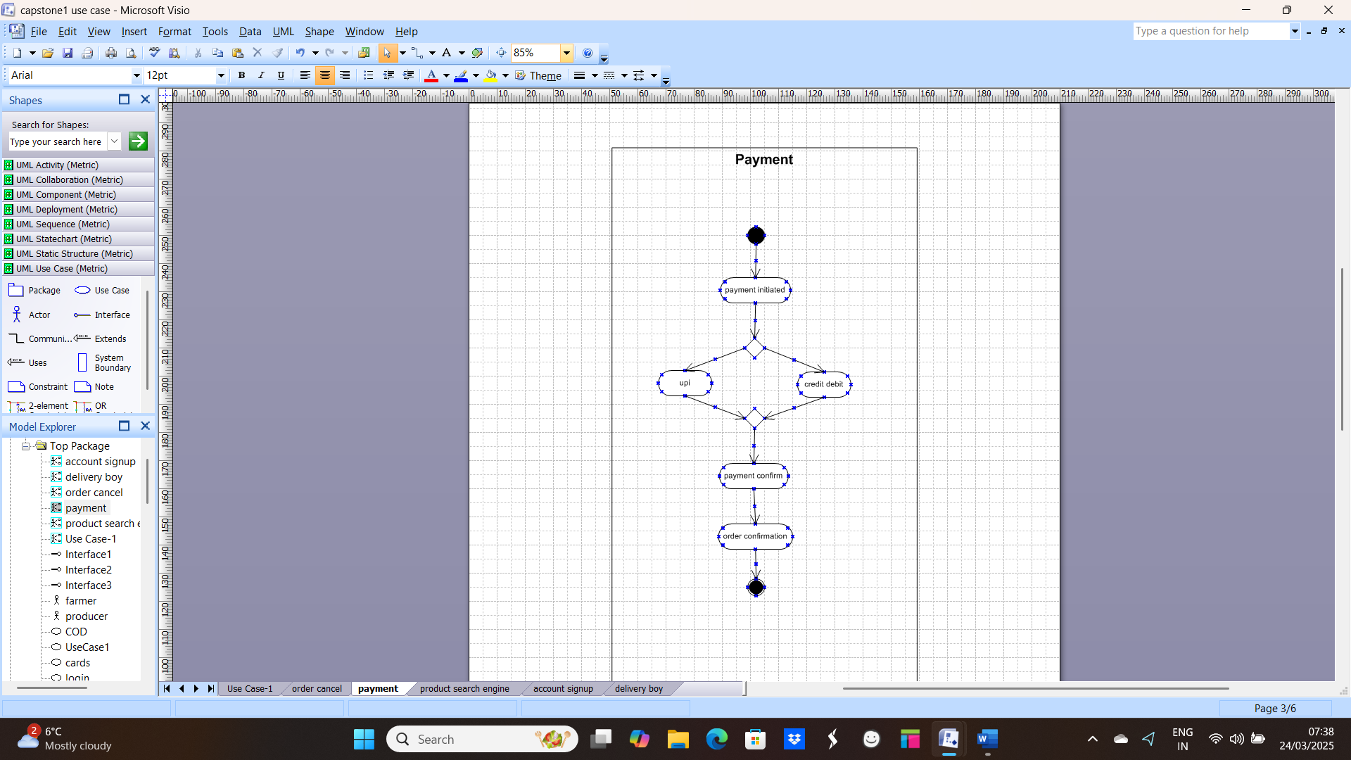

**2. cancel ordered Item**

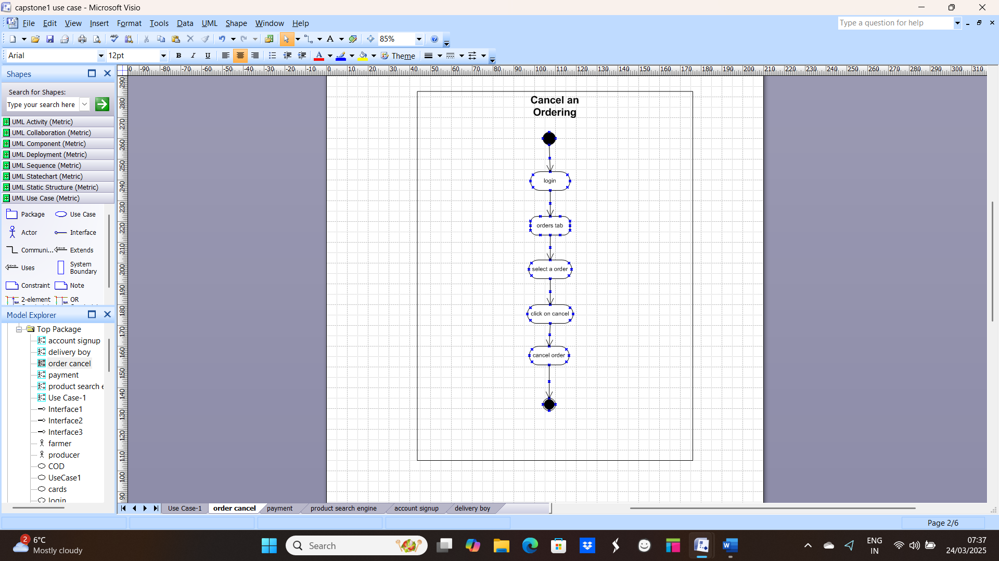

1. **Product search**

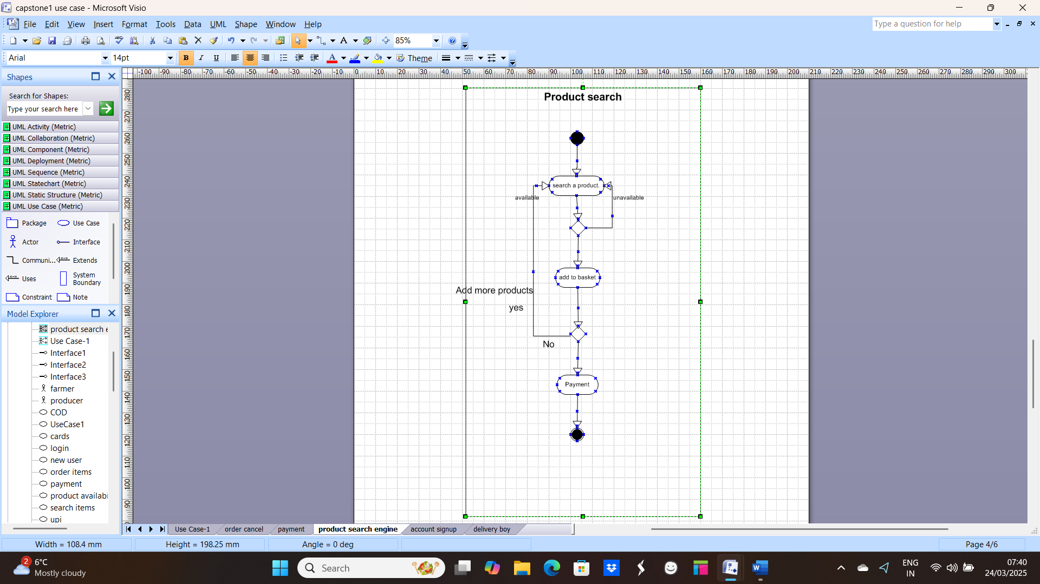

**4. Account signup**

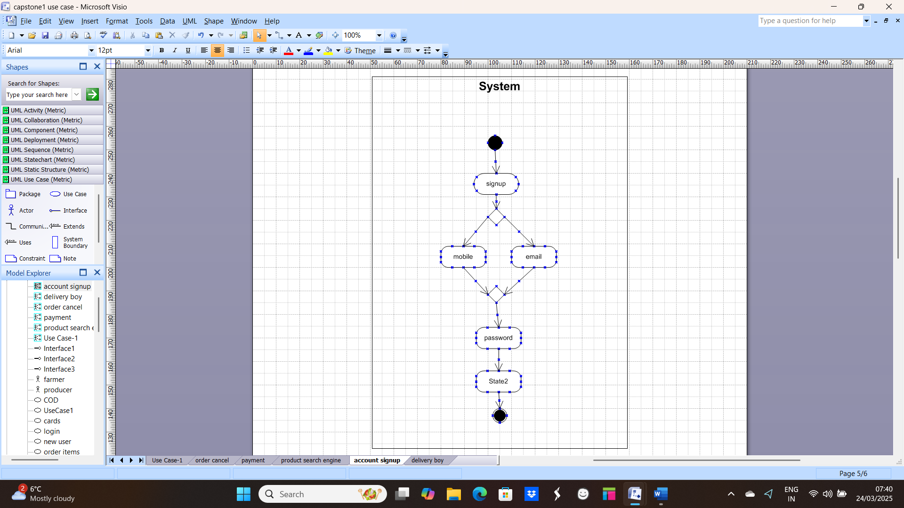

**5. Delivery Boy**

