**Document 6- Please prepare a use case diagram, activity diagram and a use case specification document.**

1. **Use Case Diagram**





1. **Activity Diagrams**
2. Employee Log in
3. Leave management- Employee applied for leave
4. Download desired month salary slips
5. Leave approval / Not approval notification
6. HR team will close position through HRMS system (Recruitment management – HR Admin)
7. Payroll Process – HR Admin



**Leave Management – Applied for leave**



**Downloading desired month Salary Slips** 

**Leaves Approved Notification**



**Recruitment Management for HR Admin**



**Payroll Process HR Admin**



**Use Case Documents**

|  |  |  |  |  |  |  |  |  |  |  |  |  |  |  |
| --- | --- | --- | --- | --- | --- | --- | --- | --- | --- | --- | --- | --- | --- | --- |
|  |  |  |  |  |  |  |  |  |  |  |  |  |  |  |
| **User ID** | UC001 | | | | | | | | | |  |  |  |  |
| **Use Case name** | **Log In for exist users** | | | | | | | | | |  |  |  |  |
| **Created by** | Ms. Anayta Nikam | | | | | **Last updated by** | | | Feb 1st 2025 | |  |  |  |  |
| **Date created** | February 24th 2023 | | | | | **Last Revision Date** | | | Feb 4th 2025 | |  |  |  |  |
| **Actor** | Employee | | | | | | | | | |  |  |  |  |
| **Description** | This use case describes how User can Log In | | | | | | | | | |  |  |  |  |
| **Pre Condition** | User should have been registered into the application | | | | | | | | | |  |  |  |  |
| **Post Condition** | User successfully able to login the account. | | | | | | | | | |  |  |  |  |
| User successfully able to login the account after re entre new password | | | | | | | | | |  |  |  |  |
| **Normal flow Event/ Basic flow/ Happy path** | User will click on application | | | | | | | | | |  |  |  |  |
| Application will ask for User ID and Password | | | | | | | | | |  |  |  |  |
| User enter UserID and password | | | | | | | | | |  |  |  |  |
| User is authenticated and successfully logged In | | | | | | | | | |  |  |  |  |
| **Alternative flow** | User will click on application | | | | | | | | | |  |  |  |  |
| Application will ask for User ID and Password | | | | | | | | | |  |  |  |  |
| Application will display "Invalid User ID or Password | | | | | | | | | |  |  |  |  |
| The use case resume at Step no 1 | | | | | | | | | |  |  |  |  |
| User not able to login and redirect to forgot Username / Password | | | | | | | | | |  |  |  |  |
| Once he click on forgot password, he will get reset password link to mobile number or email ID | | | | | | | | | |  |  |  |  |
| User will go that link & system will take to new page, where user can change to new password | | | | | | | | | |  |  |  |  |
| User will put new password | | | | | | | | | |  |  |  |  |
| System will ask to "Reconfirm the New password" | | | | | | | | | |  |  |  |  |
| System will take to the new page. "Enter User ID & Password" | | | | | | | | | |  |  |  |  |
| User will be able to login the account now with New User ID and Password | | | | | | | | | |  |  |  |  |
| **Exception** | If internet connectivity lost while doing this use case, system displays "check with your internet connection". | | | | | | | | | |  |  |  |  |
| If user entre wrong password and User ID, system displays "Invalid User ID or Password" | | | | | | | | | |  |  |  |  |
| **Frequency of the use** | High | | | | | | | | | |  |  |  |  |
| **Assumptions** | It is assumed that the customer is registered | | | | | | | | | |  |  |  |  |
|  |  |  |  |  |  |  |  |  |  |  |  |  |  |  |
| **User ID** | UC002 | | | | | | | | | |  |  |  |  |
| **Use Case name** | **Employee apply leave on HRMS application** | | | | | | | | | |  |  |  |  |
| **Created by** | Ms. Anayta Nikam | | | | | **Last updated by** | | | Feb 8th 2025 | |  |  |  |  |
| **Date created** | February 13th 2025 | | | | | **Last Revision Date** | | | Feb 12th 2025 | |  |  |  |  |
| **Actor** | Employee, Departmental Manager/ HOD | | | | | | | | | |  |  |  |  |
| **Description** | This use case describes the process of an employee applying for leaves using HRMS. It Ensure employee can request leaves, managers can approve or reject request and record and update accordingly | | | | | | | | | |  |  |  |  |
| **Pre Condition** | The employee must be registered in the HRMS System | | | | | | | | | |  |  |  |  |
| The employee must have valid login Credentials | | | | | | | | | |  |  |  |  |
| The leave balance should be available for the requested leave type | | | | | | | | | |  |  |  |  |
| **Post Condition** | The leave request is successfully submitted and recorded in the system | | | | | | | | | |  |  |  |  |
| The employee receives a confirmation notification | | | | | | | | | |  |  |  |  |
| The manager is notified for approval or rejection | | | | | | | | | |  |  |  |  |
| **Normal flow Event/ Basic flow/ Happy path** | The employee logs into the HRMS Application | | | | | | | | | |  |  |  |  |
| The employee navigate to the Apply for leaves section | | | | | | | | | |  |  |  |  |
| The employees selects the leave type, start date, and end date | | | | | | | | | |  |  |  |  |
| The employee enters any necessary comments and submits the request | | | | | | | | | |  |  |  |  |
| The HRMS system validates the leave balance and record the request | | | | | | | | | |  |  |  |  |
| The system notified the manager about the leave request | | | | | | | | | |  |  |  |  |
| The manager reviews the request and approves or reject it | | | | | | | | | |  |  |  |  |
| The system updates the leaves record and notifies the employee of the decision | | | | | | | | | |  |  |  |  |
| **Alternative flow** | If the leaves balance are insufficient, the system displays an error message and the request is not submitted. | | | | | | | | | |  |  |  |  |
| If any mandatory field is missing the system prompts the employee to complete the required information. | | | | | | | | | |  |  |  |  |
| If the manager does not approve or reject the request within a set timeframe an automatic reminder is sent. | | | | | | | | | |  |  |  |  |
| **Exception** | If the HRMS application is down employee can not apply for leave and must try again later. | | | | | | |  |  |  |  |  |  |  |
| If user entre wrong password and User ID, system displays "Invalid User ID or Password" | | | | | | |  |  |  |  |  |  |  |
| **Frequency of the use** | High | | | | | | | | | |  |  |  |  |
| **Assumptions** | It is assumed that the employee has applied for leaves | | | | | | | | | |  |  |  |  |
|  |  |  |  |  |  |  |  |  |  |  |  |  |  |  |
| **User ID** | UC003 | | | | | | | | | |  |  |  |  |
| **Use Case name** | **Employee Attends Digital Training on HRMS Application** | | | | | | | | | |  |  |  |  |
| **Created by** | Ms. Anayta Nikam | | | | | **Last updated by** | | | Feb 14th 2025 | |  |  |  |  |
| **Date created** | February 18th 2025 | | | | | **Last Revision Date** | | | Feb 17th 2025 | |  |  |  |  |
| **Actor** | Employee, Departmental Manager/ HOD | | | | | | | | | |  |  |  |  |
| **Description** | This use case describes the process where an employee enrols in and attends digital training on HRMS application. The training helps employees understand how to use the HRMS system effectively for their daily tasks | | | | | | | | | |  |  |  |  |
| **Pre Condition** | The employees must have access to the HRMS Application | | | | | | | | | |  |  |  |  |
| The digital training program must be available in the training system | | | | | | | | | |  |  |  |  |
| The employee should have the necessary credential to log in | | | | | | | | | |  |  |  |  |
| **Post Condition** | The employee completes the training successfully. | | | | | | | | | |  |  |  |  |
| A completion certificate or acknowledgment is generated | | | | | | | | | |  |  |  |  |
| The employee gains knowledge on how to use the HRMS application. | | | | | | | | | |  |  |  |  |
| **Normal flow Event/ Basic flow/ Happy path** | The employee logs into the HRMS training portal. | | | | | | | | | |  |  |  |  |
| The employee searches for the digital training program. | | | | | | | | | |  |  |  |  |
| The employee enrolls in the selected training module. | | | | | | | | | |  |  |  |  |
| The employee completes the training sessions. | | | | | | | | | |  |  |  |  |
| The system records the training completion. | | | | | | | | | |  |  |  |  |
| The employee receives a certificate or acknowledgment. | | | | | | | | | |  |  |  |  |
| **Alternative flow** | If the employee cannot log in, they request support from the IT team. | | | | | | | | | |  |  |  |  |
| If the training module is not available, they contact the HR administrator. | | | | | | | | | |  |  |  |  |
| If the employee does not complete the training, the system sends reminders. | | | | | | | | | |  |  |  |  |
| **Assumptions** | Employees should have sufficient time to complete the training. | | | | | | | | | |  |  |  |  |
| Internet connectivity should be stable for online training. | | | | | | | | | |  |  |  |  |
| The HR team should update training modules regularly. | | | | | | | | | |  |  |  |  |
| **Frequency of the use** | Mid | | | | | | | | | |  |  |  |  |
| **Assumptions** | The training system should be user-friendly and accessible. | | | | | | | | | |  |  |  |  |
|  |  |  |  |  |  |  |  |  |  |  |  |  |  |  |
|  |  |  |  |  |  |  |  |  |  |  |  |  |  |  |
| **User ID** | UC004 | | | | | | | | | |  |  |  |  |
| **Use Case name** | **Employee attend digital training on HRMS Application** | | | | | | | | | |  |  |  |  |
| **Created by** | Ms. Anayta Nikam | | | | | **Last updated by** | | | Feb 19th 2025 | |  |  |  |  |
| **Date created** | February 21st 2025 | | | | | **Last Revision Date** | | | Feb 20th 2025 | |  |  |  |  |
| **Actor** | Employee | | | | | | | | | |  |  |  |  |
| **Description** | This use case explains how an employee can download a salary slip for a desired month using the HRMS application. The system allows employees to select a specific month and download the salary slip in PDF format. | | | | | | | | | |  |  |  |  |
| **Pre Condition** | The employee must have valid login credentials to access the HRMS application. | | | | | | | | | |  |  |  |  |
| The employee’s salary slip must be available in the system for the selected month. | | | | | | | | | |  |  |  |  |
| The HRMS application should be accessible on a web or mobile platform. | | | | | | | | | |  |  |  |  |
| **Post Condition** | The employee successfully downloads the salary slip. | | | | | | | | | |  |  |  |  |
| The system records the download activity for audit purposes. | | | | | | | | | |  |  |  |  |
| The employee can access the downloaded file on their device. | | | | | | | | | |  |  |  |  |
| **Normal flow Event/ Basic flow/ Happy path** | The employee logs into the HRMS application. | | | | | | | | | |  |  |  |  |
| The employee navigates to the "Salary Slips" section. | | | | | | | | | |  |  |  |  |
| The employee selects the desired month from the dropdown list. | | | | | | | | | |  |  |  |  |
| The employee clicks on the "Download" button. | | | | | | | | | |  |  |  |  |
| The system fetches the salary slip for the selected month. | | | | | | | | | |  |  |  |  |
| The system generates a PDF file and provides a download link. | | | | | | | | | |  |  |  |  |
| The employee downloads and saves the file. | | | | | | | | | |  |  |  |  |
| **Alternative flow** | If the employee enters incorrect login credentials, the system displays an error message and prompts the user to try again. | | | | | | | | | |  |  |  |  |
| If the salary slip for the selected month is not available, the system notifies the employee with a message stating, "Salary slip not available for the selected month." | | | | | | | | | |  |  |  |  |
| If there is a system error while generating the PDF, the system displays an error message and advises the employee to try again later. | | | | | | | | | |  |  |  |  |
| **Exception** | The system should provide a user-friendly interface for easy navigation. | | | | | | | | | |  |  |  |  |
| The slips download process should be quick and secure | | | | | | | | | |  |  |  |  |
| The system should handle errors gracefully and provide clear messages. | | | | | | | | | |  |  |  |  |
| **Frequency of the use** | Mid | | | | | | | | | |  |  |  |  |
| **Assumptions** | The HRMS application has proper access controls in place to prevent unauthorized access. | | | | | | | | | |  |  |  |  |
| Employees have the necessary permissions to download their salary slips. | | | | | | | | | |  |  |  |  |
|  |  |  |  |  |  |  |  |  |  |  |  |  |  |  |
|  |  |  |  |  |  |  |  |  |  |  |  |  |  |  |
| **User ID** | UC005 | | | | | | | | | |  |  |  |  |
| **Use Case name** | **Employee Checking Daily Attendance Sheet on HRMS Application** | | | | | | | | | |  |  |  |  |
| **Created by** | Ms. Anayta Nikam | | | | | **Last updated by** | | | Feb 23rd 2025 | |  |  |  |  |
| **Date created** | February 28th 2025 | | | | | **Last Revision Date** | | | Feb 27th 2025 | |  |  |  |  |
| **Actor** | Employee | | | | | | | | | |  |  |  |  |
| **Description** | This use case describes the process where an employee logs into the HRMS (Human Resource Management System) application to check their daily attendance sheet. The system allows employees to view their check-in and check-out times, total working hours, and any attendance-related remarks. | | | | | | | | | |  |  |  |  |
| **Pre Condition** | The employee must have valid login credentials. | | | | | | | | | |  |  |  |  |
| The HRMS application must be accessible. | | | | | | | | | |  |  |  |  |
| The attendance data must be updated in the system. | | | | | | | | | |  |  |  |  |
| **Post Condition** | The employee successfully views their attendance details. | | | | | | | | | |  |  |  |  |
| The employee may raise a request for corrections if discrepancies are found. | | | | | | | | | |  |  |  |  |
| **Normal flow Event/ Basic flow/ Happy path** | The employee opens the HRMS application. | | | | | | | | | |  |  |  |  |
| The employee logs in using their credentials. | | | | | | | | | |  |  |  |  |
| The employee navigates to the 'Attendance' section. | | | | | | | | | |  |  |  |  |
| The system displays the daily attendance sheet with check-in, check-out, and total working hours. | | | | | | | | | |  |  |  |  |
| The employee reviews the information. | | | | | | | | | |  |  |  |  |
| The employee logs out of the system. | | | | | | | | | |  |  |  |  |
| **Alternative flow** | If the employee enters incorrect login credentials, the system displays an error message and prompts for re-entry. | | | | | | | | | |  |  |  |  |
| If the HRMS system is down, an error message is shown, and the employee is advised to try again later. | | | | | | | | | |  |  |  |  |
| If attendance data is missing or incorrect, the employee may raise a correction request through the system. | | | | | | | | | |  |  |  |  |
| **Exception** | If network issues occur, the employee may not be able to access the system. | | | | | | | | | |  |  |  |  |
| If the employee has not checked in/out, the system will show missing records or incomplete attendance | | | | | | | | | |  |  |  |  |
| **Frequency of the use** | Mid | | | | | | | | | |  |  |  |  |
| **Assumptions** | It is assumed that the employee has prior knowledge of navigating the HRMS application. | | | | | | | | | |  |  |  |  |
|  |  |  |  |  |  |  |  |  |  |  |  |  |  |  |
|  |  |  |  |  |  |  |  |  |  |  |  |  |  |  |
|  |  |  |  |  |  |  |  |  |  |  |  |  |  |  |
| **User ID** | UC006 | | | | | | | | | |  |  |  |  |
| **Use Case name** | **HR Team Will Close Position Through HRMS Application** | | | | | | | | | |  |  |  |  |
| **Created by** | Ms. Anayta Nikam | | | | | **Last updated by** | | | Feb 25th 2025 | |  |  |  |  |
| **Date created** | March 01st 2025 | | | | | **Last Revision Date** | | | Feb 28th 2025 | |  |  |  |  |
| **Actor** | HR Team | | | | | | | | | |  |  |  |  |
| **Description** | This use case describes how the HR team closes a job position using the HRMS (Human Resource Management System) application. The process ensures that once a job position is filled or canceled, it is marked as closed in the system. | | | | | | | | | |  |  |  |  |
| **Pre Condition** | The HR user must have login access to the HRMS application. | | | | | | | | | |  |  |  |  |
| The job position must exist in the system. | | | | | | | | | |  |  |  |  |
| The hiring process must be completed (either the position is filled or canceled). | | | | | | | | | |  |  |  |  |
| **Post Condition** | The job position status is updated as "Closed." | | | | | | | | | |  |  |  |  |
| All stakeholders (HR, hiring manager, and recruiters) receive a notification about the closure. | | | | | | | | | |  |  |  |  |
| No further hiring actions can be taken for this position. | | | | | | | | | |  |  |  |  |
| **Normal flow Event/ Basic flow/ Happy path** | The HR user logs into the HRMS application. | | | | | | | | | |  |  |  |  |
| he HR user navigates to the "Job Positions" section. | | | | | | | | | |  |  |  |  |
| The HR user searches for the specific job position to be closed. | | | | | | | | | |  |  |  |  |
| The HR user selects the job position and clicks on the "Close Position" button. | | | | | | | | | |  |  |  |  |
| The system asks for a reason for closure (position filled or canceled). | | | | | | | | | |  |  |  |  |
| The HR user enters the reason and confirms the closure. | | | | | | | | | |  |  |  |  |
| The system updates the job position status as "Closed." | | | | | | | | | |  |  |  |  |
| A confirmation message is displayed to the HR user. | | | | | | | | | |  |  |  |  |
| Notifications are sent to the hiring manager and relevant stakeholders. | | | | | | | | | |  |  |  |  |
| **Alternative flow** | If the HR user enters incorrect credentials, the system shows an error message and asks for re-entry. | | | | | | | | | |  |  |  |  |
| If the HR user searches for a non-existing job position, the system displays an error message. | | | | | | | | | |  |  |  |  |
| If the hiring process is not completed, the system prevents the closure and notifies the HR user. ry. | | | | | | | | | |  |  |  |  |
| **Exception** | The system should be user-friendly and allow easy navigation. | | | | | | | | | |  |  |  |  |
| The job closure process should be quick and require minimal steps. | | | | | | | | | |  |  |  |  |
| Data should be accurately updated in the system. | | | | | | | | | |  |  |  |  |
| **Frequency of the use** | High | | | | | | | | | |  |  |  |  |
| **Assumptions** | The HR team has proper training on how to use the HRMS application | | | | | | | | | |  |  |  |  |
| The system is functional and free from major bugs at the time of use. | | | | | | | | | |  |  |  |  |
|  |  |  |  |  |  |  |  |  |  |  |  |  |  |  |
|  |  |  |  |  |  |  |  |  |  |  |  |  |  |  |
| **User ID** | UC007 | | | | | | | | | |  |  |  |  |
| **Use Case name** | HR team will process employee salary through HRMS application | | | | | | | | | |  |  |  |  |
| **Created by** | Ms. Anayta Nikam | | | | | **Last updated by** | | | March 04th 2025 | |  |  |  |  |
| **Date created** | March 01st 2025 | | | | | **Last Revision Date** | | | March 8th 2025 | |  |  |  |  |
| **Actor** | HR Team | | | | | | | | | |  |  |  |  |
| **Description** | This use case explains how the HR team processes employee salaries using the HRMS (Human Resource Management System) application. The system calculates salaries, applies deductions, and generates payslips for employees. | | | | | | | | | |  |  |  |  |
| **Pre Condition** | The HRMS application must be functional and accessible. | | | | | | | | | |  |  |  |  |
| Employee payroll data, including working hours, deductions, and bonuses, must be updated in the system. | | | | | | | | | |  |  |  |  |
| The HR team must have the necessary login credentials and permissions. | | | | | | | | | |  |  |  |  |
| **Post Condition** | Employee salaries are successfully processed. | | | | | | | | | |  |  |  |  |
| Payslips are generated and available for employees. | | | | | | | | | |  |  |  |  |
| The salary details are recorded in the system for future reference. | | | | | | | | | |  |  |  |  |
| **Normal flow Event/ Basic flow/ Happy path** | The HR team logs into the HRMS application. | | | | | | | | | |  |  |  |  |
| The system verifies login credentials and grants access. | | | | | | | | | |  |  |  |  |
| The HR team selects the 'Payroll Processing' module. | | | | | | | | | |  |  |  |  |
| The system applies necessary deductions (tax, benefits, etc.). | | | | | | | | | |  |  |  |  |
| The HR team finalizes the payroll for processing. | | | | | | | | | |  |  |  |  |
| The system transfers the salary amount to employees' bank accounts. | | | | | | | | | |  |  |  |  |
| Payslips are generated and sent to employees via HRMS portal. | | | | | | | | | |  |  |  |  |
| The system updates salary records in the database. | | | | | | | | | |  |  |  |  |
| **Alternative flow** | **If an error occurs in salary calculation:** | | | | | | | | | |  |  |  |  |
| The system notifies the HR team about the issue. | | | | | | | | | |  |  |  |  |
| The HR team reviews and corrects the error. | | | | | | | | | |  |  |  |  |
| The process continues from Step 5 in the normal flow. | | | | | | | | | |  |  |  |  |
| **If bank transfer fails:** | | | | | | | | | |  |  |  |  |
| The system generates an alert to the HR team. | | | | | | | | | |  |  |  |  |
| The HR team manually verifies and reprocesses the payment. | | | | | | | | | |  |  |  |  |
| If required, the HR team contacts the bank for resolution. | | | | | | | | | |  |  |  |  |
| **Exception** | If an employee’s bank details are incorrect, the system will stop the salary transfer and notify HR. | | | | | | | | | |  |  |  |  |
| If the HR team lacks the necessary permissions, access to payroll processing will be denied. | | | | | | | | | |  |  |  |  |
| If the HRMS system is down, payroll processing will be delayed until it is restored. | | | | | | | | | |  |  |  |  |
| **Frequency of the use** | High | | | | | | | | | |  |  |  |  |
| **Assumptions** | All employee salary details are accurate and updated before processing. | | | | | | | | | |  |  |  |  |
| The HR team has the required knowledge to operate the HRMS application. | | | | | | | | | |  |  |  |  |

**Document 7- Screens and pages Please follow the following steps to create the mock-ups.**

**HRMS (Human Resources Management System) Software application**

1. **Employee Login Page**

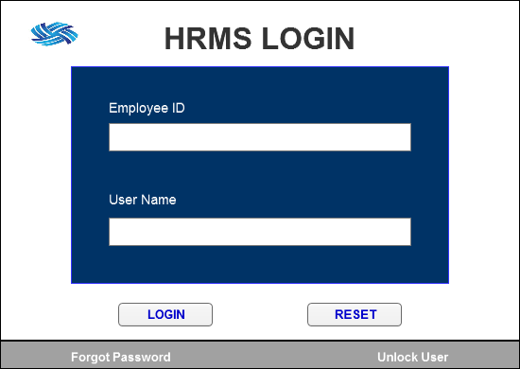

1. **Home Page**

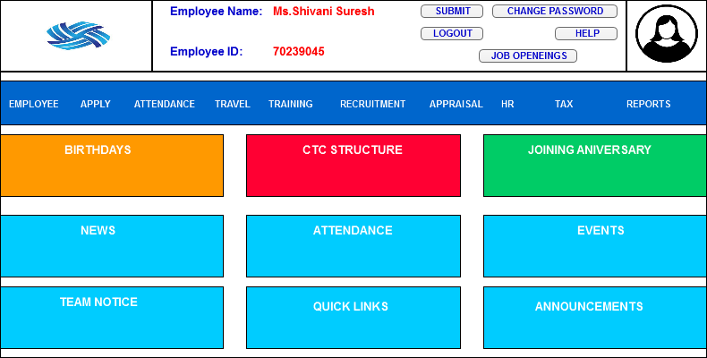

1. **Employee Dashboard**

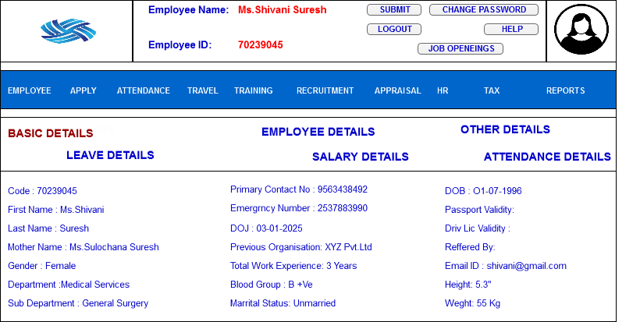

1. **Leave Management**

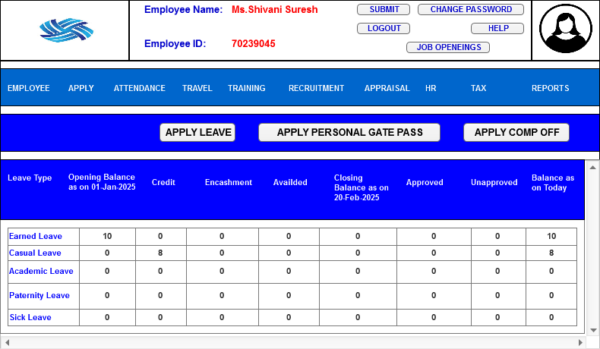

1. **Training Dashboards**

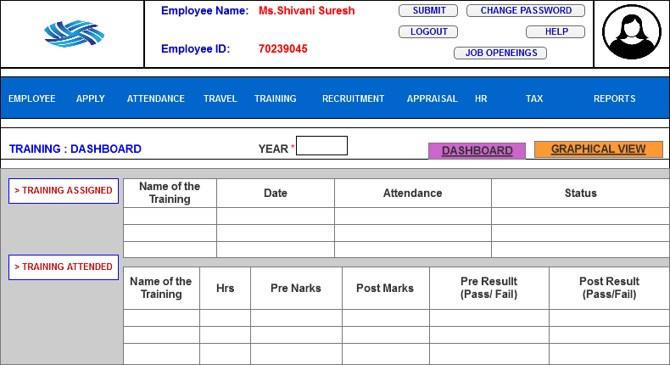

1. **Employee Daily Attendance**

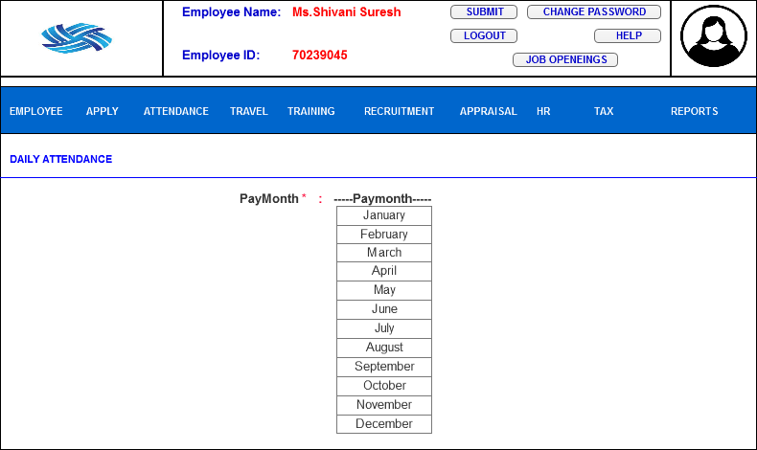

1. **Salary Slip**

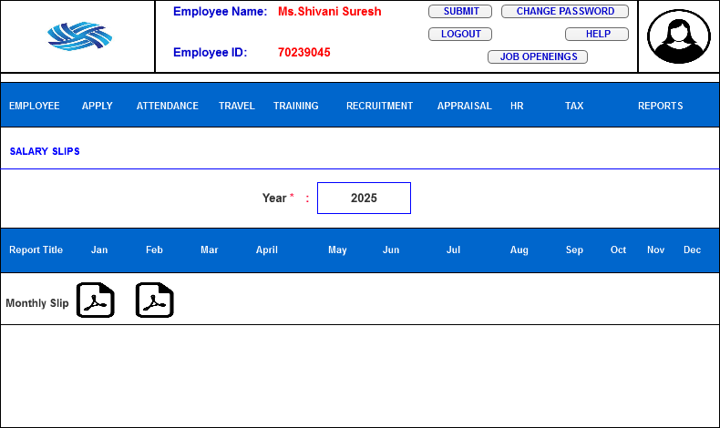

1. **Recruitment**

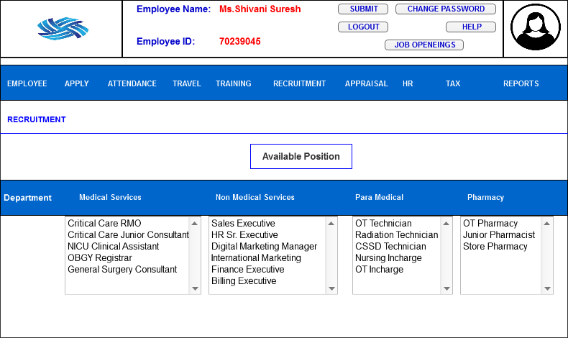

1. **Tax Declaration**

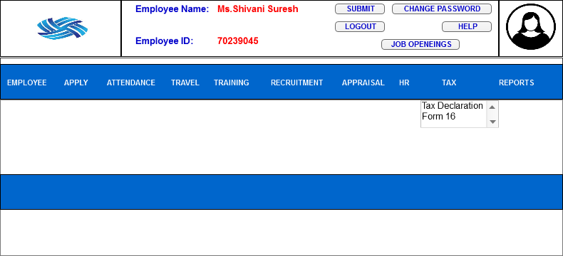

**Document 8- Tools- Visio and Axure;. Write a paragraph on your experience using Visio and Axure for the project.**

In this HRMS application software project, I used Ms Visio & Axure to create workflows, wireframe and mockups, which helped in planning the system before development. MS Visio was useful for designing process flow diagrams, allowing me to visualize HR task likes hiring, payroll and employee management step by step. I used different shapes to represent tasks, decision and action, making it easiser to explain the system to my team. These diagrams helped identify gaps, improve workflow and ensure a smooth process.

On the other hand, Axure helped me build interactive wireframes and mockups, I designed screens to show how the HRMS application would look and function. The wireframes were clickable, allowing users to teat navigation and understand system interaction. I added button, forms and pop ups to make the development phase, reducing errors and improving user experience.

Using Visio and Axure made my project well structure and organized. These tools helped in communicating ideas with the team and ensuring developers had a clear understanding of the system. They also saved time by avoiding major rework in later stage. By testing and refining the design early, the project became more efficient and user friendly. Overall, these tools played a crucial role in making my HRMS project successful.

**Document- 9 BA Experience**

As a Business Analyst, I played a crucial role in the development of an HRMS (Human Resource management System) software application, using the Waterfall Methodology. My responsibilities spanned across various phase, from gathering and analysing requirements to design, development testing, and deployment. I worked closely with stakeholder, technical teams and end users to ensure the successful implementation of the application. Below is details description of my contribution at each stage.

**My experience as BA in following phases:**

**1. Requirement gathering**: At the beginning of the project, I worked on gathering business requirements by interacting with stakeholder to understand their needs. To ensure an organized approach, I applied the MosSCow prioritization technique, which helped categorized requirements into groups: Must Have, Should Have, Could Have and Won’t Have. This technique allowed us to focus on the most critical requirements while deferring lees essential once. In case where the primary client contact was unavailable, I identified and reached out to alternate stakeholders to avoid delays in information collection. Additionally, I applied the FURPS model (Functionality, Usability, Reliability, Performance and Supportability) to validate the completeness and feasibility of the gather requirements. During this phase, I also worked on identifying and eliminating redundant or conflicting requirements to avoid ambiguity and duplication. To help stakeholders better understand and refine their requirements, I created prototypes and interactive wireframes, which visually represented features of the HRMS system. These prototypes played crucial role in aligning expectations and obtaining feedback from stakeholder.

**2. Requirement Analysis:** After gathering the requirements, I focused on analysing and structuring them in a clear and logical manner. To achieve this, I created UML (Unified Modeling Language) diagrams, which provided a visual representation of the system’s workflow and functionalities. These diagrams helped stakeholders and technical teams understand the system architecture more effectively. Additionally, I developed activity diagrams to outline step by step process flows within the HRMS application, ensuring that all business operations were mapped correctly, I then shared these diagrams with project teams and stakeholders, collected their feedback, and incorporated necessary changes to ensure accuracy. Once the analysis was finalized, documented all requirements in Business Requirement Specification (BRS) and software Requirements Specification (SRS) documents, which served as key references throughout the project lifecycle.

**3. Design:** During the design phase, I collaborated closely with developers and testers the ensure the system functionalities aligned with business requirements. One of my primary tasks was create test cases based on use case diagrams, ensuring that every scenario was covered in testing, I worked with the client to review design and solution documents, making sure that the proposed architecture met business objectives. To ensure through testing, I developed both positive & negative test case, verifying how the system responded to valid and invalid inputs, I meticulously ensured that no test case was overlooked, as even a minor oversight could significantly impact project development. Additionally, I prepared test data to facilitate testing processes and update the Requirement Traceability Matrix (RTM) to ensure that every requirements was accounted for in development process.

**4. Development:** During the development phase, I played a key role in facilitating communication between the business and technical team. I organised and led Joint Application Development (JAD) session, where stakeholders and developers collaborated to ensure alignment between requirements and system functionality. Throughout the coding process, I actively assisted the technical team by clarifying requirements whenever they had quires. In case there were disagreements or misunderstanding within the team, I took the initiative to conduct one on one discussion and foster to UML diagrams and design documents while coding individual modules. Regular team meetings were held to track progress, and if any member missed a session, I ensure they received a recording and a personalized follow up to keep them updated.

**5. Testing:** Once the development was completed, I was involved in the testing to validate the HRMS application’s functionality. I developed test cases derived from use cases and executed high level testing to identify potential issues before formal testing began. I also coordinate with the client to obtain test data, ensuring that testing scenarios reflected real world usages. Through this phase, I consistently updated the Requirements Traceability Matrix (RTM) to confirm that all requirements were successfully implemented and tested. Once testing was completed, I obtained formal client sign off on test results, ensuring that they were satisfied with the outcomes. Additionally, I assisted client in preparing for User Acceptance Testing (UAT) by guiding them through the process and addressing any concerns they had.

**6. Deployment:** The final phase of the project involved deploying the HRMS application and ensuring a smooth transition for end users. I shared the Requirements Traceability Matrix (RTM) with the client, attaching it to the project closure document for final validation. I also coordinated the preparation and distribution of end user manuals, which provided step by step guidance on using the HRMS system. To ensure user were comfortable with the new system, I organized training session tailored to different user groups. These sessions helped employee understand how to navigate the system, perform key HR functions and troubleshoot basic issues. I made sure that all relevant participants attended the training session to maximize system adoption and minimize post deployment support issues.

Though my structured approach, attention to detail and continuous collaboration with stakeholder, I contributed to the successful development and deployment of the HRMS software application. My role ensured that the application met business needs, functioned efficiently and was well received by end users.