1:-

|  |  |  |  |
| --- | --- | --- | --- |
| Req ID | Req Name | Req Description | Priorit y |
| FR0001 | Farmer  registration | Farmers should be able to register with correct attributes with the application | 9 |
| FR0002 | Farmer search for products | Farmers should be able to search variod agriculture products like seeds | 8 |
| FR0003 | Manufacturer registration | Manufacturers should be able to  register with correct attributes with the application | 8 |
| FR0004 | Manufacturer product listing | Manufactureers should be able to list their products in the catalogue | 7 |
| FR0005 | Product detail display | Application should display the detailed information about each products | 9 |
| FR0006 | Add to cart | Users should be able add products to their shopping cart | 8 |
| FR0007 | Payment gateways | The platform should offer multiplr payment gateways like UPI,Cards or COD | 9 |
| FR0008 | Order  placement | Users should be able to place their ordersfor selected items to their delivery address | 8 |
| FR0009 | Order confirmation | Users should receive confirmation details through email or sms with all details | 8 |
| FR0010 | Order Tracking | Users should be able to track their  orders to know the products real time location | 7 |

|  |  |  |  |
| --- | --- | --- | --- |
| FR0011 | Customer support | User should have customer support through live chat , email or phone for any queries | 8 |
| FR0012 | Rating and reviews | User should be able rate and review their order and can also see reviews of other products | 8 |
| NFR001 3 | Page Loading Time | Each page should load within 2 seconds of time | 9 |
| NFR001 4 | Payment Receipt | The farmers should get receipt | 8 |
| NFR001 5 | Fascinating Home Page | The home page should not contain much info. and should look good | 8 |
| NFR001 6 | Quick Payment Option | Payment option should quick and fast | 9 |
| NFR001 7 | Review option | After order customers should review orders | 8 |
| NFR001 8 | Security Of Data | Information of farmers should not be shared | 9 |
| NFR001 9 | Page refresh | After 15mins of activity the page should refresh itself | 7 |
| NFR002 0 | WCAG 2.1. | The system must meet web content accessibility guidelines WCAG 2.1. | 10 |
|  |  |  |  |

**2:- 5 Wirefarames Design**

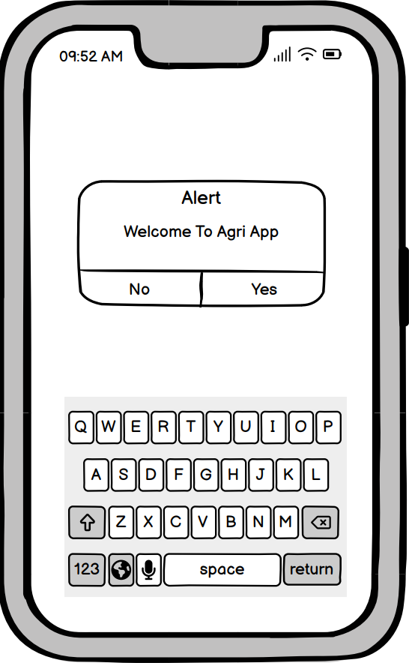

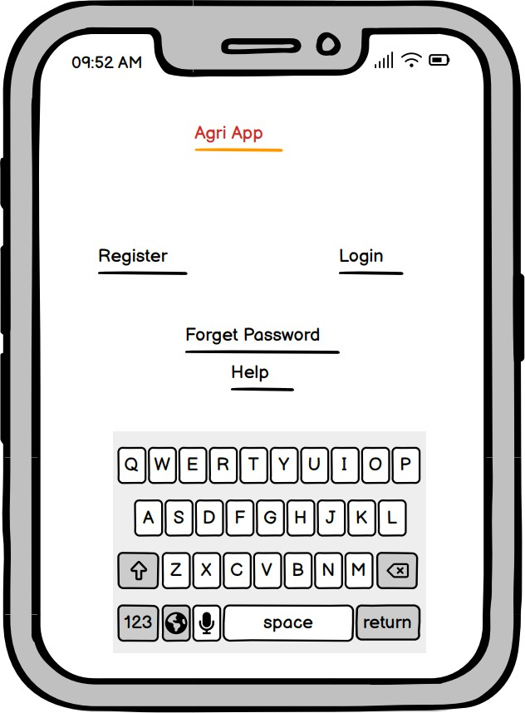

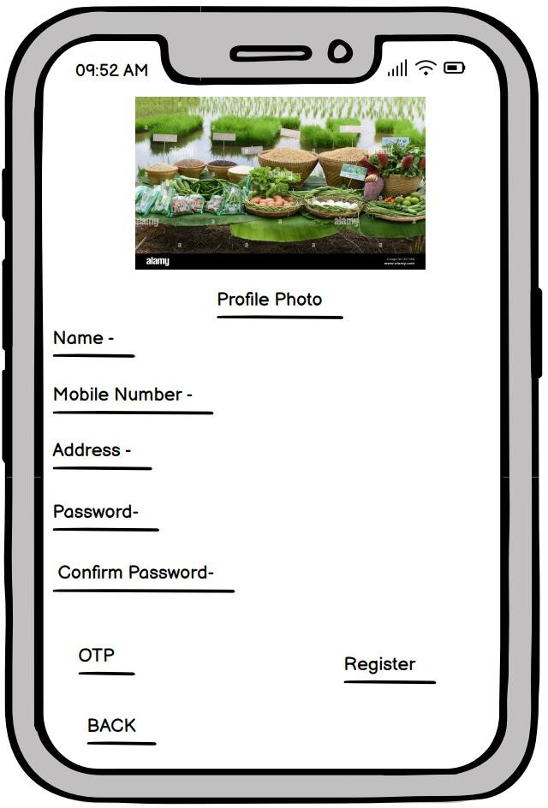

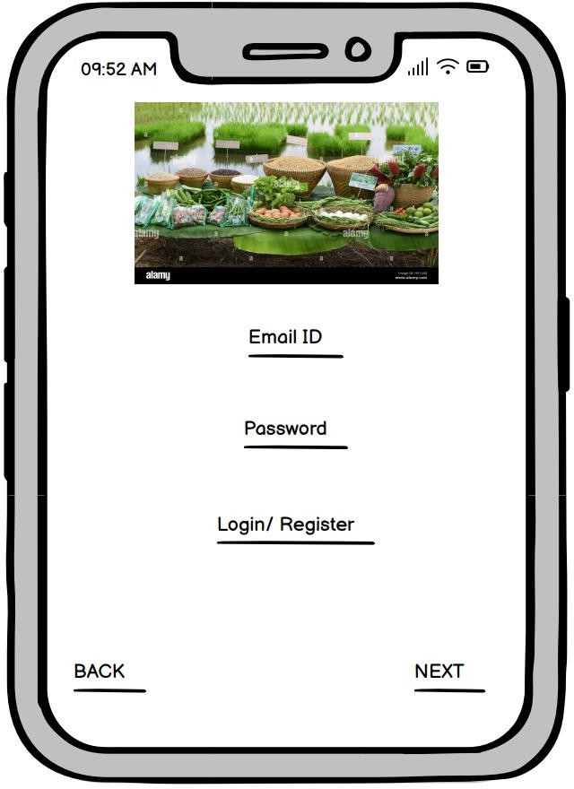

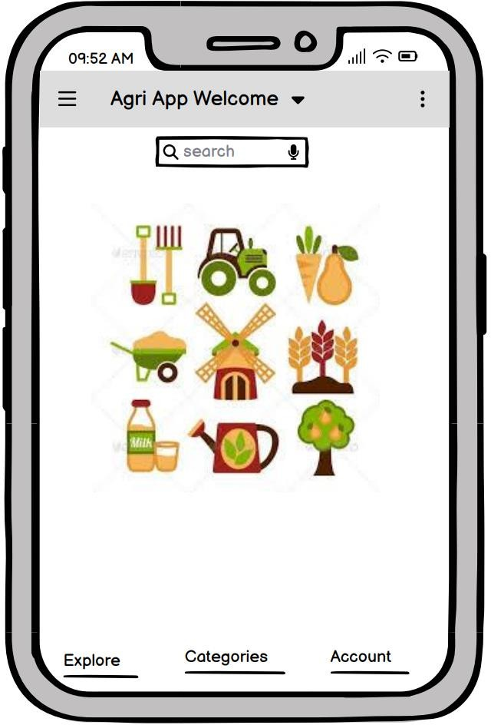

**3:-** Commonly used tools for the above concepts are –

**Microsoft Visio**- Visio is primarily used for creating diagrams and flowcharts. It’s great for visualizing complex information and processes. Offers a variety of templates and shapes for different types of diagrams (org charts, network

diagrams, etc.). It supports collaboration and integration with other Microsoft Office products. Best for professionals in fields like engineering, IT, and business who need to create detailed diagrams.

**Balsamiq -** Balsamiq is a wireframing tool designed to help users create low- fidelity prototypes of websites and applications. Focuses on quick sketching of UI designs, allowing for rapid iteration and feedback. Its drag-and-drop

interface is user-friendly, with pre-made components that mimic hand-drawn designs. Best for UX/UI designers and product teams looking to brainstorm and iterate on design concepts quickly without getting bogged down in detail.

**Axure-** Axure is a comprehensive prototyping tool that allows users to create high-fidelity, interactive wireframes and prototypes. Supports advanced

interactions, conditional logic, and dynamic content. It includes collaboration tools for team feedback and version control. Best for UX designers and product managers who need to create detailed prototypes that closely mimic the final product, allowing for thorough testing and stakeholder feedback.

**4:-** To tackle the situation and provide Mr. Henry and Peter with the current status of the project, I will prepare a Requirement Traceability Matrix (RTM).

**RTM**- An RTM (Requirements Traceability Matrix) is a tool used in project management and systems engineering to ensure that all requirements defined for a system are addressed throughout the project lifecycle. Its uses are in Verification and Validation, Change Management, Communication, and Quality Assurance.

|  |  |  |  |  |  |  |  |  |  |  |  |  |
| --- | --- | --- | --- | --- | --- | --- | --- | --- | --- | --- | --- | --- |
| Req ID | Req Name | Req Description | Design | D1 | T1 | D2 | T2 | D3 | T3 | D4 | T4 | UAT |
| FR0001 | Farmer registration | Farmers should be able to register with correct attributes with the application | Done | Done | Done | Done | Done | Done | Done | Done | Done | Done |
| FR0002 | Farmer search for products | Farmers should be able to search variod agriculture products like seeds | Done | Done | Done | Done | Done | Done | Done | Done | Done | Done |
| FR0003 | Manufacturer registration | Manufacturers should be able to register with correct attributes with the application | Done | Done | Done | Done | Done | Done | Done | Done | Done | Done |
| FR0004 | Manufacturer product listing | Manufactureers should be able to list their products in the catalogue | Done | Done | Done | Done | Done | Done | Done | Done | Done | Done |
| FR0005 | Product detail display | Application should display the detailed information about each products | Done | Done | Done | Done | Done | Done | Done | Done | Done | Done |
| FR0006 | Add to cart | Users should be able add products to their shopping cart | Done | Done | Done | Done | Done | Done | Done | Done | Done | Done |
| FR0007 | Cart management | Users should be able add to view and manage their shopping cart like adding or removing items | Done | Done | Done | Done | Done | Done | Done | Done | Done | Done |
| FR0008 | Wishlist management | Users should be able to manage their wishlist like buy later , adding or removing items | Done | Done | Done | Done | Done | Done | Done | Done | Done | Done |
| FR0009 | Payment gateways | The platform should offer multiplr payment gateways like UPI,Cards or COD | Done | Done | Done | Done | Done | Done | Done | Done | Done | Done |
| FR0010 | Order placement | Users should be able to place their ordersfor selected items to their delivery address | Done | Done | Done | Done | Done | Done | Done | Done | Done | Done |
| FR0011 | Order confirmation | Users should receive confirmation details through email or sms with all details | Done | Done | Done | Done | Done | Done | Done | Done | Done | Done |
| FR0012 | Order Tracking | Users should be able to track their orders to know the products real time location | Done | Done | Done | Done | Done | Done | Done | Done | Done | Done |
| FR0013 | Order history | Users should be able to view the order history if they want to same items | Done | Done | Done | Done | Done | Done | Done | Done | Done | Done |
| FR0014 | Customer support | User should have customer support through live chat , email or phone for any querries | Done | Done | Done | Done | Done | Done | Done | Done | Done | Done |
| FR0015 | Rating and reviews | User should be able rate and review their order and can also see reviews of other products | Done | Done | Done | Done | Done | Done | Done | Done | Done | Done |
| FR0016 | Product recommendation | Platform should provide personalised products based on user preferrence | Done | Done | Done | Done | Done | Done | Done | Done | Done | Done |
| FR0017 | Social sharing | user should have option to share products through social media platforms | Done | Done | Done | Done | Done | Done | Done | Done | Done | Done |
| FR0018 | Secure transaction | Platform should ensure secure transaction through various security features | Done | Done | Done | Done | Done | Done | Done | Done | Done | Done |
| FR0019 | Product filtering | User should be able to filter products based on price , brand , ratings etc | Done | Done | Done | Done | Done | Done | Done | Done | Done | Done |
| FR0020 | Account management | Users should be able to manage and edit their account setting | Done | Done | Done | Done | Done | Done | Done | Done | Done | Done |
| NFR0101 | Page Loading time | Each page should load within 2second time | Done | Done | Done | Done | Done | Done | Done | Done | Done | Done |
| NFR0102 | WCAG 2.1. | The system must meet web content accessibility guidelines WCAG2.1. | Done | Done | Done | Done | Done | Done | Done | Done | Done | Done |
| NFR0103 | Payment receipt | The farmer should get the receipt within a hour of loading | Done | Done | Done | Done | Done | Done | Done | Done | Done | Done |
| NFR0104 | Page timeout | After every 15minutes of activity the page will logout | Done | Done | Done | Done | Done | Done | Done | Done | Done | Done |
| NFR0105 | Fascinating home page | Home page should not contain much information and should look good | Done | Done | Done | Done | Done | Done | Done | Done | Done | Done |
| NFR0106 | Quick payment option | Payment option should be quick and fast | Done | Done | Done | Done | Done | Done | Done | Done | Done | Done |
| NFR0107 | Security of data | Information of users should not be shared | Done | Done | Done | Done | Done | Done | Done | Done | Done | Done |

**5: - TEST CASE DOCUMENTS TEST CASE No. 01**

|  |  |  |  |
| --- | --- | --- | --- |
| Test Case ID | TC-001 | Test Case Name | Registration |
| Project ID | 1234 | Project Name | Farmers website |
| PM ID | PM-001 | PM Name | Mr. Vandanam |
| Test Strategy ID | TS-9437 | Tester ID |  |
| Test Plan ID | TP-9437 | Tester Name |  |
| Test Schedule ID | TSC-9437 | Date of Test |  |

|  |
| --- |
| Scenario: Website for online shopping of farm product , in that we have to register, we have 5 inputs, 3compulsory, 1 optional and after that results are being shown |
| Link to that page |

|  |  |  |  |  |  |
| --- | --- | --- | --- | --- | --- |
|  | SET 1 | SET 2 | SET 3 | SET 4 | SET 5 |
| Input Data | User name | User name | User name | User name | User name |
|  | Password | Password | Password | Password | Password |
|  | Email verify | Email verify | Email verify | Email verify | Email verify |
|  | Captcha | Captcha | Captcha | Captcha | Captcha |
|  | OTP | OTP | OTP | OTP | OTP |
| Expected | Registered | Registered | Registered | Registered | Registered |
| Behaviour | and Home | and Home | and Home | and Home | and Home |
|  | page | page | page | page | page |
|  | shows | shows | shows | shows | shows |
| Actual | Registered | Registered | Registered | Registered | Registered |
| Behaviour | and Home | and Home | and Home | and Home | and Home |
|  | page | page | page | page | page |
|  | shows | shows | shows | shows | shows |
| Comments | Test was Good | Test was Good | Test was Good | Test was Good | Test was Good |
| Pass/Fail | Pass | Pass | Pass | Pass | Pass |
|  |  |  |  |  |  |

**TEST CASE No. 02**

|  |  |  |  |
| --- | --- | --- | --- |
| Test Case ID | TC-002 | Test Case Name | Login |
| Project ID | 1234 | Project Name | Farmers website |
| PM ID | PM-001 | PM Name | Mr. Vandanam |
| Test Strategy ID | TS-9437 | Tester ID |  |
| Test Plan ID | TP-9437 | Tester Name |  |
| Test Schedule ID | TSC-9437 | Date of Test |  |

|  |
| --- |
| Scenario: Website for online shopping of farm product , in that we have login, we have 4 inputs, 3compulsory, 1 optional and after that results are being shown |
| Link to that page |

|  |  |  |  |  |  |
| --- | --- | --- | --- | --- | --- |
|  | SET 1 | SET 2 | SET 3 | SET 4 | SET 5 |
| Input Data | User Id Password Captcha OTP | User Id Password Captcha OTP | User Id Password Captcha OTP | User Id Password Captcha OTP | User Id Password Captcha OTP |
| Expected Behaviour | Home  page/error page pops up | Home  page/error page pops up | Home  page/error page pops up | Home  page/error page pops up | Home  page/error page pops up |
| Actual Behaviour | Home  page/error page pops up | Home  page/error page pops up | Home  page/error page pops up | Home  page/error page pops up | Home  page/error page pops up |
| Comments | Test was Good | Test was Good | Test was Good | Test was Good | Test was Good |
| Pass/Fail | Pass | Pass | Pass | Pass | Pass |

**TEST CASE No. 03**

|  |  |  |  |
| --- | --- | --- | --- |
| Test Case ID | TC-003 | Test Case Name | Online order |
| Project ID | 1234 | Project Name | Farmers website |
| PM ID | PM-001 | PM Name | Mr. Vandanam |
| Test Strategy ID | TS-9437 | Tester ID |  |

|  |  |  |  |
| --- | --- | --- | --- |
| Test Plan ID | TP-9437 | Tester Name |  |
| Test Schedule ID | TSC-9437 | Date of Test |  |

|  |
| --- |
| Scenario: Website for online shopping of farm product , in that we have to order , we have 2 inputs, 1compulsory, 1 optional and after that results are being shown |
| Link to that page |

|  |  |  |  |  |  |
| --- | --- | --- | --- | --- | --- |
|  | SET 1 | SET 2 | SET 3 | SET 4 | SET 5 |
| Input Data | Product name  Filter | Product name  Filter | Product name  Filter | Product name  Filter | Product name  Filter |
| Expected Behaviour | Product name  Filter | Product name  Filter | Product name  Filter | Product name  Filter | Product name  Filter |
| Actual Behaviour | Product options | Product options | Product options | Product options | Product options |
| Comments | Product options | Product options | Product options | Product options | Product options |
| Pass/Fail | Pass | Pass | Pass | Pass | Pass |

**TEST CASE No. 04**

|  |  |  |  |
| --- | --- | --- | --- |
| Test Case ID | TC-004 | Test Case Name | Upload product |
| Project ID | 1234 | Project Name | Farmers website |
| PM ID | PM-001 | PM Name | Mr. Vandanam |
| Test Strategy ID | TS-9437 | Tester ID |  |
| Test Plan ID | TP-9437 | Tester Name |  |
| Test Schedule ID | TSC-9437 | Date of Test |  |

|  |
| --- |
| Scenario: Website for online shopping of farm product , in that we have to upload products , we have 3 inputs, 1compulsory, 1 optional and after that results are being shown |
| Link to that page |

|  |  |  |  |  |  |
| --- | --- | --- | --- | --- | --- |
|  | SET 1 | SET 2 | SET 3 | SET 4 | SET 5 |
| Input Data | Product type | Product type | Product type | Product type | Product type |
|  | Product name | Product name | Product name | Product name | Product name |
|  | image | image | image | image | image |
| Expected | Product | Product | Product | Product | Product |
| Behaviour | details and | details and | details and | details and | details and |
|  | image is | image is | image is | image is | image is |
|  | shown | shown | shown | shown | shown |
| Actual Behaviour | Product options available | Product options available | Product options available | Product options available | Product options available |
| Comments | Test was Good | Test was Good | Test was Good | Test was Good | Test was Good |
| Pass/Fail | Pass | Pass | Pass | Pass | Pass |

**TEST CASE No.05**

|  |  |  |  |
| --- | --- | --- | --- |
| Test Case ID | TC-005 | Test Case Name | Payment gateway |
| Project ID | 1234 | Project Name | Farmers website |
| PM ID | PM-001 | PM Name | Mr. Vandanam |
| Test Strategy ID | TS-9437 | Tester ID |  |
| Test Plan ID | TP-9437 | Tester Name |  |

|  |  |  |  |
| --- | --- | --- | --- |
| Test Schedule ID | TSC-9437 | Date of Test |  |

|  |
| --- |
| Scenario: Website for online shopping of farm product , in that we have to payment gateways, we have 4 inputs, 3compulsory and after that results are being shown |
| Link to that page |

|  |  |  |  |  |  |
| --- | --- | --- | --- | --- | --- |
|  | SET 1 | SET 2 | SET 3 | SET 4 | SET 5 |
| Input Data | Name Expiry cvv otp | Name Expiry cvv otp | Name Expiry cvv otp | Name Expiry cvv otp | Name Expiry cvv otp |
| Expected Behaviour | Transaction page | Transaction page | Transaction page | Transaction page | Transaction page |
| Actual Behaviour | Transaction page | Transaction page | Transaction page | Transaction page | Transaction page |
| Comments | Test was Good | Test was Good | Test was Good | Test was Good | Test was Good |
| Pass/Fail | Pass | Pass | Pass | Pass | Pass |

**TEST CASE No. 06**

|  |  |  |  |
| --- | --- | --- | --- |
| Test Case ID | TC-006 | Test Case Name | Browse product |
| Project ID | 1234 | Project Name | Farmers website |
| PM ID | PM-001 | PM Name | Mr. Vandanam |
| Test Strategy ID | TS-9437 | Tester ID |  |
| Test Plan ID | TP-9437 | Tester Name |  |
| Test Schedule ID | TSC-9437 | Date of Test |  |

|  |
| --- |
| Scenario: Website for online shopping of farm product , in that we have to browse product, we have 4 inputs, 4compulsory and after that results are being shown |
| Link to that page |

|  |  |  |  |  |  |
| --- | --- | --- | --- | --- | --- |
|  | SET 1 | SET 2 | SET 3 | SET 4 | SET 5 |
| Input Data | Category Size  Availability  Price range | Category Size  Availability  Price range | Category Size  Availability  Price range | Category Size  Availability  Price range | Category Size  Availability  Price range |
| Expected Behaviour | Different product options | Different product options | Different product options | Different product options | Different product options |
| Actual Behaviour | Same as expected | Same as expected | Same as expected | Same as expected | Same as expected |
| Comments | Test was Good | Test was Good | Test was Good | Test was Good | Test was Good |
| Pass/Fail | Pass | Pass | Pass | Pass | Pass |

**TEST CASE No. 07**

|  |  |  |  |
| --- | --- | --- | --- |
| Test Case ID | TC-007 | Test Case Name | Rating |
| Project ID | 1234 | Project Name | Farmers website |
| PM ID | PM-001 | PM Name | Mr. Vandanam |
| Test Strategy ID | TS-9437 | Tester ID |  |
| Test Plan ID | TP-9437 | Tester Name |  |
| Test Schedule ID | TSC-9437 | Date of Test |  |

|  |
| --- |
| Scenario: Website for online shopping of farm product , in that we have to rate product, we have 3 inputs, 1compulsory and after that results are being shown |
| Link to that page |

|  |  |  |  |  |  |
| --- | --- | --- | --- | --- | --- |
|  | SET 1 | SET 2 | SET 3 | SET 4 | SET 5 |
| Input Data | Rate Review  Image | Rate Review  Image | Rate Review  Image | Rate Review  Image | Rate Review  Image |
| Expected Behaviour | Review done | Review done | Review done | Review done | Review done |
| Actual Behaviour | Same as expected | Same as expected | Same as expected | Same as expected | Same as expected |
| Comments | Test was Good | Test was Good | Test was Good | Test was Good | Test was Good |
| Pass/Fail | Pass | Pass | Pass | Pass | Pass |

**TEST CASE No. 08**

|  |  |  |  |
| --- | --- | --- | --- |
| Test Case ID | TC-008 | Test Case Name | Product cancel |
| Project ID | 1234 | Project Name | Farmers website |
| PM ID | PM-001 | PM Name | Mr. Vandanam |
| Test Strategy ID | TS-9437 | Tester ID |  |
| Test Plan ID | TP-9437 | Tester Name |  |
| Test Schedule ID | TSC-9437 | Date of Test |  |

Scenario: Website for online shopping of farm product , in that we have to cancel product order, we have 2 inputs and after that results are being shown

Link to that page

|  |  |  |  |  |  |
| --- | --- | --- | --- | --- | --- |
|  | SET 1 | SET 2 | SET 3 | SET 4 | SET 5 |
| Input Data | Order ID  Captcha | Order ID  Captcha | Order ID  Captcha | Order ID  Captcha | Order ID  Captcha |
| Expected Behaviour | Order cancelled | Order cancelled | Order cancelled | Order cancelled | Order cancelled |
| Actual Behaviour | Same as expected | Same as expected | Same as expected | Same as expected | Same as expected |
| Comments | Test was Good | Test was Good | Test was Good | Test was Good | Test was Good |
| Pass/Fail | Pass | Pass | Pass | Pass | Pass |

**TEST CASE No. 09**

|  |  |  |  |
| --- | --- | --- | --- |
| Test Case ID | TC-009 | Test Case Name | Helplines |
| Project ID | 1234 | Project Name | Farmers website |
| PM ID | PM-001 | PM Name | Mr. Vandanam |
| Test Strategy ID | TS-9437 | Tester ID |  |
| Test Plan ID | TP-9437 | Tester Name |  |
| Test Schedule ID | TSC-9437 | Date of Test |  |

|  |
| --- |
| Scenario: Website for online shopping of farm product , in that we have helpline option, we have 4 inputs and after that results are being shown |
| Link to that page |

|  |  |  |  |  |  |
| --- | --- | --- | --- | --- | --- |
|  | SET 1 | SET 2 | SET 3 | SET 4 | SET 5 |
| Input Data | Name | Name | Name | Name | Name |

|  |  |  |  |  |  |
| --- | --- | --- | --- | --- | --- |
|  | Number Query | Number Query | Number Query | Number Query | Number Query |
| Expected Behaviour | Call person calls you | Call person calls you | Call person calls you | Call person calls you | Call person calls you |
| Actual Behaviour | Same as expected | Same as expected | Same as expected | Same as expected | Same as expected |
| Comments | Test was Good | Test was Good | Test was Good | Test was Good | Test was Good |
| Pass/Fail | Pass | Pass | Pass | Pass | Pass |

**TEST CASE No. 10**

|  |  |  |  |
| --- | --- | --- | --- |
| Test Case ID | TC-010 | Test Case Name | Download  payment receipt |
| Project ID | 1234 | Project Name | Farmers website |
| PM ID | PM-001 | PM Name | Mr. Vandanam |
| Test Strategy ID | TS-9437 | Tester ID |  |
| Test Plan ID | TP-9437 | Tester Name |  |
| Test Schedule ID | TSC-9437 | Date of Test |  |

|  |
| --- |
| Scenario: Website for online shopping of farm product , in that we have payment receipt option, we have 3 inputs and after that results are being shown |
| Link to that page |

|  |  |  |  |  |  |
| --- | --- | --- | --- | --- | --- |
|  | SET 1 | SET 2 | SET 3 | SET 4 | SET 5 |
| Input Data | Order ID  Captcha Password | Order ID  Captcha Password | Order ID  Captcha Password | Order ID  Captcha Password | Order ID  Captcha Password |

|  |  |  |  |  |  |
| --- | --- | --- | --- | --- | --- |
| Expected Behaviour | Call person calls you | Call person calls you | Call person calls you | Call person calls you | Call person calls you |
| Actual Behaviour | Same as expected | Same as expected | Same as expected | Same as expected | Same as expected |
| Comments | Test was Good | Test was Good | Test was Good | Test was Good | Test was Good |
| Pass/Fail | Pass | Pass | Pass | Pass | Pass |

**6:- DATA SCHEMA AND ER DIAGRAM**

**Database Schema**

A database schema is a blueprint or structure that defines how a database is

organized. It describes the relationships between various entities (tables) in the database, including the tables, fields (attributes), data types, and constraints.

The schema provides a framework for how data is stored, accessed, and managed.

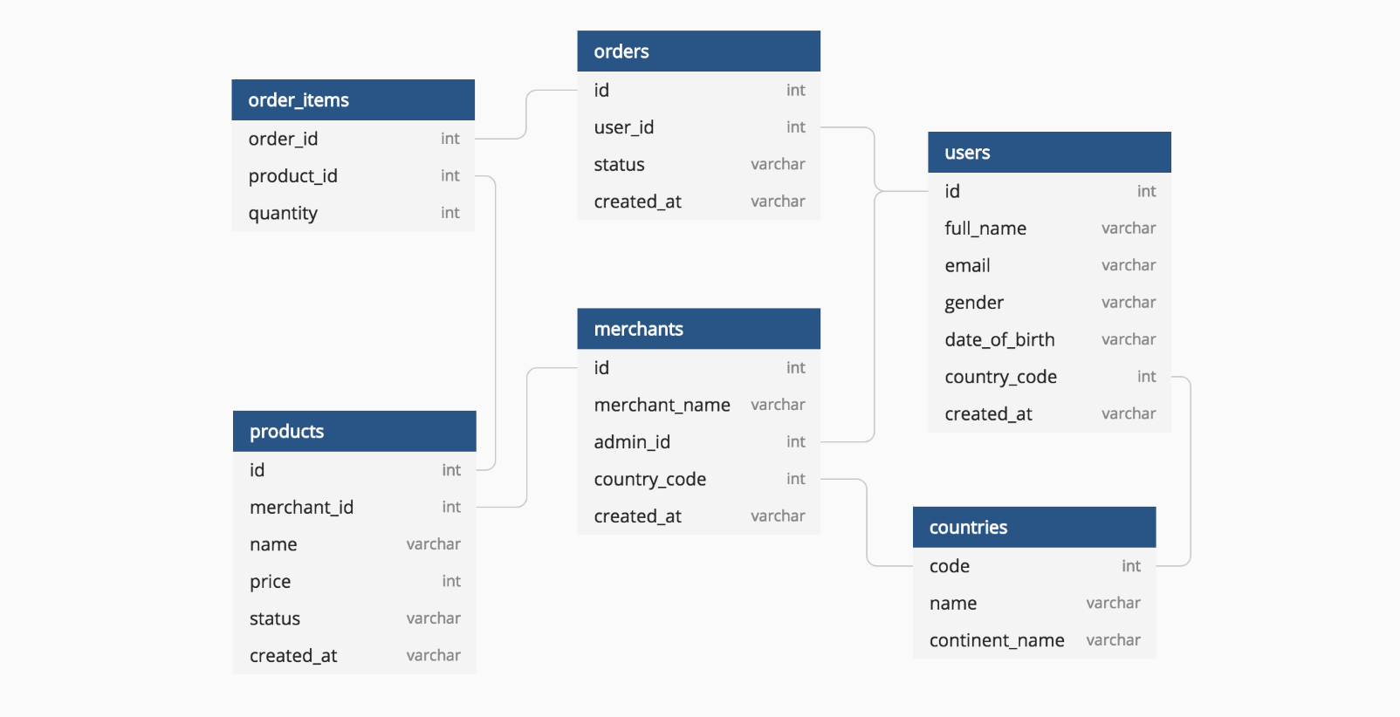

**Entity-Relationship (ER) Diagram**

An Entity-Relationship (ER) diagram is a visual representation of the database schema. It illustrates the entities in the system, their attributes, and the relationships between them. ER diagrams help in designing and understanding the structure of a database

User

**PK User ID**

Order

**PK Order ID**

**Name** Email Password Role

User ID Oerder Date Total Amount

Seller

**PK Seller ID**

Order item

**Order Item ID**

**PK**

Cart

**Order Id**

**PK**

Payment

**Payment Id**

**PK**

Product ID Name

Contact address

User ID Product ID Quantity Order Date

Order Id Payment Date Amount Payment Method

Order Id Product ID Quantity Subtotal

|  |  |  |
| --- | --- | --- |
|  | Product | |
| **PK** | **Product ID** |
|  | Mane Description Text Price  Stock Quantity |
|  |

**7:- Data Flow Diagram (DFD)**

A Data Flow Diagram (DFD) visually represents how data moves through a system. It shows the inputs and outputs of data processes, the data stores, and the interactions between the different components of a system. DFDs are

typically divided into levels:

Level 0: Context diagram showing the system as a whole.

Level 1: Breaks down the system into major processes and data flows.

**Components of a DFD**

1. **Processes:** Represented by circles or ovals, these show what happens to the data.
2. **Data Stores:** Represented by open-ended rectangles, these show where data is stored.
3. **External Entities**: Represented by squares, these are outside the system (e.g., users, other systems).
4. **Data Flows**: Arrows that show the direction of data movement**.**

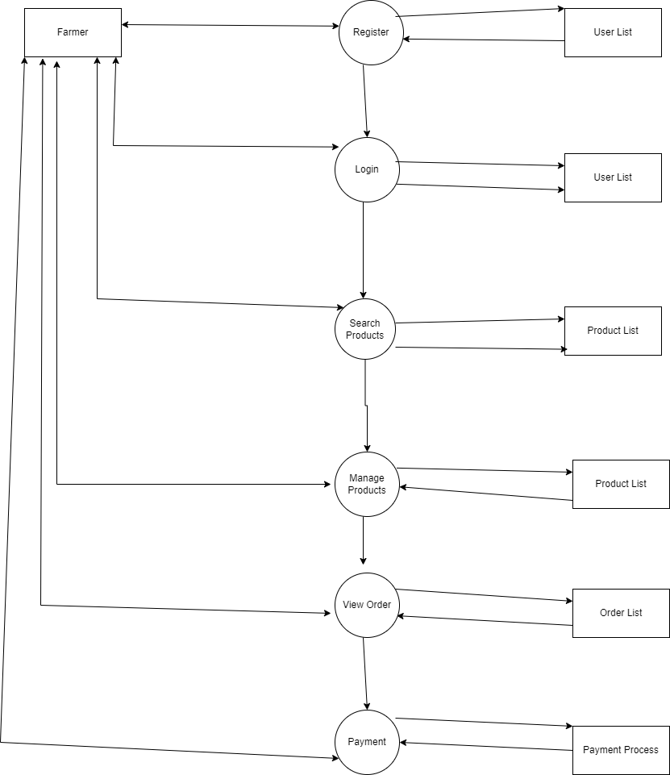

**8:-** Change in project requests refers to alterations or additions to the project scope, requirements, or deliverables after the project has begun. This can

happen for various reasons, such as evolving client needs, unforeseen issues, or new opportunities.

Steps to Handle Change Requests

1. **Identify and Document the Change:-** Clearly define the change request, including its rationale, scope, and impact on the project. Use a

standardized form to ensure consistency.

1. **Assess the Impact**:- Evaluate how the change will affect the project

timeline, budget, resources, and overall goals. Involve key stakeholders and team members in this assessment.

1. **Consult with Stakeholders**:- Present the change request and impact

analysis to stakeholders. Gather feedback and ensure everyone is aligned on the necessity and implications of the change.

1. **Prioritize the Change**:- Determine the priority of the change request compared to existing project tasks. Use a prioritization framework (e.g., MoSCoW- Must have, Should have, Could have, Won't have) to help make decisions.
2. **Update Project Plans**:- If the change is approved, update project documentation, schedules, and resource allocations accordingly. Communicate the changes to all relevant team members.
3. **Implement the Change:-** Integrate the approved changes into the project execution phase. Ensure that all team members understand their roles concerning the new requirements.
4. **Monitor and Review**:-Continuously monitor the project to assess the

impact of the change. Be open to further adjustments if new issues arise.

1. **Communicate**:-Keep communication lines open throughout the process, ensuring stakeholders are informed of progress and any new

developments.

**9:- Change Request** - A formal proposal to modify a product or system after its initial development. Often initiated due to identified issues, defects, or

necessary adjustments based on feedback or changes in requirements.

Example, Fixing a bug, updating a feature due to compliance needs, or changing a deadline.

**Enhancement -** A request to improve or add functionality to an existing system or product. Typically aimed at increasing value, usability, or performance rather than correcting a defect. Examples: Adding a new feature, improving user interface design, or upgrading performance.

As BA my response to Ben and Kevin would be to classify it as enhancement rather than change request . In this case farmers are allowed to add their crop yield , display them to public and do auction . Addition of these features are beyond project scope . So we have again perform and follow the standard

process for handling new requirements .

1. **Requirement Identification:** - Gather requirements from stakeholders, users, or market research. Initial Discussion to Conduct meetings or workshops to understand the need.
2. **Requirement Documentation:-** Write clear and concise requirement specifications, including objectives, scope, and acceptance criteria. Use standard templates to ensure consistency and completeness.
3. **Requirement Review: -** Share the documented requirements with

stakeholders for feedback. Ensure that the requirements align with business goals and user needs.

1. **Prioritization -**Evaluate requirements based on factors like urgency, impact, and resource availability. Use techniques like MoSCoW (Must have, Should have, Could have, Won't have) or prioritization matrices.
2. **Approval:-**Obtain formal approval from relevant stakeholders to proceed with the development of the requirements.
3. **Implementation:-** Work with the development team to translate requirements into functional features. Create test cases based on the requirements to ensure they are met.
4. **Verification and Validation:-** Conduct testing to verify that the implemented features meet the requirements. User Acceptance Testing (UAT): Involve end- users to validate that the solution fulfills their needs.
5. **Deployment:-** Deploy the new features or updates to the production environment. Provide training or documentation to users if necessary.
6. **Post-Implementation Review:-** Gather feedback from users to assess the effectiveness of the new requirements. Identify any additional enhancements or changes needed based on user experience.

**10:- Estimation of Project in Manhours**

1. Requirement Gathering and Analysis (40-80 hours)
   * Meetings with stakeholders to understand needs.
   * Documenting functional and non-functional requirements.
2. Design Phase (80-120 hours)
   * UI/UX Design: Creating wireframes and prototypes (40-60 hours).
   * Architecture Design: Planning app architecture and database schema (40-60 hours).
3. Development Phase (300-500 hours)
   * Frontend Development: Building user interface (100-200 hours).
   * Backend Development: Setting up server, database, and APIs (150-250 hours).
   * Integration: Connecting frontend with backend and any third-party services (50-100 hours).
4. Testing Phase (100-160 hours)
   * Unit Testing: Testing individual components (40-80 hours).
   * Integration Testing: Ensuring components work together (30-50 hours).
   * User Acceptance Testing (UAT): Validating with stakeholders (30-30 hours).
5. Deployment (40-60 hours)
   * Setting up hosting, domain, and deployment processes.
6. Training and Documentation (40-80 hours)
   * Creating user manuals and documentation.
   * Training for farmers and support staff.
7. Maintenance and Support (Ongoing)
   * Estimated at 10-20 hours per month for bug fixes and updates after launch.

Total Estimated Man-Hours: 600 - 1,000 hours

**11:-** Contacting a client for final testing is an important step to ensure that the product meets their expectations and requirements. Here’s a structured

process to effectively reach out to the client for final testing:

1. **Preparation:-** Outline the scope, objectives, and timeline for the final testing phase. Prepare test cases, scenarios, and any necessary documentation that the client will need to understand the process.
2. **Schedule a Meeting:-** Use email, phone, or project management tools to reach out. Suggest a few options for a meeting to discuss the final testing.
3. **Compose Communication** Clearly state the purpose, e.g., "Request for Final Testing Review”. Address the client formally. Briefly explain the purpose of the message and the importance of their feedback.
4. **Follow Up :-**If you don’t receive a response within a couple of days, send a polite follow-up email or make a phone call to ensure they received your

message.

1. **Conduct Testing:-** Once the client confirms, conduct the final testing as planned. Be available for any questions or clarifications during the testing process.
2. **Collect Feedback:-** After the testing is complete, schedule a debriefing

meeting to gather feedback. Discuss any issues found, potential improvements, and next steps.

1. **Documentation:-**Document the client’s feedback and any changes that need to be made. Share a summary report of the testing outcomes with the client.

**Project Closure Document**

A Project Closure Document is a formal record that summarizes the completion of a project. It serves as a comprehensive reference for

stakeholders and helps ensure that all aspects of the project are finalized. Here’s an overview of its key components and purpose:

1. **Project Overview: -** This section provides a high-level summary of the project, including its objectives, scope, and the key stakeholders involved. To give context to the document, ensuring that readers understand what the project was about and its intended outcomes.
2. **Final Deliverables: -** List all the deliverables produced by the project,

specifying which were completed, any that were modified, and those that were not delivered. To confirm that all expected outputs have been produced and to document any changes from the initial plan.

1. **Acceptance Criteria: -** This section outlines the criteria that were used to determine whether the project deliverables met the stakeholders'

expectations. It should include client sign-off and any conditions for

acceptance. To demonstrate that the project has fulfilled its requirements and to provide formal evidence of acceptance.

1. **Project Performance: -** An analysis of how the project performed compared to the original plans, focusing on key metrics such as timeline adherence, budget constraints, and quality of deliverables. To evaluate the project's overall success and to identify areas of strength and weakness.
2. **Issues and Resolutions: -** A summary of any significant issues that arose during the project, including how they were managed or resolved. To

document challenges faced, providing insights into problem-solving approaches and their effectiveness.

1. **Lessons Learned: -**Capture valuable insights gained throughout the project lifecycle, including best practices, pitfalls to avoid, and recommendations for future projects. To create a knowledge repository that can benefit future projects and help teams improve their processes.
2. **Financial Closure: -** An overview of the project’s financial performance, including budgeted versus actual costs, any variances, and justifications for them. To ensure that all financial matters are settled and to provide

transparency regarding project expenditures.

1. **Stakeholder Feedback: -** A summary of feedback gathered from project stakeholders, including team members, clients, and other involved parties regarding the project's execution and outcomes. To gain insights into the

perception of the project's success and areas for improvement from various perspectives.

**UAT (User Acceptance Testing)**

User Acceptance Testing (UAT) is the final phase of the software testing

process, where real users test the software to ensure it meets their needs and requirements. The goal of UAT is to validate that the system functions correctly in a real-world environment and is ready for production.

Here’s a structured overview of the UAT process:

1. **Planning:-** Clearly outline what the UAT aims to achieve. Choose representative end-users who will test the system. Document the scope, timeline, testing environment, and resources needed.
2. **Design Test Cases:-** Identify Scenarios: Based on user requirements, develop test scenarios that reflect real-world usage. Create detailed test cases that

specify the steps to execute, expected results, and acceptance criteria**.**

1. **Set Up the Environment:-** Prepare a UAT environment that mimics the production environment, including data and configurations.
2. **Conduct UAT:-**Users perform tests according to the defined scenarios and document their findings. Gather feedback on functionality, usability, and any issues encountered.
3. **Issue Resolution:-** Document any issues found during testing and prioritize them for resolution. The development team addresses reported defects and improvements.
4. **Re-testing:-** After fixes, re-test the affected areas to ensure issues are resolved.
5. **Approval:-** Once all tests are successfully completed and feedback addressed, obtain formal approval from stakeholders, confirming the product is ready for launch.
6. **Documentation and Reporting: -** Document the UAT results, including test cases executed, issues found, and resolutions. Prepare a UAT summary report for stakeholders**.**
7. **Post-UAT Review:-** Conduct a review meeting with stakeholders to discuss the overall process, lessons learned, and any additional feedback for future

**12 :- Project Closure Document 1:-PROJECT OVERVIEW**

|  |  |
| --- | --- |
| ITEMS | Details |
| Project Name | Agriculture Based App |
| Project Sponsor | Mr. Henry (Soony Company) |
| Project Manager | MR. Vandanam (APT IT Company) |
| Start Date | 01-08-2023 |
| End Date | 01-02-2025 |
| Total Budget | 2crore |
| Project Duration | 18 months |

**2:-PROJECT OBJECTIVES**

|  |  |
| --- | --- |
| Objective No. | Objective Descriptions |
| 1 | Develop a reliable and secure app for farmers to orders  items directly |
| 2 | Create a real time inventory management and order  tracking system |
| 3 | Ensure the app is easy to use and accessible |
| 4 | Deliver the project within the set budget and timeline  of 18months |

**3:-PROJECT KEY DELIVETABLES**

|  |  |
| --- | --- |
| Deliverable No. | Deliverable Description |
| 1 | Mobile App (cross platform and iOS) |
| 2 | Backend System (Inventory &Order management) |
| 3 | Payment Gateway Integration |
| 4 | Multilingual Support |
| 5 | Order Tracking & Notification |
| 6 | Training &Support Material |

**4:-PROJECT TIMELINE SUMMARY**

|  |  |  |  |
| --- | --- | --- | --- |
| Phase | Duration | Completion Date | Remarks |
| Initiation | Month 1 | 29/08/2023 | Successfully initiated on  schedule |
| Planning &  Design | Month 1-3 | 30/10/2023 | Completed |
| Development | Month 4-13 | 04/09/2024 | Finished ahead of  time |
| Testing | Month 14-15 | 06/11/2024 | Completed |
| Launch | Month 16 | 12/12/2024 | Successfully  launched |
| User Training | Month17-18 | 27/02/2025 | Online and in- person training  done |

**5:-ACHIEVEMENTS**

|  |  |
| --- | --- |
| Achievements No. | Descriptions |
| 1 | Successfully launched the app on schedule |
| 2 | 2.5% cost saving under the budget |
| 3 | Exceeded user adoption target with 2000+farmer |
| 4 | Local language support enhanced user engagement |

**6:-CHALLENGES**

|  |  |  |
| --- | --- | --- |
| Challenge No. | Description | Mitigation Actions |
| 1 | Rural network issues hindered  app access for some users | Optimised features for  low connectivity |
| 2 | Payment gateway integration  issues caused minor delays | Additional tome for  troubleshooting |

**7:- LESSON LEARNT**

|  |  |
| --- | --- |
| Lesson No. | Key Lesson |
| 1 | Conduct user testing in multiple phase to catch usability issues  early |
| 2 | Ensure ofline functionality for regions with intermittent  internet |

|  |  |
| --- | --- |
| 3 | Farmer feedback integration leads to improved adoption rates |

**8:- RECOMMENDATIONS**

|  |  |  |
| --- | --- | --- |
| Recommendation  No. | Description | Action Needed |
| 1 | Network optimisation for low  connectivity areas | Optimise app for low-  bandwidth use |
| 2 | More local payment options | Research and integrate additional payment  options |

**9 :-FINAL APPROVAL**

|  |  |
| --- | --- |
| Item | Details |
| Prepared By | Mr Vandaman (PM) |
| Date of submission | 28/02/2025 |
| Approved By | Mr Henry ( Soony Company ) |
| Signature |  |